Rajasthan Institute of Engineering & Technology,Jaipur.
I Midterm Examination
Session: 2017-18
M.Tech I Year II Semester Power System Branch
SUBJECT: Advanced Power System Protection
Time: 2hrs. M.M.:25
Instruction for students:
- No provision for supplementary answer book.
Q.1 What is comparator? Define and discuss different types of static comparators.
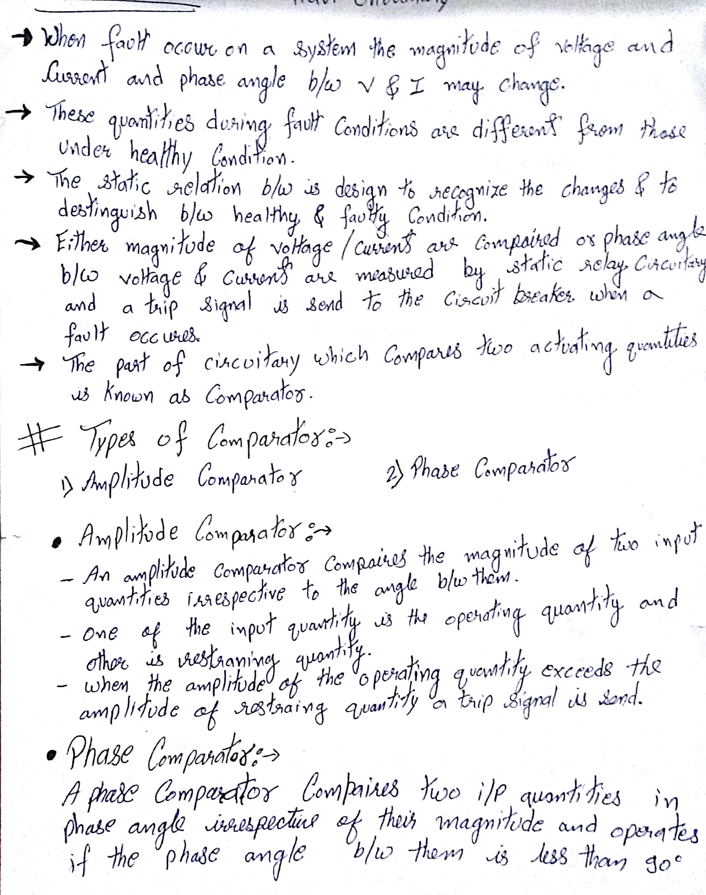
Q.2 Explain the use of CTs in protection. Discuss different types of errors present in CTs.
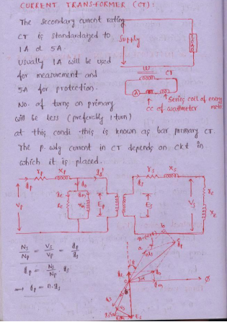
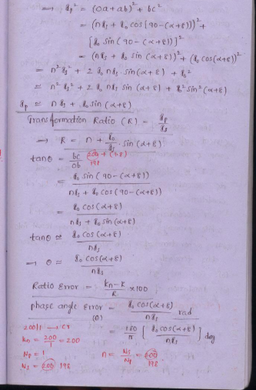
Q.3 How differential protection can be used for protection of three phase generator.
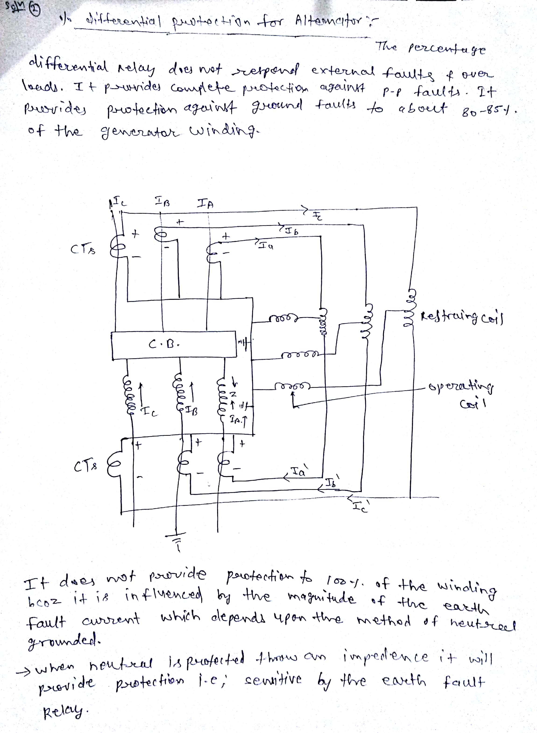
Q.4 What are the various components of a protection system? Briefly describe their functions with the help of schematic diagram.
In the Fig the basic connection of protection relay has been shown. It is quite simple. The secondary of current transformer is connected to the current coil of relay. And secondary of voltage transformer is connected to the voltage coil of the relay. Whenever any fault occurs in the feeder circuit, proportionate secondary current of the CT will flow through the current coil of the relay due to which mmf of that coil is increased. This increased mmf is sufficient to mechanically close the normally open contact of the relay. This relay contact actually closes and completes the DC trip coil circuit and hence the trip coil is energized. The mmf of the trip coil initiates the mechanical movement of the tripping mechanism of the circuit breaker and ultimately the circuit breaker is tripped to isolate the fault.
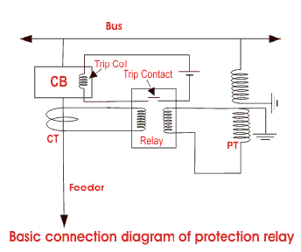

Important Elements for Power System Protection

Switchgear
Consists of mainly bulk oil circuit breaker, minimum oil circuit breaker, SF₆ circuit breaker, air blast circuit breaker and vacuum circuit breaker etc. Different operating mechanisms such as solenoid, spring, pneumatic, hydraulic etc. are employed in the circuit breaker. Circuit breaker is the main part of protection system in power system and it automatically isolate the faulty portion of the system by opening its contacts.
- Protective Gear
Consists of mainly power system protection relays like current relays, voltage relays, impedance relays, power relays, frequency relays, etc. based on operating parameter, definite time relays, inverse time relays, stepped relays etc. as per operating characteristic, logic wise such as differential relays, over fluxing relays etc. During fault the protection relay gives trip signal to the associated circuit breaker for opening its contacts.

Station Battery
All the circuit breakers of electrical power system are DC (Direct Current) operated. Because DC power can be stored in battery and if situation comes when total failure of incoming power occurs, still the circuit breakers can be operated for restoring the situation by the power of storage station battery. Hence, the battery is another essential item of the power system. Some time it is referred as the heart of the electrical substation. An electrical substation battery or simply a station battery containing a number of cells accumulate energy during the period of availability of AC supply and discharge at the time when relays operate so that relevant circuit breaker is tripped at the time failure of incoming AC power.

Q.5 What is a simple differential protection scheme? Describe its behavior during normal, external fault and internal fault conditions.
The most common application of this relay is the current differential type. The simple connection for this type of protection is given in Fig. 14.23.

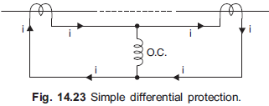
The dotted line represents the equipment to be protected which may be a transformer, an alternator, a bus etc. Two suitable CTs are connected in series as shown with the help of pilot wires. The relay operating coil is connected between the mid-points (equipotential points) of the pilot wire. The voltage induced in the secondary of the CTs will circulate a current through the combined impedance of the pilot wires and the CTs. In case the operating coil is not connected between the equipotential points (which are infinite), there will be difference current (sufficient during through fault condition) through the operating coil of the relay and this may result in maloperation of the relay. When the operating coil of the relay is not connected between the equipotential points, even though the current through each CT is same, the burden on the two CTs is unequal. This causes the heavily loaded CTs to saturate during through fault, thereby causing dissimilarity in the characteristics of the two CTs which results in maloperation of the relay.
Consider Fig. 14.24 for the operating principle of a differential relay. It is expected of the scheme that in case of a fault in the circuit between the two CTs the relay must operate and in case the fault is outside this zone the relay should not operate. Such protection is known as unit protection. When the fault is outside the zone of protection, it is known as external fault or through fault.
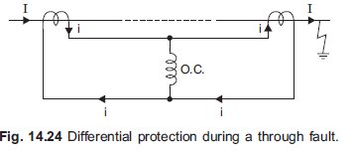
Consider the scheme in Fig. 14.24 for a through fault. The current flowing through the primaries of the two CTs is same (whether the system is fed from one end or both the ends). If the two CTs behave identically for all fault currents, the secondary currents are of the same magnitude and phase. The difference current, therefore, being zero through the operating coil, the relay does not operate. This is a desirable feature.
For an internal fault, consider Fig. 14.25 (a) when the circuit is fed from one end and Fig. 14.25 (b) when the circuit is fed from both the ends. It can be seen that in both the cases, a current will flow through the operating coil of the relay and it will operate. This form of protection is known as Merz-Price protection.
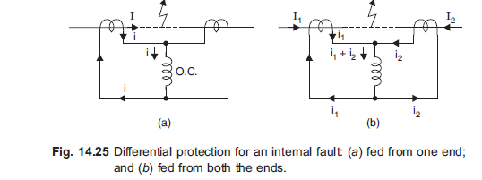

Rajasthan Institute of Engineering & Technology,Jaipur.
I Midterm Examination
Session: 2017-18
M.Tech I Year II Semester Power System Branch
SUBJECT: OCPS
Time: 2hrs. M.M.:25
Instruction for students:
No provision for supplementary answer book.
Q.1 Explain Input-Output and incremental fuel characteristics of a generating unit.
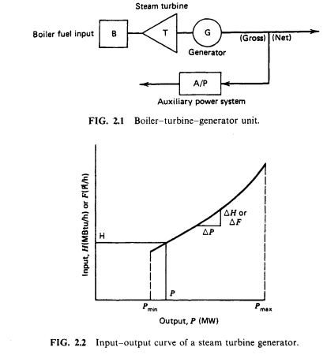
The economic dispatch problem is the determination of generation levels such that the total cost of generation becomes minimum for a defined level of load. Now, for thermal generating units, the cost of fuel per unit power output varies significantly with the power output of the unit. Therefore one needs to consider the fuel cost characteristics of the 3 generators while finding their optimal real power outputs. A typical fuel cost characteristics is shown below Figure.
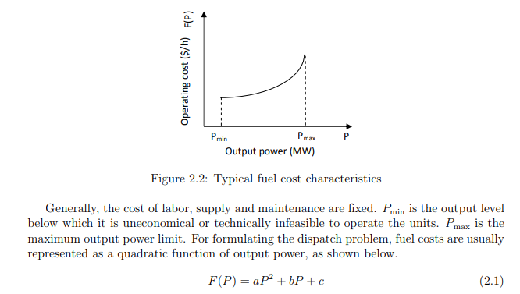
Q.2 Discuss the transmission loss formula.
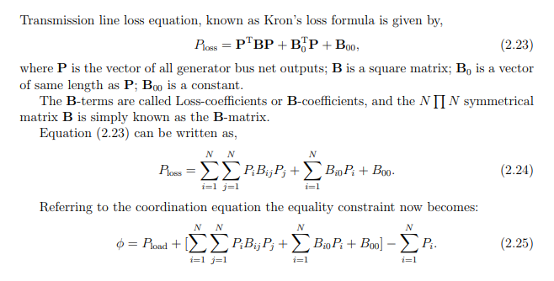
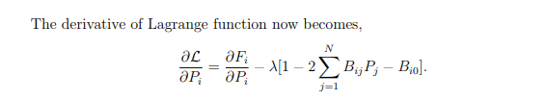
Q.3 Write short note on-

(1) Priority List method
The simplest solving method include is Priority List of units. With consideration average cost use the full load in unit. Cost is multiplication thermal net rate in full load and fuel cost. Mostly priority list method compound with other algorithm. The advantage is simple and less calculation, faster and disadvantages is less accuracy . Priority list method consisted of the following considerations:
1. When load decrease in hours, we should know that unit out of network. We have generation for load or not and have spinning reserve in circuit or not .If we have, we can out of service the unit.
2. We know that when needing unit at all out unit of network. If no problem for out unit of network otherwise at all out unit of the circuit.
3. Calculation cost in 2 states. Next unit of the circuit otherwise shouldn’t change the state. In recent years many different problems about unit commitment using priority list method investigated such as: priority list method compound modified priority list with hopfied lagrange .
(2)Dynamic programming method
In dynamic programming suppose that
1. Each state includes arrangement of units that some of them are active and another inactive
2. Cost active for each unit is independent of time (constant).
3. Cost for inactive unit is zero 4. There is priority list for units and minimum capacity should be active in a period
Q.4 Explain patton’s security function.
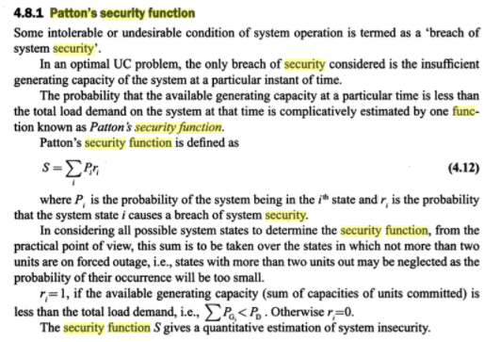
Q.5 What are the step of algorithm for Economic load dispatch.
Step 1 : Select set of initial control variables.
Step 2 : Solve power flow problem to obtain a feasible solution for the power balance equality constraint. Step 3 : Linearize the objective function and formulate linear programming problem
Step 4 : Solve LP problem and obtain optimal incremental control variables: Pi
Step 5 : Update control variables: P K+1 i = P K i +∆Pi
Step 6 : Obtain power flow solution and update control variables Step 7 : If ∆P ≤ δ, ∀i = 1, 2, ..., N, then stop otherwise go to step 3.
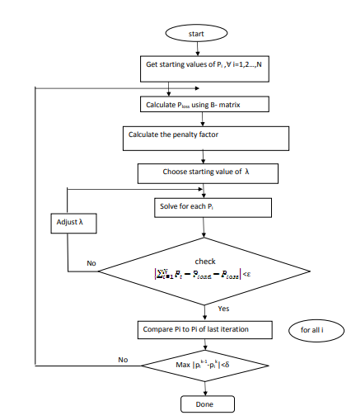

Rajasthan Institute of Engineering & Technology,Jaipur.
I Midterm Examination
Session: 2017-18
M.Tech I Year II Semester Power System Branch
SUBJECT: EHV AC/DC
Time: 2hrs. M.M.:25
Instruction for students:
No provision for supplementary answer book.
Q.1 What are the problems associated EHV transmission line?
Limitations of EHV Transmission
• Corona loss and radio Interference.
• Heavy supporting structures and erection difficulties.
• Insulation requirements.
• Suitability considerations.
• The cost of transformers, switchgear equipment and protective equipment increases with increase in transmission line voltage.
• Current carrying capacity.
• Ferranti effect.
• Environmental and biological aspects.
Heavy supporting structures and erection difficulties
• E.H.V. lines carry large mechanical loadings on towers due to bundle conductors, large air and ground clearances, considerable dynamic forces due to broken conductors etc.
• The towers with fabricated steel member, are usually employed in E HV. transmission. Since the cost of steel towers varies from 30 to 50% of the total cost of line for voltages upto 500 kV, therefore, better and cheaper designs must be evolved to effect economy.
• For the erection of E.H.V. lines, problems of transportation and erection arise as the supporting structures are to be transported over long distances, moreover a high standard workmanship is required
Insulation requirement
• The required line insulation level depends upon the magnitude of likely voltage surges which are caused due to Internal causes (switching operations) or due to external causes (atmospheric disturbances like lightning).
• The protection of E.H.V. transmission lines against lightning etc. in most cases is obtained by the use of ground wire and rapid auto-reclosing circuit breakers.
• Switching surges, especially those due to arc restriking in circuit breakers are dangerous as they may cause over-voltage of 24 times the normal operating voltage. It is possible to control and minimize switching over-voltage with a proper and effective design of relay- breaker systems.

Ferranti effect
• It is a known fact that when a line is loaded with capacitive load its receiving end voltage exceeds the sending and voltage (Ferranti effect).
• Furthermore, whenever the load on the generator is thrown off suddenly, there is a rise in the sending end voltage. Care needs to be taken from these aspects in case of E.H.V. AC. transmission system.

Environmental and biological aspects
• The recent researches in this field show that EH.V. and U.H.V. lines generate electrostatic and electromagnetic fields. These fields can induce current and voltage in animals, human beings and birds. However, fortunately these effects are minimum and within tolerate limits.
• In E.H.V. range, transmission lines also produce audible noise In line conductor, however, these noises do not exceed the satisfactory noise level up to 500 kV.

Q.2 Explain the properties of the bundled conductor and voltage gradients of conductor.
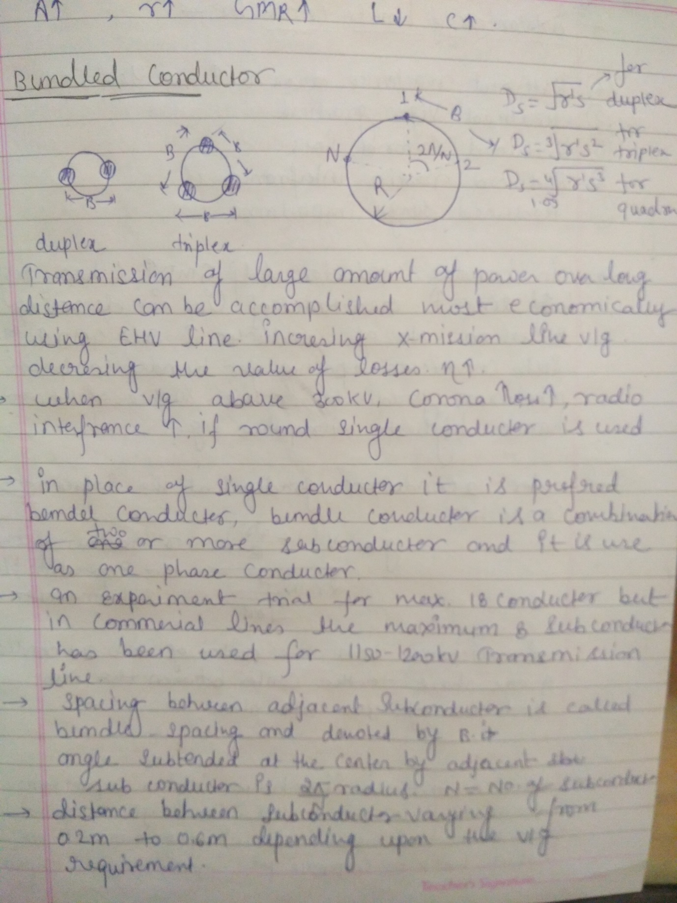
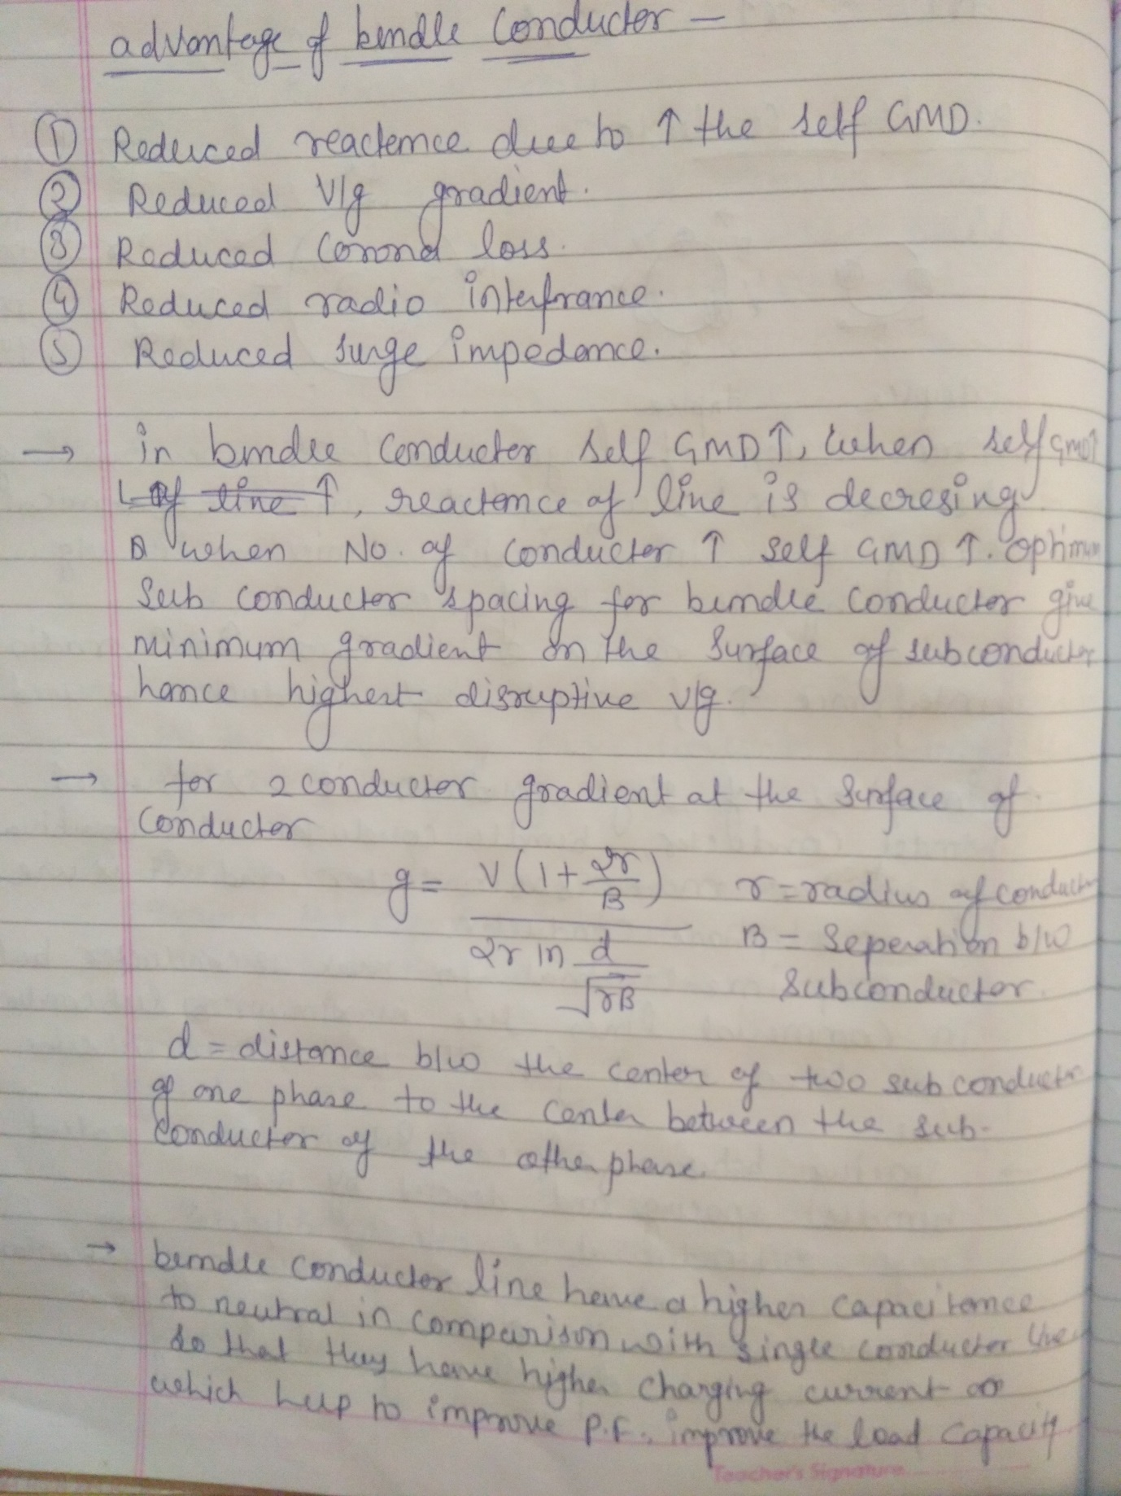
Q.3 Explain power handling capacity in transmission line.
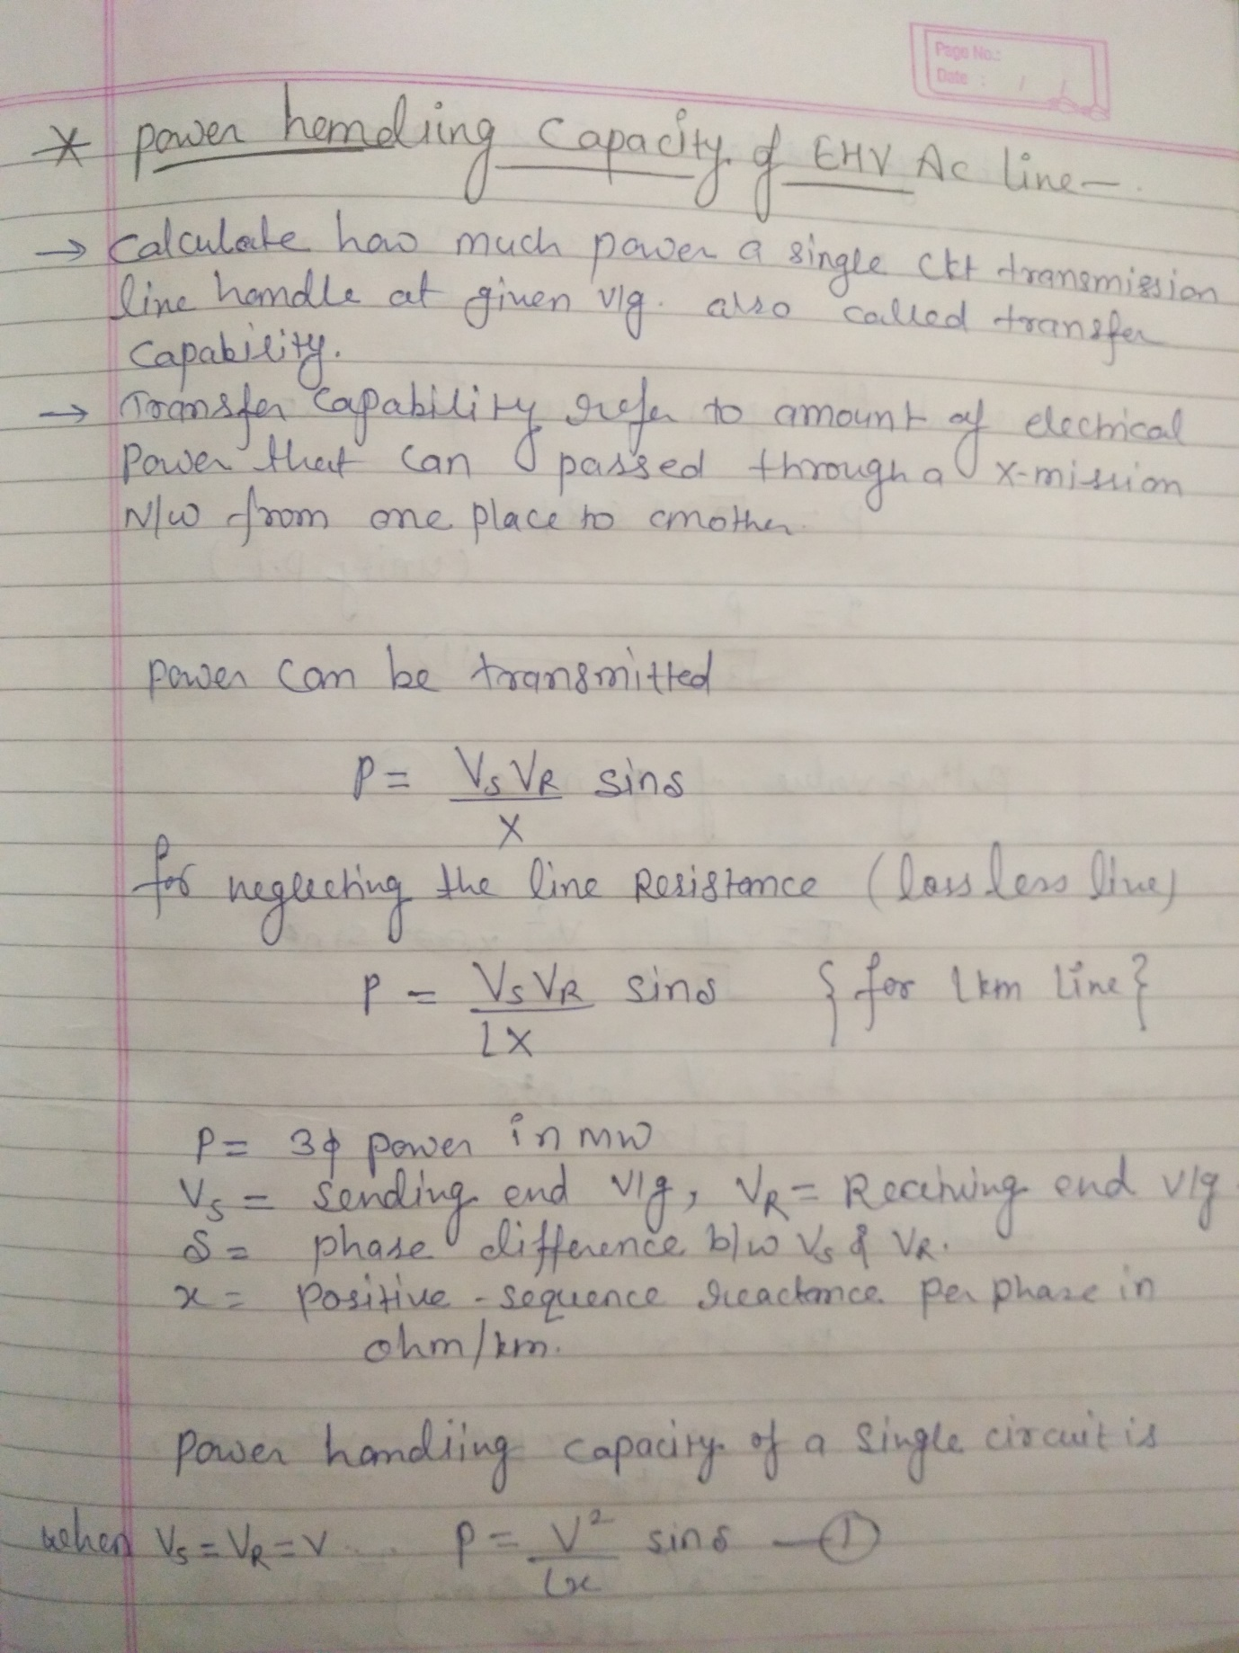
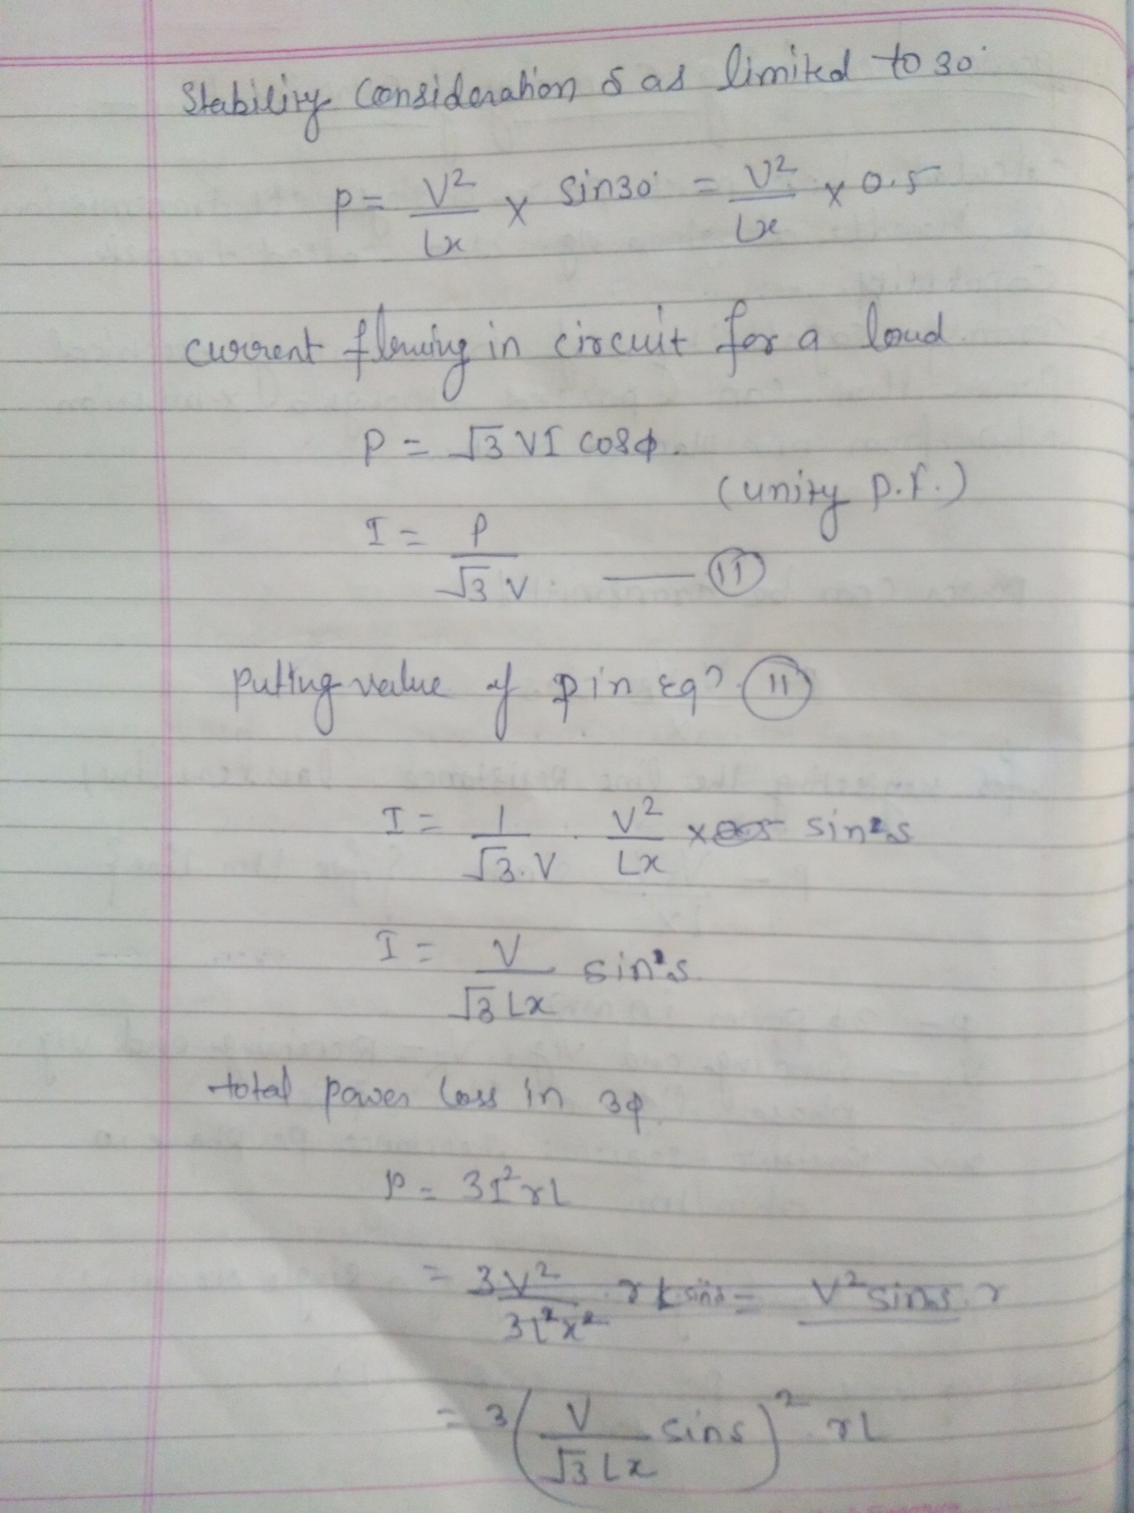
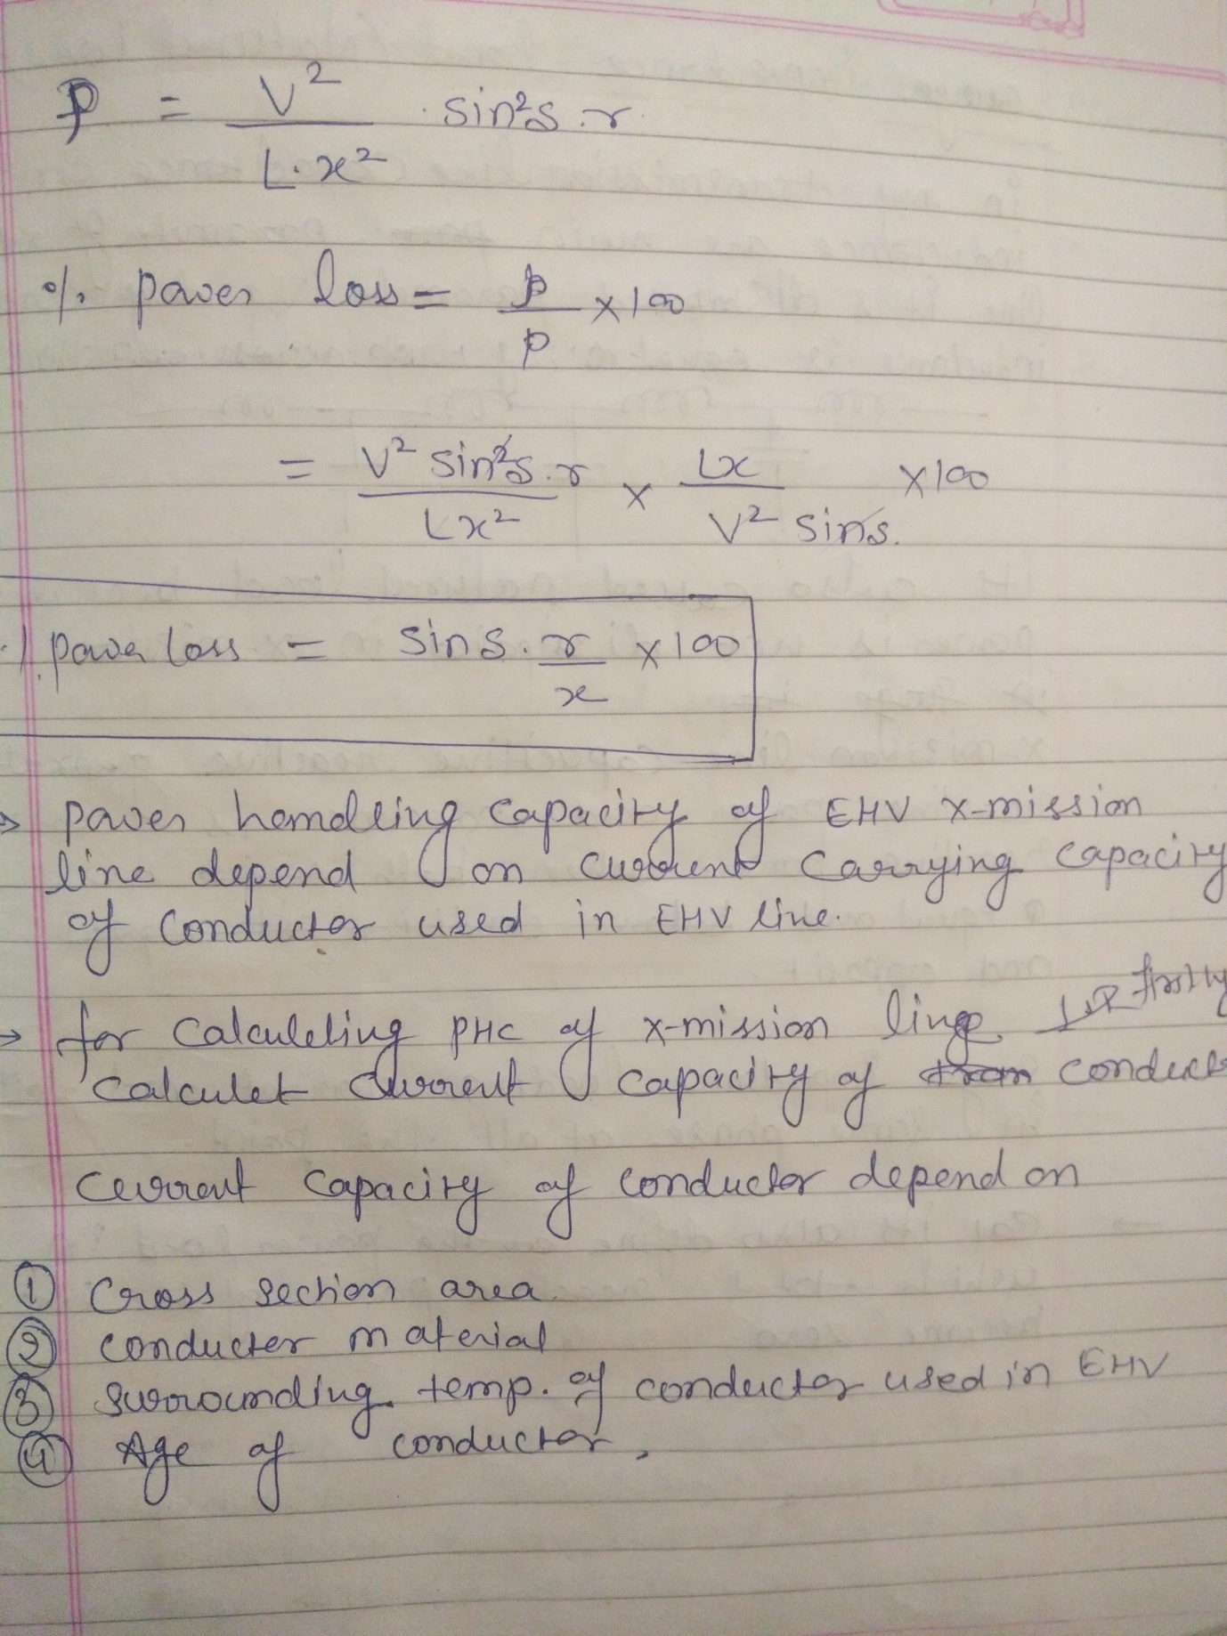
Q.4 Define Electrostatic fields of EHV lines and their effects.
ELECTROMAGNETIC FIELD EFFECT ON HUMAN BEINGS
The human body is composed of some biological materials like blood, bones, brain, lungs, etc. The permeability of the human body is equal to the permeability of the air, but within the human bodyit has different electromagnetic values at a certain frequency. The human body also contains free electric charges which are ion rich fluids like blood and limb, which move in response to forces exerted by charges on and currents flowing in nearby power lines. This process that produce these body currents are called electric and magnetic induction. In electric induction charges on power line attract or repel free charges within the body (our body contains both positive and negative charges). Since the body fluids are good conductors of electricity, charges in the body move to the surface under the influence of electric force. For example, a positively charged overhead transmission line induces negative charges to flow through the surfaces on the upper part of the body. Similarly, negative charges induces positive charges. Therefore, the charge on the power lines alternates between positive and negative many times in a second and the charges induced on the body surface also alternates, i.e., negative charges induced in the upper part of the body at one instant flow into the lower part of the body at the next instance. The power frequency electric field induce currents in the body (eddy current) as well as charges on its surface.
Magnetic induction: The current induced in the body by magnetic field are greatest near the periphery of the body and smallest at the center of the body.
• Magnetic field induces a voltage in the tissue of human body, which causes a current to flow through it due to its conductivity.
• The magnetic field has the influence on the tissues of the human body, these maybe beneficial or harmful depending upon the nature.
• The magnitude of the surface charge and internal body currents by any given source of power frequency depends upon many factors. For example, this includes magnitude of the currents and charges in the source, the distance of the body from the source, the presence of other objects that might shield or concentrate the field and the body posture, shape, and orientation. For this reason, the surface charges and the currents, which a given field induces are very different for different for different human beings.
• When a person who is isolated from the ground by some insulating material, comes in close quarters to an overhead transmission line, and electrostatic field is set up in the body of the human being whose ordinary resistance is about 2000Ω. When the same person touches the grounded object, it will discharge through his body causing a large current to flow through the body. Discharge currents from 50Hz electromagnetic field are weaker than natural currents.
• For human beings the limit of the undisturbed field is 15kV/m RMS to experience possible shock.
SHORT TERM HEALTH PROBLEMS:
High power lines emit high levels of electromagnetic radiation. These hazardous man-made EMFs interact in a destructive way with natural electromagnetic fields that exists within human beings. They interfere with cell function, break DNA strands, and erode the immune system. These biological irregularities cause initial symptoms such as dizziness, fatigue, headaches, nausea, and digestive disorders. They often culminate in causing more serious disorders in children, pregnant women, and elderly people.
LONG TERM HEALTH PROBLEMS:
Overhead high voltage power line causes ionization of air emitting trillions of corona ions into the air per second. These ions get attached to the aerosol particles of many types of carcinogenic air pollution like diesel exhaust, flame retardants in furniture, unintentional byproducts of industries, etc. The charged pollution particles are then carried by the wind up to 7kms downwind of the power line and deposit in the lungs at a significantly greater rate than uncharged pollutant particles. The analysis of corona effect risk shows that up to 400 excess cases of lung cancer mortality and 3000 excess cases of cardiovascular and respiratory illness and aggravated asthma may occur annually among 2.7 million people living within overhead high voltage lines.
EFFECT OF ELECTROMAGNETIC FIELD ON ANIMALS Exposure to high voltage power lines, EMF results in decrease of 5% in milk yield, 13.8% in fat corrected milk yield, and 16.4% in milk fat among the cows. High voltage power lines cause breathing problems and weakened system in cows and pigs. High voltage power lines cause abnormally low pig birth rate, and high piglet mortality, and undersize heifers, and some afflicted with hemorrhages or abortions. Dogs and cats exposed to high EMF levels are still born and deformed puppies and kittens and have abnormal unbreed able seasons, and show risks of lymph cancer 6.8 times the expected rate. Animals kept below high electrostatic field acquires a charge and when they try to drink water, a spark usually jumps from their nose to the grounded pipe. Like hens are unable to pick up grains because of chattering of beaks and it also affects their growth.
EFFECT OF ELECTROMAGNETIC FIELD ON PLANTS The electromagnetic field from high power transmission lines affects the growth of plants in agricultural and forest lands near high power transmission lines. Current in power transmission lines varies according to the load. Hence the effect of EMF due to the current flowing upon the growth of the plants under high power transmission lines remains unaltered throughout the year. From various practical studies, the growth characteristics like shoot length, root length, leaf area, leaf fresh weight, specific leaf weight, shoot/root ratio, total biomass content, total water content of the crop plants were reduced significantly. Similar trends were observed in the biochemical characteristics like chlorophyll. Reduced growth and physiological parameter was primarily due to the effect of cell division and cell enlargement. Further, there was a stunt in the growth, which is due to poor action of hormones responsible for cell division, and cell enlargement. Conclusively, the biochemical changes produced in the plant due to EMF affects the production leading to economic loss

Q.5 Explain surge impedance loading.
The surge impedance loading or SIL of a transmission line is the MW loading of a transmission line at which a natural reactive power balance occurs. The following brief article will explain the concept of SIL.
Transmission lines produce reactive power (Mvar) due to their natural capacitance. The amount of Mvar produced is dependent on the transmission line’s capacitive reactance (X_{C}) and the voltage (kV) at which the line is energized. In equation form the Mvar produced is:
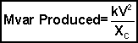
Transmission lines also utilize reactive power to support their magnetic fields. The magnetic field strength is dependent on the magnitude of the current flow in the line and the line’s natural inductive reactance (X_{L}). It follows then that the amount of Mvar used by a transmission line is a function of the current flow and inductive reactance. In equation form the Mvar used by a transmission line is:
A transmission line’s surge impedance loading or SIL is simply the MW loading (at a unity power factor) at which the line’s Mvar usage is equal to the line’s Mvar production. In equation form we can state that the SIL occurs when:
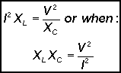
If we take the square root of both sides of the above equation and then substitute in the formulas for X_{L} (=2πfL) and X_{C} (=1/2πfC) we arrive at:
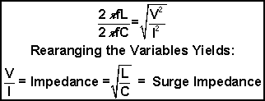
The term 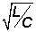 in the above equation is by definition the “surge impedance”. The theoretical significance of the surge impedance is that if a purely resistive load that is equal to the surge impedance were connected to the end of a transmission line with no resistance, a voltage surge introduced to the sending end of the line would be absorbed completely at the receiving end. The voltage at the receiving end would have the same magnitude as the sending end voltage and would have a voltage phase angle that is lagging with respect to the sending end by an amount equal to the time required to travel across the line from sending to receiving end.
The concept of a surge impedance is more readily applied to telecommunication systems than to power systems. However, we can extend the concept to the power transferred across a transmission line. The surge impedance loading or SIL (in MW) is equal to the voltage squared (in kV) divided by the surge impedance (in ohms). In equation form:
Note in this formula that the SIL is dependent only on the kV the line is energized at and the line’s surge impedance. The line length is not a factor in the SIL or surge impedance calculations. Therefore the SIL is not a measure of a transmission line’s power transfer capability as it does not take into account the line’s length nor does it consider the strength of the local power system.
The value of the SIL to a system operator is realizing that when a line is loaded above its SIL it acts like a shunt reactor—absorbing Mvar from the system—and when a line is loaded below its SIL it acts like a shunt capacitor—supplying Mvar to the system.
Figure 1 is a graphic illustration of the concept of SIL. This particular line has a SIL of 450 MW. Therefore if the line is loaded to 450 MW (with no Mvar) flow, the Mvar produced by the line will exactly balance the Mvar used by the line.
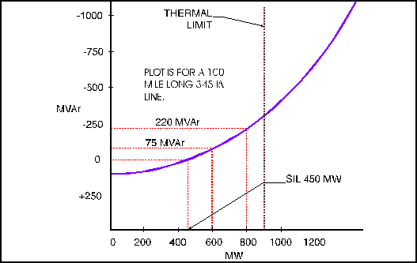
Figure 1: Surge Impedance Loading of a Transmission Loading

