BIOMEDICAL ELECTRONICS
Q1. Explain briefly about biomedical transducers?
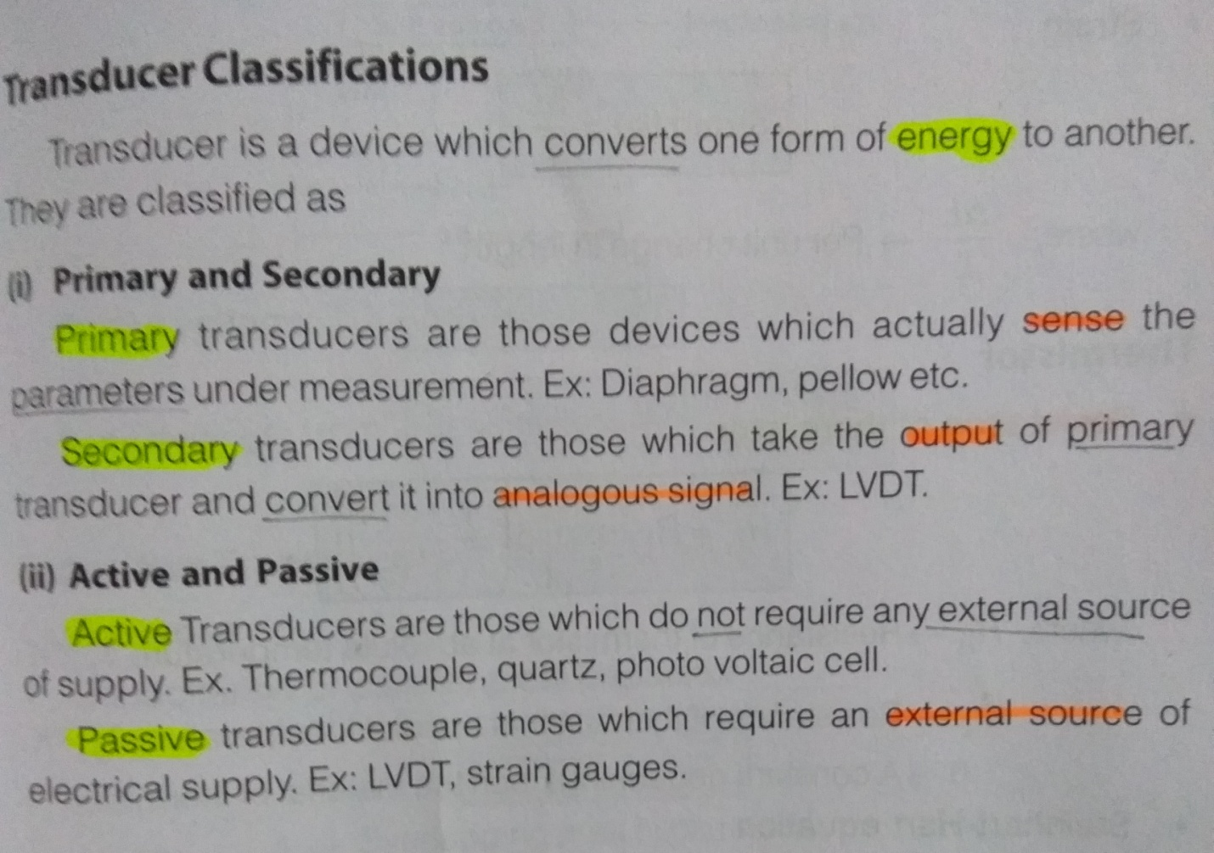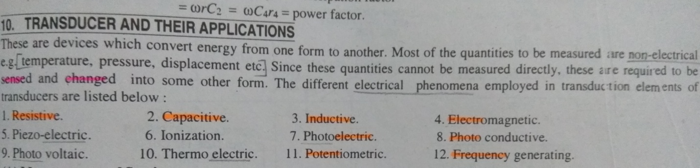
Q2. Define twelve lead configuration of ECG?
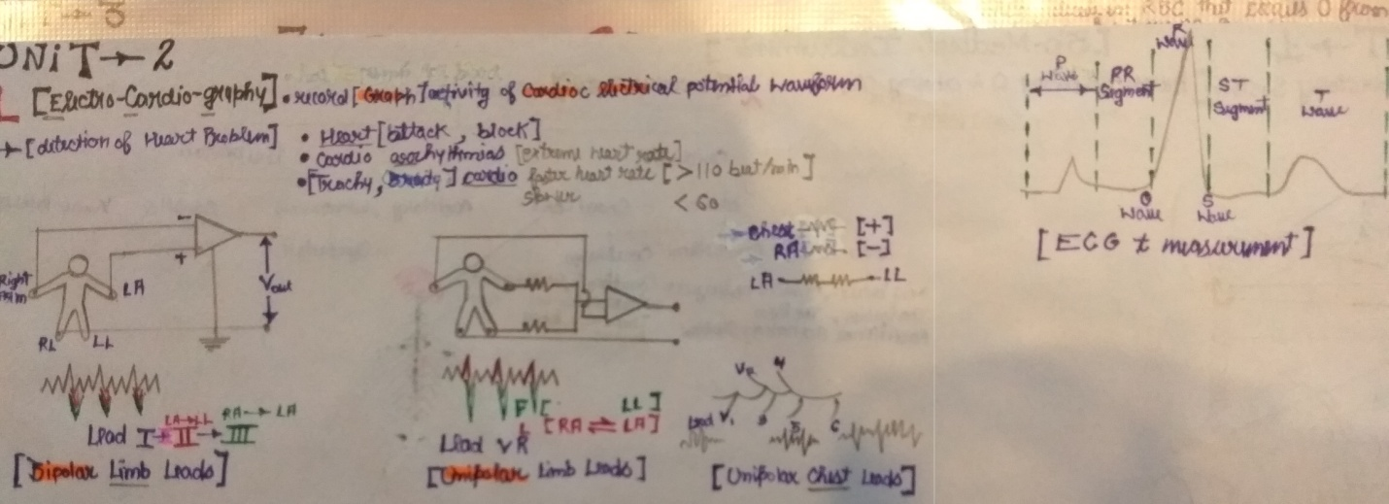

Q3. Differentiate between polarizing and non polarizing electrodes. Also mention various electrodes for ECG recording?
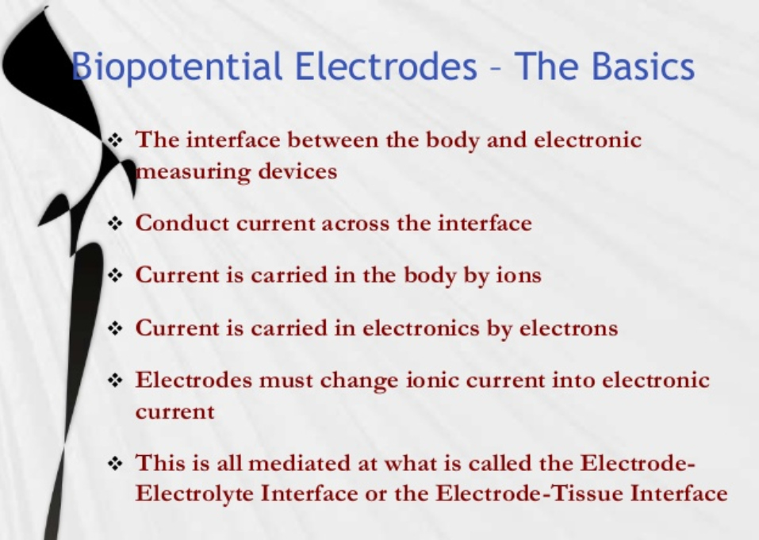

Q4. Discuss primary consideration of design of pressure transducers used in direct methods of blood pressure measurement?
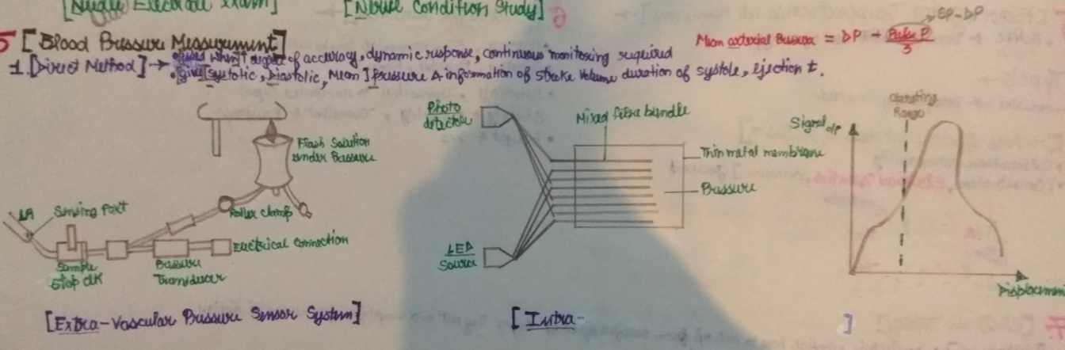

Q5. Write short note on measurement of partial pressure of carbon dioxide of blood?
