CAD OF IC
Q1) Explain the design flow of full custom design with labeled diagram.
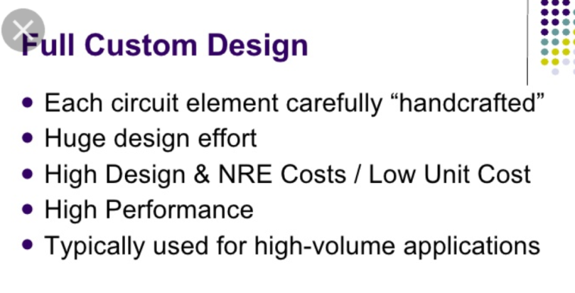
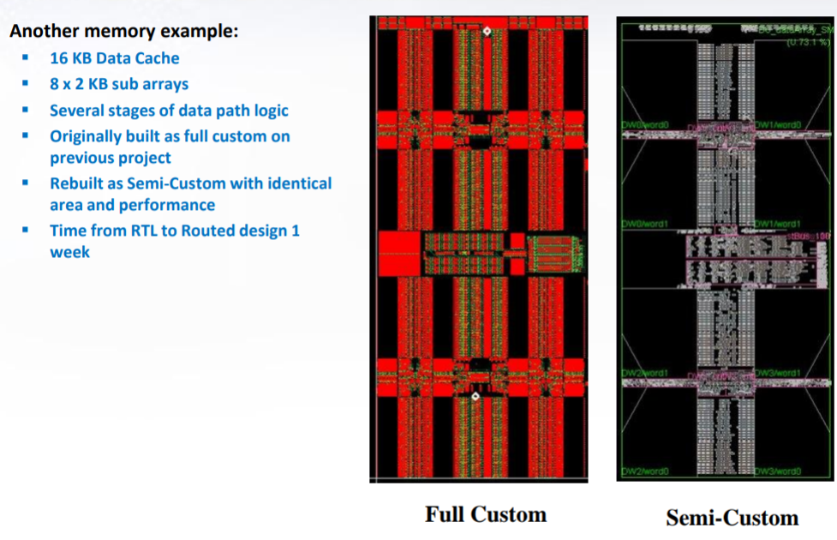
Q2) Write the advantages and disadvantages of semi custom design.
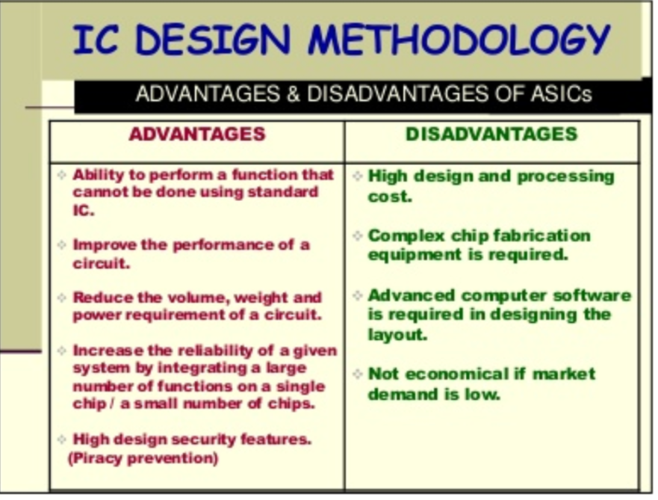
Q3) Draw the stick diagram of 2 input NAND gate. Mention the lambda based design rule. 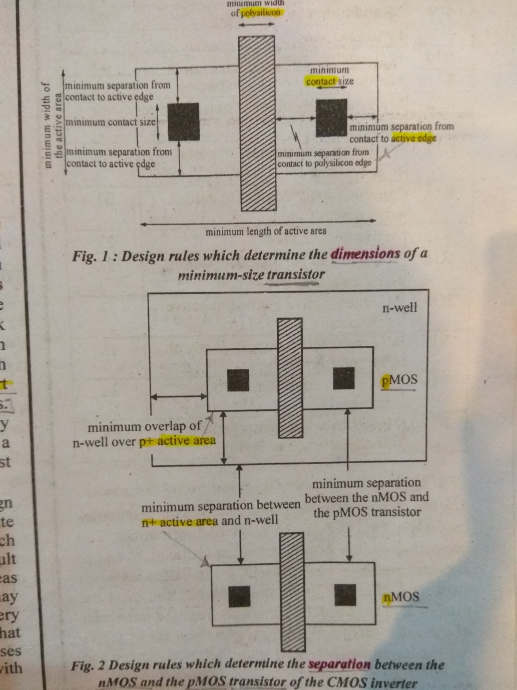
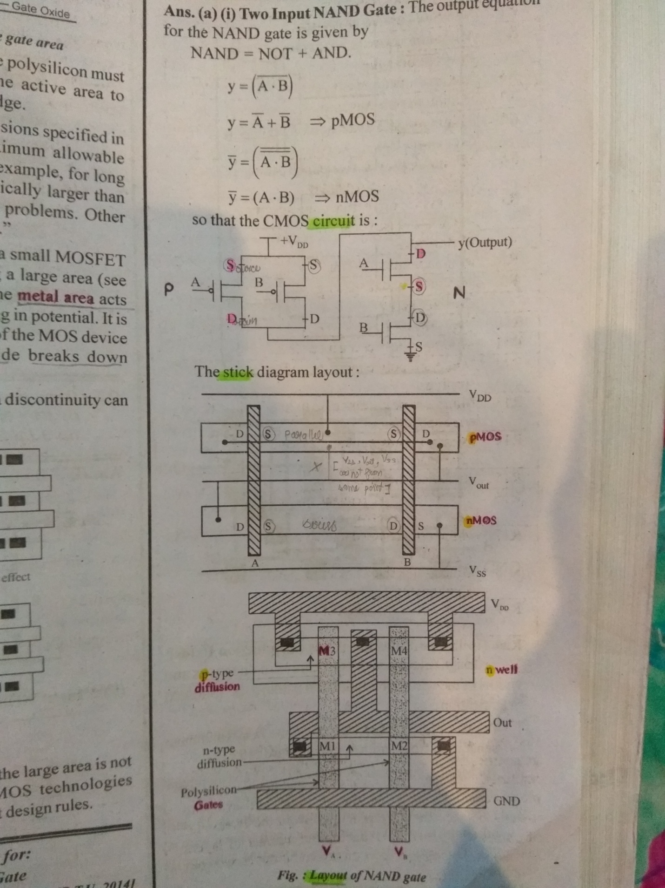
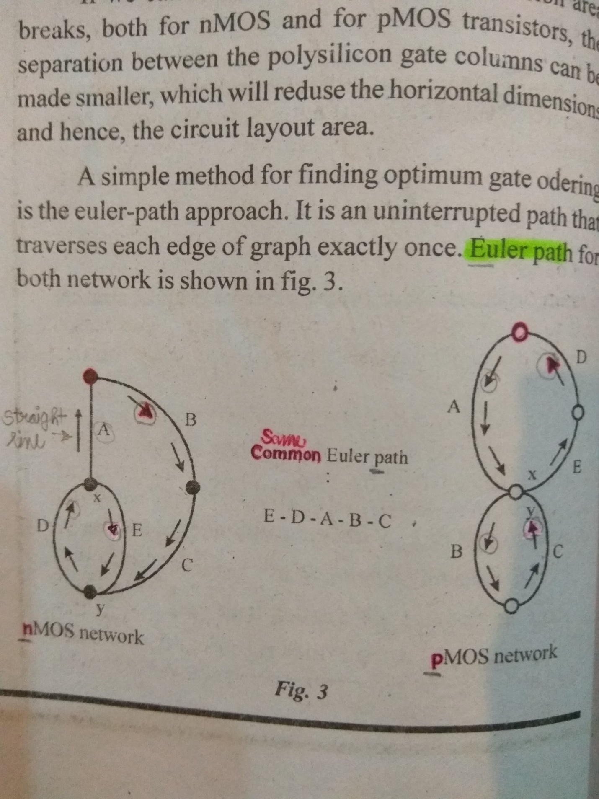
Q4) Explain the design steps included in front-end design.
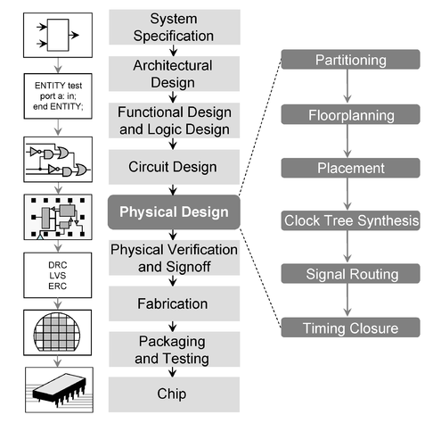
Q5) Draw the flow chart of semi custom design. Name the various design methodologies used for IC design.
