Rajasthan Institute of Engineering & Technology, Jaipur
University Roll No. ______________

1st Year MBA. II Semester 1stMid Term Examination, March – 2018
Subject: - Cost Accounting for Management SET-A
Time: -2 Hrs. [Maximum Marks: -20]
[Min. Passing Marks: 08]
Instructions to the Candidates:
Attempt any 4 questions from Section A and Section B is Compulsory.
Section A
Q 1. Briefly explain various techniques of cost accounting. (3)
a) Uniform Costing: The practice in which common methods of costing for different undertakings in the same industry are used is known as uniform costing.
b) Historical Costing: In this technique, ascertainment of cost is done after they have been incurred but the utility of this technique is limited.

c) Direct Costing: The practice of charging all direct costs to operations, processes or products leaving all indirect costs to be written off against profit’s in which they arise are called as direct costing.

d) Absorption Costing: In this all costs, both variable and fixed are charged to production, operations or processes. Marginal Costing: The method of ascertaining marginal cost by differentiating between fixed and variable costs. This technique is used to ascertain effect of changes in volume or type of output over the profits.

f) Standard Costing: The preparation of standard costs and applying them to measure the variations from actual cost and analyzing the causes of variations with a view to maintain maximum efficiency in production is known as standard costing.

g) Activity Based Costing: ABC is a system that focuses on activities as fundamental cost objects and utilizes the cost of these activities as building blocks or compiling the costs of other cost objects

Q 2. Explain the concept of strategic cost management. (3)
Strategic cost management is the process of reducing total costs while improving the strategic position of a business. This goal can be accomplished by having a thorough understanding of which costs support a company's strategic position and which costs either weaken it or have no impact. Subsequent cost reduction initiatives should focus on those costs in the second category. Conversely, it may be useful to increase costs that support the strategic position of the business. Strategic cost management is a continuing process, since the strategy of a firm may change over time. Thus, certain costs may be sacrosanct when one strategy is being used, but can be readily eliminated when the strategy shifts.

Q 3. What do you understand by term overhead? Explain its types (3)
Aggregate of all expenses relating to indirect material cost, indirect labour cost and indirect expenses is known as Overhead. Accordingly, all expenses other than direct material cost, direct wages and direct expenses are referred to as overhead.

According to Wheldon, Overhead may be defined as "the cost of indirect material, indirect labour and such other expenses including services as cannot conveniently be charged to a specific unit." Blocker and WeItmer define overhead as follows:
"Overhead costs are operating cost of a business enterprise which cannot be traced directly to a particular unit of output. Further such costs are invisible or unaccountable."

Q 4. Write short note on the following- (3)
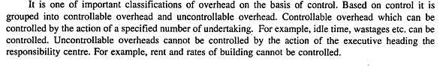
- Controllable cost and non-controllable cost

- Opportunity cost
Opportunity Costs: Opportunity cost is the cost of selecting one course of action and the losing of other opportunities to carry out that course of action. It is the amount that can be received if the asset is utilized in its next best alternative.

Q 5. What is cost sheet? Give a specimen of a simple cost sheet. (3)
Cost sheet- Cost sheet is a document which provides for the assembly of the detailed cost of a cost center or cost unit.
Format of Cost Sheet

Particulars | Total  Cost | Cost per Unit
Opening stock of raw material
Add: purchases
Add: expenses on purchases
Less: closing stock of raw material
Cost of material consumed
Direct wages
Direct expenses
Prime cost
Add: factory overhead
Add: opening stock of work in progress
Less: closing stock of work in progress
Factory/work cost
Add: administrative overhead
Cost of production
Add: opening stock of finished goods
Less: closing stock of finished goods
Cost of goods sold
Add: selling and distribution overhead
Cost of sales/Total Cost
Add: Profit(or loss)
sales

Q 6. From the following data, calculate (i) profit when sales are Rs. 20000, and (ii) new BEP if selling price is reduced by 20%.
(1) Fixed expenses Rs. 4000, (2) BEP Rs. 10000. (3)
Ans – BEP= Fixed cost/P/v ratio
10000= 4000/P/v ratio
P/V ratio= 4000/10000
=0.4*100= 40%
(i) Profit= (Sales x P/V ratio)- fixed cost
= (20000 x 40%)- 4000
=8000-4000
= Rs. 4000
Variable cost= Sales (1-P/V ratio)
= 20000(1-40%)
=20000 x 60% = Rs. 12000
If selling price is reduced by 20% then new sales will be:-
20000- 20%
New sales = Rs. 16000
New P/V Ratio= Sales-Variable cost/Sales
= 16000-12000/16000
=4000/16000*100
=25%
New BEP= Fixed cost/P/V ratio
= 4000/25%
= Rs. 16000

Section B
Q 1. Explain the types of Budget. (4)

On the basis of time
Financial expenditure
budget
Production Overhead
budget
Financial
budget
Cost
budget
Production
budget
Sales
budget
Functional or subsidiary budget
Master budget
Fixed
budget
Flexible
budget
On the basis of flexibility
On the basis of functions
Labour
budget
Plant utilization
budget
Material
budget
R & D
budget
Selling and Distribution
Cost budget
Administration
Cost
budget
Production
Cost
budget
Short term budget
Long term
budget
Capital
Expenditure budget
Cash budget
Current
budget

Q 2. How to calculate prime cost and work cost in cost sheet? Explain with hypothetical example. (4)
Particulars | Total  Cost | Cost per Unit
Opening stock of raw material
Add: purchases
Add: carriage inward
Add: custom duty
Less: closing stock of raw material
Cost of material consumed
Direct wages
Direct expenses
Prime cost
Add: factory overhead
Indirect materials
Indirect wages
Leave wages
Overtime premium
Fuel and power
Coal
Factory rent and taxes
Supervision
Work stationary
Canteen and welfare expenses
Repairs
Works salaries
Depreciation of plant & machinery
Works expenses
Gas and water
Technical director’s fees
Laboratory expenses
Works telephone expenses
Internal transport expenses

Less: sale of scrap
Add: opening stock of work in progress
Less: closing stock of work in progress
Factory/work cost

Rajasthan Institute of Engineering & Technology, Jaipur
University Roll No. ______________

1st Year MBA. II Semester 1stMid Term Examination, March – 2018
Subject: - cost accounting for management SET-B
Time: -2 Hrs. [Maximum Marks: -20]
[Min. Passing Marks: 08]
Instructions to the Candidates:
Attempt any 4 questions from Section A and Section B is Compulsory.
Section A
Q 1. Define cost management. Briefly discuss the various tools of cost management. (3)
Cost management is the process of effectively planning and controlling the costs involved in a business. It is considered one of the more challenging tasks in business management. Generally, the costs or the expenses in a business are recorded by a team of experts using expense forms.

Tools of cost management-
a) Job Costing: In this system the cost of each job is ascertained separately which is suitable in all cases where work is undertaken on receiving a customer’s order. Like a printing press, motor work shop etc.

b) Batch Costing: It is considered as the extension of job costing. It represents a number of small orders passed through the factory in batch. Each batch here is treated as a separate unit of cost.

c) Contract Costing: It is suitable for the firms which are engaged in the work of construction of bridges, roads, buildings etc.

d) Single or Output Costing: It is used in the business where a standard production is turned out and it is desired to find the cost of a basic unit of production.

e) Process Costing: It is a method of costing used to ascertain the cost of a product which may passes through various processes before completion.

f) Operating Costing: The cost of providing a service is known as operating cost and the methods to ascertain the cost of such services is known as operating costing.

g) Multiple Costing: In multiple costing, a combination of two or more methods of costing is used in conjunction to determine the cost of final product. This method is used by the industries where different components are separately manufactured and subsequently assembled into the finished
product. For e.g.: Motor car, Television, Ships etc.

Q 2. What is the difference between apportionment and absorption of overhead? (3)
Absorption: Cost absorption refers to the process of absorbing all overhead costs allocated to apportion over particular cost center or production department by the unit produced. Apportionment: Apportionment is the process of distribution factory overheads to cost centers or cost units on an equitable basis. The term apportionment refers to the allotment of expenses which cannot be identified wholly with a particular department. Such expenses require division and apportionment over two or more cost centers in proportion to estimated benefits received.
Q 3. What do you understand by SCM? (3)
It is the provision and analysis of cost and management accounting data about a business and its competitors for use in developing and monitoring the business strategy.
Strategic cost Management tools And techniques
1. Decision making techniques
2. Standard Costing in Profit Planning
3. Activity based cost Management
4. Total Quality Management
Q 4. What is cost management? How does it differ from cost accounting and management accounting? (3)
Ans- Cost management is the process of effectively planning and controlling the costs involved in a business. It is considered one of the more challenging tasks in business management. Generally, the costs or the expenses in a business are recorded by a team of experts using expense forms.
The process involves various activities such as collecting, analyzing, evaluating and reporting cost statistics for budgeting. By implementing an effective cost management system, a company’s overall budgeting can be brought under control.

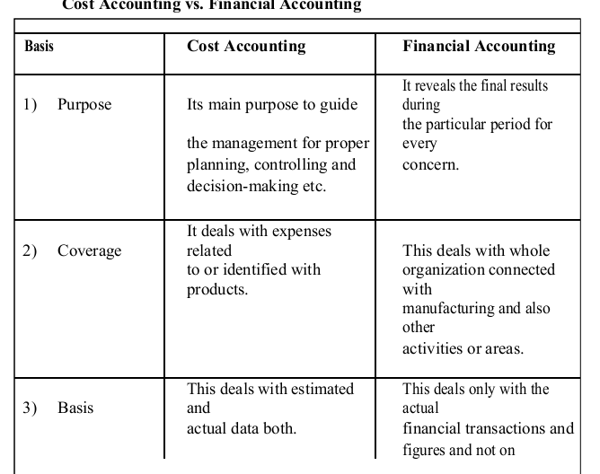

Q 5. If BEP sales is 60% of current sales and profit is Rs. 4000 then what is contribution? (3)
Ans: Margin of Safety= Sales-BEP sales
If BEP is 60% of total sales so assume sales is 100%
M/S= 100-60
=40%
Margin of safety= Profit/Contribution
40%= 4000/Contribution
Contribution= 4000/40%
= Rs. 10000
Q 6. Explain the concept and scope of Marginal Costing. (3)
Ans- Marginal Costing is defined as the amount at any given volume of output by which aggregate costs can be changed if the volume of output is increased or decreased by one unit.
Meaning :- Marginal Costing is the technique of controlling by bringing out the relationship between profit & volume.
Scope of Marginal costing
Cost volume profit analysis
Definition- The analytical technique used to study the behavior of profit in response to the changes in volume, costs and prices is called the cost volume profit analysis

It studies the interrelationship of three basic factors of business operation:
(a) Cost of production
(b) Volume of production or sales
(c) Profit

These three factors are inter-connected in such a way that they act and react on one another because of cause and effect relationship between them.

Section B
Q 1. What do you understand by budgetary control? Briefly explain the objectives of budgetary control. (4)
Budgetary control is the establishment of budgets relating to the responsibilities of executives of a policy and a continuous comparison of the actual with the budgeted results
Characteristics of budgetary control
1. Establishment of budget
2. Measurement of actual performance
3. Continues comparison or appraisal
4. Remedial action
5. Follow up and revision
Objectives:
1. Planning
2. Coordination
3. Communication
4. Motivation
5. Control
6. Performance evaluation
Q 2. Explain classification of overheads in detail. (4)
