DSP

1. Explain the decimation and interpolation process with an example.

Decimation and Interpolation are two techniques used to alter the sampling rate of a sequence. Decimation involves decreasing the sampling rate without violating the sampling theorem whereas interpolation increases the sampling rate of a sequence appropriately by considering its neighboring samples.
Decimation is a process of dropping the samples without violating sampling theorem.
The factor by which the signal is decimated is called as decimation factor and it is denoted by M. It is given by,
Ex: Let x(n)=[3 2 2 4 1 0 –3 –2 –1 0 2 3] be decimated with a factor of 2.
Let the filtered sequence be w(n)=[2.1 2 3.9 1.5 0.1 –2.9 –2 –1.1 0.1 1.9 2.9].
Decimated sequence y (m) can be obtained by dropping every alternative sample of w (n).
y (m) = [2 1.5 -2.9 -1.1 1.9]
Interpolation is a process of increasing the sampling rate by inserting new samples in between. The input output relation for the interpolation, where the sampling rate is increased by a factor L, is given as, Let x(n)= [0 3 6 9 12] be interpolated with L=3.
If the filter coefficients of the filters are bk= [1/3 2/3 1 2/3 1/3], the interpolated sequence is After inserting zeros,
W(m)=[0 0 0 3 0 0 6 0 0 9 0 0 12]

OR
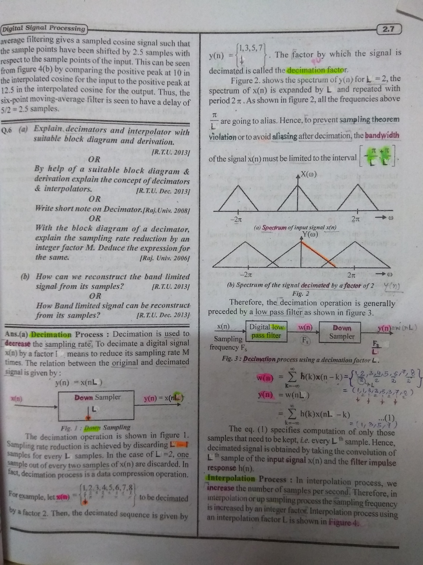
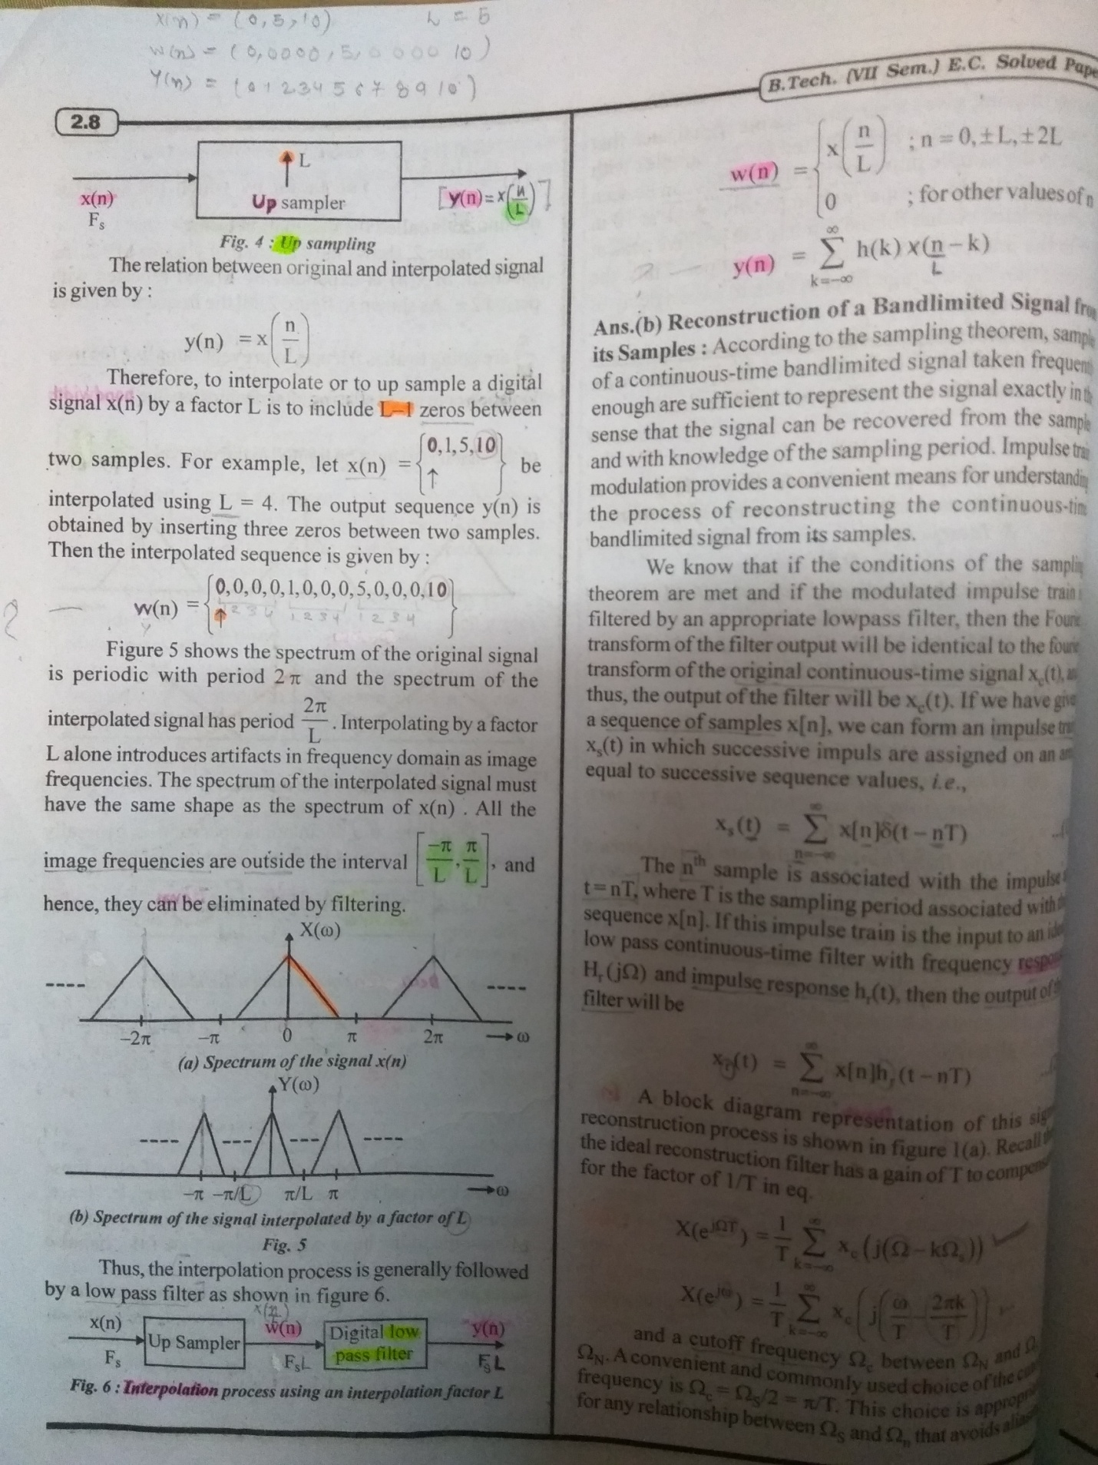

2. Explain the operation used in DSP to increase the sampling rate. The sequence
$x(n)=[0,2,4,6,8$] is interpolated using interpolation sequence $b_{k}$=[1/2,1,1/2] and the interpolation factor is 2. find the interpolated sequence y(m).

Interpolation factor L=2
W(m)={0,0,2,0,4,0,6,08}
Y(m)={0,0,1,2,3,4,5,6,7,8}
There are four special cases in this addressing mode.
They are a. SAR < EAR & updated PNTR > EAR
b. SAR < EAR & updated PNTR < SAR
c. SAR >EAR & updated PNTR > SAR
d. SAR > EAR & updated PNTR < EAR The buffer length in the first two case will be (EAR-SAR+1) whereas for the next low cases (SAR-EAR+1)

3. Explain overlap-add method for linear FIR filtering of a long sequence.
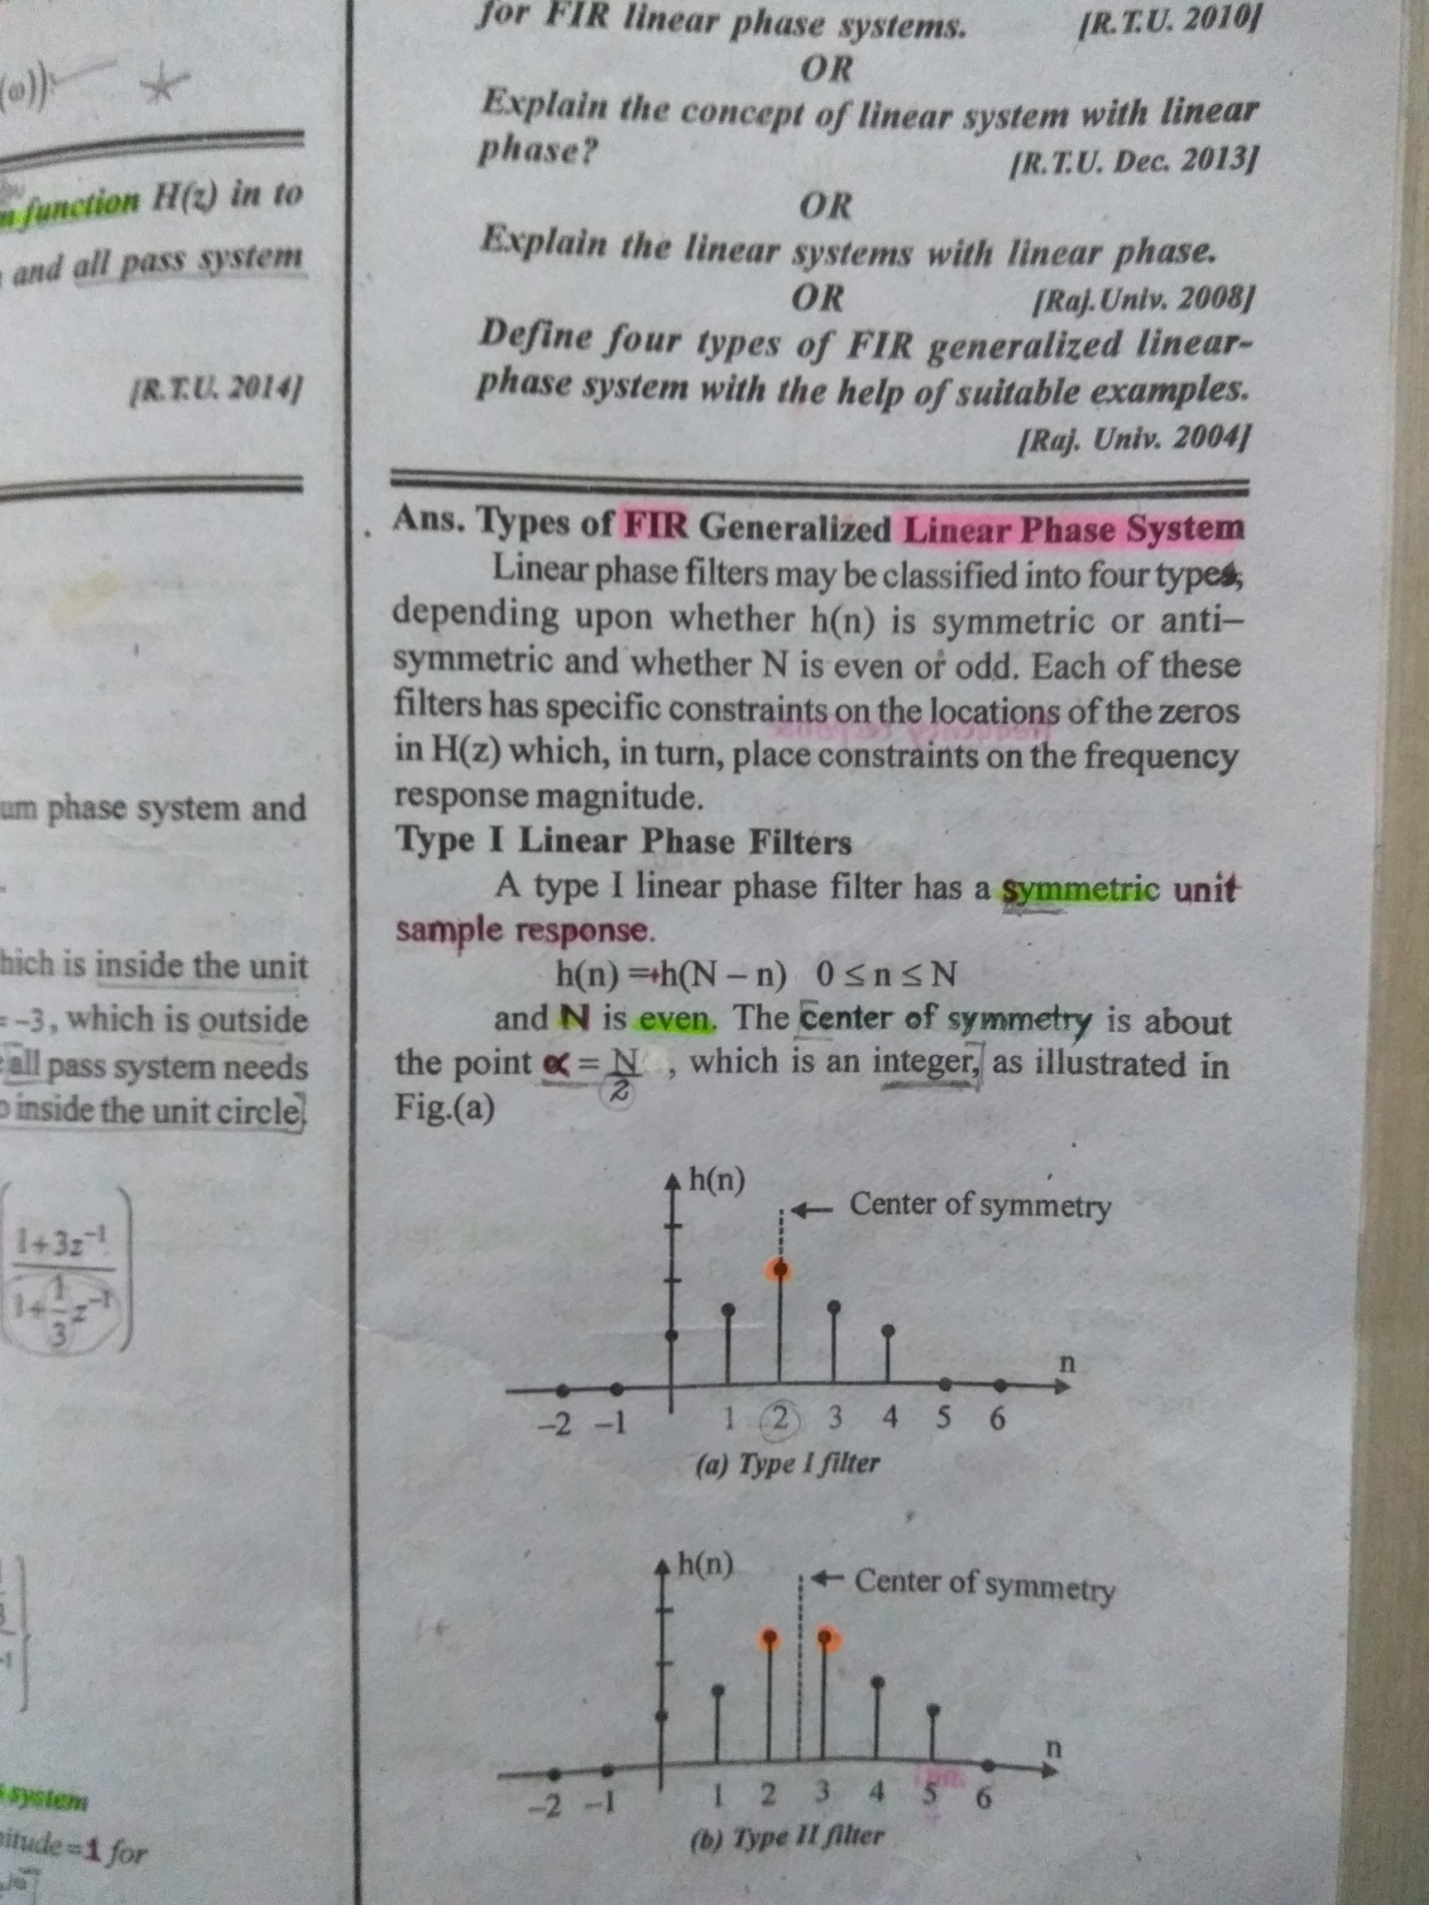
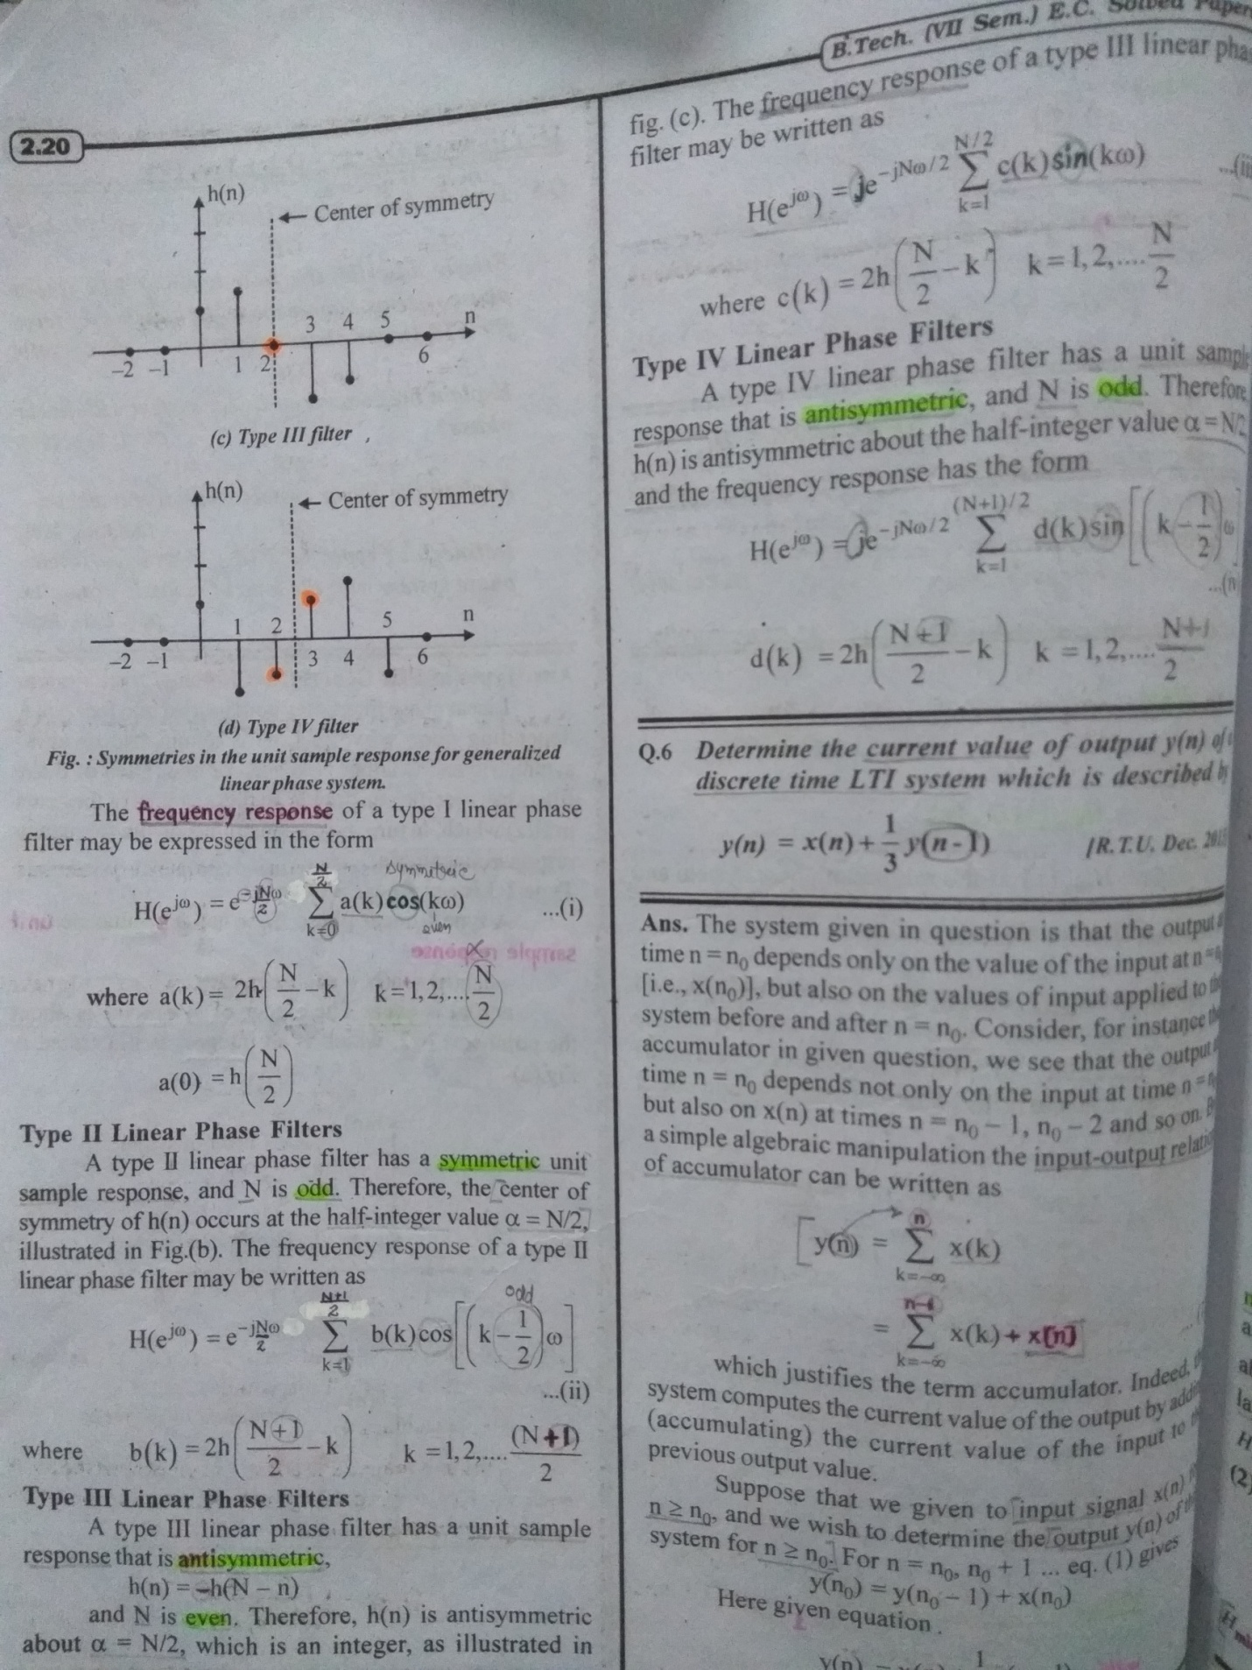

4 . Summarize the properties of DFT.
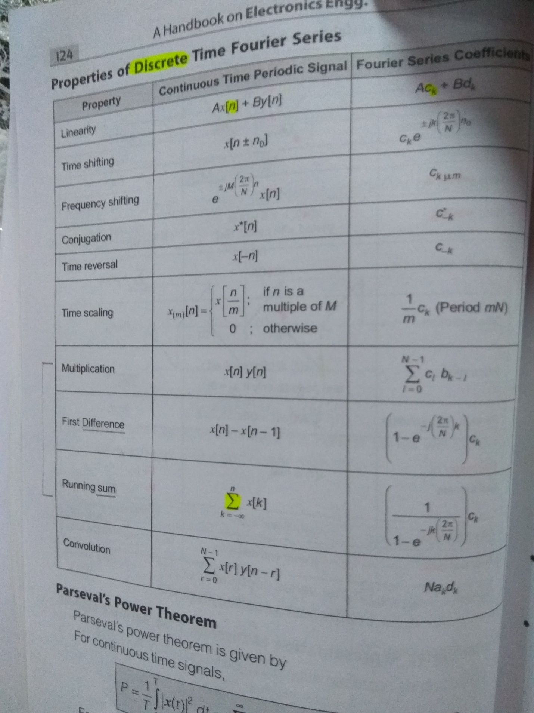
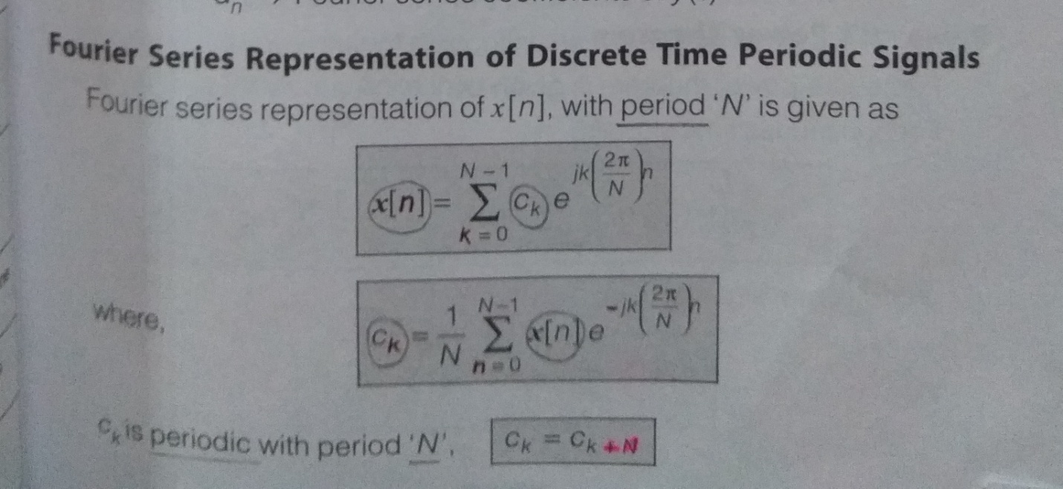
5. (a) (i) Compute the eight-point DFT of the sequence $x\left(n\right)=\left\{\frac{1}{2},\frac{1}{2},\frac{1}{2},0,0,0,0 \right\}$
Using the radix-2 decimation-in-time algorithm.
