Rajasthan Institute of Engineering & Technology,Jaipur.
I Midterm Examination
SET-A
Session: 2017-18
IV Semester & EE/EEE Branch
SUBJECT: Electric Machine-II
Time: 2hrs. M.M.:20
Instruction for students:
- No provision for supplementary answer book.

Q.1 Derive the basic equation for an induced EMF per phase for full pitch, concentrated type of winding. [5]
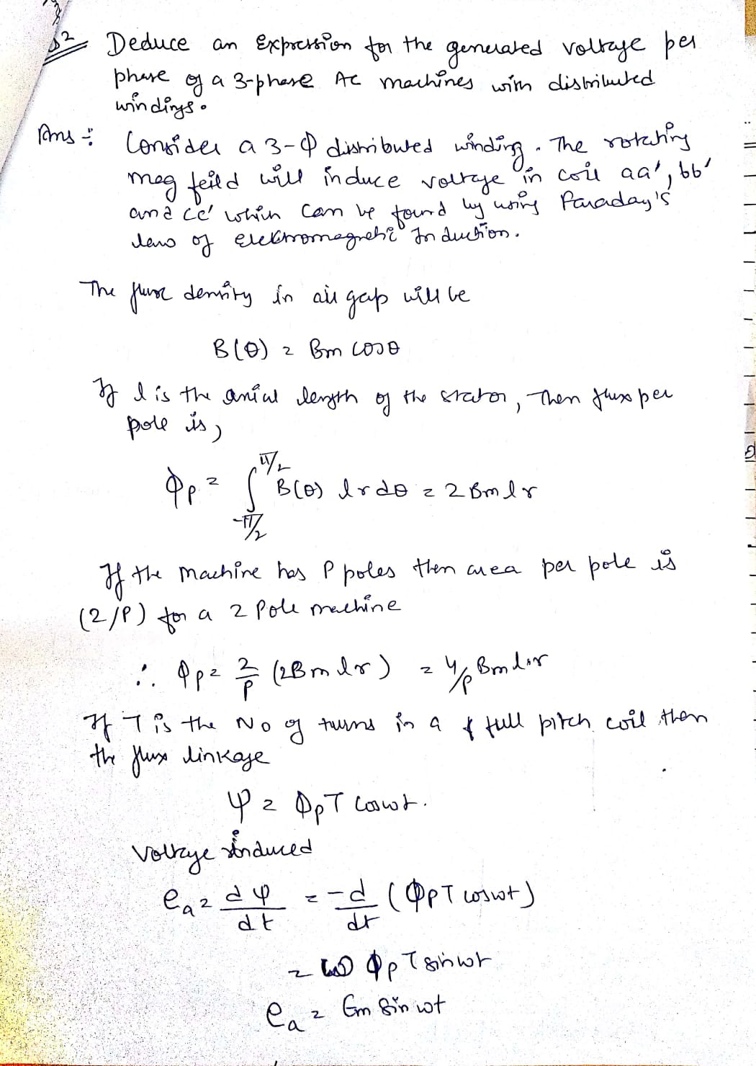
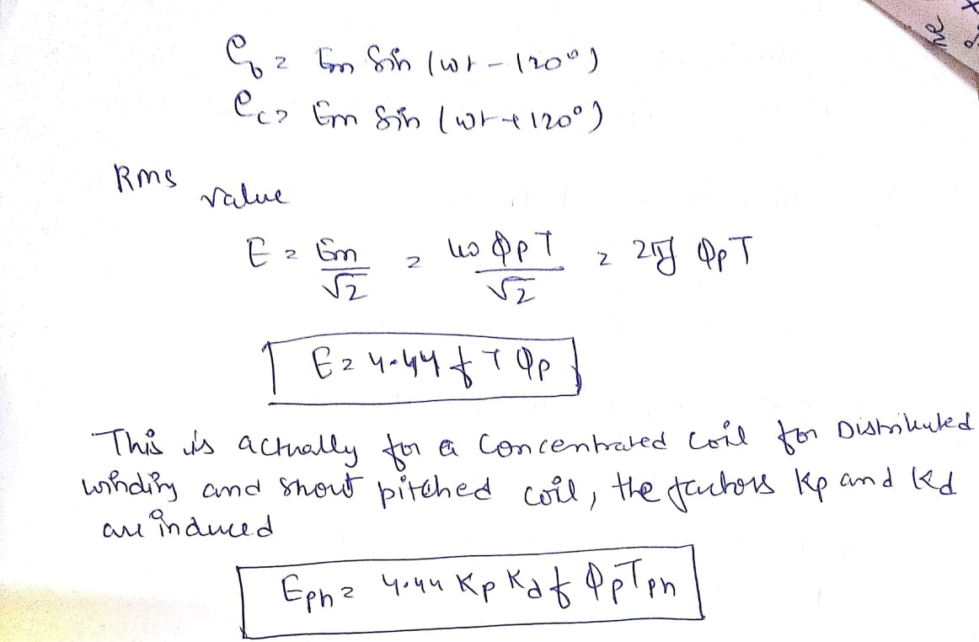
Or
Q.1 A three phases, 50 HZ, 8 pole alternator has a star connected winding with 120 slots and 8 conductors per slot. The flux per pole is 0.05Wb, sinusoidally distributed. Determine the phase and line voltages.
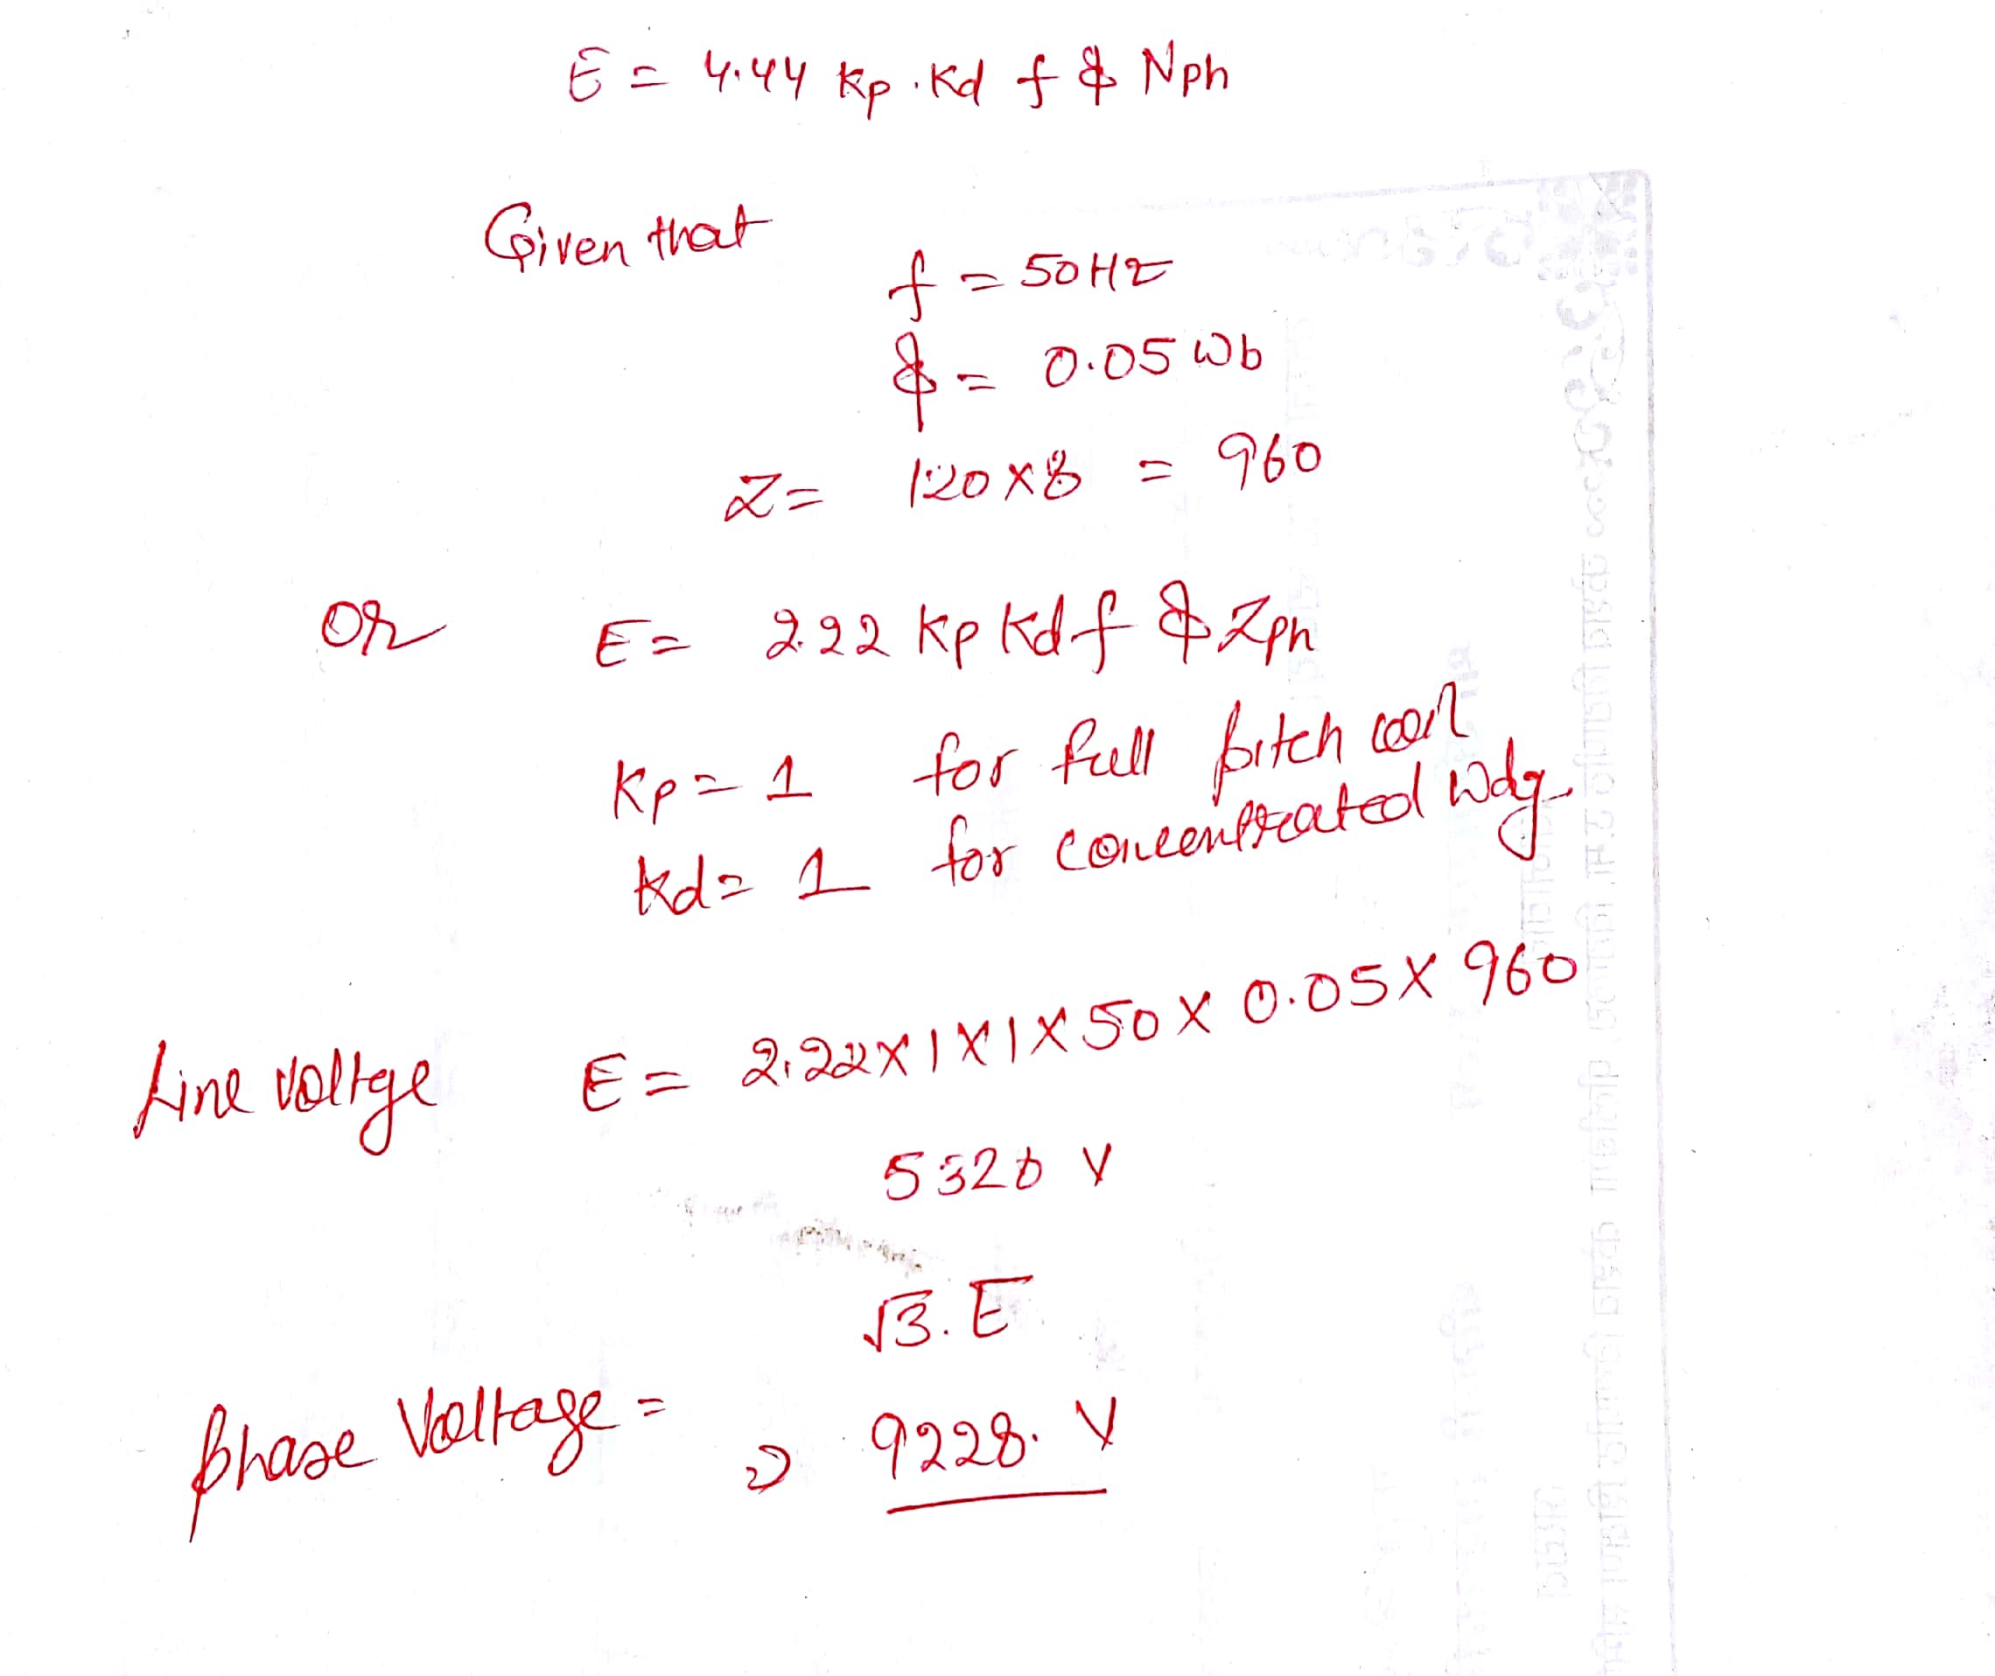
Q.2 Show that a three phase distributed winding excited by balanced 3 phase current will produce a sinusoidally distributed rotating field of constant amplitude when the phase winding are wound 120 electrical degree apart in space. [5]
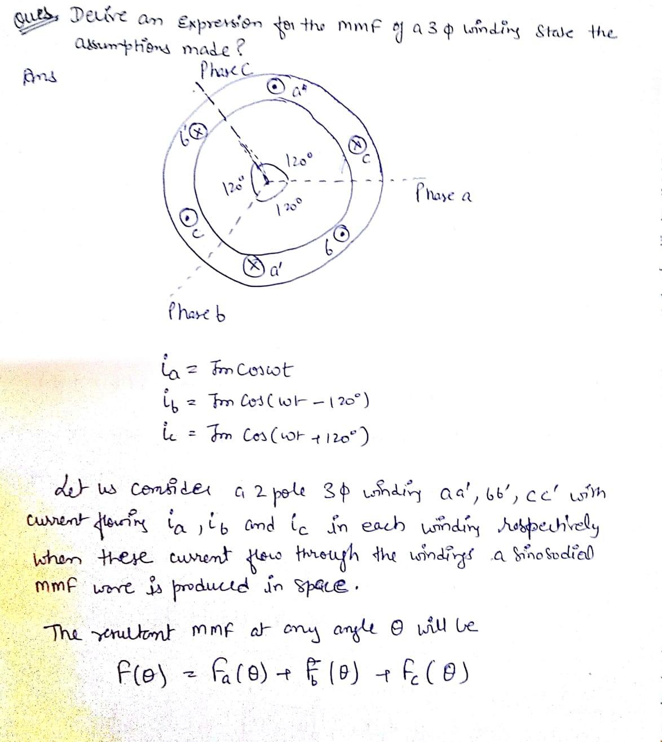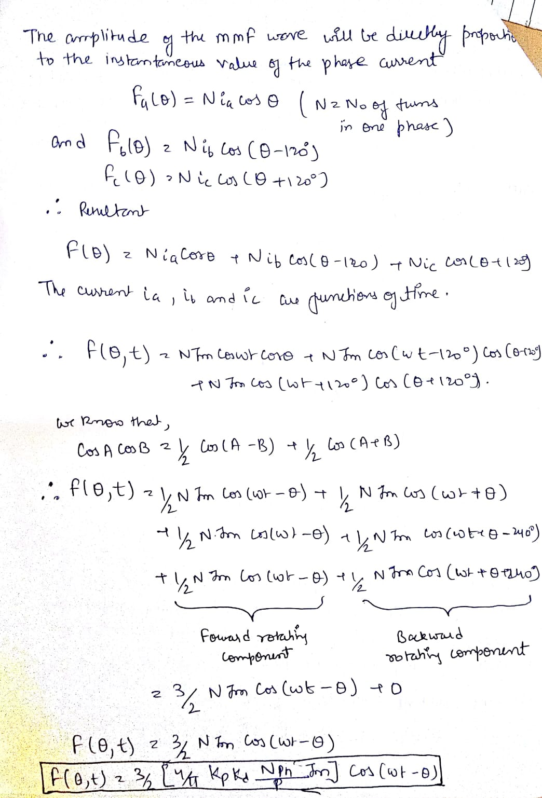
Or
Q.2 Derive an expression for the MMF of a 3 Phase concentrated winding. State the assumptions made.

MMF Space Wave of a Concentrated Coil
A cylindrical rotor machine with small air-gap as shown in Fig. 5.24(a) will be assumed here. The stator is imagined to be wound for two-poles with a single N-turn full-pitch coil carrying current i in the direction indicated. The figure shows some flux lines of the magnetic field set up. A north and corresponding south pole are induced on the stator periphery. The magnetic axis of the coil is from the stator north to the stator south. Each flux line radially crosses the air-gap twice, normal to the stator and rotor iron surfaces and is associated with constant mmf Ni. On the assumption that the reluctance of the iron path is negligible, half the mmf (Nil2) is consumed to create flux from the rotor to stator in the air-gap and the other half is used up to establish flux from the stator to rotor in the air-gap. Mmf and flux radially outwards from the rotor to the stator (south pole on stator) will be assumed to be positive and that from the stator to rotor as negative.
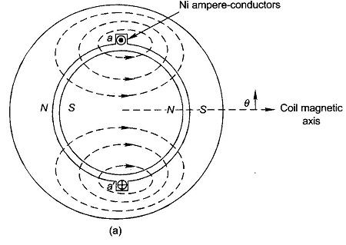
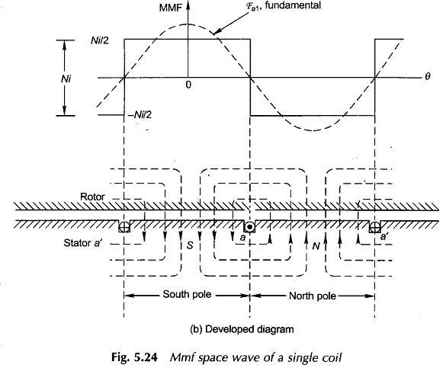

The physical picture is more easily visualized by the developed diagram of Fig. 5.24(b) where the stator with the winding is laid down flat with the rotor on the top of it. It is seen that the mmf is a rectangular space wave wherein mmf of + Ni/2 is
consumed in setting flux from the rotor to stator and mmf of – Ni/2 is consumed in setting up flux from the stator to the rotor. It has been imagined here that the coil-sides occupy a narrow space on the stator and the mmf changes abruptly from –Ni/2 to + Ni/2 at one slot and in reverse direction at the other slot. The mmf change at any slot is and its sign depends upon the current direction.
The mmf space wave of a single coil being rectangular, it can be split up into its fundamental and harmonics. It easily follows from the Fourier series analysis that the fundamental of the mmf wave as shown in Fig. 5.24(b) is
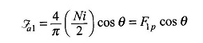
where θ is the electrical angle measured from the magnetic axis of the coil which coincides with the positive peak of the fundamental wave.
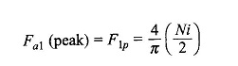

Q.3 What are advantages of rotating field alternator over stationary field. [5]
The field winding of an alternator is placed on the rotor and is connected to d.c. supply through two slip rings. The 3-phase armature winding is placed on the stator. This arrangement has the following advantages
- It is easier to insulate stationary winding for high voltages for which thealternators are usually designed. Ii is because they are not subjected tocentrifugal forces and also extra space is available due to the stationaryarrangement of the armature.
- The stationary 3-phase armature can be directly connected to load withoutgoing through large, unreliable slip rings and brushes.
- Only two slip rings are required for d.c. supply to the field winding on therotor. Since the exciting current is small, the slip rings and brush gearrequired are of light construction.

- Due to simple and robust construction of the rotor, higher speed of rotatingd.c. field is possible. This increases the output obtainable from a machineof given dimensions.
Or
Q.3 Discuss Armature Reaction in Synchronous machine. Show the armature reaction effect at lagging power Factor.
When an alternator is running at no-load, there will be no current flowing through the armature winding. The flux produced in the air-gap will be only due to the rotor ampere-turns. When the alternator is loaded, the three-phase currents will produce a totaling magnetic field in the air-gap. Consequently, the air-gap flux is changed from the no-load condition.
The effect of armature flux on the flux produced by field ampere-turns (i. e.,rotor ampere-turns) is called armature reaction. Two things are worth noting about the armature reaction in an alternator. First, the armature flux and the flux produced by rotor ampere-turns rotate at the same
speed (synchronous speed) in the same direction and, therefore, the two fluxes are fixed in space relative to each other. Secondly, the modification of flux in the air-gap due to armature flux depends on the magnitude of stator current and on the power factor of the load. It is the load power factor which determines whether the armature flux distorts, opposes or helps the flux produced by rotor ampere-turns. To illustrate this important point, we shall consider the following three cases
- When load p.f. is unity
- (ii) When load p.f. is zero lagging
- (iii) When load p.f. is zero leading
(i) When load p.f. is unity
Fig. (10.10 (i)) shows an elementary alternator on no-load. Since the armature is on open-circuit, there is no stator current and the flux due to rotor current is distributed symmetrically in the air-gap as shown in Fig. (10.10 (i)). Since the direction of the rotor is assumed clockwise, the generated e.m.f. in phase R1R2 is at its maximum and is towards the paper in the conductor R1 and outwards in conductor R2. No armature flux is produced since no current flows in the
armature winding.
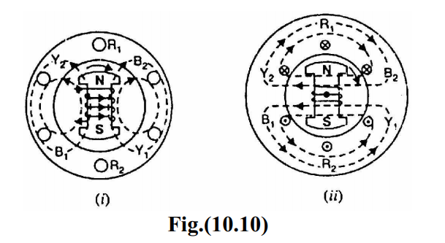
Fig. (10.10 (ii)) shows the effect when a resistive load (unity p.f.) is connected across the terminals of the alternator. According to right-hand rule, the current is “in” in the conductors under N-pole and “out” in the conductors under S-pole. Therefore, the armature flux is clockwise due to currents in the top conductors and anti-clockwise due to currents in the bottom conductors. Note that armature flux is at 90° to the main flux (due to rotor current) and is behind the main flux. In this case, the flux in the air-gap is distorted but not weakened. Therefore, at unity p.f., the effect of armature reaction is merely to distort the main field; there is no weakening of the main field and the average flux practically remains the same. Since the magnetic flux due to stator currents (i.e., armature flux) rotate; synchronously with the rotor, the flux distortion remains the same for all positions of the rotor.
(ii) When load p.f. is zero lagging
When a pure inductive load (zero p.f. lagging) is connected across the terminals of the alternator, current lags behind the voltage by 90°. This means that current will be maximum at zero e.m.f. and vice-versa.
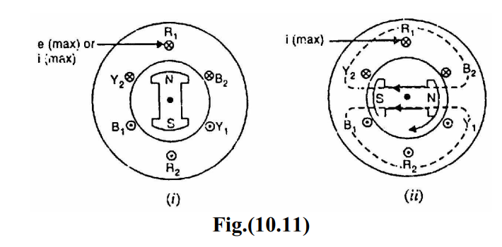
Fig. (10.11 (i)) shows the condition when the alternator is supplying resistive load. Note that e.m.f. as well as current in phase R1R2 is maximum in theposition shown. When the alternator is supplying a pure inductive load, the current in phase R1R2 will not reach its maximum value until N-pole advanced 90° electrical as shown in Fig. (10.11 (ii)). Now the armature flux is from right to left and field flux is from left to right All the flux produced by armature current (i.e., armature flux) opposes be field flux and, therefore, weakens it. In other words, armature reaction is directly demagnetizing. Hence at zero p.f. lagging, the armature reaction weakens the main flux. This causes a reduction in the generated e.m.f.
(iii) When load p.f. is zero leading
When a pure capacitive load (zero p.f. leading) is connected across the terminals of the alternator, the current in armature windings will lead the induced e.m.f. by 90°. Obviously, the effect of armature reaction will be the reverse that for pure inductive load. Thus armature flux now aids the main flux and the generated e.m.f. is increased.
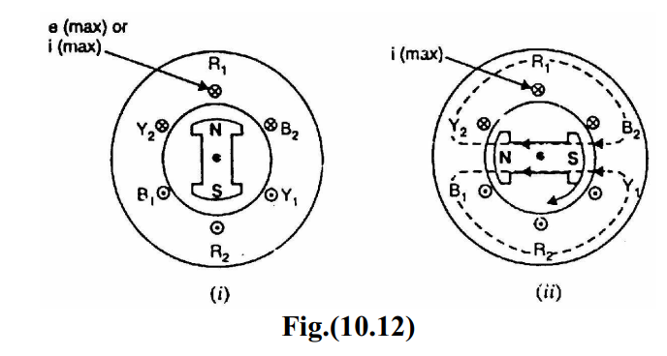

Fig. (10.12 (i)) shows the condition when alternator is supplying resistive load. Note that e.m.f. as well as current in phase R1R2 is maximum in the position shown. When the alternator is supplying a pure capacitive load, the maximum current in R1R2 will occur 90° electrical before the occurrence of maximum induced e.m.f. Therefore, maximum current in phase R1R2 will occur if the position of the rotor remains 90° behind as compared to its position under resistive load. This is illustrated in Fig. (10.12 (ii)). It is clear that armature flux is now in the same direction as the field flux and, therefore, strengthens it. This causes an increase in the generated voltage. Hence at zero p.f. leading, the armature reaction strengthens the main flux. For intermediate values of p.f, the effect of armature reaction is partly distorting and partly weakening for inductive loads. For capacitive loads, the effect of armature reaction is partly distorting and partly strengthening. Note that in practice, loads are generally inductive.
Q.4 Explain the construction and working of three phase synchronous machine [5]
An alternator has 3,-phase winding on the stator and a d.c. field winding on the rotor.
1. Stator
It is the stationary part of the machine and is built up of sheet-steel laminations having slots on its inner periphery. A 3-phase winding is placed in these slots and serves as the armature winding of the alternator. The armature winding is always connected in star and the neutral is connected to ground
2. Rotor
The rotor carries a field winding which is supplied with direct current through two slip rings by a separate d.c. source. This d.c. source (called exciter) is generally a small d.c. shunt or compound generator mounted on the shaft of the alternator. Rotor construction is of two types, namely;
(i) Salient (or projecting) pole type
(ii) Non-salient (or cylindrical) pole type
(i) Salient pole type
In this type, salient or projecting poles are mounted on a large circular steel frame which is fixed to the shaft of the alternator as shown in Fig. (10.2). The individual field pole windings are connected in series in such a way that when the field winding is energized by the d.c. exciter, adjacent poles have opposite polarities. Low and medium-speed alternators (120-400 r.p.m.) such as those driven by diesel engines or water turbines have salient pole type rotors due to the
following reasons:

(a) The salient field poles would cause .an excessive windage loss if driven at high speed and would tend to produce noise.
(b) Salient-pole construction cannot be made strong enough to withstand the mechanical stresses to which they may be subjected at higher speeds. Since a frequency of 50 Hz is required, we must use a large number of poles on the rotor of slow-speed alternators. Low-speed rotors always possess a large diameter to provide the necessary spate for the poles. Consequently, salient-pole
type rotors have large diameters and short axial lengths.
(ii) Non-salient pole type
In this type, the rotor is made of smooth solid forged-steel radial cylinder having a number of slots along the outer periphery. The field windings are embedded in these slots and are connected in series to the slip rings through which they are energized by the d.c. exciter. The regions forming the poles are usually left unslotted as shown in Fig. (10.3). It is clear that the poles formed are non-salient i.e., they do not project out from the rotor surface.
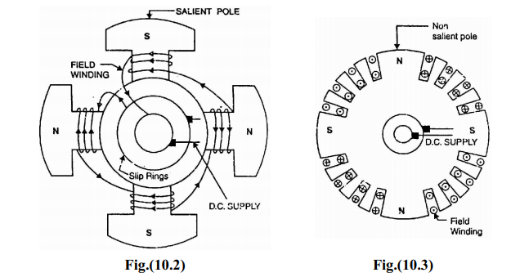
High-speed alternators (1500 or 3000 r.p.m.) are driven by steam turbines anduse non-salient type rotors due to the following reasons:
- This type of construction has mechanical robustness and gives noiseless operation at high speeds.

(b) The flux distribution around the periphery is nearly a sine wave and hencea better e.m.f. waveform is obtained than in the case of salient-pole type.
Or
Q.4 Derive the expression for Distribution factor or breadth factor.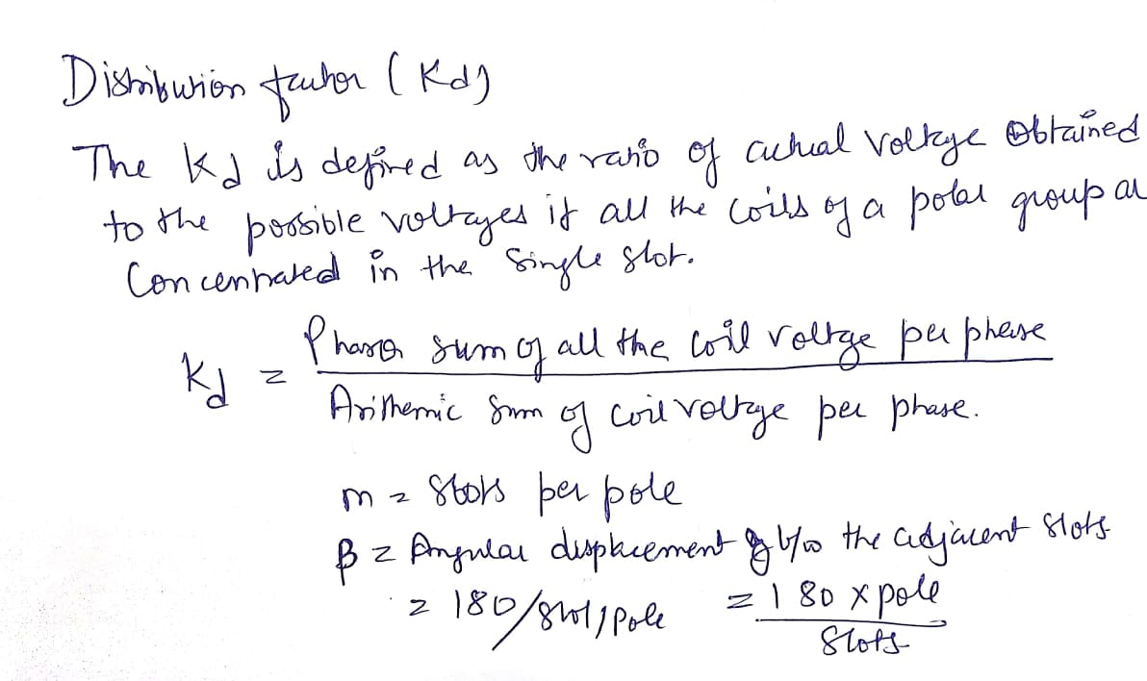
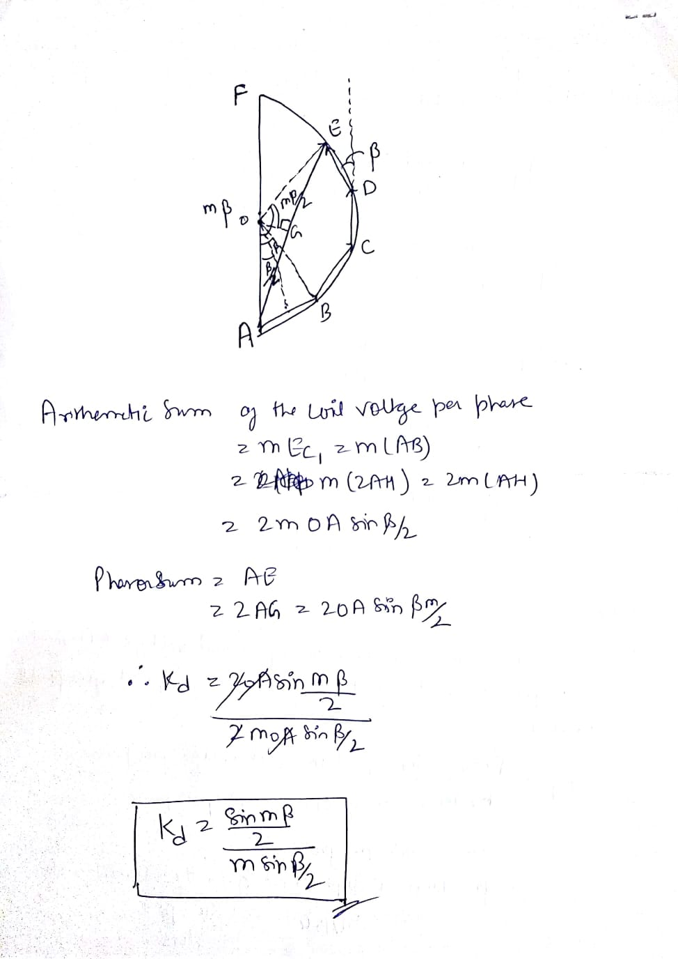

Rajasthan Institute of Engineering & Technology, Jaipur.
I Midterm Examination
SET-B
Session: 2017-18
IV Semester & EE/EEE Branch
SUBJECT: Electric Machine-II
Time: 2hrs. M.M.:20
Instruction for students:
- No provision for supplementary answer book.

Q.1 Derive the basic equation for an induced EMF per phase for short pitch, distributed type of winding. [5]
Or
Q.1 Derive an expression for the MMF of a 3 Phase Distributed winding. State the assumptions made.

MMF Space Wave of One Phase of a Distributed Winding
Consider now a basic 2-pole structure with a round rotor, with 5 slots/pole/phase (SPP) and a 2-layer winding as shown in Fig. 5.25. The corresponding developed diagram is shown in Fig. 5.26(a) along with the mmf diagram which now is a stepped wave—obviously closer to a sine wave than the rectangular mmf wave of a single coil (Fig. 5.24(b)). Here since SPP is odd (5), half the ampere-conductors of the middle slot of the phase group a and a contribute towards establishment of south pole and half towards north pole on the stator. At each slot the mmf wave has a step jump of 2N _{c}i, ampere-conductors where N_{N}. = coil turns (equal to conductors/layer) and i_{s} = conductor current.
Now F_{t p}, the peak of the fundamental of the mmf wave, has to be determined. Rather than directly finding the fundamental of the stepped wave, one can proceed by adding the fundamentals of the mmf s of individual slot-pairs (with a span of one pole-pitch). These fundamentals are progressively out of phase (space phase as different from time phase) with each other by the slot angle y. This addition is easily accomplished by defining the breadth factor Kb, which will be the same as in the case of the generated emf of a coil group.
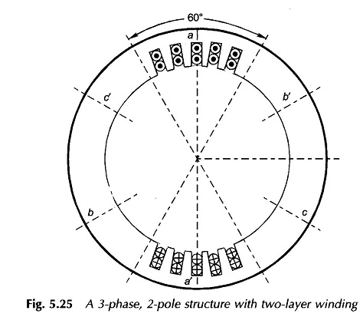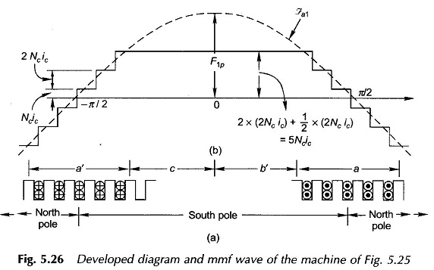

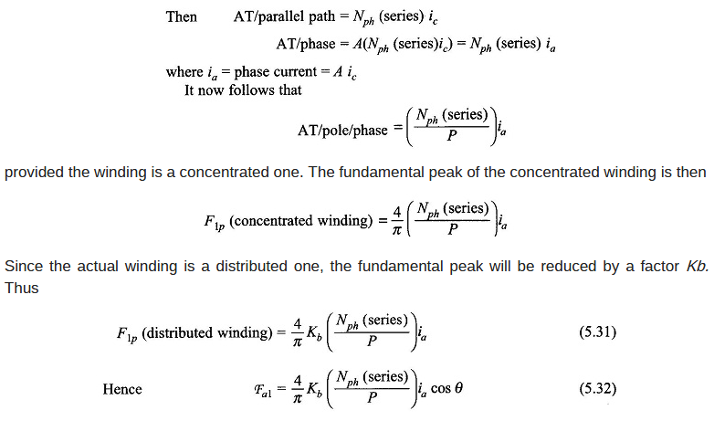
where the pole axis is taken as the angle reference (Fig. 5.26(b)).
The effect on the mmf wave of short-pitched coils can be visualized by Fig. 5.27 in which the stator has two short-pitched coils (a_{i}d_{i}, a₂a’₂) for phase a of a 2-pole structure*. The mmf of each coil establishes one pole. From the developed diagram of Fig. 5.27(b) it is seen that the mmf wave is rectangular but of shorter space length than a pole-pitch. The amplitude of the fundamental peak gets reduced by a factor KIP called the pitch factor, compared to the full-pitch rectangular mmf wave. It can be shown** by Fourier analysis that
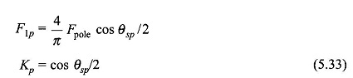
Q.2 show that a rotating magnetic field is produced by three phase distributed winding [5]

Or

\

Q.2 A 3 phases, 16 pole synchronous generator has a resultant air gap flux of 0.06 Wb. per pole. The flux is distributed sinusoidally over the pole. The stator has 2 slots per pole per phase and 4 conductors per slot are accommodated in two layers. The coil span is 150° electrical. Calculate the phase and line induced voltage when the machine runs at 375 rpm.
Q.3 Define:
- Pole Span
- Full pitch Coil
- Coil span Factor [5]

A coil whose sides are separated by one pole pitch (i.e., coil span is 180° electrical) is called full-pitch coil. With a full-pitch coil, the e.m.f.s induced in the two coil sides a in phase with each other and the resultant e.m.f. is the arithmetic sum of individual e.m.fs. However the waveform of the resultant e.m.f. can be improved by making the coil pitch less than a pole pitch. Such a coil is called short-pitch coil. This practice is only possible with double-layer type of winding The e.m.f. induced in a short-pitch coil is less than that of a fullpitch coil. The factor by which e.m.f. per coil is reduced is called pitch factor Kp
Or
Q.3 Define synchronous speed. Derive the expression for synchronous speed. Calculate the highest speed at which (a) 50Hz (b) 60Hz alternator can be operated.
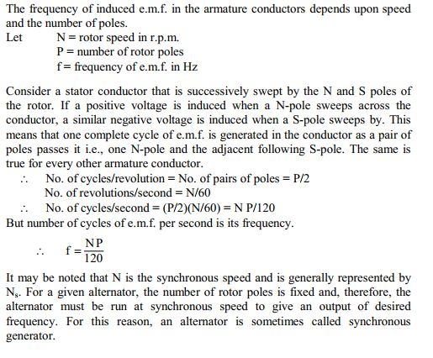
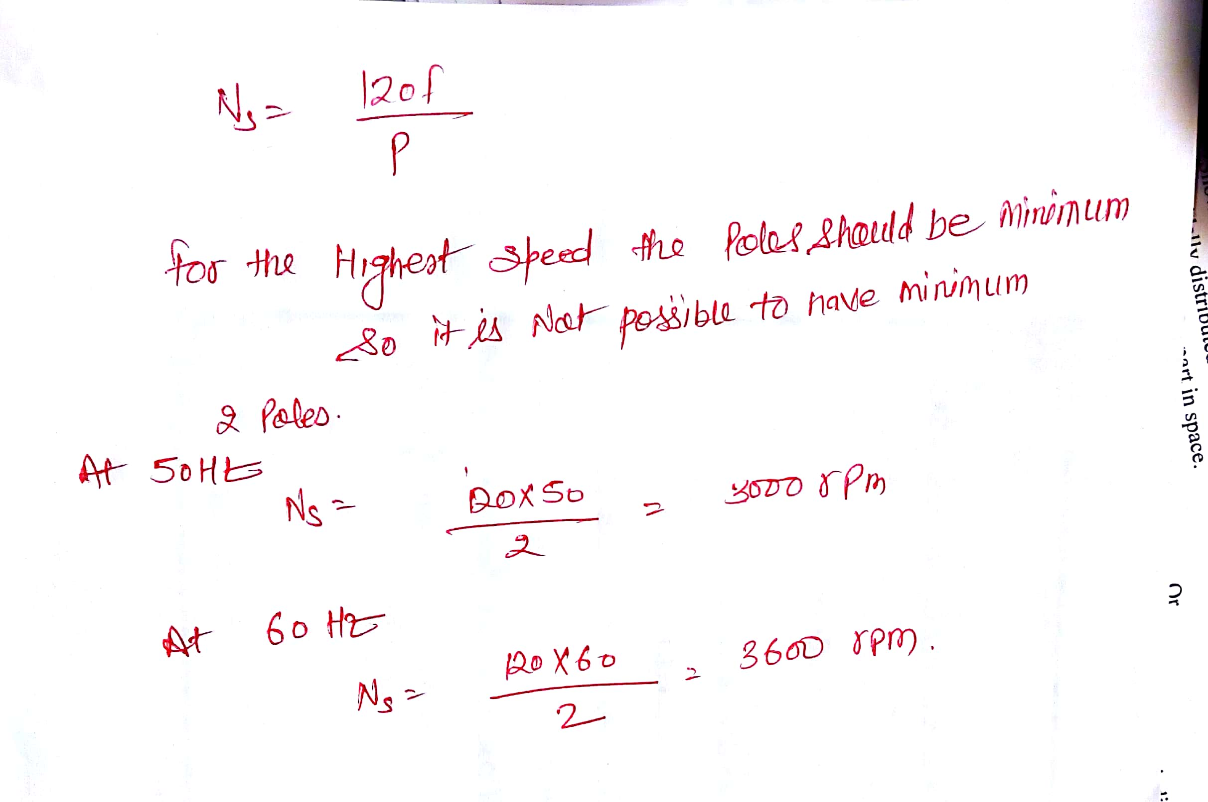
Q.4 Discuss Armature Reaction in Synchronous machine. Show the armature reaction effect at unity power Factor. [5]
When an alternator is running at no-load, there will be no current flowing through the armature winding. The flux produced in the air-gap will be only due to the rotor ampere-turns. When the alternator is loaded, the three-phase currents will produce a totaling magnetic field in the air-gap. Consequently, the air-gap flux is changed from the no-load condition.
The effect of armature flux on the flux produced by field ampere-turns (i. e.,rotor ampere-turns) is called armature reaction.Two things are worth noting about the armature reaction in an alternator. First, the armature flux and the flux produced by rotor ampere-turns rotate at the same
speed (synchronous speed) in the same direction and, therefore, the two fluxes are fixed in space relative to each other. Secondly, the modification of flux in the air-gap due to armature flux depends on the magnitude of stator current and on the power factor of the load. It is the load power factor which determines whether the armature flux distorts, opposes or helps the flux produced by rotor ampere-turns. To illustrate this important point, we shall consider the following three cases
- When load p.f. is unity
- (ii) When load p.f. is zero lagging
- (iii) When load p.f. is zero leading

- When load p.f. is unity
Fig. (10.10 (i)) shows an elementary alternator on no-load. Since the armature is on open-circuit, there is no stator current and the flux due to rotor current is distributed symmetrically in the air-gap as shown in Fig. (10.10 (i)). Since the direction of the rotor is assumed clockwise, the generated e.m.f. in phase R1R2 is at its maximum and is towards the paper in the conductor R1 and outwards in conductor R2. No armature flux is produced since no current flows in thearmature winding.
Fig. (10.10 (ii)) shows the effect when a resistive load (unity p.f.) is connected across the terminals of the alternator. According to right-hand rule, the current is “in” in the conductors under N-pole and “out” in the conductors under S-pole. Therefore, the armature flux is clockwise due to currents in the top conductors and anti-clockwise due to currents in the bottom conductors. Note that armature flux is at 90° to the main flux (due to rotor current) and is behind the main flux. In this case, the flux in the air-gap is distorted but not weakened. Therefore, at unity p.f., the effect of armature reaction is merely to distort the main field; there is no weakening of the main field and the average flux practically remains the same. Since the magnetic flux due to stator currents (i.e., armature flux) rotate; synchronously with the rotor, the flux distortion remains the same for all positions of the rotor.

Or

Q.4. What are the different types of rotor used in synchronous Machine. With the help of neat diagram, explain each. Also explain their features & applications.
Rotor
The rotor carries a field winding which is supplied with direct current through two slip rings by a separate d.c. source. This d.c. source (called exciter) is generally a small d.c. shunt or compound generator mounted on the shaft of the alternator. Rotor construction is of two types, namely;
(i) Salient (or projecting) pole type
(ii) Non-salient (or cylindrical) pole type
(i) Salient pole type
In this type, salient or projecting poles are mounted on a large circular steel frame which is fixed to the shaft of the alternator as shown in Fig. (10.2). The individual field pole windings are connected in series in such a way that when the field winding is energized by the d.c. exciter, adjacent poles have opposite polarities. Low and medium-speed alternators (120-400 r.p.m.) such as those driven by diesel engines or water turbines have salient pole type rotors due to the
following reasons:
(a) The salient field poles would cause .an excessive windage loss if driven at high speed and would tend to produce noise.
(b) Salient-pole construction cannot be made strong enough to withstand the mechanical stresses to which they may be subjected at higher speeds. Since a frequency of 50 Hz is required, we must use a large number of poles on the rotor of slow-speed alternators. Low-speed rotors always possess a large diameter to provide the necessary spate for the poles. Consequently, salient-pole
type rotors have large diameters and short axial lengths.
(ii) Non-salient pole type
In this type, the rotor is made of smooth solid forged-steel radial cylinder having a number of slots along the outer periphery. The field windings are embedded in these slots and are connected in series to the slip rings through which they are energized by the d.c. exciter. The regions forming the poles are usually left unslotted as shown in Fig. (10.3). It is clear that the poles formed are non-salient i.e., they do not project out from the rotor surface.
High-speed alternators (1500 or 3000 r.p.m.) are driven by steam turbines anduse non-salient type rotors due to the following reasons:
(a) This type of construction has mechanical robustness and gives noiseless operation at high speeds.
(b) The flux distribution around the periphery is nearly a sine wave and hencea better e.m.f. waveform is obtained than in the case of salient-pole type.

