**

**Rajasthan Institute of Engineering & Technology, Jaipur.**

**I Mid Term examination**

**Session: 2017-18**

**Semester:-IV & Branch:-EE/EEE**

**Subject: Electrical Measurement**

SET- A  
Time: 2 hrs. M.M.:20

# Q.1 Describe classification of instruments.

# Answer 1:- Classification of Measuring Instruments

**The instrument used for measuring the physical and electrical quantities is known as the measuring instrument.** The term measurement means the comparison between the two quantities of the same unit. The magnitude of one of the quantity is unknown, and it is compared with the predefined value. The result of the comparison obtained regarding numerical value.

The measuring instrument categorized into three types;

* Electrical Instrument
* Electronic Instrument
* Mechanical Instrument

**The mechanical instrument uses for measuring the physical quantities**. This instrument is suitable for measuring the static and stable condition because the instrument is unable to give the response to the dynamic condition. **The electronic instrument has quick response time**. The instrument provides the quick response as compared to the electrical and mechanical instrument.

The electrical instrument is used for measuring electrical quantities likes current, voltage, power, etc. The [ammeter](https://circuitglobe.com/ammeter.html), [voltmeter](https://circuitglobe.com/voltmeter.html), wattmeter are the examples of the electrical measuring instrument. The ammeter measures the current in amps; voltmeter measures voltage and Wattmeter are used for measuring the power. The classification of the electric instruments depends on the methods of representing the output reading.

[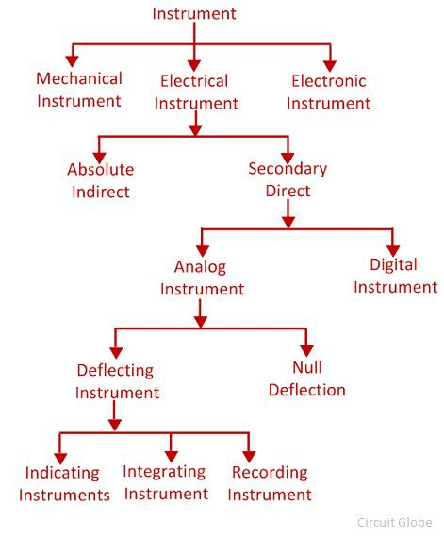](https://circuitglobe.com/wp-content/uploads/2017/11/types-of-measuring-instrument.jpg)

## Absolute Instrument

The absolute instrument gives the value of measures quantities regarding the physical constant. The physical constant means the angle of deflection, degree and meter constant. The mathematical calculation requires for knowing the value of a physical constant.

The tangent [galvanometer](https://circuitglobe.com/galvanometer.html) is the examples of the absolute instruments. In tangent galvanometer, the magnitude of current passes through the coil determines by the tangent of the angle of deflection of their coil, the horizontal component of the earth magnetic field, radius and the number of turns of wire used. The most common applications of this type of instrument are found in laboratories.

## Secondary Instrument

In the secondary instrument, the deflection shows the magnitude of the measurable quantities**.** The calibration of the instruments with the standard instrument is essential for the measurement. The output of this type of device is directly obtained, and no mathematical calculation requires for knowing their value.

**Digital Instrument**

The digital instrument gives the output in the numeric form**.** The instrument is more accurate as compared to the analogue instrument because no human error occurs in the reading.

**Analog instrument**

The instrument whose output varies continuously is known as the analogue instrument. The analogue instrument has the pointer which shows the magnitude of the measurable quantities. The analogue device classifies into two types.

### Null Type Instrument

In this instrument, the zero or null deflection indicates the magnitude of the measured quantity. The instrument has high accuracy and sensitivity.  In null deflection instrument, the one known and one unknown quantity use. When the value of the known and the unknown measuring quantities are equal, the pointer shows the zero or null deflection. The[null deflection instrument](https://circuitglobe.com/null-type-instrument.html) is used in the [potentiometer](https://circuitglobe.com/potentiometer-pot.html) and in galvanometer for obtaining the null point.

### Deflection Type Instrument

The instrument in which the value of measuring quantity is determined through the deflection of the pointer is known as the deflection type instrument. The measuring quantity deflects the pointer of the moving system of the instrument which is fixed on the calibrated scale. Thus, the magnitude of the measured quantity is known.

The deflection type instrument is further sub-classified into three types.

1. **Indicating Instrument** – The instrument which indicates the magnitude of the measured quantity is known as the indicating instrument**.** The indicating instrument has the dial which moves on the graduated dial. The voltmeter, ammeter, [power factor meter](https://circuitglobe.com/power-factor-meter.html) are the examples of the indicating instrument.
2. **Integrating Instrument** – The instrument which measures the total energy supplied at a particular interval of time is known as the integrating instrument. The total energy measured by the instrument is the product of the time and the measures electrical quantities. The [energy meter](https://circuitglobe.com/energy-meter.html), watt-hour meter and the energy meter are the examples of [integrating instrument.](https://circuitglobe.com/integrating-instrument.html)
3. **Recording Instrument** – The instrument records the circuit condition at a particular interval of time is known as the recording instrument**.** The moving system of the recording instrument carries a pen which lightly touches on the paper sheet. The movement of the coil is traced on the paper sheet. The curve drawn on the paper shows the variation in the measurement of the electrical quantities.

# Q.2 What is working principle of PMMC.

# Answer 2:-Permanent Magnet Moving Coil Instrument (PMMC) – Working

Several electrical machines and panels are fitted onboard so that the ship can sail from one port to another, safely and efficiently. The electrical machinery and system require scheduled maintenance and checks to avoid any kind of breakdown during sailing.

Different instruments are used onboard for measuring several electrical parameters to analyze and keep these machines in proper running condition. A permanent magnet moving coil (PMMC) is one such instrument which is popularly used onboard and has several applications. The other popular nomenclature of this instrument is D’alvanometer and galvanometer.

## ****Permanent Magnet Moving Coil: Principle of Working****

When a current carrying conductor is placed in a magnetic field, it experiences a force and tends to move in the direction as per Fleming’s left-hand rule.

Fleming left-hand rule:

If the first and the second finger and the thumb of the left hand are held so that they are at right angle to each other, then the thumb shows the direction of the force on the conductor, the first finger points towards the direction of the magnetic field and the second finger shows the direction of the current in the wire.

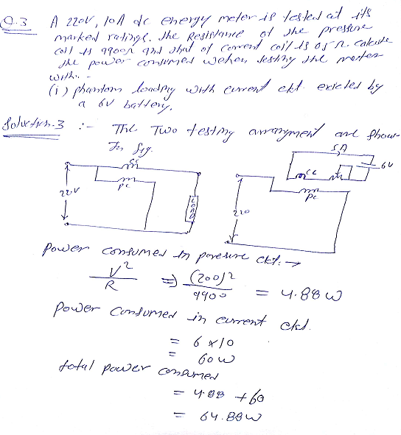

Q.4 Explain the Torque equation of Electrodynamometer instrument.

Answer4:-Torque Equation in Electrodynamometer Instruments

Electrodynamometer  instruments or [Electrodynamic instruments](http://electricalbaba.com/electrodynamic-type-instrument-construction-working-principle/) have fixed coil divided into two sections and a moving coil. It is recommended to read before going to understand the torque equation. If you are already aware of constructional feature then you may proceed.

[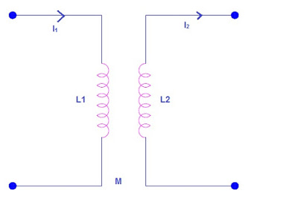](https://4.bp.blogspot.com/-xDnbFBxBCj8/Wf8bpIFARSI/AAAAAAAAC8Q/ud1QQVyJYJY8Xwm0sZe-VNVXbXf35GBGACLcBGAs/s1600/torque-in-electrodynamometer-instruments.jpg)

Let us assume that the current in fixed coil be I1 and that in moving coil be I2 as shown in figure below.

Also assume that,

L1 = Self inductance of fixed coil

L2 = Self inductance of moving coil

M = Mutual inductance between fixed and moving coils

Thus,

The [flux](http://electricalbaba.com/basics-of-magnetic-circuit/)linkage of fixed coil Ø1 = L1i1 + Mi2

The flux linkage of moving coil Ø2 = L2i2 + Mi1

The electrical energy input to the instrument,

= e1i1dt + e2i2dt

But according to [Faraday’s Law](http://electricalbaba.com/faradays-law-electromagnetic-induction/),

e1 = d Ø1/dt

and e2 = d Ø2/dt

Therefore energy input to the instrument

= i1d Ø1+ i2d Ø2

= i1d (L1i1 + Mi2) + i2d(L2i2 + Mi1)

= i1L1di1 + i12dL1 + i1i2dM + i1Mdi2 + i2L2di2 + i22dL2 + i1i2dM + i2Mdi1

Since L1 and L2 are constant, therefore dL1 = 0 and dL2 = 0

= i1L1di1 + i1i2dM + i1Mdi2 + i2L2di2 + i1i2dM + i2Mdi1 …………(1)

Some of the above input energy to electrodynamometer instruments are stored in the form of magnetic energy in the coil while rest is converted into mechanical energy of moving coil.

Thus we can write,

Energy Input = Mechanical Energy + Stored Energy

Mechanical Energy = Electrical Input – Stored Energy  …………(2)

Thus to find the mechanical energy, we need to find the change in stored energy in the magnetic field of the coil. Let us assume an infinitesimally small time dt for the sake of calculation of change in stored energy.

Change in stored energy

= d(1/2L1i12 + 1/2L2i22 + Mi1i2)

= i1L1di1+ i2L2di2+ i1Mdi2 + i2Mdi1+ i1i2dM+(i12/2)dL1 + (i22/2)dL2

But L1 and L2 are constant, therefore dL1 = 0 and dL2 = 0

= i1L1di1+ i2L2di2+ i1Mdi2 + i2Mdi1+ i1i2dM ……(3)

From equation (1), (2) and (3),

Mechanical Energy = i1i2dM

Let Td be the dflectiong torque and dƟ be the change in deflection, then mechanical energy

 = TddƟ

TddƟ = i1i2dM

**⇒Td = i1i2dM/dƟ**

The above equation gives the deflecting torque in electrodynamics or electrodynamometer instruments. It can be seen that deflecting torque depends upon the multiplication of instantaneous value of current and rate of change of mutual inductance between the fixed and moving coil.

Now we will consider two cases.

Case-1: When DC quantity is being measured.

Let I1 and I2 be the current in fixed and moving coil respectively. Therefore deflecting torque Td = I1I2dM/dƟ

But this deflecting torque is controlled by the spring. Spring provides the controlling torque. The controlling torque due to spring for a deflection of Ɵ

Tc = KƟ where K is spring constant.

At equilibrium the controlling torque and deflecting torques are equal, hence

Tc = Td

⇒KƟ = I1I2dM/dƟ

⇒Ɵ = (I1I2dM/dƟ)/K

Case-1: When AC quantity is being measured.

Let i1 and i2 are sinusoidal current having a phase displacement of Ø. Therefore we can write as

i1 = Im1Sinwt

i2 = Im2Sin(wt-Ø)

Thus the instantaneous deflecting torque is given as

Td = (Im1Sinwt)[ Im2Sin(wt-Ø)]dM/dƟ

The average torque for one time period of the currents are given by

**Td = (I1I2CosØ)dM/dƟ**

Where I1 = RMS Value of i1

I2 = RMS value of i2

From the above two cases, we can have following conclusions:

For sinusoidal alternating current, the deflecting torque is determined by the product of RMS value of coil currents and the cosine of phase angle between them.

When the instrument is used for AC, the instantaneous torque is proportional to i2. Thus the torque varies as the current varies but the direction of torque remains the same. Because of the inertia of the instrument, the needle does not follow the change in torque rather it takes a position where the average torque becomes equal to the controlling torque.

**Q.5 Explain the Torque Equation of PMMC instrument.**

**Answer 5:-Torque Equation for PMMC**  
  
The equation for the developed torque of the PMMC can be obtained from the basic law of electromagnetic torque. The deflecting torque is given by,  
  
                                               **Td = NBAI**  
  
Where,  
**Td**= deflecting torque in N-m  
**B**= flux density in air gap, Wb/m2  
**N**= Number of turns of the coils   
**A**= effective area of coil m2  
**I**= current in the moving coil, amperes  
  
Therefore, **Td = GI**  
Where, G = NBA = constant  
  
The controlling torque is provided by the springs and is proportional to the angular deflection of the pointer.  
                                               **Tc = KØ**  
  
Where,   
**Tc**= Controlling Torque   
**K**= Spring Constant Nm/rad or Nm/deg  
**Ø**= angular deflection  
For the final steady state position,  
                        **Td = Tc**  
Therefore **GI = KØ**  
So,                      Ø = (G/K)I          or            I = (K/G) Ø  
  
Thus the deflection is directly proportional to the current passing through the coil. The pointer deflection can therefore be used to measure current.

**Q.6 Explain Electrodynamic instrument as an Ammeter.**

Answer 6:-Electrodynamometer Ammeters

Figure below shows an electrodynamometer ammeter.

[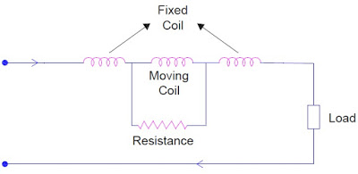](https://3.bp.blogspot.com/-zvDNNODBn8A/Wf8b8UYW6HI/AAAAAAAAC8U/ALtWCiyp8B0OpR4p0P_BmR66vLa0iha9ACLcBGAs/s1600/electrodynamometer-ammeter.jpg)

It can be seen that, the fixed coil and moving coil are connected in series and hence carries the same current. As the current through the moving coil shall not exceed 100 mA, therefore moving coil is shunted by suitable resistance to increase the range of such ammeter.

As the currents flowing in fixed and moving coils are same therefore there will not be any phase angle between them. Therefore, Ø = 0

Deflecting Torque in Ammeter

**Td = I2dM/dƟ**

where I is the RMS current flowing in fixed and moving coil.

# Answer 5:- Torque Equation for PMMC

The equation for the delevoped torque of the PMMC can be obtained from the basic law of electromagnetic torque. The deflecting torque is given by,  
  
                                               **Td = NBAI**  
  
Where,  
**Td**= deflecting torque in N-m  
**B**= flux density in air gap, Wb/m2  
**N**= Number of turns of the coils   
**A**= effective area of coil m2  
**I**= current in the moving coil, amperes  
  
Therefore, **Td = GI**  
Where, G = NBA = constant  
  
The controlling torque is provided by the springs and is proportional to the angular deflection of the pointer.  
                                               **Tc = KØ**  
  
Where,   
**Tc**= Controlling Torque   
**K**= Spring Constant Nm/rad or Nm/deg  
**Ø**= angular deflection  
For the final steady state position,  
                        **Td = Tc**  
Therefore **GI = KØ**  
So,                      Ø = (G/K)I          or            I = (K/G) Ø  
  
Thus the deflection is directly proportional to the current passing through the coil. The pointer deflection can therefore be used to measure current.

Q.6 Electrodynamic Ammeter

The moving coil and its series connected swamping resistanceare connected in parallel withthe ammeter shunt.

1.The two field coils should beconnected in series with the parallel arrangement of shunt

2.This instrument can be calibrated on dc and then used to measure either dc or ac.and moving coil.

3.The instrument scale can be read either as dc levels or rms ac values.



**Swamping**

**resistor**

**Q.7 What is Calibration.**

**Answer:-** Instrument calibration is one of the primary processes used to maintain instrument accuracy. Calibration is the process of configuring an instrument to provide a result for a sample within an acceptable range. Eliminating or minimizing factors that cause inaccurate measurements is a fundamental aspect of instrumentation design.

Although the exact procedure may vary from product to product, the calibration process generally involves using the instrument to test samples of one or more known values called “calibrators.” The results are used to establish a relationship between the measurement technique used by the instrument and the known values. The process in essence “teaches” the instrument to produce results that are more accurate than those that would occur otherwise. The instrument can then provide more accurate results when samples of unknown values are tested in the normal usage of the product.  
Calibrations are performed using only a few calibrators to establish the correlation at specific points within the instrument’s operating range. While it might be desirable to use a large number of calibrators to establish the calibration relationship, or “curve”, the time and labor associated with preparing and testing a large number of calibrators might outweigh the resulting level of performance. From a practical standpoint, a tradeoff must be made between the desired level of product performance and the effort associated with accomplishing the calibration. The instrument will provide the best performance when the intermediate points provided in the manufacturer’s performance specifications are used for calibration; the specified process essentially eliminates, or “zeroes out”, the inherent instrument error at these points.

**Q.8 Explain construction of moving iron instruments.**

**Answer 8:- Moving-iron instruments Construction**

Moving-iron [**instruments**](http://electrical-engineering-portal.com/download-center/books-and-guides/electrical-engineering/instrument-transformers-part-1-3) are generally used to measure alternating voltages and currents. In moving-iron instruments the movable system consists of one or more pieces of specially-shaped soft iron, which are so pivoted as to be acted upon by the [**magnetic field**](http://electrical-engineering-portal.com/what-is-the-eddy-current) produced by the current in coil.

There are two general types of moving-iron instruments namely:

1. **Repulsion** (or double iron) type (figure 1)
2. **Attraction** (or single-iron) type (figure 2)

The brief description of different components of a moving-iron instrument is given below:

* **Moving element:**a small piece of soft iron in the form of a vane or rod.
* **Coil:**to produce the magnetic field due to current flowing through it and also to magnetize the iron pieces.
* **In repulsion type**, a **fixed**vane or rod is also used and magnetized with the same polarity.
* **Control torque**is provided by spring or weight (gravity).
* **Damping torque**is normally pneumatic, the damping device consisting of an air chamber and a moving vane attached to the instrument spindle.
* **Deflecting torque**produces a movement on an aluminum pointer over a graduated scale.