Rajasthan Institute of Engineering & Technology, Jaipur.
I Mid Term Examination
Session: 2017-18
4th Semester & Branch EE/EEE
SUBJECT: GENERATION OF ELECTRICAL POWER
SET-B
Time: 2 hrs. M.M.:20

Q.1 Discuss main parts of nuclear reactor and their function. [5]
Main components of nuclear power plants:
i) Moderators
In any chain reaction, the neutrons produced are fast moving neutrons. These are less effective in causing fission of U²³⁵ and they try to escape from the reactor. It is thus implicit that speed of these neutrons must be reduced if their effectiveness is carrying out fission is to be increased. This is done by making these neutrons collide with lighter nuclei of other materials, which does not absorb these neutrons but simply scatter them. Each collision causes loss of energy and thus the speed of neutrons is reduced. Such a material is called a ‘Moderator’.The neutrons thus slowed down are easily captured by the fuel element at the chain reaction proceeds slowly.
ii) Reflectors
Some of the neutrons produced during fission will be partly absorbed by the fuel elements, moderator, coolant and other materials. The remaining neutrons will try to escape from the
reactor and will be lost. Such losses are minimized by surrounding (lining) the reactor core with a material called a reflector which will reflect the neutrons back to the core. They improve the neutron economy. Economy: Graphite, Beryllium.
iii) Shielding
During Nuclear fission ¥, b, gparticles and neutrons are also produced. They are harmful to human life. Therefore it is necessary to shield the reactor with thick layers of lead, or concrete to protect both the operating personnel as well as environment from radiation hazards.

iv) Cladding
In order to prevent the contamination of the coolant by fission products, the fuel element is covered with a protective coating. This is known as cladding.
Control rods are used to control the reaction to prevent it from becoming violent. They control the reaction by absorbing neutrons. These rods are made of boron or cadmium. Whenever the reaction needs to be stopped, the rods are fully inserted and placed against their seats and when the reaction is to be started the rods are pulled out.

v) Coolant
The main purpose of the coolant in the reactor is to transfer the heat produced inside the reactor. The same heat carried by the coolant is used in the heat exchanger for further utilization in the power generation.
The water, heavy water, gas (He, CO2), a metal in liquid form (Na) and an organic liquid are used as coolants.
The coolant not only carries large amounts of heat from the core but also keeps the fuel assemblies at a safe temperature to avoid their melting and destruction.

vi) Nuclear reactor
A nuclear reactor may be regarded as a substitute for the boiler fire box of a steam power plant. Heat is produced in the reactor due to nuclear fission of the fuel U²³⁵ The heat liberated in the reactor is taken up by the coolant circulating through the core. Hot coolant leaves the reactor at top and flows into the steam generator (boiler).

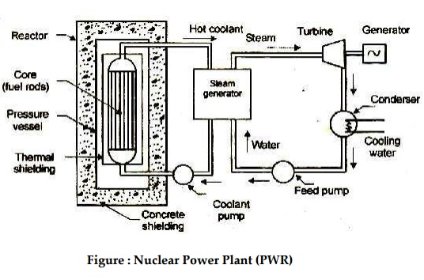

vii) Steam generator

The steam generator is fed with feed water which is converted into steam by the heat of the hot coolant. The purpose of the coolant is to transfer the heat generated in the reactor core and use it for steam generation. Ordinary water or heavy water is a common coolant
viii) Turbine
The steam produced in the steam generator is passed to the turbine and work is done by the expansion of steam in the turbine.
ix) Coolant pump and Feed pump
The steam from the turbine flows to the condenser where cooling water is circulated. Coolant pump and feed pump are provided to maintain the flow of coolant and feed water respectively.

Or
Q.1 Differentiate between nuclear fission and nuclear fusion.
Answer-

Comparison chart
Nuclear Fission versus Nuclear Fusion comparison chart
 | Nuclear Fission | Nuclear Fusion
Definition | Fission is the splitting of a large atom into two or more smaller ones. | Fusion is the fusing of two or more lighter atoms into a larger one.
Natural occurrence of the process | Fission reaction does not normally occur in nature. | Fusion occurs in stars, such as the sun.
Byproducts of the reaction | Fission produces many highly radioactive particles. | Few radioactive particles are produced by fusion reaction, but if a fission "trigger" is used, radioactive particles will result from that.
Conditions | Critical mass of the substance and high-speed neutrons are required. | High density, high temperature environment is required.
Energy Requirement | Takes little energy to split two atoms in a fission reaction. | Extremely high energy is required to bring two or more protons close enough that nuclear forces overcome their electrostatic repulsion.
Energy Released | The energy released by fission is a million times greater than that released in chemical reactions, but lower than the energy released by nuclear fusion. | The energy released by fusion is three to four times greater than the energy released by fission.
Nuclear weapon | One class of nuclear weapon is a fission bomb, also known as an atomic bomb or atom bomb. | One class of nuclear weapon is the hydrogen bomb, which uses a fission reaction to "trigger" a fusion reaction.
Energy production | Fission is used in nuclear power plants. | Fusion is an experimental technology for producing power.
Fuel | Uranium is the primary fuel used in power plants. | Hydrogen isotopes (Deuterium and Tritium) are the primary fuel used in experimental fusion power plants.

Q.2 Explain the scheme & working principle of thermal power plant?
Answer-
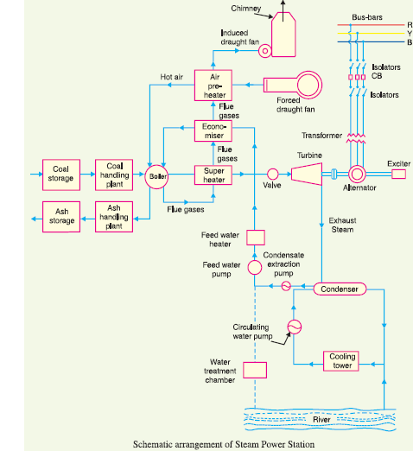
Coal Preparation

i) Fuel preparation system: In coal-fired power stations, the raw feed coal from the coal storage area is first crushed into small pieces and then conveyed to the coal feed hoppers at the boilers. The coal is next pulverized into a very fine powder, so that coal will undergo complete combustion during combustion process
.** pulverizer is a mechanical device for the grinding of many different types of materials. For example, the are used to pulverize coal for combustion in the steam-generating furnaces of fossil fuel power plants.Types of Pulverisers: Ball and Tube mills; Ring and Ball mills; MPS; Ball mill; Demolition
ii) Dryers: they are used in order to remove the excess moisture from coal mainly wetted during transport. As the presence of moisture will result in fall in efficiency due to incomplete combustion and also result in CO emission.
iii) Magnetic separators: coal which is brought may contain iron particles. These iron particles may result in wear and tear. The iron particles may include bolts, nuts wire fish plates etc. so these are unwanted and so are removed with the help of magnetic separators.
iv) The coal we finally get after these above process are transferred to the storage site.
- Boiler and auxiliaries
A Boiler or steam generator essentially is a container into which water can be fed and steam can be taken out at desired pressure, temperature and flow. This calls for application of heat on the container. For that the boiler should have a facility to burn a fuel and release the heat. The functions of a boiler thus can be stated as:-
- To convert chemical energy of the fuel into heat energy
- To transfer this heat energy to water for evaporation as well to steam for superheating.
- Economiser
It is located below the LPSH in the boiler and above pre heater. It is there to improve the efficiency of boiler by extracting heat from flue gases to heat water and send it to boiler drum.
- Air Preheater
The heat carried out with the flue gases coming out of economiser are further utilized for preheating the air before supplying to the combustion chamber. It is a necessary equipment for supply of hot air for drying the coal in pulverized fuel systems to facilitate grinding and satisfactory combustion of fuel in the furnace
- Reheater
Power plant furnaces may have a reheater section containing tubes heated by hot flue gases outside the tubes. Exhaust steam from the high pressure turbine is rerouted to go inside the reheater tubes to pickup more energy to go drive intermediate or lower pressure turbines.
- Steam turbines
Steam turbines have been used predominantly as prime mover in all thermal power stations. The steam turbines are mainly divided into two groups: –
- Condenser
The condenser condenses the steam from the exhaust of the turbine into liquid to allow it to be pumped. If the condenser can be made cooler, the pressure of the exhaust steam is reduced and efficiency of the cycle increases. The functions of a condenser are:-
1) To provide lowest economic heat rejection temperature for steam.
2) To convert exhaust steam to water for reserve thus saving on feed water requirement.
3) To introduce make up water.
We normally use surface condenser although there is one direct contact condenser as well. In direct contact type exhaust steam is mixed with directly with D.M cooling water.
- Boiler feed pump
Boiler feed pump is a multi stage pump provided for pumping feed water to economiser. BFP is the biggest auxiliary equipment after Boiler and Turbine. It consumes about 4 to 5 % of total electricity generation.
- Cooling tower
The cooling tower is a semi-enclosed device for evaporative cooling of water by contact with air. The hot water coming out from the condenser is fed to the tower on the top and allowed to tickle in form of thin sheets or drops. The air flows from bottom of the tower or perpendicular to the direction of water flow and then exhausts to the atmosphere after effective cooling.
The cooling towers are of four types: –
1. Natural Draft cooling tower
2. Forced Draft cooling tower
3. Induced Draft cooling tower
4. Balanced Draft cooling tower

- Ash handling system
The disposal of ash from a large capacity power station is of same importance as ash is produced in large quantities. Ash handling is a major problem.
i) Manual handling: While barrows are used for this. The ash is collected directly through the ash outlet door from the boiler into the container from manually.
ii) Mechanical handling: Mechanical equipment is used for ash disposal, mainly bucket elevator, belt conveyer. Ash generated is 20% in the form of bottom ash and next 80% through flue gases, so called Fly ash and collected in ESP.
iii) Electrostatic precipitator: From air preheater this flue gases (mixed with ash) goes to ESP. The precipitator has plate banks (A-F) which are insulated from each other between which the flue gases are made to pass. The dust particles are ionized and attracted by charged electrodes. The electrodes are maintained at 60KV. Hammering is done to the plates so that fly ash comes down and collect at the bottom. The fly ash is dry form is used in cement manufacture.
- Generator
Generator or Alternator is the electrical end of a turbo-generator set. It is generally known as the piece of equipment that converts the mechanical energy of turbine into electricity. The generation of electricity is based on the principle of electromagnetic induction.
Or
Q.2 W hat are the factor to be considered for selection of site for hydro power plant

1. Availability of water
the river run off data pertain to many years should be available so that and estimate of the power potential of the project and the made . the data should include minimum Flo and maximum flow and their periods.

2. Water storage
Because of white fluctuation in stream flows storage is needed most hydroelectric project to store the water during high flow periods and use it during the leading flow periods. the storage capacity can be calculated from the hydro graph.

3. Geological investigation
It is need to see that the foundation roof from the demand and other structure is stable and strong enough to with stand water thrust and other stress.

4. Water pollution
Polluted water may cause excessive corrosion and damage to metallic structure . this may make the operation of the plant un reliable and UN economical so it is necessary to sea the water is of good quality .

5. Sedimentation
the capacity of storage reserve wire is reduced dew to the gradual deposition of snit
snit may cause damage to turbine plate .
6. Environmental effect

Hydro project submerge use areas and many villages the environmental effect are also importation . The site should ensure safe soundings, avoid heath hazard and presser important cultural and storage aspect of the area.

7. Access to site
A hydro electric plant installed at the suitable location should be connected threw the rail and road facilities so that row material and heavy machinery can be transfer at the suitable location very easily it is also a important factor for selecting the suitably location for hydroelectric plant.
Q.3 Discuss the significance of load duration curve and load curve. [5]
Load Curve and Load Duration Curve
Load curve is the variation of load with time on a Power Station. As the load on a Power Station never remain constant rather it varies time to time, these variations in load is plotted on half hourly or hourly basis for the whole day. The curve thus obtained is known as Daily Load Curve.
Therefore, by having a look at the Load Curve, we can check the peak load on a Power Station and its variation. From the figure below, it is quite clear that the peak load (6 MW) on a particular Power Station is at 6 P.M.

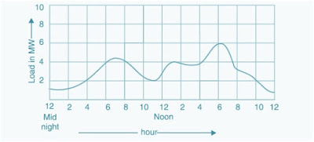
The monthly load curve can be plotted using the daily load curve for a particular month. For this purpose the average load for different time for the whole month is calculated and the value thus obtained is plotted against time to get the Monthly Load Curve. Monthly Load Curve is used to fix the rate of energy.
Load Duration Curve:
Load Duration Curve is the plot of Load versus time duration for which that load was persisting. Load Duration Curve is obtained from the Daily Load Curve as shown in figure below.
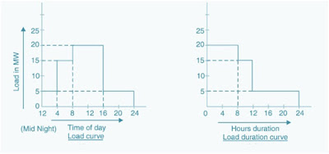
From the above Load Duration Curve, it is clear that 20 MW of Load is persisting for a period of 8 hours, 15 MW of Load for 4 hours and so on.
It is also quite clear that, the area under the load duration curve is equal to the daily load curve and gives the number of units (kWh) generated for a given day. The load duration curve can be extended for any period of time i.e. it can be drawn for a month or for year too.
Or
Q.3 Maximum demand of power plant is 40 MW. Capacity factor is 0.5 & Utilization factor of 0.8 find
- Load Factor
- Plant Capacity
- Annual energy production [5]

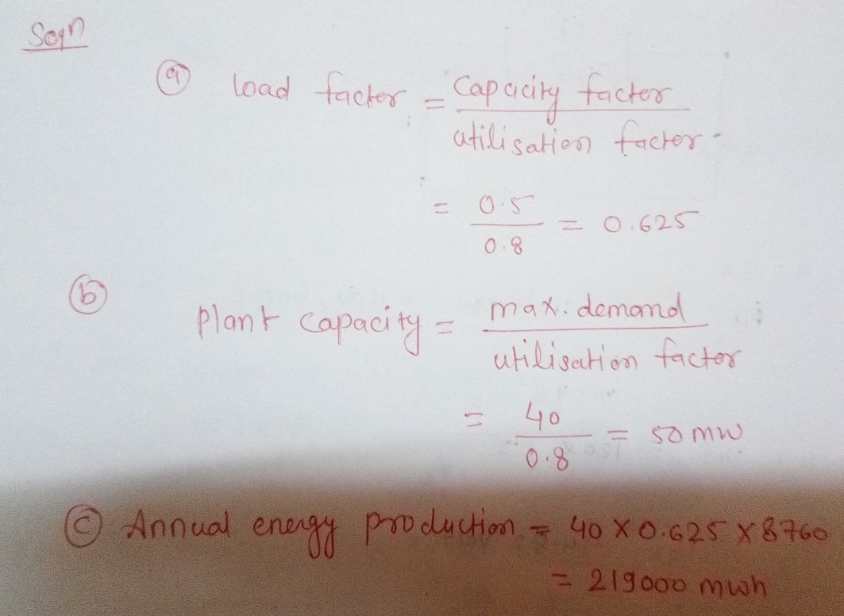
Q.4 Explain the following terms [5]
(i) Demand factor (ii) Load factor
Demand factor
- Demand Factor = Maximum demand of a system / Total connected load on the system
- Demand factor is always less than one.
- Example: if a residence having 6000W equipment connected has a maximum demand of 300W,Than demand factor = 6000W / 3300W = 55%.
- The lower the demand factor, the less system capacity required to serve the connected load.

Load factor
- Load Factor = Average load. /Maximum load during a given period.
- It can be calculated for a single day, for a month or for a year.
- Its value is always less than one. Because maximum demand is always more than avg. demand.
- It is used for determining the overall cost per unit generated. Higher the load factor, lesser will be the cost per unit.
- Load Factor = Load that a piece of equipment actually draws / Load it could draw (full load).
- Example: Motor of 20 hp drives a constant 15 hp load whenever it is on.
- The motor load factor is then 15/20 = 75%.
- Load factor is term that does not appear on your utility bill, but does affect electricity costs. Load factor indicates how efficiently the customer is using peak demand.
Or
Q.4 Explain component used in hydro power plant.

1) Dam
The dam is the most important component of hydroelectric power plant. The dam is built on a large river that has abundant quantity of water throughout the year. It should be built at a location where the height of the river is sufficient to get the maximum possible potential energy from water

2) Water Reservoir
The water reservoir is the place behind the dam where water is stored. The water in the reservoir is located higher than the rest of the dam structure. The height of water in the reservoir decides how much potential energy the water possesses. The higher the height of water, the more its potential energy. The high position of water in the reservoir also enables it to move downwards effortlessly.
The height of water in the reservoir is higher than the natural height of water flowing in the river, so it is considered to have an altered equilibrium. This also helps to increase the overall potential energy of water, which helps ultimately produce more electricity in the power generation unit.

3) Intake or Control Gates
These are the gates built on the inside of the dam. The water from reservoir is released and controlled through these gates. These are called inlet gates because water enters the power generation unit through these gates. When the control gates are opened the water flows due to gravity through the penstock and towards the turbines. The water flowing through the gates possesses potential as well as kinetic energy.

4)The Penstock
The penstock is the long pipe or the shaft that carries the water flowing from the reservoir towards the power generation unit, comprised of the turbines and generator. The water in the penstock possesses kinetic energy due to its motion and potential energy due to its height.
The total amount of power generated in the hydroelectric power plant depends on the height of the water reservoir and the amount of water flowing through the penstock. The amount of water flowing through the penstock is controlled by the control gates.

5) Water Turbines
Water flowing from the penstock is allowed to enter the power generation unit, which houses the turbine and the generator. When water falls on the blades of the turbine the kinetic and potential energy of water is converted into the rotational motion of the blades of the turbine. The rotating blades causes the shaft of the turbine to also rotate. The turbine shaft is enclosed inside the generator. In most hydroelectric power plants there is more than one power generation unit.
There is large difference in height between the level of turbine and level of water in the reservoir. This difference in height, also known as the head of water, decides the total amount of power that can be generated in the hydroelectric power plant.
There are various types of water turbines such as Kaplan turbine, Francis turbine, Pelton wheels etc. The type of turbine used in the hydroelectric power plant depends on the height of the reservoir, quantity of water and the total power generation capacity.

6) Generators
It is in the generator where the electricity is produced. The shaft of the water turbine rotates in the generator, which produces alternating current in the coils of the generator. It is the rotation of the shaft inside the generator that produces magnetic field which is converted into electricity by electromagnetic field induction. Hence the rotation of the shaft of the turbine is crucial for the production of electricity and this is achieved by the kinetic and potential energy of water. Thus in hydroelectricity power plants potential energy of water is converted into electricity.

