Rajasthan Institute of Engineering & Technology, Jaipur.
I Mid Term Examination
Session: 2017-18
4th Semester & Branch EE
SUBJECT: GENERATION OF ELECTRICAL POWER
SET-B
Time: 2 hrs. M.M.:20

Q.1 Explain the component of pumped storage plant and its advantage. [5]
Answer-Pump storage power plants consists two reservoir
Upper reservoir
Like a conventional hydropower plant, a dam creates a reservoir. The water in this reservoir flows through the hydropower plant to create electricity.
Lower reservoir
Water exiting the hydropower plant flows into a lower reservoir rather than re-entering the river and flowing downstream.
Reversible turbine
Using a reversible turbine, the plant can pump water back to the upper reservoir. This is done in off-peak hours. Essentially, the second reservoir refills the upper reservoir. By pumping water back to the upper reservoir, the plant has more water to generate electricity during periods of peak consumption.
Dam
The dam for the project is planned to be of concrete gravity type to create regulating pond for hydropower generation. Hence, the dam should be designed in consideration of safety and stability. The design requirements for the dam are given topographical, geological and structural conditions, and economical efficiency.
Spillway
The spillway and dissipation structures will radial gates on ogee crest spillway with a cute and flip bucket.
Surge Tank
The surge tank will be designed to allow for transient conditions under reservoir operating water levels between MOL and FSL. The surge tank characteristics will be determined in a way to ensure:
- Stability of the operation of the power plant under small load steps,
- Load acceptance by the units within required time period.
- Closure of the penstock discharge after load rejection in the required time without excessive surge wave overpressure in the penstock.
Intake
Gates on the dam open and gravity pulls the water through the penstock, a pipeline that leads to the turbine. Water builds up pressure as it flows through this pipe. The function of an intake structure at a hydroelectric project is to direct water to the water passages to the powerhouse under controlled conditions. An intake contains transhracks that prevent large debris from entering the water passages and gates to control the flow of water. The design requirements for intakes are based of geologic, hydraulic, structural and economic considerations.
Advantage -
- Pump Storage Method can be used as energy storage method.
- Pump Storage can use as a solution for peak demand problem.
- Increasing of the quality and reliability of the power system.
- To replace the thermal private power generation system with renewable energy.
- Increasing the availability of water and performance of the pump storage hydro power system in dry seasons.
- This will also useful to maximize the power distribution for peak hour demand.

Or
Q.1 What are the factor to be consider for selection of site for thermal power plant.
Answer-The following points should be considered while site selection of steam power station :

(i) Supply of fuel: The steam power plant should be located near the coal mines so that transportation cost of fuel is minimum. However, if such a plant is to be installed at a place where coal is not available, then care should be taken that adequate facilities exist for the transportation of coal.

(ii) Availability of water: As huge amount of water is required for the condenser, therefore, such a plant should be located on the bank of a river or near a canal to ensure the continuous supply of water.

(iii) Transportation facilities: A modern steam power plant often requires the transportation of material and machinery. Therefore, adequate transportation facilities must exist i.e., the plant should be well connected to other parts of the country by rail, road. etc.

(iv) Cost and type of land: The steam power station should be located at a place where land is cheap and further extension, if necessary, is possible. Moreover, the bearing capacity of the ground should be adequate so that heavy equipment could be installed.

(v) Nearness to load centers: In order to reduce the transmission cost, the plant should be located near the centre of the load.This is particularly important if dc supply system is adopted. However, if ac the supply system is adopted, this factor becomes relatively less important.It is because ac power can be transmitted at high voltages with consequently reduced transmission cost. Therefore, it is possible to install the plant away from the load centres, provided other conditions are favourable.

(vi) Distance from populated area: As huge amount of coal is burnt in a steam power station, therefore, smoke and fumes pollute the surrounding area. This necessitates that the plant should be located at a considerable distance from the populated areas.

Q.2 Explain the working principle and advantage of gas turbine plants.
Answer-
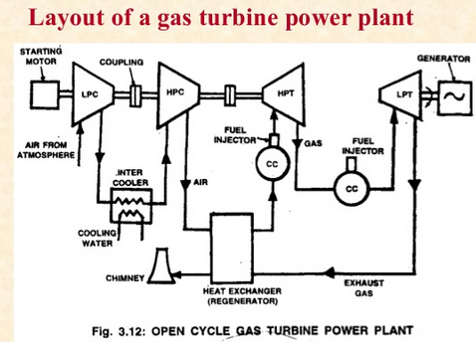
A power plant which employs gas turbine as the prime mover to generate electrical energy is called as gas turbine power plant. In gas turbine plant, air is used as the working fluid. The air is compressed by the compressor to increase the pressure of the air. The pressurised air is then passed through the combustion chamber where the air is heated to a high temperature. The heart is added to the air by burning the oil in the combustion chamber or by the air heaters. The hot and high pressure air is then expanded in the gas turbine which drives the alternator to convert the mechanical energy in to electrical energy. The exhaust gases are passed through the regenerator to heat the compressed air and then they are released to the atmosphere.The Compressor, gas turbine and alternator are mounted on the same shaft, so part of the driven power is used to drive the compressor once the plant has been started. Gas power plants are used as standby plants for hydro-electric power stations where these can be operated at peak loads.

Advantages of Gas power plant:
- The design of gas power plant is simple compared to steam power plant as that it does not require boiler and its auxiliaries.
- Occupies less space and size compared to the steam power plants where the boiler and feed water arrangement is not needed.
- Initial and Operation costs are lower compared to all other plants.
- Gas turbines are simple in construction compared to steam turbines and the maintenance of them is also less.
- It requires less water compared to steam power plants where the condenser is required.
- It can be started with less time from cold conditions.

Or
Q.2 Explain the following terms of nuclear power plant-
Answer-
(a) Boiling water reactor- the boiling water reactor (BWR), the water which passes over the reactor core to act as moderator and coolant is also the steam source for the turbine. The disadvantage of this is that any fuel leak might make the water radioactive and that radioactivity would reach the turbine and the rest of the loop.A typical operating pressure for such reactors is about 70 atmospheres at which pressure the water boils at about 285¡C. This operating temperature gives a Carnot efficiency of only 42% with a practical operating efficiency of around 32%, somewhat less than the PWR.
(b) Heavy water reactor- A heavy water molecule contains deuterium (Hydrogen-2), which is an isotope of hydrogen that has a neutron in its nucleus in addition to the proton. The hydrogen in light water molecules contains only the proton (and is therefore called protium or Hydrogen.Deuterium is much less likely to absorb neutrons than protium. As a result, more of the neutrons in a heavy water reactor are available to be absorbed by uranium than in a light water reactor. The result is that the uranium in a CANDU reactor does not need to be enriched in U-235; natural uranium can be used as fuel. This in turn means that a heavy water reactor can produce more energy per unit of uranium mined.
Q.3 Discuss the significance of chronological load curve. [5]
Answer-

Chronological load Curve
There is an average load on the power station in a given time period which could be set depending on the load variation. If this load on the power supply station is plotted against the time periods in which these loads occur, it gives rise to what is known as the chronological curve because of the chronological appearance of the power demand along the time sequence.
You can take a look at one such curve in the adjacent diagram which shows such a curve where the average load is plotted along the y-axis while the time frame of that average load comes in the x-axis. So as you can see in the diagram the load is maximum between the time periods of 5pm to 12 midnight, while it is lowest in the time period of 1pm to 5pm. This is just an imaginary graph to give you an idea about the load curve and does not represent any actual data.
Needless to say this data representation is extremely important for the power generation company as it helps to forecast the size of the generation equipment as well as to understand the load variations during the day.

Load Duration Curve
If the above variation given in chronological order is given in order of the size or magnitude of power consumption, the curve in such a case is known as load duration curve. For example if we simply rearrange the bars of the above bar graph in such an order that the highest demand comes first, and so on; we get what is known as the load duration curve.

Or

Q.3.A power station has on to supply load as follows-
Installed Capacity of plant = 195Mw
Time | 0-6 | 6-12 | 12-14 | 14-18 | 18-24
Load(Mw) | 45 | 135 | 90 | 150 | 76
- Draw load curve
- Draw load duration curve
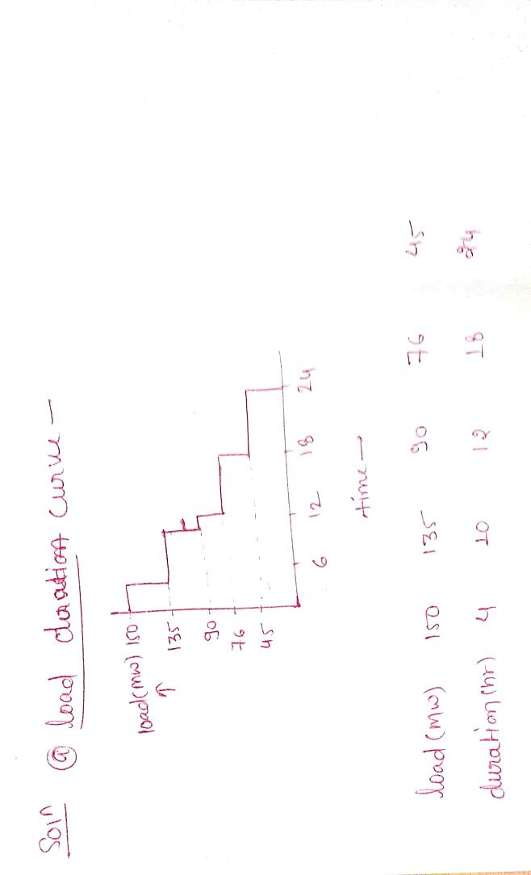

Q.4 Explain the following terms [5]
(i) Maximum demand (ii) capacity factor
Maximum demand -It is the Greatest demand of load on the power station during a given period. it sometimes also called as "system speak" It is called maximum demand
capacity factor -The capacity factor is defined as the ratio of the total actual energy produced or supply over a definite period, to the energy that would have been produced if the plant (generating unit) had operated continuously at the maximum rating. The capacity factor mainly depends on the type of the fuel used in the circuit.
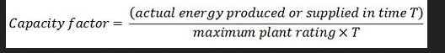
or
Q.4 Write the difference between thermal plant, hydro plant and nuclear plant.
