**Q.1) Define the Dimensional Homogeneity with two examples.**

Dimensional homogeneity is the quality of an equation having quantities of same units on both sides. A valid equation in physics must be homogeneous, since equality cannot apply between quantities of different nature. This can be used to spot errors in formula or calculations. For example, if one is calculating a speed, units must always combine to [length]/[time]; if one is calculating an energy, units must always combine to [mass]•[length]²/[time]², etc. For example, the following formulae could be valid expressions for some energy:

Ek = 1/2 mv2 ; E = m c 2 ; E = p v ; E = h c / λ

if m is a mass, v and c are velocities, p is a momentum, h is Planck's constant, λ a length. On the other hand, if the units of the right hand side do not combine to [mass]•[length]2/[time]2, it cannot be a valid expression for some energy.

**Q.1) Explain the distorted and undistorted river model.**

Distorted models are those which are not perfectly geometrically similar to the prototype.

Particularly, in case of shallow rivers, where depth is small compared to the width, without distortion the depth of flow in the model will be so small that measurements may not be accurate and the surface tension effect will be prominent which will not present in prototype. Hence it is necessary to distort the models in the vertical direction.

In the design of model, hydraulic similitude is of prime importance and not that the geometric similes. Therefore, by distortion of the model scale, even through the model is not look, like the prototype, but it gives the satisfactory results.

Undistorted models: are those models which are geometrically similar to their prototype. In other words the scale ratio for the linear dimensions of the model and its prototype are the same.

If the horizontal and vertical scale ratios for the model and the prototype are same then it is undistorted model. In this case the depth of the water in the model becomes very small which may not be measured accurately.

**Q.2) Explain the Geometric Similarity and Dynamic similarity.**

Geometric Similarity:

The ratio of all corresponding linear dimension in the model and prototype are equal.

Let Lm = length of model

bm = width of model

dm = diameter of model

Am = area of model

Vm = volume of model

Lp, bp, dp, Ap, Vp are corresponding values of the prototype.



Dynamic Similarity: means the similarity of forces between model and prototype. Thus dynamic similarity is said to exist between the model and the prototype if the ratios of the forces acting at the corresponding points in the model and prototype are the same in magnitude; the directions also should be parallel.



**Q.2) Define the type of forces in a fluid flow and describe any two dimensionless number.**

Inertial force: it is equal to the mass and acceleration of the moving fluid.



Viscous force: it is equal to the shear stress due to viscosity and surface area of the flow. It present in the flow problems where viscosity is having an important role to play.



Gravity force: product of mass and acceleration due to gravity.



Pressure force: product of pressure intensity and flow area.



Surface tension force: product of surface tension and the length of the surface of the flowing fluid.



Elastic force: product of elastic stress and area of the flow.



**dimensionless number.**





**Q.3) State the Buckingham П theorem.**

Buckingham's π. theorem states that: If there are n variables in a problem and these variables contain m primary dimensions (for example M, L, T) the equation relating all the variables will have (n-m) dimensionless groups.

Buckingham referred to these groups as π groups. The final equation obtained is in the form of :

πl = f(π2, π3 ,….. πn-m )

The π groups must be independent of each other and no one group should be formed by multiplying together powers of other groups.

This method offers the advantage of being more simple than the method of solving simultaneous equations for obtaining the values of the indices (the exponent values of the variables).

In this method of solving the equation, there are 2 conditions:

a. Each of the fundamental dimensions must appear in at least one of the m variables

b. It must not be possible to form a dimensionless group from one of the variables within a recurring set. A recurring set is a group of variables forming a dimensionless group.

**Q.3) The frictional torque T of a disc of diameter D rotating at speed N in a fluid of viscosity μ and density ρ in a turbulent flow is given by T = D5 N2 ρ Φ [(μ) / (D2N ρ)], Prove this the method of dimensions.**

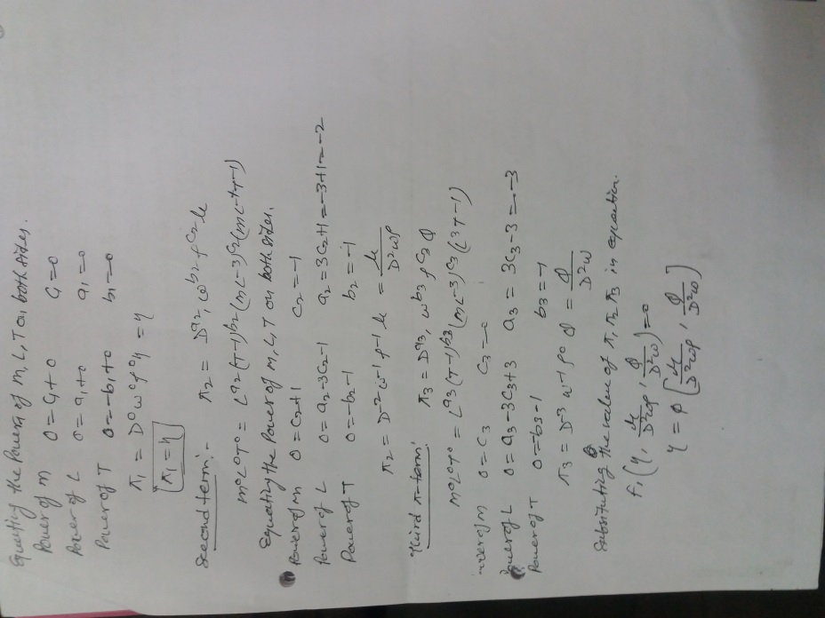

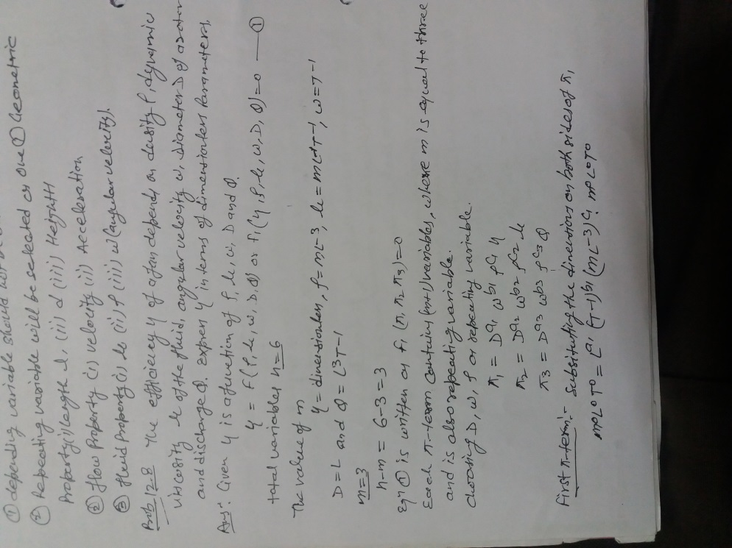

**Q.4) Explain the similarity laws and describe the Reynold model law.**

For the dynamic similarity between the model and the prototype the ratio of the corresponding forces acting at the corresponding points in the model and prototype should be equal.

It means for dynamic similarity between the model and prototype, the dimensionless numbers should be same for model and prototype.

It is quite difficult to satisfy the condition that all the dimensionless numbers are the same for the model and prototype. Therefore model are designed on the basis of equating the dimensionless number which dominate the phenomenon.

Following are the dynamic similarity laws:

1. Reynolds model law

2. Froude model law

3. Euler model law

4. Weber model law

5. Mach model law

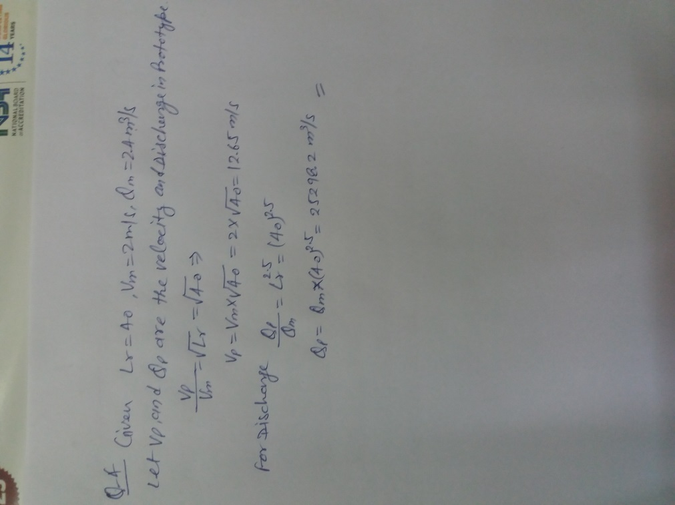

**Q.4) In 1 in 40 model of a spillway, the velocity and discharge are 2 m/s and 2.5m3/s . find the corresponding velocity and discharge in the prototype.**