**Q.1) Explain dimensional homogeneity with example.**

Dimensional homogeneity: means the dimensions of each terms in an equation on both sides are the same.

If the dimensions of each term on both sides of an equation are the same the equation is known as dimensionally homogeneous equation.



Dimensional homogeneity is the quality of an equation having quantities of same units on both sides. A valid equation in physics must be homogeneous, since equality cannot apply between quantities of different nature

**Q.1) Explain the advantage and disadvantage of the distorted river model**

**Distorted Model** Distorted models are those which are not perfectly geometrically similar to the prototype.

Different scale ratio is used in different direction.

Particularly, in case of shallow rivers, where depth is small compared to the width, without distortion the depth of flow in the model will be so small that measurements may not be accurate and the surface tension effect will be prominent which will not present in prototype. Hence it is necessary to distort the models in the vertical direction.

In the design of model, hydraulic similitude is of prime importance and not that the geometric similes. Therefore, by distortion of the model scale, even through the model is not look, like the prototype, but it gives the satisfactory results.

**Advantages**

Due to substantial height obtained by distortion, measurement in the vertical direction is fairly accurate.

Hydraulic similitude is achieved due to distortion.

Turbulent flow in the model becomes possible.

Cost of model can be reduced.

Viscous effects absent in the prototype, are eliminated in the model. For example, increase in the bed slope of the model, in an otherwise geometrically similar model, increases the velocity in the model, which decreases the effect of viscosity.

Movement of sand and silt in the model can be simulated to that of the prototype.

Adoption of the distorted model, reduces the sie of the model, which saves the space and facilitates the easy operation of the model.

**Disadvantages:**

Due to different scales in the different directions, the velocity and pressure distribution in the model is not the same as that in the prototype.

Slopes, curves bends and cutting in earth is not truly represented in the model.

Waves are not simulated in the distorted models.

Even though there are many advantages of the distorted models. interpretation of the model results for the application to the prototypes is note direct but it needs some amount of manipulation. However, the due to distortion of models, the accuracy of results can be assured.

**Q.2) Explain the Dynamic Similarity and kinematic similarity.**

**Dynamic Similarity:** means the similarity of forces between model and prototype. Thus dynamic similarity is said to exist between the model and the prototype if the ratios of the forces acting at the corresponding points in the model and prototype are the same in magnitude; the directions also should be parallel.



**Kinematic Similarity:** means the similarity of motion between model and prototype. Thus kinematic similarity is said to exist between the model and the prototype if the ratios of the velocity and acceleration at the corresponding points in the model and prototype are the same in magnitude; the directions also should be parallel.



**Q.2) Define the dimensionless number and explain Reynold Number, Froude number, Euler Number.**

**dimensionless number**

dimensionless numbers are those number which are obtained by dividing the inertia force by viscous force or gravity force or pressure force or surface force, or elastic force. This ratio of one force to the other force, it will be a dimensionless number.

**Reynolds number (Re):** It is defined as the ratio of inertia force to viscous force.



where V is the velocity of the flow, L is the characteristics length, ,and ρ, μ, ν are the density, dynamic viscosity and kinematic viscosity of the fluid respectively. If Re is very small, there is an indication that the viscous forces are dominant compared to inertia forces. Such types of flows are commonly referred to as “viscous flows”.

**Euler number** **Eu**: In most of the aerodynamic model testing, the pressure data are usually expressed mathematically as,



where Δp is the difference in local pressure and free stream pressure, V is the velocity of the flow, ρ is the density of the fluid. The denominator is “dynamic pressure”. Eu is the ratio of pressure force to inertia force and many a times the pressure coefficient

**Froude number Fr:** It is interpreted as the ratio of inertia force to gravity force. Mathematically, it is written as,



where V is the velocity of the flow, L is the characteristics length descriptive of the flow field and g is the acceleration due to gravity. This number is very much significant for flows with free surface effects such as in case of open-channel flow.

**Q.3) State Buckingham П theorem.**

Buckingham's π. theorem states that: If there are n variables in a problem and these variables contain m primary dimensions (for example M, L, T) the equation relating all the variables will have (n-m) dimensionless groups.

Buckingham referred to these groups as π groups. The final equation obtained is in the form of :

πl = f(π2, π3 ,….. πn-m )

The π groups must be independent of each other and no one group should be formed by multiplying together powers of other groups.

This method offers the advantage of being more simple than the method of solving simultaneous equations for obtaining the values of the indices (the exponent values of the variables).

In this method of solving the equation, there are 2 conditions:

a. Each of the fundamental dimensions must appear in at least one of the m variables

b. It must not be possible to form a dimensionless group from one of the variables within a recurring set. A recurring set is a group of variables forming a dimensionless group.

**Q.3) Using the Buckingham П theorem, show that the velocity through a circular orifice is given by**

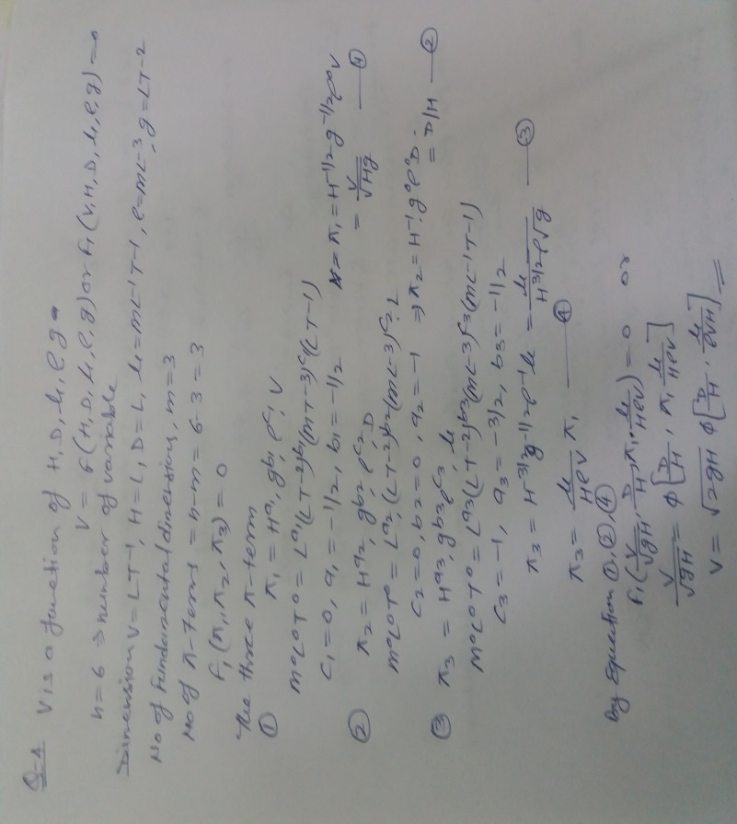**V= (2gH)1/2 Φ[D/H, μ/ ρVH], where H is the head causing flow , D is the diameter of the orifice , μ is the coefficient of the viscosity , ρ is the mass density and g is the acceleration due to gravity.**

**Q.4) Explain the similarity laws and describe the Froude model law.**

A “model” is a representation of a physical system which is used to predict the behavior of the system in some desired respect. The physical system for which the predictions are to be made is called “prototype”. Usually, a model is smaller than the prototype so that laboratory experiments/studies can be conducted. It is less expensive to construct and operate. However, in certain situations, models are larger than the prototype e.g. study of the motion of blood cells whose sizes are of the order of micrometers. “Similitude” is the indication of a known relationship between a model and prototype. In other words, the model tests must yield data that can be scaled to obtain the similar parameters for the prototype.

**Froude’s model law**: (Free-surface flow, jet from orifice or nozzle etc)



**Q.4) A pipe of diameter 1.5m is requires to transport an oil of sp. gr. 0.90 and viscosity 3*10-2 poise at the rate of 3000 litre/s Test were conducted on a 15 am diameter pipe using water an 200 C. find the velocity and rate of flow in the model. Viscosity of water at 200C is 0.01 poise.**

