RAJASTHAN INSTITUTE OF ENGINEERING & TECHNOLOGY JAIPUR, RAJASTHAN
B. Tech. I Midterm EXAMINATION 2017-18
Semester and Branch: II Year, IV Semester, EEE
Subject: LIC
SET B

Solution
Duration: 2 Hours Maximum Marks: 20

- What is the Differential Amplifier? Explain the Working of Differential Amplifier.

Differential Amplifier
A differential amplifier is a circuit that can accept two input signals and amplify the difference between these two input signals.
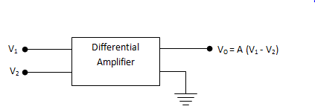
shows the block diagram of a differential amplifier
There are two input voltages v₁ and v₂.
This amplifier amplifies the difference between the two input voltages.
Therefore the output voltage is,
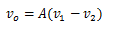
Where A is the voltage gain of the amplifier.

Basic circuit of Differential Amplifier
Fig. shows the basic circuit of a differential amplifier.
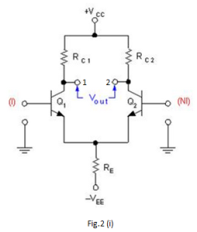
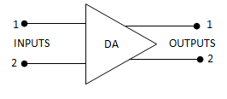
It consists of two transistors Q₁ and Q₂ that have identical (ideally) characteristics.
They share common positive supply V_{CC}, common emitter resistor R_{E} and common negative supply V_{EE}.
Fig. shows the symbol of differential amplifier.
The following points may be noted about the differential amplifier :
- The differential amplifier (DA) is a two-input terminal device using at least two transistors. There are two output terminals marked 1(v _{out 1} ) and 2 (v _{out 2} ).
- The transistors Q₁ and Q₂ are matched so that their characteristics are the same. The collector resistors (R_{C1} and R_{C2} ) are also equal. The equality of the matched circuit components makes the DA circuit arrangement completely symmetrical.
- We can apply signals to a differential amplifier in the following two ways :
a) The signal is applied to one input of DA and the other input is grounded. In this case it is called single-ended input arrangement.
b) The signals are applied to both inputs of DA. In this case it is called dual-ended or double-ended input arrangement.
4. We can take output from DA in the following two ways :
a) The output can be taken from one of the output terminals and the ground. In this case it is called single-ended output arrangement.
b) The output can be taken between the two output terminals (i.e. between the collectors of Q₁ and Q₂). In this case it is called double-ended output arrangement or differential output.
5. Generally the differential amplifier (DA) is operated for single-ended output.
Operation of Differential Amplifier
For simplicity, we shall discuss the operation of single-ended input and double-ended output DA.
Case – 1:
Suppose the signal is applied to input 1 (i.e. base of transistor Q₁) and input 2(i.e.base of transistor Q₂) is grounded as shown in fig.
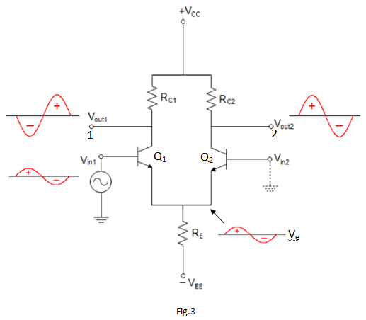
The transistor Q₁ will act in two ways: as a common emitter amplifier and as a common collector amplifier.
As a common emitter amplifier, the input signal to Q₁ will appear at output 1 (i.e. collector of Q₁) as amplified inverted signal.
As a common collector amplifier, the signal appears on the emitter of Q₁ in phase with the input and only slightly smaller.
Since the emitters of Q₁ and Q₂ are common, the emitter signal becomes input to Q₂.
Therefore, Q₂ functions as a common base amplifier.
As a result, the signal on the emitter Q₂ will be amplified and appears on output 2 (i.e. collector of Q₂) in phase with the emitter signal and hence in phase with the input signal (signal at input 1). This is shown in Fig..

Case – 2:
Now suppose the signal is applied to input 2 (i.e. base of transistor Q₂) and input 1 is grounded.
Now Q₂ acts as a common emitter amplifier and common collector amplifier while Q₁ acts as a common base amplifier.
Therefore, an inverted and amplified signal appears at output 2 and non-inverted, amplified signal appears at output 1. This is shown in Fig..

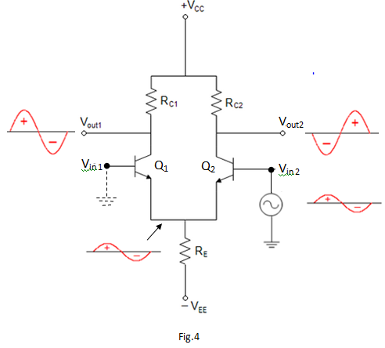
When signal applied to the input of DA produces no phase shift in the output, it is called non-inverting input. In other words, for non-inverting input, the output signal is in phase with the input signal.
When the signal applied to the input of DA produces 180⁰ phase shift, it is called inverting input. In other words, for inverting input, the output signal is 180⁰ out of phase with the input signal.
OR
Find the Bias Voltage and Current for the Differential Amplifier Circuit Shown
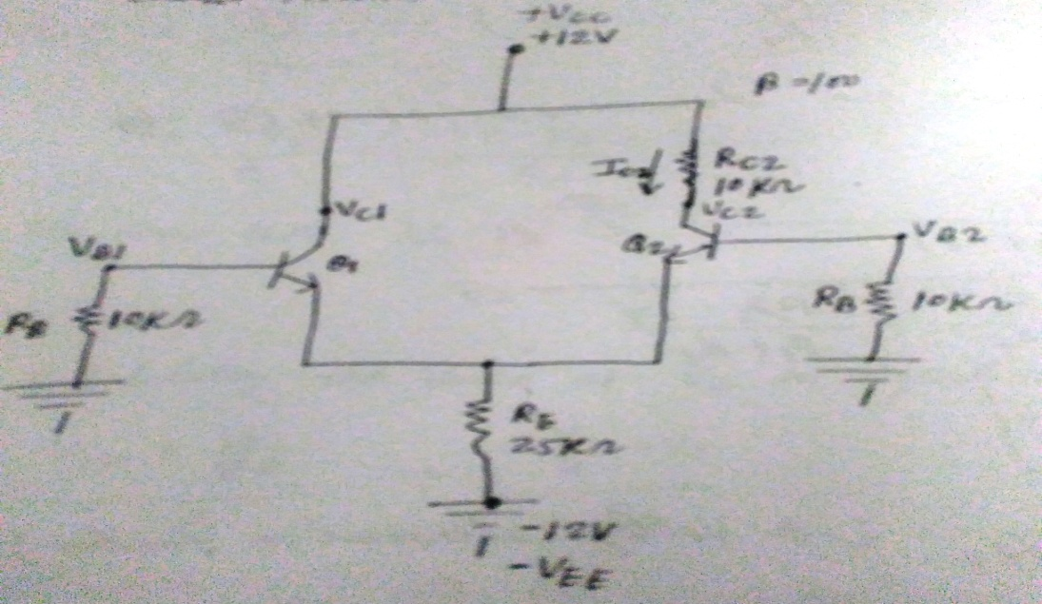
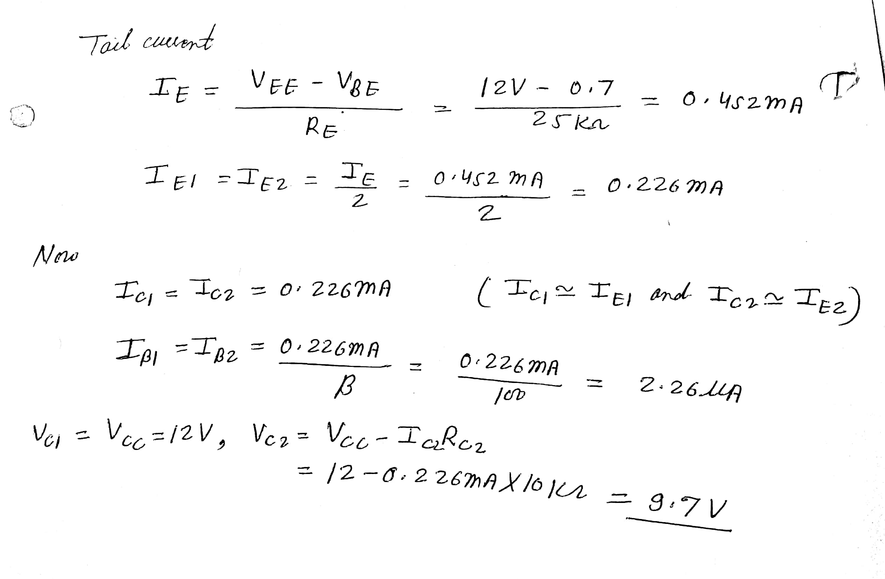
- List and explain the functions of all the basic building blocks of an operational amplifier.
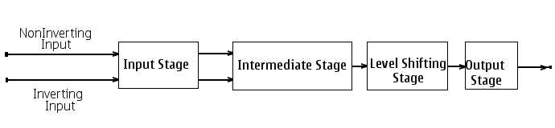

An OPAMP is a Multistage Amplifier with High Input Impedence and Low output Impedence The basic block diagram constitutes mainly four stages
1. Input stage
2. Intermediate Stage
3. level Shifting stage
4. Output Stage
The Input Stage
The input stage consisting of "Dual Input Balanced Output Differential Amplifier" This stage Determines the Input Impedence of Operational Amplifier, having two inputs Inverting and NonInverting. In these stage Differential amplifiers with a constant current source is used inorder to Increase the CMRR (common mode rejection ratio).
The Intermediate Stage
This stage also posses Two inputs but having only One Output. It is usually another Differential amplifier, which is driven by the preceding Output. This stage is commonly used to Increase the gain of amplifier. In the quiescent condition some dc error voltage may appears on the Output of This stage.
The Level Shifting stage
This stage is usually an Emitter Follower circuit in order to shift the error dc Level of preceding stage. This stage eliminate the chance of signal distortions.
The Output Stage
It is final Stage of an Operational amplifier, it is usually a complementary symmetry push pull Amplifier. This Stage Increases the Output voltage swing and the current delivering capabilities. It also essential for providing low output Impedence.

OR
Explain the Adder and Subtracted circuit with the help of 741 op-amp IC.
ADDER
The adder can be obtained by using either non-inverting mode or differential amplifier. Here the inverting mode is used. So the inputs are applied through resistors to the inverting terminal and non-inverting terminal is grounded. This is called “virtual ground”, i.e. the voltage at that terminal is zero. The gain of this summing amplifier is 1, any scale factor can be used for the inputs by selecting proper external resistors.
Inverting adder:
The input signals to be added are applied to the inverting input terminal of op-amp. The following figure shows the inverting adder using op-amp with two inputs V1 and V2.
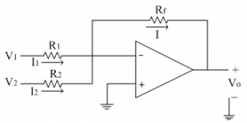
Let us assume currents I1 and I2 are flowing through resistances R1 and R2 respectively. Since input current to the op-amp is zero, the two currents are added to get current I, which flows through the feedback resistance Rf.
Thus by KCL at inverting terminal, we get
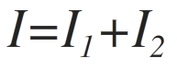
Substituting for the currents,
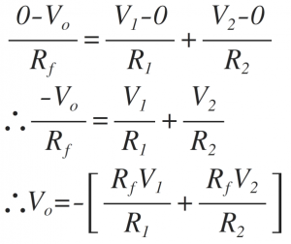
Thus the above equation gives the weighted addition of the two input signals (in the form mX + n Y, where m and n are the weights of inputs X and Y respectively)
If R1=R2=R
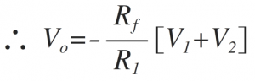
Thus the addition of the two input signals obtained with gain [-Rf/R ]
If Rf=R,
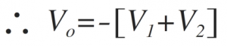
Thus the addition of two inputs obtained. The negative sign indicates that input and output are having 180̊ phase shift.
The above circuit can also be used to get the average of the two inputs, with the following substitution. Thus the circuit can be used as an averager.
If R=2Rf
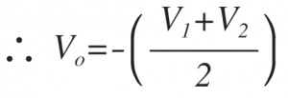
Non-inverting adder:
The input signals to be added are applied to the non-inverting input terminal of op-amp. The following figure shows the non- inverting adder using op-amp with two inputs V1 and V2.
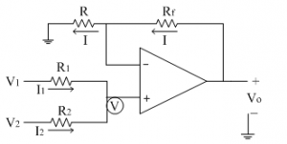
Let us assume currents I1 and I2 are flowing through resistances R1 and R2 respectively. Since input current to the op-amp is zero, the addition of the two currents is zero at non-inverting terminal.
Let the non-inverting terminal is at potential ‘V’. Due to virtual ground concept, the inverting terminal appears to be at the same potential ‘V’.
Thus by applying KCL at non-inverting terminal we get,
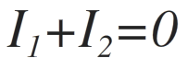
Substituting for the currents, we get
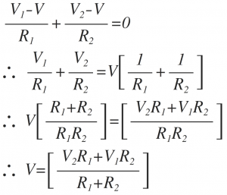
The current ‘I’ from the feedback path is given as,
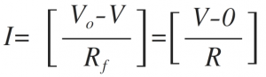
Solving the above equation for Vo, we get
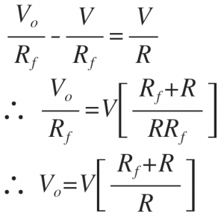
Substituting voltage ‘V’ from equation (1) in above Vo equation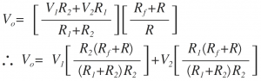

If R1=R2=R=Rf
∴Vo=V1+V2
SUBTRACTOR/DIFFERENCE AMPLIFIER
The subtraction of the two input voltages is possible with the help of subtractor. The subtractor using op-amp is shown in figure below. It is also called as difference amplifier.
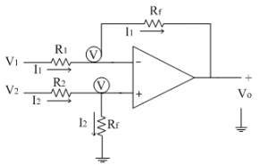
The input signals applied are V1 and V2.
Let us assume that the non-inverting terminal is at potential ‘V’. Due to virtual ground concept, the inverting terminal appears to be at the same potential ‘V’ as shown in the circuit diagram.
Let the current flowing through resistance R1 and R2 are I1 and I2 respectively. Since input current to the op-amp is zero, the two currents flows through the resistance Rf as shown in circuit diagram above. The current I2 is given as
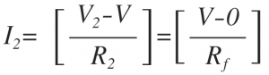
From the above equation voltage ‘V’ can be calculated as
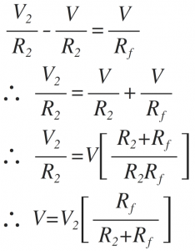
The current I1 is given as
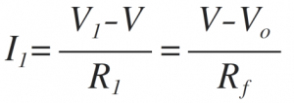
Simplify the equation,
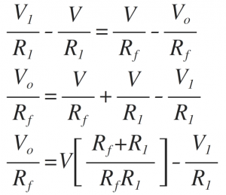
Substituting the voltage ‘V’ from the equation we get,
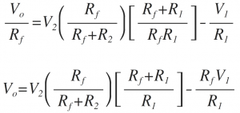
If R1=R2
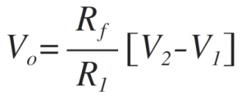
If R1=R2=Rf
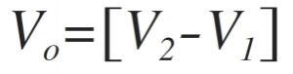
Thus at the output we get subtraction of the two input voltages.
The subtractor circuits are used to solve various mathematical equations.

- Explain the Comparator circuit of op-amp 741 IC.

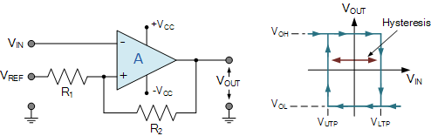
The Op-amp comparator compares one analogue voltage level with another analogue voltage level, or some preset reference voltage, V_{REF} and produces an output signal based on this voltage comparison. In other words, the op-amp voltage comparator compares the magnitudes of two voltage inputs and determines which is the larger of the two.
We have seen in previous tutorials that the operational amplifier can be used with negative feedback to control the magnitude of its output signal in the linear region performing a variety of different functions. We have also seen that the standard operational amplifier is characterized by its open-loop gain A_{O} and that its output voltage is given by the expression: V_{OUT} = A_{O}(V+ – V-) where V+ and V- correspond to the voltages at the non-inverting and the inverting terminals respectively.
Voltage comparators on the other hand, either use positive feedback or no feedback at all (open-loop mode) to switch its output between two saturated states, because in the open-loop mode the amplifiers voltage gain is basically equal to A_{VO}. Then due to this high open loop gain, the output from the comparator swings either fully to its positive supply rail, +Vcc or fully to its negative supply rail, -Vcc on the application of varying input signal which passes some preset threshold value.
The open-loop op-amp comparator is an analogue circuit that operates in its non-linear region as changes in the two analogue inputs, V+ and V- causes it to behave like a digital bistable device as triggering causes it to have two possible output states, +Vcc or -Vcc. Then we can say that the voltage comparator is essentially a 1-bit analogue to digital converter, as the input signal is analogue but the output behaves digitally.
Consider the basic op-amp voltage comparator circuit below.

Op-amp Comparator Circuit
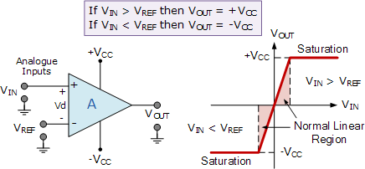
With reference to the op-amp comparator circuit above, lets first assume that V_{IN} is less than the DC voltage level at V_{REF}, ( V_{IN} < V_{REF} ). As the non-inverting (positive) input of the comparator is less than the inverting (negative) input, the output will be LOW and at the negative supply voltage, -Vcc resulting in a negative saturation of the output.
If we now increase the input voltage, V_{IN} so that its value is greater than the reference voltage V_{REF} on the inverting input, the output voltage rapidly switches HIGH towards the positive supply voltage, +Vcc resulting in a positive saturation of the output. If we reduce again the input voltage V_{IN}, so that it is slightly less than the reference voltage, the op-amp’s output switches back to its negative saturation voltage acting as a threshold detector.
Then we can see that the op-amp voltage comparator is a device whose output is dependant on the value of the input voltage, V_{IN} with respect to some DC voltage level as the output is HIGH when the voltage on the non-inverting input is greater than the voltage on the inverting input, and LOW when the non-inverting input is less than the inverting input voltage. This condition is true regardless of whether the input signal is connected to the inverting or the non-inverting input of the comparator.
We can also see that the value of the output voltage is completely dependent on the op-amps power supply voltage. In theory due to the op-amps high open-loop gain the magnitude of its output voltage could be infinite in both direction, (±&#8734). However practically, and for obvious reasons it is limited by the op-amps supply rails giving V_{OUT} = +Vcc or V_{OUT} = -Vcc.
We said before that the basic op-amp comparator produces a positive or negative voltage output by comparing its input voltage against some preset DC reference voltage. Generally, a resistive voltage divider is used to set the input reference voltage of a comparator, but a battery source, zener diode or potentiometer for a variable reference voltage can all be used as shown.

Comparator Reference Voltages
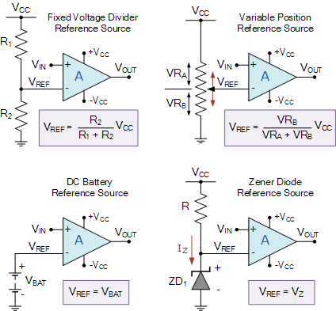
In theory the comparators reference voltage can be set to be anywhere between 0v and the supply voltage but there are practical limitations on the actual voltage range depending on the op-amp comparator being device used.
OR
Enumerate ideal parameters of an op-amp.
Op amp Parameters:
- Open Loop gain
Open loop gain is the gain of the Op Amp without a positive or negative feedback. An ideal OP Amp should have an infinite open loop gain but typically it range between 20,000 and 2, 00000.
- Input impedance
It is the ratio of the input voltage to input current. It should be infinite without any leakage of current from the supply to the inputs. But there will be a few Pico ampere current leakages in most Op Amps.
- Output impedance
The ideal Op Amp should have zero output impedance without any internal resistance. So that it can supply full current to the load connected to the output.
- Band width
The ideal Op Amp should have an infinite frequency response so that it can amplify any frequency from DC signals to the highest AC frequencies. But most Op Amps have limited bandwidth.
- Input Bias Current:
- The input bias current (I_{B}) is the average of the currents enter into the two input terminals with the output at zero volts.
- Typically the input bias current is around 80nA.
- This input bias current makes a voltage drop across the equivalent source impedance seen from the input side of opamp.
- Input Offset Current:
- The input offset current is the difference between the two input currents of the opamp with the output at zero volts.
- Typically the input offset current for a 741 op-amp is 20 nA .
- Input Offset Voltage
- In the ideal op amp when both inputs are at zero volts the output should be zero volts.
- Due to imbalances within the device a small amount of voltage will appear at the output.
- This extra voltage can be eliminated by giving a small voltage called Input offset voltage (V_{OS}) to the amplifier.
- Typically the input offset voltage for a 741 op-amp is around 1mV.
- Common-Mode Rejection Ratio:
- In OPAMP, the output voltage is proportional to the difference between the voltages applied to its two input terminals.
- When the two input voltages are equal ideally the output voltages should be zero.
- A signal applied to both input terminals of the opamp is called as common-mode signal. Usually it is an unwanted noise voltage.
- The ability of an op amp to suppress common-mode signals is expressed in terms of its common-mode rejection ratio (CMRR).
- Typically the CMRR for a 741 op-amp is around 90 dB.
CMRR=20 log₁₀[Differential Voltage Gain/Common Mode Gain] dB
- Slew Rate
- The slew rate is the maximum rate of change of output voltage for a step input voltage.
- The slew rate makes the output voltage to change at a slower rate than the applied input.
- Eventually the output waveform is a distortion of the input waveform.
- The typical value for the slew rate is 0.5V/μs.
- Draw and explain frequency to Voltage converter with suitable diagram.

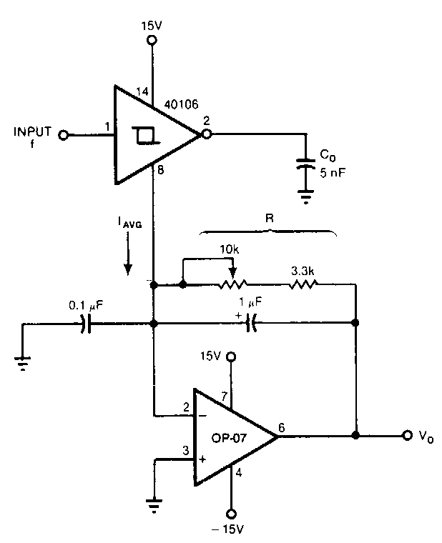
Frequency to voltage converter is an electronic device which converts the sinusoidal input frequency into a proportional current or output voltage.The basic circuit includes operational amplifiers and RC circuits (Resistor Capacitor networks). The operational amplifiers are used for signal processing. And the RC networks are used to remove the frequency dependent ripples. The diagram below shows the basic circuit of frequency to voltage converter using op-amp and RC networks:
The input frequency given to this converter can be in the range of 0-10 kHz. And the output can be between 0 to -10 V.
The above block diagram shows a frequency to voltage converter. The circuit charges the capacitor to a certain level. An integrator is connected in it and the capacitor discharges into this integrator or a low pass circuit. This happens for all the cycles of the input waveform. The precision switch and the monostable multivibrator generate a pulse of a specific amplitude and period which is fed into the averaging network. Hence we get a DC voltage at the output.
OR
Explain the Differentiator circuit of op-amp 741 IC.
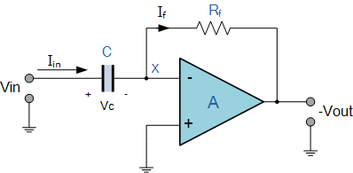
Here, the position of the capacitor and resistor have been reversed and now the reactance, X_{C} is connected to the input terminal of the inverting amplifier while the resistor, Rƒ forms the negative feedback element across the operational amplifier as normal.
This operational amplifier circuit performs the mathematical operation of Differentiation, that is it “produces a voltage output which is directly proportional to the input voltage’s rate-of-change with respect to time“. In other words the faster or larger the change to the input voltage signal, the greater the input current, the greater will be the output voltage change in response, becoming more of a “spike” in shape.
As with the integrator circuit, we have a resistor and capacitor forming an RC Networkacross the operational amplifier and the reactance ( Xc ) of the capacitor plays a major role in the performance of a Op-amp Differentiator.

Op-amp Differentiator Circuit
The input signal to the differentiator is applied to the capacitor. The capacitor blocks any DC content so there is no current flow to the amplifier summing point, X resulting in zero output voltage. The capacitor only allows AC type input voltage changes to pass through and whose frequency is dependant on the rate of change of the input signal.
At low frequencies the reactance of the capacitor is “High” resulting in a low gain ( Rƒ/Xc ) and low output voltage from the op-amp. At higher frequencies the reactance of the capacitor is much lower resulting in a higher gain and higher output voltage from the differentiator amplifier.
However, at high frequencies an op-amp differentiator circuit becomes unstable and will start to oscillate. This is due mainly to the first-order effect, which determines the frequency response of the op-amp circuit causing a second-order response which, at high frequencies gives an output voltage far higher than what would be expected. To avoid this the high frequency gain of the circuit needs to be reduced by adding an additional small value capacitor across the feedback resistor Rƒ.
Ok, some math’s to explain what’s going on!. Since the node voltage of the operational amplifier at its inverting input terminal is zero, the current, i flowing through the capacitor will be given as:
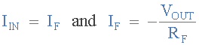
The charge on the capacitor equals Capacitance times Voltage across the capacitor
Thus the rate of change of this charge is:
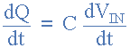
but dQ/dt is the capacitor current, i
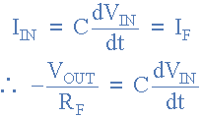
from which we have an ideal voltage output for the op-amp differentiator is given as:
