SOLUTION : Set A
Q1. Questions with "at least" are often great candidates for using the complement.
That is: P(Event A occurs) = 1 - P(Event A does not occur)

So, P(miss at least 1 test) = 1 - P(miss no tests)

P(miss no tests)
P(miss no tests) = P(no test on day 1 AND no test on day 2)
= P(no test on day 1) X P(no test on day 2)
= (4/5) X (4/5)
= 16/25

So, P(miss at least 1 test) = 1 - P(miss no tests)
= 1 - 16/25
=9/25.
OR
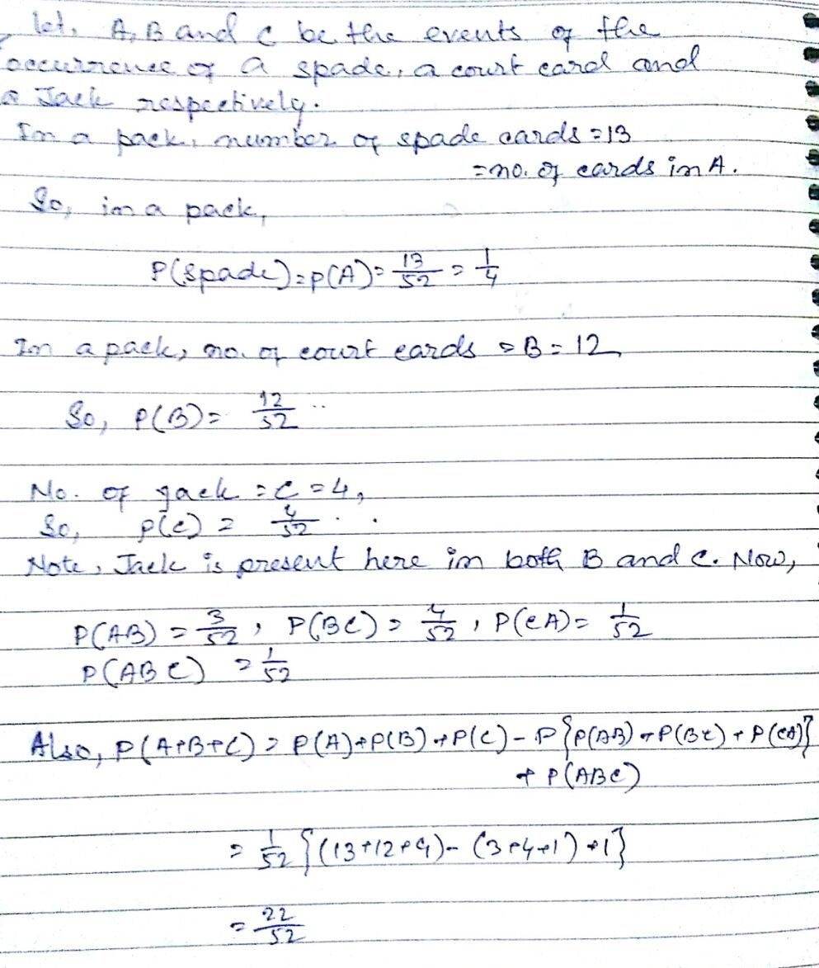
Q1.

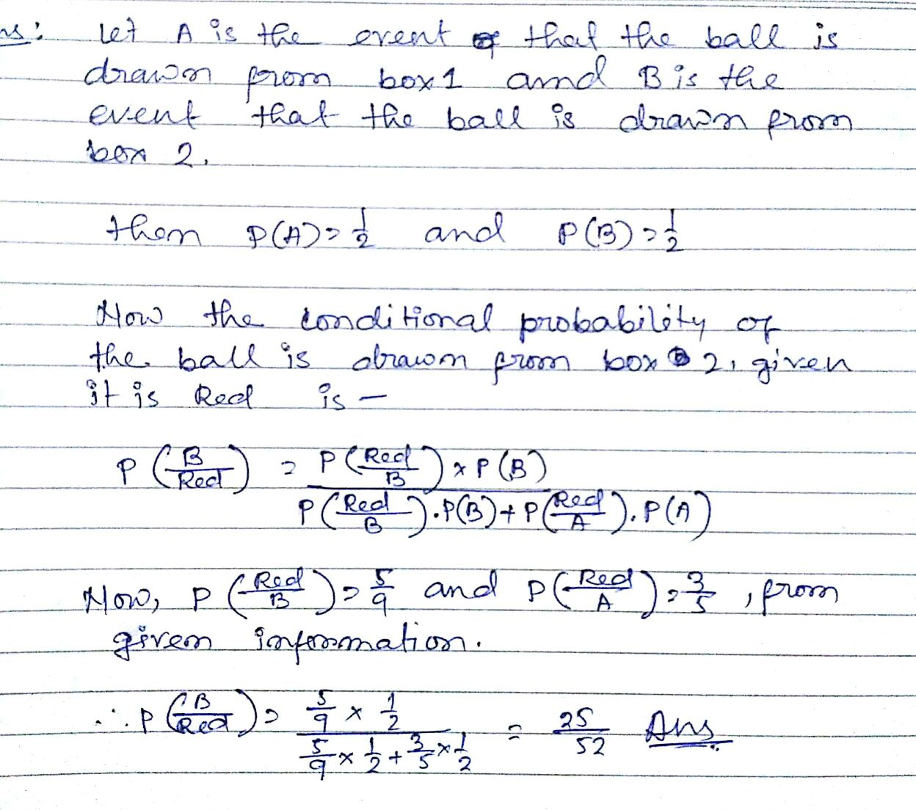
Q2.

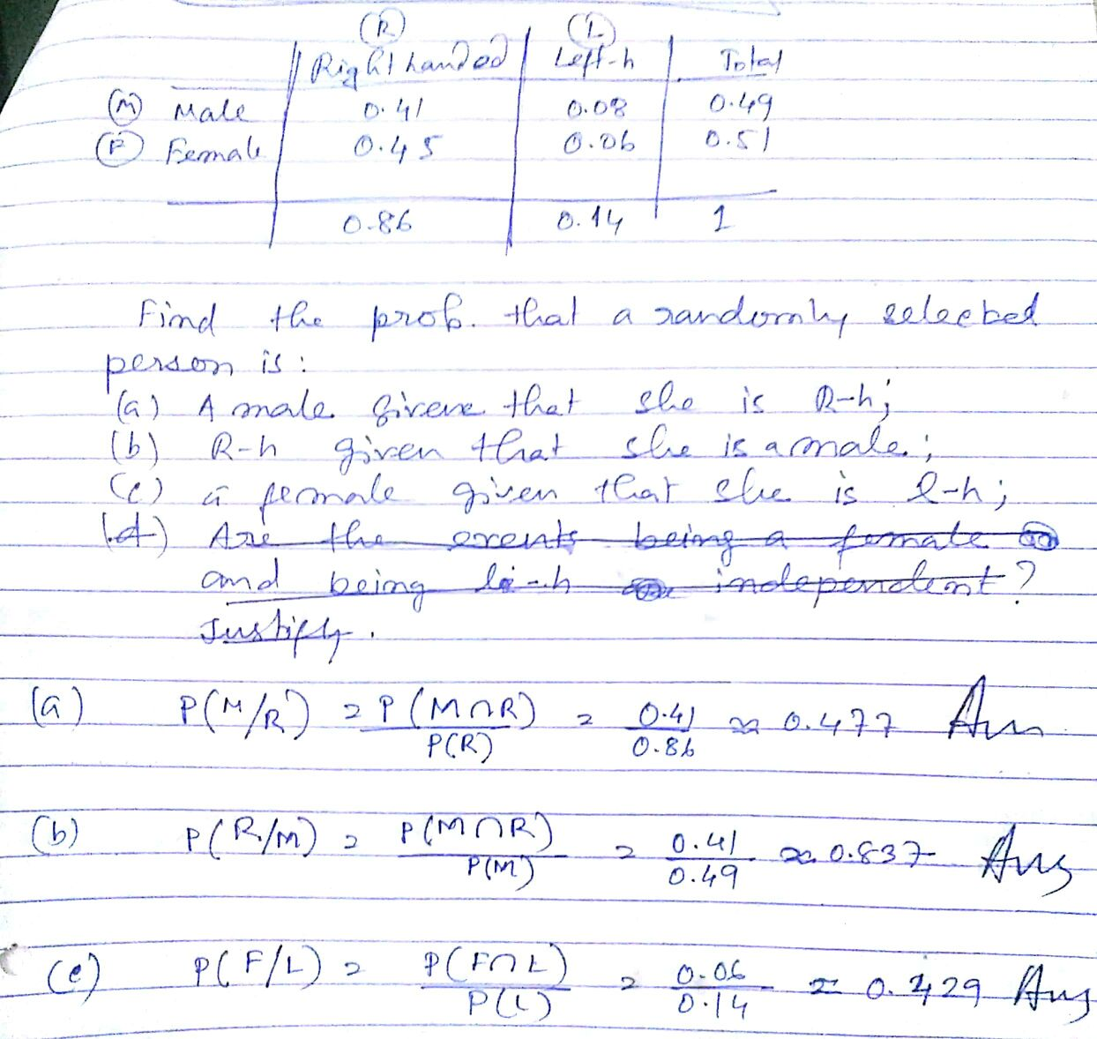
OR
Q2.

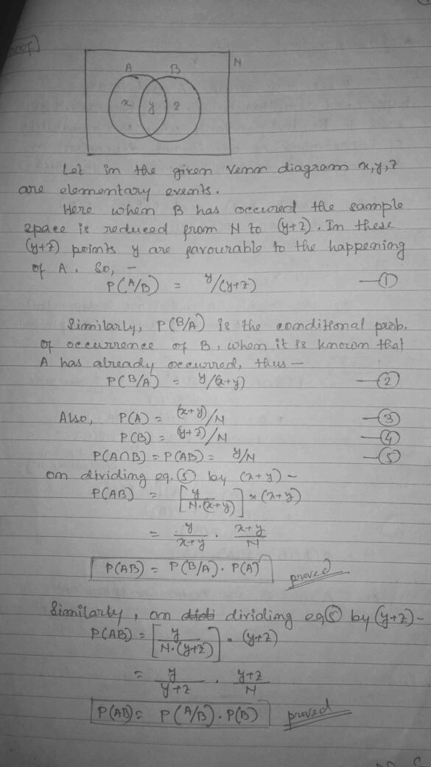
Q3.

OR
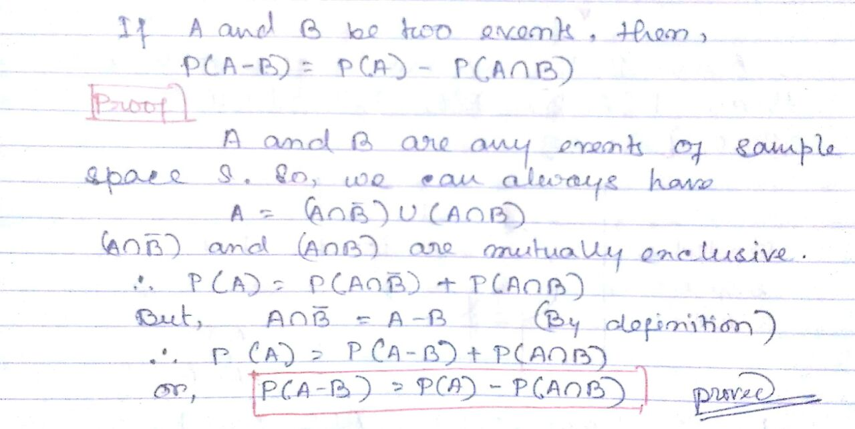
Q3.

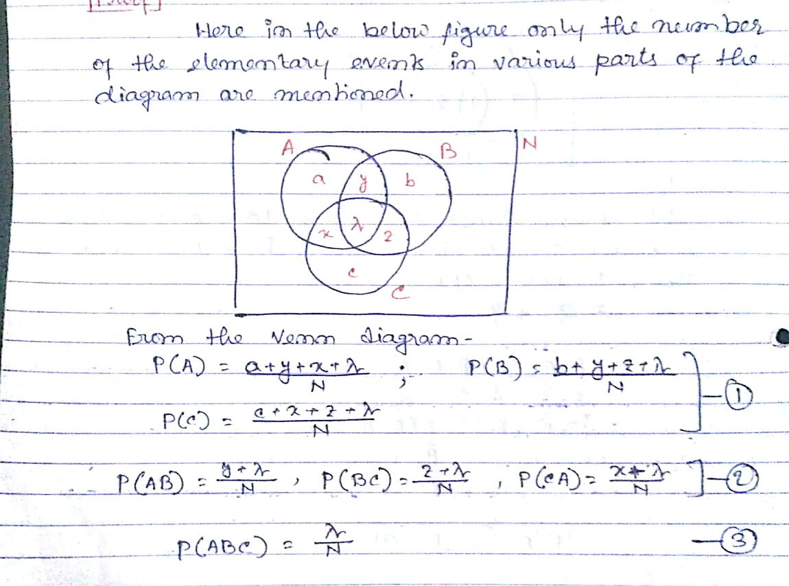
Q4.

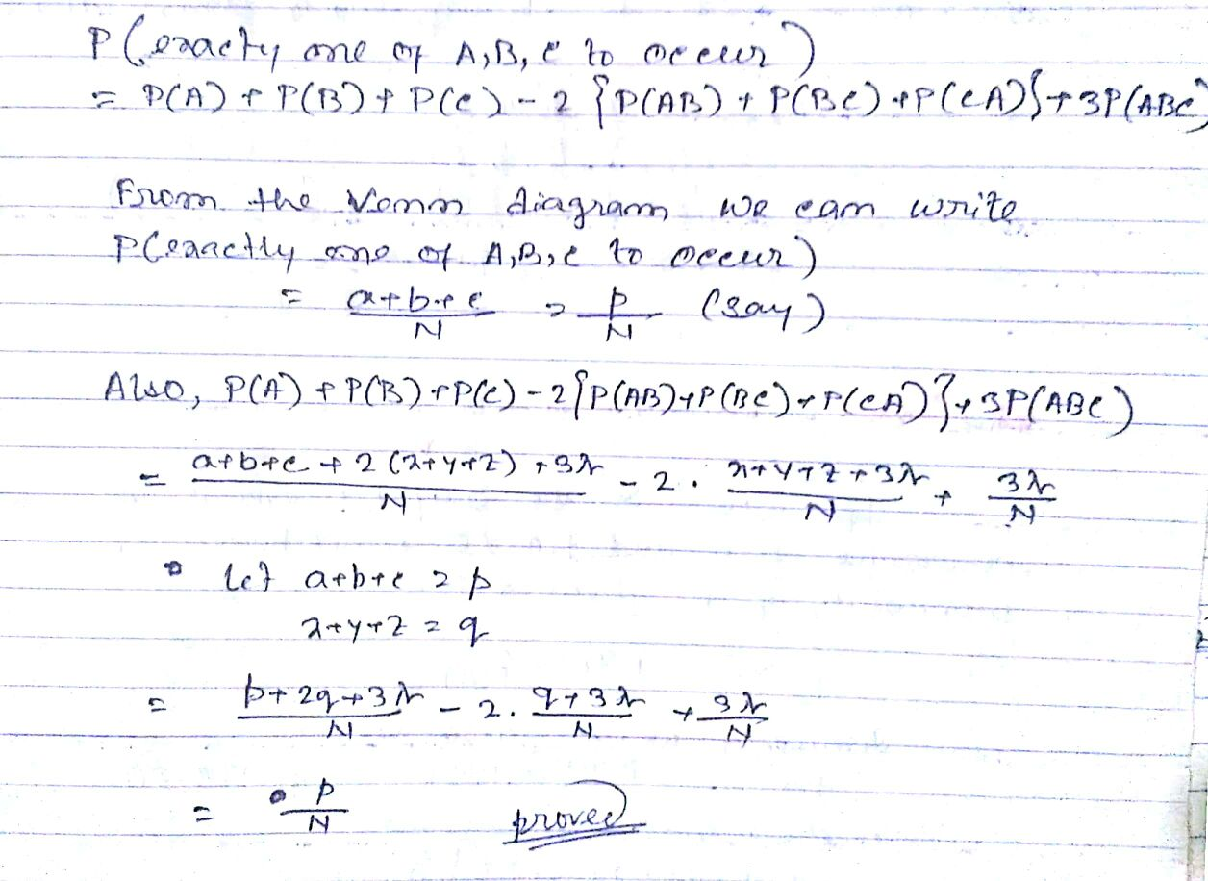

OR
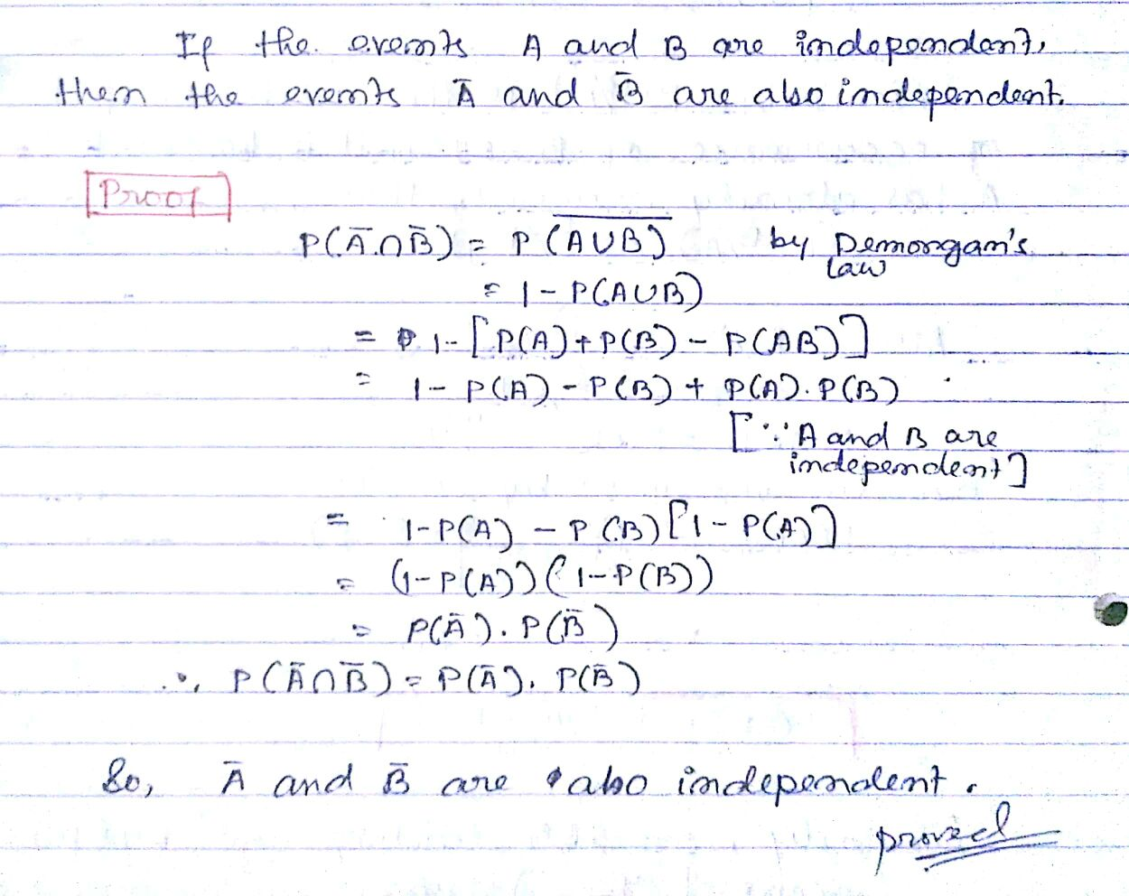
Q4.

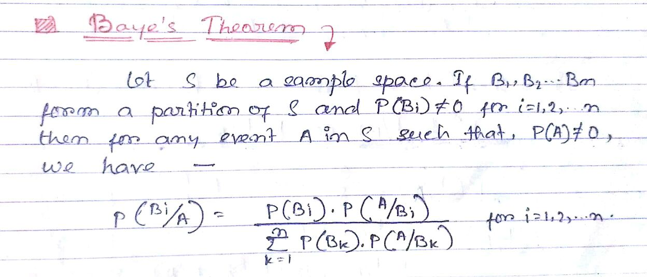
SOLUTION: SET B
Q1.

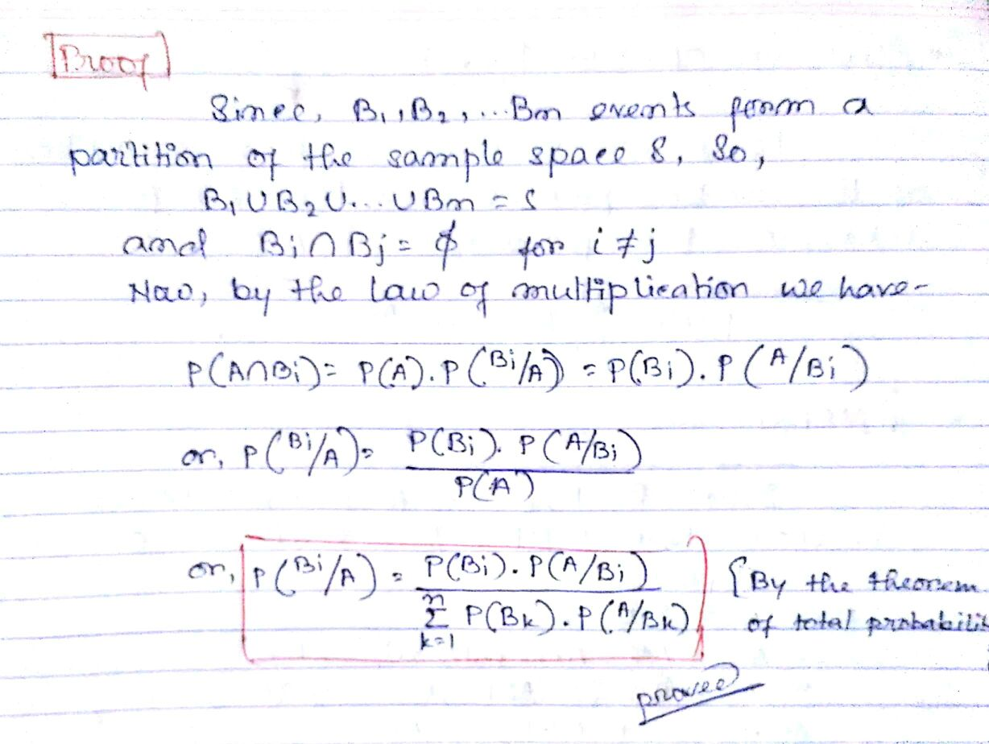

OR
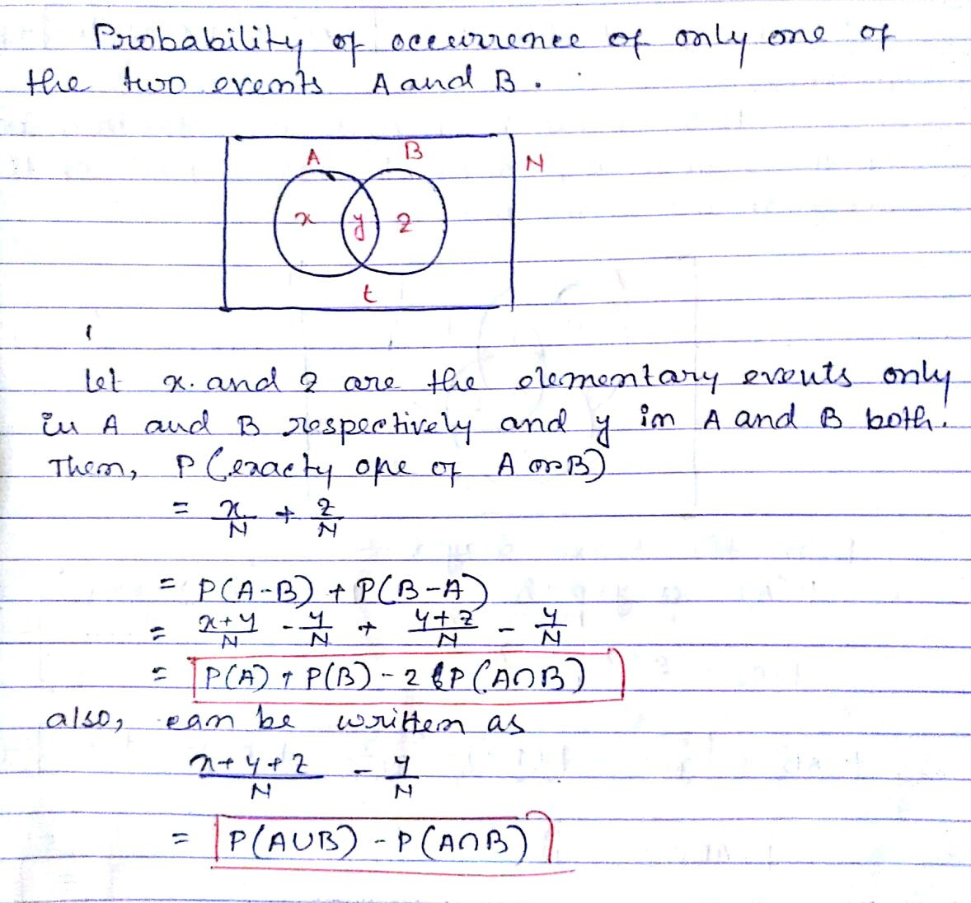
Q1.

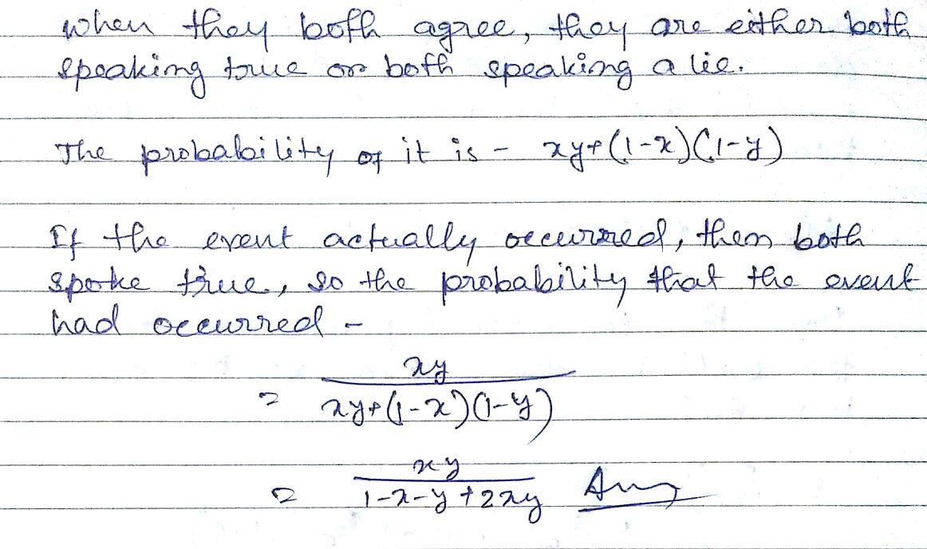
Q2

OR
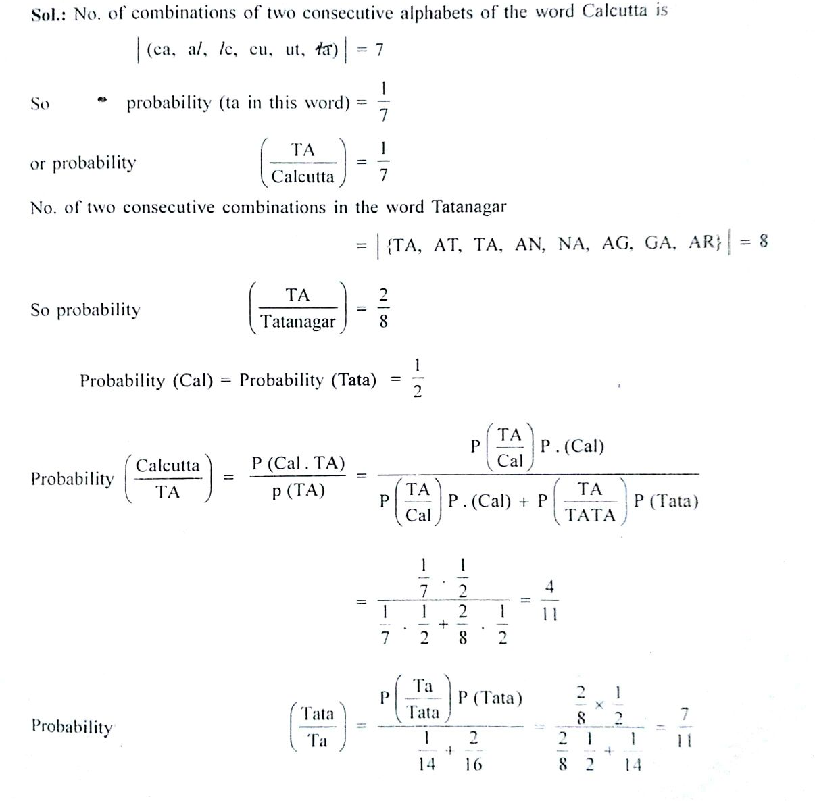
Q2.
Q3.
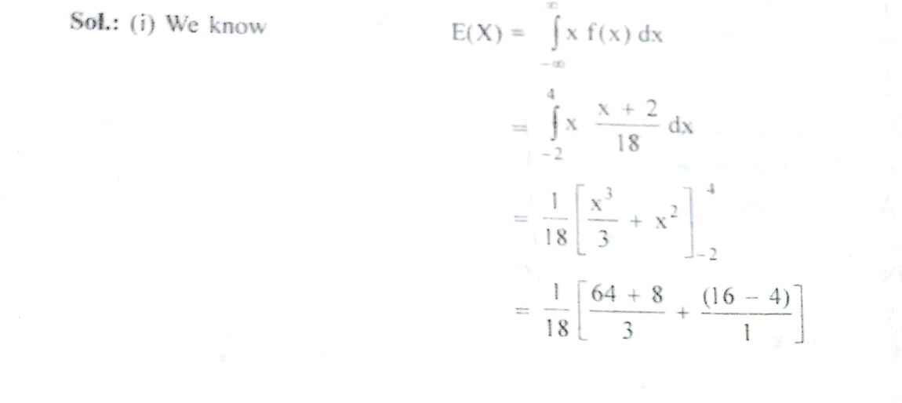

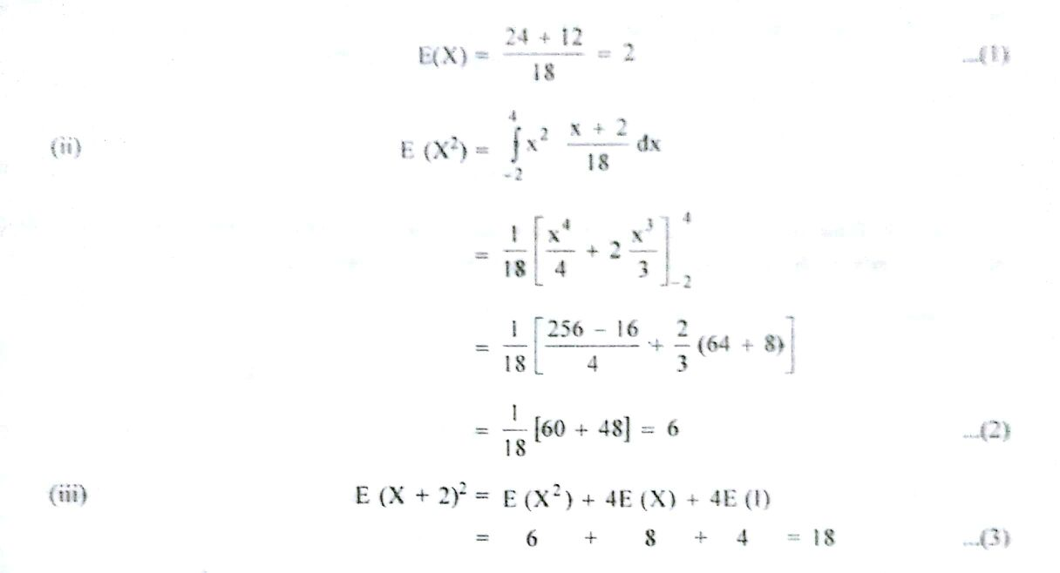

OR
Q3.
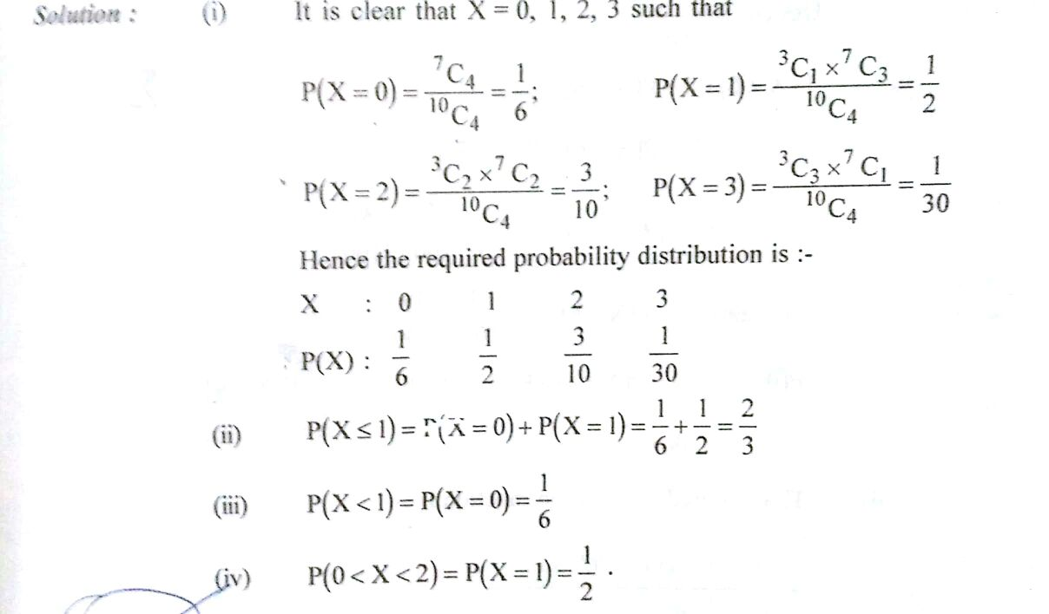

Q4.

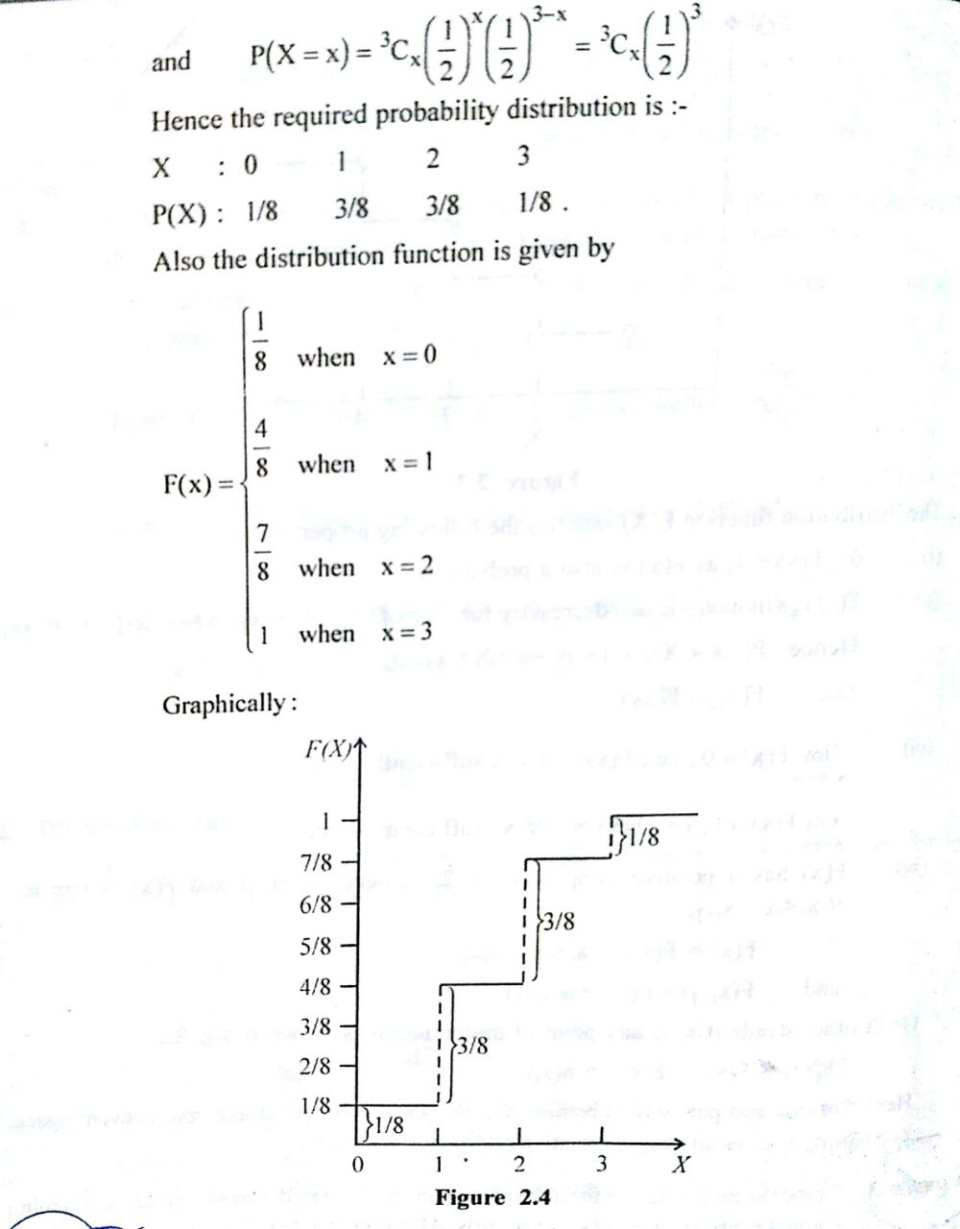
OR
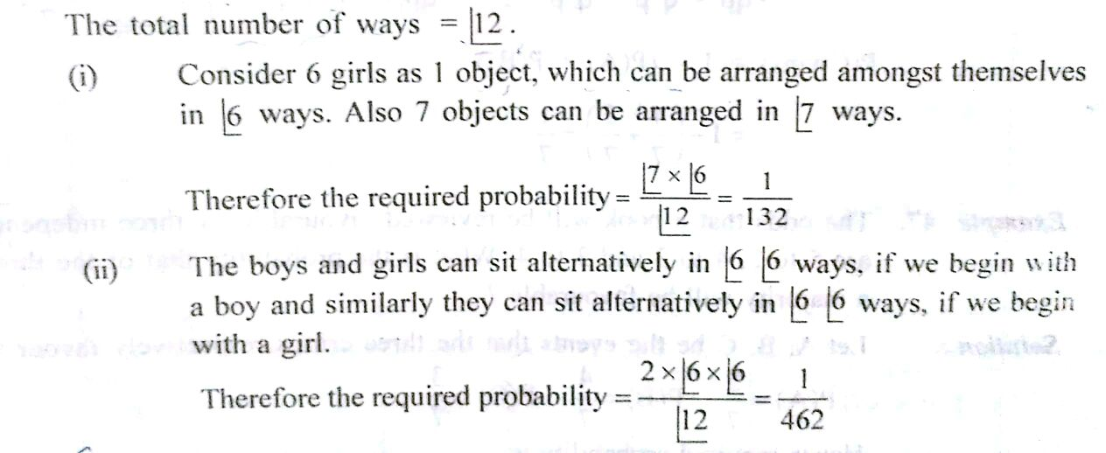
Q4.

