Q1. Explain Karush-Kuhn-Tucker conditions with example
The method of Lagrange Multipliers is used to find the solution for optimization problems constrained to one or more equalities. When our constraints also have inequalities, we need to extend the method to the KKT conditions.
The new problem can be formulated as:
x∗=argminxf(x)
subject to hi(x)=0,∀i=1,..,m
subject to gi(x)≤0,∀i=1,..,n
In words, find the solution that minimizes f(x), as long as all equalities hi(x)=0 and all inequalities gi(x)≤0 hold. It is easy to see that any equality or inequality constraint can be defined, so long as all terms are in the left side of the equation. The inequality conditions are added to the method of Lagrange Multipliers in a similar way to the equalities: Put the cost function as well as the constraints in a single minimization problem, but multiply each equality constraint by a factor λi and the inequality constraints by a factor μi (the KKT multipliers). In our example, we would have m equalities and n inequalities. Hence the expression for the optimization problem becomes:

x∗=argmin xL(x,λ,μ)=argmin xf(x)+∑mi=1λihi(x)+∑ni=1μigi(x),
where L(x,λ,μ) is the Lagrangian and depends also on λ and μ, which are vectors of the multipliers.
As usual, we find the roots of the gradient of the loss function with respect to x to find the extremum of the function. However, the constraints in the function will make x depend on λ and μ. Furthermore, we have number of variables equal to the elements in x (say k) plus the number of multipliers (m+n), and, as of now, we only have k equations coming from the gradient with respect to x. We have seen before that we can differentiate the function with respect to each lagrange multiplier λi to get m more equations. These equations are restricting the set of solutions to the ones that meet the equality constraints.
The new challenge is how to come up with n more equations coming from the inequality constraints. In order to do so, think of what the inequality constraints mean. If the extremum of the original function is in gi(x∗)<0, then this constraint will never play any role in changing the extremum compared with the problem without the constraint. Therefore, its coefficient μi can be set to zero. If, on the other hand, the new solution is at the border of the constraint, then gi(x∗)=0. The next graphical representation helps to understand this concept.
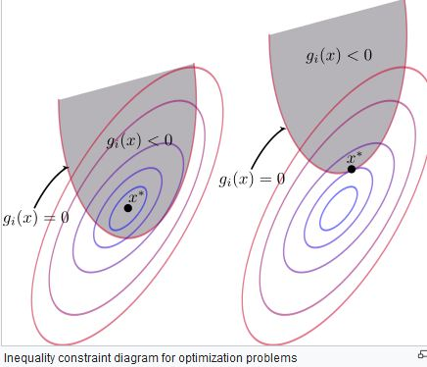
Fig. 1 - Graphical explanation for the KKT conditions.
In both situations, the equation:
itis necessary for the solution to our new problem. Therefore, we get n equations from the inequality constraints. The constraint terms are always zero in the set of possible solutions, thereby not affecting the result of the loss function. The coefficients λi can have any value. However, the coefficients μi are limited to nonnegative values. To see why that is, and with the aid of Fig. 2, imagine x∗ is in the region gi(x)=0, so that μi can be different from zero.
- Stationarity
∇xf(x)+∑mi=1∇xλihi(x)+∑ni=1μi∇xgi(x)=0 (minimization)
∇xf(x)+∑mi=1∇xλihi(x)−∑ni=1μi∇xgi(x)=0 (maximization)
- Equality constraints
∇λf(x)+∑mi=1∇λλihi(x)+∑ni=1μi∇λgi(x)=0
- Inequality constraints a.k.a. complementary slackness condition
μigi(x)=0,∀i=1,..,n
i≥0,∀i=1,..,n

An example
Consider we are trying to maximize the transmission rate of a multi-carrier communication system with N channels. Each carrier/channel can carry a signal power pi≥0 under noise ni>0. The total power must be smaller or equal than P. The transmission rate of each carrier is proportional to:
log2(1+pini)
Given this information, and noting that maximizing ln(x) also maximizes log2(x), the problem is:
max∑Ni=1ln(1+pini)
subject to ∑Ni=1pi≤P
subject to pi≥0,∀i=1,..N
Changing pi≥0 to −pi≤0 and noting that this a maximization problem, the Lagrangian is then:
L(p,μ)=ln(1+pini)−μ0(∑Ni=1pi−P)−∑Ni=1μi(−pi)
L(p,μ)=ln(1+pini)+μ0(P−∑Ni=1pi)+∑Ni=1μipi
Taking the stationarity condition, we get:
∇piL(p,μ)=1pi+ni−μ0+μi=0
pi+ni=1μ0−μi
Since ni>0, then μ0>μi, which also means that μ0>0. From the complimentary slackness conditions:
μ0(P−∑Ni=1pi)=0
μipi=0
μ0,μi≥0
and since μ0>0, we know that
P−∑Ni=1pi=0
P=∑Ni=1pi
which means that pi cannot be zero (all of them since they all have the same role in the optimization problem), forcing μi=0,∀i=1,..,N. Then
pi+ni=1μ0−μi=1μ0
pi=1μ0−ni
The final equations to solve the problem are:
pi=1μ0−ni,∀i=1,..,N
∑Ni=1pi=P
which are easily solvable.

Sufficiency and regularization
The KKT conditions are necessary to find an optimum, but not necessarily sufficient. A set of problems where these conditions are also sufficient are the ones where the functions f(x) and gi(x) are continuously differentiable and convex, and the functions hi(x) are linear.
Q2 What are the engineering applications of optimization? Explain briefly.

What is Engineering Optimization?
Optimization is the act of obtaining the best result under given circumstances. the word ‘optimum’ is taken to mean ‘maximum’ or ‘minimum’ depending on the circumstances. In design, construction, and maintenance of any engineering system, engineers have to take many technological and managerial decisions at several stages. The ultimate goal of all such decisions is either to minimize the effort required or to maximize the desired beneﬁt. Since the effort required or the beneﬁt desired in any practical situation can be expressed as a function of certain decision variables, so optimization can be deﬁned as the process of ﬁnding the conditions that give the maximum or minimum value of a function
The optimum searching methods are also known as mathematical programming techniques and are generally studied as a part of operations research. Operations research is a branch of mathematics concerned with the application of scientiﬁc methods and techniques to decision making problems and with establishing the best or optimal solutions.
ENGINEERING APPLICATIONS OF OPTIMIZATION
Optimization, in its broadest sense, can be applied to solve any engineering problem e.g.
1. Running a business to maximize proﬁt, minimize loss, maximize efficiency, or minimize risk.
2. It might mean designing a bridge to minimize weight or maximize strength. It might mean selecting a ﬂight plan for an aircraft to minimize time or fuel use.
3. Design of water resources systems for maximum Benet
4. Planning the best strategy to obtain maximum proﬁt in the presence of a competitor
5. Planning of maintenance and replacement of equipment to reduce operating costs
The power of optimization methods to determine the best case without actually testing all possible cases comes through the use of a modest level of mathematics and at the cost of performing iterative numerical calculations using clearly deﬁned logical procedures or algorithms implemented on computing machines.

Q3 Explain Penalty. Function methods of optimization with example
A penalty method replaces a constrained optimization problem by a series of unconstrained problems whose solutions ideally converge to the solution of the original constrained problem. The unconstrained problems are formed by adding a term, called a penalty function, to the objective function that consists of a penalty parameter multiplied by a measure of violation of the constraints. The measure of violation is nonzero when the constraints are violated and is zero in the region where constraints are not violated.

Example
Let us say we are solving the following constrained problem:
subject to
This problem can be solved as a series of unconstrained minimization problems

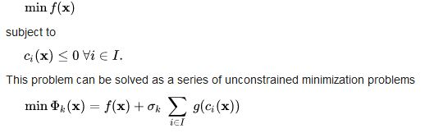
where
In the above equations, is the exterior penalty function while are the penalty coefficients. In ach iteration k of the method, we increase the penalty coefficient (e.g. by a factor of 10), solve the unconstrained problem and use the solution as the initial guess for the next iteration. Solutions of the successive unconstrained problems will eventually converge to the solution of the original constrained problem.
low bound to 0, the high bound to 1 and an exclusive range of 0 and .25. Any value > 0 and < would be excluded. Multiple exclusive ranges can be defined on one decision variable.
Q4Find the point of Minima of the Function £(x)=x² -2.6 x+2 in the interval -2 ≤x ≤3 using Golden section Method .Take the final interval of uncertainly to be 0.2

Solution
Initial step a₁ ₌ 2 b₁ =3 and l =0.2
HENCE ƛ ₁=-2 +0.382 x 5 =0,9 µ₁₌ ₂₌₀.618x 5 =1,09,
Thefore (ƒ₁₎ = 2.242+ƒ(µ) ₁ ₌67
We set k and go to iterative steps
Iterative steps
Since (Ib₁-a₁₎ =5> l =0.2and ƒ (ƛ ₁) > ƒ(µ₁₎ we put a₂= ƛ ₁ =0.09, b₁=3
And set ƛ ₂ = µ₁ =1.09
Now µ₂ =-0.09+ 0,618 x 3.09 =1.820.
And ƒ(ƛ ₂₎= 0.3541, ƒ(µ₂₎ 0.5804 so we go back (i)
Repealing the process according to algorithm we get a₈ = 1.192and b₈ 1.192
since b₈ ₋ a₈ <l the minimum value of x may be taken (1,192+1.356 )/2 = 1.274 with f(x) =0.3107

Q5. Describe the Geometric optimization and its applications

Geometric programming was introduced in 1967 by Duffin, Peterson and Zener. It is very useful in the applications of a variety of optimization problems, and falls under the general class of binomial problems [1]. It can be used to solve large scale, practical problems by quantifying them into a mathematical optimization model. Geometric programs (GP) are useful in the context of geometric design and models well approximated by power laws. Applications of GP include electrical circuit design and other topics such as finance and statistics [
A geometric program is composed of an objective function that is subjected to constraints. All of the components must be in the nature of monomials and polynomials. A monomial is a single term and takes the form of
where the coefficient C>0 and the exponents, . Note that use of “monomial” is different from the meaning in algebra; here, monomials can have negative exponents. A polynomial takes the form of the sum of one or more monomials:
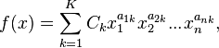
A geometric program in standard form looks like this:
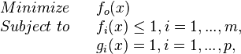
where f_{i} are polynomials, g_{i} are monomials, and x_{i} are optimization variables. The objective must be to minimize a polynomial. Often times the geometric program must be reformulated into standard form. If presented with a maximizing problem, the inverse can be taken to convert it into a minimizing problem[2].

Example
Consider the following example problem:
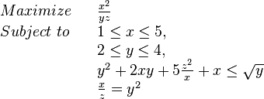
with variables .
The equivalent standard form GP is as follows

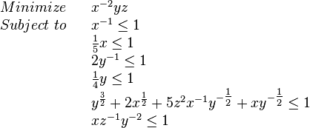
In order to solve a GP, there are many factors to consider. The GP must be in a specific form in order to solve, and we must determine the feasibility of the problem.

Convex Form
In order to solve a geometric program, it must be reformulated into a nonlinear, convex optimization problem via a change in variables. By applying a logarithmic transformation, GP can be seen as an extension of linear programming. Setting y_{i} = log x_{i} results in the following GP:
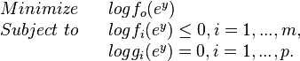
By transforming the GP into this form, it can be solved more efficiently[2].

Feasibility
In order to solve the GP, the problem must be feasible. If it is not feasible, then no optimal solution will be found. In this case, at least one constraint must be relaxed. This can be done by adding a new scalar variable, s, to find a value x̂ that is “close to feasible.” The GP now looks like this:
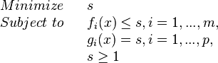
This problem can be solved to find the optimal values of x̄ and s̄. S̄ is indicative of how feasible the original GP is.For example. If s̄=1, then x̄ is feasible for the original problem. If s̄ is greater than 1, then we set x̂ equal to x̄.
Solvers also may use a trade-off analysis of the GP, where the constraints are varied to see how they may affect the optimal solution. This results in a “perturbed” GP, and can be modeled as:
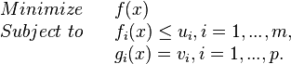
Instead of having the constraints less than or equal to 1 or equal to 1, it is instead replaced with
parameters u and v which are positive constants. If u is greater than one, then the inequality constraint is loosened; if u is less than 1, then the inequality constraint is tightened. Solving this perturbed model for different values of u and v allows analysis on how these values relate to the optimal solution. An optimal trade-off curve can be formed by plotting p(u,v) versus u_{i}, with all other u_{i} and v_{j} equal to one. This will display the “optimal trade-off” of the i th inequality constraint and objective.
Similarly, a sensitivity analysis allows the examination of how small changes in the constraints affects the optimal solution
There are many different applications of GPs in different fields. Here are some examples:
- Engineering
  - Membrane separation process design
  - Chemical equilibrium problems
  - Statistical mechanics
  - Minimum weight design
  - Entropy maximization
  - Optimizing nuclear systems
  - Structural design
- Other
  - Regional planning of economic models
  - Inventory models in management science
  - Transportation planning
  - Maximizing reliability

