Rajasthan Institute of Engineering & Technology, Jaipur
University Roll No. ______________

I Year MBA. Semester II. I Mid Term Examination, March – 2018
Subject: - OSM SET-A
Time: - 2 Hrs. [Maximum Marks: -20]
[Min. Passing Marks: 08]
Instructions to the Candidates:
Attempt any 4 questions from Section A and Section B is Compulsory.
Section A
- What is SCM? Discuss the types of supply chain in detail.
Ans- SCM Is the strategic management of activities involved in the acquisition and conversion of materials to finished products delivered to the customer.
Supply chain is the system by which organizations source, make and deliver their products or services according to market demand.

Supply Chain Includes:
- Material Flows
- Information Flows
- Financial Flows

- Explain the detail aspect of operational and supply strategy.
Ans- Main aspects are as follows:-
Strategic-
- Supply Chain Design
- Resource Acquisition
- Long Term Planning (More Than 1 Year)

Tactical-
- Production/ Distribution Planning
- Resource Allocation
- Medium Term Planning (Qarterly,Monthly)

Operational-
- Shipment Scheduling
- Resource Scheduling
- Short Term Planning (Weekly, Daily)
- Distinguish between operations and production management.
Basis for Comparison | Production Management | Operations Management
Meaning | Production Management connotes the administration of the range of activities belonging to the creation of products. | Operations Management refers to the part of management concerned with the production and delivery of goods and services.
Decision Making | Related to the aspects of production. | Related to the regular business activities.
Found in | Enterprises where production is undertaken. | Banks, Hospitals, Companies including production companies, Agencies etc.
Objectives | To produce right quality goods in right quantity at right time and at least cost. | To utilize resources, to the extent possible so as to satisfy customer wants.

- Define the importance of supply chain management.

Boost Customer Service

Reduce Operating Costs

Decreases Purchasing Cost

Decreases Production Cost

Decreases Total Supply Chain Cost

Improve Financial Position

Increases Profit Leverage

Decreases Fixed Assets

Increases Cash Flow

Improve Quality of Life

Foundation for Economic Growth

Improves Standard of Living

Job Creation

- Define the structure of supply chain management.
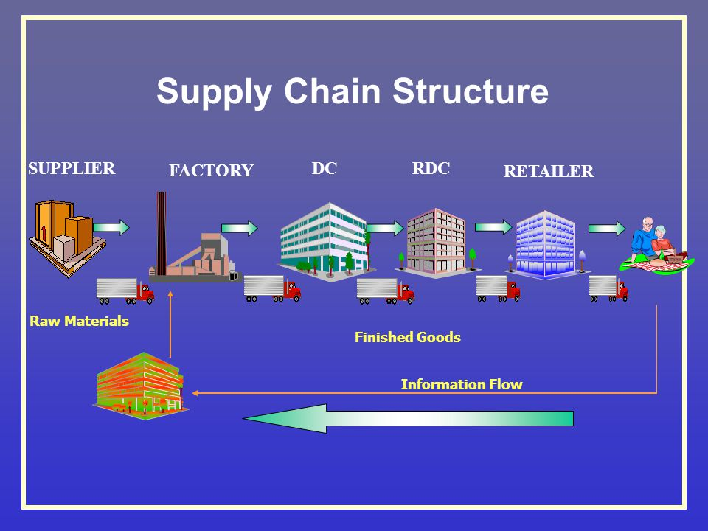
Ans-
- Explain supply chain drivers.
Ans- SUPPLY CHAIN DRIVERS
  - Demanding customers
  - Shrinking product life cycles
  - Proliferating product offerings
  - Growing retailer power in some cases
  - Doctrine of core competency
  - Emergence of specialized logistics providers
  - Globalization
  - Information technology

Section B
- Explain the Strategic decisions in operations with the help of real example.

Strategic OM Decisions
These three concepts come into play as operations managers make good decisions in the seven major functional areas of operations management, otherwise known as operations decisions.
- Product and Service Management. What good or service do we offer and what is the design of it?
- Operations and Supply Chain Management. Should we make or buy what we need to produce our good or service? If we purchase it, who can supply it?
- Inventory Management. How much should we keep on hand? When do we re-order?
- Forecasting and Capacity Planning. What does the short-term and long-term schedule look like? How much can we make in what period of time?
- Operations Scheduling. What do we need for materials? Personnel?
- Management of Quality. What quality system should we use? What impact does quality have on our organization?
- Facilities Planning and Management. How is the facility used in production? What is its relationship to other resources? How should it be arranged?
When sound operations management decisions are made, it shows that the strategies were effective, and the organization's mission can be met.
- Provide better goods and services.
- Improve the organization's supply chain.
- Reduce costs, such as labor, tariffs, taxes, and more.
- Learn to improve operations.
- Understand other markets.
- Employ top-of-the-line contributors from all over the world.
- What do you understand by operation strategy structure?
Ans- The finance flow lead in the smooth functioning of the operation department and then input material purchased and proceeds for output. Output goes out for the transformation in sales by help of supply chain management and it again creates revenue for the organization.

