**

**I Mid Term Examination**

**Session: 2017-18**

**B.Tech I Year (II Semester)**

**Subject with code: PY102**

**SET-A**

Time: 2 hrs. M.M.:20

**Instruction for students:**

1. No provision for supplementary answer book.
2. Question paper contains two sections. Sec A- compulsory (which includes 8 short answers type questions of 0.5 marks each). Sec B- contains 06 Questions out of which any 04 questions to be attempt by the student (4 marks each).

**SECTION-A**

**Q1.**What is interference of light ?

**Sol**: Interference

The superposition of two or more waves propagating through a given region. Depending on how the peaks and troughs of the interacting waves coincide with each other, the resulting wave amplitude can be higher or smaller than the amplitudes of the individual waves

◇ When two waves interact so that they rise and fall together more than half the time, the amplitude of the resulting wave is greater than that of the larger wave. This is called constructive interference.

 ◇ When two waves interact such that they rise and fall together less than half the time, the resulting amplitude is smaller than the amplitude of the stronger wave. This interference is called destructive interference. It is possible for two waves of the same magnitude to completely cancel out in destructive interference where their sum is always zero, that is, where their peaks and troughs are perfectly opposed.

|  |  |  |
| --- | --- | --- |
|  | **PATH DIFFERENCE** | |
|  | 2 sources in phase | 2 sources ππ out of phase |
| Constructive interference | nλ or 0 | (n + 1/2)λ |
| Destructive interference | (n + 1/2)λ | nλ or 0 |

**Q2.** State the condition for sustain interference ?

## Sol: **CONDITION FOR SUSTAINED INTERFERENCE OF LIGHT**

To obtain well defined interference patterns, the intensity at points corresponding to destructive interference must be zero, while intensity at the point corresponding to constructive interference must be maximum. To accomplish this the following conditions must be satisfied.

* The two interfering sources must be coherent, that is, they must keep a constant phase difference.
* The two interfering sources must emit the light of the same wavelength and time period. This condition can be achieved by using a monochromatic common original source, that is, the common source emits light of a single wavelength.
* The amplitudes or intensities of the interfering waves must be equal or very nearly equal so that the minimum intensity would be zero.
* The separation between the two coherent sources must be as small as possible so that the width (D ?/2 *d*) of the fringes is large and are separately visible.
* The two sources must be narrow or they must be extremely small. A broad source is equivalent to a large number of fine sources. Each pair of fine sources will give its own pattern. The fringes of different interference patterns will overlap.
* The distance between the two coherent sources and the screen must be as large as possible so that the width of fringes (D ? */*2 *d*) is large and are separately visible.
* The two interference waves must be propagated along the same direction so that their vibrations are along a common line.

**Q3.**State principle of superposition ?

**Sol:**The superposition principle states that when two or more waves overlap in space, the resultant disturbance is equal to the algebraic sum of the individual disturbances. Or The **Principle Of Superposition** states that when two **waves** of the same kind meet at a point in space, the resultant displacement at that point is the vector sum of the displacements that the two **waves** would separately produce at that point.

**Q4.**What are the condition for constructive and destructive interference?

Sol: Constructive Interference: When crest of one wave falls on crest of another wave,the amplitude of the resultant wave is always greater than the two superimposing waves.

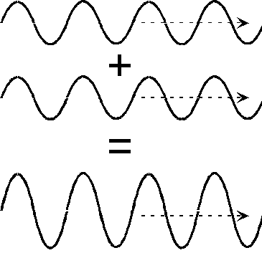

Condition for [constructive interference](http://physics.bu.edu/~duffy/sc545_notes09/interfere_sim.html):  (path difference) = nλ, where n is any integer

Destructive Iterference: When crest of one wave falls on trough of another wave,the amplitude of the resultant wave is less than or zero than the two superimposing waves.

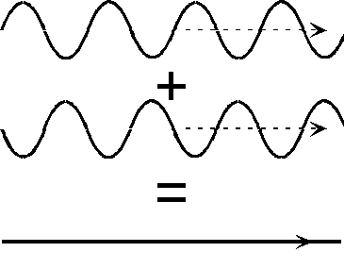

Condition for destructive interference: (path difference) = (n + 1/2) λ

**Q5.**M.I is set for circular fringes with the light of wavelength 5000 $\dot{A}.$ By changing the path length of movable mirror slowly 50 fringes cross the field of view. How much path length has been changed.

Sol: Let path length changed be

Δ=2x= Nλ

Given N= 50, λ = 5000Å

Δ=50x5x10-7 m

= 2.5 x 10-5 m

**Q6**. State the condition for diffraction.

Sol: The conditions are

i) Obstacle should of the size of the wave length of the light.

ii) Light waves are very small in wavelength, i.e. from 4 x 10-7 m to 7 x 10-7 m. If the size of opening or obstacle is near to this limit, only then we can observe the phenomenon of diffraction.

**Q7.** Write the expression for maximum intensity at a point due to single slit diffraction. On what factor does intensity depends.

Sol: The expression is I= R2 = A 2 (sin α/ α)2.

Factors on which it depends are:

i) Diffraction angle (θ)

ii)Wavelength of light used

iii)size of the slit

**Q8.** Draw the energy distribution graph of variation in intensity in diffraction.

Sol: 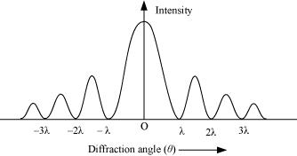

**SECTION-B**

**Q1.**What do you mean anti-reflection coating.

**Ans**

**Anti Reflection Coating**:- When light passes through a glass surface, it losses some part ,about 4% due to reflection from glass surface, which results a loss of intensity of the image formed by refracted/ transmitted light. Anti Reflection Coating are used on glass surface to reduce such reflection losses.

To decrease the reflection losses from a glass surface or a lens or a prism, anti- reflection coating (transparent thin film) of thickness t=λ/4μ is used. It may be magnesium fluoride (MgF2 and cryolite(3NaF.AlF3).

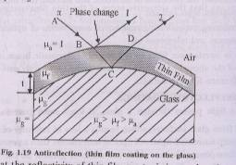

**PRINCIPLE:-**  When we create a thin transparent film i.e.anti reflected film upon the glass surface gives two reflected rays. If these waves are of nearly equal amplitude and 1800 out of phase apart, then destructive interference occurs and no reflected ray will emerge from the film.

Thus we can say that a non-reflection coating satisfies the following two conditions-----

**(a)-Nearly equal Amplitude**:- Let the amplitude of reflected waves I&II be A1and A2

For Anti-reflection Coating

A1=A2

It requires that the reflectivity of thin film w. r. to air is equal to the reflectivity of glass w. r. to thin film

i.e. RA1 =RA2

or



where =.Refractive Index of thin film/ coating



μg = Refractive Index of glass

μa =1= Refractive Index of air

⇒



⇒



⇒



⇒ 4



=0 ≠1



⇒ =



⇒



This means that the refractive index of the thin film /coating should be less than that of glass and nearly equal to square-root of the refractive index of glas

This equation shows that the R.I. of coating is equal to the square root of the R.I. of the glass.

**(b):- Phase Shift**:- The waves refracted from the top & bottom surfaces of the coating i.e.I & II are out of phase by 1800.

Let the thickness of thin film be t, then the optical path difference between ray 1&2 is

Δ=



For normal incidence of light cos r=1. The first λ/2 corresponds to π phase change at air to thin film boundary and the second λ/2 corresponds π phase change at thin film to glass boundary; both are due to the reflection from denser medium w.r.t. rearer medium. Thus

Δ =2 …..(1)



The ray 1 & 2 interfere destructively if the optical path difference is equal to the odd multiple of λ/2. Thus

Δ = (2n+1) λ/2 where n=0,1,2,3,……

Using eqn (1)

2μft = (2n+1) λ/2

For transparency of the film, its thickness should be minimum. So using n=0 we get

2μftmin = λ/2

tmin = λ/4μf

This is the desired thickness of antireflection coating.

**Q2**. Describe the construction and working of Michelson interferometer.

**Michelson’s Interferometer:-**

An interferometer is a device that can be used to measure lengths or changes in length with great accuracy by means of interference fringes. The basic principal of this instrument was given by A.A.Michelson in 1881.

**Principal**: When a parallel beam of light coming from a monochromatic extended light source is incident on a half silvered glass plate, it is divided into two parts. One part is a reflected wave and other part is a refracted wave and two other the two are coherent. In this experiment coherent waves are produced by the method of division of amplitude. These waves proceed in perpendicular directions and are incident normally on two mirrors. After reflection from these mirrors, when they superpose each other, they produce interference effect. The fringes produced are observed with the help of a telescope.

**Experimental Setup**: The essential parts of Michelson interferometer are schematically represented in fig.

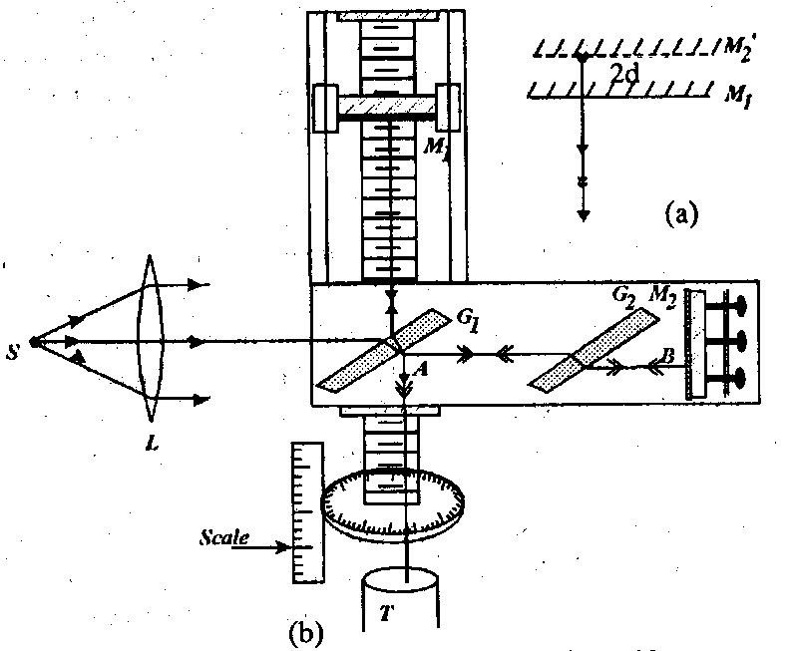

M1 and M2 are two plane mirrors which are highly silvered on this front surfaces. G1 and G2 are two plane parallel identical glass plates except that the rear side of G1 is partially silvered so that half of the intensity of the incident wave is reflected and the rest is transmitted through it. Both the plates are placed exactly parallel to each other and are inclined at 450 to the interferometer arms. The mirror M2 is fixed while the mirror M1 is movable exactly parallel to its preceding positions. These mirrors are also capable of slight rotation about the vertical as well as horizontal axes with the help of adjusting screens provided at their backs.

**Working of the Apparatus**: S is an extended source of light which is situated at the focus of a convex lens L. The parallel from the lens are incident on the partially silvered plateG1 on the silvered surface of the plat, the wave is divided into two parts of equal intensities by partial reflection and partial refraction. The reflected wave which proceeds to M1 and transmitted wave 2 which proceeds to M2 are incident normally on the mirrors. After reflection from the mirrors they retrace their paths wave 1 as wave 1’ and wave 2 as wave2’. On return at the partially silvered surface, a part of amplitude of wave 2’ from M2 is reflected as wave 2’ while a part of the amplitude of wave 1’ from M1 is transmitted as wave 1’’ along BT. Since, the two waves are derived from these are coherent. Accordingly one observers the fringes by looking from the position T into the mirror M1 through the plate G1.

**Function of the plate G2:** The wave reflected at M1 crosses the plate G1 twice while the other wave does not pass through it even once. Hence on extra optical path [2(μ-1) t] is introduced in wave 1’, where t is the thickness of the plate and μ is refraction index. Hence for observing achromatic fringe with white light in this instrument, it is essential to compensate for this extra optical path [2(μ-1) t] not only for one wavelength but for all wavelengths. This is accomplished by introducing in the path of wave 2 a plate G2 called compensating plate of the same thickness and material as G1 and placed exactly parallel to it. Light reflected fromM2 passes twice through G2 and hence the extra path difference created is thus nullified.

Form of Fringes: In Michelson interferometer the form of fringes depends on the separation between M1 and M2 and the angle between these surfaces. Two cases are of practical interest, namely (1) φ=0 and (2) e=0 but φ≠0. In the former case concentric circular fringes are produced, while in the later case central fringes is straight and all other fringes are convex towards it.

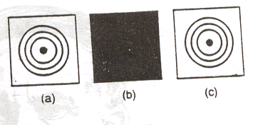

**Circular Fringes**: Circular fringes are produced with monochromatic light in a Michelson interferometer. Here the mirror M1 and the vertical mirror M2, which is the image of M2 must be parallel fig (A). The source is an extend one and S1 and S2 are the virtual images of the source due to M1 and M2. If the distance M1M2’ is d the distance between the two beams will be 2dcosθ. Therefore, the rays for which 2dcosθ=nλ will reinforce to produce maxima. These circular fringes which are due to interference with a phase difference determined by the inclination or Haidinger’s fringes. When M1 and M2’ coincide, the path difference is zero and the field of view is perfectly dark (fig B). When M2’ is nearer the eye than M1, the fringes are as shown in fig (A) when M1’ is farther from the eye than M1, the fringes are as shown in fig (C).

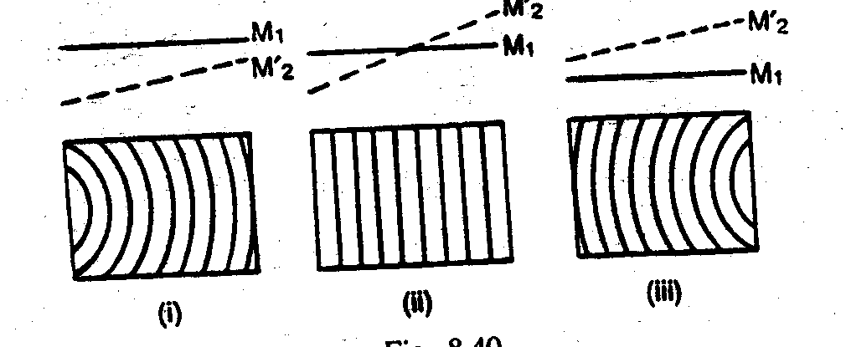

**Localized fringes**-

When the mirror M1 and the virtual mirror M’2 (images of M2) are inclined, the air film enclosed is wedge shaped and shifted line fringes are observed. The shape of the fringes observed for values of the path difference are shown in fig(c). The fringes are perfectly straight when M1 actually intersects M’2 in the middle (c ii). In the other positions, the shape of fringes is as shown in (c, i) & (c, iii). They are curved and are always convex towards the thin edge of the wedge. These types of fringes are not observed for large path differences.

**White light fringes:**

With white light, the fringes are observed only when the path difference is small. The difference colors overlap on one another and only the first few colored fringes are visible. The central fringe is dark and the other fringes are colored. After about 10 fringes a number of colors overlap at a point. White light fringes are useful for the determination of zero path difference, especially in the standerdisation of the meter.

**Q3**.A single layer of coating of thickness λ/4 is deposited on a convex lens of $μ_{g}$ =1.90 to reduce its reflectivity minimum. What is the refractive index of coating.

Sol: Condition of minimum reflectivity from coated glass surface is

μc =( μg)1/2

=(1.90)1/2

=1.38

**Q4.** Write short note on measurement of wavelength of two nearby wavelength using Michelson interferometer.

**Sol: Determination of the Difference in wavelength between two neighboring spectral lines (Resolution of the spectral lines.):**

There are two spectral linesD1 & D2 of sodium light. They are very near to each other and the difference in their wavelength is small. Suppose, the wavelength of D1 line is λ1 and the wavelength of D2 line is λ2. Also λ1 ≠ λ2. Each spectral line will give rise to its fringes in a Michelson interferometer. By adjusting the position of the mirror M1 of the Michelson interferometer, the position is found when fringes are very bright. In this position, the bright fringes due to D1 coincides with the bright fringes due to D2. When the mirror M1 is moved, the two sets of fringes get out of step because their wavelengths are different. When the mirror M1 is moved through a certain distance, the bright fringes due to one set will be seen in this case. Again by moving the mirror M1, a position is reached when a bright fringe of one set falls on the bright fringe of the other and the fringes are again distinct. This is possible when the nth order of the longer wavelength coincides with the (n+1)th order of the shorter wavelength.

Let n1 & n2 be the changes in the other at the center of the field of view, when the mirror M1is displaced through a distance “d” between two consecutive position of maximum distinctness of the fringes.



if λ1 is greater then λ2



------------(1)



Substituting the value of n11 in Eq(1)



or --------------------(2)



Taking λ as the mean of λ1 & λ2

-------------(3)



Hence the difference in wavelength λ1 - λ2 can be calculated. In actual practice, readings for ten successive positions of maximum distinctness are taken and the mean value of “d” is calculated.

Also, wave number

and



From Eqn (2)



This equation represents the difference in the wavelength of the two spectral lines.

**Q5.** Define coherent and incoherent sources of light. How are coherent sources produce, Explain with examples.

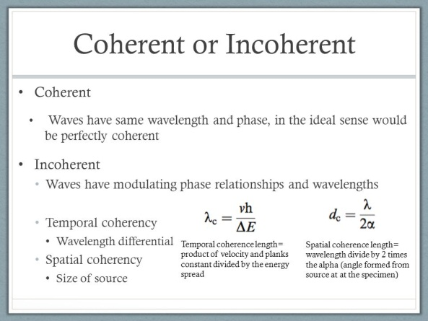 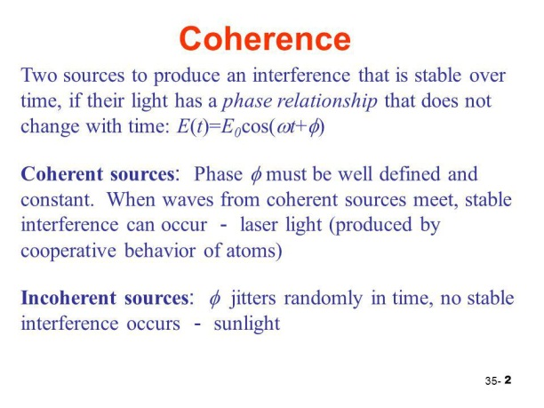

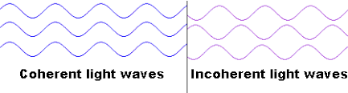

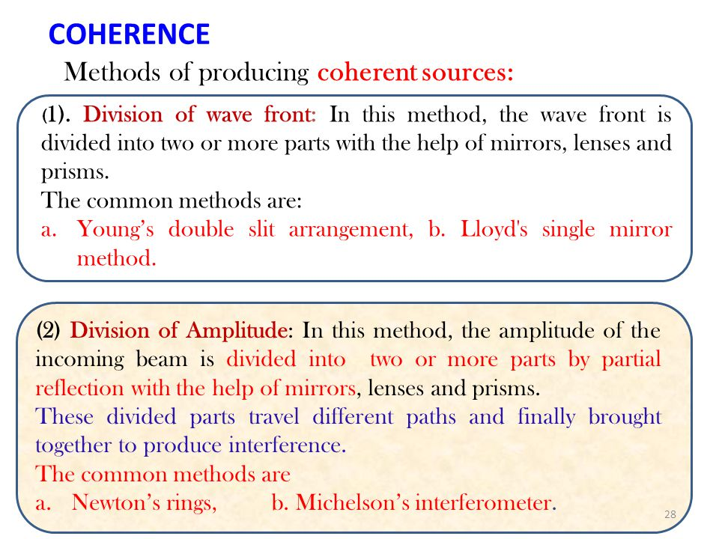

**Q6.** In Michelson interferometer ,the distance moved by the movable mirror between two consecutive positions of maximum distinctness is 0.2945 mm. If the mean wavelength of the two components of the D-lines is 5893 $Å$.Detemine the difference between the wavelengths.

Sol: The distance moved by two consecutive position maximum distinctness is given by:

Δx = λ2/2(λ2-λ1)

Therefore, (λ2-λ1) = λ2 /2Δx

= (5.893 x 10-7)2/(2 x 0.2945 x 10-3) m

= 5.896 x 10-10 m

= 5.896 Å

**

**I Mid Term Examination**

**Session: 2017-18**

**B.Tech I Year (II Semester)**

**Subject with code: PY102**

**SET-B**

Time: 2 hrs. M.M.:20

**Instruction for students:**

1. No provision for supplementary answer book.
2. Question paper contains two sections. Sec A- compulsory (which includes 8 short answers type questions of 0.5 marks each). Sec B- contains 06 Questions out of which any 04 questions to be attempt by the student (4 marks each).

**SECTION-A**

**Q1**. What is diffraction?

Ans.-Bending of the beam of the light by an obstacle is called Diffraction. Obstacle should of the size of the wave length of the light.

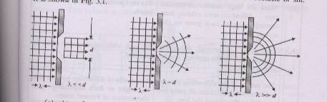

**Q2.** What are coherent sources?

Ans: **Coherent sources** of light: Two narrow **sources** of light are said to be **coherent** if they emit waves having. the same wavelength (or frequency), the same amplitude, and. have zero or constant phase difference.

**Q3.**State principle of superposition?

**Sol:**The superposition principle states that when two or more waves overlap in space, the resultant disturbance is equal to the algebraic sum of the individual disturbances. Or The **Principle Of Superposition** states that when two **waves** of the same kind meet at a point in space, the resultant displacement at that point is the vector sum of the displacements that the two **waves** would separately produce at that point

**Q4.** Draw the energy distribution graph of variation in intensity in interference

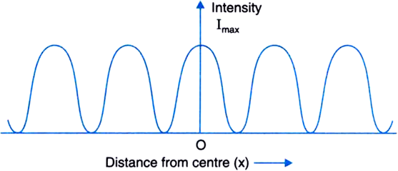

**Q5.**M.I is set for circular fringes with the light of wavelength 5000 $\dot{A}.$ By changing the path length of movable mirror slowly 50 fringes cross the field of view. How much path length has been changed?

Sol: Let path length changed be

Δ=2x= Nλ

Given N= 50, λ = 5000Å

Δ=50x5x10-7 m

= 2.5 x 10-5 m

**Q6**.why do thin films illuminated by white light appeared dark?

Ans The effective path difference in thin films is given by

Δ=2μt-λ/2

For t=0,

Δ= λ/2

This

**Q7.** State the relation between path difference and phase difference.

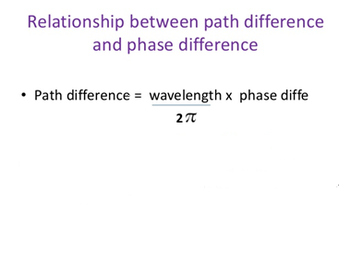

|  |
| --- |
| Image result for relation between path difference and phase difference |

**Q8.**why two individual sources cannot be used as coherent sources?

Ans. Every source of light is need of innumerable atoms which emit light when an atom in excited state comes back to ground state. Different atoms emit light wave at different time in random wave . Thus the phase of light wave from a single source varies with time. Therefore the phases of the wave from the independent sources changes i.e the phase difference between the waves will not be coherent.

**SECTION-B**

**Q1.** Discuss the phenomenon of Fraunhofer diffraction at a single slit and derive expression for the intensity of diffraction light.

**Ans Single Slit Diffraction (Franuhofer’s Diffraction)**

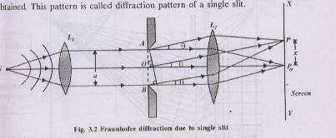

Fig. represent a section AB of a narrow slit of width a perpendicular to the plane of the paper. Let a plane waveform ww’ of monochromatic light of wavelength propagating normally to the slit be incident on it. Let the diffracted light be focused by means of a convex lens on a screen placed in the focal plane of the lens. According to Huygen’s-Fresnel; every point of the wavefront in the plane of the slit is a source of secondary spherical wavelets, which spread out of the right in all directions. The secondary wavelets traveling normally to the slit, i.e., along the direction OPoare brought to focus at Po by the lens. Thus, Po is bright central image. The secondary wavelets traveling at an angle θ with the normal are focused at a point P1 on the screen. The point P1 is the minimum intensity depending upon the path difference between the secondary waves originating form the corresponding points of the wavefront. In order to find out intensity at P1, draw a perpendicular AC on BR. The path difference between secondary wavelets from A and B in the direction θ = BC = AB sinθ = e sinθ

and corresponding phase difference =  e sin

Let us consider that the width of the slit is divided into n equal parts and the amplitude of the waveform each part is a (because width of each part is same). The Phase difference between any two consecutive waves form these parts would be-

(Total Phase) =  = d (say)

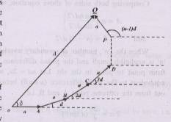

Let there be n vibration of the same period, same amplitude a and same phase difference d between successive vibrations which act on a particle simultaneously. Our aim is to consider the resultant amplitude of these vibrations. For this Purpose, We construct the Polygon of amplitudes as shown In the fig.

The closing side OP and angle θ then gives the resultant amplitude R and Phase of the resultant vibration respectively. To evaluate R and θ, we resolve the amplitudes along and perpendicular to OA and write

R cos  = a [1 + cos d + cos 2d + ……………+ cos (n-1)d ] ……(1)

R sin  = a [1 + sin d + sin 2d + ……………+ sin (n-1)d ] ……(2)

Multiplying equation (1) by 2sin d/2 we get -

2 R cosθ.sin d/2 = a[2 sin d/2+ 2 cos d. sin d/2 + …… + 2 cos (n-1) d.sind/2)]

= a 

= a 

= 2a sin 

or R cos = a  ………(3)

Similarly , multiplying equation (2) by 2 sind/2 and simplifying, we get-

R sin = a  ………..(4)

Squaring equation (3) and (4) and adding we get-

R2 = a2 

or R = a  …………(5)

= a 

= a  where 

= a  

= na 

= A ( where n α,a 0 but product na = A remains finite)

Now the intensity is givin by-

I= R2 = A2 

**Q2.**What do you mean by interference filter.

**Ans**

**(B):- Interference Filter**:- It is an optical device,which transmits a monochromatic light (a narrow change of wavelength) when white light incident on it. It is based on the principle of Fabry –Perot Interferometer. In this device, wavelength that are not transmitted are removed by interference phenomenon, rather than by absorption or scattering.

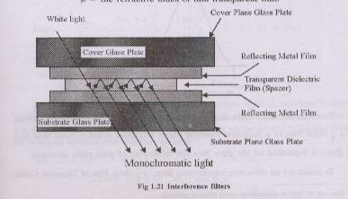

In an Interference filter, a thin transparent film, a thin transparent dielectric film is placed between two semireflective coating. When a beam of light is incident normally on the filter, multiple reflection takes places between two surfaces. If t is the separation between the two plates and μ is the R.I. of the dielectric medium, then from the theory of interference in thin film the condition for maxima in transmitted light can be given as----

2μt=nλ

If we use white light, then different colours are formed in transmitted light can be obtained using eq-Ist

λ=2μt/n

If μ=1.5, t=6*10-5 m, then only two wavelengths of visible region of value 6000A for n==3 and 4500A for n==4 gives us maxima.

If the spacer is a half wavelength for the desired wavelength then the other wavelengths will be eliminated by destructive interference.

**(Uses)-** In clinical chemistry, environment testing colorimetric, elemental and laser line separation fluroescene etc.

**Demerit**- To design and produce interference filter is a complex procedure requiring thin film expertise and sophisticated instruments.

1.An ability to apply knowledge of mathematics, science, and engineering

2.An ability to design and conduct experiment, as well as to analyze and interpret data

3.An ability to design a system, component or process to meet desired need within realistic, Constraints.

4.An ability to function on multi-disciplinary teams.

5.An ability to identify, formulate, and solve engineering Problems.

6.An understanding of professional and ethical responsibility

7.The broad education necessary to understand the impact of engineering solutions in a global, economic, environmental, and societal context.

8.A recognition of the need for, and an ability to engage in life-long learning

9.Knowledge of contemporary issues.

10.An ability to use the techniques, skills, and modern engineering tools necessary of engineering practice.

**Q3.**Write short note on measurement of wavelength of light using Michelson interferometer.

**Sol: Application of Michelson Interferometer -**

Determination of wavelength of monochromatic light : Michelson’s interferometer is adjusted in such a way that circular fringes are formed. The movable mirror M1 is moved backward or forward by the micrometer screw so that a path difference is introduced in the path of waves. Now if the mirror M1 is displayed through a distance “d”, then the path difference introduced in the path of waves will be “2d”. Due to displacement of mirror M1 fringes appear to be crossing the field of view. Let N fringes cross the field of view when the mirror M1 is displaced through a distance x. Hence



If x and N are known, then the wavelength of light used can be determined.

**Q4.** In Michelson interferometer ,the distance moved by the movable mirror between two consecutive positions of maximum distinctness is 0.2945 mm. If the mean wavelength of the two components of the D-lines is 5893 $Å$.Detemine the difference between the wavelengths.

Sol: The distance moved by two consecutive position tness is given by:

Δx = λ2/2(λ2-λ1)

Therefore, (λ2-λ1) = λ2 /2Δx

= (5.893 x 10-7)2/(2 x 0.2945 x 10-3) m

= 5.896 x 10-10 m

= 5.896 Å

**Q5.**What is difference between interference and diffraction.

Difference between Interference and Diffraction

|  |  |  |
| --- | --- | --- |
| S.NO. | INTERFERENCE | DIFFRACTION |
| 1. | It occurs between two different wavefronts originating from two coherent sources | It occurs due to the secondary wavelets originating from infinite different points of the same wavefront. |
| 2. | In an interference pattern, the regions of minima are usually perfectly dark. | In the diffraction pattern, they are not perfectly dark. |
| 3. | The interference fringes are usually (not always) of the same width. | The diffraction fringes are never of the same width. |
| 4. | All maxima are of same intensity. | They are of varying intensity. |
| 5. | Condition for maxima  (a) Path difference Δ=2n λ/2   1. Phase difference δ=2nπ | Condition for maxima  (a)Path difference Δ=(2n+1) λ/2  (b)Phase difference δ=(2n±1) π |
| 6. | Condition for minima  (a) Path difference Δ=(2n±1) λ/2  (b) Phase difference δ=(2n±1) π | Condition for minima  (a)Path difference Δ=2n λ/2  (b)Phase difference δ=2nπ |

**Q6.**A single layer of coating of thickness λ/4 is deposited on a convex lens of $μ_{g}$ =1.90 to reduce its reflectivity minimum. What is the refractive index of coating.

Sol: Condition of minimum reflectivity from coated glass surface is

μc =( μg)1/2

=(1.90)1/2

=1.38