SET A

University Roll No: -------------------------
RAJASTHAN INSTITUTE OF ENGINEERING & TECHNOLOGYJAIPUR, RAJASTHAN
B.Tech.II Midterm EXAMINATION 2017-18
Semester and Branch: III Year, VI Semester, EEE
Subject: Microprocessor and Microcontroller

Duration: $2$Hours Maximum Marks: 20
Student Instructions:
- All questions are compulsory.
- All questions carry equal marks.
- Use pencils for the diagrams.

Solution

Q.1 Explain the PIN Diagram of 8255 programmable peripheral Interface Chip.
Ans:
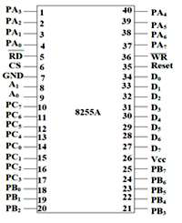

Data Bus Buffer
It is a tri-state 8-bit buffer, which is used to interface the microprocessor to the system data bus. Data is transmitted or received by the buffer as per the instructions by the CPU. Control words and status information is also transferred using this bus.

Read/Write Control Logic
This block is responsible for controlling the internal/external transfer of data/control/status word. It accepts the input from the CPU address and control buses, and in turn issues command to both the control groups.

CS
It stands for Chip Select. A LOW on this input selects the chip and enables the communication between the 8255A and the CPU. It is connected to the decoded address, and A₀ & A₁ are connected to the microprocessor address lines.
Their result depends on the following conditions −
CS | A₁ | A₀ | Result
0 | 0 | 0 | PORT A
0 | 0 | 1 | PORT B
0 | 1 | 0 | PORT C
0 | 1 | 1 | Control Register
1 | X | X | No Selection

WR
It stands for write. This control signal enables the write operation. When this signal goes low, the microprocessor writes into a selected I/O port or control register.

RESET
This is an active high signal. It clears the control register and sets all ports in the input mode.

RD
It stands for Read. This control signal enables the Read operation. When the signal is low, the microprocessor reads the data from the selected I/O port of the 8255.

A₀ and A₁
These input signals work with RD, WR, and one of the control signal. Following is the table showing their various signals with their result.
A₁ | A₀ | RD | WR | CS | Result
0 | 0 | 0 | 1 | 0 | Input Operation  PORT A → Data Bus
0 | 1 | 0 | 1 | 0 | PORT B → Data Bus
1 | 0 | 0 | 1 | 0 | PORT C → Data Bus
0 | 0 | 1 | 0 | 0 | Output Operation  Data Bus → PORT A
0 | 1 | 1 | 0 | 0 | Data Bus → PORT A
1 | 0 | 1 | 0 | 0 | Data Bus → PORT B
1 | 1 | 1 | 0 | 0 | Data Bus → PORT D

OR
Q.1 Explain the PIN Diagram of 8253/8254 timer chip.
Ans:

8254 Pin Description
Here is the pin diagram of 8254 −
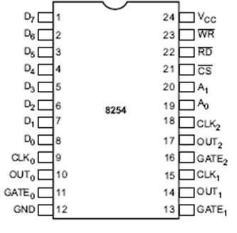
In the above figure, there are three counters, a data bus buffer, Read/Write control logic, and a control register. Each counter has two input signals - CLOCK & GATE, and one output signal - OUT.

Data Bus Buffer
It is a tri-state, bi-directional, 8-bit buffer, which is used to interface the 8253/54 to the system data bus. It has three basic functions −
- Programming the modes of 8253/54.
- Loading the count registers.
- Reading the count values.

Read/Write Logic
It includes 5 signals, i.e. RD, WR, CS, and the address lines A₀ & A₁. In the peripheral I/O mode, the RD and WR signals are connected to IOR and IOW, respectively. In the memory mapped I/O mode, these are connected to MEMR and MEMW.
Address lines A₀ & A₁ of the CPU are connected to lines A₀ and A₁ of the 8253/54, and CS is tied to a decoded address. The control word register and counters are selected according to the signals on lines A₀ & A₁.
A₁ | A₀ | Result
0 | 0 | Counter 0
0 | 1 | Counter 1
1 | 0 | Counter 2
1 | 1 | Control Word Register
X | X | No Selection

Control Word Register
This register is accessed when lines A₀ & A₁ are at logic 1. It is used to write a command word, which specifies the counter to be used, its mode, and either a read or write operation. Following table shows the result for various control inputs.
A₁ | A₀ | RD | WR | CS | Result
0 | 0 | 1 | 0 | 0 | Write Counter 0
0 | 1 | 1 | 0 | 0 | Write Counter 1
1 | 0 | 1 | 0 | 0 | Write Counter 2
1 | 1 | 1 | 0 | 0 | Write Control Word
0 | 0 | 0 | 1 | 0 | Read Counter 0
0 | 1 | 0 | 1 | 0 | Read Counter 1
1 | 0 | 0 | 1 | 0 | Read Counter 2
1 | 1 | 0 | 1 | 0 | No operation
X | X | 1 | 1 | 0 | No operation
X | X | X | X | 1 | No operation

Counters
Each counter consists of a single, 16 bit-down counter, which can be operated in either binary or BCD. Its input and output is configured by the selection of modes stored in the control word register. The programmer can read the contents of any of the three counters without disturbing the actual count in process.
Q.2 Explain the Architecture of 8259 Programmable Interrupt Controller Chip.
Ans:
Features:
- It is a LSI chip which manages 8 levels of interrupts i.e. it is used to implement 8 level interrupt systems.
- It can be cascaded in a master slave configuration to handle up to 64 levels of interrupts.
- It can identify the interrupting device.
- It can resolve the priority of interrupt requests i.e. it does not require any external priority resolver.
- It can be operated in various priority modes such as fixed priority and rotating priority.
- The interrupt requests are individually mask-able.
- The operating modes and masks may be dynamically changed by the software at any time during execution of programs.
- It accepts requests from the peripherals, determines priority of incoming request, checks whether the incoming request has a higher priority value than the level currently being serviced and issues an interrupt signal to the microprocessor.
- It provides 8 bit vector number as an interrupt information.
- It does not require clock signal.
- It can be used in polled as well as interrupt modes.
- The starting address of vector number is programmable.
- It can be used in buffered mode.
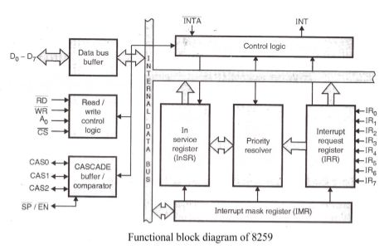
It contains following blocks-
Data bus buffer-
- It is used to transfer data between microprocessor and internal bus.
Read/write logic-
- It sets the direction of data bus buffer.
- It controls all internal read/write operations.
- It contains initialization and operation command registers.
Cascaded buffer and comparator-
- In master mode, it functions as a cascaded buffer. The cascaded buffers outputs slave identification number on cascade lines.
- In slave mode, it functions as a comparator. The comparator reads slave identification number from cascade lines and compares this number with its internal identification number.
- In buffered mode, it generates an (EN) ̅ signal.
Control logic-
- It generates an INT signal. In response to an (INTA) ̅ signal, it releases three byte CALL address or one byte vector number.
- It controls read/write control logic, cascade buffer/comparator, in service register, priority resolver and IRR.
Interrupt request register-
- It is used to store all pending interrupt requests.
- Each bit of this register is set at the rising edge or at the high level of the corresponding interrupt request line.
- The microprocessor can read contents of this register by issuing appropriate command word.
In service register (InSR)-
- It is used to store all interrupt levels currently being serviced.
- Each bit of this register is set by priority resolver and reset by end of interrupt command word.
- The microprocessor can read contents of this register by issuing appropriate command word.
Priority resolver-
- It determines the priorities of the bit set in the IRR. To make decision, the priority resolver looks at the ISR.
- If the higher priority bit in the InSR is set then it ignores the new request.
- If the priority resolvers find that the new interrupt has a higher priority than the highest priority interrupt currently being serviced and the new interrupt is not in service, then it will set appropriate bit in the InSR and send the INT signal to the microprocessor for new interrupt request.
Interrupt mask register (IMR)-
- It is a programmable register.
- It is used to mask unwanted interrupt request by writing appropriate command word.
- The microprocessor can read contents of this register without issuing any command word.
OR
Q.2 What is the DMA? Explain the PIN Diagram of DMA Controller.

Ans:

8257 Pin Description
The following image shows the pin diagram of a 8257 DMA controller –
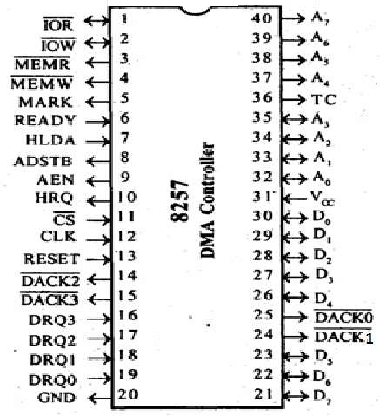

DRQ₀−DRQ3
These are the four individual channel DMA request inputs, which are used by the peripheral devices for using DMA services. When the fixed priority mode is selected, then DRQ₀ has the highest priority and DRQ₃ has the lowest priority among them.

DACK_{o} − DACK₃
These are the active-low DMA acknowledge lines, which updates the requesting peripheral about the status of their request by the CPU. These lines can also act as strobe lines for the requesting devices.

D_{o} − D₇
These are bidirectional, data lines which are used to interface the system bus with the internal data bus of DMA controller. In the Slave mode, it carries command words to 8257 and status word from 8257. In the master mode, these lines are used to send higher byte of the generated address to the latch. This address is further latched using ADSTB signal.

IOR
It is an active-low bidirectional tri-state input line, which is used by the CPU to read internal registers of 8257 in the Slave mode. In the master mode, it is used to read data from the peripheral devices during a memory write cycle.

IOW
It is an active low bi-direction tri-state line, which is used to load the contents of the data bus to the 8-bit mode register or upper/lower byte of a 16-bit DMA address register or terminal count register. In the master mode, it is used to load the data to the peripheral devices during DMA memory read cycle.

CLK
It is a clock frequency signal which is required for the internal operation of 8257.

RESET
This signal is used to RESET the DMA controller by disabling all the DMA channels.

A_{o} - A₃
These are the four least significant address lines. In the slave mode, they act as an input, which selects one of the registers to be read or written. In the master mode, they are the four least significant memory address output lines generated by 8257.

CS
It is an active-low chip select line. In the Slave mode, it enables the read/write operations to/from 8257. In the master mode, it disables the read/write operations to/from 8257.

A₄ - A₇
These are the higher nibble of the lower byte address generated by DMA in the master mode.

READY
It is an active-high asynchronous input signal, which makes DMA ready by inserting wait states.

HRQ
This signal is used to receive the hold request signal from the output device. In the slave mode, it is connected with a DRQ input line 8257. In Master mode, it is connected with HOLD input of the CPU.

HLDA
It is the hold acknowledgement signal which indicates the DMA controller that the bus has been granted to the requesting peripheral by the CPU when it is set to 1.

MEMR
It is the low memory read signal, which is used to read the data from the addressed memory locations during DMA read cycles.

MEMW
It is the active-low three state signal which is used to write the data to the addressed memory location during DMA write operation.

ADST
This signal is used to convert the higher byte of the memory address generated by the DMA controller into the latches.

AEN
This signal is used to disable the address bus/data bus.

TC
It stands for ‘Terminal Count’, which indicates the present DMA cycle to the present peripheral devices.

MARK
The mark will be activated after each 128 cycles or integral multiples of it from the beginning. It indicates the current DMA cycle is the 128th cycle since the previous MARK output to the selected peripheral device.

V_{cc}
It is the power signal which is required for the operation of the circuit.
Q.3 What is the means of Analog to Digital Converter? Explain the Successive Approximation method to convert the Analog data in the digital form.
One of the most common analog-to-digital converters used in applications requiring a sampling rate under 10 MSPS is the Successive Approximation Register ADC. This ADC is ideal for applications requiring a resolution between 8-16 bits. For more information on resolution and sampling rates, please refer to the first in this series of articles: Deciphering Resolution and Sampling Rate. The SAR ADC is one of the most intuitive analog-to-digital converters to understand and once we know how this type of ADC works, it becomes apparent where its strengths and weaknesses lie.
Basic Operation of the SAR ADC
The basic successive approximation register analog-to-digital converter is shown in the schematic below:
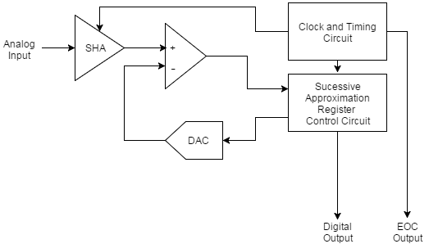
The SAR ADC does the following things for each sample:
- The analog signal is sampled and held.
- For each bit, the SAR logic outputs a binary code to the DAC that is dependent on the current bit under scrutiny and the previous bits already approximated. The comparator is used to determine the state of the current bit.
- Once all bits have been approximated, the digital approximation is output at the end of the conversion (EOC).
The SAR operation is best explained as a binary search algorithm. Consider the code shown below. In this code, the current bit under scrutiny is set to 1. The resultant binary code from this is output to the DAC. This is compared to the analog input. If the result of the DAC output subtracted from the analog input is less than 0 the bit under scrutiny is set to 0.

OR
Q.3 Explain the PIN Diagram of 8259 Programmable Interrupt Controller Chip.

Features:
- 8 levels of interrupts.
- Can be cascaded in master-slave configuration to handle 64 levels of interrupts.
- Internal priority resolver.
- Fixed priority mode and rotating priority mode.
- Individually maskable interrupts.
- Modes and masks can be changed dynamically.
- Accepts IRQ, determines priority, checks whether incoming priority > current level being serviced, issues interrupt signal.
- In 8085 mode, provides 3 byte CALL instruction. In 8086 mode, provides 8 bit vector number.
- Polled and vectored mode.
- Starting address of ISR or vector number is programmable.
- No clock required.
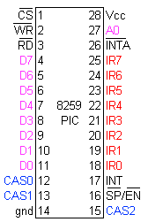
D0-D7 | Bi-directional, tristated, buffered data lines. Connected to data bus directly or through buffers
RD-bar | Active low read control
WR-bar | Active low write control
A0 | Address input line, used to select control register
CS-bar | Active low chip select
CAS0-2 | Bi-directional, 3 bit cascade lines. In master mode, PIC places slave ID no. on these lines. In slave mode, the PIC reads slave ID no. from master on these lines. It may be regarded as slave-select.
SP-bar / EN-bar | Slave program / enable. In non-buffered mode, it is SP-bar input, used to distinguish master/slave PIC. In buffered mode, it is output line used to enable buffers
INT | Interrupt line, connected to INTR of microprocessor
INTA-bar | Interrupt ack, received active low from microprocessor
IR0-7 | Asynchronous IRQ input lines, generated by peripherals.

Q.4 Explain the Architecture of Keyboard/Display Controller 8279 Chip.
Ans:
8279 programmable keyboard/display controller is designed by Intel that interfaces a keyboard with the CPU. The keyboard first scans the keyboard and identifies if any key has been pressed. It then sends their relative response of the pressed key to the CPU and vice-a-versa.

How Many Ways the Keyboard is Interfaced with the CPU?
The Keyboard can be interfaced either in the interrupt or the polled mode. In the Interrupt mode, the processor is requested service only if any key is pressed, otherwise the CPU will continue with its main task.
In the Polled mode, the CPU periodically reads an internal flag of 8279 to check whether any key is pressed or not with key pressure.

How Does 8279 Keyboard Work?
The keyboard consists of maximum 64 keys, which are interfaced with the CPU by using the key-codes. These key-codes are de-bounced and stored in an 8-byte FIFORAM, which can be accessed by the CPU. If more than 8 characters are entered in the FIFO, then it means more than eight keys are pressed at a time. This is when the overrun status is set.
If a FIFO contains a valid key entry, then the CPU is interrupted in an interrupt mode else the CPU checks the status in polling to read the entry. Once the CPU reads a key entry, then FIFO is updated, and the key entry is pushed out of the FIFO to generate space for new entries.

Architecture and Description

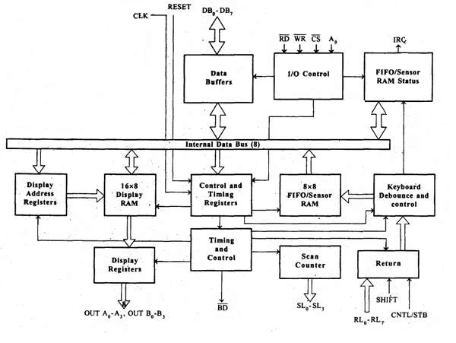

I/O Control and Data Buffer
This unit controls the flow of data through the microprocessor. It is enabled only when D is low. Its data buffer interfaces the external bus of the system with the internal bus of the microprocessor. The pins A0, RD, and WR are used for command, status or data read/write operations.

Control and Timing Register and Timing Control
This unit contains registers to store the keyboard, display modes, and other operations as programmed by the CPU. The timing and control unit handles the timings for the operation of the circuit.

Scan Counter
It has two modes i.e. Encoded mode and Decoded mode. In the encoded mode, the counter provides the binary count that is to be externally decoded to provide the scan lines for the keyboard and display.
In the decoded scan mode, the counter internally decodes the least significant 2 bits and provides a decoded 1 out of 4 scan on SL₀-SL₃.

Return Buffers, Keyboard Debounce, and Control
This unit first scans the key closure row-wise, if found then the keyboard debounce unit debounces the key entry. In case, the same key is detected, then the code of that key is directly transferred to the sensor RAM along with SHIFT & CONTROL key status.

FIFO/Sensor RAM and Status Logic
This unit acts as 8-byte first-in-first-out (FIFO) RAM where the key code of every pressed key is entered into the RAM as per their sequence. The status logic generates an interrupt request after each FIFO read operation till the FIFO gets empty.
In the scanned sensor matrix mode, this unit acts as sensor RAM where its each row is loaded with the status of their corresponding row of sensors into the matrix. When the sensor changes its state, the IRQ line changes to high and interrupts the CPU.

Display Address Registers and Display RAM
This unit consists of display address registers which holds the addresses of the word currently read/written by the CPU to/from the display RAM.
OR
Q.4 Explain the Architecture of 8051 Microcontroller.
Ans: 8051 microcontroller is designed by Intel in 1981. It is an 8-bit microcontroller. It is built with 40 pins DIP (dual inline package), 4kb of ROM storage and 128 bytes of RAM storage, 2 16-bit timers. It consists of are four parallel 8-bit ports, which are programmable as well as addressable as per the requirement. An on-chip crystal oscillator is integrated in the microcontroller having crystal frequency of 12 MHz.
Let us now discuss the architecture of 8051 Microcontroller.
In the following diagram, the system bus connects all the support devices to the CPU. The system bus consists of an 8-bit data bus, a 16-bit address bus and bus control signals. All other devices like program memory, ports, data memory, serial interface, interrupt control, timers, and the CPU are all interfaced together through the system bus.
