Rajasthan Institute of Engineering & Technology, Jaipur

II Mid Term Examination, April-2018
Session: 2017-18
B.Tech. MECHANICAL Engg. I Year II Sem
Basic Mechanical Engineering (ME102)
Set: A
Time: 2 Hrs. [Maximum Marks: -20]
Solution Sec-A
1 Boiler design is the process of designing boilers used for various purposes. The main function of a boiler is to heat water to generate steam. Steam produced in a boiler can be used for a variety of purposes including space heating, sterilisation, drying, humidification and power generation.
2
- Vapor-compression cycle.
- Vapor absorption cycle.
- Gas cycle.
- Stirling engine.
- Reversed Carnot cycle.

3Open belt drive
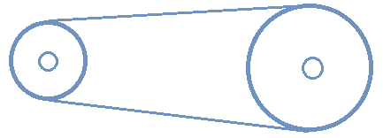
In an open belt drive, shafts are arranged in parallel and rotate in the same direction. The driver pulls the belt from the lower side and delivers it upper side of the pulley so that lower side is always tight and slack is on the top side.

Cross belt drive
Cross belt, also known as the twisted belt, is twisted as shown fig. In a cross belt drive, the shafts are arranged in parallel, and twisted arrangement makes pulleys rotating in the opposite direction. The speed is limited to 15m/s to avoid excessive wear. Both sides of the belt get contact with pulleys, so this arrangement not advisable for V-Belt and Timing Belt.
Read: Difference Between Open Belt Drive And Cross Belt Drive

Quarter turn belt
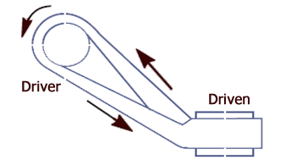
Also known as the right angle belt drive. In this type, shafts are arranged at right angles.

Compound belt drive
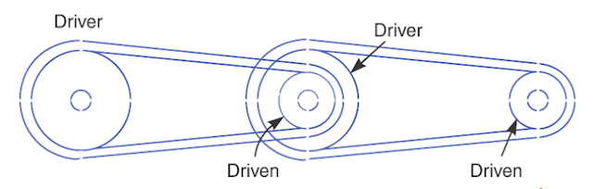
Compound belts are similar to open belt drive. They used to power transfer through one or more intermediate pulleys.

Belt drive with idler pulleys
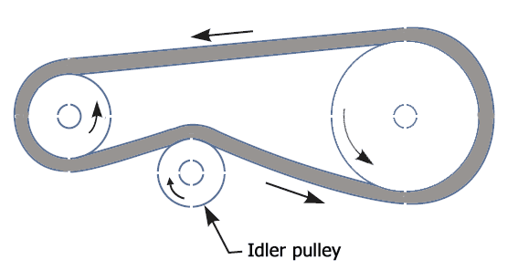
Also known as the jockey pulley drive. Idler pulleys are pressed against the belt and guide them. They change direction and increase the angle of contact. It can provide a high-velocity ratio. Idler pulleys can also reduce the vibration in the belt.

Stepped or cone pulley drive
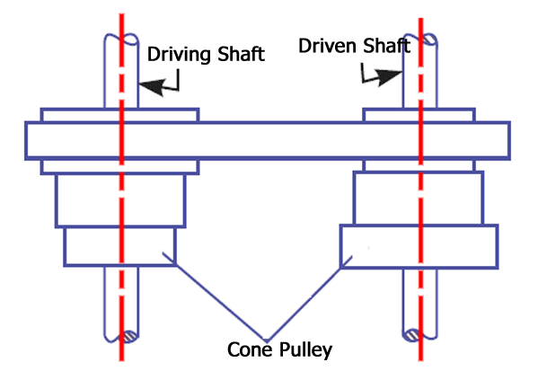
They are used to get different velocity ratio during the power transfer. The driver shaft rotates at constant speed, driven shaft can run at a different speed as the belt shifting from one cone pulley to another.

Fast and loose pulley drive

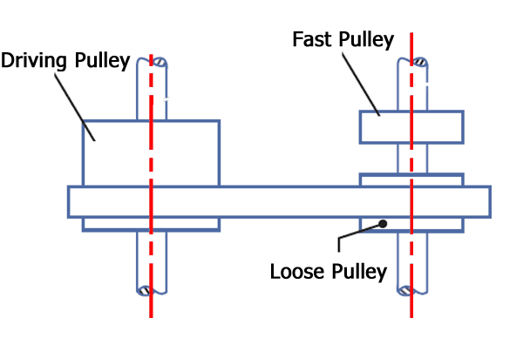
It is used to stop the machine while driver continues to run; this can accomplish by shifting the belt to a loose pulley, which is freely run over the shaft.
4 Forming processes are particular manufacturing processes which make use of suitable stresses (like compression, tension, shear or combined stresses) which cause plastic deformation of the materials to produce required shapes. ... Some of example of forming processes are: Forging. Extrusion.
5. CAD (computer-aided design) software is used by architects, engineers, drafters, artists, and others to create precision drawings or technical illustrations. CAD software can be used to create two-dimensional (2-D) drawings or three-dimensional (3-D) models.
(computer-aided design/computer-aided manufacturing) is software used to design products such as electronic circuit boards in computers and other devices.
6 A flexible manufacturing system (FMS) is a manufacturing system in which there is some amount of flexibility that allows the system to react in case of changes, whether predicted or unpredicted. This flexibility is generally considered to fall into two categories, which both contain numerous subcategories.
7 Roll forming, also spelled rollforming, is a type of rollinginvolving the continuous bending of a long strip of sheet metal (typically coiled steel) into a desired cross-section.
8 Slip in the belt drive is a phenomenon of the relative motion between belt and pulley. Due to insufficient grip of friction between pulley and belt, there is a relative motion between the belt surface and the surface of friction wheel, reducing the speed ratio, and hence power transmission.

Sec-B
2
This is an important cycle frequently employed in gas cycle refrigeration systems. This may be thought of as a modification of reversed Carnot cycle, as the two isothermal processes of Carnot cycle are replaced by two isobaric heat transfer processes. This cycle is also called as Joule or Bell-Coleman cycle. Figure 9.2(a) and (b) shows the schematic of a closed, reverse Brayton cycle and also the cycle on T-sdiagram. As shown in the figure, the ideal cycle consists of the following four processes: Process 1-2: Reversible, adiabatic compression in a compressor Process 2-3: Reversible, isobaric heat rejection in a heat exchanger Process 3-4: Reversible, adiabatic expansion in a turbine Process 4-1: Reversible, isobaric heat absorption in a heat exchangerProcess 1-2: Gas at low pressure is compressed isentropically from state 1 to state 2. Applying steady flow energy equation and neglecting changes in kinetic and potential energy, we can write: 12p )TT(cm)hh(mW . 12 . −21 −=−= 12 = ss (9.9) and γ γ −γ −γ = ⎟ ⎟ ⎠ ⎞ ⎜ ⎜ ⎝ ⎛ = 1 p1 1 1 2 12 rT P P T T where rp = (P2/P1) = pressure ratio Process 2-3: Hot and high pressure gas flows through a heat exchanger and rejects heat sensibly and isobarically to a heat sink. The enthalpy and temperature of the gas drop during the process due to heat exchange, no work transfer takes place and the entropy of the gas decreases. Again applying steady flow energy equation and second T ds equation: 32p )TT(cm)hh(mQ . 32 . −32 −=−= 3 2 p32 T T =− lncss (9.10) =PP 3Process 3-4: High pressure gas from the heat exchanger flows through a turbine, undergoes isentropic expansion and delivers net work output. The temperature of the gas drops during the process from T3 to T4. From steady flow energy equation: Process 4-1: Cold and low pressure gas from turbine flows through the low temperature heat exchanger and extracts heat sensibly and isobarically from a heat source, providing a useful refrigeration effect. The enthalpy and temperature of the gas rise during the process due to heat exchange, no work transfer takes place and the entropy of the gas increases. Again applying steady flow energy equation and second T ds equation:
3

Parts of an air conditioner
Air conditioner installations mainly come in two types: window systems and split systems (these are further classified into mini-split and central systems). In everyday language, these are commonly referred to as window ACs and split ACs, respectively.

Evaporator
An evaporator is basically a heat exchanger coil that’s responsible for collecting heat from inside a room through a refrigerant gas. This component is known as the evaporator, and is where the liquid refrigerant absorbs heat and evaporatesto become gas.

Compressor
As the name clearly signifies, this is where compression of the gaseous refrigerant occurs. It’s located in the outside unit, i.e., the part that’s installed outside the house.

Condenser
The condenser receives the vaporized refrigerant from the compressor, converts it back to liquid and expels the heat outside. Needless to say, it’s also located on the outside unit of the split AC.

Expansion valve
Also referred to as the throttling device, the expansion valve is located between the two sets of coils (the chilled coils of the evaporator and the hot coils of the condenser). It keeps tabs on the amount of refrigerant moving towards the evaporator.
Note that in the case of window ACs, the three aforementioned components are all located inside a small metal box that is installed in a window opening.
These are the main components of an air conditioner. Now let’s look at how they work together to make an AC do what it does.

Air conditioner (AC) working principle
An air conditioner collects hot air from a given space, processes it within itself with the help of a refrigerant and a bunch of coils and then releases cool air into the same space where the hot air had originally been collected. This is essentially how all air conditioners work.
Many folks believe that an air conditioner produces chilled air with the help of machines installed inside it, allowing it to cool a room so quickly. That might also explain why it consumes so much electricity. In reality, however, that’s a misconception. An air conditioner is not a magical device; it just uses some physical and chemical phenomena very effectively to cool a given space.
When you switch an AC on and set your desired temperature (say, 20 degrees Celsius), the thermostat installed in it senses that there is a difference in the temperature of the room’s air and the temperature that you’ve chosen.
Technology

How Does an Air Conditioner (AC) Work?
Ashish 1 Year Ago
- FACEBOOK

PREV ARTICLE NEXT ARTICLE
An air conditioner (AC) in a room or a car works by collecting hot air from a given space, processing it within itself with the help of a refrigerant and a bunch of coils and then releasing cool air into the same space where the hot air had originally been collected. This is essentially how air conditioners work.
Imagine that you’re outside in the sweltering heat of a particularly hot summer day, running some godforsaken errands that couldn’t be put off any longer. The heat is so unbearable that it feels like the hottest day on Earth since the dawn of civilization. However, there is one thing that keeps you going: the knowledge that you’ll be inside your air conditioned home in one hour.
Finally, that moment comes. You open the door and step inside your house. A gust of chilled air envelops every cell of your body and you instantly feel better.

I’m sure that all of you have had this experience at least once in your lives. The ‘cooling revolution’ that air conditioners brought to human society can never be discounted. Although previous generations had fans and other methods of keeping cool on hot days, they were never as amazingly effective as modern air conditioners in terms of sheer cooling capacity.
In this article, we’re going to talk about air conditioners and what they do – as well as how do they do it – which makes them almost a necessity in urban regions.

Parts of an air conditioner
Air conditioner installations mainly come in two types: window systems and split systems (these are further classified into mini-split and central systems). In everyday language, these are commonly referred to as window ACs and split ACs, respectively.
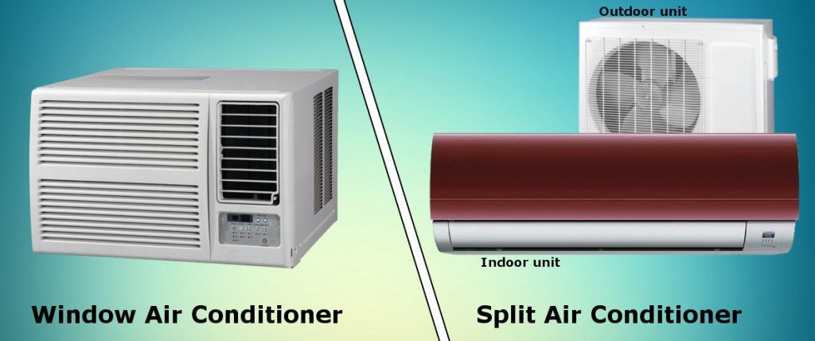
Photo Credit : ScienceABC
Regardless of the type of installation, all air conditioners consist of four major components that are listed below:

Evaporator
An evaporator is basically a heat exchanger coil that’s responsible for collecting heat from inside a room through a refrigerant gas. This component is known as the evaporator, and is where the liquid refrigerant absorbs heat and evaporatesto become gas.

The indoor unit of a split air conditioner. It contains the evaporator coil (Photo Credit : Shutterstock)
Some of the most common refrigerant gases used in air conditioning systems include hydrofluorocarbons or HFCs (like, R-410A) hydrochlorofluorocarbons or HCFCs (like, R-22) and hydrocarbons (like R-290 and R-600A). It is this gas that actually absorbs the heat from the room and travels to the the next component for further processing, which is…

Compressor
As the name clearly signifies, this is where compression of the gaseous refrigerant occurs. It’s located in the outside unit, i.e., the part that’s installed outside the house.

Condenser
The condenser receives the vaporized refrigerant from the compressor, converts it back to liquid and expels the heat outside. Needless to say, it’s also located on the outside unit of the split AC.
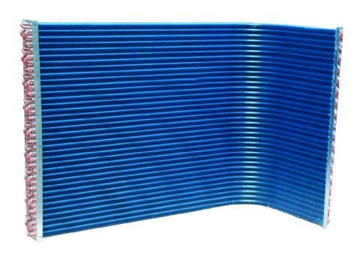
AC condenser (Photo Credit : tradekorea)

Expansion valve
Also referred to as the throttling device, the expansion valve is located between the two sets of coils (the chilled coils of the evaporator and the hot coils of the condenser). It keeps tabs on the amount of refrigerant moving towards the evaporator.
Note that in the case of window ACs, the three aforementioned components are all located inside a small metal box that is installed in a window opening.
These are the main components of an air conditioner. Now let’s look at how they work together to make an AC do what it does.

Air conditioner (AC) working principle
An air conditioner collects hot air from a given space, processes it within itself with the help of a refrigerant and a bunch of coils and then releases cool air into the same space where the hot air had originally been collected. This is essentially how all air conditioners work.
Many folks believe that an air conditioner produces chilled air with the help of machines installed inside it, allowing it to cool a room so quickly. That might also explain why it consumes so much electricity. In reality, however, that’s a misconception. An air conditioner is not a magical device; it just uses some physical and chemical phenomena very effectively to cool a given space.
When you switch an AC on and set your desired temperature (say, 20 degrees Celsius), the thermostat installed in it senses that there is a difference in the temperature of the room’s air and the temperature that you’ve chosen.

A thermostat constantly monitors the temperature of the system so that it’s maintained near a user’s desired point. (Photo Credit : Flickr)
This warm air is drawn in through a grille at the base of the indoor unit, which then flows over some pipes through which the refrigerant (i.e., a coolant fluid) is flowing. The refrigerant liquid absorbs the heat and becomes a hot gas itself. This is how heat is removed from the air that falls on the evaporator coils. Note that the evaporator coil not only absorbs heat, but also wrings out moisture from the incoming air, which helps to dehumidify the room.
This hot refrigerant gas is then passed on to the compressor (located on the outside unit). Being true to its name, the compressor compresses the gas so that it becomes hot, since compressing a gas increases its temperature.
his hot, high-pressure gas then travels to the third component – the condenser. Again, the condenser remains true to its name, and condenses the hot gas so that it becomes a liquid.
The refrigerant reaches the condenser as a hot gas, but quickly becomes a cooler liquid because the heat of the ‘hot gas’ is dissipated to the surroundings through metal fins. So, as the refrigerant leaves the condenser, it loses its heat and becomes a cooler liquid. This flows through an expansion valve – a tiny hole in the system’s copper tubing – which controls the flow of cool liquid refrigerant into the evaporator, so the refrigerant arrives at the point where its journey started.
Here’s a simplified diagram of the air-conditioning process:
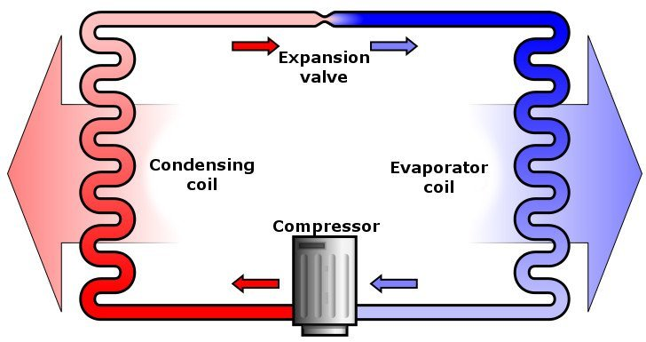
(Photo Credit : Ilmari Karonen / Wikipedia)
Although all the components involved in the air-conditioning process in window ACs are located inside the same metal box, the underlying process of cooling remains exactly the same.
4

Operation of Fire Tube Boiler

Operation of fire tube boiler is as simple as its construction. In fire tube boiler, the fuel is burnt inside a furnace. The hot gases produced in the furnace then passes through the fire tubes. The fire tubes are immersed in water inside the main vessel of the boiler. As the hot gases are passed through these tubes, the heat energy of the gasses is transferred to the water surrounds them. As a result steam is generated in the water and naturally comes up and is stored upon the water in the same vessel of fire tube boiler. This steam is then taken out from the steam outlet for utilizing for required purpose. The water is fed into the boiler through the feed water inlet. As the steam and water is stored is the same vessel, it is quite difficult to produce very high pressure steam from. General maximum capacity of this type of boiler is 17.5 kg/cm² and with a capacity of 9 Metric Ton of steam per hour. In a fire tube boiler, the main boiler vessel is under pressure, so if this vessel is burst there will be a possibility of major accident due to this explosion. Types of Fire Tube Boiler
According to the location of furnace there are two types of fire tube boiler and these are external furnace and internal furnace type. There are mainly three types of external furnace fire tube boiler.
- Horizontal return tubular fire tube boiler.
- Short fire box fire tube boiler.
- Compact fire tube boiler.
There are also two types of internal furnace fire tube boiler
- Horizontal tubular.
- Vertical tubular fire tube boiler.

Working Principle of Horizontal Return Fire Tube Boiler
Horizontal return fire tube boiler is most suitable for low capacity thermal power plant. The main constructional features of this boiler are one big size steam drum which lies horizontally upon supporting structures. There are numbers of fire tubes come from furnace and also aligned horizontally inside the drum. When the drum is filled with water these tubes are submerged in water. 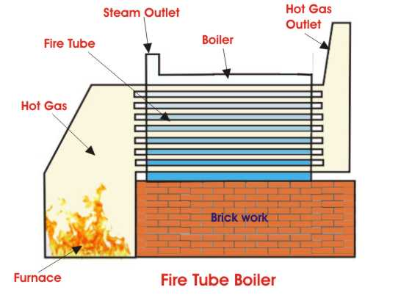
The fuels (normally coal) burnt in the furnace and combustible gasses move into the fire tubes, travel through these tubes from rear to front of the boiler drum and finally the gases come into the smoke box. The hot gasses in the tubes under water transfer heat to the water via the tube walls. Due to this heat energy steam bubbles are created and come upon the water surface. As the amount of steam is increased in that closed drum, steam pressure inside the drum increases which increase significantly the boiling temperature of the water and hence rate of production of steam is reduced. In this way a fire tube boiler controls its own pressure. In other words this is a self pressure controlled boiler.

Advantages of Fire Tube Boiler
- Compact in construction.
- Fluctuation of steam demand can be met easily.
- Cheaper than water tube boiler.

Disadvantages of Fire Tube Boiler
- Due to large water the required steam pressure rising time quite high.
- Output steam pressure cannot be very high since the water and steam are kept in same vessel.
- The steam received from fire tube boiler is not very dry.
- In a fire tube boiler, the steam drum is always under pressure, so there may be a chance of huge explosion which resulting to severe accident.

5
Consider a small element of a flat belt resting over a pulley shown in Fig. 2.3.1.
Fig. 2.3.1 Forces acting on an element of a flat-belt

The normal force (dN) acting on the belt arises due to reaction from the pulley. The coefficient of friction between pulley and belt is ‘μ’. Due to friction traction, the belt tensions on both the sides of the element are F₁(on loose side) and F₂ (on tight side), such that F₂ > F₁ and the friction force dF is equal to difference between these two forces. The angle of wrap of belt over the pulley is (in radians). If a belt having a linear density of m (in kg/m) running over a rim of pulley at a velocity, v (in m/s), the element of belt shown in figure would be subjected centrifugal force equal to (in N)
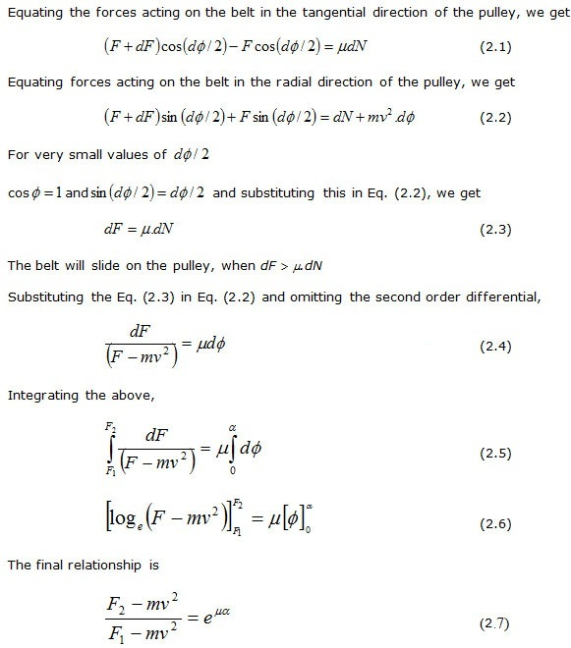
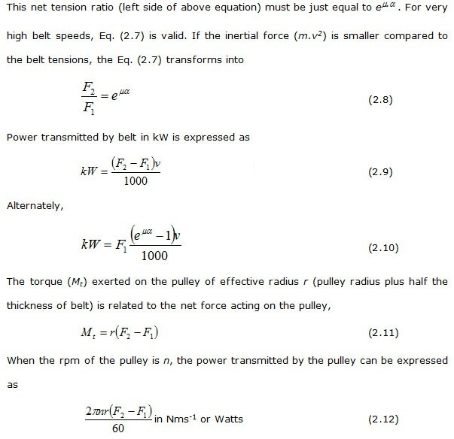
The above equation indicates that power transmission is proportional to belt speed. However, at very high belt speeds (usually above 1500 m/min), power decreases with increasing belt speed due to rapid rise of centrifugal force acting the belt. This centrifugal force reduces the pressure between the belt and the rim of the pulleys, moving the belt away from the pulley, reducing the wrap angle and hence, the belt tensions and power transmission.
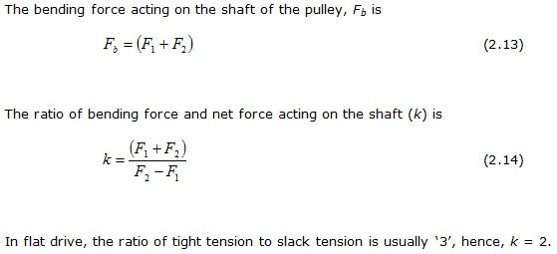

6

Introduction
Casting is an engineering manufacturing process generally used for mass production in which materials in a molten state are poured into a mold where they solidify. In this process, complex parts can be manufactured economically and rapidly that otherwise would involve a lot of time if produced by other methods like shaping or cutting. Casting process can be utilized to produce a large variety of parts that are used in different industries, ranging from a small plastic toy to a large gas turbine blade.
- Selection Of Casting Processes
Different casting processes are available for utilization, and their suitability is influenced by a number of factors including the following:
  - Quantity of castings
  - Manufacturing cost
  - Product material
  - Dimensional accuracy required
  - Surface finish required
- Casting Processes
- Sand casting
- Sand casting is normally used for the production of large parts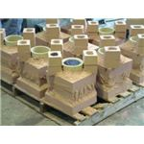, by filling a molten metal into the mold cavity that has been shaped from natural or synthetic sand. The cavity is created by the utilization of a pattern, generally made of wood or metal that is of the same shape and dimensions as the actual part. The pattern is prepared slightly oversize due to which the cavity is also a little larger and compensates for the contraction of molten metal during cooling. Surface of the sand castings is normally rough with surface impurities for which a machining allowance is included.
- Die Casting
- In this process metal is forced into the mold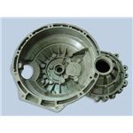 at a high pressure that ensures production of identical parts, a better surface finish, and an increased dimensional accuracy. Some parts produced by die casting even do not require machining after casting, or may require only a light machining to achieve the desired dimensions. Defects of porosity are found more often in large castings because of entrapped air and the solidification of melt before it reaches the boundaries of the cavity. Parts with a uniform wall thickness can be more accurately produced by die casting. Die casting molds are expensive since these are made from hardened steel and because a longer time duration is required for their production.
- This is a casting technique that has an extensive range of industrial applications including the casting of machine fittings where durability of the finished product is important. Television picture tubes, spherical glass objects, pipes, flywheels, and boilers are also produced by centrifugal casting. As the molten metal is poured, a perman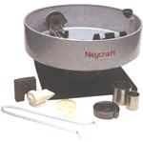ent mold spins at high speeds around its axis. The molten metal moves towards the mold walls due to centrifugal force, solidifies after cooling, producing a fine part. The external diameter of the casting has fine grains, and is resistant to atmospheric corrosion.
- Investment Casting
- Investment casting is an ancient manufacturing process used for metals that are difficult to be machined or fabricated. It is also used for the manufacture of parts that cannot be formed by usual manufacturing techniques like turbine b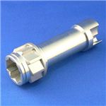lades or components of airplane that are subjected to high temperatures. This process provides an excellent dimensional accuracy and surface finish. The pattern is made of wax or other substance that is melted, leaving behind a cavity which is filled with the material of the part being produced.
7
A flexible manufacturing system (FMS) is a manufacturing system in which there is some amount of flexibility that allows the system to react in case of changes, whether predicted or unpredicted. This flexibility is generally considered to fall into two categories, which both contain numerous subcategories.
The first category, routing flexibility, covers the system's ability to be changed to produce new product types, and ability to change the order of operations executed on a part. The second category is called machine flexibility, which consists of the ability to use multiple machines to perform the same operation on a part, as well as the system's ability to absorb large-scale changes, such as in volume, capacity, or capability.
Most FMS consist of three main systems. The work machines which are often automated CNC machines are connected by a material handling system to optimize parts flow and the central control computer which controls material movements and machine flow.
The main advantages of an FMS is its high flexibility in managing manufacturing resources like time and effort in order to manufacture a new product. The best application of an FMS is found in the production of small sets of products like those from a mass production.

Advantages
- Reduced manufacturing cost
- Lower cost per unit produced,
- Greater labor productivity,
- Greater machine efficiency,
- Improved quality,
- Increased system reliability,
- Reduced parts inventories,
- Adaptability to CAD/CAM operations.
- Shorter lead times
- Improved efficiency
- Increase production rate

Disadvantages
- Initial set-up cost is high,
- Substantial pre-planning
- Requirement of skilled labor
- Complicated system

Rajasthan Institute of Engineering & Technology, Jaipur

II Mid Term Examination, April-2018
Session: 2017-18
B.Tech. MECHANICAL Engg. I Year II Sem
Basic Mechanical Engineering (ME102)
Set: B
Time: 2 Hrs. [Maximum Marks: -20]
Sec-A
  - Water is heated, turns into steam and spins a steam turbine which drives an electrical generator. After it passes through the turbine, the steam is condensed in a condenser. The greatest variation in the design of steam-electric power plants is due to the different fuel sources.
  - A major difference between refrigeration and air conditioning is the point of supply for the gases.Refrigeration systems have gas installed in a series of tubes. In old refrigerators, this gas was chloro-flouro-carbon, or CFC, but this has harmful effects on people, so refrigeratorsnot contain HFC-134a.

- Belt drives are widely used in many industries for power transmission since they are cheap and easy to maintain. However they are often a source of vibration due to misalignments, belt resonance, and belt wear.
- The main purpose of belt drives is to transfer power between machines such as motor and fan. They are subject to rotary and push-pull motions with varying dynamic characteristics. Belts are friction drives, which mean they depend on friction between the belt and pulley/sheave to transmit power.
- The most common types of belt drives include:
- Round belts
- Round belts are are generally made of rubber. This type of belt is generally used for light loads, such as in a sewing machine or a vacuum cleaner.
- V belts
- V belts are arguably the most widely used belts in industry. V belts have a V shaped cross-section, which rests against the side of V pulley under tension. The V shaped cross-section prevents belt from slipping off.
- Flat belts
- Flat belts are also used to transmit power from one shaft to another. They are generally classified as either small woven endless belts or higher power flat belts. The woven endless belts are especially useful where minimum vibration is required at the driven pulley due to semi-elastic material used in construction. The higher power flat belts are often useful because they eliminate the need to high belt tension used to grip pulleys, which in turn reduces the load on the shaft bearings. The material used for high power flat belts is sticky yet abrasion-resistant rubber compounds.
D) A lathe is a machine that rotates the piece on the axis in order to perform various operations like cutting, facing, knurling, deformation and more. Metal spinning, thermal spraying, woodturning and metalworking are the common operations performed with a lathe machine.
E) Computer-aided manufacturing (CAM) is the use of software to control machine tools and related ones in the manufacturing of workpieces. ... CAM is used in many schools alongsideComputer-Aided Design (CAD) to create objects.
F) Micro-Electro-Mechanical Systems, or MEMS, is a technology that in its most general form can be defined as miniaturized mechanical and electro-mechanical elements (i.e., devices and structures) that are made using the techniques of microfabrication. ... The term used to define MEMS varies in different parts of the world.
G) Extrusion is a process used to create objects of a fixed cross-sectional profile. A material is pushed through a die of the desired cross-section. ... The extrusion process can be done with the material hot or cold.
H)
Parallel.
- 1.Spur Gear.
- 2.Helical Gear.
- 3.Rack and Pinion.
- b. Intersecting.
- Bevel Gear.
- c. Non-intersecting and Non-parallel.
- worm and worm gears.

Sec-B
2
The Vapor Compression Refrigeration Cycle is nearly 200 years old, but it does not seem ready to leave the scene any time soon. While some people have viewed this method as environmentally harmful and inefficient, the cycle is still applicable in the industrial sphere.
Natural gas plants, petroleum refineries, and petrochemical plants and most of the food and beverage processes are some of the industrial plants that utilize vapor compression refrigeration systems.
What is its defining feature of these systems? The simplest explanation of this system is a heat engineworking in reverse, technically referred to as reverse Carnot engine. In other words, it is the transfer of heat from a cold reservoir to a hot one. Clausius Statement of the Second Law of thermodynamics states:
“It is impossible to construct a device that operates in a cycle and produces no effect other than the transfer of heat from a lower-temperature body to a higher-temperature body”.
Since the vapor compression cycle is against the Second Law of Thermodynamics, some work is necessary for the transfer to take place.

STEP 1: COMPRESSION
The refrigerant (for example R-717) enters the compressor at low temperature and low pressure. It is in a gaseous state. Here, compression takes place to raise the temperature and refrigerant pressure. The refrigerant leaves the compressor and enters to the condenser. Since this process requires work, an electric motor may be used. Compressors themselves can be scroll, screw, centrifugal or reciprocating types.

STEP 2: CONDENSATION
The condenser is essentially a heat exchanger. Heat is transferred from the refrigerant to a flow of water. This water goes to a cooling tower for cooling in the case of water-cooled condensation. Note that seawater and air-cooling methods may also play this role. As the refrigerant flows through the condenser, it is in a constant pressure.
One cannot afford to ignore condenser safety and performance. Specifically, pressure control is paramount for safety and efficiency reasons. There are several pressure-controlling devices to take care of this requirement

STEP 3: THROTTLING AND EXPANSION
When the refrigerant enters the throttling valve, it expands and releases pressure. Consequently, the temperature drops at this stage. Because of these changes, the refrigerant leaves the throttle valve as a liquid vapor mixture, typically in proportions of around 75 % and 25 % respectively.
Throttling valves play two crucial roles in the vapor compression cycle. First, they maintain a pressure differential between low- and high-pressure sides. Second, they control the amount of liquid refrigerant entering the evaporator.

STEP 4: EVAPORATION
At this stage of the Vapor Compression Refrigeration Cycle, the refrigerant is at a lower temperature than its surroundings. Therefore, it evaporates and absorbs latent heat of vaporization. Heat extraction from the refrigerant happens at low pressure and temperature. Compressor suction effect helps maintain the low pressure.
There are different evaporator versions in the market, but the major classifications are liquid cooling and air cooling, depending whether they cool liquid or air respectively.
3 The vapor absorption refrigeration system comprises of all the processes in the vapor compression refrigeration system like compression, condensation, expansion and evaporation. In the vapor absorption system the refrigerant used is ammonia, water or lithium bromide. The refrigerant gets condensed in the condenser and it gets evaporated in the evaporator. The refrigerant produces cooling effect in the evaporator and releases the heat to the atmosphere via the condenser. The major difference between the two systems is the method of the suction and compression of the refrigerant in the refrigeration cycle. In the vapor compression system, the compressor sucks the refrigerant from evaporator and compresses it to the high pressure. The compressor also enables the flow of the refrigerant through the whole refrigeration cycle. In the vapor absorption cycle, the process of suction and compression are carried out by two different devices called as the absorber and the generator. Thus the absorber and the generator replace the compressor in the vapor absorption cycle. The absorbent enables the flow of the refrigerant from the absorber to the generator by absorbing it.
Another major difference between the vapor compression and vapor absorption cycle is the method in which the energy input is given to the system. In the vapor compression system the energy input is given in the form of the mechanical work from the electric motor run by the electricity. In the vapor absorption system the energy input is given in the form of the heat. This heat can be from the excess steam from the process or the hot water. The heat can also be created by other sources like natural gas, kerosene, heater etc. though these sources are used only in the small systems.
- Absorption Refrigeration System
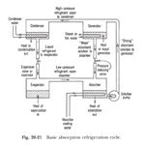
- Simple Absorption System and How it Works?
1) Condenser: Just like in the traditional condenser of the vapor compression cycle, the refrigerant enters the condenser at high pressure and temperature and gets condensed. The condenser is of water cooled type.
2) Expansion valve or restriction: When the refrigerant passes through the expansion valve, its pressure and temperature reduces suddenly. This refrigerant (ammonia in this case) then enters the evaporator.
3) Evaporator: The refrigerant at very low pressure and temperature enters the evaporator and produces the cooling effect. In the vapor compression cycle this refrigerant is sucked by the compressor, but in the vapor absorption cycle, this refrigerant flows to the absorber that acts as the suction part of the refrigeration cycle.
4
It is a Horizontal drum axis, natural draft, natural circulation, multitubular, stationary, high pressure, solid fuel fired, externally fired water tube boiler.
It was discovered by George Herman Babcock and Stephen Wilcox in the year 1967. And if was named after its discoverer as Babcock and Wilcox boiler.

Construction
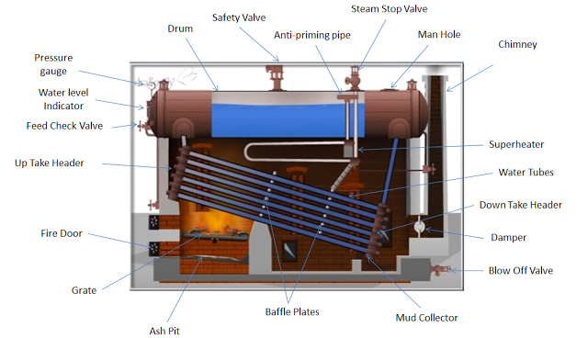
Image Source

The various main parts of Babcock and Wilcox Boiler are as follows
1. Drum: It is horizontal axis drum which contains water and steam.

2. Down Take Header: It is present at rear end of the boiler and connects the water tubes to the rear end of the drum. It receives water from the drum.

3. Up Take Header: it is present at front end of the boiler and connected to the front end of the drum. It transports the steam from the water tubes to the drum.

4. Water Tubes: They are the tubes in which water flows and gets converted into steam. It exchanges the heat from the hot flue gases to the water. It is inclined at angle of 10-15 degree with the horizontal direction. Due to its inclination the water tubes do not completely filled with water and the water and steam separated out easily.

5. Baffle Plates: Baffle plates are present in between water tubes and it allows the zigzag motion of hot flue gases from the furnace.

6. Fire Door: It is used to ignite the solid fuel in the furnace.
7. Grate: It is a base on which the burning of the solid fuel takes place.

8. Mud Collector: It is present at the bottom of down take header and used to collect the mud present in the water.

9. Feed Check Valve: it is used to fill water into the drum.10. Damper: It regulates the flow of air in the boiler.

The various boiler mounting and accessories used in this type of boiler are:

1. Superheater: It increases the temperature of saturated steam to the required temperature before discharging it from steam stop valve.

2. Pressure Gauge: It is used to check the pressure of steam within the boiler drum.

3. Water Level Indicator: It shows the level of water within the drum.

4. Safety Valve: It is a valve which acts when the pressure of steam within the boiler drum increase above the safety level. It opens and releases the extra steam in the environment to maintain the desired pressure within the
boiler.

Working
Now let’s discuss the working of Babcock and Wilcox boiler step by step.
- First the water starts to come in the water tubes from drum through down take header.
- The water present in the inclined water tubes gets heated up by the hot flue gases. The coal burning on the grate produces hot flue gases and it is forced to move in zigzag way with the help of baffle plates.
- As the hot flue gases come in contact with water tubes, it exchanges the heat with water and converts it into steam.
- The steam generated is moved upward and through up take header it gets collected at upper side in the boiler drum.
- An anti-priming pipe is provided in the drum. This anti-priming pipe filters the water content from the steam and allows only dry steam to enter into superheater.
- The superheater receives the water free steam from the anti-priming pipe. It increases the temperature of steam to desired level and transfers it to the steam stop valve.
- The superheated steam from the steam stop valve is either collected in a steam drum or made to strike on the steam turbine for electricity generation.
For Better Explanation of Working of Babcock and Wilcox Boiler, Watch the Video Given Below:

Application
The Babcock and Wilcox boiler are generally used to produce high pressure steam in power generation industries. The high pressure steam so generated is used to produce electricity.

Advantages and Disadvantages

Advantages
- Steam generation capacity is high. It is about 2000 to 40000 kg/hr.
- It occupies less space.
- Replacement of defective tubes is easy.
- It is the only boiler that is used to generate large quantity of heat in power stations.
- The draught loss is minimum.
- Inspection of this types of boiler can be done anytime during its working.

Disadvantages
- High maintenance cost.
- It is not much suitable for impure and sedimentary water. In case of impure and sedimentary water, scale may deposit in the tubes and this leads to overheating and bursting of tubes. That’s why water treatment is must before feeding into the boiler.
- Continuously supply of feed water is required for the working. In the case if feed water is not continuously supplied even for a short period of time, the boiler gets overheated. Water level must be carefully watched during the operation of the Babcock and Wilcox boiler.
5 Let r1 and r2 = Radii of the larger and smaller pulleys,
x = Distance between the centres of two pulleys (i.e. O1O2), and
L = Total length of the belt.
Let the belt leaves the larger pulley at E and G and the smaller pulley at F and H as shown in Fig. 18.13. Through O2 draw O2M parallel to FE.
From the geometry of the figure, we find that O2M will be perpendicular to O1E.
Let the angle MO2O1 = α radians.
We know that the length of the belt,
L = Arc GJE + EF + Arc FKH + HG
= 2 (Arc JE + EF + Arc FK) ……………………..(i)
From the geometry of the figure, we also find that
sin α = O1M/O1O2 = O1E – EM / O1O2 = r1 – r2 / x
Since the angle α is very small, therefore putting
sin α = α (in radians) = r1 – r2 / x …………………….(ii)
∴ Arc JE = r1 (π/2 + α) ………………………….(iii)
Similarly, arc FK = r2 (π/2 – α) ……………………..(iv)
and EF = MO2 = [(O1O2)^2 – (O1M)^2]^0.5 = [x^2 – (r1 – r2)^2]^0.5
= x [1 – {(r1-r2)/x}^2]^0.5
Expanding this equation by binomial theorem, we have
EF = x [1 – {0.5 {(r1 – r2)/x} + … ] = x – (r1 – r2)^2/2x …………………..(v)
Substituting the values of arc JE from equation (iii), arc FK from equation (iv) and EF from
equation (v) in equation (i), we get
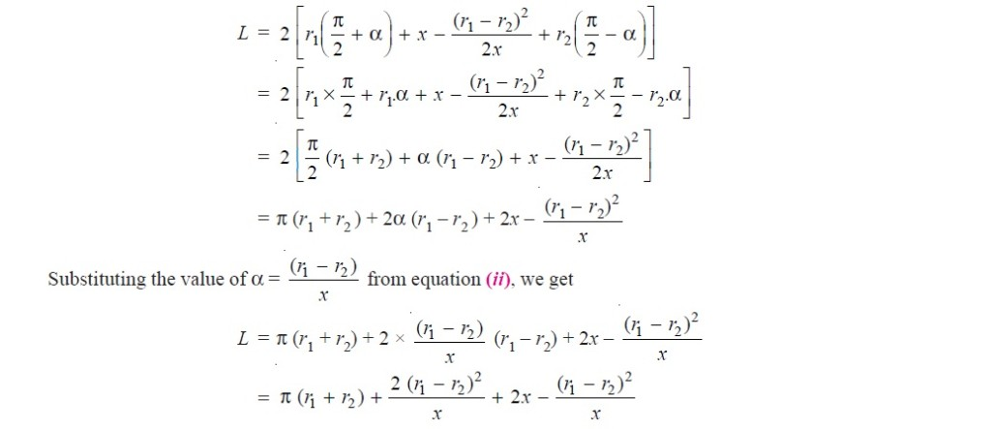

= π (r1 + r2) + 2x + (r1 – r2 )^2/x ……………. (in terms of pulley radii)
= π/2 (d1 + d2) + 2x + (d1 – d2)^2/4x …………………… (in terms of pulley diameters)
6
Arc welding is one of several fusion processes for joining metals. By applying intense heat, metal at the joint between two parts is melted and caused to intermix - directly, or more commonly, with an intermediate molten filler metal. Upon cooling and solidification, a metallurgical bond is created. Since the joining is an intermixture of metals, the final weldment potentially has the same strength properties as the metal of the parts. This is in sharp contrast to non-fusion processes of joining (i.e. soldering, brazing etc.) in which the mechanical and physical properties of the base materials cannot be duplicated at the joint.

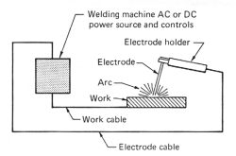
Fig. 1 The basic arc-welding circuit

In arc welding, the intense heat needed to melt metal is produced by an electric arc. The arc is formed between the actual work and an electrode (stick or wire) that is manually or mechanically guided along the joint. The electrode can either be a rod with the purpose of simply carrying the current between the tip and the work. Or, it may be a specially prepared rod or wire that not only conducts the current but also melts and supplies filler metal to the joint. Most welding in the manufacture of steel products uses the second type of electrode.
Basic Welding Circuit
The basic arc-welding circuit is illustrated in Fig. 1. An AC or DC power source, fitted with whatever controls may be needed, is connected by a work cable to the workpiece and by a "hot" cable to an electrode holder of some type, which makes an electrical contact with the welding electrode.
An arc is created across the gap when the energized circuit and the electrode tip touches the workpiece and is withdrawn, yet still with in close contact.
The arc produces a temperature of about 6500ºF at the tip. This heat melts both the base metal and the electrode, producing a pool of molten metal sometimes called a "crater." The crater solidifies behind the electrode as it is moved along the joint. The result is a fusion bond.
Arc Shielding
However, joining metals requires more than moving an electrode along a joint. Metals at high temperatures tend to react chemically with elements in the air - oxygen and nitrogen. When metal in the molten pool comes into contact with air, oxides and nitrides form which destroy the strength and toughness of the weld joint. Therefore, many arc-welding processes provide some means of covering the arc and the molten pool with a protective shield of gas, vapor, or slag. This is called arc shielding. This shielding prevents or minimizes contact of the molten metal with air. Shielding also may improve the weld. An example is a granular flux, which actually adds deoxidizers to the weld.

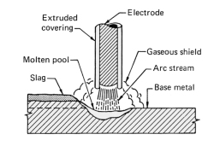
Fig. 2 This shows how the coating on a coated (stick) electrode provides a gaseous shield around the arc and a slag covering on the hot weld deposit.

Figure 2 illustrates the shielding of the welding arc and molten pool with a Stick electrode. The extruded covering on the filler metal rod, provides a shielding gas at the point of contact while the slag protects the fresh weld from the air.
The arc itself is a very complex phenomenon. In-depth understanding of the physics of the arc is of little value to the welder, but some knowledge of its general characteristics can be useful.
Nature of the Arc
An arc is an electric current flowing between two electrodes through an ionized column of gas. A negatively charged cathode and a positively charged anode create the intense heat of the welding arc. Negative and positive ions are bounced off of each other in the plasma column at an accelerated rate.
In welding, the arc not only provides the heat needed to melt the electrode and the base metal, but under certain conditions must also supply the means to transport the molten metal from the tip of the electrode to the work. Several mechanisms for metal transfer exist. Two (of many) examples include:
- Surface Tension Transfer® - a drop of molten metal touches the molten metal pool and is drawn into it by surface tension
- Spray Arc - the drop is ejected from the molten metal at the electrode tip by an electric pinch propelling it to the molten pool (great for overhead welding)
If an electrode is consumable, the tip melts under the heat of the arc and molten droplets are detached and transported to the work through the arc column. Any arc welding system in which the electrode is melted off to become part of the weld is described as metal-arc. In carbon or tungsten (TIG) welding there are no molten droplets to be forced across the gap and onto the work. Filler metal is melted into the joint from a separate rod or wire.
More of the heat developed by the arc is transferred to the weld pool with consumable electrodes. This produces higher thermal efficiencies and narrower heat-affected zones.
Since there must be an ionized path to conduct electricity across a gap, the mere switching on of the welding current with an electrically cold electrode posed over it will not start the arc. The arc must be ignited. This is caused by either supplying an initial voltage high enough to cause a discharge or by touching the electrode to the work and then withdrawing it as the contact area becomes heated.
Arc welding may be done with direct current (DC) with the electrode either positive or negative or alternating current (AC). The choice of current and polarity depends on the process, the type of electrode, the arc atmosphere, and the metal being welded.
7

Computer-Aided Manufacturing (CAM)

Computer-aided manufacturing (CAM) commonly refers to the use of numerical control (NC) computer software applications to create detailed instructions (G-code) that drive computer numerical control (CNC) machine tools for manufacturing parts. Manufacturers in a variety of industries depend on the capabilities of CAM to produce high-quality parts.
A broader definition of CAM can include the use of computer applications to define a manufacturing plan for tooling design, computer-aided design (CAD) model preparation, NC programming, coordinate measuring machine (CMM) inspection programming, machine tool simulation, or post-processing. The plan is then executed in a production environment, such as direct numerical control (DNC), tool management, CNC machining, or CMM execution.

Benefits of CAM
The benefits of CAM include a properly defined manufacturing plan that delivers expected results in production.

CAM systems can maximize utilization of a full range of production equipment, including high speed, 5-axis, multi-function and turning machines, electrical discharge machining (EDM) and CMM inspection equipment.

CAM systems can aid in creating, verifying, and optimizing NC programs for optimum machining productivity, as well as automate the creation of shop documentation.

Advanced CAM systems with product lifecycle management (PLM) integration can provide manufacturing planning and production personnel with data and process management to ensure use of correct data and standard resources.

CAM and PLM systems can be integrated with DNC systems for delivery and management of files to CNC machines on the shop floor.

