Rajasthan Institute of Engineering & Technology, Jaipur.
II Mid Term Examination
SET-A
Session: 2016-17
IV Semester & EE/EEE Branch
Electrical Machine-II
Time: 2hrs. M.M.:20
Instruction for students:
- No provision for supplementary answer book.

Q.1 Discuss the production of rotating magnetic field in three phase Induction Motor. [5]
When a 3-phase winding is energized from a 3-phase supply, a rotating magnetic field is produced. This field is such that its poles do no remain in a fixed position on the stator but go on shifting their positions around the stator. For this reason, it is called a rotating Held. It can be shown that magnitude of this rotating field is constant and is equal to 1.5 fm where fm is the maximum flux due to any phase.
To see how rotating field is produced, consider a 2-pole, 3i-phase winding as shown in Fig. (i). The three phases X, Y and Z are energized from a 3-phase source and currents in these phases are indicated as Ix, Iy and Iz [See Fig. (ii)]. Referring to Fig. (ii), the fluxes produced by these currents are given by:
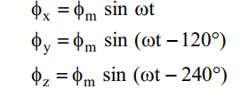
Here fm is the maximum flux due to any phase. Fig. (8.5) shows the phasor diagram of the three fluxes. We shall now prove that this 3-phase supply produces a rotating field of constant magnitude equal to 1.5 fm.
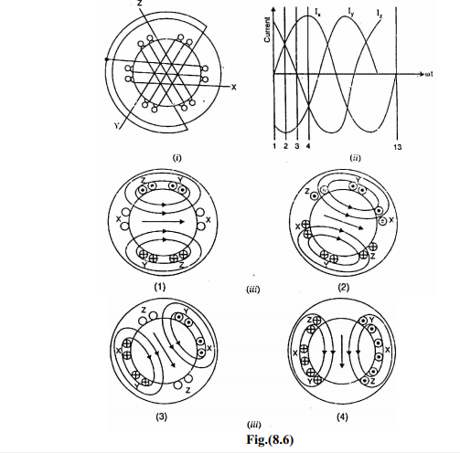
- At instant 1 [See Fig. (8.6 (ii)) and Fig. (8.6 (iii))], the current in phase X is zero and currents in phases Y and Z are equal and opposite. The currents are flowing outward in the top conductors and inward in the bottom conductors. This establishes a resultant flux towards right. The magnitude of the resultant flux is constant and is equal to 1.5 fm as proved under: At instant 1, wt = 0°. Therefore, the three fluxes are given by;
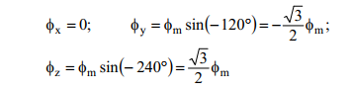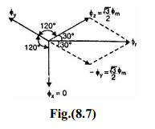

The phasor sum of − φy and φz is the resultant flux φr [See Fig. (8.7)]. It is
clear that:
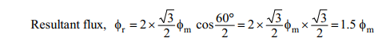
- At instant 2, the current is maximum (negative) in fy phase Y and 0.5 maximum (positive) in phases X and Y. The magnitude of resultant flux is 1.5 fm as proved under: At instant 2, wt = 30°. Therefore, the three fluxes are given by;
- 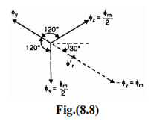
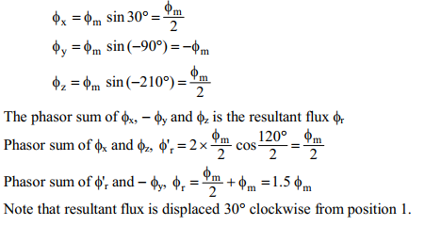
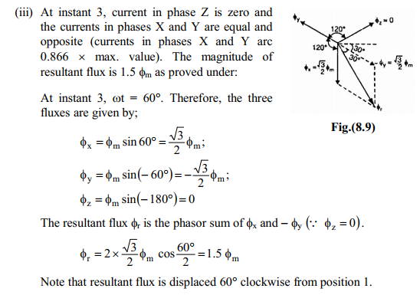
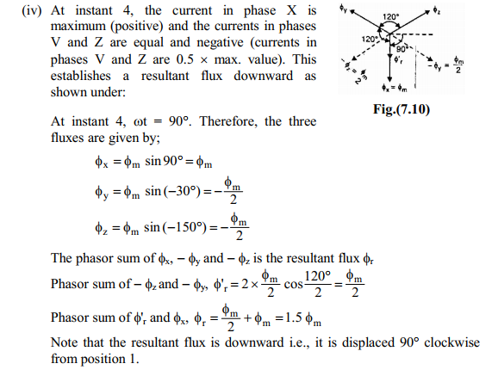
Or
Q.1 Draw the Torque-Slip Characteristics of 3-Phase Induction motor and explain it. Find condition of maximum torque also Show the effect of rotor resistance on torque-slip characteristics. [5]
The motor torque under running conditions is given by;
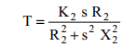
If a curve is drawn between the torque and slip for a particular value of rotor resistance R2, the graph thus obtained is called torque-slip characteristic. Fig. (8.19) shows a family of torque-slip characteristics for a slip-range from s = 0 to s = 1 for various values of rotor resistance.
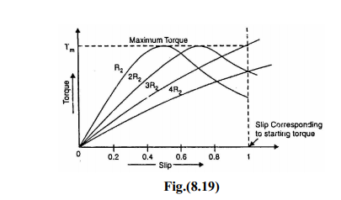
The following points may be noted carefully:
(i) At s = 0, T = 0 so that torque-slip curve starts from the origin.
(ii) At normal speed, slip is small so that s X2 is negligible as compared to R2.
∴ T ∝ s / R2
∝ s ... as R2 is constant
Hence torque slip curve is a straight line from zero slip to a slip that corresponds to full-load.
(iii) As slip increases beyond full-load slip, the torque increases and becomes maximum at s = R2/X2. This maximum torque in an induction motor is called pull-out torque or break-down torque. Its value is at least twice the full-load value when the motor is operated at rated voltage and frequency.
Maximum Torque under Running Conditions
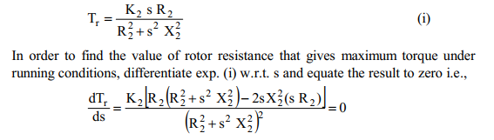
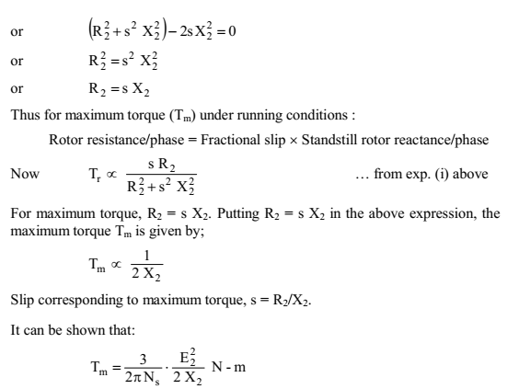
It is evident from the above equations that:
- The value of rotor resistance does not alter the value of the maximum torque but only the value of the slip at which it occurs.
- The maximum torque varies inversely as the standstill reactance. Therefore, it should be kept as small as possible.
- The maximum torque varies directly with the square of the applied voltage
- To obtain maximum torque at starting (s = 1), the rotor resistance must be made equal to rotor reactance at standstill.

Q.2 Give the advantages of providing armature winding on stator circuit rather than rotor circuit & explain the working of 2 -pole synchronous generator. [5]
Advantages of stationary armature
The field winding of an alternator is placed on the rotor and is connected to d.c. supply through two slip rings. The 3-phase armature winding is placed on the stator. This arrangement has the following advantages:
- It is easier to insulate stationary winding for high voltages for which the alternators are usually designed. Ii is because they are not subjected to centrifugal forces and also extra space is available due to the stationary arrangement of the armature.
- The stationary 3-phase armature can be directly connected to load without going through large, unreliable slip rings and brushes.
- Only two slip rings are required for d.c. supply to the field winding on the rotor. Since the exciting current is small, the slip rings and brush gear required are of light construction.
- Due to simple and robust construction of the rotor, higher speed of rotating d.c. field is possible. This increases the output obtainable from a machine of given dimensions.
Alternator Operation
The rotor winding is energized from the d.c. exciter and alternate N and S poles are developed on the rotor. When the rotor is rotated in anti-clockwise direction by a prime mover, the stator or armature conductors are cut by the magnetic flux of rotor poles. Consequently, e.m.f. is induced in the armature conductors due to electromagnetic induction. The induced e.m.f. is alternating since N and S poles of rotor alternately pass the armature conductors. The direction of induced e.m.f. can be found by Fleming’s right hand rule and frequency is given by;
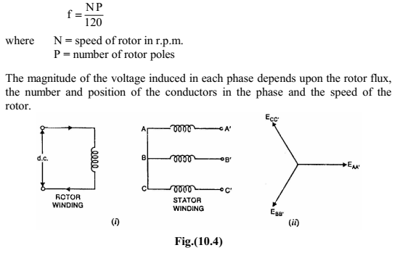
Fig. (10.4 (i)) shows star-connected armature winding and d.c. field winding. When the rotor is rotated, a 3-phase voltage is induced in the armature winding. The magnitude of induced e.m.f. depends upon the speed of rotation and the d.c. exciting current. The magnitude of e.m.f. in each phase of the armature winding is the same. However, they differ in phase by 120° electrical as shown in the phasor diagram in Fig. (10.4 (ii)).
Or
Q.2 Explain power angle characteristics of a cylindrical rotor synchronous generator. [5]
Power Output Equation
Consider a star-connected cylindrical rotor alternator operating on infinite
busbars.
Let | V = busbars voltage/phase  E = generated e.m.f./phase
Ia = armature current/phase delivered by the alternator
Zs = synchronous impedance/phase = Ra + j Xs
cosф = lagging p.f. of the alternator
q = internal angle = tan-1 Xs/Ra
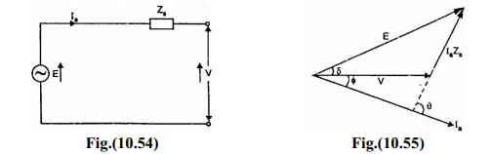
Fig. (10.54) shows the equivalent circuit for one phase of the alternator whereas Fig. (10.55) shows the phasor diagram. Note that in drawing the phasor diagram, V has been taken as the reference phasor. We shall now derive an expression for the power delivered by the alternator. Referring to Fig. (10.55),
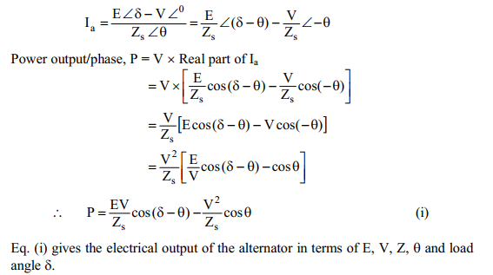
Power/Power Angle Characteristic
The power output of an alternator is given by:
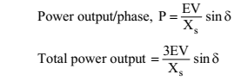
Note that power output varies sinusoidally with power angle d. Fig. (10.56) shows the power angle characteristic of the alternator. The alternator delivers maximum power when ᵟ= 90°. If d becomes greater than 90°, the machine will lose synchronism. The dotted portion of the curve refers to unstable operation, i.e., machine loses synchronism. Note that stability of the alternator is determined by the power/power angle characteristic. Suppose the operating position of the alternator is represented by point P on the curve. If unsteadiness occurs due to a transient spike of mechanical input, then load angle d increases by a small amount. The additional electrical output caused by an increase in d produces a torque which is not balanced by the driving torque once the spike has passed. This torque causes retardation of the rotor and the alternator returns to the operating point P. The torque causing the return of the alternator to the steady-state position is called the synchronizing torque and the power associated with it is known as synchronizing power.
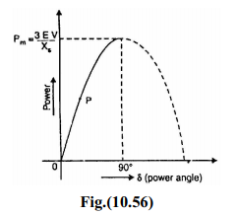
Q.3 Draw the equivalent circuit of a synchronous generator. Also draw the phasor diagram for lagging power factor current supplied by the generator & write voltage balance equation. [5]
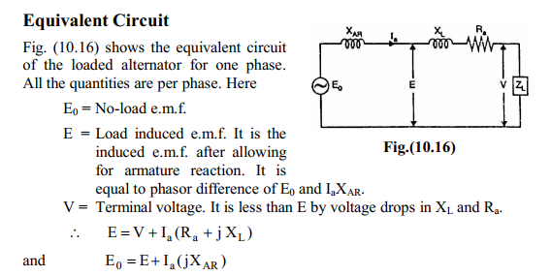
Synchronous Reactance (Xs)
The sum of armature leakage reactance (XL) and reactance of armature reaction (XAR) is called synchronous reactance Xs [See Fig. (10.17 (i))]. Note that all quantities are per phase.
Xs = XL + XAR
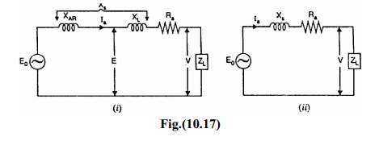
The synchronous reactance is a fictitious reactance employed to account for the voltage effects in the armature circuit produced by the actual armature leakage reactance and the change in the air-gap flux caused by armature reaction. The circuit then reduces to the one shown in Fig. (10.17 (ii)). Synchronous impedance, Zs = Ra + j Xs The synchronous impedance is the fictitious impedance employed to account for the voltage effects in the armature circuit produced by the actual armature resistance, the actual armature leakage reactance and the change in the air-gap
flux produced by armature reaction.
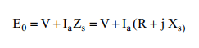
Phasor Diagram of a Loaded Alternator
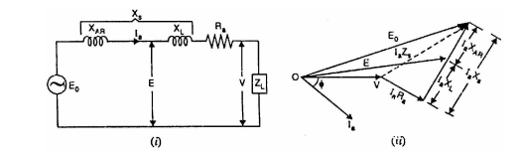

Or
Q.3 Explain the parallel operation of two alternators. Describe any one method by which alternators could be put in parallel. [5]
Alternator is really an AC generator. In alternator, an EMF is induced in the stator (stationary wire) with the influence of rotating magnetic field (rotor) due to Faraday’s law of induction. Due to the synchronous speed of rotation of field poles, it is also known as synchronous generator. Here, we can discuss about parallel operation of alternator. When the AC power systems are interconnected for efficiency, the alternators should also have to be connected in parallel. There will be more than two alternators connected in parallel in generating stations.

Condition for Parallel Operation of Alternator
There are some conditions to be satisfied for parallel operation of the alternator. Before entering into that, we should understand some terms which are as follows.
- The process of connecting two alternators or an alternator and an infinite bus bar system in parallel is known as synchronizing.
- Running machine is the machine which carries the load.
- Incoming machine is the alternator or machine which has to be connected in parallel with the system.
The conditions to be satisfied are
- The phase sequence of the incoming machine voltage and the bus bar voltage should be identical.
- The RMS line voltage (terminal voltage) of the bus bar or already running machine and the incoming machine should be the same.
- The phase angle of the two systems should be equal.
- The frequency of the two terminal voltages (incoming machine and the bus bar) should be nearly the same. Large power transients will occur when frequencies are not nearly equal.
Departure from the above conditions will result in the formation of power surges and current. It also results in unwanted electro-mechanical oscillation of rotor which leads to the damage of equipment.

General Procedure for Paralleling Alternators
The figure below shows an alternator (generator 2) being paralleled with a running power system (generator 1). These two machines are about to synchronize for supplying power to a load. Generator 2 is about to parallel with the help of a switch, S1. This switch should never be closed without satisfying the above conditions.
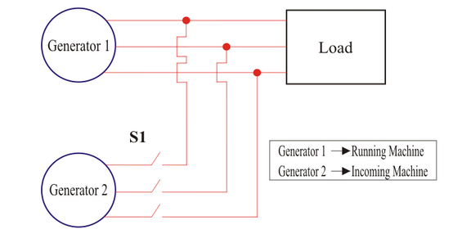
• To make the terminal voltages equal. This can be done by adjusting the terminal voltage of incoming machine by changing the field current and make it equal to the line voltage of running system using voltmeters.
• There are two methods to check the phase sequence of the machines. They are as follows
- First one is using a Synchroscope. It is not actually check the phase sequence but it is used to measure the difference in phase angles.
- Second method is three lamp method (Figure 2). Here we can see three light bulbs are connected to the terminals of the switch, S1. Bulbs become bright if the phase difference is large. Bulbs become dim if the phase difference is small. The bulbs will show dim and bright all together if phase sequence is the same. The bulbs will get bright in progression if the phase sequence is opposite. This phase sequence can be made equal by swapping the connections on any two phases on one of the generators.
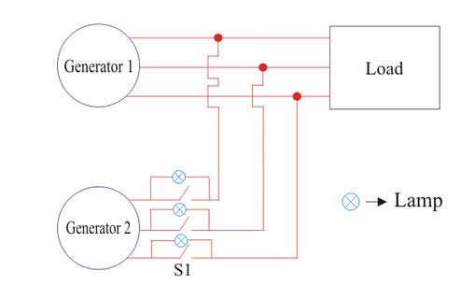
- Next, we have to check and verify the incoming and running system frequency. It should be nearly the same. This can be done by inspecting the frequency of dimming and brightening of lamps.
- When the frequencies are nearly equal, the two voltages (incoming alternator and running system) will alter the phase gradually. These changes can be observed and the switch, S1 can be made closed when the phase angles are equal.

Advantages of Parallel Operating Alternators
- When there is maintenance or an inspection, one machine can be taken out from service and the other alternators can keep up for the continuity of supply.
- Load supply can be increased.
- During light loads, more than one alternator can be shut down while the other will operate in nearly full load.
- High efficiency.
- The operating cost is reduced.
- Ensures the protection of supply and enables cost-effective generation.
- The generation cost is reduced.
- Breaking down of a generator does not cause any interruption in the supply.
- Reliability of the whole power system increases.

Q.4 Explain the operation and working of three phase synchronous motor. Why a synchronous motor is not self starting? [5]

Principle of Operation Synchronous Motor
Synchronous motor is a doubly excited machine, i.e. two electrical inputs are provided to it. Its stator winding which consists of a We provide three-phase supply to three-phase stator winding, and DC to the rotor winding. The 3 phase stator winding carrying 3 phase currents produces 3 phase rotating magnetic flux. The rotor carrying DC supply also produces a constant flux. Considering 50 Hz power frequency, from the above relation we can see that the 3 phase rotating flux rotates about 3000 revolutions in 1 min or 50 revolutions in 1 sec. At a particular instant rotor and stator poles might be of the same polarity (N-N or S-S) causing a repulsive force on the rotor and the very next instant it will be N-S causing attractive force. But due to the inertia of the rotor, it is unable to rotate in any direction due to that attractive or repulsive forces, and the rotor remains in standstill condition. Hence a synchronous motor is not self-starting. Here we use some mechanical means which initially rotates the rotor in the same direction as the magnetic field to speed very close to synchronous speed. On achieving synchronous speed, magnetic locking occurs, and the synchronous motor continues to rotate even after removal of external mechanical means.

Methods of Starting of Synchronous Motor
- Motor starting with an external prime Mover: Synchronous motors are mechanically coupled with another motor. It could be either 3 phase induction motor or DC shunt motor. Here, we do not apply DC excitation initially. It rotates at speed very close to its synchronous speed, and then we give the DC excitation. After some time when magnetic locking takes place supply to the external motor is cut off.
- Damper winding In this case, the synchronous motor is of salient pole type, additional winding is placed in rotor pole face. Initially, when the rotor is not rotating, the relative speed between damper winding and rotating air gap flux is large and an emf is induced in it which produces the required starting torque. As speed approaches synchronous speed, emf and torque are reduced and finally when magnetic locking takes place; torque also reduces to zero. Hence in this case synchronous motor first runs as three phase induction motor using additional winding and finally it is synchronized with the frequency.

Application of Synchronous Motor
- Synchronous motor having no load connected to its shaft is used for power factor improvement. Owing to its characteristics to behave at any electrical power factor, it is used in power system in situations where static capacitors are expensive.
- Synchronous motor finds application where operating speed is less (around 500 rpm) and high power is required. For power requirement from 35 kW to 2500 KW, the size, weight and cost of the corresponding three phase induction motor is very high. Hence these motors are preferably used. Ex- Reciprocating pump, compressor, rolling mills etc.

Or
Q.4 Explain the hunting of synchronous machine. What is the prevention use for eliminating the hunting? [5]
Unloaded synchronous machine has zero degree load angle. On increasing the shaft load gradually load angle will increase. Let us consider that load P₁ is applied suddenly to unloaded machine shaft so machine will slow down momentarily. Also load angle (δ) increases from zero degree and becomes δ₁. During the first swing electrical power developed is equal to mechanical load P₁. Equilibrium is not established so rotor swings further. Load angle exceeds δ₁ and becomes δ₂. Now electrical power generated is greater than the previous one. Rotor attains synchronous speed. But it does not stay in synchronous speed and it will continue to increase beyond synchronous speed. As a result of rotor acceleration above synchronous speed the load angle decreases. So once again no equilibrium is attained. Thus rotor swings or oscillates about new equilibrium position. This phenomenon is known as hunting or phase swinging. Hunting occurs not only in synchronous motors but also in synchronous generators upon abrupt change in load.

Causes of Hunting in Synchronous Motor
- Sudden change in load.
- Sudden change in field current.
- A load containing harmonic torque.
- Fault in supply system.

Effects of Hunting in Synchronous Motor
- It may lead to loss of synchronism.
- Produces mechanical stresses in the rotor shaft.
- Increases machine losses and cause temperature rise.
- Cause greater surges in current and power flow.
- It increases possibility of resonance.

Reduction of Hunting in Synchronous Motor
Two techniques should be used to reduce hunting. These are –
- Use of Damper Winding: It consists of low electrical resistance copper / aluminum brush embedded in slots of pole faces in salient pole machine. Damper winding damps out hunting by producing torque opposite to slip of rotor. The magnitude of damping torque is proportional to the slip speed.
- Use of Flywheels: The prime mover is provided with a large and heavy flywheel. This increases the inertia of prime mover and helps in maintaining the rotor speed constant.
- Designing synchronous machine with suitable synchronizing power coefficients.

Rajasthan Institute of Engineering & Technology, Jaipur.
II Mid Term Examination
SET-B
Session: 2016-17
IV Semester & EE/EEE Branch
Electrical Machine-II
Time: 2hrs. M.M.:20
Instruction for students:
- No provision for supplementary answer book.

Q.1 Explain the equivalent circuit of Induction motor. Draw basic equivalent circuit and approximate equivalent circuit. [5]
The induction motor consists of a two magnetically connected systems namely, stator and rotor. This is similar to a transformer that also has two magnetically connected systems namely primary and secondary windings. Also, the induction motor operates on the same principle as the transformer. Hence, the induction motor is also called as rotating transformer The stator is supplied by a balanced three-phase voltage that drives a three-phase current through the winding. This current induces a voltage in the rotor. The applied voltage (V1) across phase A is equal to the sum of the
–induced voltage (E1).
–voltage drop across the stator resistance (I1R1).
–voltage drop across the stator leakage reactance (I1 j X1).
Let
I1 = stator current/phase
R1 = stator winding resistance/phase
X1 = stator winding reactance/phase
RR = stator winding resistance/phase
XR = stator winding reactance/phase
IR = rotor current
V1 = applied voltage to the stator/phase
Io = Ic+Im (Im-magnetising component, Ic-core loss component)
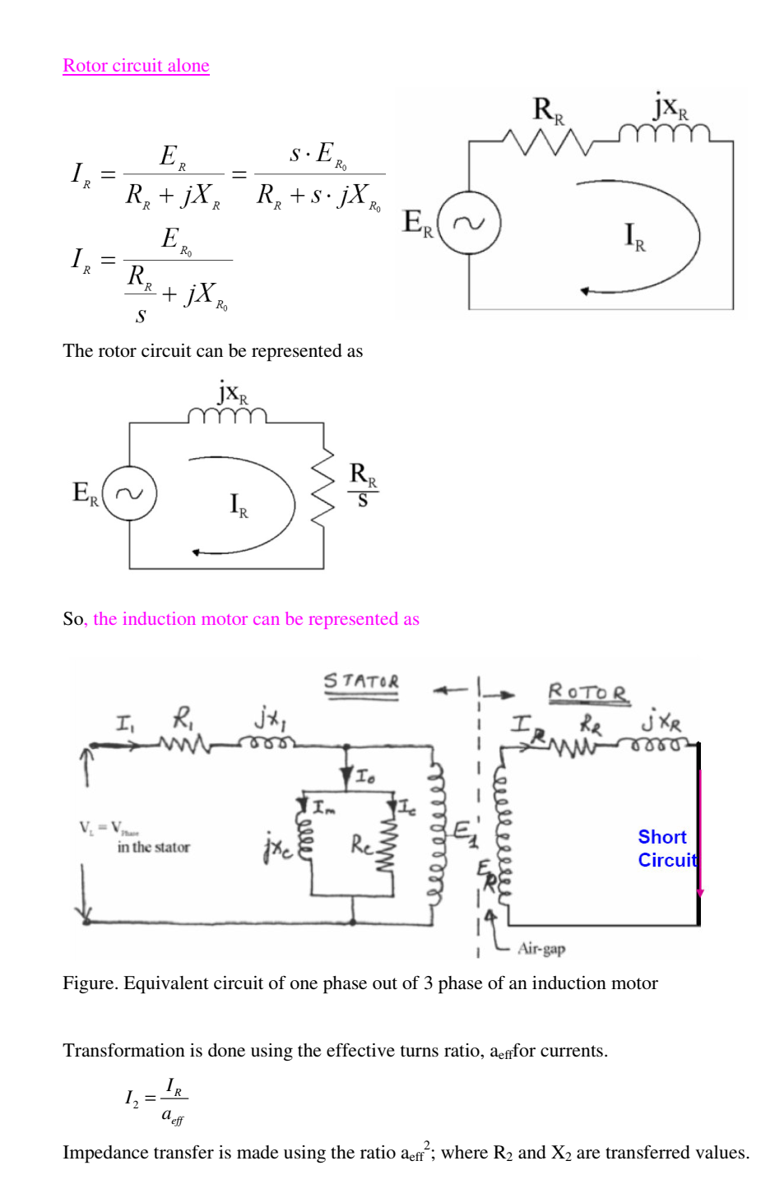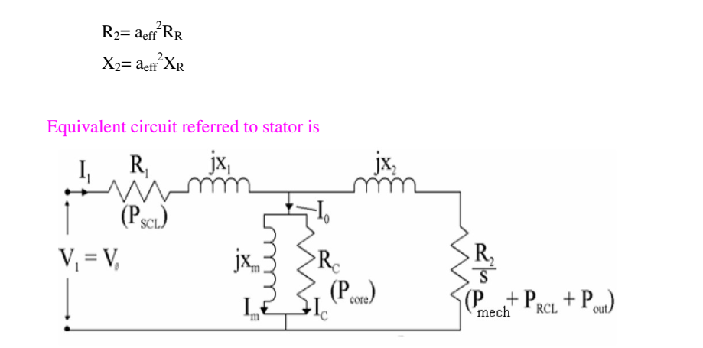
Or
Q.1what are the different starting methods of Induction Motor, explain star-delta method in detail. [5]
There are two important factors to be considered in starting of induction motors:
1. The starting current drawn from the supply, and
2. The starting torque.
The starting current should be kept low to avoid overheating of motor and excessive voltage drops in the supply network. The starting torque must be about 50 to 100% more than the expected load torque to ensure that the motor runs up in a reasonably short time.
At synchronous speed, s = 0, and therefore , 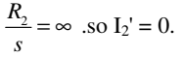
The stator current therefore comprises only the magnetizing
current i.e. I1 = Iφ and is quite therefore quite small.
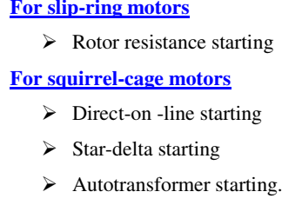
Star-Delta starting
This is applicable to motors designed for delta connection in normal running conditions. Both ends of each phase of the stator winding are brought out and connected to a 3-phase change -over switch.
For starting, the stator windings are connected in star and when the machine is running the switch is thrown quickly to the running position, thus connecting the motor in delta for normal operation. The phase voltages & the phase currents of the motor in star connection are reduced to 1/√3 of the direct -on -line values in delta. The line current is 1/3 of the value in delta. A disadvantage of this method is that the starting torque (which is proportional to the square of the applied voltage) is also reduced to 1/3 of its delta value.
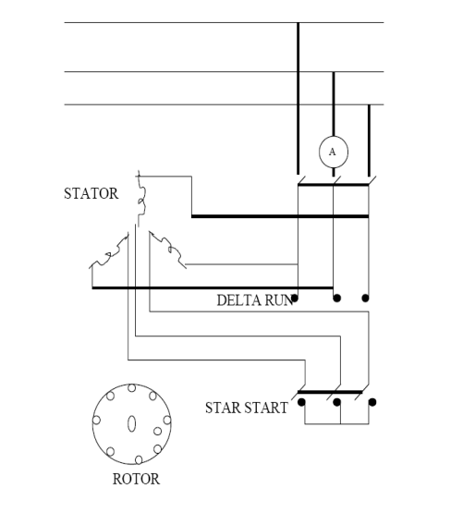

Q.2 What do you mean by “VOLTAGE REGULATION”. What are the different methods to determine voltage regulation? Explain any one in detail with the help of phasor diagram in steps. [5]
The Voltage Regulation of a Synchronous Generator is the rise in voltage at the terminals when the load is reduced from full load rated value to zero, speed and field current remaining constant. It depends upon the power factor of the load. For unity and lagging power factors, there is always a voltage drop with the increase of load, but for a certain leading power, the full load voltage regulation is zero.
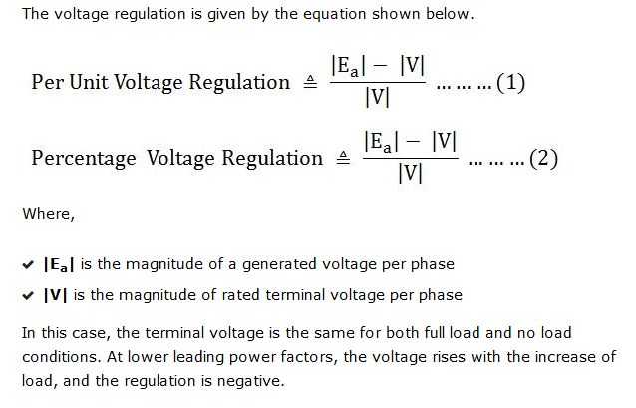

Determination of Voltage Regulation
There are mainly two methods which are used to determine the regulation of voltage of a smooth cylindrical rotor type alternators. They are named as direct load test method and indirect methods of voltage regulation. The indirect method is further classified as Synchronous Impedance Method, Ampere-turn Method and Zero Power Factor Method.

Synchronous Impedance Method
The Synchronous Impedance Method or Emf Method is based on the concept of replacing the effect of armature reaction by an imaginary reactance. For calculating the regulation, the synchronous method requires the following data; they are the armature resistance per phase and the open circuit characteristic. The open circuit characteristic is the graph of the circuit voltage and the field current. This method also requires short circuit characteristic which is the graph of the short circuit and the field current.
For a synchronous generator following are the equation given below
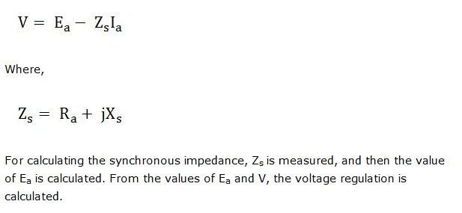

Measurement of Synchronous Impedance
The measurement of synchronous impedance is done by the following methods. They are known as
- DC resistance test
- Open circuit test
- Short circuit test

DC resistance test
In this test, it is assumed that the alternator is star connected with the DC field winding open as shown in the circuit diagram below.
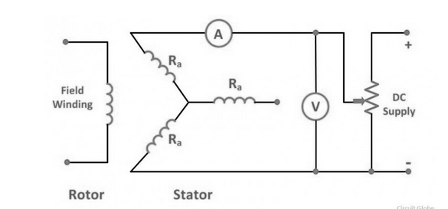
It measures the DC resistance between each pair of terminals either by using an ammeter – voltmeter method or by using the Wheatstone’s bridge. The average of three sets of resistance value R_{t} is taken. The value of R_{t} is divided by 2 to obtain a value of DC resistance per phase. Since the effective AC resistance is larger than the DC resistance due to skin effect. Therefore, the effective AC resistance per phase is obtained by multiplying the DC resistance by a factor 1.20 to 1.75 depending on the size of the machine. A typical value to use in the calculation would be 1.25.

Open Circuit Test
In the open circuit test for determining the synchronous impedance, the alternator is running at the rated synchronous speed, and the load terminals are kept open. This means that the loads are disconnected, and the field current is set to zero. The circuit diagram is shown below.
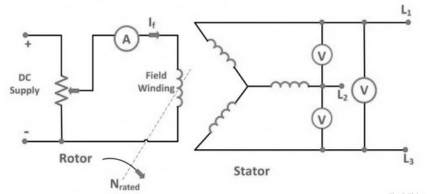
After setting the field current to zero, the field current is gradually increased step by step. The terminal voltage E_{t} is measured at each step. The excitation current may be increased to get 25% more than the rated voltage. A graph is drawn between the open circuit phase voltage E_{p} = E_{t}/√3 and the field current I_{f}. The curve so obtains called Open Circuit Characteristic (O.C.C). The shape is same as normal magnetisation curve. The linear portion of the O.C.C is extended to form an air gap line.
The Open Circuit Characteristic (O.C.C) and the air gap line is shown in the figure below.
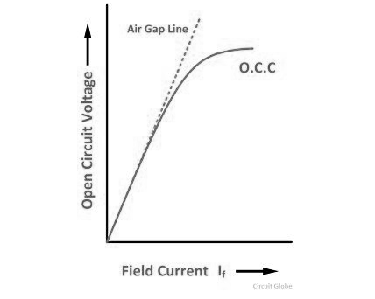

Short Circuit Test
In the short circuit test, the armature terminals are shorted through three ammeters as shown in the figure below.
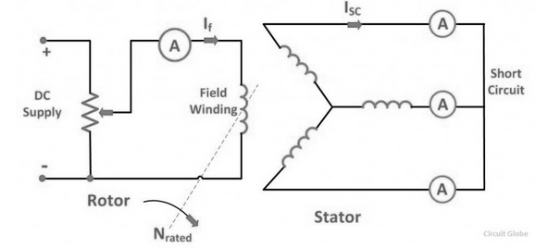
The field current should first be decreased to zero before starting the alternator. Each ammeter should have a range greater than the rated full load value. The alternator is then run at synchronous speed. Same as in an open circuit test that the field current is increased gradually in steps and the armature current is measured at each step. The field current is increased to get armature currents up to 150% of the rated value.
The value of field current If and the average of three ammeter readings at each step is taken. A graph is plotted between the armature current Ia and the field current If. The characteristic so obtained is called Short Circuit Characteristic (S.C.C). This characteristic is a straight line as shown in the figure below.
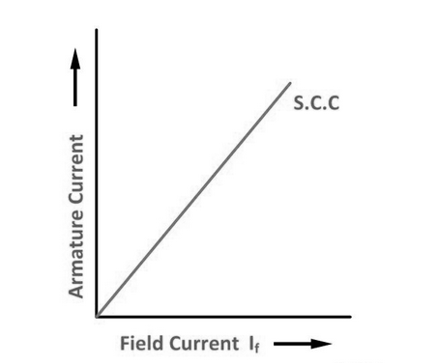

Calculation of Synchronous Impedance
The following steps are given below for the calculation of the synchronous impedance.
- The open circuit characteristics and the short circuit characteristic are drawn on the same curve.
- Determine the value of short circuit current I_{sc} and gives the rated alternator voltage per phase.
- The synchronous impedance Z_{S} will then be equal to the open circuit voltage divided by the short circuit current at that field current which gives the rated EMF per phase.
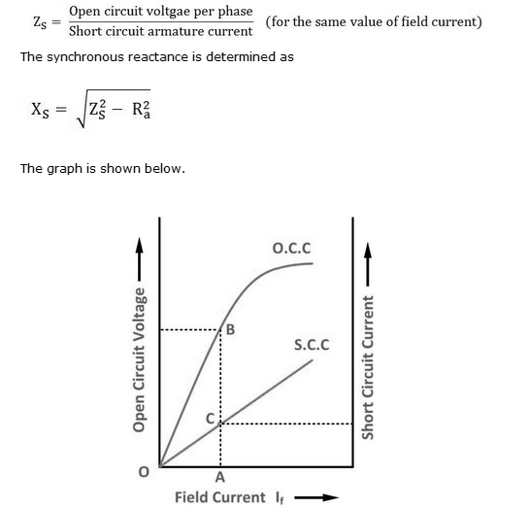
From the above figure consider the field current I_{f} = OA that produces rated alternator voltage per phase. Corresponding to this field current, the open circuit voltage is AB
Therefore,
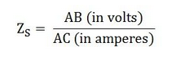

Or
Q.2 What are the benefits of having rotating field system in large size synchronous generator? [5]
- We use AC power in our daily life which has generation level around 11 kV to 33 kV, it is difficult to get induced emf in armature because we can't mount as many as conductors as required on rotating armature hence we prefer stationary armature.
- As said in above point large conductors possess high centrifugal forces while rotating. So there will be chance of conductors slipping out from slots. So by using rotating field over rotating armature we can reduce mechanical and electrical stresses.
- The problem of sparking at the slip rings can be avoided by keeping field rotating which is low voltage circuit and high voltage armature as stationary.
- It is not that much easy to collect larger currents at very high voltages from rotating armature.
- It is easier to collect larger currents at very high voltages from a stationary member than from the slip ring and brush assembly. The voltage required to be supplied to the field is very low (110 V to 220 V dc.) and hence can be easily supplied with the help of slip ring and brush assembly by keeping it rotating.
- The ventilation arrangement for high voltage side can be improved if it is kept stationary.
- It is better to rotate low inertia system than high inertia system so we use low voltage on rotor side so that inertia can be reduced along with insulation on the rotor side which also reduces cost of the system
- As we collect power from armature a rotating field type makes it easier to collect power from the armature, and greater output can be collected at low losses compared to that of rotating armature.
- If field is rotating, to excite it by an external d.c. supply two slip rings are enough. One each for positive and negative terminals. As against this, in three phase rotating armature the minimum number of slip rings required are three and can not be easily insulated due to high voltage levels.
By considering the all above reasons we can say for very high voltages, rotating field type of arrangement in alternators is better than stationary field type. For small voltage rating alternators rotating armature arrangement may be used.

Q.3 Draw the phasor diagram for lagging power factor and derive the output power equation of a salient pole synchronous generator. Also draw its power angle characteristics. [5]
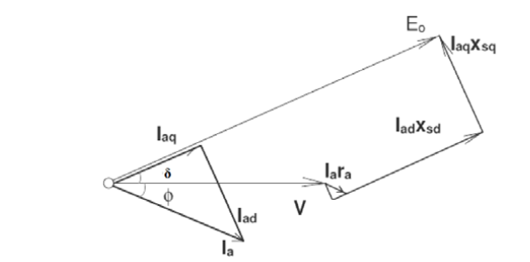
Power angle characteristics of salient pole machine
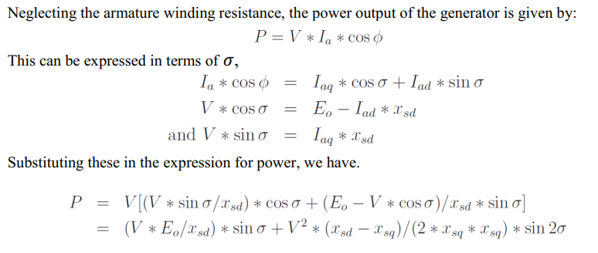
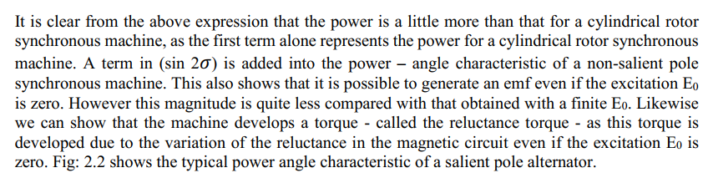
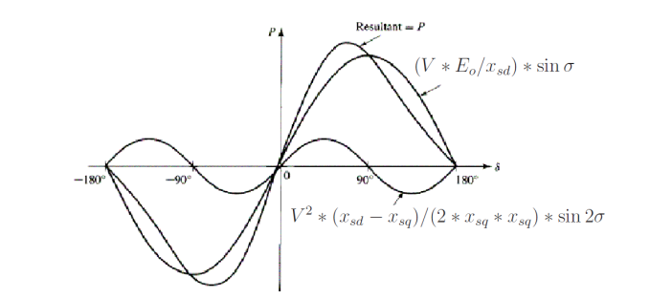
Or
Q.3 A 3- phase 10KVA, 400V, 50HZ star connected alternator supplies the rated load at 0.8 lagging power factor. if the armature resistance is 0.5Ω & synchronous reactance is 10Ω. Find the generated EMF & Voltage regulation.

Q.4 With the help of phasor diagram show the power factor control of synchronous motor through change of excitation. [5]
Synchronous motor excitation refers to the DC supply given to rotor which is used to produce the required magnetic flux.One of the major and unique characteristics of this motor is that it can be operated at any electrical power factor leading, lagging or unity and this feature is based on the excitation of the synchronous motor. When the synchronous motor is working at constant applied voltage V, the resultant air gap flux as demanded by V remains substantially constant. This resultant air gap flux is established by the co operation of both AC supply of armature winding and DC supply of rotor winding. CASE 1: When the field current is sufficient enough to produce the air gap flux, as demanded by the constant supply voltage V, then the magnetizing current or lagging reactive VA required from ac source is zero and the motor operate at unity power factor. The field current, which causes this unity power factor is called normal excitation or normal field current.
CASE 2: If the field current is not sufficient enough to produce the required air gap flux as demanded by V, additional magnetizing current or lagging reactive VA is drawn from the AC source. This magnetizing current produces the deficient flux (constant flux- flux set up by dc supply rotor winding). Hence in this case the motor is said to operate under lagging power factor and the is said to be under excited. CASE 3: If the field current is more than the normal field current, motor is said to be over excited. This excess field current produces excess flux (flux set up by DC supply rotor winding – resultant air gap flux) which must be neutralized by the armature winding.
Hence the armature winding draws leading reactive VA or demagnetizing current leading voltage by almost 90º from the AC source. Hence in this case the motor operate under leading power factor. This whole concept of excitation and power factor of synchronous motor can be summed up in the following graph. This is called V curve of synchronous motor.
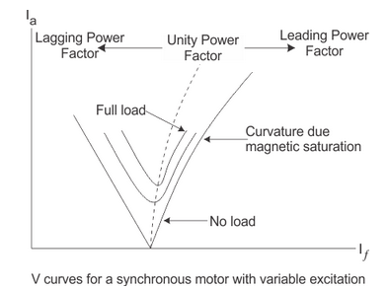
Conclusion: An overexcited synchronous motor operate at leading power factor, under-excited synchronous motor operate at lagging power factor and normal excited synchronous motor operate at unity power factor.
Or
Q.4 Draw & explain V-curves and Inverted V-Curves of a synchronous motor at different loads. [5]
Electromagnetic devices draw a magnetizing current from the a.c source, in order to establish the working flux. This magnetizing current lags the applied voltage by almost 90⁰.
A synchronous motor is a double-excited machine; its armature winding is energized from an a.c source and its field winding from d.c source. When synchronous motor is working at constant applied voltage, the resultant air gap flux demanded by applied voltage remains constant. This resultant air gap flux is established by both a.c in armature winding and d.c in the field winding. If the field current is sufficient enough to set up the air-gap flux, as demanded by constant applied voltage then magnetizing current or lagging reactive VA required from the a.c source is zero and therefore motor operates at unity power factor. This field current, which causes unity power factor operation of the synchronous motor, is called normal excitation or normal field current. If the current less than the normal excitation, i.e. the motor is under excited, then the deficiency in flux must be made up by the armature winding m.m.f. In order to do the needful, the armature winding draws a magnetizing current or lagging reactive VA from the a.c source and as a result of it, the motor operates at a lagging power factor.
In case the field current is made more than its normal excitation, i.e. the motor is over-excited, operates at leading power factor. Fig(1) shows the variation of armature current and power factor with field current at no load, half load and full load conditions.

