Rajasthan Institute of Engineering & Technology, Jaipur
University Roll No. ______________

1st Year MBA 2nd Semester II Mid-Term Examination, April – 2018
Subject: - FM SET- A
Time: - 2 Hrs. [Maximum Marks: -20]
[Min. Passing Marks: 08]
Instructions to the Candidates:
Attempt any 4 questions from Section A and Section B is Compulsory.
Section A
- Explain the concept of working capital management. Briefly explain the methods of working capital requirement. (3)
Ans- Working capital management refers to a company's managerial accounting strategy designed to monitor and utilize the two components of working capital, current assets and current liabilities, to ensure the most financially efficient operation of the company.
Working capital management commonly involves monitoring cash flow, assets and liabilities through ratio analysis of key elements of operating expenses, including the working capital ratio, collection ratio and the inventory turnover ratio.

Methods of Estimating / Analyzing Working Capital are as follows-

Percentage of Sales Method:
It is the easiest of the methods for calculating the working capital requirement of a company. This method is based on the principle of ‘history repeats itself’. For estimating, a relationship of sales and working capital is worked out for say last 5 years

Regression Analysis Method:
This method expresses the relationship between revenue & working capital in the form of an equation (Working Capital = Intercept + Slope * Revenue). The slope is the rate of change of working capital with one unit change in revenue.

Operating Cycle Method:

This is probably the best of the methods because it takes into account the actual business or industry situation into consideration while giving an estimate of working capital. A general rule can be stated in this method. Longer the working capital operating cycle, higher would be the requirement of working capital and vice versa. We would agree to the point also. The following formula can be used to estimate or calculate the working capital
- Write short note on the following-
- Factors affecting dividend policy
- Mergers and Acquisitions (3)
Ans- I. Factors affecting dividend policy-

Type of Industry

Ownership Structure

Age of corporation

The extent of Share Distribution

Different Shareholders’ Expectations

Leverage

Future Financial Requirements etc.

II. Mergers and Acquisitions-
A merger is an agreement that unites two existing companies into one new company. There are several types of mergers and also several reasons why companies complete mergers. Mergers and acquisitions are commonly done to expand a company's reach, expand into new segments, or gain market share.
An acquisition is a corporate action in which a company buys most, if not all, of another firm's ownership stakes to assume control of it. An acquisition occurs when a buying company obtains more than 50% ownership in a target company.
- What are derivatives? Explain the types. (3)
Ans- Derivatives are financial instruments whose value is derived from other underlying assets. There are mainly four types of derivative contracts such as futures, forwards, options & swaps. However, Swaps are complex instruments that are not traded in the Indian stock market.

Types of Derivative Instruments:
Derivative contracts are of several types. The most common types are forwards, futures, options and swap.
Forward Contracts
A forward contract is an agreement between two parties – a buyer and a seller to purchase or sell something at a later date at a price agreed upon today. Forward contracts, sometimes called forward commitments , are very common in everyone life. Any type of contractual agreement that calls for the future purchase of a good or service at a price agreed upon today and without the right of cancellation is a forward contract.
Future Contracts
A futures contract is an agreement between two parties – a buyer and a seller – to buy or sell something at a future date. The contact trades on a futures exchange and is subject to a daily settlement procedure. Future contracts evolved out of forward contracts and possess many of the same characteristics. Unlike forward contracts, futures contracts trade on organized exchanges, called future markets. Future contacts also differ from forward contacts in that they are subject to a daily settlement procedure. In the daily settlement, investors who incur losses pay them every day to investors who make profits.
Options Contracts
Options are of two types – calls and puts. Calls give the buyer the right but not the obligation to buy a given quantity of the underlying asset, at a given price on or before a given future date. Puts give the buyer the right, but not the obligation to sell a given quantity of the underlying asset at a given price on or before a given date.
Swaps
Swaps are private agreements between two parties to exchange cash flows in the future according to a prearranged formula. They can be regarded as portfolios of forward contracts.
- What do you understand by marginal cost of capital? (3)
Ans- The marginal cost of capital (MCC) is the cost of the last dollar of capital raised, essentially the cost of another unit of capital raised. As more capital is raised, the marginal cost of capital rises.
We may be required to calculate the cost of additional funds to be raised, called the marginal cost of capital. The marginal cost of capital is the weighted average cost of new capital calculated by using the marginal weights. The marginal weights represent the proportion of various sources of funds to be employed in raising additional funds.
- Explain bonus issues and capitalization of profit share. (3)
Ans- Bonus issue, also known as a scrip issue or a capitalization issue, is an offer of free additional shares to existing shareholders. A company may decide to distribute further shares as an alternative to increasing the dividend payout. For example, a company may give one bonus share for every five shares held.
capitalization of profits refers to the process of converting a company's retained earnings, which represent the profits held in the business over time, into capital stock. The capitalization of profits process involves issuing a stock dividend, or bonus shares, to existing shareholders.
- Describe the current assets finance policy. (3)
Ans- Current assets can be temporary (seasonal) or permanent. Permanent current assets can be defined as the base level of cash, accounts receivable (A/R), and inventory and are determined by their low point through several sales cycles. Temporary current assets are sudden increases in A/R and inventory due to spikes in sales. The current asset financing strategy focuses on determining the best method of financing both temporary and permanent current assets.
Given the temporary and permanent nature of current assets, they can be financed with either short- or long-term sources of funding, however, there is a risk/return trade-off. Short-term financing (or lines of credit) typically costs less than long-term financing, however, greater use of short-term financing results in a greater risk. Lines of credit are more susceptible to interest rate risk (changing rates) and to the risk that it may not be renewed.
There are three current asset financing strategies- maturity matching, conservative, and aggressive:
1. Maturity Matching Financing Strategy
- This strategy finances permanent current assets and fixed assets with long-term sources and temporary current assets with short-term sources.
2. Conservative Financing Strategy
- In this strategy, only a portion of temporary current assets are financed with short-term sources. Long-term financing is used to fund the other portion of temporary current assets along with the permanent current assets and fixed assets.
3. Aggressive Financing Strategy
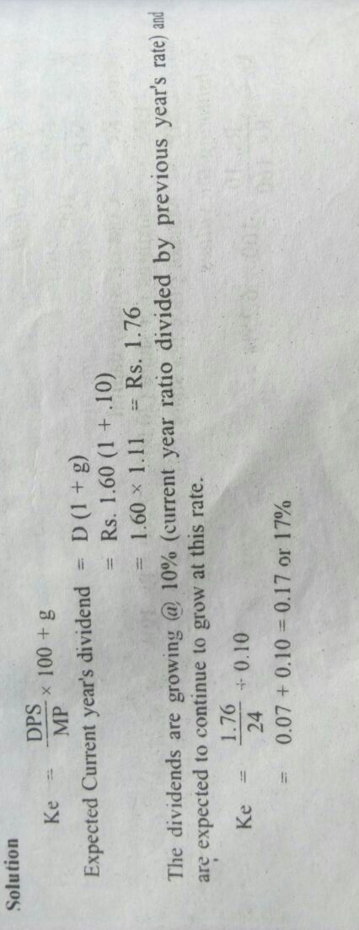
- Using an aggressive financing strategy, a company will finance a portion of permanent current assets and all temporary current assets with short-term sources. Long-term financing is used to fund the other portion of permanent current assets and fixed assets.
Section B
- Moon Ltd. Has its share of Rs. 10 each quoted on the stock exchange, the current price per share is Rs. 24. The gross dividends per share over the last four years have been Rs. 1.20, Rs. 1.32, Rs. 1.45 and Rs. 1.60. Calculate the cost of equity shares. (4)
Ans-

2. From the following information compute the operating cycle period and working capital requirement for a company-
Period covered- 365 Days
Average period allowed by Suppliers: 16 days
Total average outstanding debtors 48,000
Raw material consumption 4,40,000
Total production cost 10,00,000
Total cost of sales 10,50,000
Sales for the year 16,00,000
Value of average stock maintained:
Raw material 32,000
Work-in-progress 35,000
Finished goods 26,000 (4)
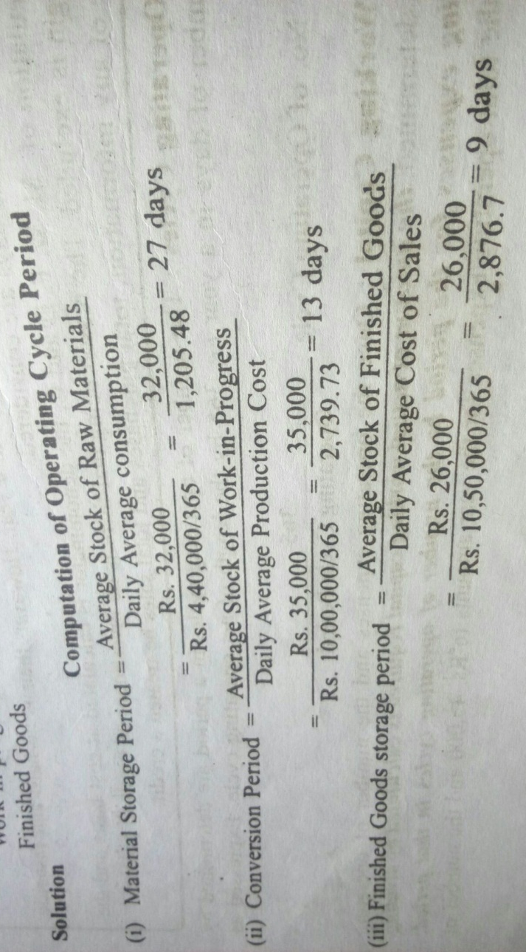
Ans-

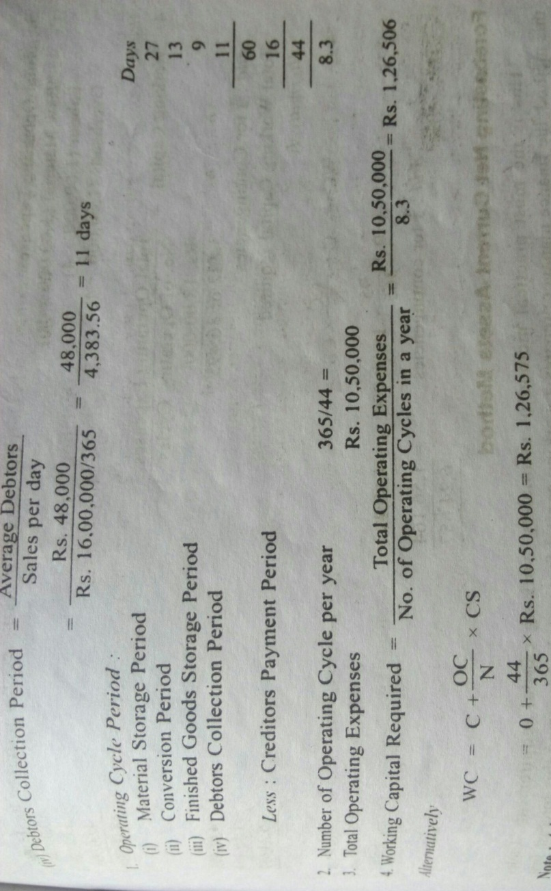

Rajasthan Institute of Engineering & Technology, Jaipur
University Roll No. ______________

1st Year MBA 2nd Semester II Mid-Term Examination, April – 2018
Subject: - FM SET- B
Time: - 2 Hrs. [Maximum Marks: -20]
[Min. Passing Marks: 08]
Instructions to the Candidates:
Attempt any 4 questions from Section A and Section B is Compulsory.
Section A
- What do you mean by cost of capital? Explain cost of equity capital. (3)
Ans- Cost of capital refers to the opportunity cost of making a specific investment. It is the rate of return that could have been earned by putting the same money into a different investment with equal risk. Thus, the cost of capital is the rate of return required to persuade the investor to make a given investment.
Cost of equity is the return (often expressed as a rate of return) a firm theoretically pays to its equity investors, i.e., shareholders, to compensate for the risk they undertake by investing their capital. Firms need to acquire capital from others to operate and grow.
K_{e} = DPS/MP*100
Or
K_{e} = EPS/MP*100
Or
K_{e} = DPS/MP*100+G

- Write short note on the following- (3)
- Preference dividend
- Financial Modeling
Ans- A preferred dividend is a dividend that is accrued and paid on a company's preferred shares. In the event that a company is unable to pay all dividends, claims to preferred dividends take precedence over claims to dividends that are paid on common shares.
Financial modelling is the process by which a firm constructs a financial representation of some, or all, aspects of the firm or given security. The model is usually characterized by performing calculations and makes recommendations based on that information. The model may also summarize particular events for the end user such as investment management returns or the Sortino ratio, or it may help estimate market direction, such as the Fed model.

- What do you understand by receivables management? (3)
Ans- Receivable management is the process of making decisions relating to investment in trade debtors. Certain investment in receivables is necessary to increase the sales and the profits of the firm.
Following are the objectives of receivables management which will help us to understand the purpose of receivables:
1. To optimize the amount of sales
2. To minimize cost of credit
3. To optimize investment in receivables.
4. To increase credit sales.
Therefore, the main objective of receivable management is to create a balance between profitability and cost.
Following are the areas covered by receivables management:
- Credit Analysis
- Credit Terms
- Financing of Receivables
- Credit Collection
- Monitoring of Receivables
- Discuss the emerging issues in financial management. (3)
Ans- Internal Fraud
- External Fraud
- Capital Risk
- Liquidity
- Currency Risk
- Lacking in management of other departments
- Employment practices
- Economic condition
- What are the major dividend theories? (3)
Ans- Two important models supporting dividend relevance are given by Walter and Gordon.
- Walter's model.
- Gordon's Model.
- Capital structure substitution theory & dividends.
- Residuals theory of dividends.
- Modigliani-Miller theorem.
- Explain the determination of operating cycle. (3)
Ans- The operating cycle is also known as the cash conversion cycle. In the context of a manufacturer the operating cycle has been described as the amount of time that it takes for a manufacturer's cash to be converted into products plus the time it takes for those products to be sold and turned back.
Determinations-
Raw material Storage period
WIP/Conversion period
Finished good storage period
Debtor’s collection period
Creditor’s payment period
Section B
- Shyam Ltd. Issued 10,000; 10 years 8% debentures of Rs. 100 each at 4% discount. These debentures are to be redeemed after 10 years at 5% premium. The cost of issue is 2% and corporate tax rate is 30%. Calculate before and after tax cost of debt capital. (4)

Ans-

2. A company has the following capital structure-
10000 Equity shares of Rs. 10 each 1,00,000
2000 10% Pref. shares of Rs. 100 each 2,00,000
2000 10% Debentures of Rs. 100 each 2,00,000
The amount of EBIT is Rs. 1,00,000. The company is in 50% tax bracket. You are required to calculate the financial leverage of the company.
What would be new financial leverage if the EBIT increases to Rs. 1,40,000 and interpret your results.(4)

Ans-

