Rajasthan Institute of Engineering & Technology, Jaipur.
II Mid Term examination
Session: 2017-18
CIVIL ENGINEERING- IV SEM/ II YEAR
Subject:- QSV (4CE6A) SET:- A
Time: 2 hrs. M.M.:20
Q.1 Explain
1. Muster Roll System 2. Travelling Allowance with its Types
Or
Q.1 Describe the terms
1. Depreciation 2. Valuation and its methods
Q.2 Explain the Imprest Account with its types.
Or
Q.2 Differentiate between Piece Work Agreement and Work Order with example.
Q.3 Reduced level of ground along the centre line of proposed road from chainage 10 to 20 are given below. The formation level at the 10th chainage is 107 and road gradients is shown below Formation width is 10 m and side slope of banking are 2:1 Length of chain is 30 m Draw Longitudinal section, Cross Section of road and also prepare estimate of earthwork @ 275% cum
Chainage | 10 | 11 | 12 | 13 | 14 | 15 | 16 | 17 | 18 | 19 | 20
R.L of Ground | 105.00 | 105.60 | 105.44 | 105.90 | 105.42 | 104.30 | 105 | 104.10 | 104.62 | 104 | 103.3
Or
Q.3 The plan and part cross section of hexagonal room are given Estimate the Quantities of (1) Excavation (2) Lime concrete (3) I class brick work in superstructure

Rajasthan Institute of Engineering & Technology, Jaipur.
II Mid Term examination
Session: 2016-17
CIVIL ENGINEERING- IV SEM/ II YEAR
Subject:- QSV (4CE6A) SET:- B
Time: 2 hrs. M.M.:20
Instruction for students:
1. No provision for supplementary answer book.
Q.1For the following drawing Find the (1) Earthwork in foundation (2) Lime Concrete in Foundation (3) b/w in cement mortar (4) 2.5 cm D.P.C (5) b/w in superstructure Or
Q.1 Q.3 The plan and part cross section of hexagonal room are given Estimate the Quantities of (1) Excavation (2) Lime concrete (3) I class brick work in superstructure
Q.2 Explain the term “Depreciation” & methods of depreciation.
Or
Q.2 Describe valuation with its importance in Civil Engineering.
Q.3 Analyze the rate of item or work for the first class brick work in 1:6 cement sand mortar.
Or
Q.4 Describe Following Term :
1. Cash Book 2. Stock Ledger

Solution Of Set A
Q1. 1. A written document containing the name's, ages, quality, place of residence, and, above all, place of birth, of every person of the ship's company. It is of great use in ascertaining the ship's;
2. Settlement at a station other than last station of duty. - It has been decided to sanction the grant of travelling allowance to retiring Government servants on the scale and the conditions set out below. The travelling allowance referred to will be admissible in respect of the journey of the Government servant and members of his family from the last station of his duty to his home town or to the place where he and his family is to settle down permanently even if it is other than his declared home town and in respect of the transportation of his personal effects between the same places.
(a) For journeys by different modes. - Entitlement as for transfer.
In regard to the question as to how the travelling allowance in respect of the members of the family of a retiring Government servant, who do not actually accompany him is to be regulated, it has been decided that the provisions of SR 116 (b) (iii) may be applied mutatis mutandis in all such cases. A member of a Government servant's family who follows him within six months or precedes him by not more than one month may, therefore, be treated as accompanying him. The period of one month or six months, as the case may be, may be counted from the date the retiring Government servant himself actually moves. The claims of travelling allowance in respect of the family members will not be payable until the head of the family himself or herself actually moves.
The time-limits of one month and six months mentioned above may be extended by the competent authority prescribed in SR 116 (b) (iii) in individual cases attendant with special circumstances.
(b) The Government servant shall, besides the fares, be also eligible to composite transfer grant equal to one month's basic pay, if the distance from the last station of duty is more than 20 km.
(c) Transportation of personal effects at the scale of allowance laid down in Order below SR 116 is allowable. The Government servant will also be entitled to claim the cost of transportation of personal effects between railway station and residence at either end of the journey as in the case of transfer.
(d) The actual cost of transporting a motor car or other conveyance maintained by the Government servant before his retirement is reimbursable as per Order below SR 116.
EXPLANATION. - In regard to the time-limits applicable for the transportation of personal effects on availment of the concession, it has been decided that the time-limits prescribed in the Explanation below sub-para. (a) above in the case of members of the family, namely, one month anterior and six months posterior to the date of the move of the retiring Government servant himself, should apply in the case of transport of his personal effects. These limits may, however, be extended by the competent authority prescribed under SR 116 (b) (iii) in individual cases attendant with special circumstances.
OR
Q. 1
1. depreciation refers to two aspects of the same concept:^{[1]}
- The decrease in value of assets (fair value depreciation)

- The allocation of the cost of assets to periods in which the assets are used (depreciation with the matching principle)
Depreciation is a method of reallocating the cost of a tangible asset over its useful life span of it being in motion. Businesses depreciate long-term assets for both tax and accounting purpose. The former affects the balance sheet of a business or entity, and the latter affects the net income that they report. Generally the cost is allocated, as depreciation expense, among the periods in which the asset is expected to be used. This expense is recognized by businesses for financial reporting and tax purposes. Methods of computing depreciation, and the periods over which assets are depreciated, may vary between asset types within the same business and may vary for tax purposes. These may be specified by law or accounting standards, which may vary by country. There are several standard methods of computing depreciation expense, including fixed percentage, straight line, and declining balance methods. Depreciation expense generally begins when the asset is placed in service. For example, a depreciation expense of 100 per year for five years may be recognized for an asset costing 500.

2. In finance, valuation is a process of determining the fair market value of an asset. Equity valuation therefore refers to the process of determining the fair market value of equity securities.

Importance of Equity Valuation: Systemic
The whole system of stock markets is based upon the idea of equity valuation. The stock markets have a wide variety of stocks on offer, whose perceived market value changed every minute because of the change in information that the market receives on a real time basis.
Equity valuation therefore is the backbone of the modern financial system. It enables companies with sound business models to command a premium in the market. On the other hand, it ensures that companies whose fundamentals are weak witness a drop in their valuation. The art and science of equity valuation therefore enables the modern economic system to efficiently allocate scare capital resources amongst various market participants.

Importance of Equity Valuation: Individual
As discussed, on a micro level, equity valuation is beneficial for the entire stock market ecosystem. However, how does it benefit an individual to study and apply the principles of equity valuation?
Well, markets receive information every moment and make an attempt to factor the financial effect of this information in the stock price. Individual estimates of the effect vary and as such different people may come up with different stock prices. Therefore, there can be a difference between the market value of a company and what investors call its true or “intrinsic value”
Investors, stand to gain a lot of money if they are able to correctly identify this difference. The second richest person in the world, Warren Buffett has made his fortune correcting and applying the art of equity valuation. In fact, the theory of equity valuation has been heavily influenced by the work of Warren Buffett and his mentor.

Process of Conducting Equity Valuation
Equity valuation is followed differently by different individuals. As such, there is no set pre-defined standard process. Instead, equity valuation consists of 4 or 5 broad categories of steps that need to be followed. The procedures maybe different but the objectives are always the same. Every person conducting equity valuation, must in one way or another account for these parameters:
- Understand the macroeconomic factors and the industry: No company operates in vacuum. As such, the performance of every business is influenced by the performance of the economy in general as well as the industry in which it operates. As such, before making an attempt to value a business, the macro-economic factors must be accounted for. A reasonably accurate prediction regarding these parameters creates the base for an accurate valuation.
- Make a reasonable forecast of the company’s performance: Mere extrapolation of the company’s current financial statements does not constitute a good forecast. A good forecast takes into account how the company may change its scale of production of the forthcoming future. Then, it also takes into account how changes in this scale will affect the costs. Costs and sales do not move in linear fashion. To come up with an accurate forecast, an analyst would require intricate knowledge of the company’s business.
- Select the appropriate valuation model: Valuation is less of a science and more of an art. There are multiple valuation models available. Also, all these valuation models do not necessarily lead to the same conclusion. Hence, it is the job of the analyst to understand which model would be most appropriate given the type and quality of data available.
- Arrive at a valuation figure based on the forecast: The next step is to apply the valuation model and come up with an exact numerical value which according to the analyst defines the worth of the business. It may be a single estimated amount or it could be a range. Investors prefer a range so that they clearly know what their lower and upper bounds for bidding should be.
- Take action based on the arrived valuation: Finally, the analyst has to give a buy, sell or hold recommendation based on the current market price and what analysis shows is the intrinsic worth of the company.

Q.2 Imprest Account : It is in the form of Advance Account which is paid to the contractor in advance to initiate the work or any instant of time The term imprest account refers to a bank or cash fund that is dedicated to a specific purpose. An imprest account will always have the same balance. Once established by a company, the account will never require a future journal entry.

Explanation
Imprest accounts are typically established by large corporations, and are classified as a current asset since the funding consists of cash. The most common examples of imprest accounts include those used for employee payroll, dividends, sales commissions, bonuses, travel expenses, and petty cash.
As money is withdrawn from the account, it is replenished to the pre-established funding level. For example, if a company's biweekly payroll is $2,000,000, this amount will be present in the imprest account when checks, or electronic funds, are transferred to employees. The account is subsequently replenished from the company's primary bank account prior to the next payroll cycle.
Since the account is dedicated to a specific purpose, and is funded to a pre-determined level, it is more difficult for unauthorized withdrawals to go unnoticed. Therefore, an imprest account is thought to offer companies some protection against fraud. It also allows the company to carefully monitor and forecast expenses.
The reliability of the system depends on detailed knowledge of the amounts to be withdrawn. Ideally, the account balance would be near zero just prior to the next replenishment cycle. For example, the funds required for employee payroll should be accurately known just prior to the next pay cycle. Once disbursed, the account balance should be close to zero.
Petty cash accounts are often owned by a custodian that disburses cash to employees in exchange for receipts for business approved expenses. The custodian is responsible for ensuring the money in the petty cash fund, plus the total of all business related receipts, is equal to the imprest account balance. When the money in the petty cash fund falls to a certain threshold, the custodian would exchange the receipts for additional cash.
OR
When paying a worker, employers can use various methods and combinations of methods.^{[2]} Some of the most prevalent methods are: paid a wage by the hour (known as "time work"); paid an annual salary; salary plus commission (common in sales jobs); base salary or hourly wages plus gratuities (common in service industries); salary plus a possible bonus (used for some managerial or executive positions); salary plus stock options (used for some executives and in start-ups and some high tech firms); salary pool systems; gainsharing (also known as "profit sharing"); paid by the piece – the number of things they make, or tasks they complete (known as ‘output work’); or paid in other ways (known as ‘unmeasured work’^{[a]}).^{[4]}
Some industries where piece rate pay jobs are common are agricultural work, cable installation, call centers, writing, editing, translation, truck driving, data entry, carpet cleaning, craftwork and manufacturing.^{[5]} Working for a piece rate does not mean that employers are exempt from paying minimum wage or overtime requirements, which vary among nations and states.^{[6]}
Employers may find it in their interest to use piece rate pay after examining three theoretical considerations; the cost and viability of monitoring output in a way that accurately measures production so that quality doesn’t decrease is first. Variable skill level is second, where piece rates are more effective in a more homogenous workforce. Thirdly, there may be more invasive managerial relations as the management is attempting to test how fast the workers can produce^{[7]}
Employees decide whether to work for piece rate pay if the relative earnings are high, and if other physical and psychological conditions are favorable. Some of these might be job stress, physicality, risks, degree of supervision and ability to work with peers or family members.^{[8]} Employees may also be more or less welcoming to performance pay depending on the leverage and risk. Leverage was defined as ratio of variable pay to base pay, and risk is the probability the employee will see increased benefits with effort. Workers tended to be suspicious of pay packages that were too heavy on variable pay and were concerned it might be a concession to remove cost-of living wage adjustments or to secure wage rollbacks.^{[9]}
Q.3 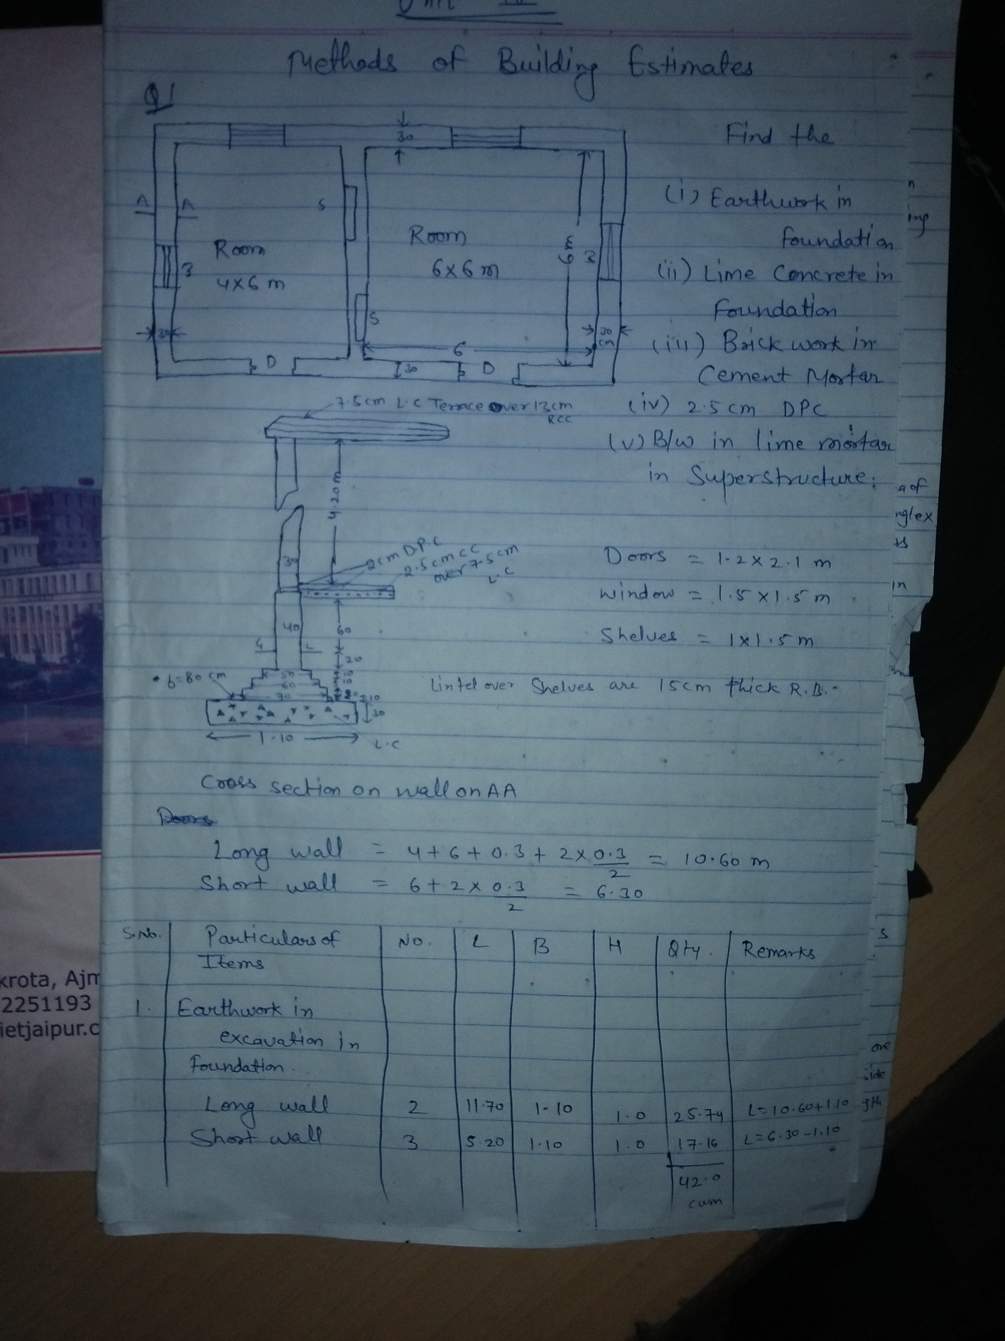

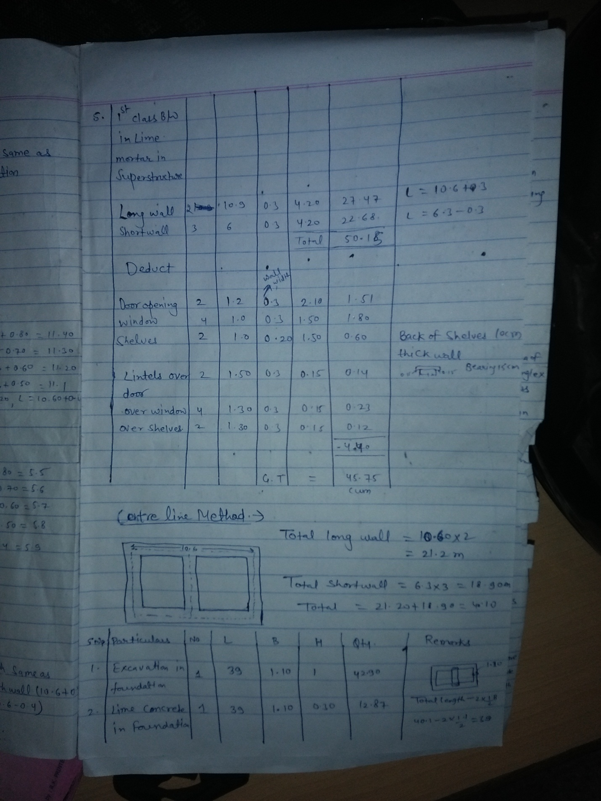

OR

