

**SET-A**

Ist Year MCA. IInd Semester IInd Mid Term Examination, April – 2018

Subject: - CONM

Time: -2 Hrs. [Maximum Marks: -20]

[Min. Passing Marks: 08]

Instructions to Candidates: -

Attempt all questions. Marks of questions are indicated against each section.

**Q. 1 Answer the following question in 1-2 lines. (1x5=5)**

i) What is Error Control & Stability?

Ans :- It is a very general technique designed to improve the performance of a variable

selection algorithm. It is based on aggregating the results of applying a selection

procedure to subsamples of the data.

ii) Define Curve Fitting.

Ans:- The process of finding the equation of the curve of best fit, which may be most

suitable for predicting the unknown values, is known as curve fitting. Therefore,

curve fitting means an exact relationship between two variables by algebraic equations.

iii) Define Interpolation & type of this.

Ans:- Interpolation is the technique of estimating the value of a function for any intermediate

value of the independent variable. Three type of This.1) Equal Difference 2) Unequal

Difference 3) Central Difference.

iv) Define Taylor Series Formula.

Ans:- y(x) = y(x0) + (x-x0) y'(x0, y0) + (x-x0)2y''(x0, y0)/2! + (x-x0)3y'''(x0, y0)/3!

+ (x-x0)4yiv(x0, y0)/4! + h5yv(x0, y0)/5! +. . .

v) Write the Equations for Straight Line & parabola?

Ans:- A straight line y =a + bx

A parabola f(x)=y= a+bx+cx2

**Q. 2 Answer the following questions in 50 words each. (2x2=4)**

i) Write The Formulas of Equal Difference in Interpolation.

1. Ans. Gregory-Newton or Newton Forward Difference Interpolation

P(x0+hs)=f0+sΔf0+s(s−1)/2!Δ2f0+⋯+s(s−1)(s−2)...(s−n+1)/n!Δnf0

Where s=(x−x0)h

1. Gregory-Newton or Newton Backward Difference P(xn+hs)=fn+s∇fn+s(s+1)/2!∇2fn+⋯+s(s+1)(s+2)...(s+n−1)/n!∇nfn

ii) Define how to Calculate Difference Table.

Ans.

. 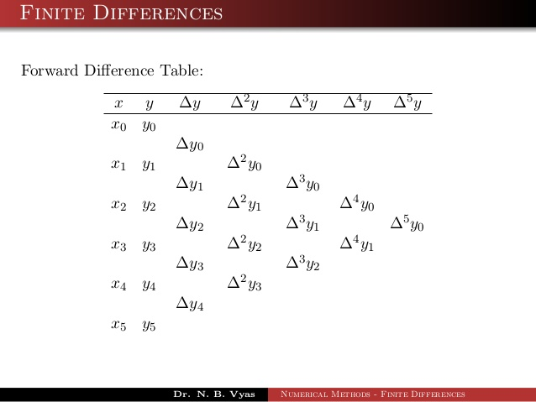

**Q. 3 Answer the following questions in 100 words each. (3x2=6)**

i) Write the algorithm Sampson’s 1/3 rule.

ii) Find f(30) from the following table values using Gauss forward difference formula:

|  |  |  |  |  |  |
| --- | --- | --- | --- | --- | --- |
| **x:** | **21** | **25** | **29** | **33** | **37** |
| **F(x):** | **18.4708** | **17.8144** | **17.1070** | **16.3432** | **15.5154** |

Ans.:- The difference table is

|  |  |  |  |  |  |
| --- | --- | --- | --- | --- | --- |
| **x** | **f** | **Δf** | **Δ2f** | **Δ3f** | **Δ4f** |
| 21 | 18.4708 |  |  |  |  |
|  |  | -0.6564 |  |  |  |
| 25 | 17.8144 |  | - 0.0510 |  |  |
|  |  | -0.7074 |  | - 0.0054 |  |
| 29 | 17.1070 |  | 0.0564 |  | - 0.0022 |
|  |  | -0.7638 |  | - 0.0076 |  |
| 33 | 16.3432 |  | - 0.0640 |  |  |
|  |  | -0.8278 |  |  |  |
| 37 | 15.5154 |  |  |  |  |



f (30) = 16.9217

**Q. 4 Answer the following questions in 150 words. (5x1=5)**

Find y in [0,3] by solving the initial value problem y' = (x - y)/2,  y(0) = 1 using RK

method of order four with  h = 1/2 and 1/4.

Ans. :-   **Given y' = (x-y)/2,     y[0.000] = 1.0**   
(Using RK method of order 4)    **with step-length = 0.5**

K1 = -0.25   K2 = -0.15625   K3 = -0.16796875    
K4 = -0.0830078125   
**y[0.500] = 0.83642578125**

K1 = -0.0841064453125   K2 = -0.0110931396484375   K3 = -0.020219802856445312    
K4 = 0.04594850540161133   
**y[1.000] = 0.8196284770965576**

K1 = 0.045092880725860596   K2 = 0.10195627063512802   K3 = 0.09484834689646959    
K4 = 0.1463807940017432   
**y[1.500] = 0.9171422953950241**

K1 = 0.14571442615124397   K2 = 0.19000012288233847   K3 = 0.18446441079095166    
K4 = 0.22459832345350605   
**y[2.000] = 1.1036825982202458**

K1 = 0.22407935044493854   K2 = 0.2585694316393212   K3 = 0.2542581714900234    
K4 = 0.2855148075724327   
**y[2.500] = 1.3595574922662559**

K1 = 0.28511062693343603   K2 = 0.3119717985667565   K3 = 0.30861415211259147    
K4 = 0.3329570889052882   
**y[3.000] = 1.6694307617991593** 

**Given y' = (x-y)/2,     y[0.0000] = 1.0**   
(Using RK method of order 4)    **with step-length = 0.25**

K1 = -0.125   K2 = -0.1015625   K3 = -0.10302734375   K4 = -0.08087158203125   
**y[0.2500] = 0.897491455078125**

K1 = -0.08093643188476562   K2 = -0.06025290489196777   K3 = -0.06154562532901764   
K4 = -0.04199322871863842   
**y[0.5000] = 0.8364036682372292**

K1 = -0.04205045852965365   K2 = -0.023797304871550296   K3 = -0.02493812697518176    
K4 = -0.007683192657755938   
**y[0.7500] = 0.8118695824237503**

K1 = -0.007733697802968786   K2 = 0.00837465830971676   K3 = 0.007367886052673911    
K4 = 0.022595316440446975   
**y[1.0000] = 0.8195940336507935**

K1 = 0.02255074579365081   K2 = 0.03676632418154763   K3 = 0.03587785053230408    
K4 = 0.0493160144771128   
**y[1.2500] = 0.8557865519338713**

K1 = 0.049276681008266085   K2 = 0.061821888445249454   K3 = 0.06103781298043799   
K4 = 0.07289695438571134   
**y[1.5000] = 0.9171020583080967**

K1 = 0.07286224271148792   K2 = 0.08393335254201992   K3 = 0.08324140817761168    
K4 = 0.09370706668928647   
**y[1.7500] = 1.0005885301147697**

K1 = 0.09367643373565379   K2 = 0.10344665662717542   K3 = 0.10283601769645534    
K4 = 0.11207193152359687   
**y[2.0000] = 1.103640815765855**

K1 = 0.11204489802926812   K2 = 0.12066709190243885   K3 = 0.12012820478536568    
K4 = 0.12827887243109742   
**y[2.2500] = 1.2239598764051842**

K1 = 0.12825501544935197   K2 = 0.13586407698376748   K3 = 0.1353885106378665    
K4 = 0.14258145161961866   
**y[2.5000] = 1.3595168167905574**

K1 = 0.14256039790118033   K2 = 0.14927537303235655   K3 = 0.14885568708665806    
K4 = 0.15520343701534808   
**y[2.7500] = 1.5085211426496503**

K1 = 0.1551848571687937   K2 = 0.1611108035957441   K3 = 0.1607404319440597    
K4 = 0.16634230317578624   
**y[3.0000] = 1.669392747887015** 

OR

Use Bessels’ Formula to find (46.24)1/3 from the following table of x1/3.

|  |  |  |  |  |
| --- | --- | --- | --- | --- |
| X | 41 | 45 | 49 | 53 |
| X1/3 | 3.4482 | 3.5569 | 3.6593 | 3.7563 |

Ans:- x0 = 45, x = 46.24, h = 4 p = 0.31

Difference table is:



Applying Bessels’ formula, we get

(46.24)1/3 = 3.5893