Rajasthan Institute of Engineering & Technology, Jaipur.
I Mid Term Examination
Session: 2018-19
7th Semester & Branch EE/EEE
SUBJECT: ECONOMIC OPERATION OF POWER SYSTEMS

SET-A
Time: 2 hrs. M.M.:20

Q.1 Explain depreciation Methods in power plant. [5]

Straight Line Method
In this method, provision is made from setting aside a certain and fixed amount of money every year. This value remains fixed for every year and depends upon the useful lifespan of the plant. It can be given as, total depreciation value divided by the useful life of the plant. The total depreciation value is calculated by subtracting the 'salvage (scrap) value after the lifespan' from the 'initial cost'.
Annual Depreciation = (Initial cost - Scrap value) / Useful life of the plant
For example, if a plant initially costs ₹ 500,000 and its scrap (salvage) value is ₹ 20,000 after 40 years of useful life, then,
Annual depreciation charges = (500,000 - 20,000) / 40 = 12,000 ₹
Advantages of straight line method
- Simple method
- Easy to apply
Disadvantages
- In actual practice, depreciation of equipment is not constant every year.
- It does not consider the amount of interest earned by the annual depreciation amount set aside annually.
Graphically, it can be expressed as follows:
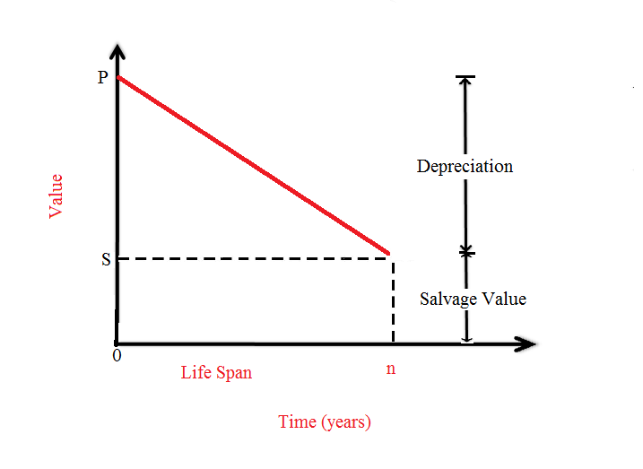

Diminishing Value Method
In this method, a fixed rate of depreciation value is set. This rate is first applied to the capital cost (P) and then to the diminishing value. The rate is decided according to the useful lifespan of the plant. Yearly depreciation value can be calculated as follows:
Let, P = Capital cost of the equipment,
x = Annual unit depreciation (if annual depreciation is 10%, then annual unit depreciation is 0.1)
After 1 year, the value of equipment = P - Px = P (1 - x)
The annual depreciation after 1st year is equal to = (P - Px)x = Px - Px²
Hence, value of the equipment after 2 years = Diminishing value - Annual depreciation
= P - Px - Px - Px²
= P(1 - x)²
After n years (useful lifespan), value of the equipment = P(1 - x)^{n}
Graphically,
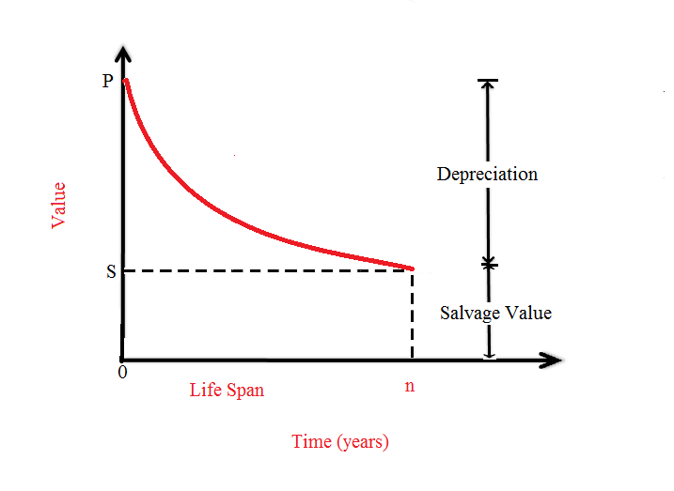
We can see that depreciation charges are higher in the early years and reduce with time.
Advantage
- Better distribution of charges: In the early years, depreciation charges are more while maintenance and repair charges are less. In the later years, depreciation charges are less while maintenance and repair charges are higher.
Disadvantage
- In the early years, the plant is supposed to collect money and then collect interest on it as time passes. But in this method, the amount of interest is not taken into account.

Sinking Fund Method
In this method, the arrangement is made such that a fixed amount is set aside annually and then invested at a certain interest rate which is compounded yearly. This fixed depreciation charges will be such that sum of these charges and the interest collected must be equal to the cost of replacement of the equipment.
Let, P = initial value of plant
n = useful life span
S = Salvage value after n years of useful life
r = Annual rate of interest
After n years, the salvage value will be received.
Therefore, Cost of equipment replacement = P - S
If the depreciation amount set aside every year is q, then interest will be received on this amount till n years are completed. Also, after n years, the total amount must be equal to the cost of replacement (i.e. P - S)
If we deposit amount q for the first year, then,
Interest after 1 year = rq
Amount after 1 year = q + rq = q(1 + r)
Similarly, after n years, amount = q(1 + r)^{n}
But, amount q is added at the end of 1st year. Hence, it will collect interest only for (n-1) years.
Therefore, amount q (deposited at the end of 1st year) = q(1+r)^{n-1}
Similarly, amount q (deposited at the end of 2nd year) = q(1+r)^{n-2}
Amount q (deposited at the end of (n-1)^{th} year) = q(1+r)^{n-(n-1)} = q(1+r)
Therefore, the total sum (after n years) = q[(1+r)^{n-1} + (1+r)n-2 + ... + (1+r)]
The terms in the brackets constitute a Geometric progression with a ratio (1+r)⁻¹
Therefore, Total funds collected = Sum of G.P = q[(1+r)^{n} - 1]/r
But, total funds must be equal to the cost of replacement, i.e. P-S. Therefore,
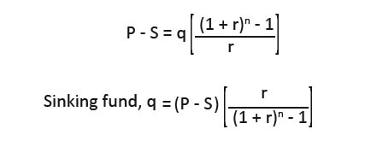

Or
Q.1 Derive an expression for cost of electrical energy of power plant.
Q.2 [5]
$\frac{{dC}_{1}}{{dP}_{1}}=0.056 P_{1}+32.8$ rs/mw-hr
$\frac{{dC}_{2}}{{dP}_{2}}=0.112 P_{2}+36.8$ rs/mw-hr
When 100mw power is transmitted over the line.a loss of 10mw take place. find the economic generation of each plant for λ= 48 per mw-hr and loss in line.
Or
Q.2 Explain economic schedulingof thermal power plants considering effectof transmission losses.
Q.3 explain the various base load peak load operation requirement for hydro thermal plant. [5]

Peak Load and Base Load defined
Base load is the minimum level of electricity demand required over a period of 24 hours. It is needed to provide power to components that keep running at all times (also referred as continuous load).
Peak load is the time of high demand. These peaking demands are often for only shorter durations. In mathematical terms, peak demand could be understood as the difference between the base demand and the highest demand.
Now going back to the examples of household loads: microwave oven, toaster and television are examples of peak demand, whereas refrigerator and HVAC systems are examples of base demand.

A broader perspective of understanding these concepts
Now on a broader perspective, it could be assumed that the electrical grid is a big household. Under normal circumstances, the power required by the electrical grid is fairly constant during various period of the day.
This constant power, which is required at all times, is called the base loading. But during a special event, like the final match of World Cup, the demand will be more, as a lot of people will watch TV. This short, high demand period is considered to be a peak loading.
Base Load and Peak Load

Base Load and Peak Load power plants
Power plants are also categorised as base load and peak load power plants.

Base Load Power plants
Plants that are running continuously over extended periods of time are said to be base load power plant.
The power from these plants is used to cater the base demand of the grid. A power plant may run as a base load power plant due to various factors (long starting time requirement, fuel requirements, etc.).
Examples of base load power plants are:
- Nuclear power plant
- Coal power plant
- Hydroelectric plant
- Geothermal plant
- Biogas plant
- Biomass plant
- Solar thermal with storage
- Ocean thermal energy conversion

Peak Load Power plants
To cater the demand peaks, peak load power plants are used. They are started up whenever there is a spike in demand and stopped when the demand recedes.
Examples of gas load power plants are:
- Gas plant
- Solar power plants
- Wind turbines
- Diesel generators

Or
Q.3 What do you mean by penalty factor.derive an expression of penalty factor.
For transmission line loss, power generation companies have to generate additional power with required to compensate this. A factor is multiplied with Cost/kWh in order to get additional cost for this power. The factor is called penalty factor. This is also charged to a consumer whose load has a poor power factor resulting in putting stress on the line for reactive power and drawing more current.
Q.4 Derive an expression for co-ordination equation of thermal power plant.
Thus it is clear that to solve the optimum load scheduling problem, it is necessary to compute ITL for each plant, and therefore we must determine the functional dependence of transmission loss on real powers of generating plants. There are several methods, approximate and exact, for developing a transmission loss model. A full treatment of these is beyond the scope of this book. One of the most important, simple but approximate, methods of expressing transmission loss as a function of generator powers is through B-coefficients. This method is reasonably adequate for treatment of loss coordination in economic scheduling of load between plants. The general form of the loss formula (derived later in this section) using B-coefficients is
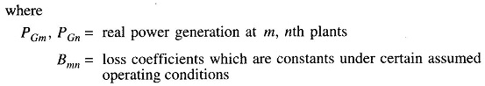
If P_{G}s are in megawatts, B_{mn} are in reciprocal of megawatts . Computations, of
course, may be carried out in per unit. Also, B_{mn} = B_{mn}.
Equation (7.26) for transmission loss may be written in the matrix form as
Where
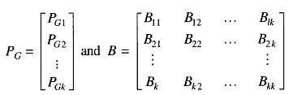
It may be noted that B is a symmetric matrix.
For a three plant system, we can write the expression for loss as
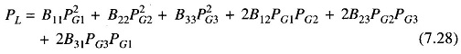
With the system power loss model as per Eq. (7.26), we can now write
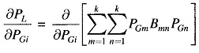
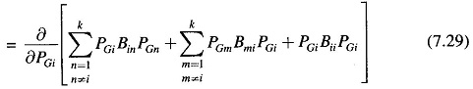
It may be noted that in the above expression other terms are independent of P_{Gi} and are, therefore, left out.
Simplifying Eq. (7.29) and recognizing that B_{ij} = B_{ji,} we can write
Assuming quadratic plant cost curves as
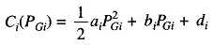
We obtain the incremental cost as
Substituting δP_{L}/δP_{Gi} and dC_{i}/dP_{Gi} from above in the coordination Eq. (7.22), we have
Collecting all terms of P_{Gi} and solving for P_{Gi}, we obtain
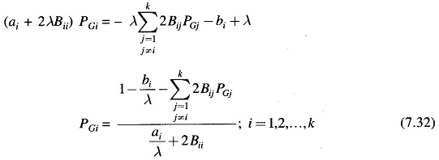
For any particular value of λ, Eq. (7.32) can be solved iteratively by assuming initial values of P_{Gi}s(a convenient choice is P_{Gi}= 0; i = 1, 2, …, k). Iterations are stopped when P_{Gi}s converge within specified accuracy.
Equation (7.32) along with the power balance Eq. (7.19) for a particular load demand P_{D} are solved iteratively on the following lines:
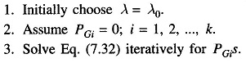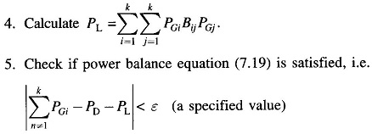
If yes, stop. Otherwise go to step 6.
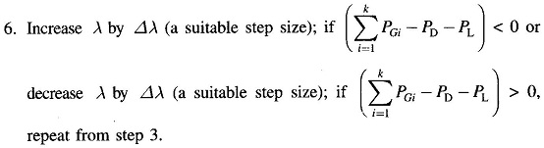
[5]
Or
Q.4 Discuss about the economics in plant selection and explain the economics of different type of generating plants.

Rajasthan Institute of Engineering & Technology, Jaipur.
I Mid Term Examination
Session: 2018-19
7th Semester & Branch EE/EEE
SUBJECT: ECONOMIC OPERATION OF POWER SYSTEMS

SET-B
Time: 2 hrs. M.M.:20

Q.1 Discuss about the economics in plant selection and explain the economics of different type of generating plants. [5]
For optimal power dispatch, the incremental fuel cost of each plant multiplied by its penalty factor should be equal to Lagrangian multiplier λ.
(IC)_{i} L_{i} = λ for i = 1, 2, …, n_{g}
where 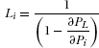 = pentaly factor of i^{th} unit.
The incremental transmission loss can be obtained by differentiating the total loss equation P_{L}. The equation for P_{L} interms of B-coefficients has been developed earlier.

Or
Q.1 what do mean by depreciation. How will you calculate the depreciation in power plants?
Q.2 A two bus system is shown in the fig if 100 mw is transmitted from plant 1 to the load, a transmission loss of 10 mw is incurred, find the required generation for each plant and the power received by the load when the system cost is rs 25/mwh.the incremental fule cost of the two plants are- [5]
$\frac{{dC}_{1}}{{dP}_{1}}=0.02 P_{1}+16$ rs/mw-hr
$\frac{{dC}_{2}}{{dP}_{2}}=0.04 P_{2}+20$ rs/mw-hr
Or
Q.2 Explain the input,output and heat rate characteristics of thermal power plant
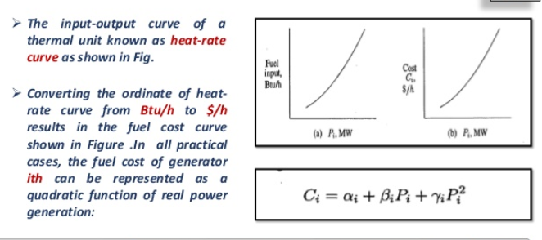
Q.3 What do you mean by incremental cost and derive an expression of incremental cost for power plant. [5]
Economic Distribution of Loads between the Units of a Plant
To determine the economic distribution of a load amongst the different units of a plant, the variable operating costs of each unit must be expressed in terms of its power output. The fuel cost is the main cost in a thermal or nuclear unit. Then the fuel cost must be expressed in terms of the power output. Other costs, such as the operation and maintenance costs, can also be expressed in terms of the power output. Fixed costs, such as the capital cost, depreciation etc., are not included in the fuel cost.
The fuel requirement of each generator is given in terms of the Rupees/hour. Let us define the input cost of an unit- i , f_{i} in Rs./h and the power output of the unit as P_{i} . Then the input cost can be expressed in terms of the power output as
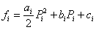 Rs./h | (5.1)
The operating cost given by the above quadratic equation is obtained by approximating the power in MW versus the cost in Rupees curve. The incremental operating cost of each unit is then computed as
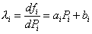 Rs./MWh | (5.2)
Let us now assume that only two units having different incremental costs supply a load. There will be a reduction in cost if some amount of load is transferred from the unit with higher incremental cost to the unit with lower incremental cost. In this fashion, the load is transferred from the less efficient unit to the more efficient unit thereby reducing the total operation cost. The load transfer will continue till the incremental costs of both the units are same. This will be optimum point of operation for both the units.
The above principle can be extended to plants with a total of N number of units. The total fuel cost will then be the summation of the individual fuel cost f_{i} , i = 1, ... , N of each unit, i.e.,
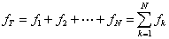 | (5.3)

Let us denote that the total power that the plant is required to supply by P_{T} , such that
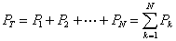 | (5.4)

where P₁ , ... , P_{N} are the power supplied by the N different units.
The objective is minimize f_{T} for a given P_{T} . This can be achieved when the total difference df_{T} becomes zero, i.e.,
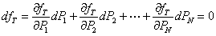 | (5.5)
Now since the power supplied is assumed to be constant we have
(5.6)

Multiplying (5.6) by λ and subtracting from (5.5) we get
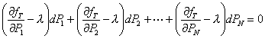 | (5.7)

The equality in (5.7) is satisfied when each individual term given in brackets is zero. This gives us
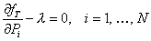 | (5.8)
Also the partial derivative becomes a full derivative since only the term f_{i} of f_{T} varies with P_{i}, i = 1,, N . We then have
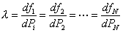
Or
Q.3 explain economics of different type of generating plants.

cost Of Electrical Energy
The total cost of power (electrical energy) generation comprises of the following charges: (i) Fixed cost, (ii) Semi-fixed cost, (iii) Running or operating cost.

Fixed Cost
As the name implies, such cost remains constant. It is independent of the maximum demand, the plant capacity and the energy generated.
Fixed cost includes:
- Annual charges of the central organization management
- Salary of the employees (usually higher officials)
- Interest on the land costs
All of these costs are fixed, and hence, fixed cost remains constant under all conditions.

Semi-Fixed Cost
Such charges are independent of the energy (kWh) generated but depend upon the maximum demand.Higher the max demand, the greater the semi-fixed costs.
Semi-fixed cost includes:
- Interest and depreciation on the capital costs (investment and insurance) on the land, the buildings (construction costs) and the costs of the equipment needed for generation, transmission and distribution of the electricity.
- The capital investment of the plant is huge and usually loaned.
- The interest of this loaned amount is considered in the cost of production.
- Such interest may range up to 8% depending upon the market conditions.
- The depreciation mentioned above relates to the reduction in value of the equipment that are used constantly.
- Due to wear and tear, the depreciation occurs and such depreciation costs are also included in the fixed and semi-fixed charges.
- Semi-fixed charges will also include the salaries of the management and other (clerical) staff, since these depend upon the size (and cost) of installation which again depends on the max demand.

Running Or Operating Cost
As the name implies, running charges will depend mainly upon the energy (in units or kWh) generated by the plant.
Running cost includes:
- Cost of fuel: This cost, of course, varies with the type of plant. It is lower in thermal (coal based) plants than nuclear plants. However, for hydroelectric plants (HPS), this cost is nil.
- Cost of maintenance and repairs: As a plant ages, wear and tear occur, and maintenance is needed. The wear and tear of the plant necessitate the use of lubricating oil which has its own cost.
- Salaries of the operating staff: The higher the size (capacity), the more the number of operating personnel required.
- Other Costs: These costs are not applicable for all plants and consist of charges for feed water (TPS), the water treatment costs (HPS and TPS) and enrichment of fuel costs (NPS).

Q.4explain the optimal load allocation for a system having large number of generating units. [5]
Or
Q.4 Explain the various techniques for power plant cost analysis with suitable examples.

Fixed Cost
As the name implies, such cost remains constant. It is independent of the maximum demand, the plant capacity and the energy generated.
Fixed cost includes:
- Annual charges of the central organization management
- Salary of the employees (usually higher officials)
- Interest on the land costs
All of these costs are fixed, and hence, fixed cost remains constant under all conditions.

Semi-Fixed Cost
Such charges are independent of the energy (kWh) generated but depend upon the maximum demand.Higher the max demand, the greater the semi-fixed costs.
Semi-fixed cost includes:
- Interest and depreciation on the capital costs (investment and insurance) on the land, the buildings (construction costs) and the costs of the equipment needed for generation, transmission and distribution of the electricity.
- The capital investment of the plant is huge and usually loaned.
- The interest of this loaned amount is considered in the cost of production.
- Such interest may range up to 8% depending upon the market conditions.
- The depreciation mentioned above relates to the reduction in value of the equipment that are used constantly.
- Due to wear and tear, the depreciation occurs and such depreciation costs are also included in the fixed and semi-fixed charges.
- Semi-fixed charges will also include the salaries of the management and other (clerical) staff, since these depend upon the size (and cost) of installation which again depends on the max demand.

Running Or Operating Cost
As the name implies, running charges will depend mainly upon the energy (in units or kWh) generated by the plant.
Running cost includes:
- Cost of fuel: This cost, of course, varies with the type of plant. It is lower in thermal (coal based) plants than nuclear plants. However, for hydroelectric plants (HPS), this cost is nil.
- Cost of maintenance and repairs: As a plant ages, wear and tear occur, and maintenance is needed. The wear and tear of the plant necessitate the use of lubricating oil which has its own cost.
- Salaries of the operating staff: The higher the size (capacity), the more the number of operating personnel required.
- Other Costs: These costs are not applicable for all plants and consist of charges for feed water (TPS), the water treatment costs (HPS and TPS) and enrichment of fuel costs (NPS).

