Rajasthan Institute of Engineering & Technology, Jaipur.
I Mid Term Examination
Session: 2018-19
7th Semester & Branch EE/EEE
SUBJECT: POWER SYSTEM ENGINEERING
SET-A
Time: 2 hrs. M.M.:20

Q.1 Derive and discuss the condition for economic loading of generating plant considering losses in transmission line. [5]
The economic load dispatch means the real and reactive power of the generator vary within the certain limits and fulfils the load demand with less fuel cost. The sizes of the electric power system are increasing rapidly to meet the energy requirement. So the number of power plants is connected in parallel to supply the system load by an interconnection of the power system. In the grid system, it becomes necessary to operate the plant units more economically.
The economic scheduling of the generators aims to guarantee at all time the optimum combination of the generator connected to the system to supply the load demand.The economic load dispatch problem involves two separate steps. These are the online load dispatch and the unit commitment.
The unit commitment selects that unit which will anticipate load of the system over the required period at minimum cost. The online load dispatch distributes the load among the generating unit which is parallel to the system in such a manner as to reduce the total cost of supplying. It also fulfils the minute to the minute requirement of the system.
Consider n generators in the same plant or close enough electrically so that the line losses may be neglected. Let C₁, C₂, …, C_{n} be the operating costs of individual units for the corresponding power outputs P₁, P₂,…., P_{n} respectively. If C is the total operating cost of the entire system and P_{R} is the total power received by the plant bus and transferred to the load, then
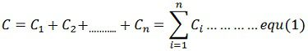
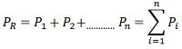
The equation (1) and equation (2) can be minimised as
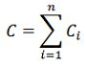
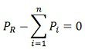
The above equation shows that if transmission losses are neglected, the total demand P_{R} at any instant must be met by the total generation. The above equation is the equality constraint.This a constrained minimising problem. This problem can be solved by using Lagrangian multiplier technique.
where f is the equality constraint equation given by
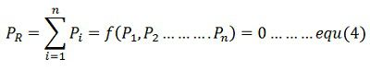
And λ is the Lagrange multiplier. Combination of equations (3) and (4) gives
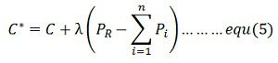
Equation (5) can be solved for minimum by determining the partial derivate of the function C* on variable Pi and equating it equal to zero.
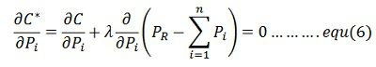
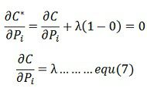
Since C_{i} is a function of P_{i} only. The partial derivates become full derivates, that is,
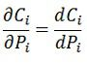
Therefore, the condition for optimum operation is
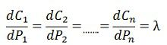
Since the dc_{i} / dp_{i} is the increment cost generation for the generator. The above equation shows that the criterion for a most economical division of load between within a plant is that all the unit is must operate at the same incremental fuel cost. This is known as the principle of equal λ criterion or the equal incremental cost-loading principle for economic operation.
Or
Q.1 Find incremental cost of received power and penalty factor of the plant show in fig. If the incremental cost of production is
$\frac{{dF}_{1}}{{dP}_{1}}=0.1P_{1}+3$ rs/mw-hr
Q.2 Draw and discuss input output curve for thermal power plant. [5]
Input-Output Curve
The input-output curve is derived simply from the heat-rate curve by multiplying it by the MW output of the unit. This yields a curve showing the amount of heat input energy required per hour as a function of the generator’s output. 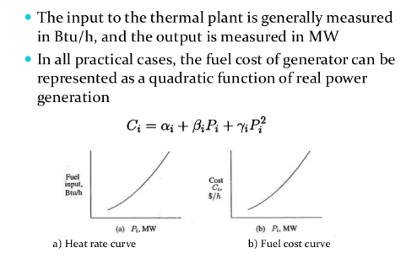

Or
Q.2 A 200 MVA 11Kv 50Hz 4 pole turbo generator has inertia constant 6MJ/MVA find (a) K.E. store in rotor (b) machine operating at load of 120 MW when load suddenly increases to 160 MW. find rotor retardation. (c) retardation calculated above is maintained for 5 cycle.
Q.3 Find stability limit for step change in mechanical power input to the machine, using equal area criterion. [5]

Equal Area Criterion for Stability
Over a lossless line, the real power transmitted will be
Consider a fault occurs in a synchronous machine which was operating in steady state. Here, the power delivered is given by
For clearing a fault, the circuit breaker in the faulted section should have to be opened up. This process takes 5/6 cycles and the successive post-fault transient will take an additional few cycles. The prime mover which is giving the input power is driven with the steam turbine. For turbine mass system, the time constant is in the order of few seconds and for the electrical system, it is in milliseconds. Thus, while the electric transients take place, the mechanical power remains stable. The transient study mainly looks into the capability of the power system to retrieve from the fault and to give the stable power with a new probable load angle (δ).
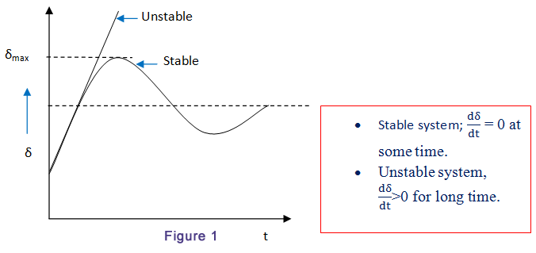
Or

Q.3 A motor received 25% of the power that it is capable of receiving from an infinite bus. if load on the motor is double calculate the maximum value of δ during the swinging of the rotor around its new equilibrium position.
Q.4 Find out power angle equation and power angle curve under study state condition. [5]
Consider a synchronous machine connected to an infinite bus through a transmission line of reactance X_{l} shown in a figure below. Let us assume that the resistance and capacitance are neglected.
Equivalent diagram of synchronous machine connected to an infinite bus through a transmission line of series reactance X_{l} is shown below:
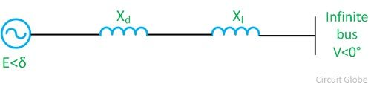Let,
V = V<0⁰ – voltage of infinite bus
E = E<δ – voltage behind the direct axis synchronous reactance of the machine.
X_{d} = synchronous / transient resistance of the machine
The complex power delivered by the generator to the system is
S = VI
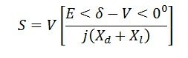Let,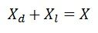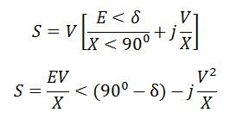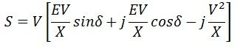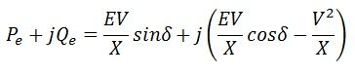
Active power transferred to the system
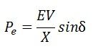
The reactive power transferred to the system
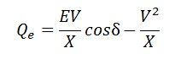The maximum steady-state power transfers occur when δ = 0
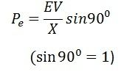
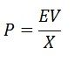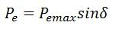
The graphical representation of P_{e} and the load angle δ is called the power angle curve. It is widely used in power system stability studies. The power angle curve is shown below
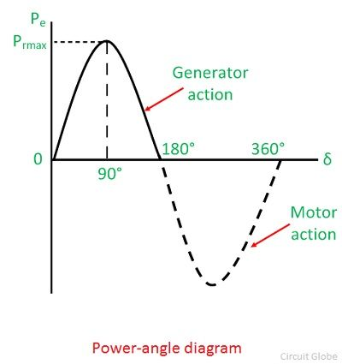
Maximum power is transferred when δ = 90⁰. As the value of load angle δ is above 90, P_{e} decrease and becomes zero at δ = 180⁰. Above 180⁰, Pe becomes negative, which show that the direction of power flow is reversed, and the power is supplied from infinite bus to the generator. The value of P_{e} is often called pull out power. It is also called the steady-state limit.
The total reactance between two voltage sources E and X is called the transfer reactance. The maximum power limit is inversely proportion to the transfer reactance.
or
Q.4 Derive formula of critical clearing angle.
The critical clearing angle is defined as the maximum change in the load angle curve before clearing the fault without loss of synchronism. In other words, when the fault occurs in the system the load angle curve begin to increase, and the system becomes unstable. The angle at which the fault becomes clear and the system becomes stable is called critical clearing angle. When the initial load is given, then there is a critical clearing angle, and if the actual clearing angle exceeds a critical clearing angle, the system becomes unstable otherwise it is stable. Let the curve A represents the power angle curve for a healthy condition; curve B represents the power angle curve for faulty condition and curve C represents the power angle curve after isolation of fault as shown below. fault as shown below.
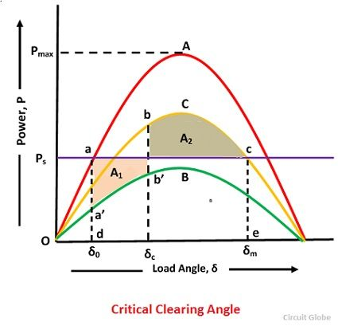
Where γ₁ is the ratio of system reactance in healthy condition to that of during the fault and γ₂ is the ratio of steady state limit of the system after the isolation of fault and that of system under the initial condition.
For transient stability limit, two areas A₁ = A₂ or in other words the area under curve adec (rectangle) is equal to the area under the curve da’b’bce.
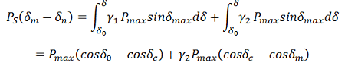Now substituting,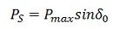we have,
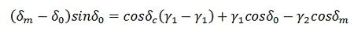 or
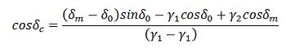Also from the curves
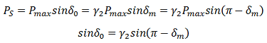
or
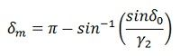
Thus if γ₁, γ₂, and δ₀ are known, the critical clearing angle δc can be determined.

Rajasthan Institute of Engineering & Technology, Jaipur.
I Mid Term Examination
Session: 2018-19
7th Semester & Branch EE/EEE
SUBJECT: POWER SYSTEM ENGINEERING
SET-B
Time: 2 hrs. M.M.:20

Q.1 Determine the incremental transmission loss formula for a system having three generating unit. [5]
Or
Q.1 For two unit loss coefficient are $B_{11}=0.001 per MW,B_{12}=-0.005 per MW and B_{12}=0.0024 per MW$
$\frac{{dC}_{1}}{{dP}_{1}}=0.08P_{1}+16$ rs/mw-hr
$\frac{{dC}_{2}}{{dP}_{2}}=0.08P_{2}+12$ rs/mw-hr
When 100mw power is transmitted over the line.a loss of 10mw take place. find the economic generation $P_{1}$and $P_{2}$of each plant for λ= 20 per mw-hr and also find transmission line loss.

Q.2 Derive the formula of synchronizing power coefficient. how it affects the stability. [5]
Synchronizing Power is defined as the varying of the synchronous power P on varying in the load angle δ. It is also called Stiffness of Coupling, Stability or Rigidity factor. It is represented as P_{syn}.A synchronous machine, whether a generator or a motor, when synchronised to infinite Busbars has an inherent tendency to remain in Synchronism. Consider asynchronous generator transferring a steady power P_{a} at a steady load angle δ₀. Suppose that, due to a transient disturbance, the rotor of the generator accelerates, resulting from an increase in the load angle by dδ. The operating point of the machine shifts to a new constant power line and the load on the machine increases to P_{a} + δP. The steady power input of the machine does not change, and the additional load which is added decreases the speed of the machine and brings it back to synchronism.
Similarly, if due to a transient disturbance, the rotor of the machine retards resulting a decrease in the load angle. The operating point of the machine shifts to a new constant power line and the load on the machine decreases to (Pa – δP). Since the input remains unchanged, the reduction in load accelerates the rotor. The machine again comes in synchronism.
The effectiveness of this correcting action depends on the change in power transfer for a given change in load angle. The measure of effectiveness is given by Synchronising Power Coefficient. given by Synchronising Power Coefficient.
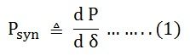
Power output per phase of the cylindrical rotor generator
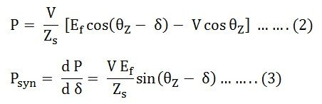
The synchronising torque coefficient
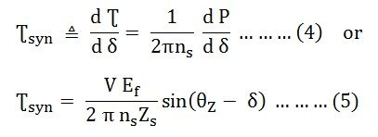
In many synchronous machines Xs>> R. Therefore, for a cylindrical rotor machine, neglecting saturation and stator resistance equation (3) and (5) becomes
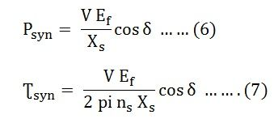
For a salient pole machine
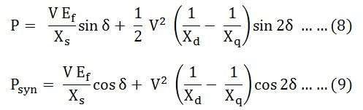

Unit of Synchronizing Power Coefficient P_{syn}
The synchronising Power Coefficient is expressed in watts per electrical radian
Therefore,
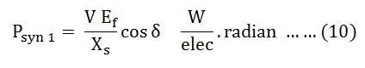
Since, π radians = 180⁰
1 radian = 180/π degrees
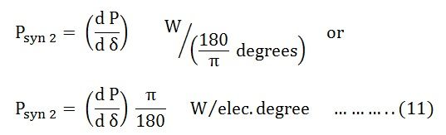
If P is the total number of pair of poles of the machine.
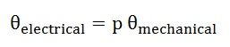
Synchronising Power Coefficient per mechanical radian is given by the equation shown below.
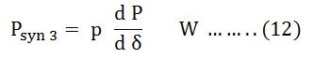
Synchronising Power Coefficient per mechanical degree is given as
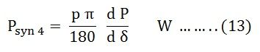

Synchronising Torque Coefficient
Synchronising Torque Coefficient gives rise to the synchronising torque coefficient at synchronous speed. That is, the Synchronizing Torque is the torque which at synchronous speed gives the synchronising power. If Ʈ_{syn} is the synchronising torque coefficient than the equation is given as shown below.
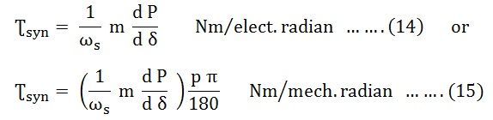Where,
- m is the number of phases of the machine
- ω_{s} = 2 π n_{s}
- n_{s} is the synchronous speed in revolution per second
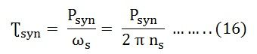

Significance of Synchronous Power Coefficient
The Synchronous Power Coefficient P_{syn} is the measure of the stiffness between the rotor and the stator coupling. A large value of P_{syn} indicates that the coupling is stiff or rigid. Too rigid a coupling means and the machine will be subjected to shock, with the change of load or supply. These shocks may damage the rotor or the windings. We have,
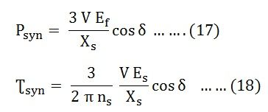
The above two equations (17) and (18) show that P_{syn} is inversely proportional to the synchronous reactance. A machine with large air gaps have relatively small reactance. The synchronous machine with the larger air gap is stiffer than a machine with a smaller air gap. Since P_{syn} is directly proportional to E_{f}, an overexcited machine is stiffer than an under the excited machine.
The restoring action is great when δ = 0, that is at no load. When the value of δ = ± 90⁰, the restoring action is zero. At this condition, the machine is in unstable equilibrium and at steady state limit of stability. Therefore, it is impossible to run a machine at the steady state limit od stability since its ability to resist small changes is zero unless the machine provided with special fast acting excitation system.
Or
Q.2 A 300 MVA 11Kv 50Hz 6 pole turbo generator has inertia constant 6MJ/MVA find (a) K.E. store in rotor (b) machine operating at load of 160 MW when load suddenly increases to 200 MW. find rotor retardation. (c) retardation calculated above is maintained for 3 cycle.
Q.3 Explain the application of equal area criterion to study transient stability for a sustained line fault. [5]

Or

Q.3 A 100 MVA 50HZ alternator is operating at rated speed the H constant of the machine is 5KW sec per KVA.the load suddenly increases by 50 MW. due to delay in governor action there is a delay of 0.6 sec in opening of steam valve. find the frequency of deviation.
Q.4Find out the relation for optimal generating scheduling of power plant including transmission losses. [5]
From the unit commitment table of a given plant, the fuel cost curve of the plant can be determined in the form of a polynomial of suitable degree by the method of least squares fit. If the transmission losses are neglected, the total system load can be optimally divided among the various generating plants using the equal incremental cost criterion of Eq. (7.10). It is, however, unrealistic to neglect transmission losses particularly when long distance transmission of power is involved.
A modern electric utility serves over a vast area of relatively low load density. The transmission losses may vary from 5 to 15% of the total load, and therefore, it is essential to account for losses while developing an economic load dispatch policy. It is obvious that when losses are present, we can no longer use the simple ‘equal incremental cost’ criterion. To illustrate the point, consider a two-bus system with identical generators at each bus (i.e. the same IC curves). Assume that the load is located near plant 1 and plant 2 has to deliver power via a lossy line. Equal incremental cost criterion would dictate that each plant should carry half the total load; while it is obvious in this case that the plant 1 should carry a greater share of the load demand thereby reducing transmission losses.
In this section, we shall investigate how the load should ,be shared among various plants, when line losses are accounted for. The objective is to minimize the overall cost of generation. at any time under equality constraint of meeting the load demand with transmission loss, i.e.
Where
k = total number of generating plants
P_{Gi} = generation of ith plant
P_{D} = sum of load demand at all buses (system load demand) P_{L} = total system transmission loss
To solve the problem, we write the Lagrangian as
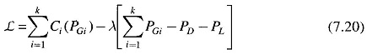
It will be shown later in this section that, if the power factor of load at each bus is assumed to remain constant, the system loss P_{L} can be shown to be a function of active power generation at each plant, i.e.
Thus in the optimization problem posed above, P_{Gi} (i = 1, 2, …, k) are the only control variables.
For optimum real power dispatch,
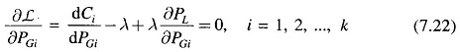
Rearranging Eq. (7.22) and recognizing that changing the output of only one plant can affect the cost at only that plant, we have
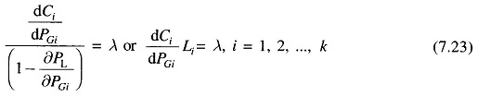
where
is called the penalty factor of the ith plant.
The Lagrangian multiplier λ is in rupees per megawatt-hour, when fuel cost is in rupees per hour. Equation (7.23) implies that minimum fuel cost is obtained, when the incremental fuel cost of each plant multiplied by its penalty factor is the same for all the plants.
The (k+1) variables (P_{G1},P_{G2,…} P_{GK,} λ can be obtained from k optimal dispatch Eq. (7.23) together with the power balance Eq. (7.19). The partial derivative δP_{L}/δP_{Gi} is referred to as the incremental transmission loss (ITL)_{i}, associated with the ith generating plant.
Equation (7.23) can also be written in the alternative form
or
Q.4 Derive formula of critical clearing time.
The critical clearing angle is defined as the maximum change in the load angle curve before clearing the fault without loss of synchronism. In other words, when the fault occurs in the system the load angle curve begin to increase, and the system becomes unstable. The angle at which the fault becomes clear and the system becomes stable is called critical clearing angle. When the initial load is given, then there is a critical clearing angle, and if the actual clearing angle exceeds a critical clearing angle, the system becomes unstable otherwise it is stable. Let the curve A represents the power angle curve for a healthy condition; curve B represents the power angle curve for faulty condition and curve C represents the power angle curve after isolation of fault as shown below. fault as shown below.
Where γ₁ is the ratio of system reactance in healthy condition to that of during the fault and γ₂ is the ratio of steady state limit of the system after the isolation of fault and that of system under the initial condition.
For transient stability limit, two areas A₁ = A₂ or in other words the area under curve adec (rectangle) is equal to the area under the curve da’b’bce.
Now substituting,we have,
or
Also from the curves
or
Thus if γ₁, γ₂, and δ₀ are known, the critical clearing angle δc can be determined.
The critical clearing time for case 1
where are initial rotor angle, maximum rotor angle, synchronous speed and mechanical power input to the machine, respectively. P_{2max} and P_{3max} are the maximum electrical power during the fault and after clearing the fault, respectively.
s

