SET-A
Subject: RAC

Q.01 Write the mechanism of a simple vapor compression refrigeration system.
Solution: The vapor-compression uses a circulating liquid refrigerant as the medium which absorbs and removes heat from the space to be cooled and subsequently rejects that heat elsewhere. Figure 1 depicts a typical, single-stage vapor-compression system. All such systems have four components: a compressor, a condenser, a thermal expansion valve (also called a throttle valve or metering device), and an evaporator. Circulating refrigerant enters the compressor in the thermodynamic state known as a saturated vapor and is compressed to a higher pressure, resulting in a higher temperature as well. The hot, compressed vapor is then in the thermodynamic state known as a superheated vapor and it is at a temperature and pressure at which it can be condensed with either cooling water or cooling air flowing across the coil or tubes. This is where the circulating refrigerant rejects heat from the system and the rejected heat is carried away by either the water or the air (whichever may be the case).
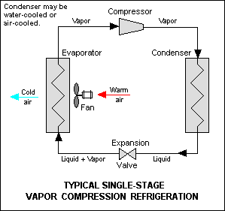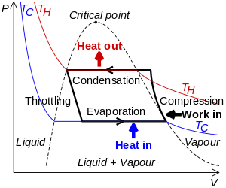
The condensed liquid refrigerant, in the thermodynamic state known as a saturated liquid, is next routed through an expansion valve where it undergoes an abrupt reduction in pressure. That pressure reduction results in the adiabatic flash evaporation of a part of the liquid refrigerant. The auto-refrigeration effect of the adiabatic flash evaporation lowers the temperature of the liquid and vapor refrigerant mixture to where it is colder than the temperature of the enclosed space to be refrigerated.
The cold mixture is then routed through the coil or tubes in the evaporator. A fan circulates the warm air in the enclosed space across the coil or tubes carrying the cold refrigerant liquid and vapor mixture. That warm air evaporates the liquid part of the cold refrigerant mixture. At the same time, the circulating air is cooled and thus lowers the temperature of the enclosed space to the desired temperature. The evaporator is where the circulating refrigerant absorbs and removes heat which is subsequently rejected in the condenser and transferred elsewhere by the water or air used in the condenser.
To complete the refrigeration cycle, the refrigerant vapor from the evaporator is again a saturated vapor and is routed back into the compressor.
OR
Q.01 Explain Cascade refrigeration system with neat sketch.
Solution: In a cascade system a series of refrigerants with progressively lower boiling points are used in a series of single stage units. The condenser of lower stage system is coupled to the evaporator of the next higher stage system and so on. The component where heat of condensation of lower stage refrigerant is supplied for vaporization of next level refrigerant is called as cascade condenser. Figures 13.6(a) and (b) show the schematic and P-h diagrams of a two-stage cascade refrigeration system. As shown, this system employs two different refrigerants operating in two individual cycles. They are thermally coupled in the cascade condenser. The refrigerants selected should have suitable pressure-temperature characteristics. An example of refrigerant combination is the use of carbon dioxide (NBP = -78.4o o C, Tcr = 31.06 C) in low temperature cascade and ammonia (NBP = -33.33o o C, Tcr = 132.25 C) in high temperature cascade. It is possible to use more than two cascade stages, and it is also possible to combine multi-stage systems with cascade systems.
Applications of cascade systems: i. Liquefaction of petroleum vapours ii. Liquefaction of industrial gases iii. Manufacturing of dry ice iv. Deep freezing etc. Advantages of cascade systems: i. Since each cascade uses a different refrigerant, it is possible to select a refrigerant that is best suited for that particular temperature range. Very high or very low pressures can be avoided ii. Migration of lubricating oil from one compressor to the other is prevented In practice, matching of loads in the cascade condenser is difficult, especially during the system pull-down. Hence the cascade condensers are normally oversized. In addition, in actual systems a temperature difference between the condensing and evaporating refrigerants has to be provided in the cascade condenser, which leads to loss of efficiency. In addition, it is found that at low temperatures, superheating (useful or useless) is detrimental from volumetric refrigeration effect point-of-view, hence in cascade systems, the superheat should be just enough to prevent the entry of liquid into compressor, and no more for all refrigerants.
Q.02 The capacity of a refrigerator is 200 TR when working between -6⁰C and 25⁰C. Determine the mass of ice produced per day from water at 25⁰C. Also find the power required to drive the unit. Assume that the cycle operates on reverse Carnot cycle and the latent heat of ice is 335 KJ/Kg.

Solution:
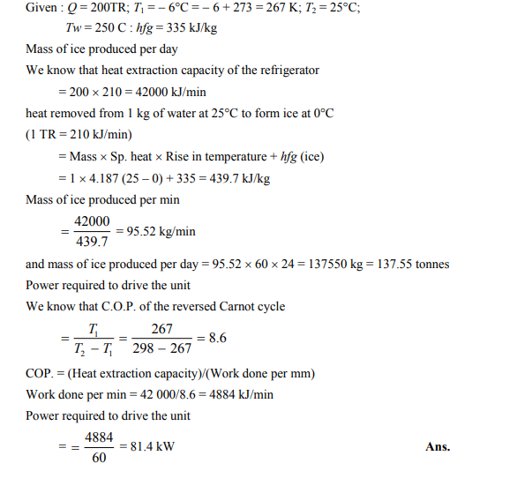
OR
Q.02. What is difference between a refrigerator and heat pump? Derive an expression for the performance factor for both if they are running on reversed Carnot cycle.
Solution:
A refrigerator or a heat pump that operates on the reversed Carnot cycle is called a Carnot refrigerator or a Carnot heat pump.
The coefficient of performance(COP) of reversible or irreversible refrigerator or heat pump is given by
COP_{R} = 1/((Q_{H}/Q_{L})-1)
COP_{HP} = 1/(1-(Q_{L}/Q_{H}))
where
Q_{H} = the amount of heat rejected to the
high-temperature reservoir
Q_{L} = the amount of heat received from the
low-temperature reservoir
For reversible refrigerators or heat pumps, such as Carnot refrigerators, or Carnot heat pumps, the COPs can be determined by replacing the heat transfer ratios in the above equations by the absolute temperature ratios. These are,
COP_{R,rev} = 1/((T_{H}/T_{L})-1)
COP_{HP,rev} = 1/(1-(T_{L}/T_{H}))
where
T_{H} = the absolute temperature of the
high-temperature reservoir
T_{L} = the absolute temperature of the
low-temperature reservoir
Q.03. A cold storage plant is required to store 20 tonnes of fish. The fish is supplied at a temperature of 30⁰C
The specific heat of fish above freezing point is 2.93 KJ/KgK. The specific heat of fish below freezing point is 1.26KJ/KgK. The fish is stored in cold storage which is maintained at -8⁰C. The freezing point of fish is -4⁰C. The latent heat of fish is 235 KJ/Kg. Assume actual COP of the plant as 0.3 of the Carnot COP. If the plant requires 75KW to drive it, Find:
- The capacity of the plant (b) Time taken to achieve cooling

Solution: 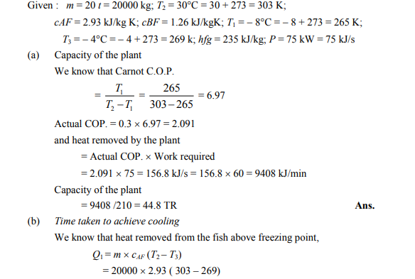
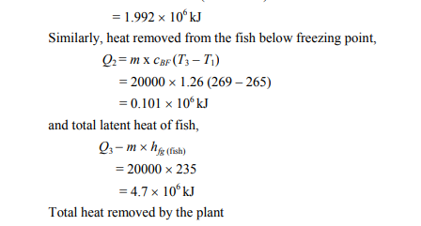
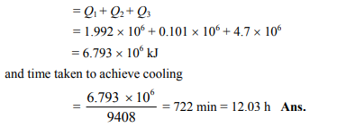
OR
Q.03 Explain the effect of superheating in compressor and under cooling in vapour compression system. Show these on T-s and P-h diagrams

Solution: The performance vapour compression refrigeration system is mainly depends on following two important processes: 1. Superheating of vapour refrigerant and 2. Sub-cooling of liquid refrigerant Superheating and sub –cooling process will influence the cooling capacity and compressor work.The effect of super heating and sub cooling in the vapour compression cycle the vapour leaving the evaporator is usually at temperature lower than the temperature of the surrounding, hence it is desirable superheat the vapour before its entry into the compressor. Superheating increases the refrigerating effect and amount of work supplied to the compressor. Since the increase in refrigerating effect is less as compared to the increase in work supplied, the net effect of superheating is to reduce COP. The higher the sub-cooling the higher is the efficiency the degree of this sub cooling depends on size of condenser, ambient conditions and refrigerant used. The greatest amount of heat is transferred during the change of state. If the refrigerant after condensation process 2-31 is cooled below saturation temperature T3 1 by throttling before expansion, then the process is called sub cooling or under cooling it is done along the saturated liquid line Sub cooling increases the refrigerating effect per kg of refrigerant circulated[81]. Since refrigerant effect is more; the amount of refrigerant circulated can be reduced.
Q.04 What do you mean by Refrigeration? Define the unit of Refrigeration and coefficient of performance of a Refrigerator. Also state the II law of thermodynamics
Solution:

Coefficient of Performance – Heat Pump, Refrigeration
In general, the thermal efficiency, η_{th}, of any heat engine as the ratio of the work it does, W, to the heat input at the high temperature, Q_{H}.

The thermal efficiency, η_{th}, represents the fraction of heat, Q_{H}, that is converted to work

It is the directional law of energy and also the law of degradation of energy. It is
based on the following statements.
(a) Kelvin-Planck statement
“It is impossible to construct an engine working on a cyclic process, whose sole
purpose is to convert heat energy from a single reservoir into an equivalent amount
of work.” No cyclic engine can convert whole of heat into equivalent work. Second
law dictates limits on the conversion of heat into work.
(b) Clausius statement
“It is impossible for a self-acting machine, working in a cyclic process, to transfer
heat from a body at a lower temperature to a body at a higher temperature without
the aid of an external energy”.
Heat cannot flow itself from a cold body to a hot body without expenditure of
mechanical work. Second law deals with the direction of flow of heat energy.

OR
Q.04 In a refrigerator working on Bell-Coleman cycle, the air is drawn into the cylinder of the compressor from the cold chamber at a pressure of 1.03bar and temperature 12°C. After isentropic compression to 5.5 bar, the air is cooled at constant pressure to a temperature of 22°C. The polytropic expansion ${pv}^{1.25}$= constant then follows and the air expanded to 1.03 bar is passed to cold chamber. Determine:
(a) Work done per kg of air
(b) Refrigerating effect per kg of air flow
(c) C.O.P.
For air take γ=1.4 and $c_{p}$=1.003KJ/kgK
Solution:

: 