Solution Set-B
Subject:RAC

Q.01 Prove that the performance of a Bell-Coleman cycle refrigeration system is given by COP = $\frac{T2}{ T3-T2}$
Solution:
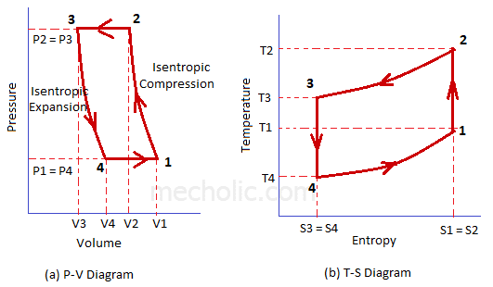
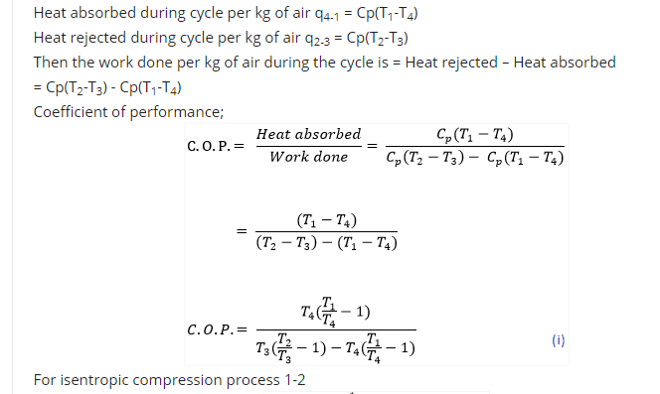
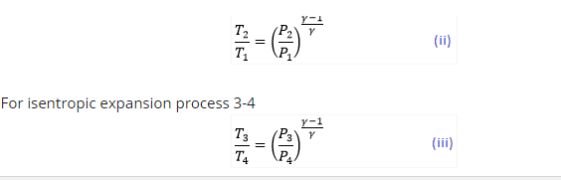
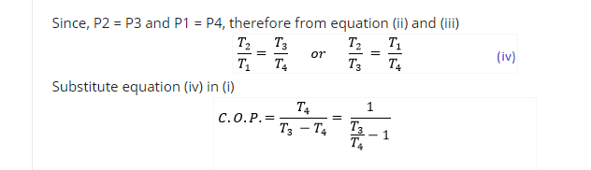
OR
Q.01 A vapour compression refrigerator works between the pressure limits of 60 bar and 25 bar. The working fluid is just dry at the end of compression and there is no undercooling of the liquid before the expansion valve. Determine: (a) COP of the cycle (b) Capacity of the refrigerator. If the fluid flow is at the rate of 5kg/min
Pressure (Bar) | Saturation Temperature (K) | Enthalpy |  | Entropy
 |  | Liquid | Vapour | Liquid | Vapour
60  25 | 295  261 | 151.96  56.32 | 293.29  322.58 | 0.554  0.226 | 1.0332  1.2464

Solution: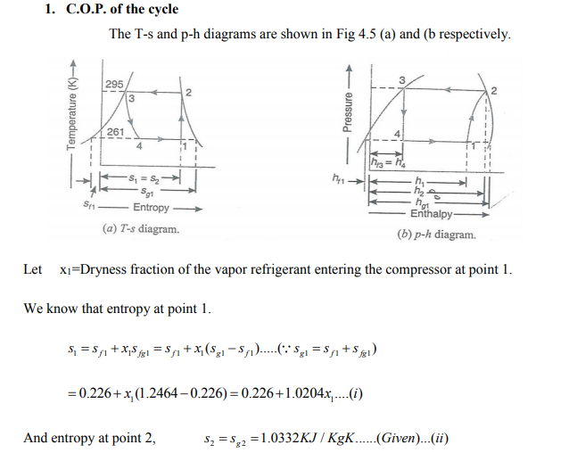
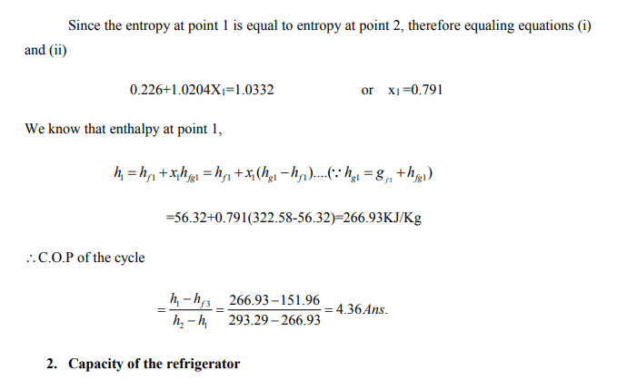
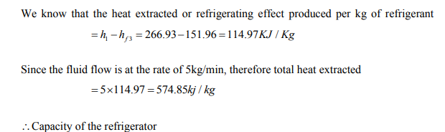
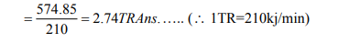
Q.02 What do you mean by Refrigeration? Define the unit of Refrigeration and coefficient of performance of a Refrigerator. Also state the II law of thermodynamics.
Solution: Refrigeration is the process of providing and maintaining temperature of the system below that of the surrounding atmosphere.
Unit of Refrigeration
The common unit used in the field of refrigeration is known as Ton of refrigeration. A ton of refrigeration is defined as the quantity of heat required to be removed to produce one ton (1000kg) of ice within 24 hours when the initial condition of water is 0ºC
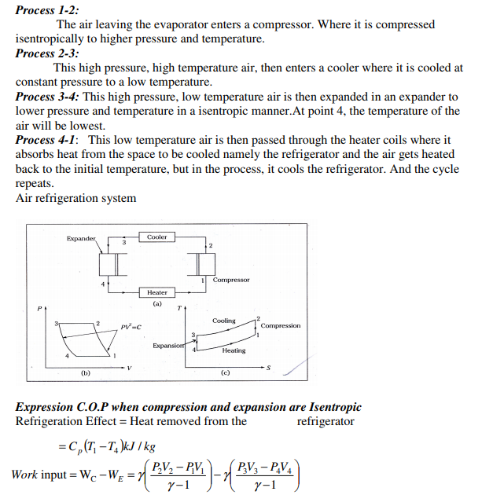
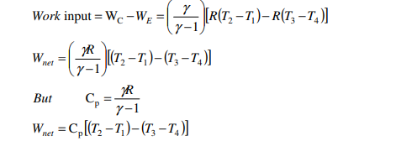
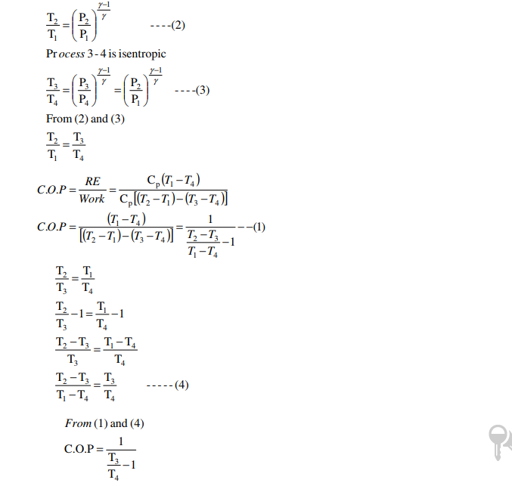
OR
Q.02 The capacity of a refrigerator is 200 TR when working between -6⁰C and 25⁰C. Determine the mass of ice produced per day from water at 25⁰C. Also find the power required to drive the unit. Assume that cycle operates on reverse Carnot cycle and the latent heat of ice is 335 KJ/Kg.
Solution:
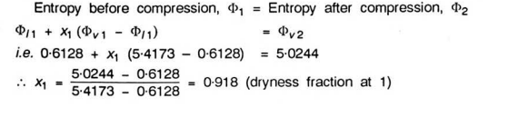
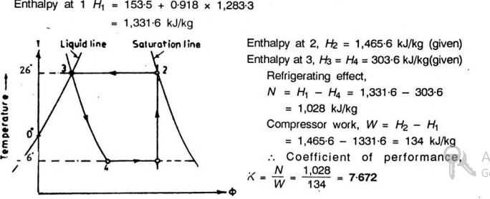
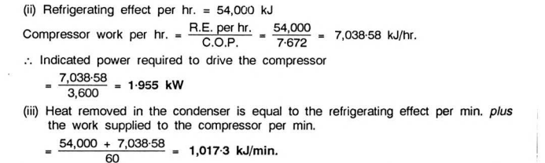
Q.03 How does an actual vapour compression cycle differ from that of a theoretical cycle?

Solution: The actual cycle deviates slightly due to pressure drop caused by friction in piping and valves. In addition to this there will be heat loss or gain depending on the temperature difference between the refrigerant and the surrounding. Further compression will be polytropic due to friction and heat transfer instead of isentropic.. It is clear from the both actual and theoretical cycles that little pressure drop takes place when refrigerant pass through the evaporator.The processes a-b and b-c are depicting superheating of suction vapour inside the evaporator and outside the evaporator respectively; where as the processes c-d and d-1 are showing the pressure drop in line and wire drawing effect pressure drop inside the compressor valve respectively. The processes 2-e and e-f are the pressure drop in compressor discharge valve and delivery line respectively. Processes f-h is desuperheating of gas in condenser and h-3 is sub cooling of liquid in condenser.
The operating cycle deviates as discussed above however, the saturated cycle is used to determine the COP of the cycle for all practical purpose. It is well observed that the pressure drop in the evaporator due to frictional pressure drop and momentum pressure drop is larger than that of the condenser.
The operating cycle of the plant can be plotted on P-H diagram corresponding to suction and the discharge pressure of the system to calculate theoretical COP of the plant. The measurement of actual COP, which is the ratio of actual cooling effect produced to the actual power consumption, is difficult under practical conditions. The work of compression can be easily obtained by installing energy meters but the rate of cooling effect produced is difficult to estimate, as the refrigerating effect is continuously in use. The measurement of actual COP is more important to know the performance of the plant.
The estimation of actual refrigerating effect produced is practically difficult; however under certain conditions, it is possible to calculate the rate of refrigerating effect produced by indirect method. For any vapour compression refrigeration plant,
Q = R + W; where Q = heat removed at condenser,
kJ/h; R = refrigerating effect produced, kJ/h;
W = work of compression, kJ/h.
If it is possible to estimate the value of heat removed at condenser by measuring the change in enthalpy of the cooling medium, the refrigerating effect can be estimated as the work of compression is measured by energy meters.
OR
Q.03. State the function of the following parts of a simple vapor compression system:
- Compressor
- Expansion valve
Solution: Reciprocating compressor is used to compress the refrigerant in domestic refrigerator. This compressor is hermetically sealed type.
Hermetic sealed compressor is one in which the two halves are sealed by welding or brazing. Electric motor and reciprocating mechanism are placed inside this housing.
A reciprocating compressor consists of piston, connecting rod, crank shaft. Crank shaft is rotated by an electric motor.
During downward motion of the piston refrigerant is sucked and in upward motion refrigerant gets compressed.
Thermostatic expansion valve or TEV is one of the most commonly used throttling devices in the refrigerator and air conditioning systems. The thermostatic expansion valve is the automatic valve that maintains proper flow of the refrigerant in the evaporator as per the load inside the evaporator. If the load inside the evaporator is higher it allows the increase in flow of the refrigerant and when the load reduces it allows the reduction in the flow of the refrigerant. This leads to highly efficient working of the compressor and the whole refrigeration and the air conditioning plant.
The thermostatic expansion valve also prevents the flooding of the refrigerant to the compressor ensuring that the plant would run safely without any risk of breakage of the compressor due to compression of the liquid. The thermostatic expansion valve does not controls the temperature inside the evaporator and it does not vary the temperature inside the evaporator as its name may suggest..

Q.04. Describe a simple vapor compression cycle giving clearly its flow diagram.
Solution: As mentioned, vapour compression refrigeration systems are the most commonly used among all refrigeration systems. As the name implies, these systems belong to the general class of vapour cycles, wherein the working fluid (refrigerant) undergoes phase change at least during one process. In a vapour compression refrigeration system, refrigeration is obtained as the refrigerant evaporates at low temperatures. The input to the system is in the form of mechanical energy required to run the compressor. Hence these systems are also called as mechanical refrigeration systems. Vapour compression refrigeration systems are available to suit almost all applications with the refrigeration capacities ranging from few Watts to few megawatts. A wide variety of refrigerants can be used in these systems to suit different applications, capacities etc. The actual vapour compression cycle is based on Evans-Perkins cycle, which is also called as reverse Rankine cycle. Before the actual cycle is discussed and analysed, it is essential to find the upper limit of performance of vapour compression cycles. This limit is set by a completely reversible cycle.
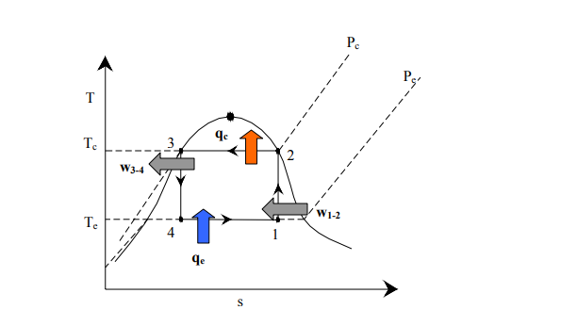
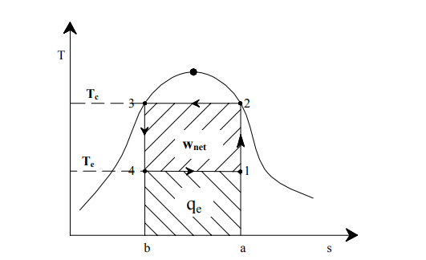
OR
Q.04 Sketch the T-S and PH diagram for the vapour compression cycles, when the vapor compression is in-
(i) Dry saturated (ii) Wet saturated
Solution: it is clear that from practical considerations, the Carnot refrigeration system need to be modified. Dry compression with a single compressor is possible if the isothermal heat rejection process is replaced by isobaric heat rejection process. Similarly, the isentropic expansion process can be replaced by an isenthalpic throttling process. A refrigeration system, which incorporates these two changes is known as Evans-Perkins or reverse Rankine cycle. This is the theoretical cycle on which the actual vapour compression refrigeration systems are based.
