SOLUTION OF TOS I
Q.1
The problem of indeterminacy arises when one observes the eventual circularity of virtually every possible definition. It is easy to find loops of definition in any dictionary, because this seems to be the only way that certain concepts, and generally very important ones such as that of existence, can be defined in the English language. A definition is a collection of other words, and in any finite dictionary if one continues to follow the trail of words in search of the precise meaning of any given term, one will inevitably encounter this linguistic indeterminacy.
Philosophers and scientists generally try to eliminate indeterminate terms from their arguments, since any indeterminate thing is unquantifiable and untestable; similarly, any hypothesis which consists of a statement of the properties of something unquantifiable or indefinable cannot be falsified and thus cannot be said to be supported by evidence that does not falsify it. This is related to Popper's discussions of falsifiability in his works on the scientific method. The quantifiability of data collected during an experiment is central to the scientific method, since reliable conclusions can only be drawn from replicable experiments, and since in order to establish observer agreement scientists must be able to quantify experimental evidence.
OR

Q.1 In statics, a structure is statically indeterminate (or hyperstatic)^{[1]} when the static equilibrium equations are insufficient for determining the internal forces and reactions on that structure.
Based on Newton's laws of motion, the equilibrium equations available for a two-dimensional body are
- : the vectorial sum of the forces acting on the body equals zero. This translates to
Σ H = 0: the sum of the horizontal components of the forces equals zero;
Σ V = 0: the sum of the vertical components of forces equals zero;
- : the sum of the moments (about an arbitrary point) of all forces equals zero.
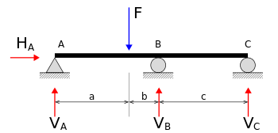
Free body diagram of a statically indeterminate beam.
In the beam construction on the right, the four unknown reactions are V_{A}, V_{B}, V_{C} and H_{A}. The equilibrium equations are:
Σ V = 0:
V_{A} − F_{v} + V_{B} + V_{C} = 0
Σ H = 0:
H_{A} = 0
Σ M_{A} = 0:
F_{v} · a − V_{B} · (a + b) - V_{C} · (a + b + c) = 0.
Since there are four unknown forces (or variables) (V_{A}, V_{B}, V_{C} and H_{A}) but only three equilibrium equations, this system of simultaneous equations does not have a unique solution. The structure is therefore classified as statically indeterminate. Considerations in the material properties and compatibility in deformations are taken to solve statically indeterminate systems or structures.

Q.2

If the support at B is removed, the reaction V_{B} cannot occur, and the system becomes statically determinate (or isostatic).^{[2]} Note that the system is completely constrained here. The system becomes an exact constraint kinematic coupling. The solution to the problem is

If, in addition, the support at A is changed to a roller support, the number of reactions are reduced to three (without H_{A}), but the beam can now be moved horizontally; the system becomes unstable or partially constrained—a mechanism rather than a structure. In order to distinguish between this and the situation when a system under equilibrium is perturbed and becomes unstable, it is preferable to use the phrase partially constrained here. In this case, the 2 unknowns V_{A} and V_{C} can be determined by resolving the vertical force equation and the moment equation simultaneously. The solution yields the same results as previously obtained. However, it is not possible to satisfy the horizontal force equation unless .
Statical indeterminacy is the existence of a non-trivial (non-zero) solution to the homogeneous system of equilibrium equations. It indicates the possibility of self-stress (stress in the absence of an external load) that may be induced by mechanical or thermal action.

OR

Calculation of Static Indeterminacy:
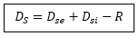
D_{s} = Total static indeterminacy
D_{se} = External indeterminacy (Related to support)
D_{si} = Internal indeterminacy (Related to type of joint and configuration of member)

External Static Indeterminacy (D_{se}):-
Now, D_{se} = r – equilibrium equations
Where, r = Total no of reactions
This relation is valid for both pin-jointed & rigid jointed structure

Internal Static Indeterminacy (D_{si}):-
- i) For pin – jointed structure:-
D_{si} = m – (2 j – 3)
Where, m = no of members
J = no of pin joints
If, m = (2j – 3) → perfect frame
m > (2j – 3) → Redundant / hyper-static frame
m < (2j – m) → Deficient frame (Internally unstable)
Example:
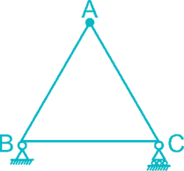
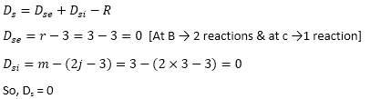
N.B: A triangle is a stable shape in pin jointed plane structure.
N.B: Additional no of members beyond triangular shape represent internal indeterminacy of pin-jointed plane structure.

Q.3
Example:
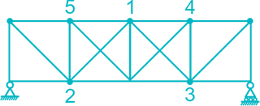
In the given truss, internal indeterminacy
D_{si} = m – (2j – 3) = 19 – (2 × 10 – 3) = 2
Shortcut: In the given truss, the member 1 – 2 & 1 – 3 are excess after framing all triangles. So there are two extra member beyond triangular shape. So the internal indeterminacy will be = 2
Example:
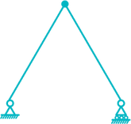
Internal indeterminacy,
D_{si} = m – (2j – 3)
= 2 – (2 × 3 – 3)
= – 1
Shortcut: Here the bottom chord member is not present, so one extra member is required to make the stable triangular shape. So the internal in determinacy will be = – 1
The given frame is internally unstable.

D_{si} for rigid jointed plane frames:-
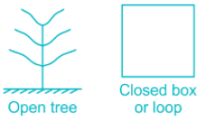
D_{si} = 3c: for rigid jointed plane frame
= 6c: for rigid jointed pace frame
Where C represents the no of cuts required to make a closed loop to an open tree configuration.
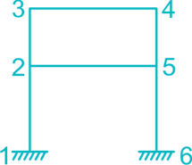
Here in this structure, 2-3-4-5-2 is a closed loop but 1-2-5-6-1 is not a closed loop
So the internal static indeterminacy will be,
D_{si} = 3c = 3 × 1 = 3

OR

Force Release:-
1.a) Moment hinge:-
The additional moment equilibrium equation due to a moment hinge is
= m’ – 1 – for rigid jointed plane frame
= 3 (m’ – 1) – for rigid jointed space frame
Where m’ = no of members connected to that hinge.
Example:-
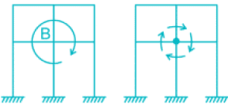
The addition rotation at B due to moment hinge = m’ – 1 = 4 – 1 = 3
1.b) Horizontal Shear Release:-
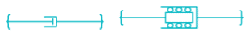
Due to the introduction of horizontal shear release, horizontal force from one side to the other side cannot be transferred. Therefore no of force release = 1
1.c) Vertical Shear Release:-
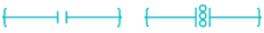
Due to vertical shear release, vertical load cannot be transferred from one side to another. So the force release is equal to one.
1.d) Link:-
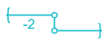
A link cannot transfer moment & horizontal forces from one side to another. So the no of force release is equal to two.
Example:-
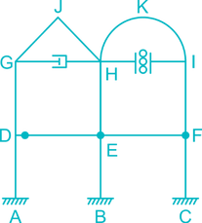
For this frame,
D_{s} = D_{se} + D_{si} – R
Now, D_{se} = r – 3 = (3 + 3 + 3) – 3 = 6
[Reaction at all the supports are 3]
D_{si} = 3c – as rigid jointed plane frame
= 3 × 4 [Closed loops are DGHED, EHIFE, GJHG, HKIH]
= 12
R = Release
Now, Release due to moment hinge at E = m’ – 1 = 4 – 1 = 3
Release due to moment hinge at F = m’ – 1 = 3 – 1 = 2
Release due to moment hinge near D = m’ – 1 = 2 – 1 = 1
Release due to horizontal shear release = 1
Release due to vertical shear release = 1
Total Release R = 8
So, static indeterminacy, D_{s} = D_{se} + D_{si} – R
= 6 + 12 – 8
= 10

OR

Example:
D_{s} = D_{se} – R
D_{se} = r – 3 = 5 – 3 = 2 [2 reaction at A, 2 reaction at B & 1 vertical reaction at C]
R = 2 (due to link present)
So, D_{s} = D_{se} – R = 2 – 2 = 0
- This exists only in frames and not for beams and trusses

- In the above frame, only one closed loop (bounded by the joints 3,4,6 and 5) is there. So C=1
- Note: Joints 1,3,4 and 2 will not make a closed loop
- If there is one more bay in the given structure, then two closed loops will be there. So C=2
- Beam is a special case of frame with no closed loops. Hence for beam C value does not exists

OR

Members (m)
- Here m denotes numbers of members
- For frames, members comprised of mostly beam and columns. So for the value of m, just count the number of beams and columns
- For trusses, members are ties (tensile member) and struts (compressive member). So for the value of m, just count the members which formed the truss
Joints (j)
- Here j denotes number of joints
- In beams, if the cross section varies (non prismatic member), the that point should also be considered as a joint
Axially inextensible members (m’)
- Here m’ represents number of axially rigid members
- In the problem, if the beams alone are mentioned axially inextensible/rigid, then m’ will be equal to number of beams in the structure
- In the problem, if the columns alone are mentioned axially inextensible/rigid, then m’ will be equal to number of columns in the structure
- If it is mentioned all members are inextensible, then m’ will be sum of all beams and columns
- If nothing is mentioned in the question regarding the axial rigidity, then m’ will take zero as its value
Internal hinge contribution (rrrr)
- This value comes into picture, if Internal Hinge is present in the frame or beam
- If Internal Hinge is not there in the given problem, then just ignore about this
- Internal Hinge Contribution is deducted in ‘Internal Static Indeterminacy’
- Internal Hinge Contribution is added in ‘Kinematic Indeterminacy’

Q.4 For the 3D truss, it is ‘m-(3j-6)’. Instead I mentioned ‘2j’ in the attached picture.
STATIC
- beams, r-2 (excluding horizontal)
- frames, 3m+r-3j
- truss, m+r-2j
m-number of members
r-no of reactions
j-number of joints
KINEMATIC
it is the number of displacement allowed at joints in a structure
for eg, take a fixed support, it restrains horizontal and vertical displacements and even the rotation . therefore deg of Ki=0

OR

Procedure
Step 1 identify start joint.
Step 2 calculate total number of unknown (member forces and support reaction at the joint).
Step 3 calculate total number of available equation (including extra equation due to release) at that joint.
Step 4 calculate step 2 & step 3 this is static indeterminacy of the joint it may be positive or negative.
Step 5 make mark on each member meeting at the joint.
Step 6 repeat steps 2 and step 5 at all joints.
Step 7 add up value obtained from Step 4 for all joint.
This is the DSI of entire structure.
NOTE: FREE AND OF OVERHANG PORTION SHOULD ALSO BE CONSIDERED AS JOINT.
EX.
