Roll No:…………………….………
RAJASTHAN INSTITUTE OF ENGINEERING & TECHNOLOGY
B. Tech. IV Year VII Semester (EE & EEE)
SUB- Non-Conventional Energy Sources
I Mid-Term Exam 2018-19
Time: 2:00 hours SET-B Max. Marks: 20
Solution
Q.1 Explain the Indian and World Energy Scenario.
Ans:

Global Primary Energy Consumption
The global primary energy consumption at the end of 2003 was equivalent to 9741 million tons of oil equivalent (MTones). The Figure 1.3 shows in what proportions the sources mentioned above contributed to this global figure.

Energy distribution between developed and developing Countries

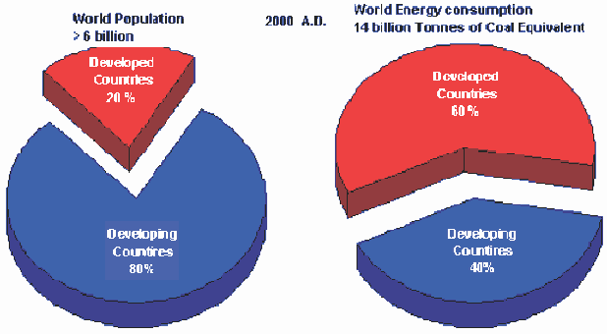
Although 80 percent of the world's population lies in the developing countries (a four- fold population increase in the past 25 years), their energy consumption amounts to only 40 percent of the world total energy consumption. The high standards of living in the developed countries are attributable to high energy consumption levels.
Fig. 1: Energy Distribution Between Developed and Developing Countries
Also the rapid population growth in the developing countries has kept the per capita energy consumption low compared with that of highly industrialized developed countries. The world average energy consumption per person is equivalent to 2.2 tones of coal. In industrialized countries, people use four to five times more than the world average and nine times more than the average for the developing countries. An American uses 32 times more commercial energy than an Indian.

Indian Energy Scenario

Coal dominates the energy mix in India, contributing to 55% of the total primary energy pro- duction. Over the years, there has been a marked increase in the share of natural gas in prima- ry energy production from 10% in 1994 to 13% in 1999. There has been a decline in the share of oil in primary energy production from 20% to 17% during the same period.

Energy Supply Coal Supply
India has huge coal reserves, at least 84,396 million tones of proven recoverable reserves (at the end of 2003). These amounts to almost 8.6% of the world reserves and it may last for about 230 years at the current Reserve to Production (R/P) ratio. In contrast, the world's proven coal reserves are expected to last only for 192 years at the current R/P ratio.
Reserves/Production (R/P) ratio- If the reserves remaining at the end of the year are divided by the production in that year, the result is the length of time that the remaining reserves would last if production were to continue at that level.
India is the fourth largest producer of coal and lignite in the world. Coal production is concentrated in these states (Andhra Pradesh, Uttar Pradesh, Bihar, Madhya Pradesh, Maharashtra, Orissa, Jharkhand, and West Bengal).

Oil Supply

Oil accounts for about 36 % of India’s total energy consumption. India today is one of the top ten oil-guzzling nations in the world and will soon overtake Korea as the third largest consumer of oil in Asia after China and Japan. The country's annual crude oil production is peaked at about 32 million tonne as against the current oil consumption by end of 2007 is expected to reach 136 million tonne(MT), of which domestic production will be only 34 MT. India will have to pay an oil bill of roughly $50 billion, assuming a weighted average price of $50 per barrel of crude. In 2003-04, against total export of $64 billion, oil imports accounted for $21 billion. India imports 70% of its crude needs mainly from gulf nations. The majority of India's roughly 5.4 billion barrels in oil reserves are located in the Bombay High, upper Assam, Cambay, Krishna-Godavari. In terms of sector wise petroleum product consumption, transport accounts for 42% followed by domestic and industry with 24% and 24% respectively. India spent more than Rs.1,10,000 crore on oil imports at the end of 2004.

Natural Gas Supply

Natural gas accounts for about 8.9 per cent of energy consumption in the country. The current demand for natural gas is about 96 million cubic metres per day (mcmd) as against availability of 67 mcmd. By 2007, the demand is expected to be around 200 mcmd. Natural gas reserves are estimated at 660 billion cubic meters.

Electrical Energy Supply

The all India installed capacity of electric power generating stations under utilities was 1,12,581 MW as on 31st May 2004, consisting of 28,860 MW- hydro, 77,931 MW- thermal and 2,720 MW- nuclear and 1,869 MW- wind (Ministry of Power).

Nuclear Power Supply

Nuclear Power contributes to about 2.4 per cent of electricity generated in India. India has ten nuclear power reactors at five nuclear power stations producing electricity. More nuclear reactors have also been approved for construction.

Hydro Power Supply

India is endowed with a vast and viable hydro potential for power generation of which only

15% has been harnessed so far. The share of hydropower in the country's total generated units has steadily decreased and it presently stands at 25% as on 31st May 2004. It is assessed that exploitable potential at 60% load factor is 84,000 MW.

Final Energy Consumption

Final energy consumption is the actual energy demand at the user end. This is the difference between primary energy consumption and the losses that takes place in transport, transmission & distribution and refinement. The actual final energy consumption (past and projected) is given in Table1.2.
TABLE 1.2 DEMAND FOR COMMERCIAL ENERGY FOR
FINAL CONSUMPTION (BAU SCENARIO)
Source | Units | 1994-95 | 2001-02 | 2006-07 | 2011-12
Electricity | Billion Units | 289.36 | 480.08 | 712.67 | 1067.88
Coal | Million Tonnes | 76.67 | 109.01 | 134.99 | 173.47
Lignite | Million Tonnes | 4.85 | 11.69 | 16.02 | 19.70
Natural Gas | Million Cubic | 9880 | 15730 | 18291 | 20853
Oil | Million Tonnes | 63.55 | 99.89 | 139.95 | 196.47
Source: Planning Commission BAU:_Business As Usual

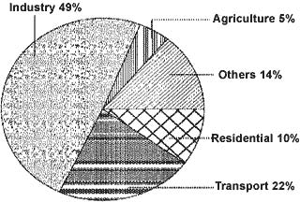
Sector Wise Energy Consumption in India

The major commercial energy consuming sectors in the country are classified as shown in the Figure 1.5. As seen from the figure, industry remains the biggest consumer of commercial energy and its share in the overall consumption is 49%. (Reference year: 1999/2000)

OR
Q.1 what is difference between Renewable and Non- Renewable Source of Energy? Explain
Ans:
Any physical activity in this world, whether carried out by human beings or by nature, is cause due to flow of energy in one form or the other. The word ‘energy’ itself is derived from the Greek word ‘en-ergon’, which means ‘in-work’ or ‘work content’. The work output depends on the energy input.
Energy is one of the major inputs for the economic development of any country. In the case of the developing countries, the energy sector assumes a critical importance in view of the ever- increasing energy needs requiring huge investments to meet them.
Energy can be classified into several types based on the following criteria:
1. Primary and Secondary energy
- Commercial and Non commercial energy
- Renewable and Non-Renewable energy
- Conventional and Non-conventional energy
Renewable energy is energy obtained from sources that are essentially inexhaustible. Examples of renewable resources include wind power, solar power, geothermal energy, tidal power and hydroelectric power. The most important feature of renewable energy is that it can be harnessed without the release of harmful pollutants.
Non-renewable energy is the conventional fossil fuels such as coal, oil and gas, which are likely to deplete with time
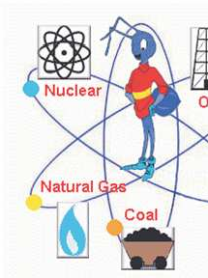
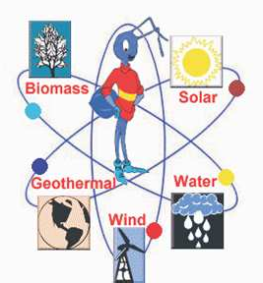

Q.2 Explain the Different Components of TIDAL Power Plant.
Ans:
Tidal power, also called tidal energy, is a form of hydropower that converts the energy of tides into electrical energy.In tidal plant power of the rise and fall of the sea level or tidal power, can be harnessed to generate electricity.Tidal power traditionally involves erecting a dam across the opening to a tidal basin. The dam includes a sluice that is opened to allow the tide to flow into the basin; the sluice is then closed, and as the sea level drops, traditional hydropower technologies.The tides contain energy that can be harnessed to produce electricity. Two types of tidal energy can be extracted. kinetic energy can be harnessed from the ebbing and surging tides. potential energy can be harnessed from differences in the high and low tides. Using tidal currents remains the primary method of generating electricity.Tidal energy is the utilization of the variations in sea level caused primarily by the gravitational effects of the moon, combined with the rotation of the Earth.
Components of Tidal Power Plants:
For utilization of tidal energy, water must be trapped at high tide behind a dam or barrage and then made to drive turbine coupled to an electric generator as it returns to sea during low tides. The available energy is proportional to the square of the amplitude.
The main components of tidal power plants are:
(i) Dam
(ii) Sluice ways from basin to sea and vice versa, and
(iii) Power house.
The function of a dam is to form a barrier between the sea and the basin or between one basin to the other basin in case of multiple basins. The most suitable word for tidal power plant is barrage. Barrages have to resist waves whose shock can be severe and where pressure changes sides continuousl.
The sluice ways are gate controlled devices. They are employed to fill the basin during the high tide or empty the basin during low tide. In existing plants, vertical lift gates have been employed. Flap gates are also used. The flap gates allow only in the direction of sea to basin. Therefore, the level of the basin rises.
Auxiliary equipments, turbines and generators are the main components of the power house. Large sized turbines are used because of low head available. Bulb types and rim type turbines are commonly used. Shaft turbines are also under steady.
Types of Tidal Plants
Tidal Fences: Tidal fences block a channel, forcing water to go through it and turning its turbines to generate electricity.
Barrage Tidal Plants: Barrage tidal plants are the most common type of tidal plant. A dam or barrage is installed, usually where there is a narrow water channel, with gates and turbines at certain points. As water flow through the turbines, they turn a generator that produces electricity.
Tidal Turbines: Tidal turbines work like an underwater wind turbine, using the tides to turn blades and generate electricity.
OR
Q.2 Explain the Different type of Power generation Systems from TIDAL Waves.
Ans:
Classification of Tidal Power Plants:
Tidal power plants can be classified on the basis of basins used in power generation.
There are two types of basin systems viz.:
1. Single Basin System, and
2. Double Basin System.
1. Single Basin System:
Single basin system can generate power only intermittently. This is the simplest system of generating tidal power. The single basin scheme has only one basin. The basin is separated from the sea by a dam (barrage, Dyke). The sluice way is opened during high tide to fill the basin. The turbine-generator units are mounted within the ducts inside the barrage.
The single basin system can be further classified as:
(i) Single Ebb-Cycle System,
(ii) Single Tide-Cycle System,
(iii) Double Cycle System.
(i) Single Ebb-Cycle System:
In single ebb-cycle system, when the high tides (flood side) are falling, sluices are opened to permit the sea water to enter the basin, while the turbine sets are shut. The level of the basin begins increasing. The energy is stored in the form of tidal range. Tidal range provides water head during low tides. The generation of power takes place, when the water from the basin flows over the turbine into the low level sea water. The turbines are designed for single way operation. The power output from such system is intermittent in nature and highly variable.
(ii) Single Tide-Cycle System:
In single tide cycle system, the generation is affected when the sea is at flood tide. The sea water is admitted into the basin over the turbines. As the flood tide period is over and the sea level begins falling again, the generation is stopped. The basin is drained into the sea through the sluice ways. In this system also the power output is intermittent.
(iii) Double Cycle System:
In double cycle system, the reversible turbines are installed and power is generated during filling and emptying of basin. Filling process occurs when the ocean is at high tide while the water in basin at low tide level, the emptying occurs when the ocean is at low tide and basin at high tide level.
The flow of water in both directions is used to drive the reversible turbines. Each turbine drives the generator. In this system also continuous generation of power is not possible because of short duration. Electric power is generated during two short periods, during each tidal period of 12 hours 25 minutes or once every 6 hours and 12.5 minutes.
2. Double Basin System:
There are two basins at different levels. A dam is provided between two basins. The turbines are located in the dam. The sluice gates are provided in the dam. One basin is called the upper basin; the water level is maintained above that in the other, the low basin. The high level basin gates are called the inlet gates and low level gates as outlet gates. The upper basin is filled with water.
When the water level in upper basin A provides a sufficient difference of head between the two basins, the turbines are started. The water flows from basin A to basin B through the turbines and the power is generated. The power generation thus continues simultaneously along with filling up of water in basin A. When the tide attains its peak value, the water level in basin A is maximum; the inlet sluices are then closed. The water flows from the upper basin to the lower basin through the turbines.
Thus, the water level in the upper basin falls and that in the lower basin rises. When the rising level in lower basin B becomes equal to the level of the falling tide, the outlet sluices are opened. When the tide reaches its lower most level, the outlet gates are closed. After some time the tide rises. When its level becomes equal to low level of the upper basin, the inlet gates are opened. Consequently the level of water in basin A starts rising. Thus, the cycle is repeated.
Two basin schemes have the advantages over normal schemes is that generation time can be adjusted with high flexibility and it is also possible to generate almost continuously. In normal estuarine situations, however, two basin schemes are very expensive to construct due to the cost of extra length of barrage. There are some favourable geographies, however, which are well suited to this type of scheme.
Q.3 Explain the Energy Scenario of TIDAL Power.
Ans:
Tidal power is the only form of energy which derives directly from the relative motions of the Earth–Moon system, and to a lesser extent from the Earth–Sun system. The tidal forces produced by the Moon and Sun, in combination with Earth’s rotation, are responsible for the generation of the tides. Tidal power is the only form of energy which derives directly from the relative motions of the Earth–Moon system, and to a lesser extent from the Earth–Sun system. The tidal forces produced by the Moon and Sun, in combination with Earth’s rotation, are responsible for the generation of the tides.
Tidal power, also called tidal energy, is a form of hydropower that converts the energy of tides into electricity or other useful forms of power.
Although not yet widely used, tidal power has potential for future electricity generation. Tides are more predictable than wind energy and solar power. Among sources of renewable energy, tidal power has traditionally suffered from relatively high cost and limited availability of sites with sufficiently high tidal ranges or flow velocities, thus constricting its total availability. However, many recent technological developments and improvements, both in design (e.g. dynamic tidal power, tidal lagoons) and turbine technology (e.g. new axial turbines, crossflow turbines), indicate that the total availability of tidal power may be much higher than previously assumed, and that economic and environmental costs may be brought down to competitive levels.
Because the Earth’s tides are caused by the tidal forces due to gravitational interaction with the Moon and Sun, and the Earth’s rotation, tidal power is practically inexhaustible and classified as a renewable energy source.
Global Scenario:
The first tidal power station was the Rance tidal power plant built over a period of 6 years from 1960 to 1966 at La Rance, France. It has 240 MW installed capacity.
The first tidal power site in North America is the Annapolis Royal Generating Station, Annapolis Royal, Nova Scotia, which opened in 1984 on an inlet of the Bay of Fundy. It has 20 MW installed capacity.
The Jiangxia Tidal Power Station, south of Hangzhou in China has been operational since 1985, with current installed capacity of 3.2 MW. More tidal power is planned near the mouth of the Yalu River.
The first in-stream tidal current generator in North America (Race Rocks Tidal Power Demonstration Project) was installed at Race Rocks on southern Vancouver Island in September 2006. The next phase in the development of this tidal current generator will be in Nova Scotia.
A small project was built by the Soviet Union at Kislaya Guba on the Barents Sea. It has 0.4 MW installed capacity. In 2006 it was upgraded with a 1.2MW experimental advanced orthogonal turbine.
Jindo Uldolmok Tidal Power Plant in South Korea is a tidal stream generation scheme planned to be expanded progressively to 90 MW of capacity by 2013. The first 1 MW was installed in May 2009.
A 1.2 MW SeaGen system became operational in late 2008 on Strangford Lough in Northern Ireland.
254 MW Sihwa Lake Tidal Power Plant in South Korea is under construction and planned to be completed by the end of 2010.
The contract for an 812 MW tidal barrage near Ganghwa Island north-west of Incheon has been signed by Daewoo. Completion is planned for 2015.
A 1,320 MW barrage built around islands west of Incheon is proposed by the Korean government, with projected construction start in 2017.
Other South Korean projects include barrages planned for Garorim Bay, Ansanman, and Swaseongho, and tidal generation associated with the Saemangeum reclamation project. The barrages are all in the multiple-hundred megawatts range.
Estimates for new tidal barrages in England give the potential generation at 5.6GW mean power.
Station Capacity (MW) Country Comm
Rance Tidal Power Station 240 France 1966
Annapolis Royal Generating Station 20 Canada 1984
Jiangxia Tidal Power Station 3.2 China 1980
Kislaya Guba Tidal Power Station 1.7 Russia 1968
Strangford Lough SeaGen 1.2 United Kingdom 2008
Uldolmok Tidal Power Station 1.0 South Korea 2009
Indian Scenario:
A British tidal energy company, Atlantis Resources, is expected to set up a tidal power plant with the capacity to generate over 250 MW in the Gulf of Kutch or Khambhat.
India’s first attempt to harness tidal power for generating electricity would be in the form of a three MW plant proposed at the Durgaduani creek in Sundarbans delta of West Bengal.
The Gulf of Kutch and Gulf of Cambay in Gujarat and Ganga delta in the Sunderbans, the world’s largest mangrove, are the three sites identified as potential areas for tidal power generation.
OR
Q.3 Write Notes on Beam and Diffuse radiation.
Ans:
Diffuse and direct beam solar radiation
The solar radiation reaching the Earth's surface can be divided into two types of solar radiation: Direct beam solar radiation and diffuse solar radiation.
As sunlight passes through the atmosphere, some of it enters the surface of the Earth direct and undisturbed - the so called beam solar radiation. Beam solar radiation throws sharp shadows and can be focused.
Another component of sunlight is the diffuse solar radiation. On it's way through the atmosphere it is absorbed, scattered, or reflected by:
Dust
Water vapor
Clouds
Pollutants
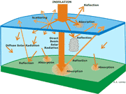
Diffuse solar radiation does not throw sharp shadows and cannot be focused.
The sum of the diffuse and direct beam solar radiation is called global solar radiation.Beam Radiation is also known as direct radiation. Here, the rays travel in a straight line and has a direction. The magnitude of energy that is being carried by beam radiation is always higher when compared to diffuse radiation.
Diffused Radiation is nothing but the rays that are being reflected by some molecules or surfaces and reaching/crossing the point of interest. Also, the direction of diffused rays may vary depending upon the angle of scattering or angle of reflection.
One of the quite interesting example is, shadows can only be formed by direct radiation.
A large fraction of the solar energy scattered out of the direct beam as it passes through the atmosphere nevertheless reaches ecosystems at the earth's surface. The flux they receive tends to be stronger in the short wavelengths than is beam radiation, and they receive it from the whole dome of the sky. It causes no glare and casts no shadows and penetrates deep into ecosystem canopies. It remains for many hours daily at an intensity well-suited to photosynthetic energy conversion and reduces the abrupt change in radiant-energy loading that otherwise would occur when a moving line of shade crosses the photosynthetic apparatus in a leaf. Scattering takes several forms. Radiation of short wavelengths is effectively scattered by air molecules. Rayleigh scattering by air molecules is the dominant process in clean, dry air. The coefficient of scattering of beam radiation in a unit volume of air is very small for wavelengths in the solar infrared portion of the spectrum—a tenth of the coefficient of scattering of red light and a hundredth of that of blue light. Haze makes a unit volume of air a more effective scattering agent and substantially increases the flux density of diffuse radiation at the earth's surface, its influence being greater on the diffuse than on the beam flux. Clouds of small ice crystals or water droplets scatter beam radiation and, even when thin, become powerful sources of diffuse solar radiation. A wisp of cloud floating in a clear sky generates a strong diffuse flux, obvious in its whiteness and intensity. Clouds, such as haze, increase the effect of sun altitude on the diffuse flux. The chapter presents the spectral composition of the diffuse flux.

Q.4 Write the name of the Instruments used to measure Solar Radiation? Explain the Pyranometer Instrument using the Diagram.
Ans:
ULTRAVIOLET MEASUREMENTS
For the measurement of sun and sky ultraviolet radiation in the wavelength interval 0.295 to 0.385 µm, which is particularly important in environmental, biological, and pollution studies the Total Ultraviolet Radiometer (Model TUVR) was developed. This instrument utilizes a photoelectric cell protected by a quartz window. A specially designed teflon diffuser not only reduces the radiant flux to acceptable levels but also provides close adherence to the Lambert cosine law. An encapsulated narrow bandpass (interference) filter limits the spectral response of the photocell to the wavelength interval 0.295-.0385 µm.
SHORTWAVE MEASUREMENTS: DIRECT, DIFFUSE AND GLOBAL
As solar radiation passes through the earth’s atmosphere, some of it is absorbed or scattered by air molecules, water vapor, aerosols, and clouds. The solar radiation that passes through directly to the earth’s surface is called Direct Normal Irradiance (DNI). The radiation that has been scattered out of the direct beam is called Diffuse Irradiance. The direct component of sunlight and the diffuse component of skylight falling together on a horizontal surface make up Global Irradiance. The three components have a geometrical relationship.
Direct radiation is best measured by use of a pyrheliometer, which measures radiation at normal incidence. The Normal Incidence Pyrheliometer (Model sNIP) consists of a wirewound thermopile at the base of a tube with a viewing angle of approximately 5º which limits the radiation that the thermopile receives to direct solar radiation only.
The pyrheliometer is mounted on a Solar Tracker (Models ST-1 and ST-3) or an Automatic Solar Tracker (Model SMT) for continuous readings.
Diffuse radiation can either be derived from the direct radiation and the global radiation or measured by shading a pyranometer from the direct radiation so that the thermopile is only receiving the diffuse radiation. Eppley has developed Shade Disk Adaption Kit (Model SDK) that mounts on the SMT which allows you to measure the diffuse and direct at the same time. We also manufacture the Shadow Band Stand, (Model SBS) for Diffuse measurements in sites where there is no power available to operate an Automatic Tracker.
Global radiation is measured by a pyranometer. The modern pyranometer manufactured by the Eppley Laboratory, using wirewound plated thermopiles, can be one of three models: the Standard Precision Pyranometer (Model SPP), the Global Precision Pyranometer (Model GPP), and the Black & White Pyranometer (Model 8-48). The SPP has a black sensor protected by two precision ground, polished hemispheres and is the preferred instruments for Global measurements. Based on the SPP, the GPP is specifically designed as a lower cost alternative for the PV/CSP industry. The 8-48 has a black and white sensor that is protected by a single polished hemisphere and is the preferred instrument for Diffuse measurements.
LONGWAVE (INFRARED) MEASUREMENTS
The Precision Infrared Radiometer, (Model PIR) was a development of the PSP Pyranometer (forerunner to the SPP Pyranometer) and continues to be the industry standard for precise measurement of incoming or outgoing longwave radiation. The PIR comprises the same wirewound thermopile detector and temperature compensation circuitry as found in the PSP/SPP. This thermopile detector is used to measure the “net radiation” of the PIR and a case thermistor (YSI 44031) is used to determine the outgoing radiation from the case. A dome thermistor is also included if one wishes to measure the dome temperature as compared to the case temperature to make any “corrections” to the final result.
ALBEDO/REFLECTION MEASUREMENTS
Albedo is the ratio of the incoming shortwave divided by the reflected shortwave. Eppley believes the best way to measure albedo is with two (2) distinct SPPs instead of mounting the two sensors in the same body. This allows for better calibration results and prevents the cold junctions of the two sensors from affecting each other. We have supplied Albedometers as well a Roof Reflectance Kits based on customers wishes.
NET RADIATION MEASUREMENTS
Net radiation is the sum of four individual measurements: Incoming Shortwave, Reflected Shortwave, Incoming Longwave and Outgoing Longwave. Eppley recommends measuring each of the four componants separately using two (2) SPPs and two (2) PIRs.
SUNSHINE DURATION MEASUREMENTS
Sunshine duration is typically defined as the amount of time that the Direct Normal Irradiance (DNI) is greater than 120 Wm-2. This can be determined by using the data collected from the sNIP.

A pyranometer is a type of actinometer used for measuring solar irradiance on a planar surface and it is designed to measure the solar radiation flux density (W/m2) from the hemisphere above within a wavelength range 0.3 μm to 3 μm. The name pyranometer stems from the Greek words πῦρ (pyr), meaning "fire", and ἄνω (ano), meaning "above, sky".
A typical pyranometer does not require any power to operate. However, recent technical development includes use of electronics in pyranometers, which do require (low) external power.

Explanation
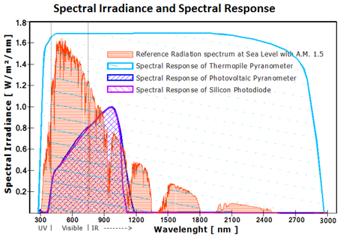
The solar radiation spectrum that reaches earth's surface extends its wavelength approximately from 300 nm to 2800 nm. Depending on the type of pyranometer used, irradiance measurements with different degrees of spectral sensitivity will be obtained.
To make a measurement of irradiance, it is required by definition that the response to “beam” radiation varies with the cosine of the angle of incidence. This ensures a full response when the solar radiation hits the sensor perpendicularly (normal to the surface, sun at zenith, 0° angle of incidence), zero response when the sun is at the horizon (90° angle of incidence, 90° zenith angle), and 0.5 at a 60° angle of incidence. It follows that a pyranometer should have a so-called “directional response” or “cosine response” that is as close as possible to the ideal cosine characteristic.

Classification of pyranometers
Following the classifications and definitions noted in the ISO 9060,^{[1]} three types of pyranometers can be recognized and grouped in two different technologies: thermopile technology and silicon semiconductor technology.
The light sensitivity, known as 'spectral response', depends on the type of pyranometer. The figure here above shows the spectral responses of the three types of pyranometer in relation to the Solar Radiation Spectrum. The Solar Radiation Spectrum represents the spectrum of sunlight that reaches the Earth’s surface at sea level, at midday with A.M. (air mass) = 1.5.
The latitude and altitude influence this spectrum. The spectrum is influenced also by aerosol and pollution.

Thermopile pyranometers
A thermopile pyranometer is a sensor based on thermopiles designed to measure the broadband of the solar radiation flux density from a 180° field of view angle. A thermopile pyranometer thus usually measures 300 to 2800 nm with a largely flat spectral sensitivity (see the Spectral Response graph) The first generation of thermopile pyranometers had the active part of the sensor equally divided in black and white sectors. Irradiation was calculated from the differential measure between the temperature of the black sectors, exposed to the sun, and the temperature of the white sectors, sectors not exposed to the sun or better said in the shades.
In all thermopile technology, irradiation is proportional to the difference between the temperature of the sun exposed area and the temperature of the shadow area.

Design
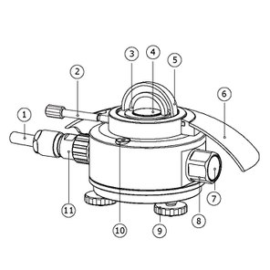
Linedrawing of a pyranometer, showing essential parts: (1) cable, (3) and (5) glass domes, (4) black detector surface, (6) sun screen, (7) desiccant indicator, (9) levelling feet, (10) bubble level, (11) connector
In order to attain the proper directional and spectral characteristics, a thermopile pyranometer is constructed with the following main components:
- A thermopile sensor with a black coating. It absorbs all solar radiation, has a flat spectrum covering the 300 to 50,000 nanometer range, and has a near-perfect cosine response.
- A glass dome. It limits the spectral response from 300 to 2,800 nanometers (cutting off the part above 2,800 nm), while preserving the 180° field of view. It also shields the thermopile sensor from convection. For first class and secondary standard pyranometers (see ISO 9060 classification of thermopile pyranometers) a second glass dome is used. This construction provides an additional “radiation shield”, resulting in a better thermal equilibrium between the sensor and inner dome, compared to using a single dome. The effect of having a second dome is a strong reduction of instrument offsets.
In the modern thermopile pyranometers the active (hot) junctions of the thermopile are located beneath the black coating surface and are heated by the radiation absorbed from the black coating.^{[2]} The passive (cold) junctions of the thermopile are fully protected from solar radiation and in thermal contact with the pyranometer housing, which serves as a heat-sink. This prevents any alteration from yellowing or decay when measuring the temperature in the shade, thus impairing the measure of the solar irradiance.
The thermopile generates a small voltage in proportion to the temperature difference between the black coating surface and the instrument housing. This is of the order of 10 µ • VW/m². Typically, on a sunny day the output is around 10 mV. Each pyranometer has a unique sensitivity, unless otherwise equipped with electronics for signal calibration.
OR
Q.4 write Short note on Declination and Zenith Angle.
Ans:
The declination angle, denoted by δ, varies seasonally due to the tilt of the Earth on its axis of rotation and the rotation of the Earth around the sun. If the Earth were not tilted on its axis of rotation, the declination would always be 0°. However, the Earth is tilted by 23.45° and the declination angle varies plus or minus this amount. Only at the spring and fall equinoxes is the declination angle equal to 0°. The rotation of the Earth around the sun and the change in the declination angle is shown in the animation below.
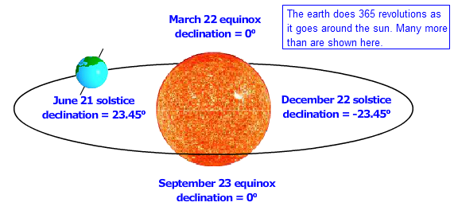
Animation showing how the tilt angle changes from the summer solstice in the northern hemisphere (or winter in the southern hemisphere) to the northern hemisphere winter solstice (summer in the south).
The declination of the sun is the angle between the equator and a line drawn from the centre of the Earth to the centre of the sun. The seasonal variation of the declination angle is shown in the animation below.
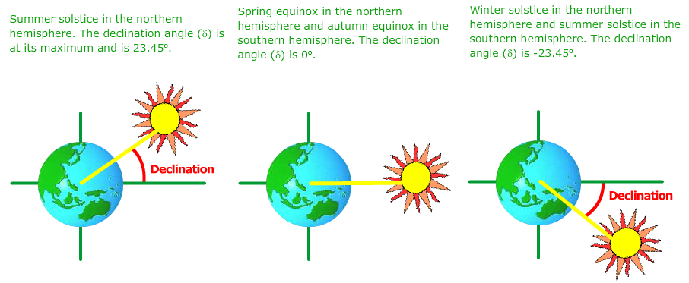

Declination Angle
δ=−23.45°×cos(360365×(d+10))δ=-23.45°×cos360365×d+10

where d is the day of the year with Jan 1 as d = 1 The declination is zero at the equinoxes (March 22 and September 22), positive during the northern hemisphere summer and negative during the northern hemisphere winter. The declination reaches a maximum of 23.45° on June 22 (summer solstice in the northern hemisphere) and a minimum of -23.45° on December 21-22 (winter solstice in the northern hemisphere). In the equation above, the +10 comes from the fact that the winter soltice occurrs before the start of the year. The equation also assumes that the suns orbit is a perfect circle and the factor of 360/365 converts the day number to a position in the orbit.
Zenith angle
The solar zenith angle is the angle between the zenith and the centre of the Sun's disc. The solar elevation angle is the altitude of the Sun, the angle between the horizon and the centre of the Sun's disc. Since these two angles are complementary, the cosine of either one of them equals the sine of the other. They can both be calculated with the same formula, using results from spherical trigonometry.
in which is the declination of the sun, the latitude (defined as positive in the northern hemisphere) and the hour angle. The latter is a measure of the local time, i.e. it is defined as the angle through which the earth must turn to bring the meridian of the location of observation directly under the sun. The solar declination is a function of the day of the year and is independent of the location. It varies from 23º27' on June 21 to -23º27' on December 22.

