Solutions

Sleepers:
Railway sleepers, also called railroad ties, railway ties or crossties, are an important railway component. Generally, the rail sleeper is always laying between two rail tracks to keep the correct space of gauge.

Historically, wooden ties were made of a variety of softwood and some popular hardwoods such as oak, jarrah, and karri. They are only suitable for low-speed lines with a speed limit of 160 km/h. As to acceptable species of wood for sleepers, the types are European oak, beech, pine etc. But nowadays, wooden sleepers are mostly replaced by concrete sleepers in some countries.
Wooden sleeper advantages:
- Easy to manufacture and handle
- Electrically insulated
- Easily adapted to non-standard situations
Disadvantages:
- Non reusable
- Expensive of the limit wood resource
In recent times, steel sleepers mostly handle heavy loads and can be designed to suit different rail track specifications. Weighing the same as timber, steel sleeper can replace wood sleepers and be used on a ballasted bridge, providing a more durable and stronger solution without increasing bridge load.
Steel sleeper advantages:
- Easy to install and manufacture
- Handle more weight
Disadvantages:
- Sensitive to the chemical attacks
- Hard to maintain
- Low transverse resistance
Compared with wooden sleepers, which are increasingly difficult and expensive to source in sufficient quantities and quality, concrete ties are cheaper and easier to obtain.
In general, it can also be divided into pre-stressed mono block concrete sleepers and reinforced twin block concrete sleepers. Due to the greater weight, which helps sleepers remain in the correct position longer, concrete ties require less maintenance than timber and have a longer service life.
In some countries, concrete sleepers occupy an important position. For example, on the highest line categories in the UK, pre-stressed concrete ties are the only ones permitted by Network Rail standards.
Concrete sleeper advantages:
- Cheaper
- Easier to obtain
- Less maintenance required
- Longer service life
Disadvantages:
- Hard to handle due to large weight
- Difficult to maintain longitudinal level due to higher inertia moment and lower elasticity
- Brake pipe
- The main air pipe of a train's air brake system^{[34]}
- Branch line
- A secondary railway line that splits off from a main line^{[21]}
- Brick arch
- A brick or concrete baffle provided at the front of a locomotive firebox below the tubes to extend the flame path. Early locomotives burned coke; provision of a brick arch was necessary before coal could be used without producing excessive smoke.
- British Rail Universal Trolley Equipment (BRUTE)
- A type of platform trolley found on stations all over the UK rail network from the late 1960s to the early 1980s
- Broad gauge
- Track where the rails are spaced farther apart than standard gauge, or 1,435 mm (4 ft 8 ¹⁄₂ in)^{[21]}
- Bubble car
- A nickname for a British Rail Class 121 railcar^{[35]}
- Buckeye coupler
- A side-operated version of the top- or bottom-operated Janney coupler^{[36]}
- Buffer
- A device that cushions the ends of rail vehicles against each other
- Buffer stop or bumper post
- The barrier installed at the end of a dead-end track to prevent rail vehicles from proceeding further
- Builder's plate
- The nameplate fitted by their manufacturer to locomotives and items of rolling stock
- Bulkhead flatcar
- An open-top flatcar with a wall at each end
- Bungalow
- The housing for signals and communications computers that control switches, crossings, and other such controls, relaying information to and from the rail traffic control (RTC)^{[37]}
- Bustitution
- A portmanteau of the words "bus" and "substitution", the practice of replacing a train service with one provided by buses, whether as a temporary or a permanent measure
- Container on flat car (COFC)
- The loading of a shipping container onto a simple flat car^{[40]}
- Continuous welded rail (CWR)
- A form of track made from rails welded together by with a thermite reaction or flash butt welding to form one continuous rail that may be several kilometres long^{[40]}
- Control car
- A passenger coach with a full set of train controls at one end, allowing for the use of push-pull train operation^{[54]}
- Coupler pulling faces, length over
- Effective length of piece of rolling stock
- Coupling rods
- Rods between crank pins on the wheels, transferring power from a driving axle to a driven axle of a locomotive^{[55]}
- Covered goods wagon (UIC)
- A type of rolling stock with a flat bottom enclosed on all sides and top, which is loaded and unloaded from sliding doors on each side^{[21][56]}
- Cow-calf or cow and calf
- A diesel locomotive with a crew cab permanently coupled to and acting as a controller for a similar slave diesel locomotive without a crew cab, primarily used for switching or shunting duties for large groups of rolling stock. Also known as master and slave.
- Crank pin
- A pin protruding from a wheel into a main or coupling rod
- Crosshead
- In a steam locomotive, the moving member of a sliding guide that absorbs upward and downward forces from the connecting (main) rod, which otherwise would tend to bend the piston rod^{[57]}
- Cut
- To uncouple one or more cars from a train (i.e. to "make a cut")^{[58]}
- Same as "cutting"^{[58]}
- Cut lever
- A manual lever that releases the pin of an automatic coupler when pulled to separate cars or locomotives^{[59][60]}
- Cut off
- A variable device on steam locomotives that closes the steam valve to the steam cylinder before the end of the piston stroke, thus conserving steam while letting steam in the cylinder expand under its own energy. See also: Reverser handle.
- Cutting
- A channel dug through a hillside to enable rail track to maintain a shallow gradient. See also embankment.
- Cycle braking
- Making repeated service brake reductions in short succession to maintain a constant speed on short but steep grades. Each reduction must be at least 5 PSI lower than the previous one to keep the brakes applying regularly, but excessive cycle braking can deplete the air supply and require an emergency application.^{[61]}
- Cylinder
- A cavity in a reciprocating engine in which a piston travels
- Cylinder cock
- On steam locomotives, crews use this appurtenance to drain water from the steam cylinders when the throttle is open, thus preventing damage to the pistons, running gear, and cylinder heads^{[62]}
- D[edit]
- Dark signal
- A block signal that is displaying no discernible aspect, often due to burned out lamps or local power failure. Most railroads require that a dark signal be treated as displaying its most restrictive aspect (e.g. stop and stay for an absolute signal).^{[63]}
- Dark territory
- A section of track without block signals^{[64]}
- Dead man's handle
- A safety mechanism on a train controller that automatically applies the brake if the driver releases the handle. It is intended to stop a train if the driver is incapacitated. In some forms, this device may be pedal-actuated. See also Dead-man's vigilance device.
- Decapod type
- The Decapodwheel arrangement
- A steam locomotive with a 2-10-0 wheel arrangement^{[65][66][67]}
- Defect detector
- A track side device used to detect various defects such as hotboxes (overheated axle bearings), dragging equipment, leaning cars, overloaded cars, overheight cars, seized (locked) wheels, etc.^{[68]}
- Degraded Operation
- Operation resulting from an unplanned event that prevents the normal delivery of train services^{[69]}
- Demurrage
- A monetary charge levied by a railroad to a customer for excessive delay in loading or unloading cars
- Derail or derailer
- A safety device that derails vehicles that pass it, typically to prevent rolling stock from accidentally entering the mainline from a siding^{[68]}
A rail is a steel bar extending horizontally between supports which is used as a track for rail road, cars or other vehicles.

Types of Rails
Rails can be divided in three types
- Double Headed Rails
- Bull Headed Rails
- Flat Footed Rails

1. Double Headed Rails
These rails indicate the early stage of development. It essentially consists of three parts,
- Upper Table
- Web
- Lower Table
Both the upper and lower tables were identical and they were introduced with the hope of double doubling the life of rails. When the upper table is worn out then the rails can be placed upside down reversed on the chair and so the lower table can be brought into use. But this idea soon turned out to b wrong because due to continuous contract of lower table with the chair made the surface of lower table rough and hence the smooth running of the train was impossible. Therefore, this type of rail is practically out of use. Nowadays, these rails vary in lengths from 20 – 24. A 100 lb double headed rail is shown in the figure.

. Bull Headed Rails
This type of rail also consists of three parts,
- The Head
- The Web
- The Foot
These rails were made of steel. The head is of larger size than foot and the foot is designed only to hold up properly the wooden keys with which rails are secured. Thus, the foot is designed only to furnish necessary strength and stiffness to rails. Two cast iron chairs are required per each sleeper when these rails are adopted. Their weight ranges from 85lb to 95lb and their length is up to 60 ft.
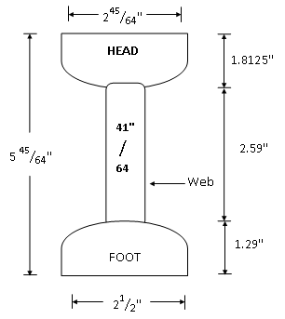
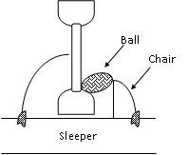

3. Flat Footed Rails
These rails were first of all invented by Charles Vignoles in 1836 and hence these rails are also called vignols rails. It consist of three parts
- The Head
- The Web
- The Foot
The foot is spread out to form a base. This form of rail has become so much popular that about 90% of railway tracks in the world are laid with this form of rails.
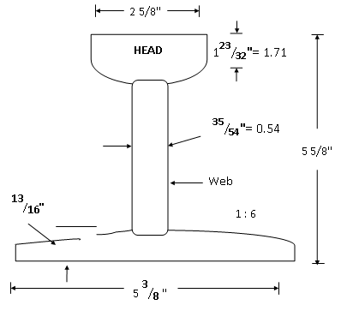

Flat footed rails has the following advantages
- They do not need any chair and can be directly spiked or keyed to the sleepers. Thus they are economical.
- They are much stiffer both vertically and laterally. The lateral stiffness is important for curves.
- They are less liable to develop kinks and maintain a more regular top surface than bull headed rails.
- They are cheaper than bull headed rails.
- The loads from wheels of trains are distributed over large number of sleepers and hence larger area which results in greater track stability, longer life of rails and sleepers, reduced maintenance, costs, less rail failure and few interruptions to traffic.

Wear of Rails
The separation or cutting of rail due to friction and abnormal heavy load is called wear. There are three types of wears of rail.
- Wear of Rails on top OR Head of Rail
- Wear at the End of Rails
- Wear at the side of head of Rails

Methods for Reducing Wear of Rails
The following methods are adopted for reducing wear of rails.
- Use of Special Alloy Steel
- Good Maintenance of Track
- Reduction of Expansion Gap
- Exchange of Inner and Outer Rails on Curves
- Use of Lubricating Oil

Coning of Wheels
The rim or flanges of the wheels are never made flat but they are in the shape of a cone with a slope of about 1 to 20. This is known as coning of wheels.
- The two principal types of embankment dams are earth and rock-fill dams, depending on the predominant fill material used. Some generalized sections of earth dams showing typical zoning for different types and quantities of fill materials and various methods for controlling seepage are presented in Figure 2-1.
- When practically only one impervious material is available and the height of the dam is relatively low, a homogeneous dam with internal drain may be used as shown in Figure 2-1a. The inclined drain serves to prevent the downstream slope from becoming saturated and susceptible to piping and/or slope failure and to intercept and prevent piping through any horizontal cracks traversing the width of the embankment.
- constructed when local borrow materials do not provide adequate quantities of impervious material. A vertical core located near the center of the dam is preferred over an inclined upstream core because the former provides higher contact pressure between the core and foundation to prevent leakage, greater stability under earthquake loading, and better access for remedial seepage control. An inclined upstream core allows the downstream portion of the embankment to be placed first and the core later and reduces the possibility of hydraulic fracturing. However, for high dams in steep-walled canyons the overriding consideration is the abutment topography. The objective is to fit the core to the topography in such a way to avoid divergence, abrupt topographic discontinuities, and serious geologic defects. For dams on pervious foundations, as shown in Figure 2-1d to 2-1f, seepage control is necessary to prevent excessive uplift pressures and piping through the foundation.
- The methods for control of under seepage in dam foundations are horizontal drains, cutoffs (compacted backfill trenches, slurry walls, and concrete walls), upstream impervious blankets, downstream seepage berms, toe drains, and relief wells. Rock-fill dams may be economical due to large quantities of rock available from required excavation and/or nearby borrow sources, wet climate and/or short construction season prevail, ability to place rock fill in freezing climates, and ability to conduct foundation grouting with simultaneous placement of rock fill for sloping core and decked dams (Walker 1984). Two generalized sections of rock-fill dams are shown in Figure 2-2. A rock-fill dam with steep slopes requires better foundation conditions than an earth dam, and a concrete dam (or roller-compacted concrete dam) requires better foundation conditions than a rock-fill dam. The design and construction of seepage control measures for dams are given in EM 1110-2-1901.

Earth Dams
- An earth dam is composed of suitable soils obtained from borrow areas or required excavation and compacted in layers by mechanical means.
- Following preparation of a foundation, earth from borrow areas and from required excavations is transported to the site, dumped, and spread in layers of required depth. The soil layers are then compacted by tamping rollers, sheep foot rollers, heavy pneumatic-tired rollers, vibratory rollers, tractors, or earth-hauling equipment. One advantage of an earth dam is that it can be adapted to a weak foundation, provided proper consideration is given to thorough foundation exploration, testing, and design.

Rock-fill Dams

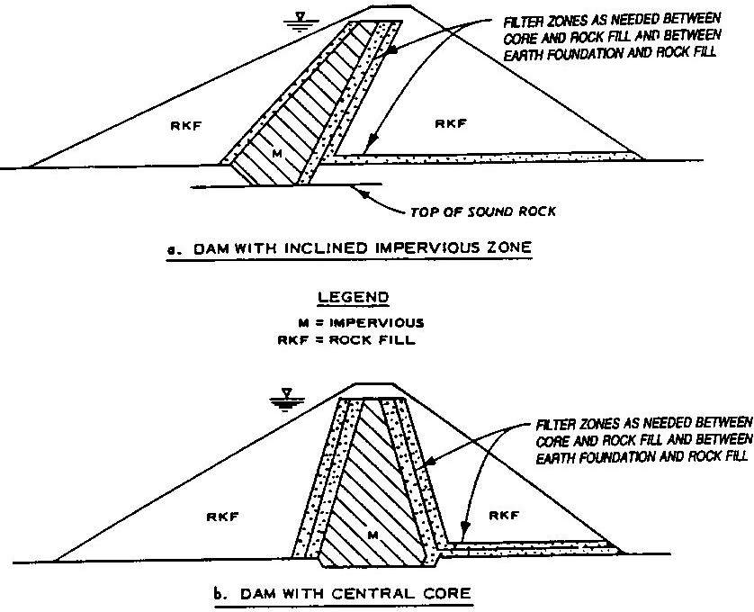
- A rockfill dam is one composed largely of fragmented rock with an impervious core. The core is separated from the rock shells by a series of transition zones built of properly graded material. A membrane of concrete, asphalt, or steel plate on the upstream face should be considered in lieu of an impervious earth core only when sufficient impervious material is not available.
- However, such membranes are susceptible to breaching as a result of settlement. The rock-fill zones are compacted in layers 12 to 24 in. thick by heavy rubber-tired or steel-wheel vibratory rollers. It is often desirable to determine the best methods of construction and compaction on the basis of test quarry and test fill results. Dumping rock fill and sluicing with water, or dumping in water, is generally acceptable only in constructing cofferdams that are not to be incorporated in the dam embankment.
- A rail yard, railway yard or railroad yard is a complex series of railroad tracks for storing, sorting, or loading and unloading, railroad cars and locomotives. Railroad yards have many tracks in parallel for keeping rolling stock stored off the mainline, so that they do not obstruct the flow of traffic. Railroad cars are moved around by specially designed yard switchers, a type of locomotive. Cars in a railroad yard may be sorted by numerous categories, including railroad company, loaded or unloaded, destination, car type, or whether they need repairs. Railroad yards are normally built where there is a need to store cars while they are not being loaded or unloaded, or are waiting to be assembled into trains. Large yards may have a tower to control operations.^{[1]:46}

Freight yards[edit]
For freight cars, the overall yard layout is typically designed around a principal switching (US term) or shunting (UK) technique:
- A hump yard has a constructed hill, over which freight cars are shoved by yard locomotives, and then gravity is used to propel the cars to various sorting tracks;
- A gravity yard is built on a natural slope and relies less on locomotives; generally locomotives will control a consist being sorted from uphill of the cars about to be sorted. They are decoupled and let to accelerate into the classification equipment lower down.
- A flat yard has no hump, and relies on locomotives for all car movements.

Sorting yard basics[edit]
Main article: classification yard
In the case of all classification or sorting yards, human intelligence plays a primary role in setting a strategy for the 'switching operations'; the fewer times coupling operations need to be made and the less distance traveled, the faster the operation, the better the strategy and the sooner the newly configured consist can be joined to its outbound train.
- Switching yards, staging yards or Shunting yards are typically graded to be flat yards, where switch engines manually shuffle and maneuver cars from: a) train arrival tracks, to a b)consist breakdown track, c) to an consist assembly track, thence to d) departure tracks of the yard.
  - A large sub-group of such yards are known as Staging yards, which are yards serving an end destination that is also a collection yard starting car groups for departure. These seemingly incompatible tasks are because the operating or road company and its locomotive drops off empties and picks up full cars waiting departure which have been spotted and assembled by local switch engines. The long haul carrier makes the round trip with a minimal turn around time, and the local switch engine transfers empties to the loading yard when the industries output is ready to be shipped.
  - This activity is duplicated in a Transfer yard, the difference being in the latter many or several businesses and industries are serviced by the local switcher, which is part of the yard equipment, and the industry pays a cargo transfer fee to the railroad or yard operating company. In the staging yard, the locomotive is most likely operated by industry (refinery, chemical company or coal mine personnel); and ownership of the yard in both cases is a matter of business, and could be any imaginable combination. Ownership and operation are quite often a matter of leases and interests^{[2]}
- Hump yard and gravity yard tracks are usually highly automated and designed for the efficient break-down, sorting, and recombining of freight into consists, so they are equipped with mechanical retarders (external brakes) and scales that a computer or operator uses along with knowledge of the gradient of the hump to calculate and control the speed of the cars as they roll downhill to their destination tracks. These modern sorting and classification systems are sophisticated enough to allow a first car to roll to a stop near the end of its classification track, and, by slowing the speed of subsequent cars down the hump, shorten the distance for the following series of cars so they can bump and couple gently, without damaging one another. Since overall throughput speed matters, many have small pneumatic, hydraulic or spring-driven braking retarders (below, right) to adjust and slow speed both before and after yard switch points. Along with car tracking and load tracking to destination technologies such as RFID, long trains can be broken down and reconfigured in transfer yards or operations in remarkable time.

rail fastening system is a means of fixing rails to railroad ties (North America) or sleepers (British Isles, Australasia, and Africa). The terms rail anchors, tie plates, chairs and track fastenersare used to refer to parts or all of a rail fastening system. Various types of fastening have been used over the years.
Fang bolts or rail anchor bolts have also been used for fixing rails or chairs to sleepers. The fang bolt is a bolt inserted through a hole in the sleeper with a fanged nut that bites into the lower surface of the sleeper. For fastening flat-bottomed rails, an upper-lipped washer can be used to grip the edge of the rail. They are more resistant to loosening by vibrations and movement of the rail.^{[20]} They are thought more effective than spikes and screws and so are used in positions such as switch (point) tieplates^{[21]} and on sharp curves.

Tie plates[edit]
A tie plate, baseplate or sole plate is a steel plate used on rail tracks between flanged T rail and the crossties. The tie plate increases bearing area and holds the rail to correct gauge. They are fastened to wooden ties by means of spikes or bolts through holes in the plate.
The part of the plate under the rail base is tapered, setting the cant of the rail, an inward rotation from the vertical. The usual slope is one in forty ( 1.4 degrees ). The top surface of the plate has one or two shoulders that fit against the edges of the base of the rail. The double-shoulder type is currently used. Older single-shoulder types were adaptable for various rail widths, with the single shoulder positioned on the outside (field side) of the rails. Most plates are slightly wider on the field side, without which the plates tend to cut more into the outsides of the tie, reducing cant angle.
Many railways use large wood screws, also called lag screws, to fasten the tie plates (or baseplates) to the railroad ties.
Tie plates came into use around the year 1900, before which time flanged T railsleeper density
Number of sleepers provided for one rail length of track is called sleeper density. If “N” is the length of one rail in meters,
Sleeper Density = N+ X , (X –> 3 to 6)
For a Broad Gauge track, total number of sleepers required for 1km length of railway track if sleeper density = N+5
Length of one rail = 12.8m =13m
Sleeper Density = N+5 = 13+ 5 = 18
Total number of sleepers required for 1km length = (18/12.8)x1000 = 1406 sleepers.

