SET-A
Rajasthan Institute of Engineering & Technology, Jaipur.
I Mid Term examination
5th Semester & Branch EEE/EE
Subject: Transmission and distribution

Q.1 write short notes on-
(a) kelvin’s law and its limitation
As economy is one of the most important factors while designing any transmission line, the cost of required conductor material is a considerable part. Thus, it becomes vital to select a proper size of the conductor. The most economic design of a transmission line is for which the total annual cost is minimum. Total annual cost can be divided into two parts, viz. annual charges on capital outlay and running charges. Annual charges on capital outlay include depreciation, interest on the capital cost, maintenance cost etc.. The cost of energy lost during the operation is counted in running charges. Regarding this, there are two important points that must be noted -
- if the cross-sectional area of the conductor is decreased, the total capital cost of the conductor decreases but the line losses increase (resistance increases with the decrease in the conductor size, hence, I²R loss increases)
- whereas, if the cross-sectional area of the conductor is increased, the line losses decrease but the total capital cost increases.
Therefore, it is important to find the most economical size of the conductor. Kelvin's law helps in finding this.

Kelvin's Law For Finding Economic Size Of A Conductor
Let, area of cross-section of conductor = a
annual interest and depreciation on capital cost of the conductor = C₁
annual running charges = C₂
Now, annual interest and depreciation cost is directly proportional to the area of conductor.
i.e., C₁ = K₁a
And, annual running charges are inversely proportional to the area of conductor.
C₂ = K₂/a
Where, K₁ and K₂ are constants.
Now, Total annual cost = C = C₁ + C₂
C = K₁a + K₂/a
For C to be minimum, the differentiation of C w.r.t a must be zero. i.e. dC/da = 0.
Therefore,
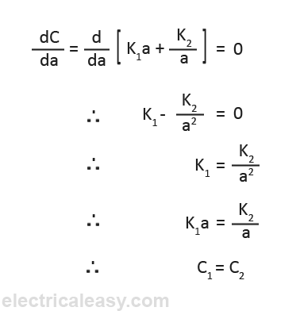

"The Kelvin's law states that the most economical size of a conductor is that for which annual interest and depreciation on the capital cost of the conductor is equal to the annual cost of energy loss."
From the above derivation, the economical cross-sectional area of a conductor can be calculated as,
a = √(K₂/K₁)
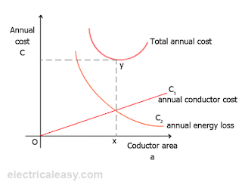

Limitations Of Kelvin's Law
Although Kelvin's law holds good theoretically, there is often considerable difficulty while applying it in practice. The limitations of this law are:
- It is quite difficult to estimate the energy loss in the line without actual load curves which are not available at the time of estimation.
- Interest and depreciation on the capital cost cannot be determined accurately.
- The conductor size determined using this law may not always be practicable one because it may not have sufficient mechanical strength.
- This law does not take into account several factors like safe current carrying capacity, corona loss etc.
- The economical size of a conductor may cause the voltage drop beyond the acceptable limits.

(b) choice of voltage for transmission line.
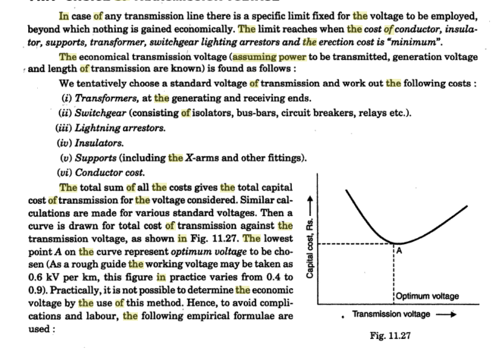
Or
Q.1 A 3 core 11 kv cable supplies a load of 1500kw at 0.8 pf lagging for 300 days in a year at an average of 8 hours per day. The capital cost per km of cable is Rs 8000+20000a(a is cross sectional area of cable).The resistance per km of cable of cross sectional 1 ${cm}^{2}$ is 0.173 ohm. If the energy loss cost is 2 paisa per unit, and the rate of interest and depreciation is 12% calculate the most economical current density and diameter of the conductor.
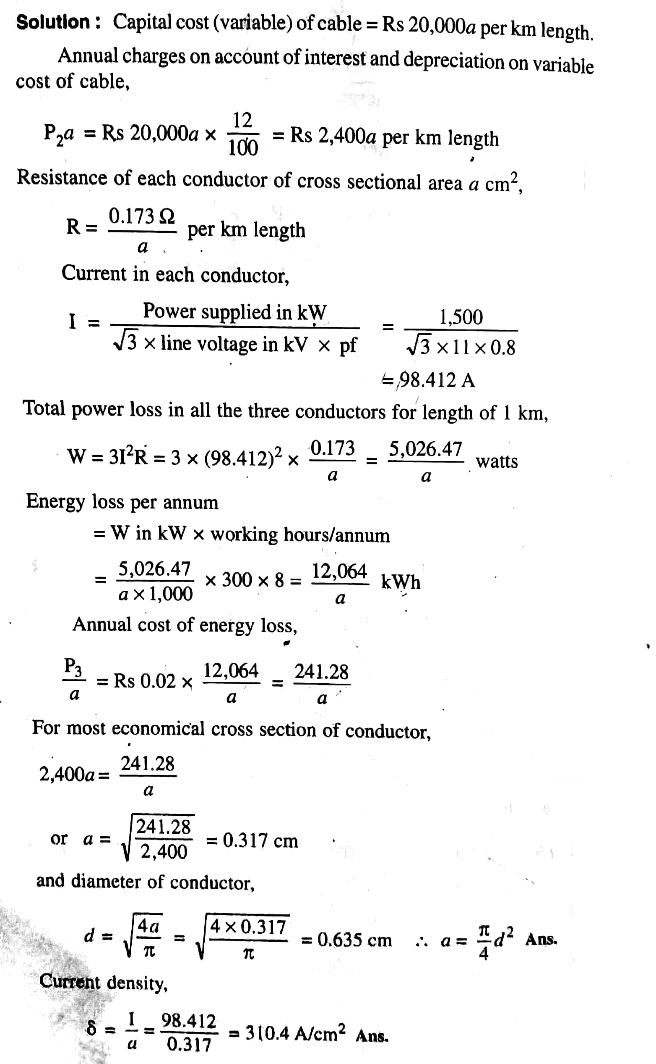
Q.2 Compare the copper volume of single-phase three wire supply system assuming equal power loss in transmitting same power over given distance.
In comparing the relative amounts of Conductor Material in Overhead System necessary for different systems of transmission, similar conditions will be assumed in each case viz.,
- same power (P watts) transmitted by each system.
- the distance (1 metres) over which power is transmitted remains the same.
- the line losses (W watts) are the same in each case.
- the maximum voltage between any conductor and earth (V_{m}) is the same in each case.

1.Two-Wire D.C. system with one conductor earthed:
In the 2-wire d.c. system, one is the outgoing or positive wire and the other is the return or negative wire as shown in Fig. 7.4. The load is connected between the two wires.
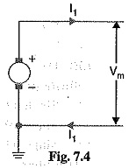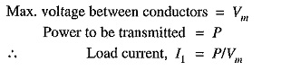
If R₁ is the resistance of each line Conductor Material in Overhead System, then,
where a₁ is the area of X-section of the conductor.
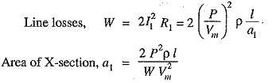
Volume of conductor material required
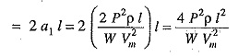
It is a usual practice to make this system as the basis fo comparison with other systems. Therefore, volume of conductor material required in this system shall be taken as the basic quantity i.e.
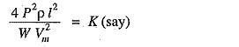

Single phase, 3-wire system:
The single phase 3-wire system is identical in principle with 3-wire d.c. system. The system consists of two outers and neutral wire taken from the mid-point of the phase winding as shown in Fig. 7.9. If the load is balanced, the current through the neutral wire is zero. Assuming balanced load,
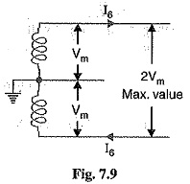
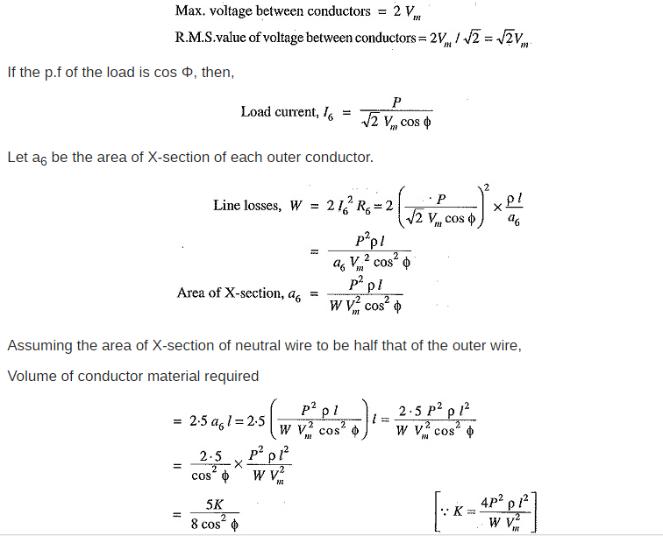
Hence, the volume of Conductor Material in Overhead System required in this system is 5/8 cos² Φ times that required in a 2-wire d.c. system with one conductor earthed.
Or
Q.2 Draw single line diagram of a typical power system. Locate various section of it and mention their on typical voltage of generation Transmission and distribution.
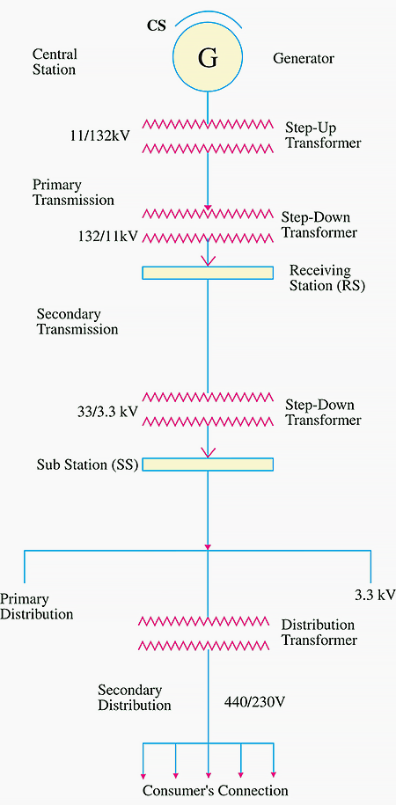

Q.3 Derive an expression for sag of s line supported between two supports of the same height.
Calculation of sag and tension in transmission line depend on the span of the conductor. Span having equal level supports is called level span, whereas when the level of the supports is not at an equal level is known as unequal level span. The calculation of conductor at an equal level shown below.
Consider a conductor AOB suspended freely between level supports A and B at the same level.The lowest point of the conductor is O. Let the shape of the conductor be a parabola.
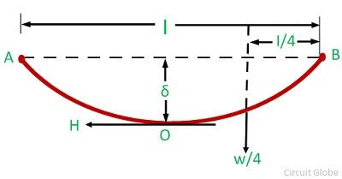
Let,
l – span length
w- weight per unit length of the conductor
δ – conductor sag
H – tension in the conductor at the point of maximum deflection O
T_{B} – tension in the conductor at the point of support B.
Consider OB is the equilibrium tension of the conductor and force acting on it are the horizontal tension H at O. The weight (w.OB) of the conductor OB acting vertically downwards through the center of gravity at a distance l/4 from B, and the tension T_{B} at the support B.
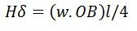
Since OB is approximately equal to the l/2
Take moments about B
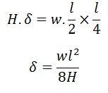
Above equation shows that the sag in a freely suspended conductor is directly proportional to the weight per unit length of the conductor, and the square of the span length and inversely proportional to the horizontal tension H.
Or
Q.3 A transmission line conductor at a river crossing is supported from two towers at height of 50m and 80m above water level.the horizontal distance between the tower is 300meters.if the tension in the conductor is 2000kg,find the clearance between the conductor and water level at a point midway between the tower.weight of conductor per meter = 0.844kg.assume that the conductor taken the shape of parabolic curve.
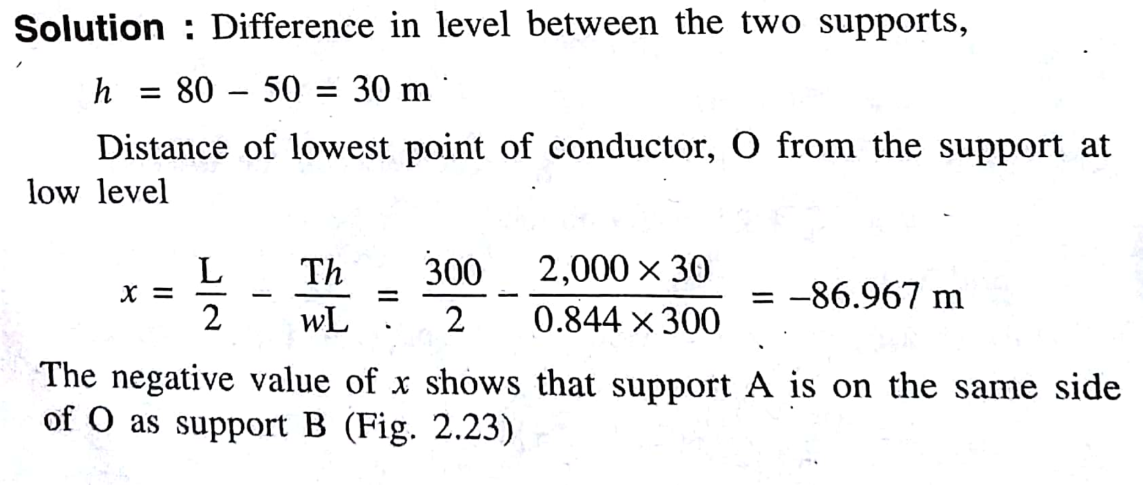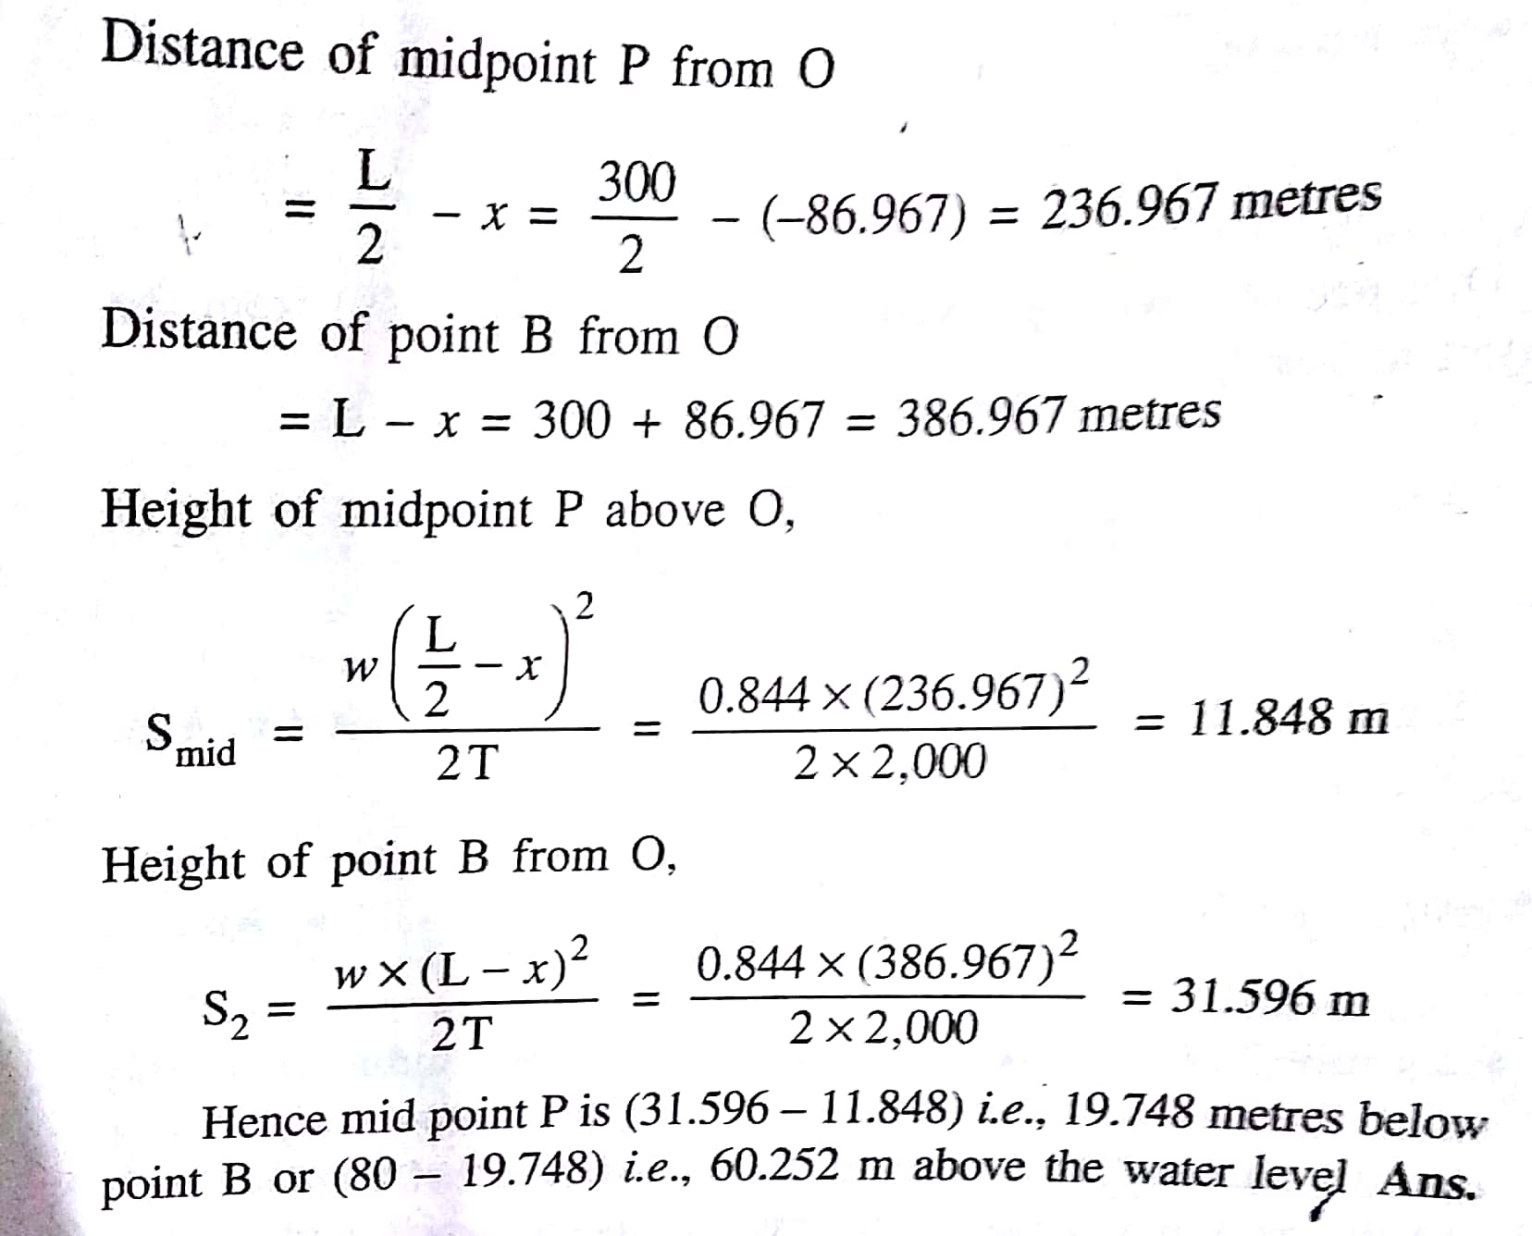
Q.4 Derive an expression of flux linkages of one conductor in a group of conductors.
Consider a composite conductor which is made up of two or more strands which are in parallel. For simplicity let us assume that all the strands are identical and share the current equally. The sum of the currents in all the conductors is zero. Such a group of conductors is shown in the Fig. 1.
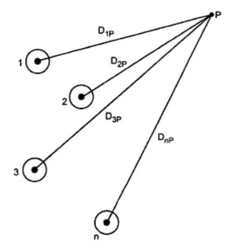
The conductors 1, 2, 3, ... n carry the currents , , .... n carry the currents I₁, I₂, I₃ ... I_{n}. Let the distances of the conductors from a point P be D_{1p}, D_{2p} , D_{3p} ... D_{np} respectively. Let ψ_{1p1} be flux linkages of conductor due to its own current I₁ due to internal and external flux. The flux beyond point P is excluded.
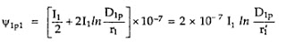
Now ψ_{1p2} is the flux linkages of conductor 1 due to current is equal to flux produced by I₂ between the point P and conductor 1. Again flux beyond P is neglected
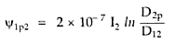
Similarly the flux linkages ψ_{1p} with conductor 1 due to all the conductors in the group but the flux beyond point P is neglected.
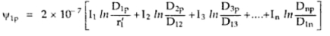
By expanding the logarithmic terms and rearranging the terms
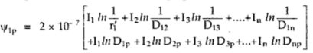
The sum of all currents is zero.
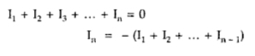
Substituting this value in above equation
If point P is at infinite distance so that ln (D_{1p}/D_{np}) ln (D_{2p}/D_{np}) etc will approach to zero (since ln 1 = 0) then we have,
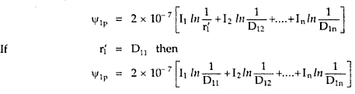
All the flux linkages of conductor 1 are included in the above derivation. The above expression is valid only only if sum of the currents is zero.

SET-B
Rajasthan Institute of Engineering & Technology, Jaipur.
I Mid Term examination
5th Semester & Branch EEE/EE
Subject: Transmission and distribution

Q.1 Distinguishes between a feeder and distributor. Draw single line diagram representing element of transmission system.
Feeder is a line which supplies a point of distribution network without being tapped at any intermediate points. In simple term, the feeder may be defined as the line carrying current from the secondary substation to the distribution substation or as a primary distribution line.
Distributor is a line from which tapping are taken along its length for providing supply to the consumer.

Or
Q.1 The cost per km for each of the copper conductor of a section a ${cm}^{2}$ for a transmission line is Rs (2800 a + 1300).the load factor of the load current is 80% and the load factor of the losses is 65%.the interest and depreciation is 10% and the cost of energy is 50 paisa per kwh. find the most economical current density for the transmission line by the use of kelvin’s law.
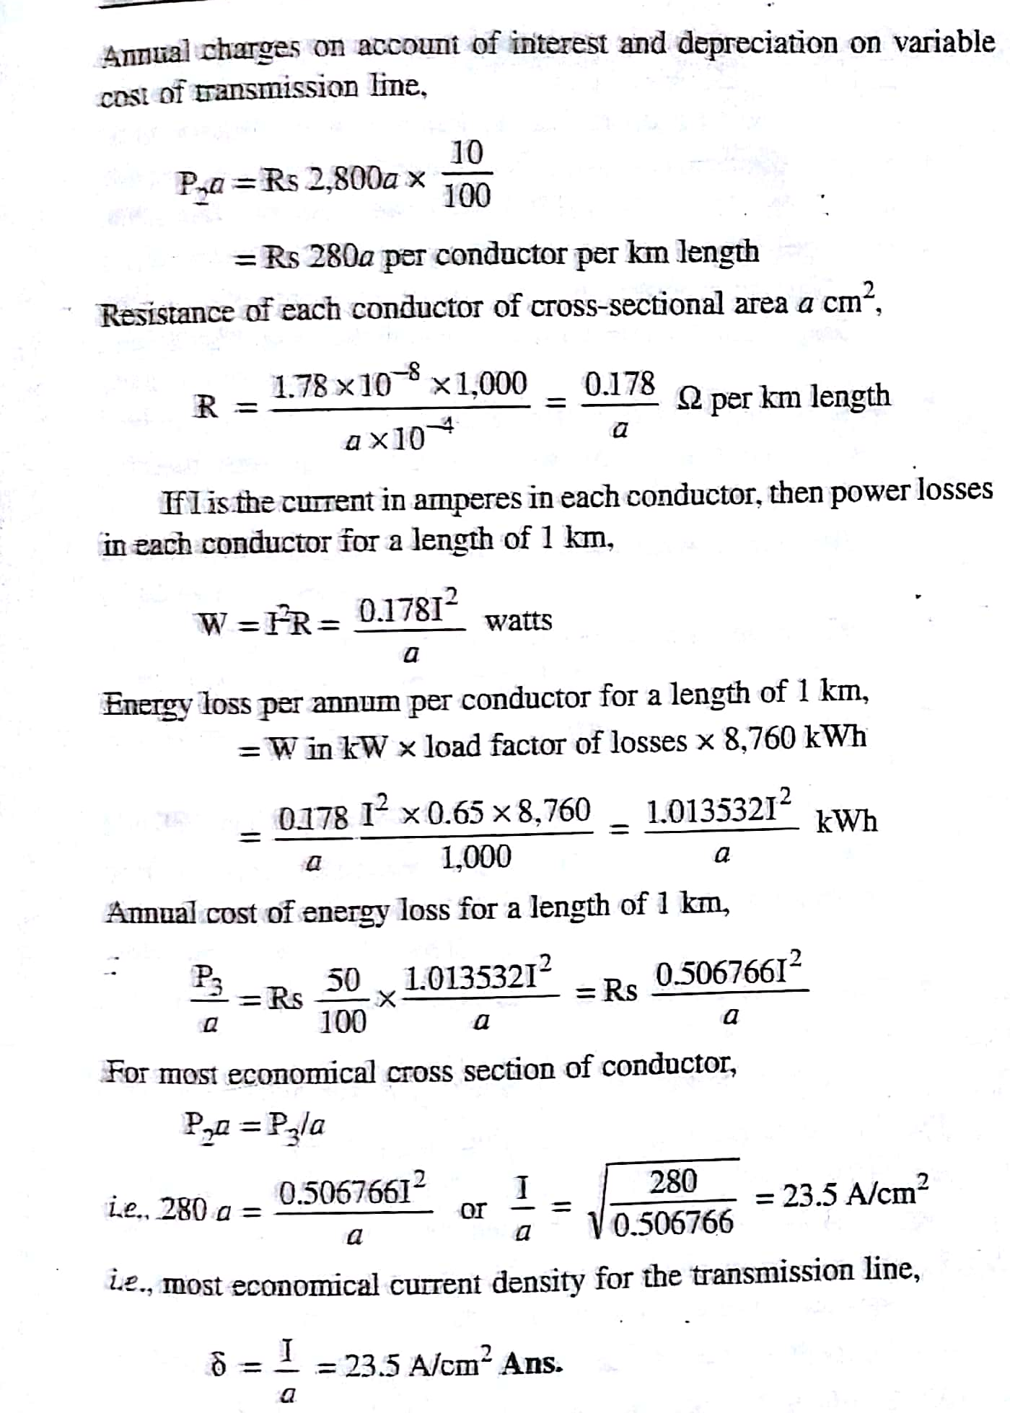
$ρ=1.78 ×{10}^{-8}$ohm-m
Q.2 A 50 km long transmission line supplies a load of 5MVA at 0.8pf lagging at 33KV.the efficiency of transmission is 90%. Calculate the volume of conductor required for the line when
(a) Single-phase two wire system used
(b) three-phase three wire system is used
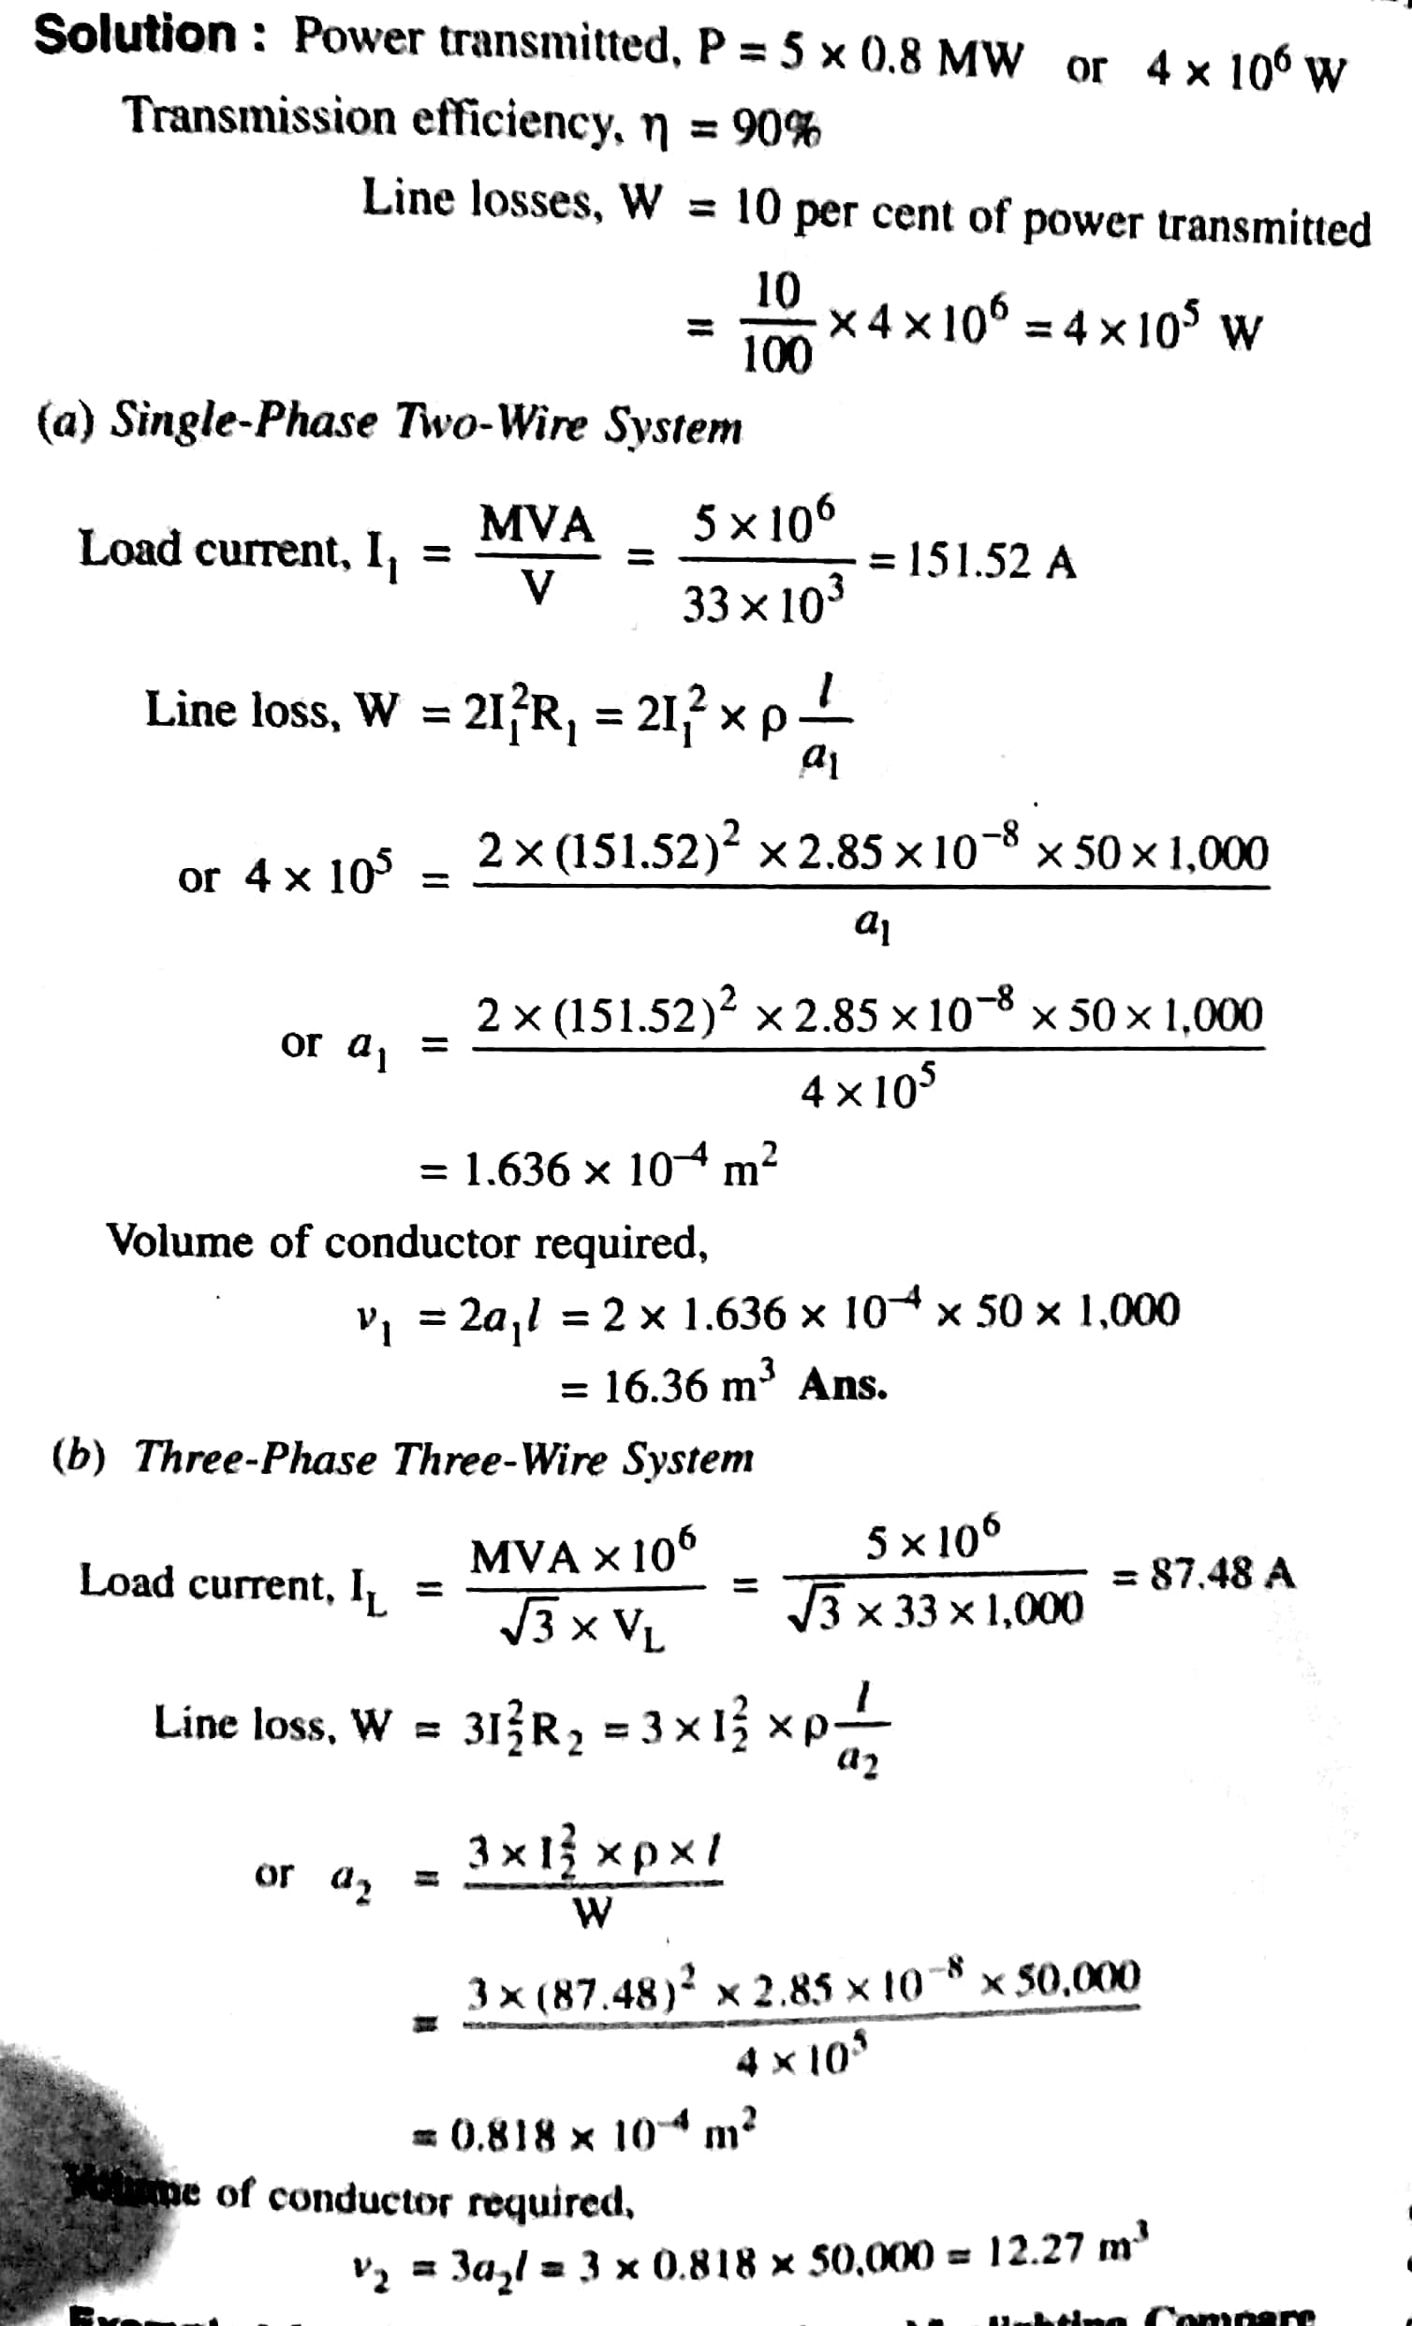
Or
Q.2 Proves that the volume of conductor required in a transmission system is inversely proportional to square of voltage as well as power factor.
Let P = power transmitted in watts
V = line voltage in volts
cos φ = power factor of the load
l = length of the line in metres
R = resistance per conductor in ohms
ρ = resistivity of conductor material in ohms metre
a = area of X-section of conductor in sq. metres
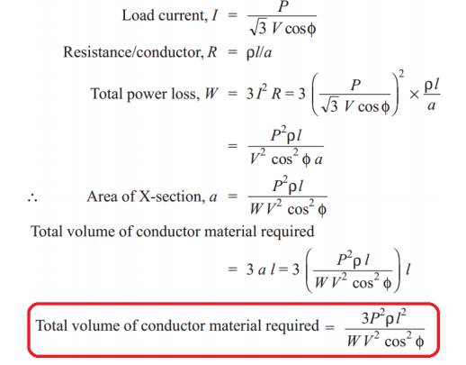
Q.3 Explains the necessity and method of preparing “stringing charts” for overhead transmission line.
Stringing chart is basically a graph between Sag, Tension with Temperature. As we want low Tension and minimum sag in our conductor but that is not possible as sag is inversely proportional to tension. It is because low sag means a tight wire and high tension whereas a low tension means a loose wire and increased sag. Therefore, we make compromise between two but if the case of temperature is considered and we draw graph then that graph is called Stringing chart.
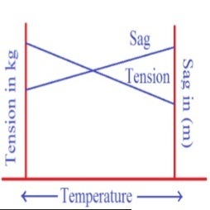
Or
Q.3 A transmission line has a span of 150m between level supports. The cross sectional area of the conductor is 1.25 ${cm}^{2}$ and weight 1 kg/m. The breaking stress is 4,200Kg/${cm}^{2}$. Calculate the maximum sag for safety factor of 4.assume a maximum wind pressure of 100kg/$m^{2}$ of projected surface. 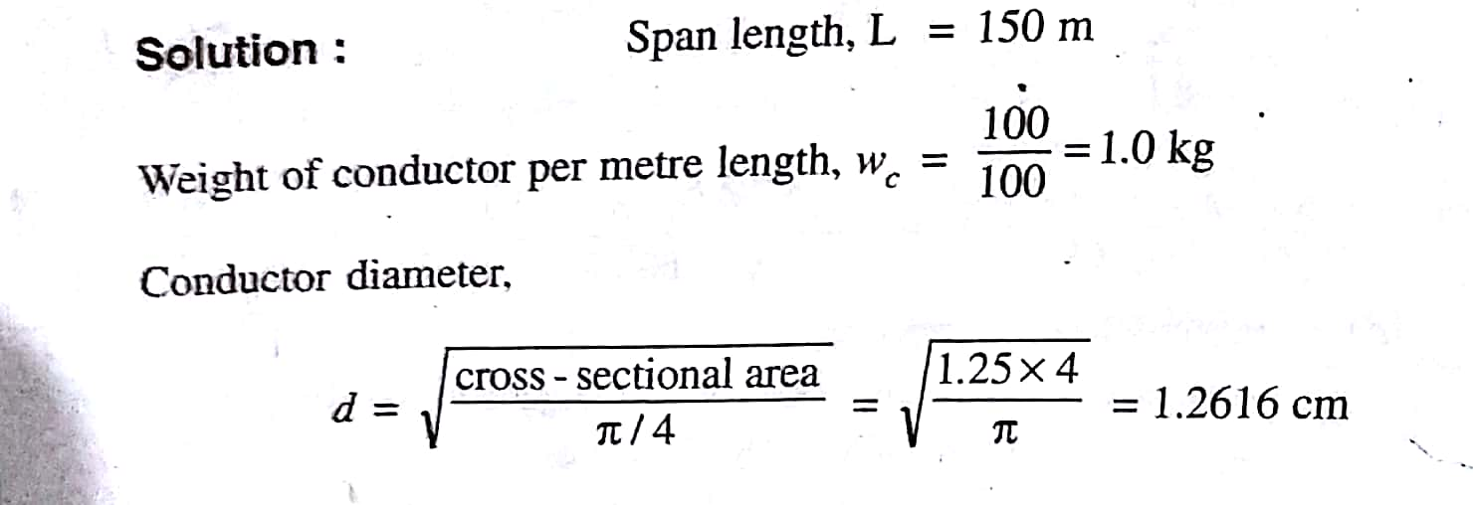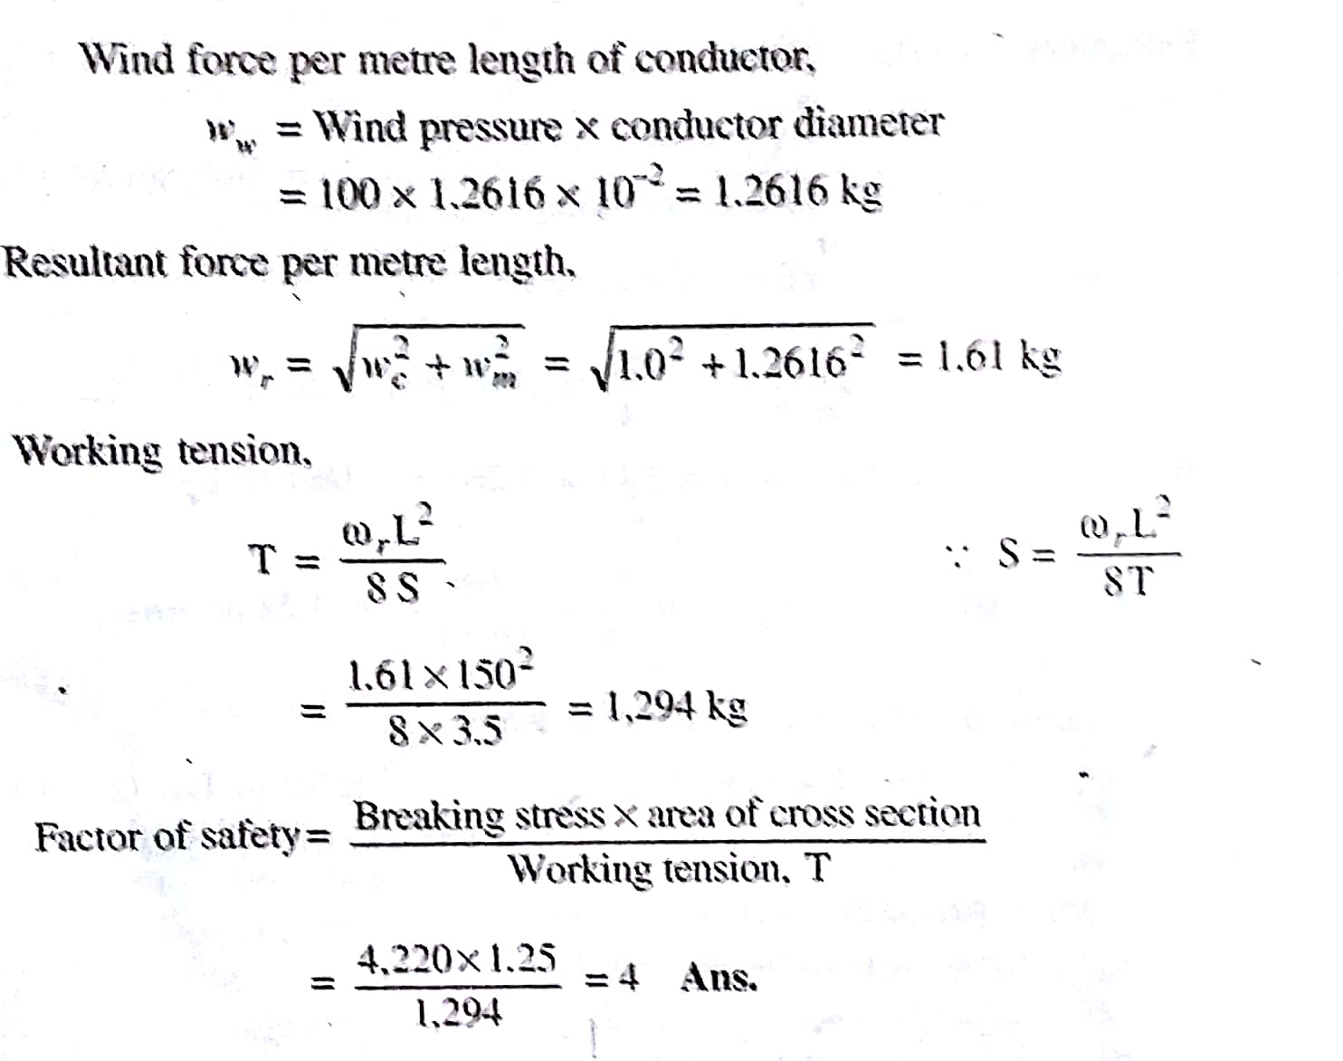

Q.4 Find the loop inductance and reactance per km of single-phase overhead line consisting of two conductors, each 1.25 cm diameter. The spacing between conductors is 1m and frequency is 50HZ.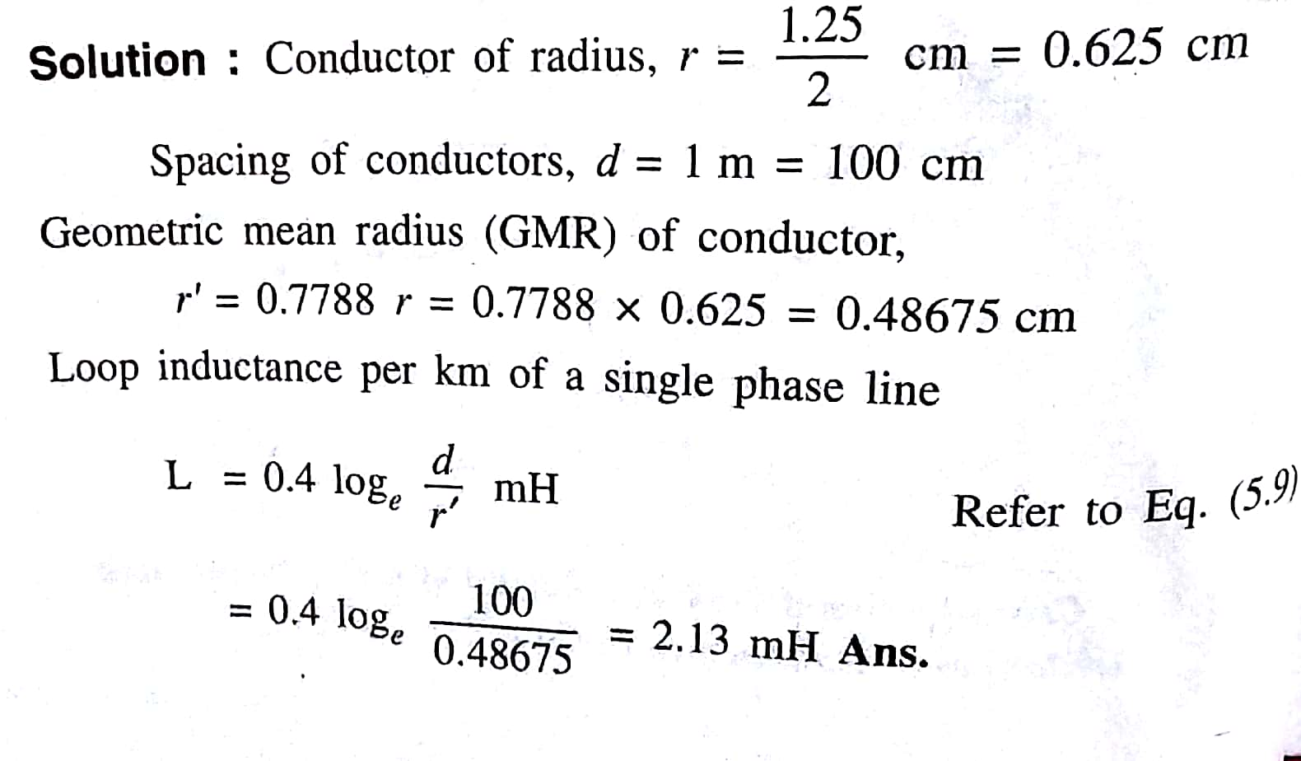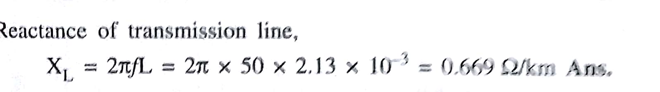
Or
Q.4 Derive an expression for inductance of a single phase two wire line.
Consider a single phase line consisting of two parallel conductors. These conductors are forming a rectangular loop of one turn. These conductors are solid conductors of radius r₁ and r₂ respectively. One conductor is forming a return circuit for the other. The two conductors are carrying currents I₁ and I₂respectively.
In a single phase circuit we have
I₁ + I₂ = 0
... I₂ = - I₁
Here we are neglecting the effect of earth's presence of magnetic field geometry as earth's relative permeability is same as that of air and its conductivity is relatively small.
The arrangement of the conductors and variation of flux density due to each conductor is shown in the Fig. 1 and Fig. 2 respcetively.
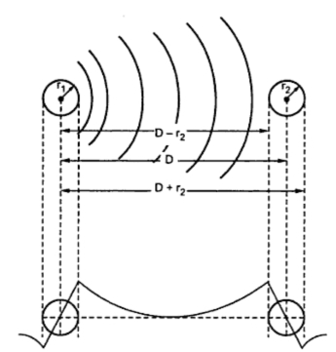
Fig. 1 and Fig. 2
In the beginning, let us consider only the flux linkages of the circuit caused by the current in conductor 1. The flux line set up by the current flowing in conductor 1 at a distance equal to or greater than D+ r₂ from the centre of conductor 1 does not link the circuit and hence is not responsible for inducing and voltage in the circuit. This is because conductor 2 carries current which is equal and opposite to that in conductor 1.
The external flux from r₁ to D - r₂ links all the current I₁ in conductor 1. Over the surface of conductor 2 i.e. between (D - r₂) and (D + r₂), the external flux links a current whose magnitude is progressively reduces from I₁ to zero because of negative current in conductor 2.
The total inductance of the current carrying in conductor 1 can be calculated by assuming that D is much greater than r₁ and r₂. Under this condition it can be assumed that flux from (D - r₂) to the centre of conductor 2 links I₁ current and flux from the centre of conductor 2 to (D + r₂) links zero current.
The inductance due to current in conductor 1 can be calculated by using the relation,
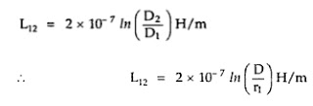
This expression is valid for external flux only. For internal flux we have
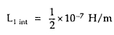
The total inductance of the circuit due to current in conductor 1 only is,
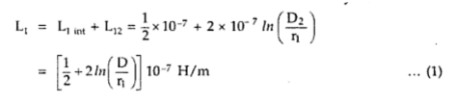
The above equation can conveniently be written as,
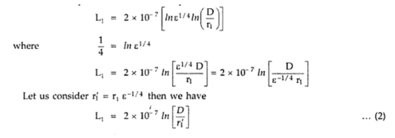
The radius r₁' is that of an imaginary or fictitious conductor assumed to have no internal flux. The quantity ε^{-1/4} equals to 0.7778.
The value of inductance given by equation (2) is same as that given by equation (1). The difference is that equation (2) omits the term on account of internal flux. But it is compensated by adjusted value of radius of conductor.
The above equation is derived by considering solid round conductors. Equation II is algebraic manipulation of equation (1). Hence the multiplying factor of 0.7778 is applicable only to solid round conductors in order to account for internal flux.
The conductor 2 carries current in opposite direction to that in conductor 1. The flux linkages produced by current in conductor 2 considered alone are in the same direction as those produced by current in conductor 1.
The resultant flux for the two conductors is determined by sum of mmfs of the two conductors. If permeability is assumed to be constant then the flux linkages and inductances of the two conductors calculated separately may be added.
The inductance of conductor 2 in comparison with equation (2) can be written as,
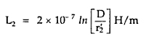
For the total circuit
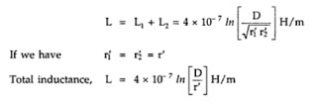

The above equation gives the inductance of two wire single phase line taking into consideration the flux linkages caused by current in both the conductors.
The value of inductance obtained is the inductance per loop meter or per loop mile. The inductance given by equation (2) is one half of the total inductance of single phase line and is called inductance per conductor.

