I Mid Term examination
Session: 2018-19
B. Tech II Year (III Semester)
Subject with code: Electronic Devices, (3EC4-07)
SET-B
Solution
Time: 2 hrs. M.M.:40
Instruction for students:
- No provision for supplementary answer book.
- Question paper contains three sections. Sec A includes 5 Short answers type questions (upto 25 words) Sec B- contains 06 Questions out of which any 04 questions to be attempt by the student (Analytical/Problem solving questions.).Sec C- contains 03 Questions out of which any 02 questions to be attempt by the student (Descriptive /Design questions.)
Sec-A(5*2=10 Marks)
Q.1 What is the Diffusion Current?
Ans:
Diffusion current is a current in a semiconductor caused by the diffusion of charge carriers. This is the current which is due to the transport of charges occurring because of non-uniform concentration of charged particles in a semiconductor.
Q.2 What is the Use of Zener Diode
Ans:
Zener diodes are widely used as voltage references and as shunt regulators to regulate the voltage across small circuits. When connected in parallel with a variable voltage source so that it is reverse biased, a Zener diode conducts when the voltage reaches the diode's reverse breakdown voltage.
Q.3 What is the Use of Transistor?
Ans:
n digital circuits(transistor operating in saturation or cut-off region) they are used for switching applications. It can amplify and switch electrical power and electronic signals. Transistors are made of semiconductor material with three or more terminals used to connect to an external circuit.
Q.4 Write the Transistor Current equation.
Ans:

Q.5 Write the Relation between Alpha and Beta
Ans:

Sec-B(4*4=16 Marks)
Q.1 Explain the Difference between direct and indirect band Gap Semiconductor.
Ans:
The band gap represents the minimum energy difference between the top of the valence band and the bottom of the conduction band, However, the top of the valence band and the bottom of the conduction band are not generally at the same value of the electron momentum. In a direct band gap semiconductor, the top of the valence band and the bottom of the conduction band occur at the same value of momentum, as in the schematic below.

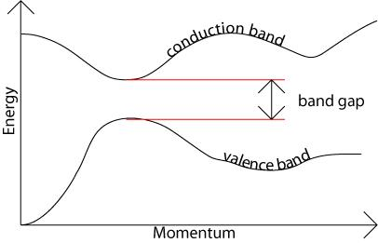

In an indirect band gap semiconductor, the maximum energy of the valence band occurs at a different value of momentum to the minimum in the conduction band energy:
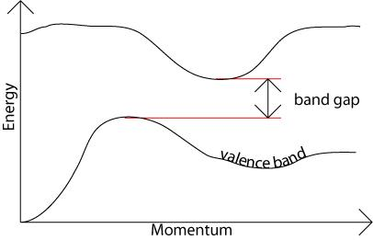

The difference between the two is most important in optical devices. As has been mentioned in the section charge carriers in semiconductors, a photon can provide the energy to produce an electron-hole pair.
Each photon of energy E has momentum p = E / c, where c is the velocity of light. An optical photon has an energy of the order of 10^{–19} J, and, since c = 3 × 10⁸ ms^{–1}, a typical photon has a very small amount of momentum.
A photon of energy E_{g}, where E_{g} is the band gap energy, can produce an electron-hole pair in a direct band gap semiconductor quite easily, because the electron does not need to be given very much momentum. However, an electron must also undergo a significant change in its momentum for a photon of energy E_{g} to produce an electron-hole pair in an indirect band gap semiconductor. This is possible, but it requires such an electron to interact not only with the photon to gain energy, but also with a lattice vibration called a phonon in order to either gain or lose momentum.
The indirect process proceeds at a much slower rate, as it requires three entities to intersect in order to proceed: an electron, a photon and a phonon. This is analogous to chemical reactions, where, in a particular reaction step, a reaction between two molecules will proceed at a much greater rate than a process which involves three molecules.
The same principle applies to recombination of electrons and holes to produce photons. The recombination process is much more efficient for a direct band gap semiconductor than for an indirect band gap semiconductor, where the process must be mediated by a phonon.
As a result of such considerations, gallium arsenide and other direct band gap semiconductors are used to make optical devices such as LEDs and semiconductor lasers, whereas silicon, which is an indirect band gap semiconductor, is not. The table in the next section lists a number of different semiconducting compounds and their band gaps, and it also specifies whether their band gaps are direct or indirect.

Q.2 Write Short note on Sensitors and thermistors.
Ans:
Sensistor is a resistor whose resistance changes with temperature.
The resistance increases exponentially with temperature, that is the temperature coefficient is positive (e.g. 0.7% per degree Celsius).
Sensistors are used in electronic circuits for compensation of temperature influence or as sensors of temperature for other circuits.

Sensistors are made by using very heavily doped semiconductors so that their operation is similar to PTC-type thermistors. However, very heavily doped semiconductor behaves more like a metal[4] and the resistance change is more gradual than it is the case for other PTC thermistors.
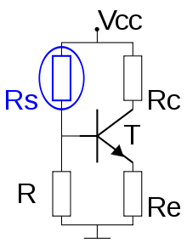

Thermistor
A thermistor is a type of resistor whose resistance is dependent on temperature, more so than in standard resistors. The word is a portmanteau of thermal and resistor. Thermistors are widely used as inrush current limiter, temperature sensors (Negative Temperature Coefficient or NTC type typically), self-resetting overcurrent protectors, and self-regulating heating elements. (Positive Temperature Coefficient or PTC type typically).
Thermistors are of two opposite fundamental types:
With NTC, resistance Decreases as temperature rises to protect against inrush overvoltage conditions. Commonly installed series in a circuit.
With PTC, resistance Increases as temperature rises to protect against overcurrent conditions. Commonly installed series in a circuit.
Thermistors differ from resistance temperature detectors (RTDs) in that the material used in a thermistor is generally a ceramic or polymer, while RTDs use pure metals. The temperature response is also different; RTDs are useful over larger temperature ranges, while thermistors typically achieve a greater precision within a limited temperature range, typically −90 °C to 130 °C.
Negative temperature coefficient (NTC) thermistor, bead type, insulated wires

Q.3 What do you understand by Sheet Resistance?
Ans:
Sheet resistance (also known as surface resistance or surface resistivity) is a common electrical property used to characterise thin films of conducting and semiconducting materials. It is a measure of the lateral resistance through a thin square of material, i.e. the resistance between opposite sides of a square. The key advantage of sheet resistance over other resistance measurements is that it is independent of the size of the square - enabling an easy comparison between different samples. Another advantage is that it can be measured directly using a four-point probe.
General Theory
Sheet resistance (RS) is commonly defined as the resistivity (ρ) of a material divided by its thickness (t):
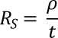
The units of this equation resolve to ohms (Ω); however, it actually represents the resistance between opposite sides of a square of a material (rather than bulk resistance). As such the units Ω/□ (ohms per square) are commonly used.

Examples of Applications
Sheet resistance is a critical property for any thin film of material in which electrical charges are intended to travel along (rather than pass through). For example, thin-film devices (such as perovskite solar cells or organic LEDs) require conducting electrodes which generally have thicknesses in the nanometre to micrometre range. Figure 1 shows how charges move within an LED device. The electrodes must transport electrical charge laterally and need low sheet resistances to reduce losses during this process. This becomes even more important when attempting to scale up the size of these devices, as the electrical charges will have to travel further along the electrodes before they can be extracted.
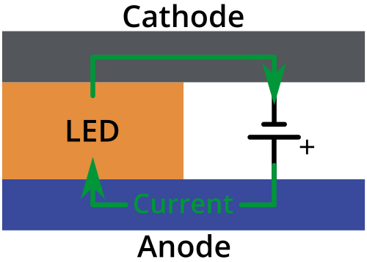
Furthermore, the resistivity and conductivity can be calculated if the sheet resistance and material thickness are known. This allows for the materials to be electrically characterised, purely by measuring their sheet resistance.

Measuring Sheet Resistance
The primary technique for measuring sheet resistance is the four-probe method (also known as the Kelvin technique), which is performed using a four-point probe. A four-point probe consists of four electrical probes in a line, with equal spacing between each of the probes as shown in Figure 2.
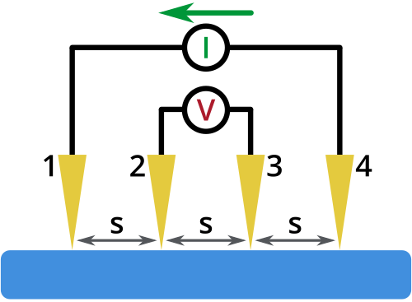
Figure 2: A schematic diagram of a four-point probe. The four probes have equal spacing (s) and are shown in contact with a surface. A current (I) is injected through probe 1 and collected through probe 4, whilst the voltage is measured between probes 2 and 3.

It operates by applying a current (I) on the outer two probes and measuring the resultant voltage drop between the inner two probes. The sheet resistance can then be calculated using the equation below:
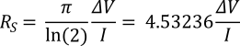
It should be noted that this equation is only valid if: i) the material being tested is no thicker than 40% of the spacing between the probes, and ii) the lateral size of the sample is sufficiently large. If this is not the case, then geometric correction factors are needed to account for the size, shape, and thickness of the sample. The value of this factor is dependent on the geometry being used, and is covered in detail in the next section.
Eliminating Contact Resistance
One of the primary advantages of using a four-point probe to perform electrical characterisation is the elimination of contact and wire resistances from the measurement. A diagram of the circuit resistances is shown in Figure 3 below.
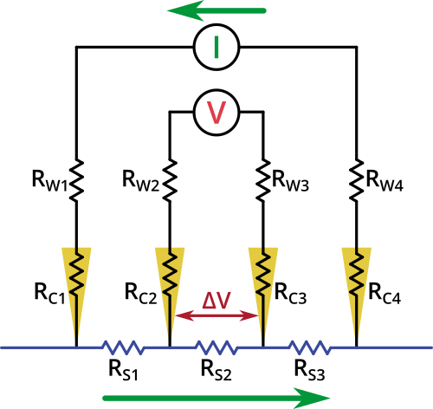
Figure 3: Equivalent circuit diagram of a four-point probe, showing the wire resistances (R_{W}), contact resistances (R_{C}), and sample resistances (R_{S}). The green arrows represent current flow.

Q.4 Explain the Working of the PN Junction Diode.
Ans:
With the externally applied voltage, a potential difference is altered between the P and N regions.When positive terminal of the source is connected to the P side and the negative terminal is connected to N side then the junction diode is said to be connected in forward bias condition. Forward bias lowers the potential across the PN junction.
The majority charge carriers in N and P regions are attracted towards the PN junction and the width of the depletion layer decreases with diffusion of the majority charge carriers. The external biasing causes a departure from the state of equilibrium and a misalignment of Fermi levels in the P and N regions, and also in the depletion layer.

So an electric field is induced in a direction converse to that of the incorporated field. The presence of two different Fermi levels in the depletion layer represents a state of quasi-equilibrium. The amount of charge Q stored in the diode is proportional to the current I flowing in the diode.
With the increase in forward bias greater than the built in potential, at a particular value the depletion region becomes very much thinner so that a large number of majority charge carriers can cross the PN junction and conducts an electric current. The current flowing up to built in potential is called as ZERO current or KNEE current.
Forward Biased Diode Characteristics
With the increase in applied external forward bias, the width of the depletion layer becomes thin and forward current in a PN junction diode starts to increase abruptly after the KNEE point of forward I-V characteristic curve.
Firstly, a small amount of current called as reverse saturation current exists due to the presence of the contact potential and the related electric field. While the electrons and holes are freely crossing the junction and causes diffusion current that flows in the opposite direction to the reverse saturation current.
The net result of applying forward bias is to reduce the height of the potential barrier by an amount of eV. The majority carrier current in the PN junction diode increases by an exponential factor of eV/kT. As result the total amount of current becomes I = Is * exp(eV/kT), where Is is constant.
The excess free majority charge carrier holes and electrons that enter the N and P regions respectively, acts as a minority carriers and recombine with the local majority carriers in N and P regions. This concentration consequently decreases with the distance from the PN junction and this process is named as minority carrier injection.
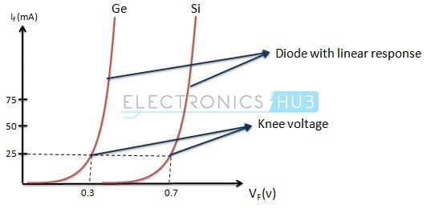
The forward characteristic of a PN junction diode is non linear, i.e., not a straight line. This type of forward characteristic shows that resistance is not constant during the operation of the PN junction. The slope of the forward characteristic of a PN junction diode will become very steep quickly.
This shows that resistance is very low in forward bias of the junction diode. The value of forward current is directly proportional to the external power supply and inversely proportional to the internal resistance of the junction diode.

Applying forward bias to the PN junction diode causes a low impedance path for the junction diode, allows for conducting a large amount of current known as infinite current. This large amount current starts to flow above the KNEE point in the forward characteristic with the application of a small amount of external potential.
The potential difference across the junction or at the two N and P regions is maintained constant by the action of depletion layer. The maximum amount of current to be conducted is kept limited by the load resistor, because when the diode conducts more current than the usual specifications of the diode, the excess current results in the dissipation of heat and also leads to severe damage of the device.
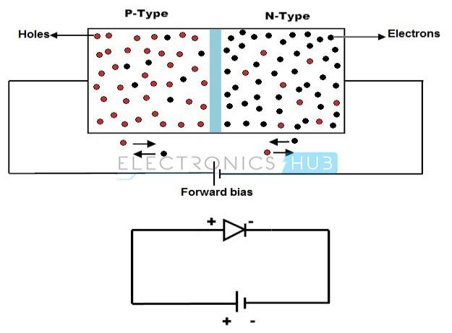
Reverse Biased Diode
When positive terminal of the source is connected to the N side and the negative terminal is connected to P side, then the junction diode is said to be connected in reverse bias condition. In this type of connection majority charge carriers are attracted away from the depletion layer by their respective battery terminals connected to PN junction.
The Fermi level on N side is lower than the Fermi level on P side. Positive terminal attracts the electrons away from the junction in N side and negative terminal attracts the holes away from the junction in P side. As a result of it, the width of the potential barrier increases that impedes the flow of majority carriers in N side and P side.
The width of the free space charge layer increases, thereby electric field at the PN junction increases and the PN junction diode acts as a resistor. But the time of diode acting as a resistor is very low. There will be no recombination of majority carriers taken place at the PN junction; thus, no conduction of electric current.
The current that flows in a PN junction diode is the small leakage current, due to minority carriers generated at the depletion layer or minority carriers which drift across the PN junction. Finally, the result is that the growth in the width of the depletion layer presents a high impedance path which acts as an insulator.

In reverse bias condition, no current flows through the PN junction diode with increase in the amount of applied external voltage. However, leakage current due to minority charge carriers flows in the PN junction diode that can be measured in micro amperes.
As the reverse bias potential to the PN junction diode increases ultimately leads to PN junction reverse voltage breakdown and the diode current is controlled by external circuit. Reverse breakdown depends on the doping levels of the P and N regions.
With the increase in reverse bias further, PN junction diode become short circuited due to overheat in the circuit and maximum circuit current flows in the PN junction diode.
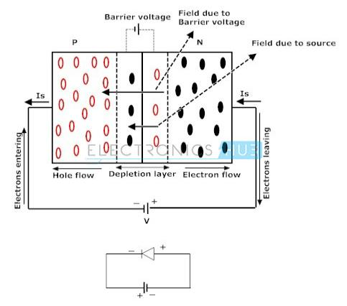

Reverse Biased Diode Characteristics:
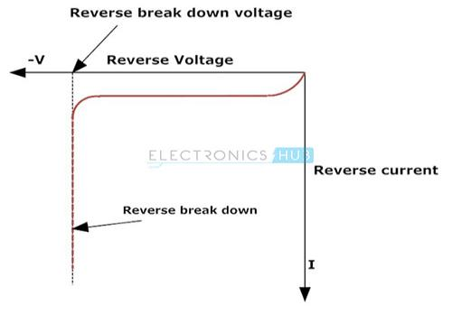

Q.5 What is the basic Difference between Avalanche Breakdown and Zener Breakdown?
Ans:

Comparison Chart
PARAMETERS | ZENER BREAKDOWN | AVALANCHE BREAKDOWN
Basic Definition | It occurs when the electric field is created due to high reverese voltage. | It occurs when high velocity electrons collide with bounded electrons.
Reverse Voltage Range | Less than 5 V | More than 5 V
Doping density | High Doping density | Low doping density
Temperature Coefficient | Exhibit Negative temperature coefficient | Exhibit Positive temperature coefficient
Nature of V-I Characteristics | Very Sharp | Not as sharp as Zener Breakdown
Mechanism | Due to collision between electrons | Due to High electric field

Zener Breakdown
When the reverse biased is applied to the heavily doped PN junction diode, the depletion region begins to expand. This expansion of depletion region in the diode consists of charge carriers electrons and holes. Thus, the depletion region consists of holes on one side and electron on other.
These depleted charge carriers create a strong electric field across the junction. The magnitude of the electric field generated will depend on the reverse voltage applied. The more the reverse voltage, the more will be the strength of electric field.
Thus, electric field exerts the force on the electrons present in the valence band and pulls them in higher energy band that is conduction band. In this way more and more electrons enter conduction band and contribute in the conduction process.
Therefore, the high magnitude of electric current flows in the circuit due to these electrons entering valence band. The value of current becomes excessive high that it can even lead to the breakdown of the diode. This phenomenon is called Zener Breakdown.
Avalanche Breakdown
In PN junction device the electrons when moving across the depletion region possess velocity and thus kinetic energy because kinetic energy is the products of mass and velocity of a moving body. Thus, electrons also possess kinetic energy.
These minority charge carriers randomly move in the semiconductor specimen due to the velocity they possess. These electrons, in turn, collide with other electrons which are tightly bounded to the atom due to covalent bonding.
But these electrons break the covalent bond and participate in conduction by jumping into the conduction band. This happens because high-velocity electrons which are moving in the semiconductor specimen collide with the tightly bounded electrons they impart some part of their kinetic energy to them.
Consequently, the electrons by acquiring kinetic energy start moving toward conduction band. The magnitude of kinetic energy increases with the increase in reverse voltage applied to the diode. Thus, the current starts increasing due to the collision of more and more electrons. Therefore, this high current can lead to the breakdown of the diode.

Q.6 Find the Q- Point (Ic and V₀) of the Given Circuit.
Where Beta=50
V_{BE}= 0.7V
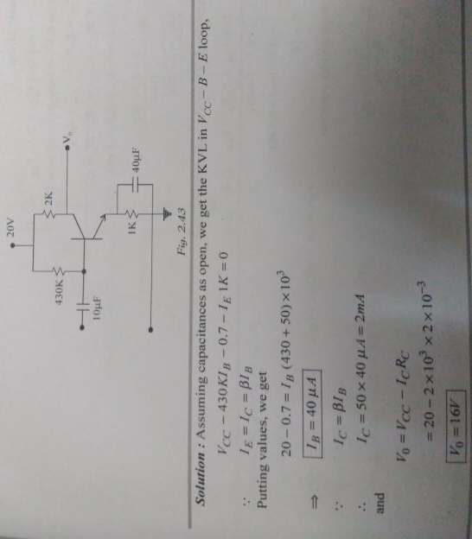
Sec-C(2*7=14 Marks)
Q.1 Derive the Poison Equation and Continuity Equation?
Ans:
In mathematics, Poisson's equation is a partial differential equation of elliptic type with broad utility in mechanical engineering and theoretical physics. It arises, for instance, to describe the potential field caused by a given charge or mass density distribution; with the potential field known, one can then calculate gravitational or electrostatic field. It is a generalization of Laplace's equation, which is also frequently seen in physics. The equation is named after the French mathematician, geometer, and physicist Siméon Denis Poisson
Statement of the equation
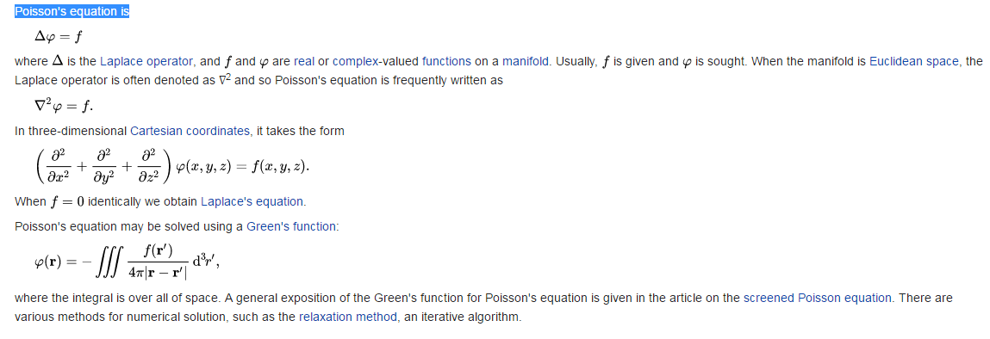

Continuity Equation
A continuity equation in physics is an equation that describes the transport of some quantity. It is particularly simple and powerful when applied to a conserved quantity, but it can be generalized to apply to any extensive quantity. Since mass, energy, momentum, electric charge and other natural quantities are conserved under their respective appropriate conditions, a variety of physical phenomena may be described using continuity equations.

Continuity equations are a stronger, local form of conservation laws. For example, a weak version of the law of conservation of energy states that energy can neither be created nor destroyed—i.e., the total amount of energy in the universe is fixed. This statement does not rule out the possibility that a quantity of energy could disappear from one point while simultaneously appearing at another point. A stronger statement is that energy is locally conserved: energy can neither be created nor destroyed, nor can it "teleport" from one place to another—it can only move by a continuous flow. A continuity equation is the mathematical way to express this kind of statement. For example, the continuity equation for electric charge states that the amount of electric charge in any volume of space can only change by the amount of electric current flowing into or out of that volume through its boundaries.

Continuity equations more generally can include "source" and "sink" terms, which allow them to describe quantities that are often but not always conserved, such as the density of a molecular species which can be created or destroyed by chemical reactions. In an everyday example, there is a continuity equation for the number of people alive; it has a "source term" to account for people being born, and a "sink term" to account for people dying.

Any continuity equation can be expressed in an "integral form" (in terms of a flux integral), which applies to any finite region, or in a "differential form" (in terms of the divergence operator) which applies at a point.

Q.2 Explain the working of the Transistor with the help of input and output Waveform.
Ans:
We know that generally the transistor has three terminals – emitter (E), base (B) and collector. But in the circuit connections we need four terminals, two terminals for input and another two terminals for output. To overcome these problems we use one terminal as common for both input and output actions. Using this property we construct the circuits and these structures are called transistor configurations. Generally the transistor configurations are three types they are common base (CB) configuration, common collector (CC) configuration and common emitter (CE) configuration. The behavior of these three configurations with respect to gain is given below.

Common Base (CB) Configuration: no current gain but voltage gain
Common Collector (CC) Configuration: current gain but no voltage gain
Common Emitter (CE) Configuration: current gain and voltage gain
Now we discuss about these three configurations with their input and output characteristics in the below.

Common Emitter Configuration

In this configuration we use emitter as common terminal for both input and output. This common emitter configuration is an inverting amplifier circuit. Here the input is applied between base-emitter region and the output is taken between collector and emitter terminals. In this configuration the input parameters are VBE and IB and the output parameters are VCE and IC.
This type of configuration is mostly used in the applications of transistor based amplifiers. In this configuration the emitter current is equal to the sum of small base current and the large collector current. i.e. IE = IC + IB. We know that the ratio between collector current and emitter current gives current gain alpha in Common Base configuration similarly the ratio between collector current and base current gives the current gain beta in common emitter configuration.

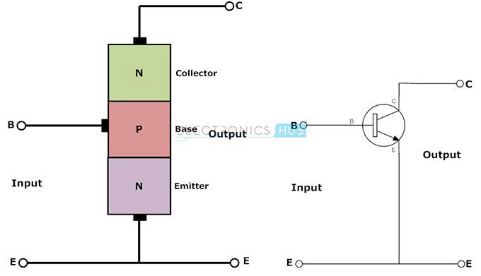
Now let us see the relationship between these two current gains.
Current gain (α) = I_{C}/I_{E}
Current gain (β) = I_{C}/I_{B}
Collector current I_{C} =α I_{E} = βI_{B}
This configuration is mostly used one among all the three configurations. It has medium input and output impedance values. It also has the medium current and voltage gains. But the output signal has a phase shift of 1800 i.e. both the input and output are inverse to each other.

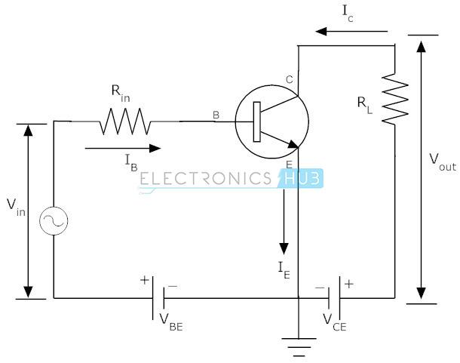

Input Characteristics
The input characteristics of common emitter configuration are obtained between input current I_{B} and input voltage V_{BE} with constant output voltage V_{CE}. Keep the output voltage V_{CE}constant and vary the input voltage V_{BE} for different points, now record the values of input current at each point. Now using these values we need to draw a graph between the values of I_{B} and V_{BE} at constant V_{CE}. The equation to calculate the input resistance R_{in} is given below.
R_{in} = V_{BE}/I_{B} (when V_{CE} is at constant)

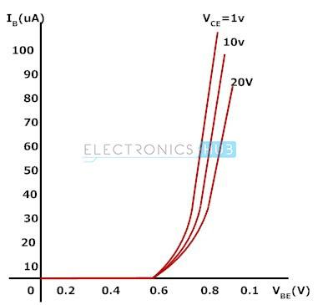

Output Characteristics
The output characteristics of common emitter configuration are obtained between the output current I_{C} and output voltage V_{CE} with constant input current I_{B}. Keep the base current I_{B}constant and vary the value of output voltage V_{CE} for different points, now note down the value of collector I_{C} for each point. Plot the graph between the parameters I_{C} and V_{CE} in order to get the output characteristics of common emitter configuration. The equation to calculate the output resistance from this graph is given below.
R_{out} = V_{CE}/I_{C} (when I_{B} is at constant)
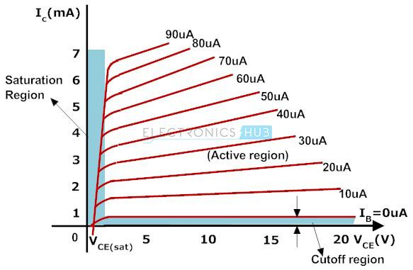

Q.3 Derive the E-K Diagram for Semiconductor Material
Ans:

