SET-A

IIIrd Year MCA. Vth Semester IstMid Term Examination, October – 2018
Subject: - Wireless Technoolgies (SOLUTION)

Q. 1
(i)
- Television and Radio Broadcasting
- Satellite Communication
- Radar
- Mobile Telephone System (Cellular Communication)
- Global Positioning System (GPS)

ii) In telecommunications and computer networks, multiplexing (sometimes contracted to mixing) is a method by which multiple analog or digital signals are combined into one signal over a shared medium

iii) A handoff refers to the process of transferring an active call or data session from one cell in a cellular network to another or from one channel in a cell to another..

iv) Temporary identification numbers are assigned to the subscriber’s number to maintain the privacy of the user. The privacy of the communication is maintained by applying encryption algorithms and frequency hopping that can be enabled using digital systems and signalling.

v) Orbital inclination measures the tilt of an object's orbit around a celestial body. It is expressed as theangle between a reference plane and the orbital plane or axis of direction of the orbiting object. For asatellite orbiting the Earth directly above the equator, the plane of the ... For planets in the SolarSystem, the plane of reference is usually the ecliptic

Q. 2
i) Digital Video Broadcasting (DVB) is a set of standards that define digital broadcasting using existing satellite, cable, and terrestrial infrastructures. In the early 1990s, European broadcasters, consumer equipment manufacturers, and regulatory bodies formed the European Launching Group (ELG) to discuss introducing digital television (DTV) throughout Europe. The ELG realized that mutual respect and trust had to be established between members later became the DVB Project. Today, the DVB Project consists of over 220 organizations in more than 29 countries worldwide. DVB-compliant digital broadcasting and equipment is widely available and is distinguished by the DVB logo. Numerous DVB broadcast services are available in Europe, North and South America, Africa, Asia, and Australia. The term digital television is sometimes used as a synonym for DVB. However, the Advanced Television Systems Committee (ATSC) standard is the digital broadcasting standard used in the U.S

ii) Differences between FDMA, TDMA, and CDMA
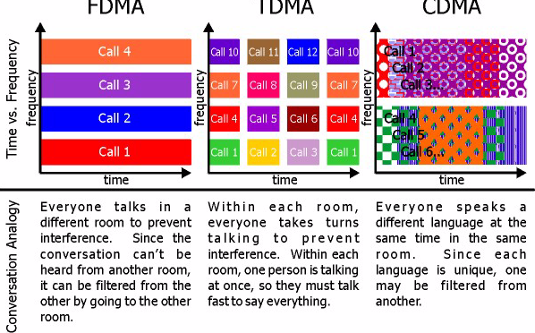

Q. 3
i) GSM (Global System for mobile communication) provides many useful services in which, one of the most important is the automatic, worldwide localization of users. The service provider system always knows where a user currently is, and the same phone number is valid worldwide.

For localization of users, GSM performs periodic location updates even if a user does not use the mobile phones or some other devices but user should not be out of GSM network and is not completely switched off their devices.

GSM uses two types of databases:

Home Location Register (HLR)
Visitor Location Register (VLR)

The Home Location Register is a database from a mobile network in which information from all mobile subscribers is stored.

The VLR contains the exact location of all mobile subscribers currently present in the service area.

VLR is responsible for the MS (Mobile Station) to inform the HLR about location changes.

As soon as user moves from one location to another location, the HLR sends all user data needed to the new VLR (New Location). Changing of one VLR to another VLR and their uninterrupted services is called as Roaming.

Roaming can be taken place as follows:

- Within the network of one provider
- Between two providers in one country (National Roaming)
- Different providers in different countries (International Roaming)

To locate an MS and to address the MS, several numbers are needed:

- Mobile station international ISDN number (MSISDN)
- International mobile subscriber identity (IMSI)
- Temporary mobile subscriber identity (TMSI)
- Mobile station roaming number (MSRN)

ii) Direct Sequence Spread Spectrum (DSSS) is a spread spectrum technique whereby the original data signal is multiplied with a pseudo random noise spreading code. This spreading code has a higher chip rate (this the bitrate of the code), which results in a wideband time continiuous scrambled signal.

Direct Sequence Spread Spectrum
Direct Sequence Spread Spectrum

DSSS significantly improves protection against interfering (or jamming) signals, especially narrowband and makes the signal less noticeable. It also provides security of transmission if the code is not known to the public. These reasons make DSSS very popular by the military. In fact, DSSS was first used in the 1940s by the military.

DSSS can also be used as a multiple access technique, whereby several different pseudo random spreading codes are being used simultaneously. This multiple access technique is better known as Direct Sequence CDMA. Direct Sequence Spread Spectrum (DSSS) is a spread spectrum technique whereby the original data signal is multiplied with a pseudo random noise spreading code. This spreading code has a higher chip rate (this the bitrate of the code), which results in a wideband time continiuous scrambled signal.
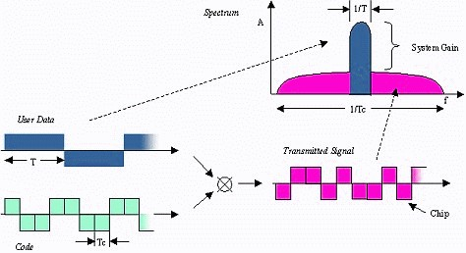
Direct Sequence Spread Spectrum

DSSS significantly improves protection against interfering (or jamming) signals, especially narrowband and makes the signal less noticeable. It also provides security of transmission if the code is not known to the public. These reasons make DSSS very popular by the military. In fact, DSSS was first used in the 1940s by the military.
DSSS can also be used as a multiple access technique, whereby several different pseudo random spreading codes are being used simultaneously. This multiple access technique is better known as Direct Sequence CDMA.

Q. 4

A communications satellite is an artificial satellite that relays and amplifies radio telecommunications signals via a transponder; it creates a communication channel between a source transmitter and a receiver at different locations on Earth. Communications satellites are used for television, telephone, radio, internet, and military applications. There are over 2,000 communications satellites in Earth’s orbit, used by both private and government organizations.

Wireless communication uses electromagnetic waves to carry signals. These waves require line-of-sight, and are thus obstructed by the curvature of the Earth. The purpose of communications satellites is to relay the signal around the curve of the Earth allowing communication between widely separated points. Communications satellites use a wide range of radio and microwave frequencies. To avoid signal interference, international organizations have regulations for which frequency ranges or "bands" certain organizations are allowed to use. This allocation of bands minimizes the risk of signal interference.

OR
ALOHA: ALOHA is a system for coordinating and arbitrating access to a shared communication Networks channel. It was developed in the 1970s by Norman Abramson and his colleagues at the University of Hawaii. The original system used for ground based radio broadcasting, but the system has been implemented in satellite communication systems.
A shared communication system like ALOHA requires a method of handling collisions that occur when two or more systems attempt to transmit on the channel at the same time. In the ALOHA system, a node transmits whenever data is available to send. If another node transmits at the same time, a collision occurs, and the frames that were transmitted are lost. However, a node can listen to broadcasts on the medium, even its own, and determine whether the frames were transmitted.
Aloha means "Hello". Aloha is a multiple access protocol at the datalink layer and proposes how multiple terminals access the medium without interference or collision. In 1972 Roberts developed a protocol that would increase the capacity of aloha two fold. The Slotted Aloha protocol involves dividing the time interval into discrete slots and each slot interval corresponds to the time period of one frame. This method requires synchronization between the sending nodes to prevent collisions.

There are two different versions of ALOHA
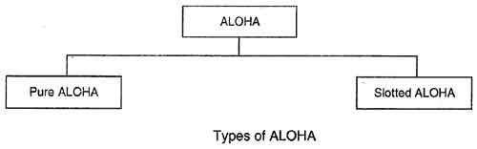

Pure ALOHA
• In pure ALOHA, the stations transmit frames whenever they have data to send.
• When two or more stations transmit simultaneously, there is collision and the frames are destroyed.
• In pure ALOHA, whenever any station transmits a frame, it expects the acknowledgement from the receiver.
• If acknowledgement is not received within specified time, the station assumes that the frame (or acknowledgement) has been destroyed.
• If the frame is destroyed because of collision the station waits for a random amount of time and sends it again. This waiting time must be random otherwise same frames will collide again and again.
• Therefore pure ALOHA dictates that when time-out period passes, each station must wait for a random amount of time before resending its frame. This randomness will help avoid more collisions.
• Figure shows an example of frame collisions in pure ALOHA.
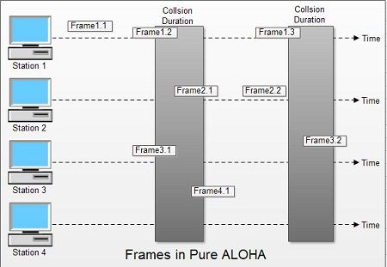
• In fig there are four stations that .contended with one another for access to shared channel. All these stations are transmitting frames. Some of these frames collide because multiple frames are in contention for the shared channel. Only two frames, frame 1.1 and frame 2.2 survive. All other frames are destroyed.
• Whenever two frames try to occupy the channel at the same time, there will be a collision and both will be damaged. If first bit of a new frame overlaps with just the last bit of a frame almost finished, both frames will be totally destroyed and both will have to be retransmitted.

Slotted ALOHA
• Slotted ALOHA was invented to improve the efficiency of pure ALOHA as chances of collision in pure ALOHA are very high.
• In slotted ALOHA, the time of the shared channel is divided into discrete intervals called slots.
• The stations can send a frame only at the beginning of the slot and only one frame is sent in each slot.
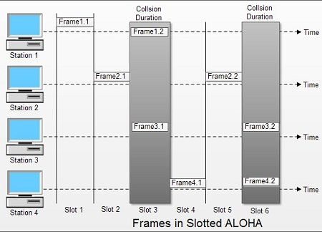
• In slotted ALOHA, if any station is not able to place the frame onto the channel at the beginning of the slot i.e. it misses the time slot then the station has to wait until the beginning of the next time slot.
• In slotted ALOHA, there is still a possibility of collision if two stations try to send at the beginning of the same time slot as shown in fig.
• Slotted ALOHA still has an edge over pure ALOHA as chances of collision are reduced to one-half.

