**SET-B**

III**rd** Year MCA. Vth Semester IstMid Term Examination, October – 2018

Subject: **- Wireless Technoolgies (SOLUTION)**

**Q. 1**

i) GSM (Global System for Mobile communications) is a standard developed by the European Telecommunications Standards Institute (ETSI) to describe the protocols for second-generation digital cellular networks used by mobile devices such as tablets. It was first deployed in Finland in December 1991. As of 2014, it has become the global standard for mobile communications – with over 90% market share, operating in over 193 countries and territories

ii) Telecommunication is the transmission of signs, signals, messages, words, writings, images and sounds or information of any nature by wire, radio, optical or electromagnetic systems. Telecommunication occurs when the exchange of information between communication participants includes the use of technology

iii) In telecommunications and computer networks, multiplexing (sometimes contracted to mixing) is a method by which multiple analog or digital signals are combined into one signal over a shared medium

iv) The perigee is the point in the orbit of an object circling the Earth when that object is closest to the Earth. The opposite of perigee is apogee. A perigee is measured from the center of the earth to the center of the orbiting object.

v) An antenna is a transducer that converts radio frequency (RF) fields into alternating current or vice versa.

**Q. 2**

i) Wireless Communication Systems also provide different services like video conferencing, cellular telephone, paging, TV, Radio etc. Due to the need for variety of communication services, different types of Wireless Communication Systems are developed. Some of the important Wireless Communication Systems available today are:

* Television and Radio Broadcasting
* Satellite Communication
* Radar
* Mobile Telephone System (Cellular Communication)
* Global Positioning System (GPS)
* Infrared Communication
* WLAN (Wi-Fi)
* Bluetooth
* Paging
* Cordless Phones
* Radio Frequency Identification (RFID)

ii) When cell phone A user dials the number of B, presses the send or talk key, and the mobile phone sends a call setup request message to the mobile phone network via the nearest mobile phone base transceiver station (BTS).

The call setup request message is handled next by the mobile switching center(MSC), which checks the subscriber's record held in the visitor location register to see if the outgoing call is allowed. If so, the MSC then routes the call in the same way that a telephone exchange does in a fixed network.

If the subscriber is on a prepaid tariff, then an additional check is made to see if the subscriber has enough credit to proceed. If not, the call is rejected. If the call is allowed to continue, then it is continually monitored and the appropriate amount is decremented from the subscriber's account. When the credit reaches zero, the call is cut off by the network.

**Q. 3**

i) Digital audio broadcasting (DAB), also known as digital radio and high-definition radio, is audio broadcasting in which analog audio is converted into a digital signal and transmitted on an assigned channel in the AM or (more usually) FM frequency range. DAB is said to offer compact disc (CD)- quality audio on the FM (frequency modulation) broadcast band and to offer FM-quality audio on the AM (amplitude modulation) broadcast band. The technology was first deployed in the United Kingdom in 1995, and has become common throughout Europe.

Digital audio broadcast signals are transmitted in-band, on-channel (IBOC). Several stations can be carried within the same frequency spectrum. Listeners must have a receiver equipped to handle DAB signals. At the transmitting site, the signal is compressed using MPEG algorithms and modulated using coded orthogonal frequency division multiplexing (COFDM). A digital signal offers several advantages over conventional analog transmission, including improved sound quality, reduced fading and multipath effects, enhanced immunity to weather, noise, and other interference, and expansion of the listener base by increasing the number of stations that can broadcast within a given frequency band.

A DAB receiver includes a small display that provides information about the audio content in much the same way that the menu screen provides an overview of programs in digital television (DTV). Some DAB stations provide up-to-the-minute news, sports, and weather headlines or bulletins in a scrolled text format on the display. Using the DAB information, it may also be possible to see what song is coming up next.

ii) **ALOHA:**ALOHA is a system for coordinating and arbitrating access to a shared communication Networks channel. It was developed in the 1970s by Norman Abramson and his colleagues at the University of Hawaii. The original system used for ground based radio broadcasting, but the system has been implemented in satellite communication systems.

A shared communication system like ALOHA requires a method of handling collisions that occur when two or more systems attempt to transmit on the channel at the same time. In the ALOHA system, a node transmits whenever data is available to send. If another node transmits at the same time, a collision occurs, and the frames that were transmitted are lost. However, a node can listen to broadcasts on the medium, even its own, and determine whether the frames were transmitted.

Aloha means "Hello". Aloha is a multiple access  protocol at the datalink layer and proposes how multiple terminals access the medium without interference or collision. In 1972 Roberts developed a protocol that would increase the capacity of aloha two fold. The Slotted Aloha protocol involves dividing the time interval into discrete slots and each slot interval corresponds to the time period of one frame. This method requires synchronization between the sending nodes to prevent collisions.

**There are two different versions of ALOHA**

[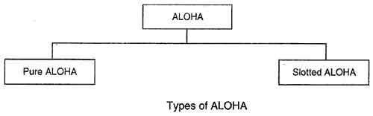](http://ecomputernotes.com/images/Type-of-ALOHA.jpg)

**Pure ALOHA**

**• In**pure ALOHA, the stations transmit frames whenever they have data to send.

• When two or more stations transmit simultaneously, there is collision and the frames are destroyed.

• In pure ALOHA, whenever any station transmits a frame, it expects the acknowledgement from the receiver.

• If acknowledgement is not received within specified time, the station assumes that the frame (or acknowledgement) has been destroyed.

• If the frame is destroyed because of collision the station waits for a random amount of time and sends it again. This waiting time must be random otherwise same frames will collide again and again.

• Therefore pure ALOHA dictates that when time-out period passes, each station must wait for a random amount of time before resending its frame. This randomness will help avoid more collisions.

• Figure shows an example of frame collisions in pure ALOHA.

[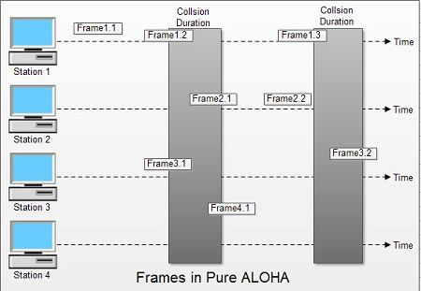](http://ecomputernotes.com/images/Frames-in-Pure-ALOHA.jpg)

• In fig there are four stations that .contended with one another for access to shared channel. All these stations are transmitting frames. Some of these frames collide because multiple frames are in contention for the shared channel. Only two frames, frame 1.1 and frame 2.2 survive. All other frames are destroyed.

• Whenever two frames try to occupy the channel at the same time, there will be a collision and both will be damaged. If first bit of a new frame overlaps with just the last bit of a frame almost finished, both frames will be totally destroyed and both will have to be retransmitted.

**Slotted ALOHA**

• Slotted ALOHA was invented to improve the efficiency of pure ALOHA as chances of collision in pure ALOHA are very high.

• In slotted ALOHA, the time of the shared channel is divided into discrete intervals called slots.

• The stations can send a frame only at the beginning of the slot and only one frame is sent in each slot.

[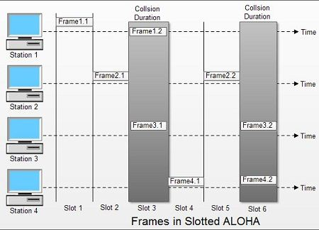](http://ecomputernotes.com/images/Frames-in-Slotted-ALOHA.jpg)

• In slotted ALOHA, if any station is not able to place the frame onto the channel at the beginning of the slot *i.e.*it misses the time slot then the station has to wait until the beginning of the next time slot.

• In slotted ALOHA, there is still a possibility of collision if two stations try to send at the beginning of the same time slot as shown in fig.

• Slotted ALOHA still has an edge over pure ALOHA as chances of collision are reduced to one-half.

**Q. 4**

**I) SPREAD SPECTRUM:-**

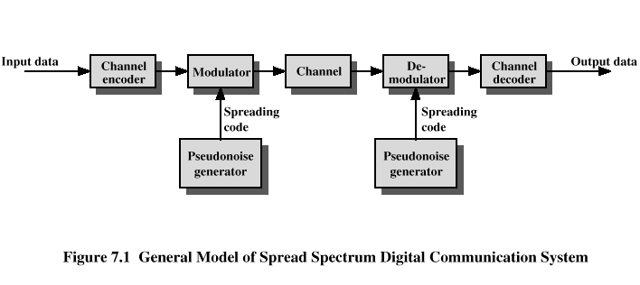

(II) GSM architecture.

