Sec-A

Q.1 Explain the usage of stack in recursive algorithm implementation?
In recursive algorithms, stack data structures is used to store the return address when a recursive call is encountered and also to store the values of all the parameters essential to the current state of the procedure.

Q.2 List out Applications of queue
Operating systems often maintain a queue of processes that are ready to execute or that are waiting for a particular event to occur.
Computer systems must often provide a “h processes, two programs, or even two systems. This holding area is usually called a “buffer” and is often implemented as a queue.

Q.3 What are applications of stack?
Conversion of expression
Evaluation of expression
Parentheses matching
Recursion
Q.4 Define double circularly linked list?
In a doubly linked list, if the last node or pointer of the list, point to the first element of the list, then it is a circularly linked list.

Q.5 How to implement stack using singly linked list

Stack is an Last In First Out (LIFO) data structure. Here , elements are inserted from one end called push operation and the same elements are deleted from the same end called pop operation
So, using singly linked list stack operations are performed in the front or other way ew can perform rear end also.

Sec-B (4*2.5=10 Marks)
Q.1 Define Bubble sort. Explain with example and algorithm.
Bubble sort is the one of the easiest sorting method. In this method each data item is compared with its neighbor and if it is an descending sorting , then the bigger number is moved to the top of all
The smaller numbers are slowly moved to the bottom position, hence it is also called as the exchange sort.
take an unsorted array for our example. Bubble sort takes Ο(n²) time so we're keeping it short and precise.
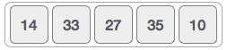
Bubble sort starts with very first two elements, comparing them to check which one is greater.
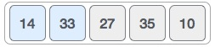
In this case, value 33 is greater than 14, so it is already in sorted locations. Next, we compare 33 with 27.
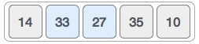
We find that 27 is smaller than 33 and these two values must be swapped.
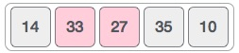
The new array should look like this −
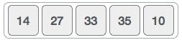
Next we compare 33 and 35. We find that both are in already sorted positions.
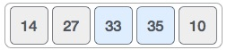
Then we move to the next two values, 35 and 10.
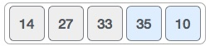
We know then that 10 is smaller 35. Hence they are not sorted.
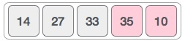
We swap these values. We find that we have reached the end of the array. After one iteration, the array should look like this −
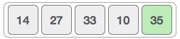
To be precise, we are now showing how an array should look like after each iteration. After the second iteration, it should look like this −
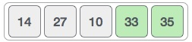
Notice that after each iteration, at least one value moves at the end.
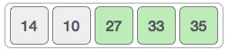
And when there's no swap required, bubble sorts learns that an array is completely sorted.
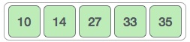
Now we should look into some practical aspects of bubble sort.

Algorithm
We assume list is an array of n elements. We further assume that swap function swaps the values of the given array elements.
begin BubbleSort(list)

for all elements of list
if list[i] > list[i+1]
swap(list[i], list[i+1])
end if
end for

return list

Q.2 Define merge sort with taking any example.
Merge sort is based on divide and conquer method. It takes the list to be stored and divide it in half to create two unsorted lists.The two unsorted lists are then sorted and merge to get a sorted list
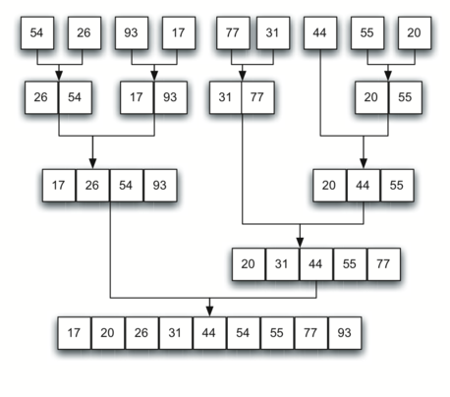

Q.3 how to implement queue using stacks.
Method 1 (By making enQueue operation costly) This method makes sure that oldest entered element is always at the top of stack 1, so that deQueue operation just pops from stack1. To put the element at top of stack1, stack2 is used.
Method 2 (By making deQueue operation costly)In this method, in en-queue operation, the new element is entered at the top of stack1. In de-queue operation, if stack2 is empty then all the elements are moved to stack2 and finally top of stack2 is returned.

Q.4 Mention the various types of searching techniques in C.
Linear search:
A simple approach is to do linear search, i.e
- Start from the leftmost element of arr[] and one by one compare x with each element of arr[]
- If x matches with an element, return the index.
- If x doesn’t match with any of elements, return -1.
Binary search
Binary Search: Search a sorted array by repeatedly dividing the search interval in half. Begin with an interval covering the whole array. If the value of the search key is less than the item in the middle of the interval, narrow the interval to the lower half. Otherwise narrow it to the upper half. Repeatedly check until the value is found or the interval is empty.

Q.5 Give a brief working of queue in round robin scheduling algorithm
Solution:
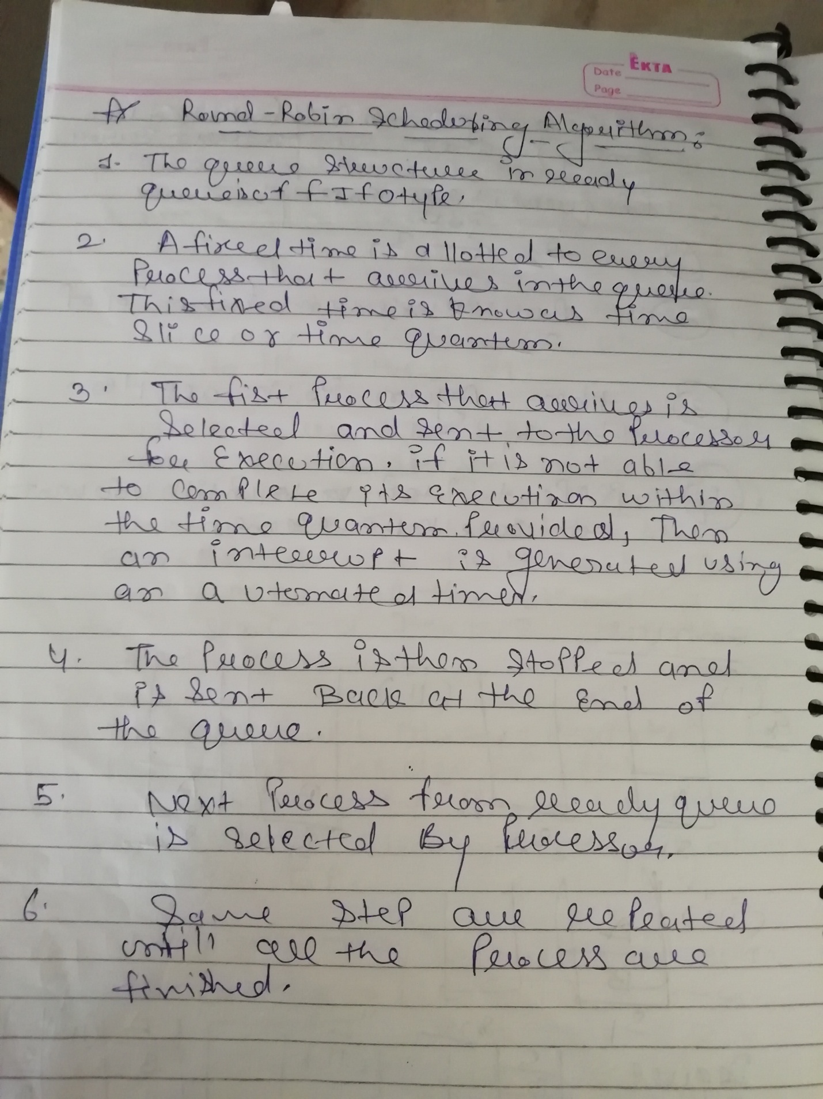
Q.6 What are the two operations of Stack? Explain any one with example and algorithm working.
Solution:
PUSH
POP
Concept | Definition
Stack Push | The procedure of inserting a new element to the top of the stack is known as Push Operation
Stack Overflow | Any attempt to insert a new element in already full stack is results into Stack Overflow.
Stack Pop | The procedure of removing element from the top of the stack is called Pop Operation.
Stack Underflow | Any attempt to delete an element from already empty stack results into Stack Underflow.

Sec-C
Q.1 Convert (a+(b*(c-d)+(e)-(f*g))) into postfix notation. write down the algorithm of infix to prefix conversion
Solution:
a b c d - * e + f g * - +
- Step 1. Push “)” onto STACK, and add “(“ to end of the A
- Step 2. Scan A from right to left and repeat step 3 to 6 for each element of A until the STACK is empty
- Step 3. If an operand is encountered add it to B
- Step 4. If a right parenthesis is encountered push it onto STACK
- Step 5. If an operator is encountered then:
- a. Repeatedly pop from STACK and add to B each operator (on the top of STACK) which has same
- or higher precedence than the operator.
- b. Add operator to STACK
- Step 6. If left parenthesis is encontered then
- a. Repeatedly pop from the STACK and add to B (each operator on top of stack until a left parenthesis is encounterd)
- b. Remove the left parenthesis
- Step 7. Exit

Q.2 What is difference between singly and doubly linked list? Explain it with example. Write down the algorithm to insert a data item in singly linked list.
The main difference between singly linked list and doubly linked list is the ability to traverse. In a single linked list, node only points towards next node, and there is no pointer to previous node, which means you can not traverse back on a singly linked list. On the other hand doubly linked list maintains two pointers, towards next and previous node, which allows you to navigate in both direction in any linked list.
Step 1: If AVAIL=NULL then
Write “Availability Stack is Empty”
Else
NEW_NODE=AVAIL
AVAIL = AVAIL->LINK
Step 2: If FIRST = NULL then
NEW_NODE -> INFO = X
NEW_NODE -> LINK = NULL
FIRST = NEW_NODE
Else
NEW_NODE -> INFO = X
NEW_NODE -> LINK = NULL
SAVE = FIRST
Repeat while SAVE->LINK ≠ NULL
SAVE = SAVE->LINK
SAVE->LINK = NEW_NODE
Step 3: Exit
Q.3 Explain the application of stack in case of tower of Hanoi problem. Solve the tower (3, A, B, C).
N=3, Beg=A, Aux=B, End=C. also write down the algorithm.
Step 1 − Move n-1 disks from source to aux
Step 2 − Move n^{th} disk from source to dest
Step 3 − Move n-1 disks from aux to dest
A recursive algorithm for Tower of Hanoi can be driven as follows −
START
Procedure Hanoi(disk, source, dest, aux)

IF disk == 1, THEN
move disk from source to dest
ELSE
Hanoi(disk - 1, source, aux, dest) // Step 1
move disk from source to dest // Step 2
Hanoi(disk - 1, aux, dest, source) // Step 3
END IF

END Procedure
STOP

