I Mid Term examination
Session: 2018-19
B.Tech II Year (IIISemester)
Subject with code:
SET-A
Time: 2 hrs. M.M.: 20
Instruction for students:
- No provision for supplementary answer book.
- Question paper contains three sections. Sec A includes 5 Short answers type questions (upto 25 words) Sec B- contains 06 Questions out of which any 04 questions to be attempt by the student (Analytical/Problem solving questions.). Sec C- contains 03 Questions out of which any 02 questions to be attempt by the student (Descriptive /Design questions.)
Sec-A
Q.1 (5*1=5 Marks)
(a) What do you mean by Weathering. Write types of Chemical Weathering
(b) What are dunes Explain in Short
(c) Write about river Profile? Draw Diagram also
(d) Explain river erosion and its method ?
(e) Define Meandering of river draw Sketch also

Sec-B
(4*2=8 Marks)
Q.2 Explain Concordant & Dis concordant bodies with their types
Q.3 Write Short note on Sandstone & Conglomerates
Q.4. Explain Causes of Folding?
Q.5.Explain Classification of Fold on 3 Basis with diagram
Q.6. Explain
a. Dip & Strike b. Loess
Q.7. Explain Various Factor affecting Weathering
Sec-C (2*3.5=7 Marks)

Q.8 Write Detailed note on Classification of Sedimentary rocks
Q.9 Explain Fault in Detail & how it can be Identified in Field
Q.10 What do you Understand by Delta Explain its Structure & Various factor affecting Its growth

I Mid Term examination
Session: 2018-19
B.Tech II Year (IIISemester)
Subject with code:
SET-B
Time: 2 hrs. M.M.: 20
Instruction for students:
- No provision for supplementary answer book.
- Question paper contains three sections. Sec A includes 5 Short answers type questions (upto 25 words) Sec B- contains 06 Questions out of which any 04 questions to be attempt by the student. Sec C- contains 03 Questions out of which any 02 questions to be attempt by the student

Sec-A
Q.1 (5*1=5 Mark)
(a) Define Metamorphic rocks & Metamorphism process with example
(b) Explain Directive & Inequigranular texture with diagram
(c) Define Texture & Structure of rocks write name of Textures in Sedimentary rocks
(d) Classify Rocks
1. Granite 2.Dolomite 3 Schist 4. Gabbro
(e) Write name of Various texture in metamorphic rocks

Sec-B (4*2=8 Marks)
Q.2 Explain Fold with its Components and their Engineering Consideration
Q.3 Explain structure of Igneous Rocks ?
Q.4. Explain
a. Meandering of River b. Dip & Strike
Q.5. Write short note on structure of Sedimentary rocks
Q.6. Differentiate between Sills & Dykes
Q.7 How Fault is different from Fractures ?
Sec – C (2*3.5=7 Marks)
Q.8 Explain Geological Time Scale in Detail
Q.9 What do you Understand by Delta Explain its Structure & Various factor affecting Its growth
Q.10 Explain four rocks of any types

SOLUTION
Set – A
Q.1 a Weathering breaks down and loosens the surface minerals of rock so they can be transported away by agents of erosion such as water, wind and ice. There are two types of weathering: mechanical and chemical. Mechanical weathering is the disintegration of rockinto smaller and smaller fragments.
B Chemical weathering transforms the original material into a substance with a different composition and different physical characteristics. The new substance is typically much softer and more susceptible to agents of erosion than the original material. The rate of chemical weathering is greatly accelerated by the presence of warm temperatures and moisture. Also, some minerals are more vulnerable to chemical weathering than others. For example, feldspar is far more reactive than quartz.
C Differential weathering occurs when some parts of a rock weather at different rates than others. Excellent examples of differential weathering occur in the Idavada silicic volcanic rocks in the Snake River Plains. Balanced Rock and the Gooding City of Rocks are outstanding examples of differential weathering.
D In physical geography, a dune is a hill of loose sand built by aeolian processes (wind) or the flow of water. Dunes occur in different shapes and sizes, formed by interaction with the flow of air or water
E RIVER EROSION River erosion is the wearing away of the land as the water flows past the bed and banks. There are four main types of river erosion. These are: Attrition - occurs as rocks bang against each other gradually breaking each other down (rocks become smaller and less angular as attrition occurs) Abrasion - this is the scraping away of the bed and banks by material transported by the river Solution - chemicals in the river dissolve minerals in the rocks in the bed and bank, carrying them away in solution. Hydraulic Action - this is where the water in the river compresses air in cracks in the bed and banks. This results in increased pressure caused by the compression of air, mini 'explosions' are caused as the pressure is then released gradually forcing apart parts of the bed and banks.
Q.2 DEPOSITION is where material carried by the river is dropped. occur when there is no longer sufficient energy to transport material. May result in the formation of features such as slip off slopes (on the inner bends of meanders); levees (raised banks) alluvial fans; meanders; braided streams and the floodplain. Remember - it is the largest material that will be dropped first as it requires the most energy to be transported. Eroded material carried in suspension and solution will be dropped last.
Rivers flowing over gently sloping ground begin to curve back and forth across the landscape. These are called meandering rivers. Meandering rivers erode sediment from the outer curve of each meander bend and deposit it on an inner curve further down stream. This causes individual meanders to grow larger and larger over time. Meandering river channels are asymmetrical. The deepest part of the channel is on the outside of each bend. The water flows faster in these deeper sections and erodes material from the river bank. The water flows more slowly in the shallow areas near the inside of each bend. The slower water can't carry as much sediment and deposits its load on a series of point bars.
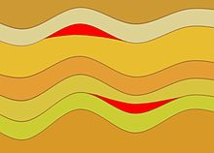
Cross-sectional diagram of phacoliths (red) in older folded rocks
Q.3A phacolith is a pluton of igneous rock parallel to the bedding plane or foliation of folded country rock. More specifically, it is a typically lens-shaped pluton that occupies either the crest of an anticline or the trough of a syncline. In rare cases the body may extend as a sill from the crest of an anticline through the trough of an adjacent syncline, such that in cross section it has an S shape. In intensely folded terrain the hinge of folds would be areas of reduced pressure and thus potential sites for magma migration and emplacement.
A lopolith is a large igneous intrusion which is lenticular in shape with a depressed central region. Lopoliths are generally concordant with the intruded strata with dike or funnel-shaped feeder bodies below the body. The term was first defined and used by Frank Fitch Grout during the early 1900s in describing the Duluth gabbro complex in northern Minnesota and adjacent Ontario.
Q.4 Lopoliths typically consist of large layered intrusions that range in age from Archean to Eocene. Examples include the Duluth gabbro, the Sudbury Igneous Complex of Ontario, the Bushveld igneous complex of South Africa, the Great Dyke in Zimbabwe, the Skaergaard complex of Greenland and the Humboldt lopolith of Nevada. The Sudbury occurrence has been attributed to an impact event and associated crustal melting.

Section B
Q.5 Sandstone is a clastic sedimentary rock composed mainly of sand-sized (0.0625 to 2 mm) mineral particles or rock fragments. Most sandstone is composed of quartz or feldspar (both silicates) because they are the most resistant minerals to weathering processes at the Earth's surface, as seen in Bowen's reaction series
Conglomerate is a coarse-grained clastic sedimentary rock that is composed of a substantial fraction of rounded to subangular gravel-size clasts, e.g., granules, pebbles, cobbles, and boulders, larger than 2 mm (0.079 in) in diameter.
Q.6 CAUSES OF FOLDING

The Tectonic Folding may be due to any one or more of the following mechanisms:

Folding Due to Tangential Compression

Lateral Compression is believed to be the main cause for throwing the rocks of the crust into different types of folds depending upon the types of rocks involved in the process and also the direction and magnitude of the compression effecting those rocks.

In general, this primary force is believed to act at right angles to the trend of folds. under the influence of the tangential stresses, folding may develop in either of the three ways: flexural folding, flowage folding and shear folding.
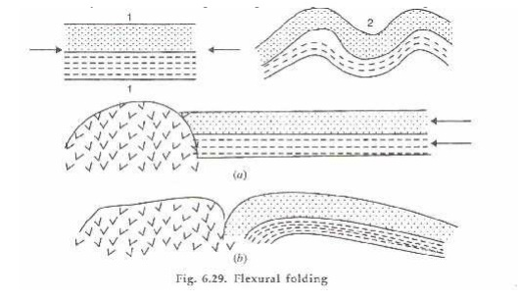
Flexural Folding.

It is that process of folding in which the competent or stronger rocks are thrown into folds due to their sliding against each other under the influence of lateral compression.
This is also distinguished as flexural-slip-folding in which the slip o r movement of the strata involved takes place parallel to the bedding planes of the layers.

It has been establis hed that in flexural folding, the amount of slip (and hence the ultimate type of fold) depends on a number of factors such as:

thickness o f the layers and nature of the contact; thick er the layers, greater is the slip; further, cohesionless contacts favour easy and greater slips;

distance fr om the hinge point; greater the distance from the hinge points, larger is the

displacement, so much so that it may be negligible at the hin ge point;

type of the rocks involved; siltstones, sandstones and li mestones are more prone t o flexure slip folding compared to soft clays and shales.

Flowage Folding

� It is t he principal process of folding in incompetent or weaker, plasti c type of rocks such as clays, shales, gypsum an d rock salt etc.

� Duri ng the compression, the material of the involved layers behaves almost as a viscous or plastic mass and gets buckled up and d eformed at varying rates suffering unequal disto rtion.

� In such cases the thickness of the resulting fold does not remain unifor m.

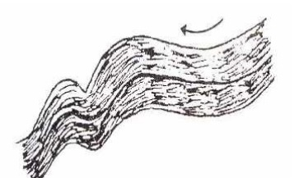
Shear Folding.

� In many cases, folding is attributed to shearing stresses rather than simple compression.

� It is assumed that in such a process, numerous closely spaced fractures develop in the rock at the first stage of the process.

� This is followed by displacement of the blocks so developed by different amounts so that ultimately the rocks take up folded or bent configuration.

� The folded outline becomes more conspicuous when the minor fractures get sealed up due to subsequent recrystallisation.

Folding Due to lnsrusions

� Intrusion of magma or even rock salt bodies from beneath has been found to be the cause of uparching of the overlying strata.

� In magmatic intrusions, highly viscous magma may be forced up very gradually and with considerable force so that the overlying sedimentary host rocks are bodily lifted up to provide space for the rising magma.
� In extreme cases, the magma may even rupture the overlying strata to flow out as lava

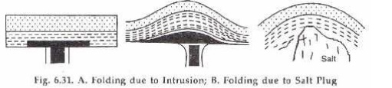
Folding Due to Differential Compression

� Strata that are being compacted under load in a basin of sedimentation develop, with passage of time, downward bending especially in the zones of maximum loading.

� If the strata in question is not homogeneous, the bending may not be uniform in character and results in warping or folding of different types.

� Such folds are, however, totally dependent on the load from above and are attributed to superficial causes.

� These are, therefore, non- tectonic folds.

Q.7 Classification of Folds:
Folds are classified into two main types namely anticlines or up-folds and synclines or down-folds.
1. Anticline Folds:
An anticline consists of beds bent upwards with limbs dipping away from each other.
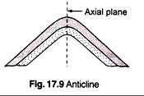
2. Syncline Folds:
A syncline consists of beds bent downwards with limbs dipping towards each other.

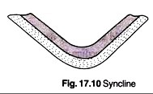3. Symmetrical Fold and Asymmetrical Fold:
A symmetrical fold is a fold whose axial plane is vertical and the limbs dip equally. The axial plane in this case divides the fold into two equal halves. If the two limbs dip at different angles the fold is an Asymmetrical fold.
4. Monocline:
This is a fold in which only one limb is bent. This is a case when a rock-bed bends abruptly and resumes the original attitude at the lower level.
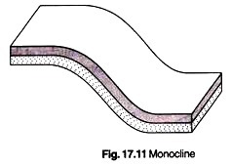
5. Plunging Fold or Pitching Fold:
This is a fold whose axis is at some angle with the horizontal. The inclination of the fold axis with the horizontal is called plunge of the fold.

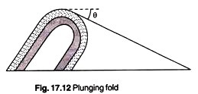 6. Isocline or Carinate Fold:
This is a fold whose limbs dip at the same angle in the same direction. The two limbs in this case are parallel. The axial plane may be vertical, inclined or horizontal.
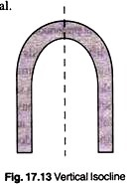
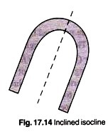
7. Overturned Fold:
This is a fold whose limbs dip unequally in the same direction.
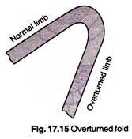
8. Recumbent Fold:
This is a fold whose limbs are bent back on themselves almost horizontally.

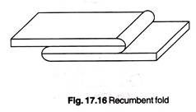 9. Zigzag Fold or Chevron Fold:
This is a fold having a sharp angular crest or trough.
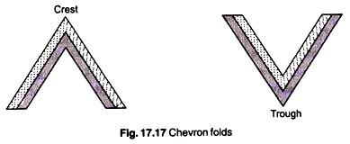
10. Supratenuous Fold:
This is a fold whose beds are thinner at the crest and thicker at the trough. Such folds are formed due to contemporaneous sedimentation, compaction over irregular surfaces uplift folding, sinking etc.
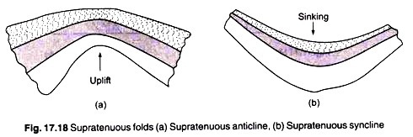
These folds are produced by tangential pressures which lift up the beds slowly and vertically at the crests. The thick troughs are formed due to sinking and large accumulation of sediments.
11. Dome Fold or Quaquaversal Fold or Pericline:
Dome fold consists of a set of rock beds lifted centrally giving the feature of a dome. The area of rock bed lifted may be circular or oval shaped. In a vertical section through the summit, the fold exhibits an anticlinal feature. For this reason this fold is also called a compound anticline. After the domes are eroded, the younger rocks appear surrounding the older rocks.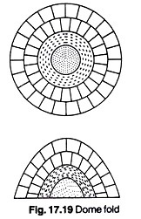
12. Basin Fold or Centrocline:
Basin fold consists of a set of rock beds which are sunk down centrally giving the feature of a basin. The area of the rock bed sunk may be circular or oval shaped. In a vertical section taken centrally the fold exhibits a synclinal feature. For this reason this fold is also called a compound syncline.
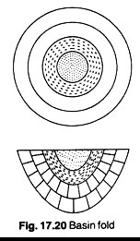

Fold Systems:
A rock strata is unlikely to form a single fold. In most cases it forms a series or a group of folds. Such a series of folds brought about by the same earth movement extending to great distances is called a fold system. A fold system consisting of a number of symmetrical anticlines and synclines, with their axes horizontal and parallel is called a non-plunging fold system.
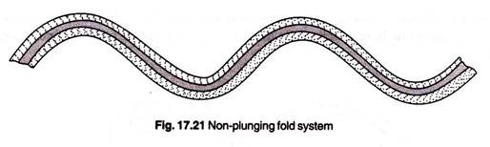
i. Plunging Fold System:
This is a fold system with plunging anticlines and synclines. The limbs of the folds dip in one direction.
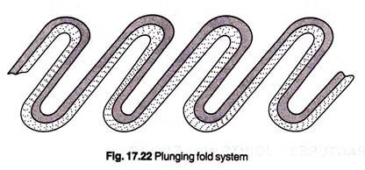
ii. Anticlinorium:
This is a system of anticlines and synclines which are all arched up into a major up fold.
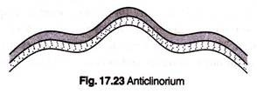
iii. Synclinorium:
This is a system of anticlines and synclines which are all arched down into a major down fold.
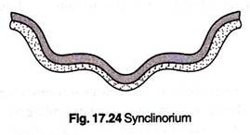
iv. Fan Fold:
This is a system of folds consisting of anticlines and synclines but with limbs having contrasting features. In this case the limbs of anticlines dip towards each other and the limbs of synclines dip away from each other.
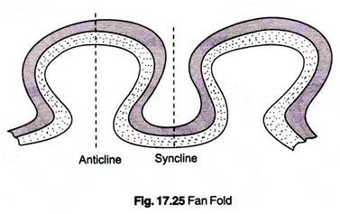
Q. 8 DIP is the acute angle that a rock surface makes with a horizontal plane. STRIKE is the direction of the line formed by the intersection of a rock surface with a horizontal plane.
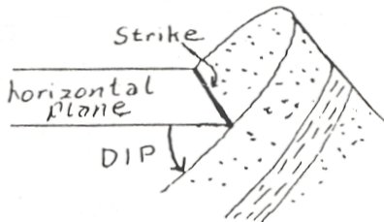
Strike and dip are always perpendicular to each other on a map.
On a fold, the AXIS is the ridge or plane of sharpest folding. PLUNGE is the acute angle the axis of a folded rock mass makes with a horizontal plane. Think of arching a piece of paper that has its edges against the floor. The top of the arch will be parallel to the floor. This "fold" would NOT be plunging. If you would raise one of the open ends so that the corners and that end of the edges were no longer against the floor, the "fold" would be PLUNGING.
Agents of EROSION wear away the rocks at the earth's surface. So, an upfold may no longer be a rise in elevation, and a downfold may no longer be a low. Differential erosion results in the stronger rocks or the rocks that are more resistant to these erosion processes, end up higher because they take longer to wear away than the less resistant or weaker rocks. Folds are then worn down. The topography is the result of the interplay between the geologic structure, tectonic activity, gradation, and time. The geologic structure involves the rocks and their characteristics. Tectonic activity involves how the forces have effected those rocks such as the folding, faulting, uplift, and volcanism. Gradation is transportation and deposition of the material. Time is the stage in the whole process, because with time the surface is worn down, exposing new materials on the surface and completely changing the topography of the surface. The text demonstrates some of these changes and processes. Our interest here is to note that the folds are usually truncated. Look at figure 3.
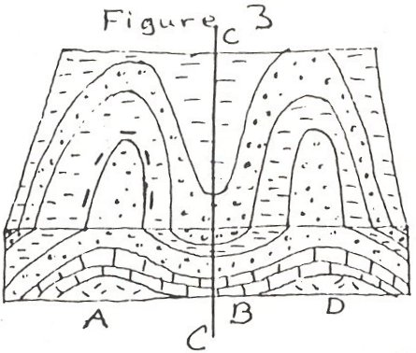
Find the part of the figure that would be the cross section. The geologic structure at A is a(n) (anticline, syncline). B is a(n) (anticline, syncline). C is the axis of the (anticline, syncline).
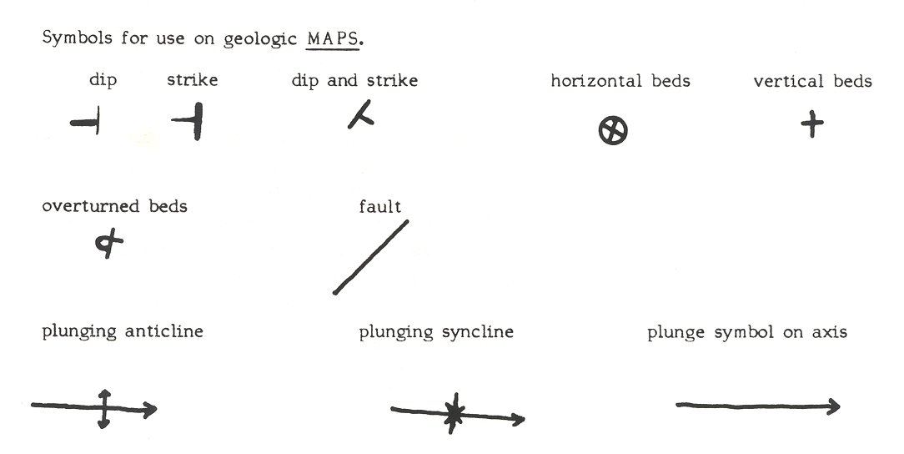
The symbol that should be added to this axis line to show the structure would be (double arrows pointing to the line, double arrows pointing away from the line).
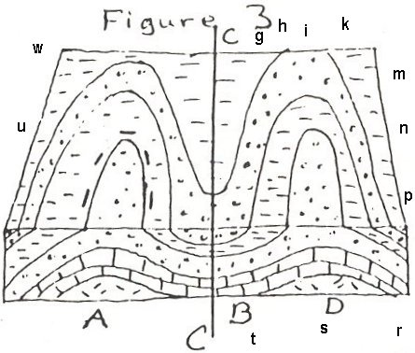
The axis for D should run from point (g, h, i, k, m, n) to point (p, r, s, t, u, w). The symbol shown on the axis line should be (double arrows pointing to the line, double arrows pointing away from the line).
he strength characteristics of structural loess, a type of soil material, are presented in terms of shear properties and tensile properties. In loess plateau regions, numerous towering steep slopes of structural loess can be found, with some slopes reaching as high as 10 m or more.
Sedimentary rocks are formed by the accumulation of sediments. There are three basic types of sedimentary rocks.
Clastic sedimentary rocks such as breccia, conglomerate, sandstone, siltstone, and shale are formed from mechanical weathering debris.
Chemical sedimentary rocks, such as rock salt, iron ore, chert, flint, some dolomites, and some limestones, form when dissolved materials precipitate from solution.
Organic sedimentary rocks such as coal, some dolomites, and some limestones, form from the accumulation of plant or animal debris.
Chert is a microcrystalline or cryptocrystalline sedimentary rock material composed of silicon dioxide (SiO₂). It occurs as nodules and concretionary masses, and less frequently as a layered deposit. It breaks with a conchoidal fracture, often producing very sharp edges. Early people took advantage of how chert breaks and used it to fashion cutting tools and weapons. The specimen shown above is about two inches (five centimeters) across. Dolomite (also known as "dolostone" and "dolomite rock") is a chemical sedimentary rock that is very similar to limestone. It is thought to form when limestone or lime mud is modified by magnesium-rich ground water. The specimen shown above is about four inches (ten centimeters) across

Factor # 1. Climate:
This is the most important factor affecting weathering of rocks. The extent of weathering is dependent on the average atmospheric condition prevailing in a region over a long period of time.
There are two factors that play in weathering, viz. Temperature and Precipitation. Warm climates affect by chemical weathering while cold climates affect by physical weathering (particularly by frost action). In either case the weathering is more pronounced with more moisture content.
ADVERTISEMENTS:
At higher temperatures chemical reactions are likely to take place faster. Chemical reactions in most cases need water which is a reactant in hydration and carbonation. Water is also the medium in which the reaction can take place.
Biological activities are supported by hot moist climates. For instance burrowing humic acid production during decomposition of plant matter are most likely in hot moist climates. In fact a hot moist climate provides the most ideal environment for fast chemical weathering.
Physical weathering by frost action is most likely in cold climate where freeze and thaw occur alternately during the cold weather. In this case again precipitation is the main factor. In the absence of water ice cannot form and frost action is not possible. Hence an effective frost action occurs in the cold moist climate.

Factor # 2. Particle Size:
Rate of chemical weathering is affected by size of rock particles. If the rock pieces are smaller, the weathering is faster. This is because if the rock pieces are smaller, the surface area exposed to weather action is greater.

Factor # 3. Exposure:
ADVERTISEMENTS:
The extent of exposure i.e. the extent to which the rock comes into contact with the agents of weather is an important factor affecting the weathering. In some situations, vegetation, soil, ice, etc. may cover a rock, thereby reducing the area exposed to weather action.
Such rocks so protected weather slowly compared to rocks whose surfaces are wholly exposed to weather. Slope of the region is also a factor affecting weathering. Where the slopes are steep, loose materials are displaced downhill either by gravity or by erosion resulting in continuous exposure of the fresh rock.

Factor # 4. Mineral Composition:
We know, the chemical properties of a rock depend on the mineral composition to a great extent. Mineral in a rock may readily react with acids, water or oxygen causing considerable weathering. For example limestone can get severely acted upon by even very mildly acidic rainwater. Granite on the contrary mostly containing silica remains unaffected by such agents.
Physical weathering is also dependent on mineral composition. Rocks which are soft are liable to be abraded more readily than hard rocks. The solid crystalline rocks are quite compact with very little opening and are very resistive to entry of water into them, and can therefore resist weathering.

Factor # 5. Time:
The process of weathering is a time taking process. The duration of time for which a rock is exposed to weather determines the extent of weathering. Very strong rocks, however strong they might be will severely undergo weathering in hundreds of years.

a fault is a planar fracture or discontinuity in a volume of rock, across which there has been significant displacement as a result of rock-mass movement. Large faults within the Earth's crust result from the action of plate tectonic forces, with the largest forming the boundaries between the plates, such as subduction zones or transform faults. Energy release associated with rapid movement on active faults is the cause of most earthquakes.
A fault plane is the plane that represents the fracture surface of a fault. A fault trace or fault line is a place where the fault can be seen or mapped on the surface. A fault trace is also the line commonly plotted on geologic maps to represent a fault.^{[1][2]}
Since faults do not usually consist of a single, clean fracture, geologists use the term fault zone when referring to the zone of complex deformation associated with the fault plane. Because of friction and the rigidity of the constituent rocks, the planes cannot glide or flow past each other easily, and so occasionally all movement stops. Thus, stress builds up, and when it reaches a level that exceeds the strain threshold, the accumulated potential energy is released into the fault.
Strain occurs accumulatively or instantaneously, depending on the liquid state of the rock; the ductile lower crust and mantle accumulate deformation gradually via shearing, whereas the brittle upper crust reacts by fracture – instantaneous stress release – resulting in motion along the fault. A fault in ductile rocks can also release instantaneously when the strain rate is too great. The energy released by instantaneous strain-release causes earthquakes.
Q. 10 A river delta is a landform that forms from deposition of sediment carried by a river as the flow leaves its mouth and enters slower-moving or stagnant water.^{[1][2]} This occurs where a river enters an ocean, sea, estuary, lake, reservoir, or (more rarely) another river that cannot carry away the supplied sediment. The size and shape of a delta is controlled by the balance between watershed processes that supply sediment, and receiving basin processes that redistribute, sequester, and export that sediment.^{[3][4]} The size, geometry, and location of the receiving basin also plays an important role in delta evolution. River deltas are important in human civilization, as they are major agricultural production centers and population centers. They can provide coastline defense and can impact drinking water supply.^{[5]} They are also ecologically important, with different species' assemblages depending on their landscape position. River deltas form when a river carrying sediment reaches either (1) a body of water, such as a lake, ocean, or reservoir, (2) another river that cannot remove the sediment quickly enough to stop delta formation, or (3) an inland region where the water spreads out and deposits sediments. The tidal currents also cannot be too strong, as sediment would wash out into the water body faster than the river deposits it. The river must carry enough sediment to layer into deltas over time. The river's velocity decreases rapidly, causing it to deposit the majority, if not all, of its load. This alluvium builds up to form the river delta.^{[7]} When the flow enters the standing water, it is no longer confined to its channel and expands in width. This flow expansion results in a decrease in the flow velocity, which diminishes the ability of the flow to transport sediment. As a result, sediment drops out of the flow and deposits. Over time, this single channel builds a deltaic lobe (such as the bird's-foot of the Mississippi or Ural river deltas), pushing its mouth into the standing water. As the deltaic lobe advances, the gradient of the river channel becomes lower because the river channel is longer but has the same change in elevation (see slope).
As the slope of the river channel decreases, it becomes unstable for two reasons. First, gravity makes the water flow in the most direct course down slope. If the river breaches its natural levees (i.e., during a flood), it spills out into a new course with a shorter route to the ocean, thereby obtaining a more stable steeper slope.^{[8]} Second, as its slope gets lower, the amount of shear stress on the bed decreases, which results in deposition of sediment within the channel and a rise in the channel bed relative to the floodplain. This makes it easier for the river to breach its levees and cut a new channel that enters the body of standing water at a steeper slope. Often when the channel does this, some of its flow remains in the abandoned channel. When these channel-switching events occur, a mature delta develops a distributary network.
Another way these distributary networks form is from deposition of mouth bars (mid-channel sand and/or gravel bars at the mouth of a river). When this mid-channel bar is deposited at the mouth of a river, the flow is routed around it. This results in additional deposition on the upstream end of the mouth-bar, which splits the river into two distributary channels. A good example of the result of this process is the Wax Lake Delta.
In both of these cases, depositional processes force redistribution of deposition from areas of high deposition to areas of low deposition. This results in the smoothing of the planform (or map-view) shape of the delta as the channels move across its surface and deposit sediment. Because the sediment is laid down in this fashion, the shape of these deltas approximates a fan. The more often the flow changes course, the shape develops as closer to an ideal fan, because more rapid changes in channel position results in more uniform deposition of sediment on the delta front. The Mississippi and Ural River deltas, with their bird's-feet, are examples of rivers that do not avulse often enough to form a symmetrical fan shape. Alluvial fan deltas, as seen by their name, avulse frequently and more closely approximate an ideal fan shape.

SET –B
Rocks like crush breccia, mylonite and slate show this type of structure. These rocks are mainly formed under the effect of shearing stresses in the upper zone of the earth crust. One of the most obviousstructural features of most of the metamorphicrocks
It is the alignment of platy or flaky minerals in parallel layers. ypes Of Igneous Rock Textures A Equigranular Texture ▪ Panidiomorhic Texture: a relationship between equigranular Euhedral crystals and characterizes plutonic rocks especially " Lamprophyre ". ▪ Mico-granitic Texture: a relationship between equigranular fine Anhedral or Subhedral crystals as in Rhyolite\

Sedimentary Textures

The Sedimentary Rock Textures Chart on the following illustrates the major sedimentary rock textures. Below, we define a few of the terms geologists use to describe these textures.

♦ Clastic texture: grains or clasts do not interlock but rather are piled together and cemented. Boundaries of individual grains may be another grain, cement or empty pore space. Overall rock is generally porous and not very dense. Because clasts are only cemented together, grains are relatively easy to “scrape off" using a rock hammer point or metal nail. If the grains are visible, all of the above characteristics may be noted.

♦ Microclastic texture: This texture is the same as the clastic texture except that the clasts are not visible to the eye. Because the grains are invisible, examining the ease in which grains (silt or clay) may be knocked off is the best test to perform.

♦ Bioclastic texture: The texture is similar to clastic texture except that all of the clasts or grains are fossils.

♦ Crystalline texture: Crystals are visible and form an interlocking network. Unlike igneous crystalline textures, however, sedimentary crystalline textures are typically formed from one mineral throughout the entire rock.

♦ Microcrystalline texture: no crystals are visible but the rock is composed of interlocking microscopic crystals. Such rocks are dense and typically nonporous. Microcrystalline rocks break with a characteristic conchoidal fracture. That is, the broken surface may smooth concentric lines resembling the inside of an oyster shell or broken glass.

♦ Fossiliferous texture: Rocks containing an abundance of fossils. The matrix may be eithe crystalline, microcrystalline, or clastic (micro)clastic.
The first step in the classification of sedimentary rocks is to determine whether it is clastic or chemical so that you can then determine which of the charts in Figure you should be using. This distinction is based primarily on texture. First determine if the rock has a (micro)clastic or (micro)crystalline texture. If the texture is (micro) crystalline, you are dealing with a chemical rock. If the texture is (micro) clastic, you must determine whether the rock is clastic or bioclastic. If clastic, use the clastic rock chart. From this point, the following description of sedimentary rocks should guide you to the appropriate rock name.
Classification of igneous rocks is one of the most confusing aspects of geology. This is partly due to historical reasons, partly due to the nature of magmas, and partly due to the various criteria that could potentially be used to classify rocks.
- Early in the days of geology there were few rocks described and classified. In those days each new rock described by a geologist could have shown characteristics different than the rocks that had already been described, so there was a tendency to give the new and different rock a new name. Because such factors as cooling conditions, chemical composition of the original magma, and weathering effects, there is a potential to see an infinite variety of igneous rocks, and thus a classification scheme based solely on the description of the rock would eventually lead to a plethora of rock names. Still, because of the history of the science, many of these rock names are firmly entrenched in the literature, so the student must be aware of all of these names, or at least know where to look to find out what the various rocks names mean.
- Magmas, from which all igneous rocks are derived, are complex liquid solutions. Because they are solutions, their chemical composition can vary continuously within a range of compositions. Because of the continuous variation in chemical composition there is no easy way to set limits within a classification scheme.
- There are various criteria that could be used to classify igneous rocks. Among them are:
  - Minerals Present in the Rock (the mode). The minerals present in a rock and their relative proportions in the rock depend largely on the chemical composition of the magma. This works well as a classification scheme if all of the minerals that could potentially crystallize from the magma have done so - usually the case for slowly cooled plutonic igneous rocks. But, volcanic rocks usually have their crystallization interrupted by eruption and rapid cooling on the surface. In such rocks, there is often glass or the minerals are too small to be readily identified. Thus a system of classification based solely on the minerals present can only be used.
We can easily the inadequacy of a mineralogical classification based on minerals present if you look at the classification schemes for volcanic rocks given in introductory geology textbooks. For example, most such schemes show that a dacite is a rock that contains small amounts of quartz, somewhat larger amounts of sanidine or alkali feldspar, plagioclase, biotite, and hornblende, In all the years I have been looking at igneous rocks (since about the mid-cretaceous) I have yet to see a dacite that contains alkali feldspar. Does this mean that the intro geology textbooks lie? Not really, these are the minerals that should crystallize from a dacite magma, but don't because the crystallization history is interrupted by rapid cooling on the surface.
  - Texture of the Rock. Rock texture depends to a large extent on cooling history of the magma. Thus rocks with the same chemical composition and same minerals present could have widely different textures. In fact we generally use textural criteria to subdivide igneous rocks in to plutonic (usually medium to coarse grained) and volcanic (usually fine grained, glassy, or porphyritic.) varieties.
  - Color. Color of a rock depends on the minerals present and on their grain size. Generally, rocks that contain lots of feldspar and quartz are light colored, and rocks that contain lots of pyroxenes, olivines, and amphiboles (ferromagnesium minerals) are dark colored. But color can be misleading when applied to rocks of the same composition but different grain size. For example a granite consists of lots of quartz and feldspar and is generally light colored. But a rapidly cooled volcanic rock with the same composition as the granite could be entirely glassy and black colored (i.e. an obsidian). Still we can divide rocks in general into felsic rocks (those with lots of feldspar and quartz) and mafic rocks (those with lots of ferromagnesium minerals). But, this does not allow for a very detailed classification scheme.
  - Chemical Composition. Chemical composition of igneous rocks is the most distinguishing feature.
  - The composition usually reflects the composition of the magma, and thus provides information on the source of the rock.
  - The chemical composition of the magma determines the minerals that will crystallize and their proportions.
  - A set of hypothetical minerals that could crystallize from a magma with the same chemical composition as the rock (called the Norm), can facilitate comparison between rocks.
  - Still, because chemical composition can vary continuously, there are few natural breaks to facilitate divisions between different rocks.
  - Chemical composition cannot be easily determined in the field, making classification based on chemistry impractical.

Because of the limitations of the various criteria that can used to classify igneous rocks, geologists use an approach based on the information obtainable at various stages of examining the rocks.
- In the field, a simple field based classification must be used. This is usually based on mineralogical content and texture. For plutonic rocks, the IUGS system of classification can be used. For volcanic rocks, the following table can be used.

Dyke” and “sill” are geological terms used to describe an intrusion, usually a mass of igneous or volcanic rocks that have forcibly entered, penetrated, and embedded into layers of another rock or landform. Dykes and sills are often associated with volcanoes, though they are not exclusive to that particular landform.
As intrusions, both dykes and sills are igneous rocks that were left or a result of crystallization of molten magma flow that exists beneath the Earth’s surface. They are naturally occurring in nature and considered as “foreign” rock in relation to their surrounding rock environment or form, which is “local” or “original” rock. They can be injected into existing cracks in the bedding plates or erupt as a pressure or force from a particular point of origin.
Dykes and sills “intrude” due to the pressure, stress, and deformation from the surrounding rocks or beneath the Earth’s surface. It is often in a molten or unstable state when it “intrudes” into another formation and hardens as it cools down over a period of time. The main forms of dykes and sills are magmatic and sedimentary.
The geologic time scale (GTS) is a system of chronological dating that relates geological strata (stratigraphy) to time. It is used by geologists, paleontologists, and other Earth scientists to describe the timing and relationships of events that have occurred during Earth's history. The table of geologic time spans, presented here, agree with the nomenclature, dates and standard color codes set forth by the International Commission on Stratigraphy (ICS)

Formulation of geologic time scale[edit]
The first serious attempts to formulate a geologic time scale that could be applied anywhere on Earth were made in the late 18th century. The most influential of those early attempts (championed by Werner, among others) divided the rocks of Earth's crust into four types: Primary, Secondary, Tertiary, and Quaternary. Each type of rock, according to the theory, formed during a specific period in Earth history. It was thus possible to speak of a "Tertiary Period" as well as of "Tertiary Rocks." Indeed, "Tertiary" (now Paleogene and Neogene) remained in use as the name of a geological period well into the 20th century and "Quaternary" remains in formal use as the name of the current period.
The identification of strata by the fossils they contained, pioneered by William Smith, Georges Cuvier, Jean d'Omalius d'Halloy, and Alexandre Brongniartin the early 19th century, enabled geologists to divide Earth history more precisely. It also enabled them to correlate strata across national (or even continental) boundaries. If two strata (however distant in space or different in composition) contained the same fossils, chances were good that they had been laid down at the same time. Detailed studies between 1820 and 1850 of the strata and fossils of Europe produced the sequence of geologic periods still used today.

Naming of geologic periods, eras and epochs[edit]
Early work on developing the geologic time scale was dominated by British geologists, and the names of the geologic periods reflect that dominance. The "Cambrian", (the classical name for Wales) and the "Ordovician", and "Silurian", named after ancient Welsh tribes, were periods defined using stratigraphic sequences from Wales.^{[12]:113–114} The "Devonian" was named for the English county of Devon, and the name "Carboniferous" was an adaptation of "the Coal Measures", the old British geologists’ term for the same set of strata. The "Permian" was named after Perm, Russia, because it was defined using strata in that region by Scottish geologist Roderick Murchison. However, some periods were defined by geologists from other countries. The "Triassic" was named in 1834 by a German geologist Friedrich Von Alberti from the three distinct layers (Latin trias meaning triad)—red beds, capped by chalk, followed by black shales—that are found throughout Germany and Northwest Europe, called the ‘Trias’. The "Jurassic" was named by a French geologist Alexandre Brongniart for the extensive marine limestone exposures of the Jura Mountains. The "Cretaceous" (from Latin creta meaning ‘chalk’) as a separate period was first defined by Belgian geologist Jean d'Omalius d'Halloy in 1822, using strata in the Paris basin^{[13]} and named for the extensive beds of chalk (calcium carbonate deposited by the shells of marine invertebrates) found in Western Europe.
British geologists were also responsible for the grouping of periods into eras and the subdivision of the Tertiary and Quaternary periods into epochs. In 1841 John Phillips published the first global geologic time scale based on the types of fossils found in each era. Phillips’ scale helped standardize the use of terms like Paleozoic ("old life") which he extended to cover a larger period than it had in previous usage, and Mesozoic ("middle life") which he invented.^{[14]}

Dating of time scales[edit]
Main article: Chronological dating
When William Smith and Sir Charles Lyell first recognized that rock strata represented successive time periods, time scales could be estimated only very imprecisely since estimates of rates of change were uncertain. While creationists had been proposing dates of around six or seven thousand years for the age of Earth based on the Bible, early geologists were suggesting millions of years for geologic periods, and some were even suggesting a virtually infinite age for Earth.^{[citation needed]} Geologists and paleontologists constructed the geologic table based on the relative positions of different strata and fossils, and estimated the time scales based on studying rates of various kinds of weathering, erosion, sedimentation, and lithification. Until the discovery of radioactivity in 1896 and the development of its geological applications through radiometric dating during the first half of the 20th century, the ages of various rock strata and the age of Earth were the subject of considerable debate.
The first geologic time scale that included absolute dates was published in 1913 by the British geologist Arthur Holmes.^{[15]} He greatly furthered the newly created discipline of geochronology and published the world-renowned book The Age of the Earth in which he estimated Earth's age to be at least 1.6 billion years.^{[16]}
In 1977, the Global Commission on Stratigraphy (now the International Commission on Stratigraphy) began to define global references known as GSSP (Global Boundary Stratotype Sections and Points) for geologic periods and faunal stages. The commission's most recent work is described in the 2004 geologic time scale of Gradstein et al.^{[17]} A UML model for how the timescale is structured, relating it to the GSSP, is also available.^{[18]}

The Anthropocene[edit]
Popular culture and a growing number^{[citation needed]} of scientists use the term "Anthropocene" informally to label the current epoch in which we are living. The term was coined by Paul Crutzenand Eugene Stoermer in 2000 to describe the current time, in which humans have had an enormous impact on the environment. It has evolved to describe an "epoch" starting some time in the past and on the whole defined by anthropogenic carbon emissions and production and consumption of plastic goods that are left in the ground.^{[19]}
Critics of this term say that the term should not be used because it is difficult, if not nearly impossible, to define a specific time when humans started influencing the rock strata—defining the start of an epoch.^{[20]} Others say that humans have not even started to leave their biggest impact on Earth, and therefore the Anthropocene has not even started yet.
The ICS has not officially approved the term as of September 2015.^{[21]} The Anthropocene Working Group met in Oslo in April 2016 to consolidate evidence supporting the argument for the Anthropocene as a true geologic epoch.^{[21]} Evidence was evaluated and the group voted to recommend "Anthropocene" as the new geological age in August 2016.^{[22]} Should the International Commission on Stratigraphy approve the recommendation, the proposal to adopt the term will have to be ratified by the International Union of Geological Sciences before its formal adoption as part of the geologic time scale.^{[23]}

Table of geologic time[edit]
The following table summarizes the major events and characteristics of the periods of time making up the geologic time scale. This table is arranged with the most recent geologic periods at the top, and the most ancient at the bottom. The height of each table entry does not correspond to the duration of each subdivision of time.
The content of the table is based on the current official geologic time scale of the International Commission on Stratigraphy,^{[1]} with the epoch names altered to the early/late format from lower/upper as recommended by the ICS when dealing with chronostratigraphy.^{[2]}
A service providing a Resource Description Framework/Web Ontology Language representation of the timescale is available through the Commission for the Management and Application of Geoscience Information GeoSciML project as a service^{[24]} and at a SPARQL end-point.^{[25][26]}
Argillite - a sedimentary rock composed primarily of clay-sized particles
Arkose - a sandstone with <25% feldspar crystals
Banded iron formation - a fine-grained chemical sedimentary rock composed of iron oxide minerals
Breccia - a sedimentary or tectonic rock composed of fragments of other, broken rocks
Calcarenite - a sedimentary rock composed of > 50% detrital carbonate grains
Chalk - a sedimentary rock composed primarily of coccolith fossils
Chert - a fine-grained chemical sedimentary rock composed of silica
Claystone - a sedimentary rock formed from clay
Coal - a sedimentary rock formed from organic matter
Conglomerate - a sedimentary rock composed of large rounded fragments of other rocks
Coquina - a sedimentary carbonate rock formed by accumulation of abundant shell fossils and fragments
Diamictite - a lithified sedimentary deposit with a wide range of grain sizes
Diatomite - sedimentary rock formed from diatom fossils
Dolomite or dolostone - a carbonate rock composed of the mineral dolomite +/- calcite
Evaporite - chemical sedimentary rock formed by accumulation of minerals after evaporation; varieties include rock salt (halitite) and rock gypsum
Flint - a form of chert occurring in chalk and marly limestone deposits
Geyserite - opaline silica deposit formed around hot springs and geysers
Greywacke - a type of sandstone with quartz, feldspar and rock fragments within a clay matrix
Gritstone - essentially a coarse sandstone formed from small pebbles
Itacolumite - porous, yellow-orange sandstone which is flexible if cut into thin strips
Jaspillite - an iron-rich chemical sedimentary rock similar to chert or banded iron formation
Laterite - residual sedimentary rock formed from a parent rock under tropical conditions
Lignite - sedimentary rock composed of 60%- 70% organic material; otherwise known as brown coal
Limestone - composed primarily of carbonate minerals
Marl - limestone with a considerable proportion of silicate material
Mudstone - clastic sedimentary rock that contains a mixture of silt- and clay-sized particles
Oil shale - sedimentary rock composed dominantly of organic material
Oolite - chemical sedimentary limestone formed from ooids, spherical grains composed of concentric layers
Sandstone - clastic sedimentary rock defined by its grain size (0.0625 mm to 2 mm)
Shale - clastic, fissile sedimentary rock defined by clay-sized particles
Siltstone - clastic sedimentary rock defined by 50% or greater silt-sized particles
Sylvinite - sedimentary rock made of a mechanical mixture of the minerals sylvite and halite
Tillite - lithified glacial till
Travertine - sedimentary rock containing calcite and iron oxides
Tufa - porous limestone formed by the precipitation of carbonate minerals from ambient temperature water bodies
Turbidite - particular sequence of sedimentary rocks which form within the deep ocean environment
Wackestone - matrix-supported carbonate sedimentary rock.
Andesite - an intermediate volcanic rock
Alkali feldspar granite - a granitoid in which at least 90% of the total feldspar is in the form of alkali feldspar
Anorthosite - a mafic intrusive igneous rock composed predominantly of plagioclase
Aplite - a very fine-grained intrusive igneous rock composed of quartz and feldspar, similar composition to granite but with grains <1mm
Basalt - a volcanic rock of mafic composition
A'a - basaltic lava with a crumpled appearance
Pahoehoe - basaltic lava with a flowing, often ropy appearance
Basaltic trachyandesite
Mugearite - sodic basaltic trachyandesite
Shoshonite - potassic basaltic trachyandesite
Basanite - a volcanic rock of mafic composition; essentially a silica-undersaturated basalt
Blairmorite - a rare volcanic rock
Boninite - a magnesium-rich basalt dominated by pyroxene
Carbonatite - a rare igneous rock composed of >50% carbonate minerals
Charnockite - a type of granite containing orthopyroxene
Enderbite - a variety of charnockite
Dacite - a felsic to intermediate volcanic rock containing hornblende and with more plagioclase than orthoclase
Diabase or dolerite - an intrusive mafic rock forming dykes or sills
Diorite - a coarse-grained intermediate plutonic rock composed of plagioclase, pyroxene and/or amphibole
Napoleonite - a variety of diorite which is characterized by orbicular structure. Also called corsite.
Dunite - a phaneritic ultramafic rock composed of more than 90% olivine
Essexite - a silica-undersaturated mafic plutonic rock (essentially a feldspathoid-bearing gabbro)
Foidolite - a plutonic igneous rock in which more than 60% (by volume) of light-coloured minerals are feldspathoids
Gabbro - a coarse-grained plutonic rock composed of pyroxene and plagioclase basically equivalent to basalt
Granite - a coarse-grained plutonic rock composed of orthoclase, plagioclase and quartz
Granodiorite - a granitic plutonic rock with more plagioclase than orthoclase
Granophyre - a subvolcanic intrusive rock of granitic composition
Harzburgite - a variety of peridotite; an ultramafic cumulate rock
Hornblendite - a mafic or ultramafic cumulate rock dominated by >90% hornblende
Hyaloclastite - a volcanic rock composed primarily of glasses and glassy tuff
Icelandite - an iron-rich, aluminium-poor andesite
Ignimbrite - a fragmental volcanic rock
Ijolite - a very rare silica-undersaturated plutonic rock
Kimberlite - a rare ultramafic, ultrapotassic volcanic rock and a source of diamonds
Komatiite - an ultramafic volcanic rock with very high magnesium content
Lamproite - an ultrapotassic volcanic rock
Lamprophyre - an ultramafic, ultrapotassic intrusive rock dominated by mafic phenocrysts in a feldspar groundmass
Latite - a silica-undersaturated form of andesite
Lherzolite - an ultramafic rock, essentially a peridotite
Monzogranite - a silica-undersaturated granite with <5% normative quartz
Monzonite - a plutonic rock with <5% normative quartz
Nepheline syenite - a silica-undersaturated plutonic rock of nepheline and alkali feldspar
Nephelinite - a silica-undersaturated plutonic rock with >90% nepheline
Norite - a hypersthene-bearing gabbro
Obsidian - a type of volcanic glass
Pegmatite - an igneous rock (or metamorphic) rock with crystals >1 inch, usually granitic
Peridotite - a plutonic or cumulate ultramafic rock composed of olivine and pyroxene
Phonolite - a silica-undersaturated volcanic rock; essentially similar to nepheline syenite
Phonotephrite - a volcanic rock with a composition between phonolite and tephrite
Picrite - an olivine-bearing basalt
Porphyry - a rock, usually granitic, with a porphyritic texture
Pumice - a fine grained, vesicular volcanic rock
Pyroxenite - a coarse grained plutonic rock composed of >90% pyroxene
Quartz diorite - a diorite with >5% modal quartz
Quartz monzonite - an intermediate plutonic rock, essentially a monzonite with 5-10% modal quartz
Quartzolite - an intrusive rock composed mostly of quartz
Rhyodacite - a felsic volcanic rock which is intermediate between a rhyolite and a dacite
Rhyolite - a felsic volcanic rock
Comendite - a peralkaline rhyolite
Pantellerite - an alkaline rhyolite-rhyodacite with amphibole phenocrysts
Scoria - an extremely vesicular mafic volcanic rock
Sovite - a coarse-grained carbonatite rock
Syenite - a plutonic rock dominated by orthoclase feldspar; a type of granitoid
Tachylyte - essentially a basaltic glass
Tephriphonolite - a volcanic rock with a composition between phonotephrite and phonolite
Tephrite - a silica-undersaturated volcanic rock
Tonalite - a plagioclase-dominant granitoid
Trachyandesite - an alkaline intermediate volcanic rock
Benmoreite - sodic trachyandesite
Trachybasalt - a volcanic rock with a composition between basalt and trachyte
Hawaiite - a sodic type of trachybasalt, typically formed by ocean island (hot spot) volcanism
Trachyte - a silica-undersaturated volcanic rock; essentially a feldspathoid-bearing rhyolite
Troctolite - a plutonic ultramafic rock containing olivine, pyroxene and plagioclase
Trondhjemite - a form of tonalite where plagioclase-group feldspar is oligoclase
Tuff - a fine-grained volcanic rock formed from volcanic ash
Websterite - a type of pyroxenite, composed of clinoproxene and orthopyroxene
Wehrlite - an ultramafic plutonic or cumulate rock, a type of peridotite, composed of olivine and clinopyroxene

