Rajasthan Institute of Engineering & Technology, Jaipur
University Roll No. ______________

II Year MBA IV Semester I Mid Term Examination, Feb – 2019
Subject: - Banking & Insurance SET-A
Time: -2 Hrs. [Maximum Marks: -20]
[Min. Passing Marks: 08]
Instructions to the Candidates:
Attempt any 4 questions from Section A and Section B is Compulsory
Section A
1. Describe the deposit products offered by banks. Give the important innovations made in this respect by banks in India. (3)
Ans- Accepting deposits is the prime function of a commercial bank.
They generally accept 3 types of deposits
1. Current Deposits
2. Savings Deposits
3. Term Deposits
Current Deposits/Current Account
• Current Deposits/Current Account is also known as demand deposit as any amount can be withdrawn at any time by drawing a cheque or giving the Cheques favouring the payee.
• No interest is allowed on these.
Savings deposits/Savings Bank Account
• This account is designed to promote savings among the households.
• This is mainly for non-commercial transactions.
• Companies, firms and other business entities are prohibited to open such accounts.
Term deposit
• While opening the term deposit one has to state the period for which the deposit is required and the rateof interest on deposit is dependent on period of deposit.
• At present the deposit rate varies from 8.25-9.10%
• The minimum period at present is 7 days and maximum is 10 years.
• The bank prescribes the rules for premature withdrawals and charges penalty for premature withdrawal.

2. Describe the concept and objectives of monetary policy. (3)
Ans- Monetary policy is how central banks manage liquidity to create economic growth. Liquidity is how much there is in the money supply. That includes credit, cash, checks and money market mutual funds. The most important of these is credit. It includes loans, bonds and mortgages.
Objectives of Monetary Policy:
As the objective of monetary policy varies from country to country and from time to time, a brief description of the same has been as following:
(i) Neutrality of money
(ii) Stability of exchange rates
(iii) Price stability
(iv) Full Employment
(v) Economic Growth
(vi) Equilibrium in the Balance of Payments.

3. Define the various types of mandate? (3)
Ans- A Mandate (called a Power of Attorney in other states) is a document that allows you to appoint a person or organization to manage your affairs if you become unable to do so. However, all Mandates are not created equal. Each type gives your Agent (the person who will be making decisions on your behalf) a different level of control.
Types of Mandate-

General Mandate
A General Mandate gives broad powers to a person or organization (known as an agent or attorney-in-fact) to act in your behalf. These powers include handling financial and business transactions, buying life insurance, settling claims, operating business interests, making gifts, and employing professional help. General Mandates are an effective tool if you will be out of the country and need someone to handle certain matters, or when you are physically or mentally incapable of managing your affairs. A General Mandate is often included in an estate plan to make sure someone can handle financial matters.

Special Mandate
You can specify exactly what powers an agent may exercise by signing a Special Mandate. This is often used when one cannot handle certain affairs due to other commitments or health reasons. Selling property (personal and real), managing real estate, collecting debts, and handling business transactions are some of the common matters specified in a Special Mandate.

Health Care Mandate
A Health Care Mandate grants your Agent authority to make medical decisions for you if you are unconscious, mentally incompetent, or otherwise unable to make decisions on your own. While not the same thing as a Living Will, it also allows you to include your preference about being kept on life support. Both Living Wills and Health Care Mandates are also called Advanced Directives.

Durability
Suppose you become mentally incapacitated due to illness or accident while you have a Mandate in effect. Will the document remain valid? To safeguard against any problems, our Mandates are Durable. This means that a mandate that has a durability provision to keep it in effect in the event of incapacitation.

Originals and True Copies
Originals are Mandates that you actually signed and were notarized correctly. True Copies are copies made of the Original and certified by a Notary Public as being a true and exact copy of the Original. Usually True Copies can be used for every purpose an Original can be used. Field Law keeps copies of your Original on file so we can provide you with True Copies down the road when needed.

4. Explain the concept and advantages of credit monitoring. (3)
Credit monitoring is a service that alerts you whenever a change is made to one of your credit reports. This gives you the chance to quickly confirm the accuracy of the change and, if necessary, start sorting out any problems before they really get out of hand. Any suspicious credit-report change can be a sign of fraud, after all, and credit reports often contain errors that can cause rejection by a lender.
Advantages of Credit Monitoring-
- Hard Inquiries: When a credit card or loan application is submitted in your name, the financial institution will run a credit check, adding a “hard inquiry” listing to your credit report.
- New Accounts: Credit reports note whenever a new credit card or loan is opened under your identity.
- Existing-Account Changes: Credit reports include details on your payment history and highest balance with each of your credit cards.
- New Public Records: These include information about bankruptcies, tax liens and civil court judgments.
- Address Changes: Any address associated with a credit card or loan listed in your name can be found on your credit report (with a few key pieces of info, a criminal can officially change your address on file with the U.S. Postal Service to intercept your mail and sneakily assume greater control over your financial life).
- Non-Credit Red Flags: In recent years, security companies have created identity-theft solutions that are more comprehensive than a traditional credit-monitoring service. For example, they might monitor sex-offender registries, bank-account activity or payday-loan applications. Such providers are often referred to as “identity-protection services.”

5. What is E-banking? Briefly explain the characteristics. (3)
Ans- Electronic commerce (E-Commerce or EC) is an emerging concept that describes the process of buying and selling or exchanging of products, services, and information via computer networks including the Internet.
Electronic Commerce can be defined as : Any Transaction involving some exchange of value over a Communication Network.
The basic characteristics of internet banking are:
- To help bank perspective to save costs.
- To save time and money.
- To minimize the likelihood committing errors.
- To fulfill undergraduate students convenience.
- To lower the transaction costs.

6. Define emerging issues of retail banking. (3)
Ans- EMERGING ISSUES IN HANDLING RETAIL BANKING

Knowing Customer- ‘Know your Customer’ is a concept which is easier said than practiced. Banks face several hurdles in achieving this. In order to that the product lines are targeted at the right customers-present and prospective-it is imperative that an integrated view of customers is available to the banks.
Technology Issues - Retail banking calls for huge investments in technology. Whether it is setting up of a Customer Relationship Management System or Establishing Loan Process Automation or providing anytime, anywhere convenience to the vast number of customers or establishing channel/product/customer profitability, technology plays a pivotal role.
Organizational Alignment- It is of utmost importance that the culture and practices of an institution support its stated goals. Having decided to take a plunge into retail banking, banks need to have a well defined business strategy based on the competitive of the bank and its potential.
Product Innovation- Product innovation continues to be yet another major challenge. Even though bank after bank is coming out with new products, not all are successful.
Pricing of Product- The next challenge is to have appropriate policies in place. The industry today is witnessing a price war, with each bank wanting to have a larger slice of the cake that is the market, without much of a scientific study into the cost of funds involved, margins, etc.
Process Changes- Business Process Re-engineering is yet another key requirement for banks to handle the growing retail portfolio. Simplified processes and aligning them around delivery of customer service impinging on reducing customer touch-points are of essence.
Section B
1. Describe the nature and composition of Indian financial system. (4)
Financial System refers to the financial needs of different sectors of the economy and the ways and means to meet such needs efficiently and economically. Funds are required for meeting various monetary needs.
The formal financial system consists of four components:
- Financial institutions,
- Financial markets,
- Financial instruments and
- Financial services.
The financial system acts as a connecting link between savers of money and users of money and thereby promotes faster economic and industrial growth.
Thus financial system may be defined as “a set of markets and institutions to facilitate the exchange of assets and risks.”
Efficient functioning of the financial system enables proper flow of funds from investors to productive activities which in turn facilitates investment.

Classification of Financial Market in India:
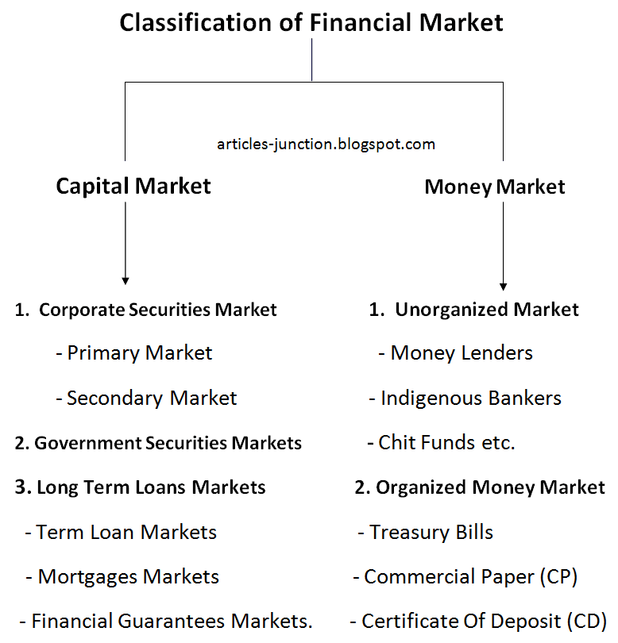

This discusses the main functions of financial intermediaries and financial markets, and their comparative roles. Financial systems, i.e. financial intermediaries and financial markets, channel funds from those who have savings to those who have more productive uses for them. They perform two main types of financial service that reduce the costs of moving funds between borrowers and lenders, leading to a more efficient allocation of resources and faster economic growth. These are the provision of liquidity and the transformation of the risk characteristics of assets.

2. What are the different sources and uses of bank fund? (4)

Ans- Uses of bank funds
- Capital expenditure: The amounts to be spent for acquiring additional fixed assets and for normal replacement and renewals are to be shown separately under the relevant periods. Moreover, the total of the figures relating to the project shone against this item should be equal to the figure of capital cost of the project as shown in the statement of cost of the project.
- Decrease in Long-term Loans: The long-term loans raised form financial institutions are repayable in installments as per the schedule of repayment agreed upon. Similarly, payment for plants and machinery purchased on deferred payment basis is to be made in an agreed manner. The installments of these payments should be shown under the respective years.
- Increase in Current Assets: Estimates about the increase in the amount of book debts, stock in trade, bills receivable and other current assets are to be shown under this head. The level of these assets increases with an increase in the level of working capital raise through short –term borrowings.
- Decrease in Use cured Loans and other current Liabilities: The short-term borrowings are to be repaid, as per the terms agreed upon. The cash credit limits are fixed on year-to-year basis and are usually renewed. The amount of such loans should not be shown as repaid.

Sources of Funds

Deposits

Reserve Funds

Shareholders Capital

Retained Earnings

Rajasthan Institute of Engineering & Technology, Jaipur
University Roll No. ______________

II Year MBA IV Semester I Mid Term Examination, Feb – 2019
Subject: - Banking & Insurance SET-A
Time: -2 Hrs. [Maximum Marks: -20]
[Min. Passing Marks: 08]
Instructions to the Candidates:
Attempt any 4 questions from Section A and Section B is Compulsory.
Section A
1 What are the major functions of financial system? (3)
Ans- The financial system acts as a connecting link between savers of money and users of money and thereby promotes faster economic and industrial growth. Efficient functioning of the financial system enables proper flow of funds from investors to productive activities which in turn facilitates investment.
The formal financial system consists of four components:
- Financial institutions,
- Financial markets,
- Financial instruments and
- Financial services.

A financial institution (FI) is a company engaged in the business of dealing with monetary transactions, such as deposits, loans, investments and currency exchange.

Financial instruments are monetary contracts between parties. They can be created, traded, modified and settled. They can be cash (currency), evidence of an ownership interest in an entity (share), or a contractual right to receive or deliver cash (bond).

Financial services are the economic services provided by the finance industry, which encompasses a broad range of businesses that manage money, including credit unions, banks, credit-card companies, insurance companies, accountancy companies, consumer-finance companies, stock brokerages, investment funds etc.

2 Write detailed note on technological trends in banking. (3)
Ans- Technology Application in Banks
Indian banking industry adopted various technology applications in
banking. They are classified in to:
1) Data Warehousing
2) Data Mining
3) Electronic Data Interchange
4) Corporate Web Sites
5) Management Information System
Data warehouse
Data warehouse is a repository of an organization's electronically stored data. Data warehouses are designed to facilitate reporting and analysis. A data warehouse houses a standardized, consistent, clean and integrated form of data sourced from various operational systems in use in the organization, structured in a way to specifically address the reporting and analytic requirements.

Data mining
Data mining is the process of extracting patterns from data. As more data are gathered, with the amount of data doubling every three years. data mining is becoming an increasingly important tool to transform these data into information.

Electronic Data Interchange (EDI)
Electronic Data Interchange (EDI) refers to the structured transmission of data between organizations by electronic means. It is used to transfer electronic documents from one computer system to another, i.e. from one trading partner to another trading partner.

Corporate Website
A corporate website or corporate site is an informational website operated by a business or other private enterprise such as a charity or non-profit foundation.

Management Information System (MIS)
A management information system (MIS) is a subset of the overall internal controls of a business covering the application of people, documents, technologies, and procedures by management accountants to solve business problems such as costing a product, service or a business-wide strategy.

3 What are the monetary policy implications on bank? (3)
Ans- Impacts of Monetary Policy

Borrowing
The Federal Reserve sets the interest rate at which banks borrow money from them. When the Fed lowers interest rates, they make it cheaper for banks to access money, which in turn makes banks more likely to lend to businesses and consumers. Your business's ability to borrow or establish a line of credit can be largely affected by how expensive or cheap it is for banks to get money.

Interest Rates
The primary thing the Fed controls is the interest rate for banks to borrow money. Not surprisingly, banks turnaround and pass the savings or cost on to their borrowers. When the real interest rate is set low for banks, commercial and consumer interest rates also tend to run lower, making loans more affordable.

Foreign Exchange
Interest rates and the value of the dollar have a distinct relationship. When the Federal Reserve makes the cost of borrowing cheaper, more money starts flowing in the economy. The more dollars that are out there, the less each one is worth. The dollar value drops. Often, when the Fed drops interest rates, it intends to lower the dollar's value in order to make U.S. goods more affordable, and therefore, increase U.S. exports, which can foster growth in business and jobs.

Inflation
During a time of low interest rates and increased money flowing through the economy, inflation can occur if economic production and employment do not increase. Stagnant business, despite increased cash, means that more money is chasing fewer goods and prices rise. One of the goals of monetary policy is to prevent excessive inflation while fostering economic growth.
4 Explain the major difference between PoA and LoA? (3)
Ans- Power Of Attorney (PoA) Is Different From Letter Of Authority (LoA)
If you are going abroad and want someone else to handle all your personal affairs like business and other legal matters then you need to authorize that person for the same. You can do this by handed over a written document which can either be a ‘Power Of Attorney’ or a ‘Letter of Authority’. But here comes the very important question ‘ What is the difference between Power Of Attorney (PoA) and Letter Of Authority (LoA)?’. So let have a look what this documents are and which one is useful to you for your need :-
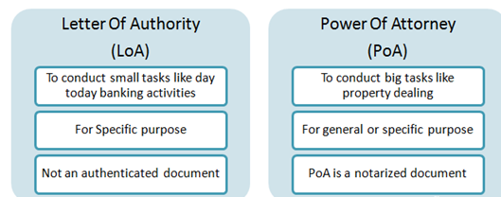

Letter Of Authority (LoA)- Letter of Authority (LoA) is a letter which authorizes one to act on someone’s behalf for some specific purposes. This written document offers authority but limited for some defined purpose or some other small works on behalf of the original person. It is not only limited for some specific purposes but also offers small powers which let the holder perform some regular tasks only like routine banking transactions, submission or collection of some important documents etc..
- Holder of Letter of Authority should act on behalf of the assignee under the limits of the authorities delegated to him but acting beyond limits only in case of some emergency can save him from legal actions.
- Assignee of Letter Of Authority should cancel the agreement on completion of the task for which the authority has been assigned and intimate the same to the third party involved in the transaction.

5 Define the retail banking advantages and disadvantages. (3)
Advantages of retail banking
Retail banking is mass market banking, where individual consumer’s diverse needs are fulfilled at the local level i.e. by providing multiple products.5 It has been facilitated by growth of banking technology and automation of banking process.
Retail banking has the following advantages:-
· Retail deposits are stable and constitute core deposits.
· They are interest insensitive and less bargaining for additional interest.
· Effective customer relationship management with retail customers builds a strong customer base.
· Retail banking increases the subsidiary business of banks.
· Retail banking results in better yield and improved bottom line for banks.
· Retail segment is a good avenue for funds deployment.
· Consumer loans are presumed to be of lower risk and NPA perception.
· Improves lifestyle and fulfils aspirations of people through affordable credit.
· Retail banking provides an opportunity for banks to innovate banking products as per the expectations of various classes of customers.
Retail banking involves minimum marketing efforts in a demand-driven economy.
· Diversified portfolio due to huge customer base enables banks to reduce their dependence on a few or single borrower.
· Banks can earn good profits by providing non-fund based or fee based services without deploying their funds.
· Credit risk tends to be well diversified as loan amounts are relatively small.

Disadvantages of retail banking
· There can be problems in managing large number of clients, especially if IT systems are not sufficiently robust.
· The cost of maintaining branch networks and handling large number of low value transactions tend to be relatively high.
· Designing own and new financial products is very costly and time consuming for the bank.
· Though banks are investing heavily in technology; they are not able to exploit it to the maximum.
· Major disadvantages are monitoring and follow-up of huge volume of loan accounts inducing banks to spend heavily on the human resource department.
· Long term loans like housing loan, due to its long repayment term, can become NPA in the absence of proper follow-up.

6 Write detailed note on evolution of baking technology. (3)
Evolution of banking technology in India-
The usage of information technology (IT), broadly referring to computers and peripheral equipment, has seen tremendous growth in service industries in the recent past. The most obvious example is perhaps the banking industry, where through the introduction of IT related products in internet banking, electronic payments, security investments, information exchanges (Berger, 2003), banks now can provide more diverse services to customers with less manpower.
Phases of Banking Technology in India
Technological innovation in general and information technology (IT)applications in particular, have had a major effect in banking and finance.
Outstanding IT-based innovations are considered and grouped into four distinct periods: early adoption, specific application, emergence and diffusion and their periods based on Indian scenarios are-
• Early adoption (1960-1980),
• Specific application (1980-1990),
• Emergence (1990-2000) and
• Diffusion (2000-till date).

Section B
1 Banks are the hub for providing fee based and fund based financial services; discuss the services. (4) Ans- Fee Based Banking Services
Banks earn their income in two parts. One type of income is generated by undertaking risk i.e. by lending their deposits. This is called interest income and forms the major portion of any bank’s earnings. However, banks can also generate earnings from other sources wherein they do not have to lend money or collect interest. Such sources are called fee based banking services and form an important part of any banks profit and loss statement. In this article we will list down the various sources from which banks can generate non interest i.e. fee based income.

Cards

Commissions

Capital Market Advisory
Banks often assist corporations in their debt issues in the bond market. They understand the macro-economic conditions very well given their vast experience with capital markets. Hence, they can advise corporations regarding the quantum of debt to be issued, the interest rate at which it needs to be issued as well as the time when issuing such debt would make selling it easier.
Banks usually do not underwrite these debt issues. Instead, they simply charge a flat fee for the advise that they provide and the expertise that they bring to the table.

Demand Drafts and Pay Orders
Demand drafts are different from negotiable instruments like cheques. When a bank issues a demand draft, it is no longer the customer’s credibility which is at stake. Unlike cheques, demand drafts are issued by banks and therefore are paid and settled by banks on their own account. The bank is therefore providing a kind of guarantee to the party accepting the demand draft.

Guarantees
Banks also provide the service of providing guarantees for a given fee. This service is used to bridge the trust gap between two parties. For instance, party A wants an advance payment whereas party B is willing to pay only after the work is completed. Neither party is willing to trust the other party. In such a case party B can deposit the funds with a bank and the bank can issue a guarantee to party A.

Account Related Fees
Banks also charge a wide variety of fees in order to maintain their customer’s accounts. For instance when customers request checkbooks or additional debit cards, they are charged a fee. Besides, banks also charge penalties if the deposits maintained fall below a certain limit. They also charge fees if there are more than a certain number of withdrawals made within a given time period. Some form of payments made via bank accounts also result in fees being charged to the account.

Lockers
Lastly, banks also provide locker services to their customers. This was what the business of banking was originally about and most banks offer this service till date. Customers can store their valuables in the safe vaults of the bank and benefit from the extensive security that the bank has arranged for.

Fund Based Services
Working Capital Finance, Short Term Finance, Bill Discounting, Export Finance, Term Lending, Buyer’s Credit / Supplier’s Credit for MSME Sector

2 Explain the structure of financial institutions. (4)
Financial Institutions
- Financial institutions are the firms that provide access to the financial markets;
- They sit between savers and borrowers and so are known as financial intermediaries.
- Banks, insurance companies, securities firms and pension funds
- A system without financial institutions would not work very well for three reasons
- Individual transactions between saver-lenders and borrower-spenders would be extremely expensive.
- Lenders need to evaluate the creditworthiness of borrowers and then monitor them, and individuals are not equipped to do this.
- Most borrowers want to borrow long term, while lenders favor short-term loans

Role of Financial Institutions
- Reduce transactions cost by specializing in the issuance of standardized securities
- Reduce information costs of screening and monitoring borrowers.
- Curb information asymmetries, helping to ensure that resources flow into their most productive
- uses
- Make long-term loans but allow savers ready access to their funds.
- Provide savers with financial instruments (more liquid and less risky than the individual stocks
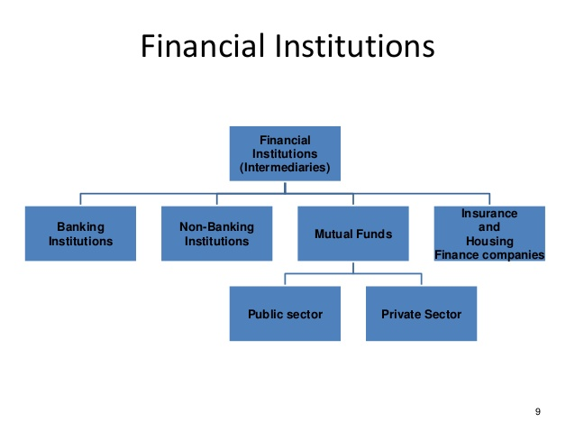
- and bonds) that savers would purchase directly in financial markets

