Rajasthan Institute of Engineering & Technology, Jaipur
University Roll No. ______________
1st year MBA. Semester II I Mid Term Examination, Feb– 2019
Subject: - FM (M-203) SET-A
Time: - 2 Hrs. [Maximum Marks: -20]
[Min. Passing Marks: 08]
Instructions to the Candidates:
Attempt any 4 questions from Section A and Section B is Compulsory.
Section A
Q 1. Explain the objective of financial management in detail. (3)
DEFINITION OF FINANCE
Finance may be defined as the art and science of managing money. It includes financial service and financial instruments. Finance also is referred as the provision of money at the time when it is needed. Finance function is the procurement of funds and their effective utilization in business concerns.

According to Khan and Jain, “Finance is the art and science of managing money”.
OBJECTIVES OF FINANCIAL MANAGEMENT
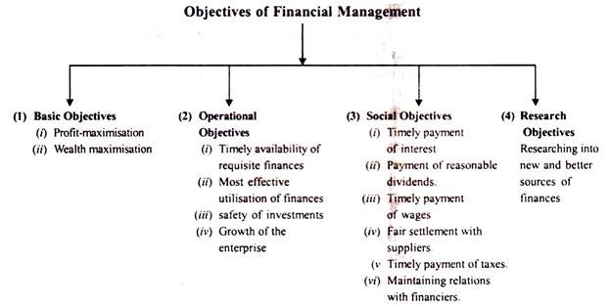

Q 2. What are the sources of long term finance? (3)
Ans- Long term finance refer to those requirements of funds which are for a period exceeding 5-10 years.
Shares- A shares indicates a smaller unit into which the overall requirement of a company is subdivided.
TYPES OF SHARES
THERE ARE TWO TYPES:
- Equity shares
- Preference shares
Debentures- It means a document containing acknowledgement of indebtedness issued by a company and giving an undertaking to repay the debt at a specified date.
Retained earnings- Retained earnings means that part of trading profits which is not distributed in the form of dividends but retained by directors for future expansion of the company.
GDRs :-A negotiable certificate held in the bank of one country representing no. of shares traded on the exchange of another country.
ADRs :-It allows US investors to buy shares of ADS companies without the cost of investing directly in Foreign Stock Exchange.
IDRs :-It allows foreign companies to raise the funds from Indian markets.
Venture capital- The venture capital financing refers to financing & funding of the small scale enterprises, high technology & risky volumes
Securitization- Securitization is a process in which liquid assets are pooled into marketable securities that can be sold to investors.
Q 3. Mr. X deposited Rs. 4,000 at the end of every year for 5 years in his saving account paying 10% interest compounded annually. He wants to determine, how much sum of money he will have at the end of the 5th year?(3)
Solution-
Deposit amount | Compounded years | Compound value(future value) | Compound sum
4000 | 4 | 1.464 | 5856
4000 | 3 | 1.331 | 5324
4000 | 2 | 1.210 | 4840
4000 | 1 | 1.110 | 4440
4000 | 0 | 1.000 | 4000
Total |  |  | 24460

So the sum of money he have at the end of the 5th year will be Rs. 24460.
Q 4. What do you understand by shares as sources of finance? (3)
Ans- Shares- A shares indicates a smaller unit into which the overall requirement of a company is subdivided.
TYPES OF SHARES
THERE ARE TWO TYPES:
- Equity shares
- Preference shares
Equity Shares- An equity share, commonly referred to as ordinary share also represents the form of fractional or part ownership in which a shareholder, as a fractional owner, undertakes the maximum entrepreneurial risk associated with a business venture. The holders of such shares are members of the company and have voting rights.
Preference shares- Preference shares, more commonly referred to as preferred stock, are shares of a company's stock with dividends that are paid out to shareholders before common stock dividends are issued. If the company enters bankruptcy, the shareholders with preferred stock are entitled to be paid from company assets first.

Q 5. What do you mean by unsystematic risk? Explain in detail. (3)
Ans- Unsystematic risk, also known as "specific risk," "diversifiable risk" or "residual risk," is the type of uncertainty that comes with the company or industry you invest in. Unsystematic risk can be reduced through diversification.
To reduce or eliminate this risk, investors diversify their portfolios by buying shares of different sectors, companies, and geographical regions. The greater the diversification, the lower the residual risk in the overall position. Unsystematic risk is measured and managed through the implementation of various risk management tools, including the derivatives market.

Types of unsystematic risk-
- Credit Risk (also known as Default Risk)
- Country Risk.
- Political Risk.
- Reinvestment Risk.
- Interest Rate Risk.
- Foreign Exchange Risk.
- Inflationary Risk.
- Market Risk.
Q 6 Write down structure of Indian financial system. (3)
Financial System refers to the financial needs of different sectors of the economy and the ways and means to meet such needs efficiently and economically. Funds are required for meeting various monetary needs.
The financial needs are met from different sources and agencies.
Indian Financial System

The financial system acts as a connecting link between savers of money and users of money and thereby promotes faster economic and industrial growth.
Thus financial system may be defined as “a set of markets and institutions to facilitate the exchange of assets and risks.”
Efficient functioning of the financial system enables proper flow of funds from investors to productive activities which in turn facilitates investment.
Section B
1. Write short note on any two:- (4)
- Time value of money 3) Capital Budgeting
- Finance Decision 4) Formula of ARR and payback Period

1) Time value of money- Time value of money is the premise that an investor prefers to receive a payment of a fixed amount of money today, rather than an equal amount in the future, all else being equal.
Calculations based on the time value of money-
- Present Value (PV) of an amount that will be received in the future.
- Future Value (FV) of an amount invested (such as in a deposit account) now at a given rate of interest.
- Present Value of an Annuity (PVA)
- Future Value of an Annuity (FVA)
2) Finance Decision- Investment Decision relates to the determination of total amount of assets to be held in the firm, the composition of these assets and the business risk complexions of the firm as perceived by its investors. It is the most important financial decision. Since funds involve cost and are available in a limited quantity, its proper utilization is very necessary to achieve the goal of wealth maximization.
Stages in Investment Process-
- Generating alternative investment proposals
- Estimating the incremental cash flows associated with projects
- Estimation of required rate of return (opportunity cost of capital)
- Evaluating and selecting project
3) Capital Budgeting- Capital Budgeting is the process of evaluating and selecting long-term investment projects that achieve the goal of owner wealth maximization.
- Features of investment decision:
1. Exchange of current funds for future benefits
- funds are invested in long term assets
- future benefits will occur to firm over a series of year
- The purposes of Capital Budgeting Projects include: to expand, replace, or renew fixed assets over a long period.
- requires intensive planning
- As It involve commitment of financial resources to a project on a long-term basis, it is important that a firm makes the right decision.
- A wrong decision can lead to huge financial distress and even bankruptcy for a firm.
- The longer the time horizon associated with a capital expenditure, the greater the uncertainty ( outflow and inflow, product life, economic conditions, cost of capital, technological change)
4) Formula of ARR and payback Period-
ARR- Average Annual Income after tax and depreciation/ Average Investment*100
Average Annual Cash Inflows- Annual Depreciation/ Average Investment*100
Payback period- Initial investment/Annual cash inflows
2. . Write a detailed note on short term sources of finances.
Ans- Working Capital-Commercial banks grants short terms finance to business firms which is known as “Bank Credit”.
Bank Credit may be granted in the following ways:-
- Loans
- Purchase/ Discounting of bills.
- Cash Credit
- Over draft
Trade Credit- Trade credit represents credit granted by the suppliers of goods, etc. as an incident of sale.
Inter Corporate deposits- A deposit made by one company to another is called as inter-corporate deposit.
Factoring- Factoring is an agreement in which receivable arising out of sale are sold by a firm (client) to the factor (a financial intermediary).

Rajasthan Institute of Engineering & Technology, Jaipur
University Roll No. ______________
1st year MBA. Semester II I Mid Term Examination, Feb– 2019
Subject: - FM (M-203) SET-B
Time: - 2 Hrs. [Maximum Marks: -20]
[Min. Passing Marks: 08]
Instructions to the Candidates:
Attempt any 4 questions from Section A and Section B is Compulsory.
Section A
Q 1. “Systematic Risk is a macro in nature as it affects a large number of organizations operating under a similar stream or same domain” comment on this statement (3)
Ans- Systematic risk, also known as "market risk" or "un-diversifiable risk", is the uncertainty inherent to the entire market or entire market segment. Also referred to as volatility, systematic risk consists of the day-to-day fluctuations in a stock's price.
Interest rate changes, inflation, recessions and wars all represent sources of systematic risk because they affect the entire market. Systematic risk underlies all other investment risks. The Great Recession provides a prime example of systematic risk. ... Unsystematic risk can be mitigated through diversification.
Systematic risk can negatively impact stock prices during times of high volatility and market risk. Systematic risk refers to the inherent risk in the entire marketplace or in a particular market segment

Q 2. Write short note on the following-
- Debentures
- Preference Share Capital
- Shares (3)
Ans-
- Debentures- It means a document containing acknowledgement of indebtedness issued by a company and giving an undertaking to repay the debt at a specified date.
- Preference Share Capital- ‘preference share capital’’, with reference to any company limited by shares, means that part of the issued share capital of the company which carries or would carry a preferential right with respect to—(a) payment of dividend, either as a fixed amount or an amount calculated at a fixed rate, which may either be free of or subject to income-tax; and
(b) repayment, in the case of a winding up or repayment of capital, of the amount of the share capital paid-up or deemed to have been paid-up, whether or not, there is a preferential right to the payment of any fixed premium or premium on any fixed scale, specified in the memorandum or articles of the company;
(iii) Capital shall be deemed to be preference capital, notwithstanding that it is entitled to either or both of the following rights, namely:—
(a) that in respect of dividends, in addition to the preferential rights to the amounts specified in sub-clause (a) of clause (ii), it has a right to participate, whether fully or to a limited extent, with capital not entitled to the preferential right aforesaid;
(b) that in respect of capital, in addition to the preferential right to there payment, on a winding up, of the amounts specified in sub-clause (b) of clause
( ii), it has a right to participate, whether fully or to a limited extent, with capital not entitled to that preferential right in any surplus which may remain after the entire capital has been repaid.
- Shares- A shares indicates a smaller unit into which the overall requirement of a company is subdivided.
TYPES OF SHARES
THERE ARE TWO TYPES:
- Equity shares
- Preference shares
Equity Shares- An equity share, commonly referred to as ordinary share also represents the form of fractional or part ownership in which a shareholder, as a fractional owner, undertakes the maximum entrepreneurial risk associated with a business venture. The holders of such shares are members of the company and have voting rights.
Preference shares- Preference shares, more commonly referred to as preferred stock, are shares of a company's stock with dividends that are paid out to shareholders before common stock dividends are issued. If the company enters bankruptcy, the shareholders with preferred stock are entitled to be paid from company assets first.

Q 3. Explain scope and functions of financial management (3)
Ans- Functions of Finance Management-
- Forecasting Financial Requirements
- Acquiring Necessary Capital
- Investment Decision
- Cash Management
- Interrelation with Other Departments

Scope of Financial Management-
- Financial Management and Economics
- Financial Management and Accounting
- Financial Management or Mathematics
- Financial Management and Production Management
- Financial Management and Marketing
- Financial Management and Human Resource

Q 4. Define financial management. Briefly discuss the functions of financial management. (3)
Ans- Financial management is an integral part of overall management. It is concerned with the duties of the financial managers in the business firm.
Thus, Financial Management is mainly concerned with the effective funds management in the business. In simple words, Financial Management as practiced by business firms can be called as Corporation Finance or Business Finance.
Functions of Finance Management-
- Forecasting Financial Requirements
- Acquiring Necessary Capital
- Investment Decision
- Cash Management
- Interrelation with Other Departments

Q 5. Mr. Z deposited Rs. 5,000 at the end of every year for 6 years in his saving account paying 10% interest compounded annually. He wants to determine, how much sum of money he will have at the end of the 6th year?(3)
Solution-
Deposit amount | Compounded years | Compound value(future value) | Compound sum
5000 | 5 | 1.611 | 8055
5000 | 4 | 1.464 | 7320
5000 | 3 | 1.331 | 6655
5000 | 2 | 1.210 | 6050
5000 | 1 | 1.110 | 5550
5000 | 0 | 1.000 | 5000
Total |  |  | 38630

So the sum of money he have at the end of the 6th year will be Rs. 38630.

Q 6. Distinguish between financing decision and investing decision. (3)
When we take up a project, we really need to understand that we are making two decisions not one. The first decision is regarding the assets that we must invest in. This means that if we are opening up a restaurant we need to consider what the real estate would cost, what the improvements would cost to create the desired ambience, what the kitchen equipment would cost and so on. Then we must consider the returns that these investments will generate. This is the investing decision.
Now, the above investments could be done from spare cash that the company has, the company could sell more stock to raise the funds or they could even borrow to raise the funds for the project. How the company raises money for the project is an investment decision. Each of the above options has its own related costs. For instance debt will have interest cost, equity will have dividend cost etc. But that does not really change the cash flows of the project, does it?
The restaurant (investment) will generate the same returns regardless of how it is financed. Financing merely changes the people entitled to those profits. It does not change the amount of profits that are earned by the project.
Section B
Q 1. Write short note on any two-
- Equity Share 3. Private Equity
- GDR and ADR 4. Debenture (4)
1. Equity Shares- An equity share, commonly referred to as ordinary share also represents the form of fractional or part ownership in which a shareholder, as a fractional owner, undertakes the maximum entrepreneurial risk associated with a business venture. The holders of such shares are members of the company and have voting rights.

2. GDRs :-A negotiable certificate held in the bank of one country representing no. of shares traded on the exchange of another country.
ADRs :-It allows US investors to buy shares of ADS companies without the cost of investing directly in Foreign Stock Exchange.
3. Private equity- It is capital that is not noted on a public exchange. Private equity is composed of funds and investors that directly invest in private companies, or that engage in buyouts of public companies, resulting in the delisting of public equity. Institutional and retail investors provide the capital for private equity, and the capital can be utilized to fund new technology, make acquisitions, expand working capital, and to bolster and solidify a balance sheet.
4. Debentures- It means a document containing acknowledgement of indebtedness issued by a company and giving an undertaking to repay the debt at a specified date.
Types of debentures-
Redeemable
Irredeemable
Convertible
Non-convertible

Q 2. Explain the Changing role of finance managers in contemporary business environment.
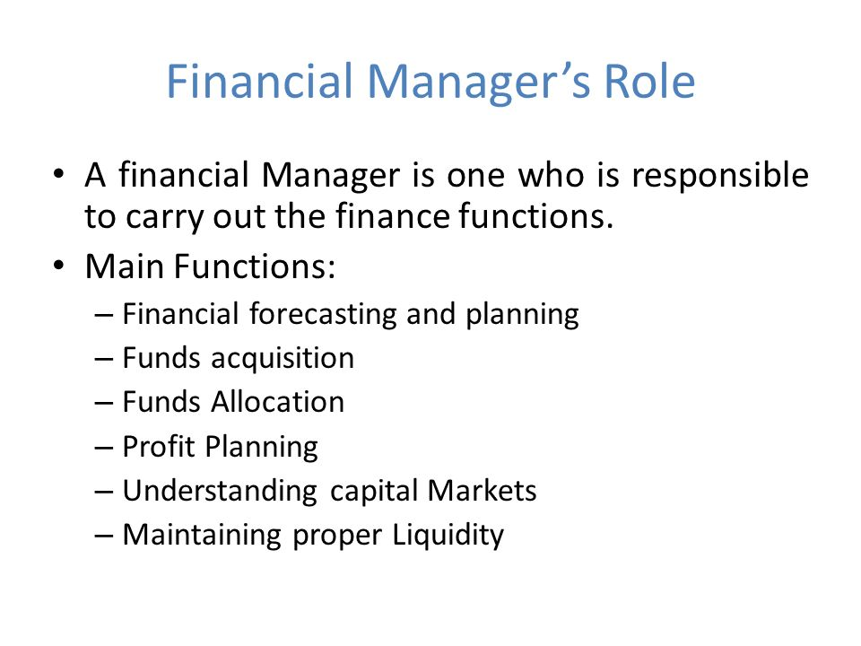
Ans-

- Forecasting Financial Requirements
- Acquiring Necessary Capital
- Investment Decision
- Cash Management
- Interrelation with Other Departments

