Rajasthan Institute of Engineering & Technology, Jaipur
University Roll No. ______________

1ST year MBA Semester III, I Mid Term Examination, March 2018
Subject: - Marketing Management
SET-B

Time: - 2 Hrs. [Maximum Marks: -20]
[Min. Passing Marks: 08]

Instructions to the Candidates:
Attempt any 4 questions from Section A and Section B is Compulsary for all.
Section A
- Differentiate between Consumer and Customer. (3)
Ans :
Basis for Comparison | Customer | Consumer
Meaning | The purchaser of goods or services is known as the Customer. | The end user of goods or services is known as a Consumer.
Resell | A customer can be a business entity, who can purchase it for the purpose of resale. | No a consumer does not resell the products.
Purchase of goods | Yes | Not necessary
Purpose | Resale or Consumption | Consumption
Price of product or service | Paid by the customer | May not be paid by the consumer
Person | Individual or Organization | Individual, Family or Group of people

- Explain the elements of marketing . (3)
Ans : The elements of marketing are :

NEED : Human needs are states of felt deprivation. Needs are the basic requirements of human being, without these basic requirements like food, cloths and shelter no one can live life in this world. The extended form of needs are health and education which for sure every on basic need in today’s world but they come after food, clothEs and shelter. Marketers play no role in creating needs, they are natural default requirements of every human being. Organization already know the needs there is no requirement for any research work to develop product which covers the needs of human beings.

Wants :
Wants are the form human needs take as they are shaped by culture and individual personality. Wants are marketed by marketers in such a way that everyone feel these wants should be mandatory part of life. We can take the examples of telephone, Internet, different variety of foods and clothing these all come under umbrella of human wants.
For Example : Any person can eat food to feed himself, but he want to eat fast food, fried rice and Chinese food. Cloths are required for a person to cover himself but we can see people wearing jeans, suit just because of culture influence.

Demands:
Demand is want backed by buying power, human being have unlimited wants but resource are limited in the world. Its not possible that each human being get the desire things in the world. Wants are wishes of human, buying power will convert these wants to demand.
For Example :Willingness to buy BMW is want but if you have the buying power then it becomes demand. Manager and marketers always focus on people wants and demands to do that they conduct in depth research using number of different tools such as surveys, interviews, observation and others. That’s the reason CEO of huge company like Wal-Mart visit store to have a check on customer, talk to them, observe them to understand their needs and Wants.
- Explain the concept of Micro environment. (3)
Ans: 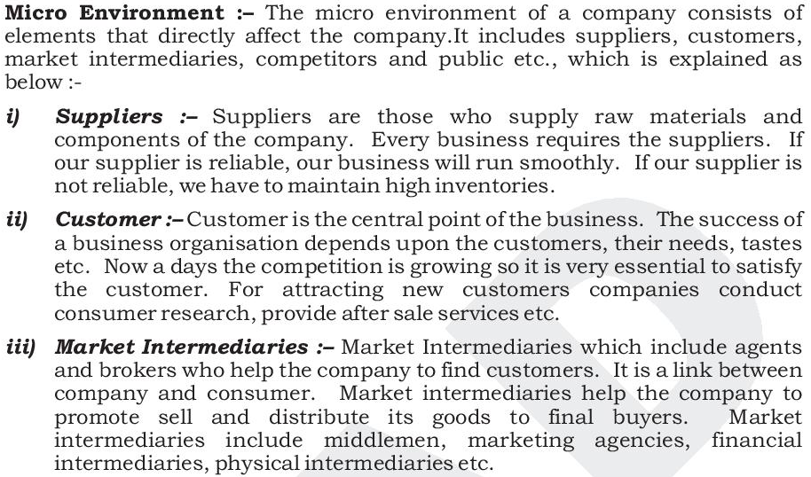
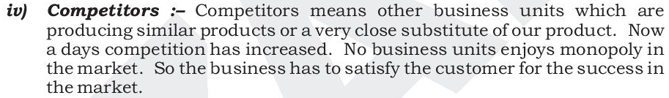
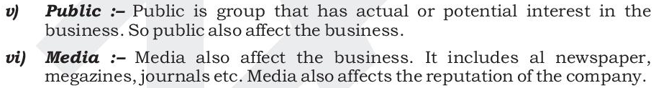

- What do you understand by marketing information system ?
Ans: A marketing information system (MKIS) is defined a set of procedures and methods designed to generate, analyze, disseminate, and store anticipated marketing decision information on a regular, continuous basis. An information system can be used operationally, managerially, and strategically for several aspects of marketing.
A Marketing Information System can also be defined as 'a system in which marketing data is formally gathered, stored, analysed and distributed to managers in accordance with their informational needs on a regular basis' A marketing information system can be used operationally, managerially, and strategically for several aspects of marketing.
Advantages of Marketing Information System :
The advantages of a Marketing information system are
1. Organized data collection.
2. A broad perspective.
3. The storage of important data.
4. An avoidance of crises.
5. Coordinated marketing plans.
6. Speed in obtaining sufficient information to make decisions.
7. Data amassed and kept over several time periods.
8. The ability to do a cost-benefit analysis.
Disadvantages of Marketing Information System:
The disadvantages of a Marketing information system are
- high initial time
- labor costs and
- the complexity of setting up an information system.
- Marketers often complain that they lack enough marketing information or the right kind,
- have too much of the wrong kind.

5. Explain the targeting strategies. (3)
Ans : Targeting : Market targeting is a process of selecting the target market from the entire market. Target market consists of group/groups of buyers to whom the company wants to satisfy or for whom product is manufactured, price is set, promotion efforts are made, and distribution network is prepared.

LIMITED COVERAGE MARKET TARGETING :
1. Single Segment Concentration:
It is the simplest case. The company selects only a single segment as target market and offers a single product. Here, product is one; segment is one. For example, a company may select only higher income segment to serve from various segments based on income, such as poor, middleclass, elite class, etc. All the product items produced by the company are meant for only a single segment.
2. Selective Specialization:
In this option, the company selects a number of segments. A company selects several segments and sells different products to each of the segments. Here, company selects many segments to serve them with many products. All such segments are attractive and appropriate with firm’s objectives and resources.
There may be little or no synergy among the segments. Every segment is capable to promise the profits. This multi-segment coverage strategy has the advantage of diversifying the firm’s risk. Firm can earn money from other segments if one or two segments seem unattractive. For example, a company may concentrate on all the income groups to serve.
3. Product Specialization:
In this alternative, a company makes a specific product, which can be sold to several segments. Here, product is one, but segments are many. Company offers different models and varieties to meet needs of different segments. The major benefit is that the company can build a strong reputation in the specific product area. But, the risk is that product may be replaced by an entirely new technology. Many ready-made garment companies prefer this strategy.
4. Market Specialization:
This strategy consists of serving many needs of a particular segment. Here, products are many but the segment is one. The firm can gain a strong reputation by specializing in serving the specific segment. Company provides all new products that the group can feasibly use. But, reduced size of market, reduced purchase capacity of the segment, or the entry of competitors with superior products range may affect the company’s position.
5. Full Market Coverage:
In this strategy, a company attempts to serve all the customer groups with all the products they need. Here, all the needs of all the segments are served. Only very large firm with overall capacity can undertake a full market coverage strategy.

METHODS OF FULL MARKET COVERAGE:

Undifferentiated Marketing: undifferentiated targeting strategy is used when a company decides to communicate the benefits of its product by sending the same promotional message to everyone. For an undifferentiated strategy to be successful, the company's product must be readily available and affordable and must provide the same benefits to all consumers. Very few companies with consumer products meet these criteria

Differentiated Marketing : A differentiated marketing strategy is when a company creates campaigns that appeal to at least two market segments or target groups. For example, a store can promote a sale that appeals to people in at least two cities or locations, or a company can market a product that appeals to women in at least two age groups.

Concentrated Marketing: A concentrated marketing strategy is targeted to one specific market segment or audience. For example, a company might market a product specifically for teenage girls, or a retailer might market his business to residents in a specific town.

Micromarketing: Micromarketing is a marketing strategy in which advertising efforts are focused on a small group of highly targeted consumers. Micromarketing requires a company to narrowly define an audience by a specific characteristic, such as ZIP code or job title, and tailor campaigns for that particular segment.

6. What is market Positioning ? (3)

Ans : Market Positioning refers to the ability to influence consumer perception regarding a brand or product relative to competitors. The objective of market positioning is to establish the image or identity of a brand or product so that consumers perceive it in a certain way.
For example:
- A handbag maker may position itself as a luxury status symbol
- A TV maker may position its TV as the most innovative and cutting-edge
- A fast-food restaurant chain may position itself as the provider of cheap meals
To Create an Effective Market Positioning Strategy :

Create a positioning statement that will serve to identify your business and how you want the brand to be perceived by consumers.

For example, the positioning statement of Volvo: “For upscale American families, Volvo is the family automobile that offers maximum safety.”

1. DETERMINE COMPANY UNIQUENESS BY COMPARING TO COMPETITORS
Compare and contrast differences between your company and competitors to identify opportunities. Focus on your strengths and how it can exploit these opportunities.

2. IDENTIFY CURRENT MARKET POSITION
Identify your existing market position and how the new positioning will be beneficial in setting you apart from competitors.

3. COMPETITOR POSITIONING ANALYSIS
Identify the conditions of the marketplace and the amount of influence each competitor can place on each other.

4. DEVELOP A POSITIONING STRATEGY
Through the preceding steps, you should achieve an understanding of what your company is, how your company is different from competitors, the conditions of the marketplace, opportunities in the marketplace, and how your company can position itself.

SECTION B

7 .Explain the factors affecting marketing environment. (4)
Ans : “A company’s marketing environment consists of the actors and forces outside of marketing that affect marketing management ability to build and maintain successful relationships with target customers”.
– Philip Kotler
In other words, a firm is surrounded by internal and external force which have a great effect on firm’s ability to maintain lasting relation with target customers.

Internal Environment factors
The internal marketing environment of a firm comprises all those factors which are inside firm, including the firms' employees, firms policies, firms capital assets, firms organizational structure and its products and services. Firm can control these factors.

External Marketing Environment
External marketing environment consist both Micro environment and Macro Environment. These factors are not controlled by a firm, but they greatly influence the decision of marketers during marketing strategy.

Micro Environment Factors
The Supplier: Business success depends on the suppliers when they enjoy an authority. The supplier of a company holds the power when they are the only one in market or when they are the largest supplier of the goods. The buyer is not essential to the suppliers business, as the supplier’s good is core ingredient of the finished product of buyer.
The Resellers: The success of companies marketing strategy also depends on resellers if the finished goods of a company is taken to market by market intermediaries or any other third party. These forces include wholesaler, retailers etc. For example If the retail seller holds a reputable name in the market then their reputation can impact the marketing of company’s product.
The Customers: The success of marketing strategy also depends on the customers of company’s product. The nature of customer such as b2c, b2b, international or local and the reason for buying the product will play a role in establishing the marketing strategy of company and how they approach the customers and serve them.

The Competition: Market competition exists when two or more firms sell same or similar products and services. The companies must take into account the way they approach the customers and sell their products to the customer, what price and product differentiation they have for their customer. These factors can be taken into account to get edge over their competitors.
The General Public: The satisfaction of general public is a duty of organization. Company must take decisions while taking the perspective of general public into consideration and how they will get affected by their decision. The customers hold the power to make a win-win situation for a company by helping it reach the goals.

Macro Environment Factors
Demographic Factors: Demographic forces do impact the different market segments, which includes region, country, age, educational level, ethnicity, lifestyle, cultural norms and values.
Economic Factors: The organization production and decision making process of customer also affected by the economic environment.
Natural/physical Factors: The Company must take into account the renewal of the natural resources of the earth such as agricultural product, forest, marine resources etc. The organizations production can also be affected by the non renewable resources which includes coal, oil mineral.
Technological factors: The organization must consider the technological factors as the knowledge and skills used in production of goods. The technology and materials used in production of goods and services helps in smoothing the process of business.
Political and Legal Factors: The organization should take into consideration the political and legal development relating to market and organization during decision-making process.
Social and Cultural Forces: The impact of your organization’s services and products on the society must be taken into consideration. If there is any element used in production process or product that is harmful to society should be avoided as it is a social responsibility of an organization. A most recent example is the environment and the organizations and sectors who have reviewed their services and products to be considered environmentally friendly.

8. Explain the basis of Consumer market segmentation . (4)
Ans : Definition: The Market Segmentation means dividing the entire consumer market into the subgroups, such that the customers in each group share the common set of needs and wants and have more or less similar or related characteristics.

Bases of Market Segmentation:

The firms can segment the market on the following bases:
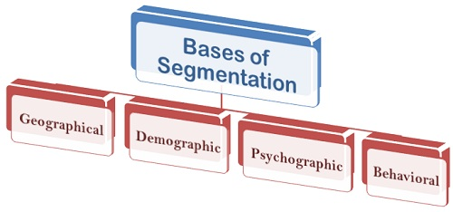
- Geographical Segmentation: Here, the segmentation is done on the basis of the geographical location of the customers. The geographical segmentation is based on the premise that people living in one area have different purchasing or buying habits than those living in other areas of the country.
For example, the banking needs of people living in rural and urban areas are different and. Therefore, different banking products and services are designed keeping in mind the different preferences of each customer group. Also, the factors like climatic zone, state, region, constitutes geographic segmentation.
- Demographic Segmentation: The demographic segmentation means dividing the customer market on the basis of several variables such as age, sex, gender, occupation, income, education, marital status, family size, community, social status, etc. Such segmentation is based on the premise, that customer’s buying behavior is very much influenced by his demographics, and moreover, these variables can be measured easily as compared to the other factors.
- Psychographic Segmentation: The psychographic segmentation relates to the personality, lifestyle, and attitude of the individual. It is believed that the consumer buying behavior can be determined by his personality and lifestyle. The personality refers to the traits, attitudes and habits of an individual and the market is segmented according to the personal traits such as introvert, extrovert, ambitious, aggressiveness, etc.
The lifestyle means the way a person lives his life and do the expenditures. Here the companies segment the market on the basis of interest, activities, beliefs and opinions of the individuals.
- Behavioral Segmentation: Here, the marketer segments the market on the basis of the individual’s knowledge about the product and his attitude towards the usage of the product. Several behavioral variables are occasions, benefits, user status, usage rate, buyer readiness stage, loyalty status and the attitude.
The buyers can be classified as those who buy the product or services occasionally, or who buy only those products from which they derive some sort of benefits. Also, there are buyers who can be called as ex-users, potential users, first-time users and regular users; the marketers can segment the market on this classification. Often, the market is segmented on the basis of the usage rate of the customers, such as light, medium and heavy users.
Thus, market segmentation helps the companies to divide the prospective customers into small groups who have similar needs and plan the marketing strategies accordingly. This enables a firm to concentrate more on a specific group and earn more profits rather than catering to the needs of the entire market who have different needs and desires.

