Rajasthan Institute of Engineering & Technology, Jaipur
University Roll No. ______________

…I. Year MCA. II…Semester …..Ist Mid-Term Examination February– 2019
Subject: - Data Structures
Time:-2 Hrs. [Maximum Marks:-20]
[Min. Passing Marks: 08]
Instructions to Candidates: -
Attempt all questions. Marks of questions are indicated against each question.

1.Answer each question. Each question carries 1 marks.

    - Abstract Data type (ADT) is a type (or class) for objects whose behavior is defined by a set of value and a set of operations.
    - Underflow happens when we try to pop an item from an empty stack. Overflow happens when we try to push more items on a stack than it can hold. An error is a mistake that is probably unrecoverable. An exception is an error that can often be handled, so the program can recover.
    - Non linear data structure are in which all the data are arranged in random manner. for example :trees, graphs.
    - a stack is a data structure used to store a collection of objects. Individual items can be added and stored in a stack using a push operation. Objects can be retrieved using a pop operation, which removes an item from the stack?
    - Deque a linear data structure in which elements may be appended to or removed from either end. Origin: Shortened from double-ended queue.

- Answer each question. Each question carries 2 marks.

- Difference array v/s linked list
BASIS FOR COMPARISON | ARRAY | LINKED LIST
Basic | It is a consistent set of a fixed number of data items. | It is an ordered set consisting of a variable number of data items.
Size | Specified during declaration. | No need to specify; grow and shrink during execution.
Storage Allocation | Element location is allocated during compile time. | Element position is assigned during run time.
Order of the elements | Stored consecutively | Stored randomly
Accessing the element | Direct or randomly accessed, i.e., Specify the array index or subscript. | Sequentially accessed, i.e., Traverse starting from the first node in the list by the pointer.
Insertion and deletion of element | Slow relatively as shifting is required. | Easier, fast and efficient.
Searching | Binary search and linear search | linear search
Memory required | Less | More
Memory Utilization | Ineffective | Efficient

Algorithm for Delete Operation in queue

Step 1: If FRONT = -1 then
Write “Queue is Underflow”
Step 2: Return QUEUE [FRONT]
Step 3: If FRONT = REAR then
FRONT = 0
REAR = 0
Else
FRONT = FRONT + 1
- Answer each question. Each question carries 3 marks.

- An array of arrays is known as 2D array. The two dimensional (2D) array in C programming is also known as matrix. A matrix can be represented as a table of rows and columns.
This program examples how to store the elements entered by user in a 2d array and how to display the elements of a two dimensional array.
#include<stdio.h>
int main(){
/* 2D array declaration*/
int disp[2][3];
/*Counter variables for the loop*/
int i, j;
for(i=0; i<2; i++) {
for(j=0;j<3;j++) {
printf("Enter value for disp[%d][%d]:", i, j);
scanf("%d", &disp[i][j]);
}
}
//Displaying array elements
printf("Two Dimensional array elements:\n");
for(i=0; i<2; i++) {
for(j=0;j<3;j++) {
printf("%d ", disp[i][j]);
if(j==2){
printf("\n");
}
}
}
return 0;
}
Output:
Enter value for disp[0][0]:1
Enter value for disp[0][1]:2
Enter value for disp[0][2]:3
Enter value for disp[1][0]:4
Enter value for disp[1][1]:5
Enter value for disp[1][2]:6
Two Dimensional array elements:
1 2 3
4 5 6

Insertion at Location in linear linked list

Algorithm

InsertAtlocDll(info,next,start,end,loc,size)
1.set nloc = loc-1 , n=1
2.create a new node and address in assigned to ptr.
3.check[overflow] if(ptr=NULL)
write:overflow and exit
4.set Info[ptr]=item;
5.if(start=NULL)
set next[ptr] = NULL
set start = ptr
else if(nloc<=size)
repeat steps a and b while(n != nloc)
a. loc = next[loc]
b. n = n+1
[end while]
next[ptr] = next[loc]
next[loc] = ptr
else
set last = start;
repeat step (a) while(next[last]!= NULL)
a. last=next[last]
[end while]
last->next = ptr ;
[end if]
6.Exit.

Types of linked lists 5 marks
1. Linear Linked List or One Way List or Singly Linked List:-
It is linear collection of data elements which are called ‘Nodes’. The elements may or may not be stored in consecutive memory locations. So pointers are used maintain linear order. Each node is divided into two parts. The first part contains the information of the element and is called ‘INFO Field’. The second part contains the address of the next node and is called ‘LINK Field’ or ‘NEXT Pointer Field’. The START contains the starting address of the linked list i.e. it contains the address of the first node of the linked list. The LINK Field of last node contains NULL Value which indicates that it is the end of linked list. It is shown below: 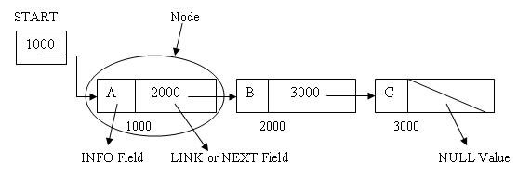
2. Doubly Linked List or Two-Way Linked List or Two-Way Chain:-
In it each node is divided into three parts:
1. The first part is PREV part. It is previous pointer field. It contains the address of the node which is before the current node.
2. The second part is the INFO part. It contains the information of the element.
3. The third part is NEXT part. It is next pointer field. It contains the address of the node which is after the current node.
There are two pointers FIRST and LAST. FIRST points to the first node in the list. LAST points to the last node in the list. The PREV field of first node and the NEXT field of last node contain NULL value. This shows the end of list on both sides. This list can be traversed in both directions that is forward and backward.
It is shown below: 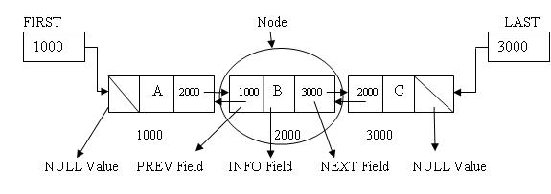
3. Circular Linked List:-
In it the last node does not contain NULL pointer. Instead the last node contains a pointer that has the address of first node and thus points back to the first node.
It is shown below:
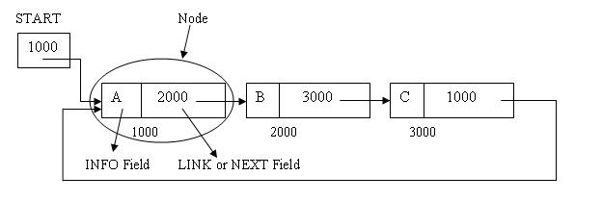

OR

4) Insertion Operation in array
Insert operation is to insert one or more data elements into an array. Based on the requirement, a new element can be added at the beginning, end, or any given index of array.
Here, we see a practical implementation of insertion operation, where we add data at the end of the array −

Algorithm
Let Array be a linear unordered array of MAX elements.

Example
Result
Let LA be a Linear Array (unordered) with N elements and K is a positive integer such that K<=N. Following is the algorithm where ITEM is inserted into the K^{th} position of LA −
1. Start
2. Set J = N
3. Set N = N+1
4. Repeat steps 5 and 6 while J >= K
5. Set LA[J+1] = LA[J]
6. Set J = J-1
7. Set LA[K] = ITEM
8. Stop

Deletion Operation
Deletion refers to removing an existing element from the array and re-organizing all elements of an array.

Algorithm
Consider LA is a linear array with N elements and K is a positive integer such that K<=N. Following is the algorithm to delete an element available at the K^{th} position of LA.
1. Start
2. Set J = K
3. Repeat steps 4 and 5 while J < N
4. Set LA[J] = LA[J + 1]
5. Set J = J+1
6. Set N = N-1
7. Stop

