SET-A
Subject: -Software engineering
II Year MCA. IV Semester Ist Mid Term Examination, February – 2018
Time: -2 Hrs. [Maximum Marks: -20]
[Min. Passing Marks: 08]
Q. 1 Answers
- Software engineering is the process of analyzing user needs and designing, constructing, and testing end user applications that will satisfy these needs through the use of software programming languages. It is the application of engineering principles to software development.
- Software requirements specification (SRS) is a description of a software system to be developed. It lays out functional and non-functional requirements, and may include a set of use cases that describe user interactions that the software must provide.
- An act of identifying something precisely or of stating a precise requirement. A standard of workmanship or materials required to be met in a piece of work.‘everything was built to a higher specification’
- Prototyping refers to an initial stage of a software release in which developmental evolution and product fixes may occur before a bigger release is initiated. These kinds of activities can also sometimes be called a beta phase or beta testing, where an initial project gets evaluated by a smaller class of users before full development.
- A data dictionary is a structured repository of data elements in the system. It stores the descriptions of all DFD data elements that is, details and definitions of data flows, data stores, data stored in data stores, and the processes.
Q. 2 Answers

- Data Flow Diagrams (DFD) or Bubble Chart.
It is a technique developed by Larry Constantine to express the requirements of system in a graphical form.
• It shows the flow of data between various functions of system and specifies how the current system is implemented.
• It is an initial stage of design phase that functionally divides the requirement specifications down to the lowest level of detail.
• Its graphical nature makes it a good communication tool between user and analyst or analyst and system designer.
• It gives an overview of what data a system processes, what transformations are performed, what data are stored, what results are produced and where they flow.
DFD Components
• Entities - Entities are source and destination of information data. Entities are represented by a rectangles with their respective names.
• Process - Activities and action taken on the data are represented by Circle or Round-edged rectangles.
• Data Storage - There are two variants of data storage - it can either be represented as a rectangle with absence of both smaller sides or as an open-sided rectangle with only one side missing.
• Data Flow - Movement of data is shown by pointed arrows. Data movement is shown from the base of arrow as its source towards head of the arrow as destination.

- The spiral model is more emphasis placed on risk analysis. It has four phases: Planning, Risk Analysis, Engineering and Evaluation. A software project repeatedly passes through these phases in iterations (called Spirals in this model). The baseline spiral, starting in the planning phase, requirements are gathered and risk is assessed. Each subsequent spirals builds on the baseline spiral.
- Planning Phase: Requirements are gathered during the planning phase. It is like ‘BRS’ and ‘SRS’.
- Risk Analysis: In the risk analysis phase, a process is undertaken to identify risk and alternate solutions. A prototype is produced at the end of the risk analysis phase. If any risk is found during the risk analysis then alternate solutions are suggested and implemented.
- Engineering Phase: In this phase software is developed, along with testing at the end of the phase. Hence in this phase the development and testing is done.
- Evaluation phase: This phase allows the customer to evaluate the output of the project to date before the project continues to the next spiral.
Diagram of Spiral model:
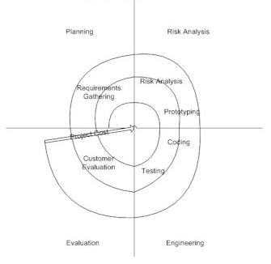
Q. 3 Answers
1) Different individuals judge software on different basis. Software characteristics are classified into six major components.
• Functionality: Refers to the degree of performance of the software against its intended purpose.
• Reliability: Refers to the ability of the software to provide desired functionality under the given conditions.
• Usability: Refers to the extent to which the software can be used with ease.
• Efficiency: Refers to the ability of the software to use system resources in the most effective and efficient manner.
• Maintainability: Refers to the ease with which the modifications can be made in a software system to extend its functionality, improve its performance, or correct errors.
• Portability: Refers to the ease with which software developers can transfer software from one platform to another, without (or with minimum) changes. In simple terms, it refers to the ability of software to function properly on different hardware and software platforms without making any changes in it.

II) A Layered Technology
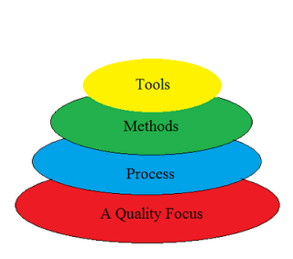
Divided into 4 layers:-
1. A quality Process :-
- Any engineering approach must rest on an quality.
- The "Bed Rock" that supports software Engineering is Quality Focus.
2. Process :-
- Foundation for SE is the Process Layer
- SE process is the GLUE that holds all the technology layers together and enables the timely development of computer software.
- It forms the base for management control of software project.
3. Methods :-
- SE methods provide the "Technical Questions" for building Software.
- Methods contain a broad array of tasks that include communication requirement analysis, design modeling, program construction testing and support.
4. Tools :-
- SE tools provide automated or semi-automated support for the "Process" and the "Methods".
- Tools are integrated so that information created by one tool can be used by another.
Q. 4 Answers
I) we have the list of some common myths of software in software engineering according to the category:
1. Management myths: The managers are often grasps at a belief in a software myth, same as a drowning person who grasps at a straw.
- Members acquires all the information: Generally, there is a myth that the members of the organization acquire all the information containing procedures, principles and standards. In reality, the developers don’t have information about all the established standards because they are often outdated, incomplete and unadaptable. Plus, there is a rare chance that the developer will follow all the standards.
- Adding more people can reduce the time gap: Another myth in the people is that more the number of programmers, lesser will be the time gap. If a project is behind the schedule, adding more manpower will further delay it because new workers will take more time to learn about the ongoing project.
- The management can relax themselves by outsourcing its project: If an organization outsource its software to a third party, it does not relieve the management of its duties. When the organization outsources the software project, they suffer invariably.
2. Customers Myths: The customers are encouraged by some marketing people in underestimating the difficulty of developing software.
- Software is malleable as a result of which changes are easy to accommodate: There is an enormous amount of labor required to have a change in the software after the release. It is not so easy to accommodate these changes.
- To start coding, a general statement of need is enough: The developers can’t read the customer’s mind and requires detailed descriptions of the requirements, in order to start coding.
3. Developer Myths: The software development art is becoming an engineering discipline, but there are lots of myths.
- Once the code is delivered, the software can be called complete: In reality, more than 60% of the efforts are expended after the delivery of the software to the user.
- The software’s success depends on the product’s produced quality: The project does not become successful on the quality of the programs because both the software configuration and documentation also play an important role in its success.
- The unnecessary documentation is required in software engineering, which further slows down the growth rate of a project: This myth is a no brainer because in reality, the proper documentation enhances the project’s quality and results in reduction of the rework. Also, this field is just about creating quality at all the level of the project.
- The assessment of the software quality can be addressed after the execution of the program: During any phase of the development process, the software’s quality can be measured just by applying the mechanism of quality assurance.
- The product, which is delivered after the project’s completion can be called working program: The deliverables of a successful project don’t only consist working program, but also the documentation which can guide the users about how to use the software.
OR
A software requirements specification (SRS) is a description of a software system to be developed. It lays out functional and non-functional requirements, and may include a set of use cases that describe user interactions that the software must provide.
The purpose of the SRS is to:
Establish the basis for agreement between the customers and the suppliers on what the software product is to do. The complete description of the functions to be performed by the software specified in the SRS will assist the potential user to determine if the software specified meets their needs or how the software must be modified to meet their needs
- Provide a basis for developing the software design. The SRS is the most important document of reference in developing a design
- Reduce the development effort. The preparation of the SRS forces the various concerned groups in the customer's organisation to thoroughly consider all of the requirements before design work begins. A complete and correct SRS reduces effort waisted on redesign, recoding and retesting. Careful review of the requirements in the SRS can reveal omissions, misunderstandings and inconsistencies early in the development cycle when these problems are easier to correct
- Provide a basis for estimating costs and schedules. The description of the product to be developed as given in the SRS is a realistic basis for estimating project costs and can be used to obtain approval for bids or price estimates
- Provide a baseline for validation and verification. Organisations can develop their test documentation much more productively from a good SRS. As a part of the development contract, the SRS provides a baseline against which compliance can be measured
- Facilitate transfer. The SRS makes it easier to transfer the software product to new users or new machines. Customers thus find it easier to transfer the software to other parts of their organisation and suppliers find it easier to transfer it to new customers
- Serve as a basis for enhancement. Because the SRS discusses the product but not the project that developed it, the SRS serves as a basis for later enhancement of the finished product. The SRS may need to be altered, but it does provide a foundation for continued product evaluation.
Guidelines for use
1 Introduction
1.1 Purpose
1.2 Scope
1.3 Definitions, acronyms, and abbreviations
1.4 References
1.5 Document overview
2 General description
2.1 Purpose
2.2 Product context
2.3 Product functions
2.4 User characteristics
2.5 General constraints
2.6 Assumptions and dependencies
2.7 Apportioning of requirements
3 Product functions
3.1 Purpose
3.2 Function description
3.2.1 Introduction
3.2.2 Inputs
3.2.3 Processing
3.2.4 Outputs
4 External interfaces
4.1 Purpose
4.2 User interfaces
4.3 Hardware interfaces
4.4 Software interfaces
4.5 Communications interfaces
5 Performance requirements
5.1 Purpose
5.2 Static capacity

SET-B
Subject: -Software engineering
II Year MCA. IV Semester Ist Mid Term Examination, February – 2018
Time: -2 Hrs. [Maximum Marks: -20]
[Min. Passing Marks: 08]
Q. 1 Answers
- Systems engineering is a methodical, disciplined approach for the design, realization, technical management, operations, and retirement of a system.
- Software requirements specification (SRS) is a description of a software system to be developed. It lays out functional and non-functional requirements, and may include a set of use cases that describe user interactions that the software must provide.
- Throwaway refers to the creation of a model that will eventually be discarded rather than becoming part of the final delivered software & it can be done quickly. Evolutionary prototyping acknowledges that we do not understand all the requirements and builds only those that are well understood.
- It is a technique developed by Larry Constantine to express the requirements of system in a graphical form.It shows the flow of data between various functions of system and specifies how the current system is implemented.
- Requirement analysis is a software engineering task that bridges the gap between system level requirements engineering and software design. Requirements engineering activities result in the specification of software’s operational characteristics, indicate software’s interface with other system elements, and establish constraints that software must meet.
Q. 2 Answers

I) Decision Tables
Decision tables are a method of describing the complex logical relationship in a precise manner which is easily understandable.
- It is useful in situations where the resulting actions depend on the occurrence of one or several combinations of independent conditions.
- It is a matrix containing row or columns for defining a problem and the actions.

Components of a Decision Table
- Condition Stub − It is in the upper left quadrant which lists all the condition to be checked.
- Action Stub − It is in the lower left quadrant which outlines all the action to be carried out to meet such condition.
- Condition Entry − It is in upper right quadrant which provides answers to questions asked in condition stub quadrant.
- Action Entry − It is in lower right quadrant which indicates the appropriate action resulting from the answers to the conditions in the condition entry quadrant.
- The Waterfall Model was first Process Model to be introduced. It is also referred to as a linear-sequential life cycle model. It is very simple to understand and use. In a waterfall model, each phase must be completed fully before the next phase can begin. This type of software development model is basically used for the project which is small and there are no uncertain requirements. At the end of each phase, a review takes place to determine if the project is on the right path and whether or not to continue or discard the project. In this model software testing starts only after the development is complete. In waterfall model phases do not overlap.
Diagram of Waterfall-model:
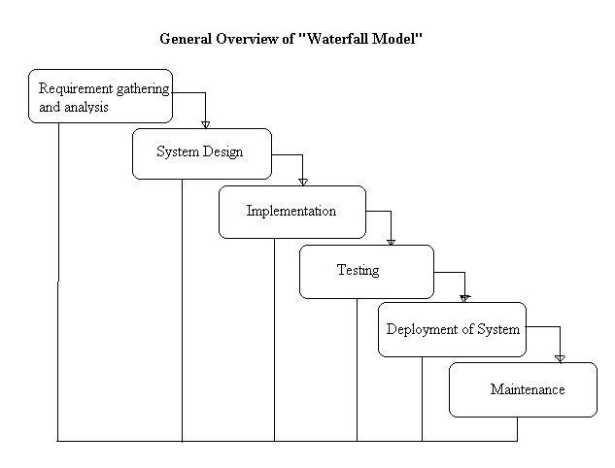

Q. 3 Answers
1) Fourth Generation Techniques (4GT)

“Fourth generation techniques are the package of software tools that enable a software Engineer to specify the characteristics at a high level and then a source code is automatically generated based on these specifications”
It is based on the Non-Procedural Language techniques. That is Depending upon the specifications made the 4GT move towards uses various tools for the automatic generation of source codes.
Like any other models used, the 4GT approach requires the requirement analysis step. Once the requirement analysis is done upto the expectations, its translation into the operational prototype begins. The most important phase in the 4GT approach is the customer developer approach, all the major decisions regarding the implementations, costs and functioning of the system is taken in this phase.

The 4GT includes following tools:
1. Data definition 2 . Data manipulation 3. Non procedural language for query
4.Report generation 5. Code generation 6. Spreadsheet capability
Four steps for making a software product using 4GT:
- Requirement gathering 2. Design strategy 3. Implementation 4. Transformation into product
Advantages of 4GT:
- Reduction in software development time.
- Improved productivity of software engineers.
- 4GT helped by CASE, tools and code generators that offer solution to many problems.
Disadvantages:
- Some 4GT are not at all easier than programming languages.
- Generated source code are sometimes³inefficient´
- Time is reduced for only small and medium projects.
- Large software developed by 4GT is not maintainable or difficult to maintain.
II) Prototyping is an iterative analysis technique in which users are actively involved in the mocking-up of screens and reports. The purpose of a prototype is to show people the possible design(s) for the user interface of an application.
There are 4 steps involved for Prototyping:
1) Determine the needs of your users.
The requirements of your users drive the development of your prototype as they define the business objects that your system must support. You can gather these requirements in interviews, in CRC (class responsibility collaborator) modeling sessions, in use-case modeling sessions, and in class diagramming sessions
2) Build the prototype. Using a prototyping tool or high-level language you develop the screens and reports needed by your users. The best advice during this stage of the process is to not invest a lot of time in making the code “good” because chances are high that you may just scrap your coding efforts anyway after evaluating the prototype.
3) Evaluate the prototype. After a version of the prototype is built it needs to be evaluated. The main goal is that you need to verify that the prototype meets the needs of your users. I’ve always found that you need to address three basic issues during evaluation: What’s good about the prototype, what’s bad about the prototype, and what’s missing from the prototype.
4) Determine if you’re finished yet. You want to stop the prototyping process when you find the evaluation process is no longer generating any new requirements, or is generating a small number of not-so-important requirements.
Q. 4 Answers

I) What is RAD model- advantages, disadvantages and when to use it?
RAD model is Rapid Application Development model. It is a type of incremental model. In RAD model the components or functions are developed in parallel as if they were mini projects. The developments are time boxed, delivered and then assembled into a working prototype. This can quickly give the customer something to see and use and to provide feedback regarding the delivery and their requirements.
The phases in the rapid application development (RAD) model are:
Business modeling: The information flow is identified between various business functions.
Data modeling: Information gathered from business modeling is used to define data objects that are needed for the business.
Process modeling: Data objects defined in data modeling are converted to achieve the business information flow to achieve some specific business objective. Description are identified and created for CRUD of data objects.
Application generation: Automated tools are used to convert process models into code and the actual system.
Testing and turnover: Test new components and all the interfaces.
Advantages of the RAD model:
1. Reduced development time. 2. Increases reusability of components
3. Quick initial reviews occur 4. Encourages customer feedback
. Disadvantages of RAD model:
1 Depends on strong team and individual performances for identifying business requirements.
2. Only system that can be modularized can be built using RAD & requires highly skilled developers/designers.
3. High dependency on modeling skills & Inapplicable to cheaper projects.
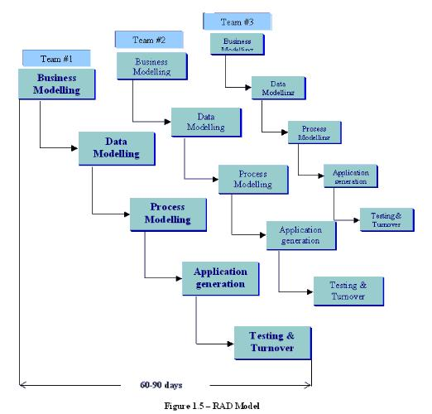
OR
Analysis Principles
Over the past two decades, a large number of analysis modeling methods have been developed. Investigators have identified analysis problems and their causes and have developed a variety of notations and corresponding sets of heuristics to overcome them. Each analysis method has a unique point of view.
- The information domain of a problem must be represented and understood.
- The functions that the software is to perform must be defined.
- The behavior of the software must be represented.
- The models that depict information, function, and
- The models that depict information function and behavior must be partitioned in a manner that uncovers details in a layered fashion.
- The analysis process should move from essential information toward implementation detail.
In addition to these operational analysis principles for requirements engineering:
- Understand the problem before you begin to create the analysis model.
- Develop prototype that enable a user to understand how human/machine interaction will occur.
- Record the origin of and the reason for every requirement.
- Use multiple views of requirements.
- Rank requirements.
- Work to eliminate ambiguity

Elements of the analysis model
1. Scenario based element
- This type of element represents the system user point of view.
- Scenario based elements are use case diagram, user stories.
2. Class based elements
- The object of this type of element manipulated by the system.
- It defines the object, attributes and relationship.
- The collaboration is occurring between the classes.
- Class based elements are the class diagram, collaboration diagram.
3. Behavioral elements
- Behavioral elements represent state of the system and how it is changed by the external events.
- The behavioral elements are sequenced diagram, state diagram.
4. Flow oriented elements
- An information flows through a computer-based system it gets transformed.
- It shows how the data objects are transformed while they flow between the various system functions.
- The flow elements are data flow diagram, control flow diagram.
