Rajasthan Institute of Engineering and Technology
Department of Computer Engineering
I-Mid Term Exam- 2018
SET: B Branch: CSE/IT
Microprocessors and Interfaces
IV SEM
Q1. What is a Microprocessor? Explain the Register set of 8085 MP.
The 8085 has the following registes
- Accumulator Register
- Flag Registers
- GENERAL PURPOSE REGISTERS
- Stack pointer (SP)
- Program counter(PC)
The general purpose registers in 8085 processors are B, C, D, E, H and L. Each register can hold 8-bit data. Apart from the above function these registers can also be used to work in pairs to hold 16-bit data. They can work in pairs such as B-C, D-E and H-L to store 16-bit data. The H-L pair works as a memory pointer.
8-bit B and 8-bit C registers can be used as one 16-bit BC register pair. When used as a pair the C register contains low-order byte. Some instructions may use BC register as a data pointer.

8-bit D and 8-bit E registers can be used as one 16-bit DE register pair. When used as a pair the E register contains low-order byte. Some instructions may use DE register as a data pointer.

8-bit H and 8-bit L registers can be used as one 16-bit HL register pair. When used as a pair the L register contains low-order byte. HL register usually contains a data pointer used to reference memory addresses.

Stack pointer (SP)is a 16 bit register. This register is always decremented/incremented by 2 during push and pop.
Program counter(PC) is a 16-bit register.

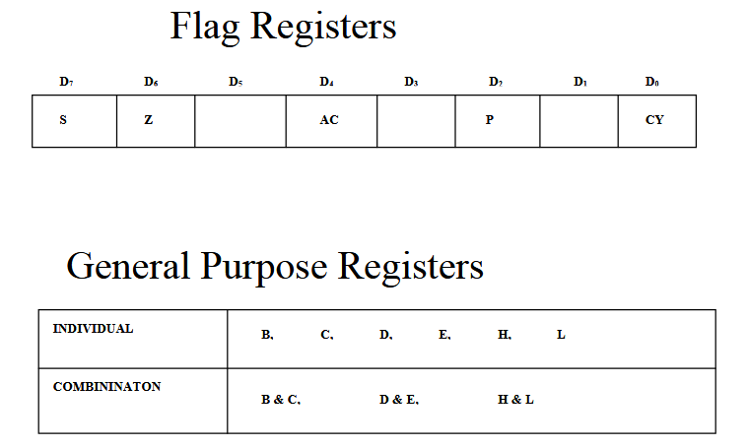
OR
Q 1. Explain the MP with the help of signal diagram.
- 8085 is a 40 pin IC, The signals from the pins can be grouped as follows

- Power supply and clock signals
- Higher order Address bus
- Multiplexed address /Data bus
- Control and status signals
- Interrupts and externally initiated signals
- Serial I/O ports

- Power supply and Clock frequency signals:

- Vcc + 5 volt power supply
- Vss Ground
- X1, X2 : Crystal or R/C network or LC network connections to set the frequency of internal clock generator.
- The frequency is internally divided by two. Since the basic operating timing frequency is 3 MHz, a 6 MHz crystal is connected externally.
- CLK (output)-Clock Output is used as the system clock for peripheral and devices interfaced with the microprocessor.

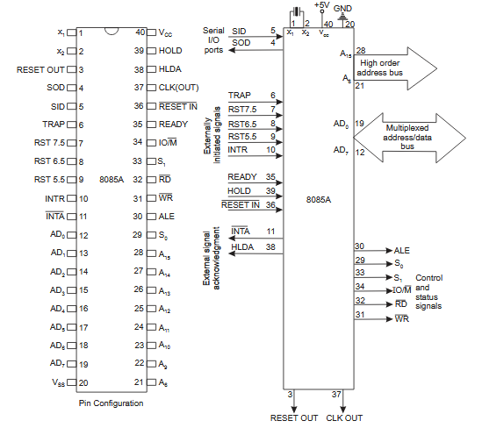
Fig (a) - Pin Diagram of 8085 & Fig(b) - logical schematic of Pin diagram.
2. Higher order Address bus
- A8 - A15 (output; 3-state)
- It carries the most significant 8 bits of the memory address or the 8 bits of the I/O address;

3. Multiplexed Address / Data Bus:

- AD0 - AD7 (input/output; 3-state)
- These multiplexed set of lines used to carry the lower order 8 bit address as well as data bus.
- During the opcode fetch operation, in the first clock cycle, the lines deliver the lower order address A0 - A7.
- In the subsequent IO / memory, read / write clock cycle the lines are used as data bus.
- The CPU may read or write out data through these lines.

4. Control and Status signals:

- ALE (output) - Address Latch Enable.
- This signal helps to capture the lower order address presented on the multiplexed address / data bus.
- RD (output 3-state, active low) - Read memory or IO device.
- This indicates that the selected memory location or I/O device is to be read and that the data bus is ready for accepting data from the memory or I/O device.
- WR (output 3-state, active low) - Write memory or IO device.
- This indicates that the data on the data bus is to be written into the selected memory location or I/O device.
- IO/M (output) - Select memory or an IO device.
- This status signal indicates that the read / write operation relates to whether the memory or I/O device.
- It goes high to indicate an I/O operation.
- It goes low for memory operations.

Status Signals:

- It is used to know the type of current operation of the microprocessor.

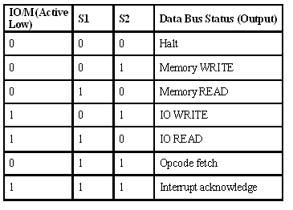

5. Interrupts and Externally initiated operations:

- They are the signals initiated by an external device to request the microprocessor to do a particular task or work.
- There are five hardware interrupts called,
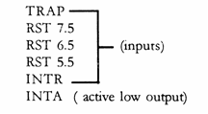
- On receipt of an interrupt, the microprocessor acknowledges the interrupt by the active low INTA (Interrupt Acknowledge) signal.

Reset In (input, active low)
- This signal is used to reset the microprocessor.
- The program counter inside the microprocessor is set to zero.
- The buses are tri-stated.

Reset Out (Output)
- It indicates CPU is being reset.
- Used to reset all the connected devices when the microprocessor is reset.
READY (input)
- Memory and I/O devices will have slower response compared to microprocessors.
- Before completing the present job such a slow peripheral may not be able to handle further data or control signal from CPU.
- The processor sets the READY signal after completing the present job to access the data.
- The microprocessor enters into WAIT state while the READY pin is disabled.

6. Single Bit Serial I/O ports:
- SID (input) - Serial input data line
- SOD (output) - Serial output data line
- These signals are used for serial communication.
- On receipt of an interrupt, the microprocessor acknowledges the interrupt by the active low INTA (Interrupt Acknowledge) signal.
Q 2. What is the Last address rang of a memory chip, containing 256 X 8 bit size. The stating address of memory chip is 7000H.
Size= 2^{Address line} X Data line =256X 8bit= 2⁸ X 8 bit
Address Line needed to address the register= 8
Chip select line= 16-8=8

 | Chip select line |  |  |  |  |  |  |  | Register select Line
 | A15 | A14 | A13 | A12 | A11 | A10 | A9 | A8 | A7 | A6 | A5 | A4 | A3 | A2 | A1 | A0
Starting Address= 8000H | 0 | 1 | 1 | 1 | 0 | 0 | 0 | 0 | 0 | 0 | 0 | 0 | 0 | 0 | 0 | 0
Last Address =?= 70FF H | 0 | 1 | 1 | 1 | 0 | 0 | 0 | 0 | 1 | 1 | 1 | 1 | 1 | 1 | 1 | 1

Q 2. Give the operation of the following instructions
- STA 3000H, (2) MOV C, A
STA: - the content of accumulator are copied into the memory location.

Eg: - STA 3000H (the content of accumulator is stored into the memory location 3000h)

MOV: - This instruction is used to copy the data from one place to another.

Eg: - MOV Rd, Rs (This instruction copies the content of Rs to Rd)

Q 3. Write a program in assembly language to arrange 5 memory block in ascending order.

Algorithm

1) Load the DE pair with the destination address.
2) Load the HL pair with the count of elements in the data block.
3) Load element in the data block.
4) Increment the source address.
5) Copy the element to the accumulator and then transfer it to the destination address.
6) Increment destination address.
7) Decrement the count.
8) If Count = 0 then go to the next step else go to step 3.
9) Terminate the program.

MEMORY | LABEL | MNEMONIC | HEX CODE | COMMENT
4200 |  | LXI D,4500 | 11 | Load destination address in DE pair
4201 |  |  | 00 | Load destination address in DE pair
4202 |  |  | 45 | Load destination address in DE pair
4203 |  | LXI H,4100 | 21 | Load the count in HL pair
4204 |  |  | 00 | Load the count in HL pair
4205 |  |  | 41 | Load the count in HL pair
4206 |  | MOV C,M | 4E | Copy the count to register C
4207 | LOOP | INX H | 23 | Increment memory
4208 |  | MOV A,M | 7E | Copy element to Accumulator
4209 |  | STAX D | 12 | Store the element to the address in the DE pair
420A |  | INX D | 13 | Increment destination address
420B |  | DCR C | OD | Decrement count
420C |  | JNZ LOOP | C2 | Jump on non-zero to the label LOOP
420D |  |  | 07 | Jump on non-zero to the label LOOP
420E |  |  | 42 | Jump on non-zero to the label LOOP
420F |  | HLT | 76 | Program ends

Q 3. Write a program in assembly language to find largest number from the given two numbers.

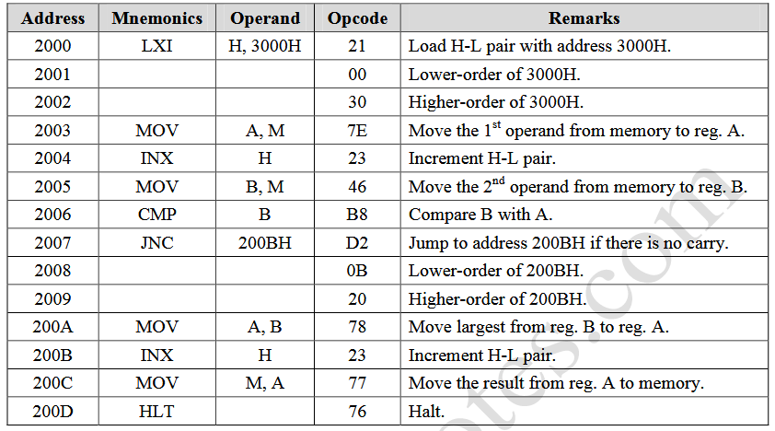

Q 4. Write short notes on the following
1). Microcontroller
2). HOLD signal

Microcontroller: Microcontrollers are used in automatically controlled products and devices, such as automobile engine control systems, implantable medical devices, remote controls, office machines, appliances, power tools, toys. or in other world A microcontroller is a self-contained system with peripherals, memory and a processor that can be used as an embedded system. Most programmable microcontrollers that are used today are embedded in other consumer products or machinery including phones, peripherals, automobiles and household appliances for computer systems. Due to that, another name for a microcontroller is "embedded controller." Some embedded systems are more sophisticated, while others have minimal requirements for memory and programming length and a low software complexity. Input and output devices include solenoids, LCD displays, relays, switches and sensors for data like humidity, temperature or light level, amongst others.
HOLD: When the HOLD line goes high, it indicates to the processor that another master is requesting the bus access. The processor, after receiving the HOLD request, issues the hold acknowledge signal on HLDA pin, in the middle of the next clock cycle after completing the current bus (instruction) cycle. At the same time, the processor floats the local bus and control lines. When the processor detects the HOLD line low, it lowers the HLDA signal. HOLD is an asynchronous input, and it should be externally synchronized.
Q 4.Write short notes on following.
1). Difference between SRAM and DRAM
2). volatile and nonvolatile memory

1). SRAM (static RAM) is random access memory (RAM) that retains data bits in its memory as long as power is being supplied. Unlike dynamic RAM (DRAM), which stores bits in cells consisting of a capacitor and a transistor, SRAM does not have to be periodically refreshed. Static RAM provides faster access to data and is more expensive than DRAM. SRAM is used for a computer's cache memory and as part of the random access memory digital-to-analog converter on a video card.

2). volatile memory loses data over
time or when power is removed
• RAM is volatile
non-volatile memory stores date even when power is removed
• ROM is non-volatile

http://www.egr.msu.edu/classes/ece331/mason/web_files/HO8_Memory.pdf

