Rajasthan Institute of Engineering and Technology
Department of Computer Engineering
I-Mid Term Exam- 2018
SET: A Branch: CSE/IT
Microprocessors and Interfaces
V SEM

Q 1. What is a Microprocessor? Explain the 8085 MP with the help of pin out diagram.
The microprocessor is a clock-driven semiconductor device consisting of electronic logic circuits manufactured by using either a large-scale integration (LSI) or very-large-scale integration (VLSI) technique.
- 8085 is a 40 pin IC, The signals from the pins can be grouped as follows

- Power supply and clock signals
- Higher order Address bus
- Multiplexed address /Data bus
- Control and status signals
- Interrupts and externally initiated signals
- Serial I/O ports

- Power supply and Clock frequency signals:

- Vcc + 5 volt power supply
- Vss Ground
- X1, X2 : Crystal or R/C network or LC network connections to set the frequency of internal clock generator.
- The frequency is internally divided by two. Since the basic operating timing frequency is 3 MHz, a 6 MHz crystal is connected externally.
- CLK (output)-Clock Output is used as the system clock for peripheral and devices interfaced with the microprocessor.

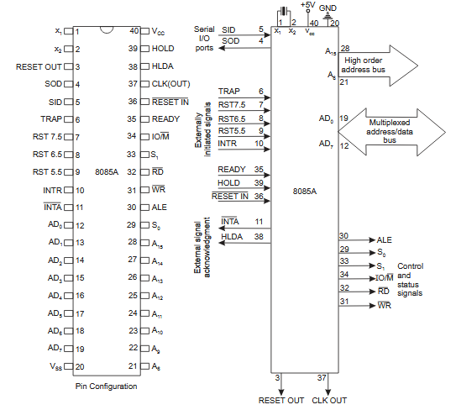
Fig (a) - Pin Diagram of 8085 & Fig(b) - logical schematic of Pin diagram.
2. Higher order Address bus
- A8 - A15 (output; 3-state)
- It carries the most significant 8 bits of the memory address or the 8 bits of the I/O address;

3. Multiplexed Address / Data Bus:

- AD0 - AD7 (input/output; 3-state)
- These multiplexed set of lines used to carry the lower order 8 bit address as well as data bus.
- During the opcode fetch operation, in the first clock cycle, the lines deliver the lower order address A0 - A7.
- In the subsequent IO / memory, read / write clock cycle the lines are used as data bus.
- The CPU may read or write out data through these lines.

4. Control and Status signals:

- ALE (output) - Address Latch Enable.
- This signal helps to capture the lower order address presented on the multiplexed address / data bus.
- RD (output 3-state, active low) - Read memory or IO device.
- This indicates that the selected memory location or I/O device is to be read and that the data bus is ready for accepting data from the memory or I/O device.
- WR (output 3-state, active low) - Write memory or IO device.
- This indicates that the data on the data bus is to be written into the selected memory location or I/O device.
- IO/M (output) - Select memory or an IO device.
- This status signal indicates that the read / write operation relates to whether the memory or I/O device.
- It goes high to indicate an I/O operation.
- It goes low for memory operations.

Status Signals:

- It is used to know the type of current operation of the microprocessor.

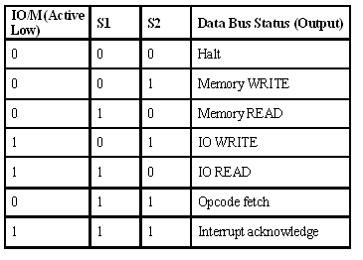

5. Interrupts and Externally initiated operations:

- They are the signals initiated by an external device to request the microprocessor to do a particular task or work.
- There are five hardware interrupts called,
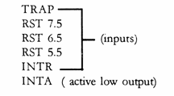
- On receipt of an interrupt, the microprocessor acknowledges the interrupt by the active low INTA (Interrupt Acknowledge) signal.

Reset In (input, active low)
- This signal is used to reset the microprocessor.
- The program counter inside the microprocessor is set to zero.
- The buses are tri-stated.

Reset Out (Output)
- It indicates CPU is being reset.
- Used to reset all the connected devices when the microprocessor is reset.
READY (input)
- Memory and I/O devices will have slower response compared to microprocessors.
- Before completing the present job such a slow peripheral may not be able to handle further data or control signal from CPU.
- The processor sets the READY signal after completing the present job to access the data.
- The microprocessor enters into WAIT state while the READY pin is disabled.

6. Single Bit Serial I/O ports:
- SID (input) - Serial input data line
- SOD (output) - Serial output data line
- These signals are used for serial communication.
- On receipt of an interrupt, the microprocessor acknowledges the interrupt by the active low INTA (Interrupt Acknowledge) signal.
Q. 1. Explain 8085 MP with the help of multiplexing and Demultiplexing of Buses.
The data bus and the low order address bus on the 8085 microprocessor are multiplexed with each other. This allows 8 pins to be used where 16 would normally be required. The hardware interface is required to demultiplex the bus by latching the low order address in the first T cycle, on the falling edge of ALE.
The address bus is multiplexed in 8085. The multiplexing is done with the help of ALE signal. ALE stands for address latch enable. When ALE is High (Logic 1) : Upper address lines (line 15-8) and Lower address lines (line 7-0) combinely holds the 16 bits of the address. When ALE is Low (Logic 0) : Upper address lines (line 15-8) holds the upper 8 bit address & Lower address lines (line 7-0) holds the "8 bit DATA"
Multiplexing is used to reduce the number of pins of 8085, which otherwise would have been a 48 pin chip. But because of multiplexing, external hardware is required to demultiplex the lower byte address cum data bus.
The Pin no= 30 of 8085 is the ALE pin which stands for ‘Address Latch Enable’. ALE signal is used to demultiplex the lower order address bus (AD0 – AD7).
Pins 12 to 19 of 8085 are AD0 – AD7 which is the multiplexed address-data bus. Multiplexing is done to reduce the number of pins of 8085.
Lower byte of address (A0 – A7) are available from AD0 – AD7 (pins 12 to 19) during T1 of machine cycle. But the lower byte of address (A0 – A7), along with the upper byte A8 – A15 (pins 21 to 28) must be available during T2 and rest of the machine cycle to access memory location or I/O ports.
Now ALE signal goes high at the beginning of T1 of each machine cycle and goes low at the end of T1 and remains low during the rest of the machine cycle. This high to low transition of ALE signal at the end of T1 is used to latch the lower order address byte (A0 – A7) by the latch IC 74LS373, so that the lower byte A0 – A7 is continued to be available till the end of the machine cycle. The situation is explained in the following
figure:
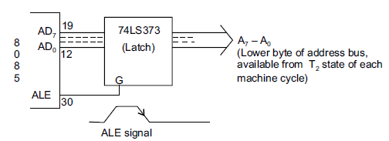
Fig: Lower byte of address latching achieved by the H to L transition of ALE signal, which occurs at the end of T1 of each machine cycle

Q3. What is the Last address rang of a memory chip, containing 256 X 8 bit size. The stating address of memory chip is 8000H.

Size= 2^{Address line} X Data line =256X 8bit= 2⁸ X 8 bit
Address Line needed to address the register= 8
Chip select line= 16-8=8

 | Chip select line |  |  |  |  |  |  |  | Register select Line
 | A15 | A14 | A13 | A12 | A11 | A10 | A9 | A8 | A7 | A6 | A5 | A4 | A3 | A2 | A1 | A0
Starting Address= 8000H | 1 | 0 | 0 | 0 | 0 | 0 | 0 | 0 | 0 | 0 | 0 | 0 | 0 | 0 | 0 | 0
Last Address =?= 80FF H | 1 | 0 | 0 | 0 | 0 | 0 | 0 | 0 | 1 | 1 | 1 | 1 | 1 | 1 | 1 | 1

Q2. Give the operation of the following instructions
(1). LXI H, 3005H, (2) MVI C, 05H
LXI(Load register pair immediate): - The instruction loads 16-bit data in the register pair designated in the
operand.
LXI H, 3005H (3005H is stored in HL pair so that it act as memory pointer)
MVI: - move immediate date to a register or memory location.
MVI C, 05H (05h is stored in register C)

Q 3. Write a program in assembly language to transfer 5 memory blocks from one memory location to another location.
Algorithm

1) Load the DE pair with the destination address.
2) Load the HL pair with the count of elements in the data block.
3) Load element in the data block.
4) Increment the source address.
5) Copy the element to the accumulator and then transfer it to the destination address.
6) Increment destination address.
7) Decrement the count.
8) If Count = 0 then go to the next step else go to step 3.
9) Terminate the program.

MEMORY | LABEL | MNEMONIC | HEX CODE | COMMENT
4200 |  | LXI D,4500 | 11 | Load destination address in DE pair
4201 |  |  | 00 | Load destination address in DE pair
4202 |  |  | 45 | Load destination address in DE pair
4203 |  | LXI H,4100 | 21 | Load the count in HL pair
4204 |  |  | 00 | Load the count in HL pair
4205 |  |  | 41 | Load the count in HL pair
4206 |  | MOV C,M | 4E | Copy the count to register C
4207 | LOOP | INX H | 23 | Increment memory
4208 |  | MOV A,M | 7E | Copy element to Accumulator
4209 |  | STAX D | 12 | Store the element to the address in the DE pair
420A |  | INX D | 13 | Increment destination address
420B |  | DCR C | OD | Decrement count
420C |  | JNZ LOOP | C2 | Jump on non-zero to the label LOOP
420D |  |  | 07 | Jump on non-zero to the label LOOP
420E |  |  | 42 | Jump on non-zero to the label LOOP
420F |  | HLT | 76 | Program ends
OR
Q 3. Write a program in assembly language to add two numbers.

MVI C, 8 bit data
MVI A, 8 bit data
ADD C
STA 16 bit address
HLT
Q 4.Write short notes on following.
- SRAM and DRAM
- ALE

SRAM (static RAM) is random access memory (RAM) that retains data bits in its memory as long as power is being supplied. Unlike dynamic RAM (DRAM), which stores bits in cells consisting of a capacitor and a transistor, SRAM does not have to be periodically refreshed. Static RAM provides faster access to data and is more expensive than DRAM. SRAM is used for a computer's cache memory and as part of the random access memory digital-to-analog converter on a video card.
ALE:- The address bus is multiplexed in 8085. The multiplexing is done with the help of ALE signal. ALE stands for address latch enable. When ALE is High (Logic 1) : Upper address lines (line 15-8) and Lower address lines (line 7-0) combinely holds the 16 bits of the address. When ALE is Low (Logic 0) : Upper address lines (line 15-8) holds the upper 8 bit address & Lower address lines (line 7-0) holds the "8 bit DATA"
Q4. Explain the following
1). Control and Status signal
2). General Purpose register
Control and Status signals:

- ALE (output) - Address Latch Enable.
- This signal helps to capture the lower order address presented on the multiplexed address / data bus.
- RD (output 3-state, active low) - Read memory or IO device.
- This indicates that the selected memory location or I/O device is to be read and that the data bus is ready for accepting data from the memory or I/O device.
- WR (output 3-state, active low) - Write memory or IO device.
- This indicates that the data on the data bus is to be written into the selected memory location or I/O device.
- IO/M (output) - Select memory or an IO device.
- This status signal indicates that the read / write operation relates to whether the memory or I/O device.
- It goes high to indicate an I/O operation.
- It goes low for memory operations.

Status Signals:

- It is used to know the type of current operation of the microprocessor.

GENERAL PURPOSE REGISTERS:
The general purpose registers in 8085 processors are B, C, D, E, H and L. Each register can hold 8-bit data. Apart from the above function these registers can also be used to work in pairs to hold 16-bit data. They can work in pairs such as B-C, D-E and H-L to store 16-bit data. The H-L pair works as a memory pointer.

References/ Bibliography:

  - http://www.rgcetpdy.ac.in/Notes/BME/III%20YEAR/MICROPROCESSOR%20AND%20ITS%20APPLICATIONS/Unit%201.pdf
  - https://www.google.co.in/search?source=hp&ei=B2CWWtyIDofXvgSOj6bICQ&q=general+purpose+registers+of+8085&oq=general+purpose+registers+of+&gs_l=psy-ab.3.1.0l5j0i22i30k1l2.30082.41774.0.43818.21.17.0.4.4.0.456.3441.0j1j9j2j1.13.0....0...1c.1.64.psy-ab..4.17.3531...0i131k1.0.xKiErBL0XlE

