Subject: - Data Communication and Computer Networks
I Year MCA. II Semester Ist Mid Term Examination, February – 2018
Time: -2 Hrs. [Maximum Marks: -20]
[Min. Passing Marks: 08]

Q. 1 Answer following question in 1-2 lines. (1*5=5)
1 .1 Unshielded twisted pair (UTP) cables are widely used in the computer and
telecommunications industry as Ethernet cables and telephone wires.
1.2 CTI (computer-telephony integration), or sometimes simply "computer telephony,"
is the use of computers to manage telephone calls. The term is used in describing
the computerized services of call centers, such as those that direct your phone call
to the right department at a business you're calling. It's also sometimes used to
describe the ability to use your personal computer to initiate and manage phone
calls (in which case you can think of your computer as your personal call center).
1.3 Dynamic Host Configuration Protocol (DHCP) is a client/server protocol that automatically
provides an Internet Protocol (IP) host with its IP address and other related configuration
information such as the subnet mask and default gateway. RFCs 2131 and 2132 define
DHCP as an Internet Engineering Task Force (IETF) standard based on Bootstrap
Protocol (BOOTP), a protocol with which DHCP shares many implementation details.
DHCP allows hosts to obtain necessary TCP/IP configuration information from a DHCP
server.
1.4 TCP/IP, or the Transmission Control Protocol/Internet Protocol, is a suite of
communication protocols used to interconnect network devices on the
internet. TCP/IP can also be used as a communications protocol in a private
network (an intranet or an extranet).
1.5 A computer network is a group of computer systems and other computing hardware
devices that are linked together through communication channels to facilitate
communication and resource-sharing among a wide range of users. Networks are
commonly categorized based on their characteristics.

Q. 2 Answer the following questions in 50 words each. (2*2=4)

2.1 Network allows computers to connect and communicate with different computers via

any medium. LAN, MAN, and WAN are the three types of the network designed to

operate over the area they cover. There are some similarities and dissimilarities

between them. One of the major differences is the geographical area they cover, i.e.

LAN covers the smallest area; MAN covers an area larger than LAN and WAN

comprises the largest of all.
BASIS OF COMPARISON | LAN | MAN | WAN
Expands to | Local Area Network | Metropolitan Area Network | Wide Area Network
Meaning | A network that connects a group of computers in a small geographical area. | It covers relatively large region such as cities, towns. | It spans large locality and connects countries together. Example Internet.
Ownership of Network | Private | Private or Public | Private or Public
Design and maintenance | Easy | Difficult | Difficult
Propagation Delay | Short | Moderate | Long
Speed | High | Moderate | Low
Fault Tolerance | More Tolerant | Less Tolerant | Less Tolerant
Congestion | Less | More | More
Used for | College, School, Hospital. | Small towns, City. | Country/Continent.

2.2 Difference
BASIS FOR COMPARISON | SIMPLEX | HALF DUPLEX | FULL DUPLEX
Direction of Communication | Communication is unidirectional. | Communication is two-directional but, one at a time. | Communication is two directional and done simultaneously.
Send/Receive | A sender can send data but, can not receive. | A sender can send as well as receive the data but one at a time. | A sender can send as well as receive the data simultaneously.
Performance | The half duplex and full duplex yields better performance than the Simplex. | The full duplex mode yields higher performance than half duplex. | Full duplex has better performance as it doubles the utilization of bandwidth.
Example | Keyboard and monitor. | Walkie-Talkies. | Telephone.

Q. 3 Answer the following questions in 150 words. (3*2=6)

3.1 Types of Network Topology
Computer network topology refers to the physical communication schemes used by connected devices on a network. The basic computer network topology types are:
- Bus
- Ring
- Star
- Mesh
- Tree
Networks that are more complex can be built as hybrids using two or more of these basic topologies.

Bus Network Topology
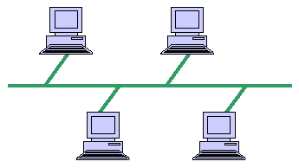
Bus Network Topology.
Bus networks share a common connection that extends to all devices. This network topology is used in small networks, and it is simple to understand. Every computer and network device connects to the same cable, so if the cable fails, the whole network is down, but the cost of setting up the network is reasonable.
This type of networking is cost effective. However, the connecting cable has a limited length, and the network is slower than a ring network.

Ring Network Topology
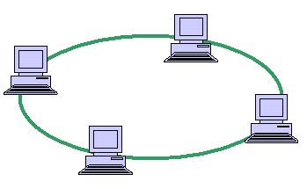
Ring Network Topology.
Each device in a ring network is attached to two other devices, and the last device connects to the first to form a circular network. Each message travels through the ring in one direction—clockwise or counterclockwise—through the shared link. Ring topology that involves a large number of connected devices requires repeaters. If the connection cable or one device fails in a ring network, the whole network fails.
Although ring networks are faster than bus networks, they are more difficult to troubleshoot.

Star Network Topology
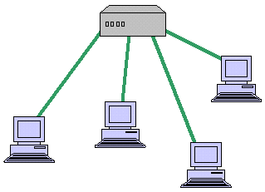
Star Network Topology.
A star topology typically uses a network hub or switch and is common in-home networks. Every device has its own connection to the hub. The performance of a star network depends on the hub. If the hub fails, the network is down for all connected devices. The performance of the attached devices is usually high because there are usually fewer devices connected in star topology that in other types of networks.
A star network is easy to set up and easy to troubleshoot. The cost of setup is higher than for bus and ring network topology, but if one attached device fails, the other connected devices are unaffected.

Mesh Network Topology
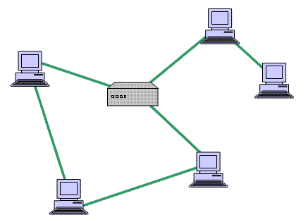
Mesh Network Topology.
Mesh network topology provides redundant communication paths between some or all devices in a partial or full mesh. In full mesh topology, every device is connected to all the other devices. In a partial mesh topology, some of the connected devices or systems are connected to all the others, but some of the devices only connect to a few other devices.
Mesh topology is robust and troubleshooting is relatively easy. However, installation and configuration are more complicated than with the star, ring and bus topologies.

Tree Network Topology
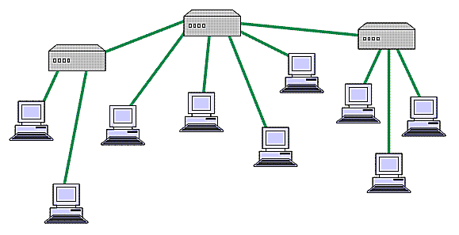
Tree Network Topology.
Tree topology integrates the star and bus topologies in a hybrid approach to improve network scalability. The network is ​setup as a hierarchy, usually with at least three levels. The devices on the bottom level all connect to one of the devices on the level above it. Eventually, all devices lead to the main hub that controls the network.
This type of network works well in companies that have various grouped workstations. The system is easy to manage and troubleshoot. However, it is relatively costly to set up. If the central hub fails, then the network fails.
3.2

The five components are data communication :
1. Message - It is the information to be communicated. Popular forms of information include text, pictures, audio, video etc. Text is converted to binary, number doesnt converted, image is converted to pixels, etc.
2. Sender - It is the device which sends the data messages. It can be a computer, workstation, telephone handset etc.
3. Receiver - It is the device which receives the data messages. It can be a computer, workstation, telephone handset etc.
4. Transmission Medium - It is the physical path by which a message travels from sender to receiver. Some examples include twisted-pair wire, coaxial cable, radio waves etc.
5. Protocol - It is a set of rules that governs the data communications. It represents an agreement between the communicating devices. Without a protocol, two devices may be connected but not communicating.

Q. 4 Answer (5x1=5)
Telecommunication links can broadly be classied into two categories, namely, guided media (wired) and unguided media(wireless). Both media are used for short distance (LANs, MANs) and long distance (WANs) communication.

Guided Media or Wired links:
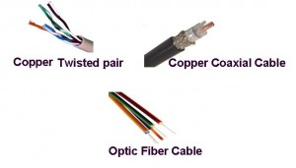
Examples of Wired Media
As the name indicates, in guided media
- Electrical/Optical signals are passed through a solid medium (different types of cables/wires)
- As the path traversed by the signals is guided by the size, shape and length of the wire, this type of media is called guided media. Also, in guided media, the signals are confined within the wire and do not propogate outside of the wire/media.
- E.g., Copper Unshielded Twisted Pair (UTP), Copper Shielded Twisted Pair (STP), Copper Co-axial cables, Fiber Optic Cables.

Twisted Pair Copper:
- It is the most widely deployed media type across the world, as the last mile telephone link connecting every home with the local telephone exchange is made of twisted pair copper. These telephone lines are reused as last mile DSL access links to access the internet from home.
- They are also used in Ethernet LAN cables within homes and offices.
- They support low to High Data Rates (in order of Giga bits)
- However, they are effective only upto a maximum distance of a few kilometres/miles, as the signal strength is lost significantly beyond this distance.
- They come in two variants, namely UTP (unshielded twisted pair) and STP (shielded twisted pair). Within each variant, there are multiple sub-variants, based on the thickness of the material (like UTP-3, UTP-5, UTP-7 etc.)
- E.g. DSL, 10/100/1000Mbps Ethernet cables

Copper Co-axial Cables
- Co-axial copper cables have an inner copper conductor and an outer copper shield, separated by a di-electric insulating material, to prevent signal losses.
- It is primarily used in cable TV networks and as trunk lines between telecommunication equipments.
- It serves as an internet access line from the home.
- It supports medium to High Data Rates
- It has much better immunity to noise and hence signal strength is retained for longer distances than in copper twisted pair media.

Fiber Optic Cables
- Here, information is transmitted by propogation of optical signals (light) through fiber optic cables and not through electrical/electromagnetic signals. Due to this, fiber optics communication supports longer distances as there is no electrical interference.
- As the name indicates, fiber optic cables are made of very thin strands of glass (silica).
- As they support very high data rates, fiber optic lines are used as WAN backbone and trunk lines between data exchange equipments.
- They are also used for accessing internet from home through FTTH (Fiber-To-The-Home) lines.
- Additionally, they are used even for LAN environment with different LAN technologies like Fast Ethernet, Gigabit Ethernet etc. using optical links at the physical layer.

OC-48, OC-192, FTTC, HFC are examples of Fiber Optical links.

Unguided Wireless Media:
Here information is transmitted by sending electromagnetic signals through free space and hence the name unguided media, as the signals are not guided in any specific direction or inside any specific medium.
All unguided media transmission are classified as wireless transmission.
Wireless transmission can be used as the medium in both LAN and WAN environments, as illustrated in the diagrams below:
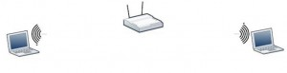
Two laptops communicating within a LAN using a wireless Access Points
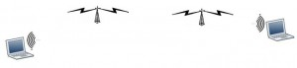
Two laptops communicating via. a long distance WAN using a WiMax Wireless transmission network
Different forms of wireless communication used in the internet vary mainly based on the following attributes:
- Distance separating the end stations
- Frequency spectrum used by the electromagnetic signals
- Line Encoding technique used
Based on these attributes, a wide variety of wireless PHYs and different types of antennaes are used in wireless communication.
The diagram given below illustrates different types of antennaes typically used in wireless communication
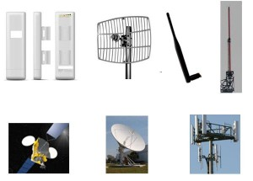
Different Types of Antennaes Used in wireless communication
As illustrated in the diagram, antennaes can be of many sizes and shapes. Some of them are point to point antennaes while others are omni-directional antennaes. Even satellites act as giant antenaes in the sky, by receiving and transmitting signals generated from the earth.
Wi-Fi, Wi-Max. 3G are example wireless networks used for internet communication

OR

Open Systems Interconnection (OSI) Model
The Open Systems Interconnection (OSI) model defines a networking framework to implement protocols in layers, with control passed from one layer to the next. It is primarily used today as a teaching tool. It conceptually divides computer network architecture into 7 layers in a logical progression. The lower layers deal with electrical signals, chunks of binary data, and routing of these data across networks. Higher levels cover network requests and responses, representation of data, and network protocols as seen from a user's point of view.
The OSI model was originally conceived as a standard architecture for building network systems and indeed, many popular network technologies today reflect the layered design of OSI.

01 Physical Layer
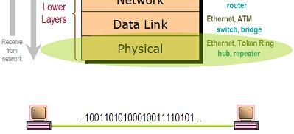
At Layer 1, the Physical layer of the OSI model is responsible for ultimate transmission of digital data bits from the Physical layer of the sending (source) device over network communications media to the Physical layer of the receiving (destination) device. Examples of Layer 1 technologies include Ethernet cables and Token Ring networks. Additionally, hubs and other repeaters are standard network devices that function at the Physical layer, as are cable connectors.
At the Physical layer, data are transmitted using the type of signaling supported by the physical medium: electric

02 Data Link Layer
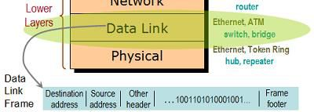
When obtaining data from the Physical layer, the Data Link layer checks for physical transmission errors and packages bits into data "frames". The Data Link layer also manages physical addressing schemes such as MACaddresses for Ethernet networks, controlling access of any various network devices to the physical medium. Because the Data Link layer is the single most complex layer in the OSI model, it is often divided into two parts, the "Media Access Control" sublayer and the "Logical Link Control" sublayer.

03 Network Layer
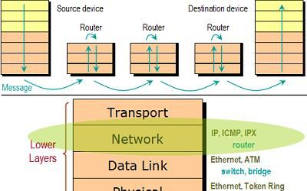
The Network layer adds the concept of routing above the Data Link layer. When data arrives at the Network layer, the source and destination addresses contained inside each frame are examined to determine if the data has reached its final destination. If the data has reached the final destination, this Layer 3 formats the data into packets delivered up to the Transport layer. Otherwise, the Network layer updates the destination address and pushes the frame back down to the lower layers.
To support routing, the Network layer maintains logical addresses such as IP addresses for devices on the network. The Network layer also manages the mapping between these logical addresses and physical addresses. In IP networking, this mapping is accomplished through the Address Resolution Protocol (ARP).

04 Transport Layer
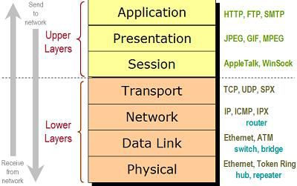
The Transport Layer delivers data across network connections. TCP is the most common example of a Transport Layer 4 network protocol. Different transport protocols may support a range of optional capabilities including error recovery, flow control, and support for re-transmission.

05 Session Layer
The Session Layer manages the sequence and flow of events that initiate and tear down network connections. At Layer 5, it is built to support multiple types of connections that can be created dynamically and run over individual networks.

06 Presentation Layer
The Presentation layer is the simplest in function of any piece of the OSI model. At Layer 6, it handles syntax processing of message data such as format conversions and encryption / decryption needed to support the Application layer above it.

07 Application Layer
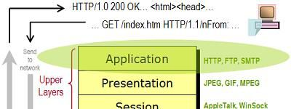
The Application layer supplies network services to end-user applications. Network services are typically protocols that work with user's data. For example, in a Web browser application, the Application layer protocol HTTP packages the data needed to send and receive Web page content. This Layer 7 provides data to (and obtains data from) the Presentation layer.

