SET-A
Rajasthan Institute of Engineering & Technology, Jaipur
University Roll No. ______________
III Year B. Tech VI Semester II mid Term Examination, April – 2018
Branch: - Computer Science and Engineering
Subject : Theory of Computation Section: A
Time : 2 Hrs. [Maximum Marks: 20]
[Min. Passing Marks: 8]
Instructions to Candidates: -
Attempt all five questions. All questions carry equal marks. Schematic diagrams must be shown wherever necessary. Any data you feel missing suitably be assumed and stated clearly.
Q 1. Consider the Turing machine description given in table.
Present State | b | 0 | 1
→ q₁ | 1Lq₂ | 0Rq₁
q₂ | bRq₃ | 0Lq₂ | 1Lq₂
q₃ |  | bRq₄ | bRq₅
q₄ | 0Rq₅ | 0Rq₄ | 1Rq₄
q₅ | 0Lq₂
Draw the computation sequence of the input string 00.
OR
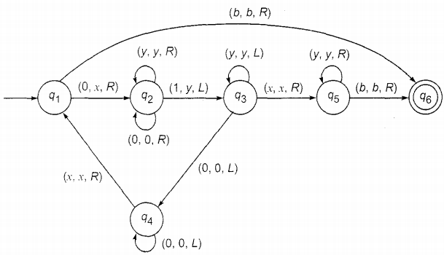
Q 1. Design a TM that accepts {0^{n}1^{n}2^{n} n>=1}.

Q2 (a) Construct a PDA an equivalent to the following context-free grammar S→0BB, B→0S | 1S | 0. Test whether 010⁴ is in N(A).
Q2 (b) . Find a grammar in CNF equivalent to the grammar
S → ~ S | [ S ﬤ ) S] | p | q (S being the only variable)
OR
Q 2 (a)Design a Turing machine over {1, b} which can compute a concatenation function over L = {1}. If a pair of words (W_{1 ,} W₂ ) is the input. the output has to be W₁W_{2.}
Q. 2 (b) Convert the Grammar S→ AB, A → BS | b, B→ SA | a into GNF.
Q 3. Write Short Notes on the Following
- State and Explain Rice Theorem.
- Explain Linear Bounded Automata (LBA) with the help of example
or
Q 3. Write Short Notes on the Following
- Explain Chomsky hierarchy of Languages with the help of diagram and table?
- What do you understand by an un-decidable Problem that is Recursively enumerable? Explain with the help of Diagrams.

Q 4. Construct context-free grammar G which accepts N(A),where
A =({q₀,q₁}, [a,b}, {Z₀,Z₁}, δ, q₀,Z₀,ϕ)
and δ is given by
δ (q₀,b, Z₀)= {(q₀, ZZ₀)}
δ (q₀,A,Z₀)={(q₀, A)}
δ (q₀,b. Z)= {(q₀, ZZ)}
δ (q₀,a, Z)={(q₁, Z)}
δ (q₁.b, Z)= {(q₁. ˄)}
δ (q₁.a, Z₀)={(q₀, Z₀)}

or
Q 4. M is aTuring machine represented by the transition system in Fig . Obtain the computation sequence of M for processing the input string 0011.

SET-B
Rajasthan Institute of Engineering & Technology, Jaipur
University Roll No. ______________
III Year B. Tech VI Semester II mid Term Examination, April – 2018
Branch: - Computer Science and Engineering
Subject : Theory of Computation Section: A
Time : 2 Hrs. [Maximum Marks: 20]
[Min. Passing Marks: 8]
Instructions to Candidates: -
Attempt all five questions. All questions carry equal marks. Schematic diagrams must be shown wherever necessary. Any data you feel missing suitably be assumed and stated clearly.
Q 1 (a). Construct a PDA an equivalent to the following context-free grammar S→0BB, B→0S | 1S | 0. Test whether 010⁴ is in N(A).
Q 1(b) . Find a grammar in CNF equivalent to the grammar
S → ~ S | [ S ﬤ ) S] | p | q (S being the only variable)
OR
Q1 Construct context-free grammar G which accepts N(A),where
A =({q₀,q₁}, [a,b}, {Z₀,Z₁}, δ, q₀,Z₀,ϕ)
and δ is given by
δ (q₀,b, Z₀)= {(q₀, ZZ₀)}
δ (q₀,A,Z₀)={(q₀, A)}
δ (q₀,b. Z)= {(q₀, ZZ)}
δ (q₀,a, Z)={(q₁, Z)}
δ (q₁.b, Z)= {(q₁. ˄)}
δ (q₁.a, Z₀)={(q₀, Z₀)}

Q 2. Consider the Turing machine description given in table.
Present State | b | 0 | 1
→ q₁ | 1Lq₂ | 0Rq₁
q₂ | bRq₃ | 0Lq₂ | 1Lq₂
q₃ |  | bRq₄ | bRq₅
q₄ | 0Rq₅ | 0Rq₄ | 1Rq₄
q₅ | 0Lq₂
Draw the computation sequence of the input string 00.

OR
Q 2. M is a Turing machine represented by the transition system in Fig . Obtain the computation sequence of M for processing the input string 0011.

Q3. Write Short Notes on the Following
- Explain Chomsky hierarchy of Languages with the help of diagram and table?
- What do you understand by an un-decidable Problem that is Recursively enumerable? Explain with the help of Diagrams.
OR
Q 3. Design a TM that accepts {0^{n}1^{n}2^{n} n>=1}.

Q 4 (a) Design a Turing machine over {1, b} which can compute a concatenation function over L = {1}. If a pair of words (W_{1 ,} W₂ ) is the input. the output has to be W₁W_{2.}
Q. 4 (b) Convert the Grammar S→ AB, A → BS | b, B→ SA | a into GNF.
_{OR}
Q 4. Write Short Notes on the Following
- State and Explain Rice Theorem.
- Explain Linear Bounded Automata (LBA) with the help of example

