SET-A
Rajasthan Institute of Engineering & Technology, Jaipur
University Roll No. ______________
II Year MCA. …III……..IstMid Term Examination, October – 2018
Subject: Theory of Computation
Time: -2 Hrs. [Maximum Marks: 20]
[Min. Passing Marks: 08]
Instructions to Candidates: -
Attempt all questions. Marks of questions are indicated against each section.

Q. 1 Answer following in 1-2 lines. (1x5=5)
- DFA
- NDFA
- Automata
- L(G)
- Stuck Condition

Q. 2 Answer the following questions in 50 words each. (2x2=4)
Q2 (a) Construct a Mealy machine which is equivalent to the Moore machine defined by the table
Present State | Next State |  | Output
Present State | a=0 | a=1 | Output
q₀ | q₁ | q₂ | 1
q₁ | q₃ | q₂ | 0
q₂ | q₂ | q₁ | 1
q₃ | q₀ | q₃ | 1

Q2 .(b) Construct a Moore Machine equivalent to the Mealy Machine M defined by Table:
Present State | Next State
Present State | a=0 |  | a=1
Present State | State | Output | State | Output
q₁ | q₁ | 1 | q₂ | 0
q₂ | q₄ | 1 | q₄ | 1
q₃ | q₂ | 1 | q₃ | 1
q₄ | q₃ | 0 | q₁ | 1

Q. 3 Answer the following questions in 150 words. (3x2=6)
Q. 3 (a) Let L Be the set of all the palindromes over {a,b}. Construct a grammar G generating L.
Q. 3 (b) Explain null removal technique with the help of example.

Q. 4 Answer the following questions in 100 words. (5x1=5)
Q.4 Construct a DFA with reduced state equivalent to the RE
0+ (0+11)0*1

OR
Q. 4 Prove that the finite automaton whose transition diagram is as shown in Fig. accepts the set of all strings over the alphabet {a, b}with an equal number of a's and b's, such that each prefix has at most one more a than the b's and at most one more b than the a's.
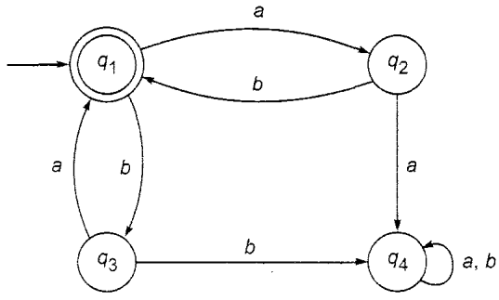
Q. 5 Answer the following questions in 150 words. (5x1=5)
Q. 5 Write “Identities for regular expression”.
OR
Q. 5 (a)Construct a deterministic finite automaton equivalent to (2.5x2=5)
M= ({q₀, q_{1,} q₃, q₄}, {0,1}), δ, qo, {q₃})
Where δ is given by Table below
State | 0 | 1
q₀ | q_{0,} q₁ | q₀
q₁ | q₂ | q₁
q₂ | q₃ | q₃
q₃ |  | q₂
Q. 5 (b) Write short Notes on “Arden’s Theorem” with proof.
*****************

