SET-B
Rajasthan Institute of Engineering & Technology, Jaipur
University Roll No. ______________

II Year MCA. …III……..Ist Mid Term Examination, October – 2018
Subject: Theory of Computation
Time: -2 Hrs. [Maximum Marks: 20]
[Min. Passing Marks: 08]
Instructions to Candidates: -
Attempt all questions. Marks of questions are indicated against each section.

Q. 1 Answer following in 1-2 lines. (1x5=5)
- L(G)
- Automata
- Regular Grammar
- Regular Sets
- ^ Symbol

Q. 2 Answer the following questions in 50 words each. (2x2=4)

Q2(a) Construct a Mealy machine which is equivalent to the Moore machine defined by the table

Present State | Next State |  | Output
Present State | a=0 | a=1 | Output
q₀ | q₃ | q₁ | 0
q₁ | q₁ | q₂ | 1
q₂ | q₂ | q₃ | 0
q₃ | q₃ | q₀ | 0

Q2(b) Discuss differences
- DFA & NDFA
- Finite Automata and Regular Expression

Q. 3 Answer the following questions in 100 words. (3x2=6)
Q. 3 (a) Write “Identities for regular expression”.
Q. 3 (b) Consider the following two DFAs M and M’ over {0,1} given in Figure Determine whether M and M’ are equivalent
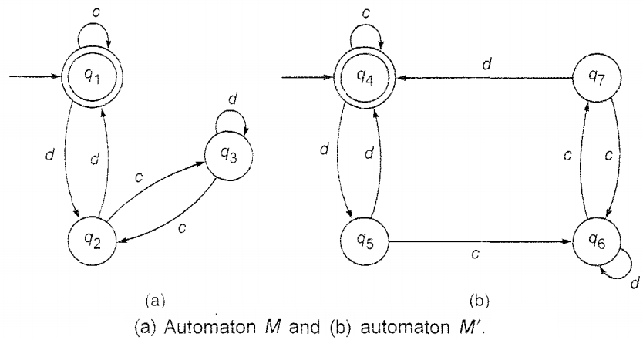

Q. 4 Answer the following questions in 150 words. (5x1=5)
Q. 4 Find the regular expression corresponding to figure
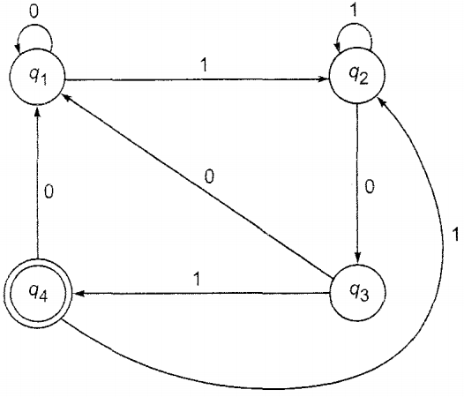

or
Q. 4 (a) M = ({q₁, q₂, q₃}, {0, 1}, δ, q_{l} {q₃}) is a nondeterministic finite automaton. Where δ is given by
δ (q1,0) = {q₂, q₃} | δ (q1,0) = {q₁ }
δ (q2,0) = {q₁, q₂ } | δ (q3,0) = ϕ
δ (q3,0) = {q₂ } | δ (q3,0) = {q₁, q₂ }
Construct an equivalent DFA.
(b) Write short Notes on “Arden’s Theorem” with proof.
Q. 5 Answer the following questions in 150 words. (5x1=5)
Q. 5 Let L Be the set of all the palindromes over {a,b}. Construct a grammar G generating L.
OR
Q.5 Construct the finite automaton equivalent to the regular expression
10+(0+11)0*1
***************

